The image of the creative city, eight years later: Turin, urban branding and the economic crisis taboo
Alberto Vanolo
Editor’s manuscript; final version published in Cities, v. 46 (2015), doi:10.1016/j.cities.2015.04.004
http://www.sciencedirect.com/science/article/pii/S0264275115000566

Abstract
The article looks at the evolution of urban branding in the city of Turin, Italy, over a period of about ten years. As reported in a previous article published in Cities, at the end of the nineties the city of Turin started investing heavily in creative and cultural branding strategies, in order to modify its former image of an industrial one-company town. This article looks at the same city eight years later: both Turin and the general socio-economic situation have changed, primarily because of the ongoing economic crisis. As a result, other discourses are emerging in the field of urban branding, with a meaningful divide between the ‘internal’ dimension of branding (messages directed to inhabitants and city users) and its ‘external’ dimension. Specifically, the article considers the role and heritage of ‘old’ discourses on culture and creativity and the diffusion of new branding messages related to food and to the imagery of the ‘smart city’.

Keywords: Turin, crisis, urban branding, urban marketing, creative city, cultural city, smart city

1. Introduction
The aim of this paper is to discuss potential relations between urban branding discourses and the economic crisis. Turin, Italy, will be used as a case study; the global crisis, which started in 2008, impacted the city in many significant and unexpected ways. In the twentieth century, Turin was the most typical Italian example of a Fordist one-company town. Home to the FIAT car manufacturing company, Turin experienced the well-known urban dynamics of Fordist cities, from massive growth and immigration in the early twentieth century, to industrial stagnation, and ultimately the social and economic crisis of the eighties. At the end of nineties urban branding was mobilised as a key tool to modify the way in which the city was perceived by external investors, tourists, and local inhabitants, i.e., fighting the stigma typically associated with decaying industrial cities. Like many other cities all over Europe, Turin tried to represent itself as a dynamic, technologically advanced and culturally vibrant city.
In the early twenty-first century, many circumstances led to the ‘golden age’ of urban branding in Turin. First and foremost, the 2006 Winter Olympic Games: political momentum and huge amounts of money poured into the city to implement several urban projects and internationally celebrate the idea of a ‘new’ Turin – dynamic, cosmopolitan, cultural and creative (Vanolo, 2008).
The situation has changed radically since the end of the 2006 Winter Olympic Games and the gradual demise of the hyper-optimistic aspirations of a ‘wannabe global city’ (Rossi and Vanolo, 2012); these two events then overlapped with the massive economic crisis which began in 2008. Now, at the end of 2014, Turin is arguably the northern Italian city hardest hit by the economic crisis: massive public debt and growing unemployment, issues which will be discussed later.
The article investigates the changing role and changing mechanics of urban branding after Turin’s shift from a period of generalised optimism to the current difficulties linked to the economic crisis. The paper will argue that the elements behind the pre-crisis urban image are still at play (stereotypes and visual referents involving creative and vibrant cultural lifestyles), since the economic crisis is a taboo subject in urban branding discourses, and yet many aspects of urban branding have changed somewhat over the years. This is particularly visible in the case of internal branding, i.e., promoting the city’s image vis-à-vis local residents. In fact, there has been a shift from the celebration of Turin’s beauty ‘here and now’ to a growing emphasis of what Turin ‘will be’: this aspect will discussed in the paper in relation to the notion of making Turin a ‘smart city’. At the same time, the city’s manifest economic crisis is a sort of ‘taboo’, or ‘invisible presence’: clearly there is no mention of it in branding materials, but it nevertheless hovers around the city.
From a methodological point of view, the arguments presented in this article are based on the mobilisation of multiple sources of evidence, including observation, qualitative interviews and critical discourse analysis (Lees, 2014). More specifically, branding materials concerning Turin – both in English and Italian – have been collected between September and October 2014. These include web-based materials as well as brochures and other printed materials distributed by local tourist offices. The materials have been carefully analysed and catalogued using keywords according to their content. Secondly, three qualitative interviews with local policy-makers and five interviews with local scholars working in the field of place promotion have been carried out between October and November 2014. The interviews, which have been quite open and loosely structured, have had the two functions of acquiring new perspectives and impressions, and getting informed feedbacks on the thesis obtained from the analysis of marketing materials. Finally, being an inhabitant of the city, I have had the possibility of observing, over the years, the development of many branding activities, and to informally discuss both past and current branding processes with people.
The article is organised as follows: the next section reviews theoretical discussions on urban branding, with particular emphasis on the role of the economic crisis, followed by a section focusing on the analysis of branding in Turin and, finally, the conclusions summarising the most important results.

2. City branding in times of crisis
Urban branding is a well-known concept in urban studies, and will only be overviewed in brief. In the early nineties, several authors began to analyse how to apply business marketing and business management tools, approaches and perspectives to urban policy-making (Ashworth and Voogd, 1990 and 1994; Paddison, 1993; Gold, 1994; Gold and Ward, 1994; van den Berg and van Klink, 1995). The concept of city marketing, now more commonly known as city branding (for a systematic discussion of the two terms see Kavaratzis, 2004), refers to the production and circulation of attractive urban images (or, more precisely, imageries: ideas, stereotypes, mental associations, etc.; see Zenker and Erfgen, 2014). Of course, building and improving the image of a city involves social and political practices situated not only in the realm of the virtual, immaterial and discursive. There are many reasons why urban branding overlaps with complex and controversial politics of representation (Pike, 2009; Rossi and Vanolo, 2012; Eshuis and Edwards, 2013); here the discussion will be limited to three key arguments.
First, urban representations are always performative. As widely discussed in philosophy (see the classic works of Austin, 1962, and Butler, 1990), there are two ways in which representation tends to produce ‘reality’. First, representations generate different ways with which to frame social phenomena and issues, thus paving the way for different kinds of interventions and discursive tactics. For example, representations linking a city’s economic success to the presence of artists, intellectuals and members of the creative milieu in general (Florida, 2002). In fact, this discursive construction tends to implicitly support the idea that a city’s lack of success may be due to the absence of members of the creative milieu, thereby legitimating creative policies as a mean to achieve urban development (Peck, 2005). Then, representations influence the actions and choices of human agents. For example, if an urban place is represented as dangerous (e.g., due to the alleged presence of criminal activities), people may be scared and start to avoid it: as a result, the place will become stigmatised as less dynamic and, arguably, more dangerous (see Wacquant, 2008). There is another example more closely linked to urban branding: the more a city is represented as an interesting and attractive place, the more people will visit it, and this has a cumulative effect thanks to people’s feedbacks, ideas and discussions (see the classic work by Urry, 1990). Of course, these examples are mere schematisations aimed at emphasising the performative nature of images and representations; nevertheless, it is always difficult to predict the effects and consequences of branding campaigns. For example, a badly designed urban branding campaign may be perceived as ridiculous and out of place, and may provoke unexpected and undesired consequences.
Second, urban branding has been described as ‘selective story-telling’ (Sandercock, 2003; Jensen, 2007): only a limited number of optimistic voices, images and representations will conflate in urban branding materials. For example, urban branding campaigns will focus on vibrant city centres and potential cultural experiences and amenities, while there will be absolutely no mention of several urban problems such as unemployment, urban decadence in the suburbs and lack of welfare services. In this sense, urban branding may be a highly controversial terrain: representing a city as a place of pleasure may be offensive or even violent in the eyes of those who do not fit into the optimistic picture, such as the unemployed, homeless, elderly (Rossi and Vanolo, 2012; Johansson, 2012). This consideration begs a more general question: who has the right to produce an urban image which, in a certain sense, represents the collective identity of a place? In this perspective, recent contributions in the literature on place branding have stressed the need for participation and consultation of residents, and local stakeholders in general, in order to produce a more effective and sustainable place branding (Kavaratzis, 2012; Braun et al., 2013; Zenker and Erfgen, 2014). In fact, in order to avoid the pitfall of developing ‘artificial’ place brands which lack credibility, it is necessary to produce brands which are coherent with local identities, where identities have to be considered as dynamic and contested social constructions (Boisen et al., 2011; Kavaratzis, 2012).
Third, images and stereotypes at the heart of urban branding campaigns circulate globally. This means that urban representations are not only consumed in distant places, but that there is a kind of global imagery of urban success (McNeill, 2009; Rossi and Vanolo, 2012). In other words, the symbols, narrations and ingredients of urban branding are often all the same. For example, during the nineties most of the cities in the global north wanted to become ‘intelligent’, ‘technological’ cities, while the twenty-first century has been the turn of ‘creative’, ‘cultural’ cities. There are a number of reasons behind the global convergence of urban branding messages. For example, urban policy making tends to imitate individual cases considered ‘successful best practices’, giving rise, for instance, to well known urban policy-making phenomena such as the ‘Bilbao effect’ (construction of a cultural image; Plaza, 2000; Gonzales, 2006) or the ‘Barcelona model’ (with reference to the management of the Olympic Games; Gonzales, 2011; Cook and Ward, 2011). There is a trap behind the obvious consequence of this global convergence: the ‘serial reproduction’ of promotional policies – to use the expression introduced by David Harvey (1989) in the framework of his ‘entrepreneurial city’ thesis – with the risk that branding messages disappear in the mass of almost identical urban images.
An interesting and rather unexplored topic in urban branding is the ambiguous relationship between image promotion and urban crisis. On the one hand, literature stresses how the impetus for urban branding often depends on crisis situations, for instance the need to face the gradual deindustrialisation of many industrial cities (see for example Short and Kim, 1998; Greenberg, 2008). On the other hand, there is seemingly little room for discourses about crises in the optimistic representations of urban branding. In this sense, challenging a crisis implies, in the world of urban branding, an effort to avoid mentioning the crisis at all, a phenomenon I will label the ‘economic crisis taboo’. This may undoubtedly be linked to the discussed performativity of representations: many people think that mention of a local crisis will stop investors from investing, and tourists from visiting, thereby further reinforcing the crisis. But what about a city that has based most of its urban branding arguments on the idea that the city ‘has changed’ and then, after years of optimistic expectations, finds itself facing a massive and severe crisis?

3. Turin, at the dawn of 2015
The last available figures for Turin set the unemployment rate at 11,4%, the highest of all metropolitan cities in northern Italy. In 2007, immediately after the 2006 Winter Olympic Games (and when Vanolo, 2008, was written), the figure was 4,7%, while in 2006 it was 4,1%. The number of poor people rose by 46% between 2011 and 2013. In 2007, 256 businesses closed in the city, and in 2013 the figure rose to 519; the city was described in the most popular Italian newspaper as ‘a Spoon River of enterprises’. Turin also has the highest level of public debt per capita (i.e., about 3,520 euro per head), equal to a total public debt of about 3 billion euro. Many critics believe this high level of debt is due to the organisational costs of the 2006 Olympic Games (it is not a coincidence that the second municipality in terms of public debt is Milan, currently organising Expo 2015).
Other data and figures can be cited, but the overall idea is always the same: Turin is going through a severe urban crisis, one which was largely unexpected since most economic indicators for the city had shown positive trends in 2006 and 2007, in the aftermath of the Winter Olympic Games hosted by the city in February 2006. However, in the years that followed, the city and regional governments were severely affected by the fiscal consolidation rules and related austerity policies imposed by the EU Stability and Growth Pact which was reformed in 2011 in order to deal with the consequences of the sovereign debt crisis of many European countries, including Italy. In this scenario, it is meaningful to analyse the various branding messages and urban imageries promoted by the city of Turin in the last few years. Specifically, the following sections of the article will focus on three overlapping discourses related to (a) culture and tourism, (b) food and eno-gastronomic experiences, and (c) to the idea of the smart city. It has to be stressed once more that these discourses been developed in a scenario of an unexpected crisis and economic uncertainty, which has also been due to the changing strategies of FIAT.

3.1 Culture and tourism in the post-industrial city
As discussed in Vanolo (2008), the Winter Olympic Games boosted urban branding and were an opportunity for the city to show the world that Turin was no longer a dull and decaying industrial city known as ‘the Italian version of Detroit’ (cf. Pizzolato, 2008). The main branding message was that the city has changed (‘always on the move’, to quote a slogan widely used during the Games) and had become a vibrant cultural and creative city, a place for arts, culture and urban amenities (emphasising, for example, the possibility of enjoying music, hi-quality food, night-outs, etc.). Turin-based academics and researchers (Crivello, 2006; Guala, 2009) reported that the inhabitants of Turin strongly supported hosting the Games. In surveys conducted in 2003 and 2004, 79% of people agreed with the project to host the Games, while negative answers made up just 2% of the sample. More than 90% said that they felt proud that Turin won the bidding competition to host the Games (Guala, 2009). Immediately after the Games in 2006, most of the people interviewed (53%) were confident that the positive effects of the Games would last for years. Optimism was ubiquitous.
An obvious effect of the massive branding campaign linked to the Games was the city’s gradual emancipation from the polarising image of FIAT (Vanolo, 2008). Policy makers nearly all agreed that Turin needed to promote ‘other’ identities and ‘other’ economic vocations: FIAT and car manufacturing in general increasingly moved to the margins of promotional materials and branding messages. But the situation has again changed in recent years. The partnership between FIAT and the American company Chrysler, which began in 2009, developed and grew over time, and in October 2014, the two companies merged. One important outcome involved moving the headquarters of FIAT away from Turin. FIAT Chrysler Automobiles (FCA) in a now a multinational company with headquarters in London and Amsterdam. Many manufacturing, design and engineering facilities are still located in Turin, but considering FIAT a ‘local’ or ‘Italian’ company is rather confusing.
The huge and unexpected economic crisis and irreversible erosion of the local urban identity/FIAT pairing has put the branding approach of the early twenty-first century in an ambiguous position. On the one hand, the hyper-celebration of culture, tourism and creativity, and the representation of Turin as a vibrant city of amenities, clashes with the social and economic crisis experienced daily by its inhabitants. In particular, the economic crisis has led to huge financial cuts in the budget of the cultural sector (both nationally and at urban level; cf. Rota and Salone, 2014) and in 2012 ‘creative workers’ started a huge protest movement at the foot of the Mole Antonelliana, the most important city landmark now hosting the popular Cinema Museum. The precarious economic conditions of the roughly 37,000 people working in the art and culture sector are at odds with the idea of Turin as a dynamic cultural city. Of course, this does not mean that Turin is abandoning cultural branding, or that the city’s overall cultural offer is being downsized. On the contrary, the city is still heavily branded as a cultural city, and many cultural events are still proposed: for example, the city (unsuccessfully) bid to be the European Capital of Culture in 2019. But the financial crisis has led to reduced investments in branding activities as a whole, and to an overall reconfiguration of the way in which urban branding is managed locally. Local branding activities have been carried out by several independent offices (Martina, 2006; Vanolo, 2008). However, budget cuts, together with suspect episodes of corruption (currently under investigation), led to the merger of several offices, and branding activities are now managed by Turismo Torino e Provincia, an “organisation for the promotion of the province of Turin as a tourist destination for leisure, sport, nature, culture, individual and group trips, conferences, conventions, incentive travel and business travel”. Turismo Torino e Provincia is a consortium of all the provincial municipalities and several private and public-private companies. In 2003 the consortium produced an action plan outlining the main goals of its promotional activities. According to the plan, different segments of local tourism have to be strategically enhanced, especially those involving mountains, sports, urban tourism, business tourism, culinary or food tourism, and school tourism. Clearly, the afore-mentioned erosion of the identitarian connections between Turin and FIAT makes it more important to promote ‘alternative’ identities and ‘alternative’ economic sectors, and specifically those related to high-quality food and wine.

3.2 A city of eno-gastronomic experiences
The main focus of recent urban branding in Turin has involved an interesting transposition and reconfiguration of meanings and messages regarding industry, culture and the high-end culinary sector, which is a key economic sector that is still showing positive trends in Turin and the Piedmont region. For example, over the years there has been an evident reframing of local wines and local foods thanks to the promotion of specific cultural constructions. Several local, regionally produced wines used to be considered ‘cheap’, while today they are increasingly appreciated and branded by the market economy as ‘rare’ and ‘authentic’ high-quality wines to be sold both locally and internationally. Local wines such as Nebbiolo and Barolo, for example, are now well-known high-quality wines, in many cases considered superior to the more famous Tuscan wines. Twenty years ago no one expected certain kinds of wine-production systems or wine-cultures to one day become so economically important or even strategic, nevertheless this has led to the renaissance of rural areas like the Langhe and Roero (Santagata, 2002). This phenomenon was heavily promoted by the popular local association Slow Food which has had a global impact in the revitalisation and reinvention of old culinary traditions (Pietrykowski, 2004). Particularly, Slow Food organizes the world’s largest food and wine fair, the Salone del Gusto, in Turin. It is extremely emblematic that the fair takes place in the Lingotto building which in the first half of the twentieth century was the main FIAT factory. And Eataly, the famous high-end Italian food mall chain, is located right next to the Lingotto. In synthesis, the food market is currently considered a strategic economic sector for the Piedmont region, despite the open anti-corporation and non-utilitarian approach of the Slow Food association (Vanolo, 2015). An example of this could be the local company Grom, which is a popular ice cream brand expanding all over Italy and abroad, is considered a successful symbol of the growth of the city’s food sector.
In synthesis, food is a key ingredient in the urban branding of Turin. A large part of Torino Sette – basically a local version of ‘Time out’ providing information about the main weekly events in the city – deals with food and culinary experiences in general. In the framework of the ongoing crisis of the local economy and to some extent of the local cultural industry, one important point to note is that food has been reframed as both a cultural experience and a local industry. Consider figure 1, which shows extracts from the main promotional brochure Turismo Torino illustrating what Turin offers foreign tourists. The section ‘capital of taste’ introduces several local food products and culinary experiences. What is probably more interesting is the next section, ‘industrial excellence’. The section starts by subverting the stereotype of the Fordist city:
There’s no denying, for a long time Torino meant industry, greyness and immobility…. And perhaps that what it was really like. But now the city has dramatically changed (…).
When the brochure lists local industries, FIAT is not mentioned in any particular way but is simply included in a list along with all the other companies, despite the fact that FIAT’s role in the city is clearly different to that of all the other listed companies (cf. Whitford and Enrietti, 2005). There are no photos of cars, but there are pictures of a luxury pen, the art museum (the Pinacoteca Agnelli located in the Lingotto), industrial coffee processing (Lavazza) and stereotyped researchers in white coats. Culinary issues are then repeatedly discussed despite the fact that most marketing materials tend to associate hi-quality food with artisanal rather than industrial production, for example the numerous local chocolate manufacturers.

Figure 1 – Pages from the promotional brochure ‘One territory, infinite emotions’ (2014)
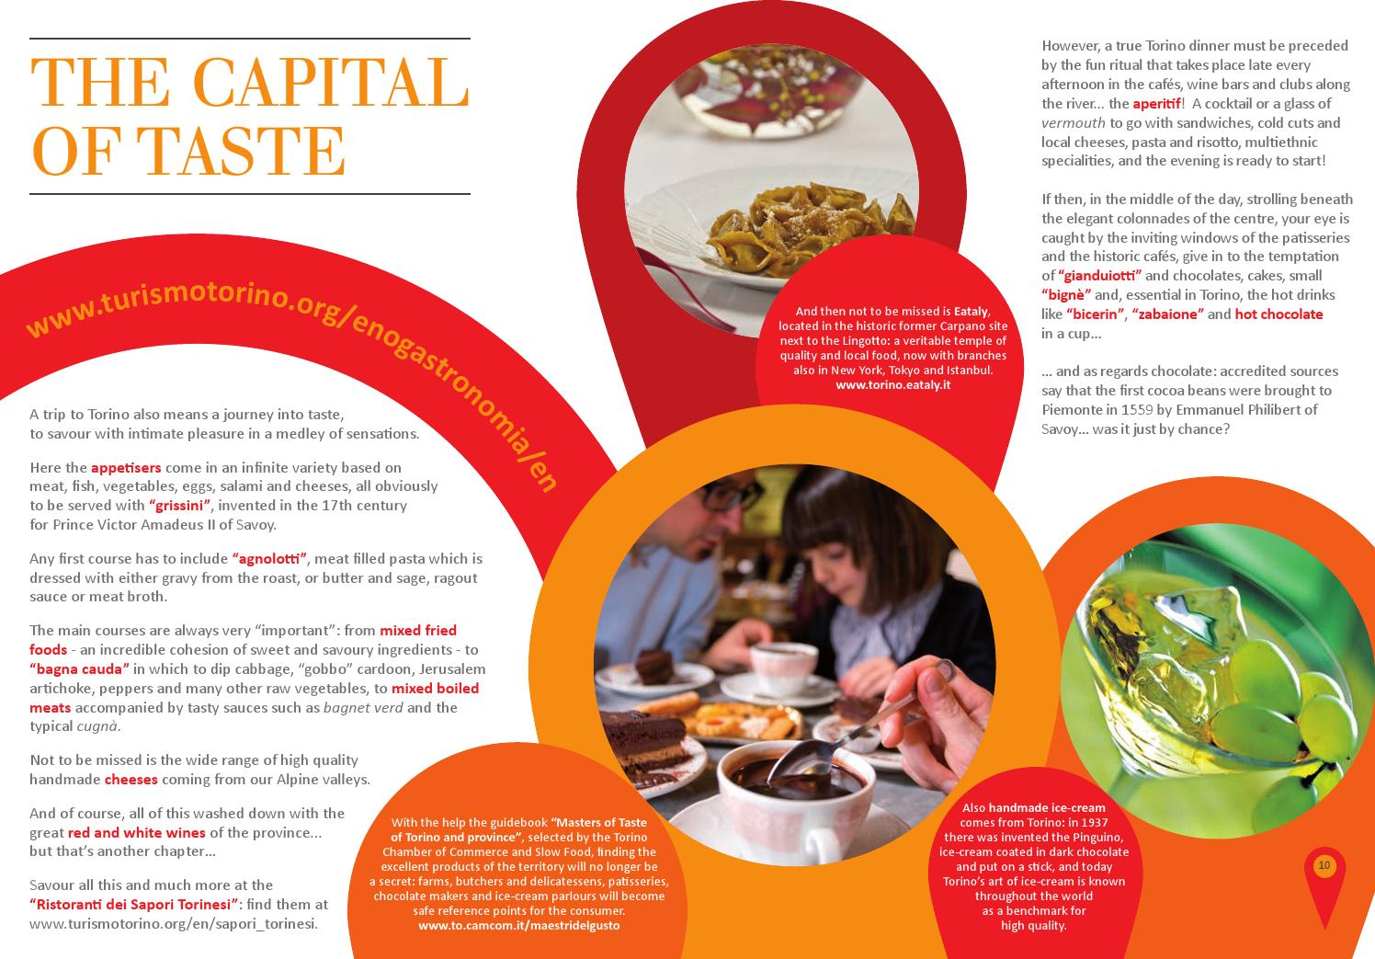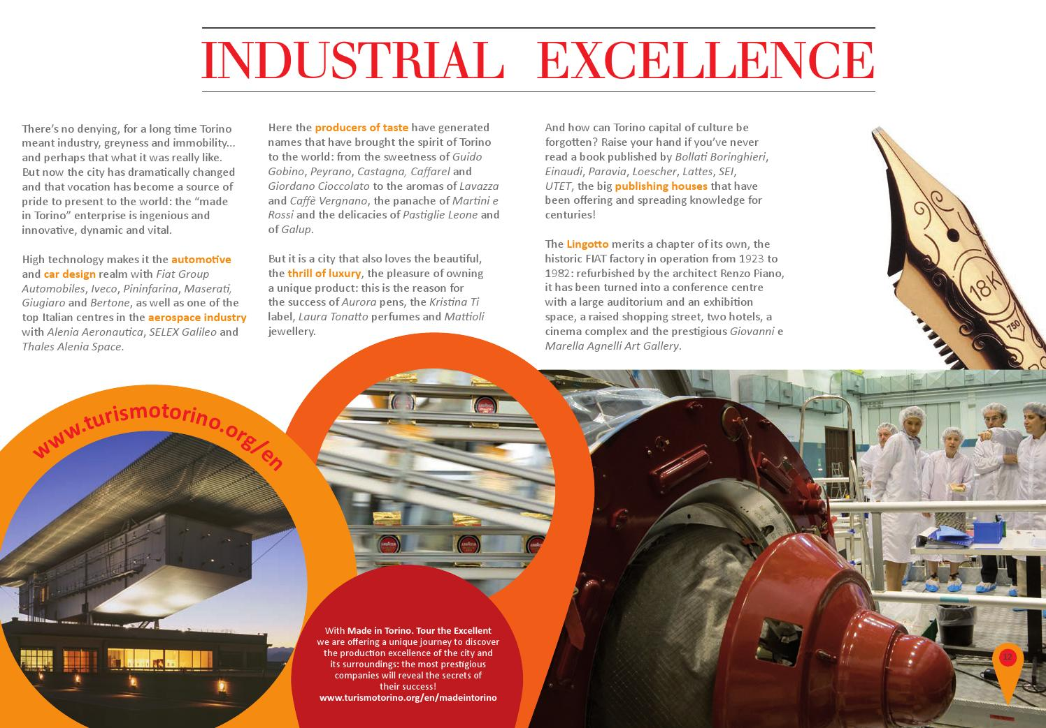
Source: www.turismotorino.org (accessed 3 November 2014)
3.3 Smartness will save Turin
Finally, another link between the crisis and branding is the project to make Turin a ‘smart city’. It will be argued that this project is chiefly linked to internal marketing and specifically to the attempt to provide optimism, hope and pride to the local population.
As fully discussed elsewhere (Söderström et al., 2014; Vanolo, 2014), the European Union has recently introduced the theme of ‘smart cities’ among its policy priorities and massive funds have been allocated in support of ‘smart’ projects. In brief, the smart city concept relies on the implicit assumption that urban infrastructures and everyday life can/should be optimised and ‘greened’ through technologies and innovations produced by global IT companies such as IBM, Cisco and Siemens. Such a vast deployment of resources, at a time of widespread crisis in urban economies, has had a fallout effect on the strategies of Italian cities (Vanolo, 2014).
Turin is no exception, and the city wholeheartedly embraced the quest for European funds. The Foundation Torino Smart City was purposely created to make Turin “the smart city of the future”. It is not in the interests of this paper to debate the positive or negative effects of urban smartness policies (on this topic see Hollands, 2008; Vanolo, 2014), but instead it is simply interesting to consider the branding dimension of the Turin smart city project. According to the Torino Smart City website,
Turin becomes intelligent. Turin become smart. A smart city, in which the quality of life improves with the ability to promote a clean and sustainable mobility, reducing the energy consumption, producing high technology, offering culture, be accessible. These are the objectives that the city is given within the Torino Smart City Project.
The promotional dimension of the project is more than obvious here. An official video from the Torino Smart City Foundation offers an interesting text and proposes the slogan “Turin is the city where the future is born. Starting yesterday”. The video celebrates the ‘glorious’ days of the industrial past when Turin gave birth to many technological innovations; it argues that Turin will be smarter and smarter thanks to numerous ongoing projects which will improve quality of life, provide an extensive cultural offer, produce sustainability, etc. From the point of view of urban marketing, the text gives the impression that the smart city project deals with internal branding, i.e., branding for the inhabitants (see Braun et al., 2013). The external dimension seems, in fact, marginal: most of the promotional materials are produced only in the Italian language, and most of the promotional events organised in the field have a clear focus on the local population. This may be the case, for example, of projects aimed at encouraging the use of e-commerce tools among local small shops or the diffusion of LED lights in public spaces instead of energy-intensive lightbulbs. These two actions, in fact, are two rather disconnected top-down initiatives (arguably, cheap initiatives) proposed by the local government in order to support local stakeholders and to provide infrastructure maintenance. Hence, these two actions are branded under the umbrella label ‘smart city’, in order to promote the idea that Turin is evolving in technologically-advanced and environmentally-friendly ways. During these difficult times, the smart city project essentially nurtures optimistic expectations about the future in the eyes of local stakeholders. At the same time, from the point of view of local policy makers, the smart city project will allow private enterprises (with their money) to be involved in an eco-friendly and economically sustainable management of various urban services, such as water and transport. In this way, the search for sustainability is touted as a win-win strategy coupling urban boosterism with the protection of the environment and the defence of effective citizenship (Raco and Flint, 2012). Of course, promotional discourses – such as the promotional video by the Torino Smart City Foundation mentioned previously – makes no mention of the economic crisis: as discussed earlier, the crisis is a taboo in branding discourses. The idea that the smart city development strategy will help overcome the crisis is implicit in statements about a city that “is able to spend less and better without lowering the quantity and quality of services provided to citizens and businesses”. This is coherent with the kind of branding message that is proposed by most corporations developing smart technological solutions for cities: promotional discourses celebrate how Apps, smartphones and big data analysis will help to solve problems such as global change, the lack of social cohesion in cities and the ongoing economic crisis, without questioning for example the inner contradictions of the economic system and our consumeristic lifestyles (Morozov, 2013; Söderström et al., 2014).
At the same time, in the field of city branding, the imagery of the smart city does not seem to be relevant for the attraction of tourists and investments, and in fact it is absent in promotional materials in the English language; even in the economic sphere, the official web site ‘Invest in Torino Piemonte’ does not mention smart cities at all, privileging the other elements of local branding discussed previously.

4. Conclusions: the Janus face of branding
The way in which promotional discourses have evolved in Turin provides interesting insights into the dynamics of urban branding, in particular by emphasising the ambiguous and controversial relationship between branding messages and the economic crisis. As discussed previously, the crisis is a relevant issue in Turin not only because it is dramatic, but also because it was quite unexpected due to both the optimism of the early twenty-first century and massive local branding campaigns.
As discussed in the paper, urban branding consists of selective and optimistic storytelling, and therefore the crisis is a forbidden ‘taboo’. Consequently, the unexpected crisis has produced a realignment of branding practices in Turin, creating a certain divide between the messages and strategies used in the external and internal dimensions of branding.
As regards external branding, promotional materials and branding messages simply make no reference to the current crisis, and problematic elements such as the relationship with FIAT are clearly ignored. On the contrary, the most successful and promising economic sector, i.e. food, is reframed as both an industrial and a cultural phenomenon. In fact, the imagery of the post-industrial city, the discourse on the cultural city and the representation of Turin as a gastronomic paradise overlap in many ways: as discussed in the paper, food is branded as both a local cultural sector and as a typical economic activity. But the pictures of luxurious dishes and elegant dinners which abound on tourist brochures are not primarily targeted at the wider public of the local population. In fact, in the current scenario, the consumption of expensive foods and wines is primarily a privilege of rich tourists and foreign markets. In other words, the branding of Turin as a food paradise is particularly crucial for the external dimension of branding, while it plays a minor role in internal branding because of the contraction of local consumption levels. In fact, internal branding veers, to some extent, in another direction, that is the smart city discourse, which is connected to the celebration of the salvific role of new technologies. Apps, sensors, big data and smartphones will apparently ensure sustainability, inclusion, quality of life, justice, wealth, European funds, and other positive effects, all of which are highly needed in current times of crisis. However, the smart city discourse does not seem to be considered relevant in terms of attracting tourists and investments, as suggested by its invisibility in promotional materials targeting tourists and investors.
Summing up, Turin makes it possible to observe one possible effect of urban branding during an economic crisis: the partial loss of adherence between internal and external branding messages. The ‘selective storytelling’ used by branding has to provide dreams and positive expectations which, during a crisis, differ for local inhabitants and external actors. In the case of Turin, this gap is probably connected to the absence of mechanisms for participation and consultation of local stakeholders: branding has been essentially developed with a top-down approach. This is particularly evident in the case of the smart city discourse, as the concept of the smart city was unknown to most of the inhabitants up to a couple of years ago (and, arguably, it is still unknown to many). At the same time, this case study raises a challenging question that has not been fully discussed in the literature on place branding: what to do when the brand that fits the expectations of the inhabitants, for example by giving them a sense of hope and commonality, is patently unfitting for attracting external resources? Alternatively, inverting the perspective, what can be done if the brand that seems successful for attracting tourists and investments clashes with the needs, aspirations and perceived identities of the local stakeholders? In such cases, it is hardly possible to have the positive synergies discussed by Braun et al. (2013), because residents will not necessarily grant credibility and legitimization to place branding. In these cases, branding has the difficult task of providing an imagery that may look sufficiently credible, respectful and optimistic to satisfy both local stakeholders and the potential external audience. But the case of Turin shows an alternative path: developing two slightly different brands for the two different audiences, a strategy which is probably risky in terms of credibility and social legitimisation. This controversial strategy has not yet been fully explored in the literature, and further lines of research may expand the debate on inclusive branding strategies (Kavaratzis, 2012; Braun et al., 2013; Zenker and Erfgen, 2014) by exploring those cases in which it is difficult to mobilise local stakeholders in support of effective branding strategies.

References
Ashworth G.J. and Voogd H. (1990), Selling the City: Marketing Approaches in Public Sector Urban Planning, Belhaven, Oxford.
Ashworth G.J. and Voogd H. (1994), Marketing and place promotion, in S.V. Ward and J.R. Gold (eds.), Place Promotion. The Use of Publicity and Marketing to Sell Towns and Regions, John Wiley & Sons, Chichester, pp. 39-52.
Austin J.L. (1962), How to do things with words, Harvard University Press, Cambridge
Boisen M., Terlouw K. and van Gorp B. (2011), "The selective nature of place branding and the layering of spatial identities", Journal of Place Management and Development, v. 4, n. 2, pp. 135-147.
Braun E., Kavaratzis M. and Zenker S. (2013), "My city – my brand: the different roles of residents in place branding", Journal of Place Management and Development, v. 6, n. 1, pp. 18-28.
Butler J. (1990), Gender Trouble. Feminism and the Subversion of Identity, Routledge, New York.
Cook I.G. and Ward K. (2011), "Trans-urban networks of learning, mega events and policy tourism. The case of Manchester’s Commonwealth and Olympic Games projects", Urban Studies, v. 48, n. 12, pp. 2519-2535.
Crivello, S. (2006), Torino, verso una nuova immagine della città? In Olimpiadi, oltre il 2006, P. Bondonio, E. Dansero and A. Mela (eds), Carocci, Roma, pp. 295-312.
Eshuis, J. and Edwards, A. (2013), "Branding the City: The Democratic Legitimacy of a New Mode of Governance", Urban Studies, v. 50, n. 5, pp. 1066-1082.
Florida R. (2002), The Rise of the Creative Class. And How It's Transforming Work, Leisure, Community, and Everyday Life, Basic Books, New York.
Gold J.R. (1994), Locating the message: place promotion as image communication, in S.V. Ward and J.R. Gold (eds), Place Promotion. The Use of Publicity and Marketing to Sell Towns and Regions, John Wiley & Sons, Chichester, pp. 19-37.
Gold J.R. and Ward S.V. (1994), Introduction, in S.V. Ward and J.R. Gold (eds), Place Promotion. The Use of Publicity and Marketing to Sell Towns and Regions, John Wiley & Sons, Chichester, pp. 1-17.
Gonzales S. (2006), "Scalar narratives in Bilbao: A cultural politics of scales approach to the study of urban policy", International Journal of Urban and Regional Research, v. 30, n. 4, pp. 836-857.
Gonzales S. (2011), "Bilbao and Barcelona ‘in Motion’. How Urban Regeneration ‘Models’ Travel and Mutate in the Global Flows of Policy Tourism", Urban Studies, v. 48, n. 7, pp. 1397-1418.
Greenberg M. (2008), Branding New York: How a City in Crisis was Sold to the World, Routledge, New York.
Guala C. (2009), To bid or not to bid: public opinion before and after the Games. The case of the Turin 2006 Olympic Winter Games, in J. Kennell, C. Bladenand and E. Booth (Eds), The Olympic Legacy. People, Place, Enterprise. Proceedings of the first annual conference on Olympic Legacy 8 and 9 May 2008, University of Greenwich, London, pp. 21-30.
Harvey D. (1989), The Condition of Postmodernity, Blackwell, Oxford.
Hollands R. (2008), "Will the real smart city please stand up? Intelligent, progressive or entrepreneurial?" City, v. 12, n. 3, pp. 303-320.
Jensen O.B. (2007), "Culture stories: understanding cultural urban branding", Planning Theory, v. 6, n. 3, pp. 211-236.
Johansson M. (2012), "Place Branding and the Imaginary: The Politics of Re-imagining a Garden City", Urban Studies, v. 49, n. 16, pp. 3611-3626.
Kavaratzis M. (2004), "From city marketing to city branding: towards a theoretical framework for developing city brands", Place Branding, v. 1, n. 1, pp. 58-73.
Kavaratzis M. (2012), "From “necessary evil” to necessity: stakeholders' involvement in place branding", Journal of Place Management and Development, v. 5, n. 1, pp. 7-19.
Lees L. (2004), "Urban geography: discourse analysis and urban research", Progress in Human Geography, v. 28, n. 1, pp. 101-107.
Martina A. (2006), Comunicare la città, Paravia, Torino.
McNeill D. (2009), The Global Architect. Firms, Fame and Urban Form, Routledge, New York.
Morozov E. (2013), To Save Everything, Click Here. Technology, Solutionism and the Urge to Fix Problems That Don’t Exists, Allen Lane, London.
Paddison R. (1993), "City marketing, image reconstruction and urban regeneration", Urban Studies, v. 30, n. 2, pp. 339-350.
Plaza B. (2000), Evaluating the Influence of a Large Cultural Artifact in the Attraction of Tourism The Guggenheim Museum Bilbao Case, Urban Affairs Review, v. 36, n. 2, pp. 264-274.
Peck J. (2005), "Struggling with the creative class", International Journal of Urban and Regional Research, v. 29, n. 4, pp. 740-770.
Pietrykowski, B. (2004), “You are what you eat: The social economy of the Slow Food movement”, Review of Social Economy, v. 62, n. 3, pp. 307-321.
Pike A. (2009), "Geographies of brands and branding", Progress in Human Geography, v. 33, n. 5, pp. 619-645
Pike A. (2013), "Economic geographies of brands and branding", Economic Geography, v. 89, n. 4, pp. 317-339.
Pizzolato N. (2008), Challenging Global Capitalism: Labor Migration, Radical Struggle, and Urban Change in Detroit and Turin, Palgrave MacMillan, New York.
Raco M. and Flint J. (2012), Introduction: Characterising the 'new' politics of sustainability: from managing growth to coping with crisis, in J. Flint and M. Raco (eds), The Future of Sustainable Cities. Radical Reflections, Policy Press, Bristol, pp. 3-27.
Rossi U. and Vanolo A. (2012), Urban Political Geographies. A Global Perspective, Sage, London.
Rota F.S. and Salone C. (2014), "Place-making processes in unconventional cultural practices. The case of Turin’s contemporary art festival Paratissima", Cities, v. 40, n. A, pp. 90-98.
Sandercock L. (2003), Cosmopolis II. Mongrel Cities for the 21st Century, Continuum, London.
Santagata W. (2002), "Cultural districts, property rights and sustainable economic growth", International Journal of Urban and Regional Research, v. 26, n. 1, pp. 9-23.
Short J.R. and Kim Y.-H. (1998), Urban crisis/urban representations: selling the city in difficult times, in T. Hall and P. Hubbard (eds), The Entrepreneurial City. Geographies of Politics, Regime and Representation, John Wiley & Sons, Chichester, pp. 55-75.
Söderström O., Paasche T. and Klauser F. (2014), "Smart cities as corporate storytelling", City, v. 18, n. 3, pp. 307-320.
Urry J. (1990), The Tourist Gaze. Leisure and Travel in Contemporary Societies, Sage, London.
van den Berg L. and van Klink H. A. (1995), Regional competition, city marketing and strategic urban networks, in P.C. Cheshire and I.R. Gordon (eds), Territorial Competition in an Integrating Europe, Ashgate, Hants/Brookfield.
Vanolo A. (2008), "The image of the creative city: some reflections on urban branding in Turin", Cities, v. 25, n. 6, pp. 370-382.
Vanolo A. (2014), "Smartmentality: the smart city as disciplinary strategy", Urban Studies, v. 51, n. 5, pp. 881-896.
Vanolo A. (2015), "The Fordist and the creative city: evolution and resilience in Turin, Italy", City, Culture and Society, doi: 10.1016/j.ccs.2015.01.003
Wacquant L. (2008), Urban Outcasts. A Comparative Sociology of Advanced Marginality, Polity Press, Cambridge.
Whitford J. and Enrietti A. (2005), "Surviving the Fall of a King: The Regional Institutional Implications of Crisis at FIAT Auto", International Journal of Urban and Regional Research, v. 29, n. 4, pp. 771-795.
Zenker S. and Erfgen S.Z.C. (2014), "Let them do the work: a participatory place branding approach", Journal of Place Management and Development, v. 7, n. 3, pp. 225-234.

Endnotes

The case of Berlin can be mentioned, as the city has been unofficially branded ‘poor but sexy’ because of its bad economic performance compared to all other German cities. See: http://www.theguardian.com/cities/2014/sep/11/poor-but-sexy-not-enough-rise-fall-berlin-mayor-klaus-wowereit (last consulted 21 November 2014).
If not otherwise stated, the data presented in the article are from ISTAT (www.istat.it) and refer to 2013.
Data from CARITAS (www.caritas.it; last consulted 21 November 2014).
http://torino.repubblica.it/dettaglio/crisi-la-spoon-river-delle-aziende/1733984 (accessed 20 November 2014).
It is estimated that the cultural sector as a whole employs about 6,6% of the workers of the province of Turin and generates about 5,9% of local GDP; data from http://www.piemonteincifre.it (accessed 25 November 2014)
http://www.turismotorino.org/docs_big/EN/A472/about_us (accessed 22 November 2014).
http://www.turismotorino.org/public/file/Piano_azione_2013.pdf (accessed 21 November 2014).
The complex relation between product branding and urban branding is not explored in this paper. There are a number of potential synergies in the co-branding of products and places, as for example in the sphere of foods, local products are generally considered more ‘authentic’ and ‘genuine’ that products coming from distant places. On the relationships between brands and places, see Pike (2009, 2013).
http://www.torinosmartcity.it/english-version (accessed 21 November 2014).
Ibid.
http://www.youtube.com/watch?v=sRjsVebllpI&list=UUXm1E1LH5r5mQ0AvmvCTgVA#t=19 (accessed 21 November 2014).
http://www.torinosmartcity.it/english-version (accessed 21 November 2014).
http://www.centroestero.org/invest/index.php?lang=eng (accessed 18 February 2015).
Only in the case of high-end street food such as ice creams, it is still possible to see an explicit targeting of the local population.

