Beta1-integrin and TRPV4 are involved in osteoblast adhesion to different titanium surface topographies

Mussano Federico^{a*}, Genova Tullio^{a,b*}, Laurenti Marco^{c}, Gaglioti Deborah^{b}, Scarpellino Giorgia^{b}, Rivolo Paola^{c}, Faga Maria Giulia^{d}, Petrillo Sara, Tolosano Emanuela, Fiorio Pla Alessandra^{b}, Munaron Luca^{b,f °}, Mandracci Pietro^{c°}, Carossa Stefano^{1°}
*Equally contributed to the paper
° Equally contributed to the paper
a. CIR Dental School, Department of Surgical Sciences UNITO, via Nizza 230, 10126 Turin, Italy;
b. Department of Life Sciences and Systems Biology, UNITO, via Accademia Albertina 13, 10123, Turin, Italy;
c. Department of Applied Science and Technology–Materials and Microsystems Laboratory (ChiLab), Politecnico di Torino, Corso Duca degli Abruzzi 24, 10129 Torino, Italy;
d. Istituto per le Macchine Agricole e Movimento Terra (IMAMOTER)-UOS di Torino, Consiglio Nazionale delle Ricerche, Strada delle Cacce 73, 10135, Torino, Italy
e. Department of Molecular Biotechnology and Health Sciences, UNITO, Via Nizza 52, 10126 Turin, Italy
f. Centre for Nanostructured Interfaces and Surfaces (NIS), via Accademia Albertina 13, 10123, Turin, Italy;

Correspondence:
Federico Mussano
Via Nizza 230
10126 Torino, Italy
e-mail: federico.mussano@unito.it
Fax number: 0116708389
10126 Torino, Italy

Abstract
This paper aimed to assess how four different and representative dental implant surfaces (machined MAC, grit blasted GB, acid etched AE and grit blasted acid etched GBAE) could affect cell adhesion possibly modulating protein adsorption and a paramount cell receptor such as α5ß1 integrin. Based on non-contact 3D profilometry, GBAE was rougher than the other surfaces, while GB and AE reached similar intermediate S_{a} values and MAC resulted the smoothest one. According to X-ray Photoelectron Spectroscopy and Raman spectroscopy, all the surfaces showed amorphous titania with similar amounts of carbon contaminants. The lesser protein adsorption and delayed cell adhesion of GB, which did not hinder cell proliferation, were correlated to the altered dispersive to polar SE ratio, that was at least double-fold for GB (2.6) compared to MAC (0.8), SL (1.3) and AE (1.2). The biological response in vitro relied on β1 integrin activation that cooperated with the putative mechano-protein transient receptor potential vanilloid 4 (TRPV4) in determining the adhesion of the osteoblasts. In fact, it could be rescued by over activating β1 integrin. On the other hand, silencing TRPV4 strongly inhibited cell adhesion on selected substrates, proving the role of this protein in mediating osteoblasts adhesion on titanium substrates.

Keywords
dental implants; surface free energy; cell adhesion; osteoblasts; TRPV4; integrin beta-1.

1. Introduction
Dental implants have become a fundamental therapeutic means in nowadays dentistry, since the advent of osseointegrated implantology based on Brånemark’s studies [1] Implant surface is supposed to promote cell colonization allowing de novo formation of bone adherent to the fixture. Owing to a rich body of literature preferring rougher to smoother surfaces, the majority of commercially available implant systems currently receive micro-roughened patterns. Clinical observations are also consistent with numerous in vitro studies that demonstrate the role of rough surfaces, both machine generated [2–4] and natural ones [5], in enhancing the osteogenic commitment of mesenchymal cells and osteoblasts. Although several surface modifications have been proposed during the last few decades, based on either additive or subtractive treatments [6], a variable combination of sand blasting and acid etching attaining micro-rough substrates seems the most diffused surface treatment still used in the dental market [7]. Submicrometric and nanometric surface features have been tested more recently in different cell [8] and animal models [9]. Further studies have investigated the properties of surfaces with multiscale topographies [10,11]. Specifically, surface topographical features are powerful drivers in dictating cell morphology through the modulation of cell adhesion complexes [12–14]. The interaction between surfaces and cells is directly mediated by protein adsorbed on the substrates and proceeds with cell adhesion, spreading and proliferation [15]. Under this perspective, it is not surprising that even slight changes may produce dramatic responses in the recipient. For instance, ensuring higher wettability of implant surfaces was welcome as a technological improvement by many authors [16–19] although a thorough mechanistic explanation remains unattained.
Ultimately, the biological effects elicited at the biomaterial interface rely on the transmembrane proteins that mediate the interaction with the extracellular environment. Integrins are paramount in this process [20] and specifically the fibronectin receptor integrin α5β1 is known to play an important role in the osteogenesis of mesenchymal stem cells [21,22]. Recently, an α5β1-selective peptidomimetic molecule was developed and successfully applied to titanium surfaces enhancing the adhesion of mesenchymal stem cells [23]. Even more interestingly, it was demonstrated that TRPV4 is responsible for β1 integrin activation in response to mechanical strain application [24].
Based on these premises, the present paper aimed to assess how the conventional subtractive surface modifications, through their own physical and chemical features, are capable to affect cell adhesion. Thus, four different subtractive treatments were compared: machined surfaces as milled, grit blasted, acid etched, as well as large grit blasted and subsequently acid etched. A series of physical and chemical assays were implemented to characterize thoroughly the surfaces prior to executing the cellular tests, with murine pre-osteoblasts. Moreover, we showed that TRPV4 is involved in cell adhesion properties of murine pre-osteoblasts to different surfaces analyzed by a mechanism involving β1 integrin activation.

2. Material and methods
2.1 Sample preparation
Commercially pure titanium (cpTi) samples were machined to obtain 8 mm × 3 mm cylinders (2r × h) (Titanmed s.r.l., Milan, Italy). Four different surfaces were prepared: a) machined surfaces as milled (MAC); b) grit blasted (alumina particles in the size range 70–130 μm) surfaces (GB) c) acid etched surfaces treated with hydrofluoric acid and hydrochloric/sulfuric acid mixtures (AE), d) large grit blasted surfaces (alumina particles in the size range 250–400 μm) treated with hydrofluoric acid and hydrochloric/sulfuric acid mixtures (GBAE). All the samples were cleaned in an acetone ultrasonic bath for 10 min, immersed in isopropanol for 10 min, then rinsed in deionized water and finally dried by blowing them with dry nitrogen gas. A representative number of samples underwent physical and chemical characterization prior to undergoing the biological experiments.

2.2 Microscopy
Microstructure was studied by means of a Scanning Electron Microscope (Zeiss SUPRA 40, Carl Zeiss AG, Oberkochen, Germany). Before examination, the samples were: a) washed in distilled water; b) rinsed thoroughly in 70% ethanol water solution; c) cleaned ultrasonically in absolute ethanol for 20 minutes and d) air dried under a chemical hood.

2.3 Roughness
To determine the surface roughness of MAC, GB, GBAE and AE samples, a non-contact 3D surface profiler (White light interferometer Talysurf CCI 3000, Taylor Hobson Limited, Leicester, England) was used [25]. Twenty measurements were conducted for each specimen according to four amplitude parameters: S_{a}, S_{sk}, S_{ku} and S_{Z}. S_{a} is the arithmetic mean of the absolute values of the surface point departures from the mean plane within the sampling area. S_{Z} is the difference between the height of the highest peak and the depth of the lowest valley. S_{sk} represents the asymmetry of the height distribution: positive S_{sk} values indicate a majority of peaks on the surface, while negative values indicates a majority of valleys. S_{ku} ,also known as kurtosis, is mainly related to the presence of peaks or valleys with a height or depth, which differ of more than one standard deviation from the mean, so a high S_{ku} value reveals a surface with a higher spikiness, while a low value is typical of a bumpier one. A S_{ku} value of 3 is expected for a normal distribution of the heights. Before the calculation of the roughness values, a Gaussian filter with a 0.8 mm cut-off length was applied to separate roughness from waviness. [26].

2.4 X-ray Photoelectron Spectroscopy
Samples were characterized respect to their surface chemical composition by means of X-ray Photoelectron Spectroscopy (XPS), using a PHI 5000 VersaProbe (Physical Electronics) system, with a monochromatic Al Kα radiation as X-source. A binding energy value of 284.8 eV was assigned to the main C1s contribution in order to calibrate the binding energy scale. A SPECS (Phoibos MCD 150) X-ray photoelectron spectrometer was used to collect the XPS signal, with Mg Kα radiation (1253.6 eV) as X-ray source, having a power of 150 W (12 mA, 12.5 kV). After collection, the binding energies were calibrated using as reference the adventitious carbon C1s peak. The accuracy of the reported binding energies can be estimated to be ± 0.1 eV. The XPS peak areas were determined after subtraction of a background. The atomic ratio calculations were performed after normalization using the Scoﬁeld factor of each element.

2.5 Raman Spectroscopy
The differently surface-treated Ti substrates were characterized by means of a Renishaw InVia Reflex micro-Raman spectrometer (Renishaw plc, Wottonunder-Edge, UK), equipped with a cooled CCD camera. The Raman source was a diode laser (λ=514.5 nm), and samples inspection occurred in backscattering light collection through a 50X microscope objective. 50 mW laser power, 10 s of exposure time and 3 accumulations were employed to collect all the spectra.

2.6 Contact angle and surface energy evaluation
The wetting properties of the samples were investigated using an OCAH 200 (DataPhysic Instruments GmbH) to measure the optical contact angle (OCA) with the sessile drop technique. Two different liquid probes were used: water (dH₂O) and diiodomethane (CH₂I₂). Each liquid drop (1 μl in volume) was dispensed and the image of the drop on the sample was acquired with the integrated high-resolution camera. The drop profiles were extracted and fitted with dedicated software (SCA20) through the Young–Laplace method. At the liquid–solid interface, contact angles between fitted function and base line were calculated. For each sample and each liquid probe, the contact angle measurement was repeated five times on different areas. The surface energy, both polar and dispersive components, was then estimated according to the Owens Wendt method [32], starting from the average contact angle estimated for each of the two different liquid probes.

2.7 Protein adsorption
To quantify the amount of protein adsorbed onto the titanium disks, Fibronectin, Bovine Serum Albumin (BSA) and a mixture of Collagen were used as a 2% solution in Posphate Buffered Saline (PBS). Specimens were incubated at 37°C, for 30 minutes, and they were washed twice with PBS. The total adsorbed protein amount was first eluted with Tris Triton buffer (10mM Tris (pH 7.4), 100mM NaCl, 1mM EDTA, 1mM EGTA, 1% Triton X-100, 10% Glycerol and 0.1% SDS), for 10 minutes, and subsequently it was quantified by means of Pierce™ BCA Protein Assay Kit (Life Technologies, Carlsbad, California, USA) according to the manufacturer’s instructions.

2.8 Cell experiments
2.8.1 Cell culture
To characterize the biological response in vitro, the pre-osteoblastic murine cell line MC3T3-E1 (ECACC, Salisbury, UK) was used. Cells were maintained in DMEM supplemented with 10% fetal bovine serum (Life Technologies, Milan, Italy), 100 U/ml penicillin, 100 μg/ml streptomycin, under humidified atmosphere of 5% CO₂ in air, at 37°C. Cells were passaged at subconfluency to prevent contact inhibition.
2.8.2 Cell adhesion
As reported previously [27,28], cell adhesion was evaluated on titanium samples using a 48-well plate (BD, Milan Italy). Cells were detached using trypsin for 3 minutes, carefully counted and seeded at 500 cells/well on the disks with different roughness. Before and after fixation in 4% paraformaldehyde in PBS for 15 min at room temperature, cells were washed two times with PBS and then stained with 1 μM DAPI (Molecular Probes, Eugene, California, USA) for 15’ at 37°C to stain cell nuclei [29]. Images were acquired using a Nikon Eclipse T-E microscope with a Nikon Plan 10X. In order to perform adhesion assay with the integrin-activating 9EG7 antibody, the cells were preincubated with cells with 9EG7 Ab in the presence of 0.1 mM MnCl₂ as described in [30]. The samples were coated with 0.5 μg/ml or 10 μg/ml of fibronectin. Cell nuclei were counted using the 'Analyze particles' tool of ImageJ software (ImageJ, U. S. National Institutes of Health, Bethesda, Maryland, USA, http://imagej.nih.gov/ij/).
2.8.3 Cell viability
Cells were plated at a density of 2000 cells/well in 48-well culture dishes to assess their viability by Cell Titer GLO (Promega, Milan, Italy) according to the manufacturer’s protocol at 48 h [31].
2.8.4 Ca2+ imaging
Cells were grown on glass cover slips at a density of 5000 cells/cm² for 24h. Cells were next loaded (30 min at 37 °C) with 2 μM Fura-2AM (Invitrogen, Carlsbad, CA, USA), for ratiometric cytosolic Ca²⁺ concentration ([Ca²⁺]c) measurements. Cells were then treated with the agonist 4α-Phorbol 12,13-didecanoate 10 µM (4αPDD; Sigma Aldrich) in the extracellular physiological solution Tyrode standard (NaCl 154 mM, KCl 4 mM, CaCl2 2 mM, MgCl2 1 mM, Glucose 5.5 mM and HEPES 5 mM) [32]. Fluorescence was acquired by Nikon Eclipse TE-2000S (Minato, Tokyo, Japan) inverted microscope. The calcium imaging set-up was assembled and integrated by “Crisel Instruments”. [Ca²⁺]c was expressed as a ratio (R) of emitted fluorescence at 510 nm corresponding to excitation wavelengths of 340 nm and 380 nm. Metafluor Imaging System (Molecular Devices, Sunnyvale, CA, USA) was used for image acquisition (3 s frequency). For each experiment, several regions of interest (ROIs) have been selected corresponding to single cells in the chosen image field. Real time background subtraction was applied in order to limit noise. Calcium imaging analysis and peak amplitude quantification were performed using IgorPro software and analysed with GraphPad Prism 7 (GraphPad Software, Inc., La Jolla, CA, USA) [33].
2.8.5 Western Blot
Semi-confluent adherent cells were carefully lysate by using ice-cold RIPA buffer (150 mM NaCl, 25 mM Tris-HCl pH 7.6, 1% sodium deoxycholate, 1% NP-40, and 0.1% SDS) adding protease inhibitor cocktail (Sigma-Aldrich) [34]. In order to determine the protein concentration, bicinchoninic acid kit (Thermo) was used following the manufacturer’s instructions. Antibody against TRPV4 (Abcam, ab94868) and antibodies anti–β-actin (Sigma-Aldrich) were used as indicated by manufacturer.
2.8.6 TRPV4 downregulation
TRPV4 was downregulated with sh-RNA as published previously [35], by transfecting cells by using Lipofectamine 3000 (Thermo).
2.8.7 RNA extraction and real-time PCR analysis
Total RNA was extracted from cell samples using PureLink® RNA Mini Kit (ThermoFisher Scientific). For quantitative real-time polymerase chain reaction (qRT-PCR), 1μg total RNA was transcribed into complementary DNA (cDNA) by M-MLV reverse transcriptase (Invitrogen) and random primers (Invitrogen). [36] qRT-PCR was performed on a QuantStudio™ 6 Real-Time PCR System (Applied Biosystems, Monza, Italy). Primers and probes were designed using the Universal ProbeLibrary Assay Design Center software (www. lifescience.roche.com). [37] Transcript abundance, normalized to 18s mRNA expression is expressed as a fold increase over a calibrator sample. Integrin β1 chain primers: Left, atgcaggttgcggtttgt – Right, catccgtggaaaacaccag; Integrin α5 chain primers: Left, caccattcaatttgacagcaa – Right, tgcaaggacttgtactccaca.

2.8.8 Cell interactions evaluation
In order to investigate cell behaviour associated to cell morphology, cell interactions were measured by counting for each cell the number of interactions with filipodia of neighbouring cells found in the field. For each condition, the mean of total cell interactions found in each field was evaluated.

2.9 Statistical analysis
Data were analyzed by means of the GraphPad Prism6 (GraphPad Software, Inc., La Jolla, CA, USA). Each experiment was repeated at least three times. Expanded uncertainties were calculated by multiplying the standard uncertainty by the coverage factor at 95% level of confidence, based on the Student’s t-distribution. For the directly measured quantities, the number of degrees of freedom was considered equal to the number of repeated measurements reduced by one, while for the quantities calculated by means of equations the effective number of degrees of freedom was obtained from the Welch-Satterthwaite formula [38,39]. Statistical analysis was performed by using the Student t-test and Wilcoxon Mann Whitney test. A p-value lower than 0.05 was considered significant.

3. Results
3.1 Topography and surface analyses
A representative SEM image of each surface is provided in Fig.1. Machined (MAC) samples display the typical marks produced by the milling process (Fig. 1A), while GB (Fig. 1B), GBAE (Fig. 1C) and AE (Fig. 1D) surfaces appear as roughened surfaces consistently with the subtractive process used to generate them showing stochastic presence of peaks and valleys.
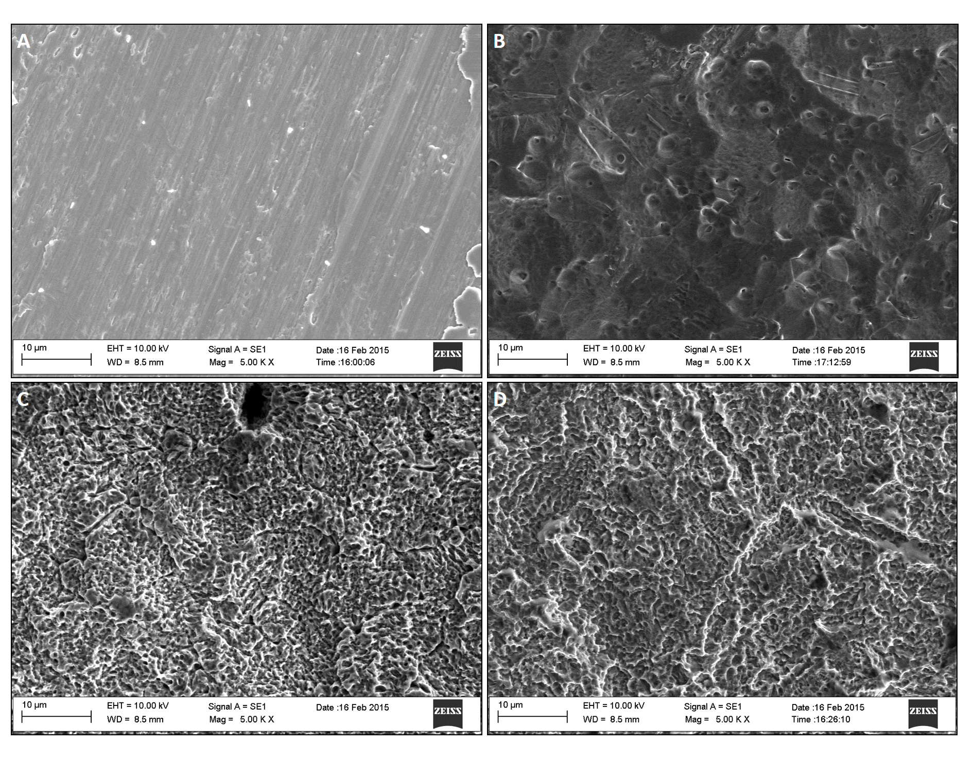Fig. 1 SEM images showing MAC (A), GB (B), AE (C) and GBAE (D)

The tridimensional analysis of the samples obtained by non contact profilometry is illustrated in Fig.2, while Fig. 3 shows a comparison between the measured values of the S_{a}, S_{Z}, S_{sk} and S_{ku} parameters. Based on S_{a} values, GBAE was rougher than the other surfaces, while GB and AE reached similar intermediate S_{a} values and MAC resulted the smoothest one. Similarly, S_{Z} values measured on GBAE were considerably higher compared to the other surfaces, while the minimum value was observed for MAC samples and GB and AE were in the middle. Skewness (S_{sk}) values measured on MAC and AE did not differ significantly from zero, and particularly MAC samples showed a greater variation of this parameter on their surface respect to the other treatments, as portrayed by the wider confidence bands in the graph. On the other hand, both GB and GBAE samples showed skewness values significantly lower than zero, revealing a prevailing presence of valleys respect to peaks on these surfaces. All the samples except GBAE ones, showed comparable kurtosis values, while GBAE surfaces showed a significantly lower value of this parameter, which means that the GBAE was the bumpiest surface of all the tested ones.
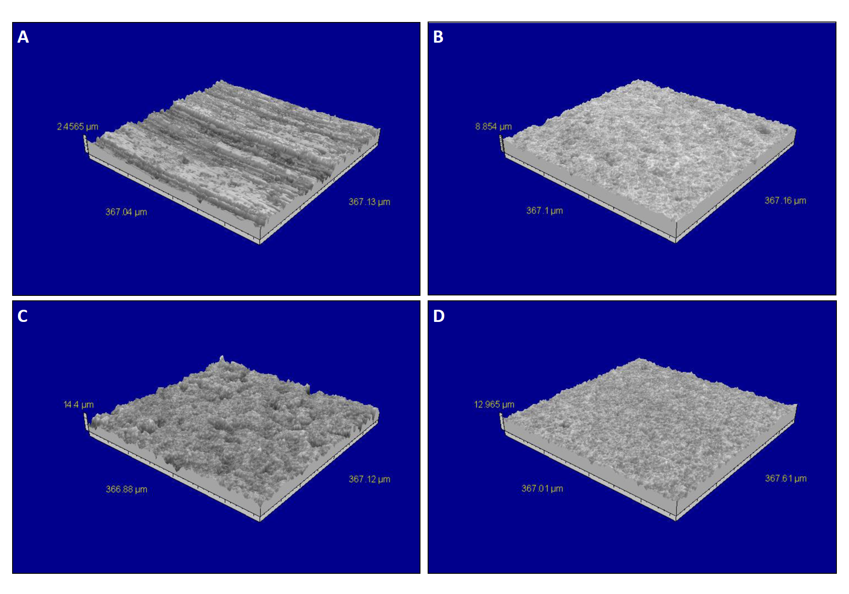
Fig 2. 3D picture of MAC (A), GB (B), AE (C) and GBAE (D) samples, as analyzed by the optical profiler.
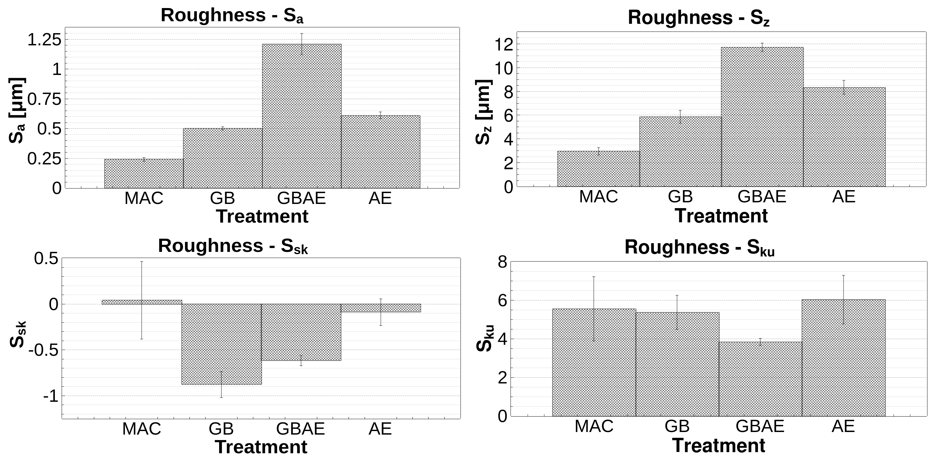

Fig. 3 Results of roughness analysis of the Ti samples after MAC, GB, GBAE and AE treatments according to S_{z}, S_{z}, S_{sk} and S_{ku} parameters. Error bars represent expanded uncertainties at 95% level of confidence.

3.2 Chemical composition analysis
3.2.1 X-ray Photoelectron Spectroscopy (XPS)
To study the surface chemical composition, wide-scan XPS spectra were collected from the tested samples and results are shown in Table 1. The emitting lines characteristic of titanium (Ti), oxygen (O) and carbon (C) were detected, supporting that these are the main elements composing the surface of the investigated samples, and also a low percentage of silicon (Si) was observed. All the specimens showed a similar chemical composition at their surface, where Ti, O and C are the most abundant elements. A considerable amount of C, variable between about 19 and 37 %, was detected on all surfaces, as is typical of all samples analyzed by XPS, due to the presence of contaminants, such as the atmospheric hydrocarbons, adsorbed onto the surface. In fact, a surface cleaning is often performed on surfaces, usually by irradiation with Ar⁺ ions, prior to the XPS analysis to remove contamination. However, in this work, this cleaning process was avoided, since it would have prevented the detection of possible inorganic contaminants left on the samples by the surface treatments under analysis. The presence of small amounts of Si is also very common on all samples analyzed by XPS, due to very wide abundance of this element in many contaminants. The relevant presence of oxygen is due to the native titanium oxide layer of nanometric thickness that spontaneously forms at ambient conditions, as well as to the presence of organic contaminants, which contain carbon and oxygen in a variable amount.

 | MAC | GB | AE | GBAE
Ti | 13.7 % | 20.6 % | 18.9 % | 20.7 %
O | 47.8 % | 58.5 % | 52.0 % | 56.0 %
C | 36.8 % | 18.9 % | 26.1 % | 21.5 %
Si | - | 1.4 % | 3.0 % | 1.8 %
Other | 1.7 % | 0.6 % | - | -

Table 1. Chemical composition of MAC. GB, AE and GBAE surfaces, analyzed by XPS.

3.2.2 Micro-Raman Spectroscopy
The Raman spectra of the differently surface-treated Ti samples (MAC, GB, AE, GBAE) are reported in Fig. 4. The observed vibrational features are typical of amorphous titania [40,41], as the related two main broad bands are visible around 430 and 600 cm⁻¹ , superimposed to other two bands centered about 300 and 800 cm⁻¹ respectively. For this reason, the differences observed among them in the surface behavior towards protein adsorption/cells adhesion cannot be ascribable to the surface microstructure.
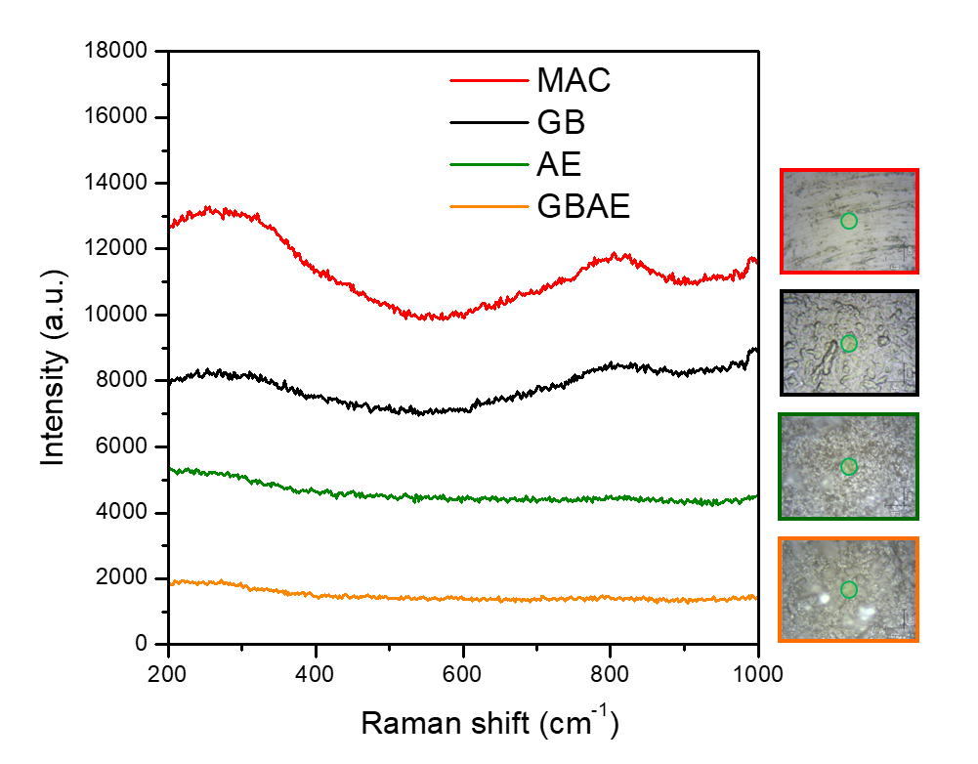
Figure 4. Raman spectra of machined titanium (MAC), GB, AE and GBAE surfaces and related optical microscope images. Both the spectra and the images were collected through a 50X objective. The size of focused laser spot (10x10 mm) is represented by means of a green circle at the center of each image.

3.2.3 Contact angle and surface energy evaluation
The wetting properties of the titanium surfaces were evaluated by optical contact angle (OCA) measurements and are reported in Fig. 5. MAC surface showed a quite hydrophilic behavior, with an average contact angle (CA) value of 35° and 40°, for water and diiodomethane, respectively. GBAE and AE surface resulted slightly less hydrophilic than MAC, their CA (H₂0) being 51° for both. The Contact Angle of GBAE in presence of CH₂I₂ reached a value of 40°, while that of AE was 43°. A limited transition toward the hydrophobic regime was found for GB with an average CA of 62° and 37° for H₂O and CH₂I₂, respectively. The surface free energy (SFE) computed following the Owens-Wendt theory was the highest for MAC and the lowest for GB. It can be noted that GB surface was the only one to show a significant difference between H₂O and CH₂I₂ contact angles and, consequently, between the polar and dispersive components of the surface energy. In fact, the dispersive to polar SE ratio of GB was 2.6, while for MAC, GBAE and AE were respectively 0.8, 1.3 and 1.2.
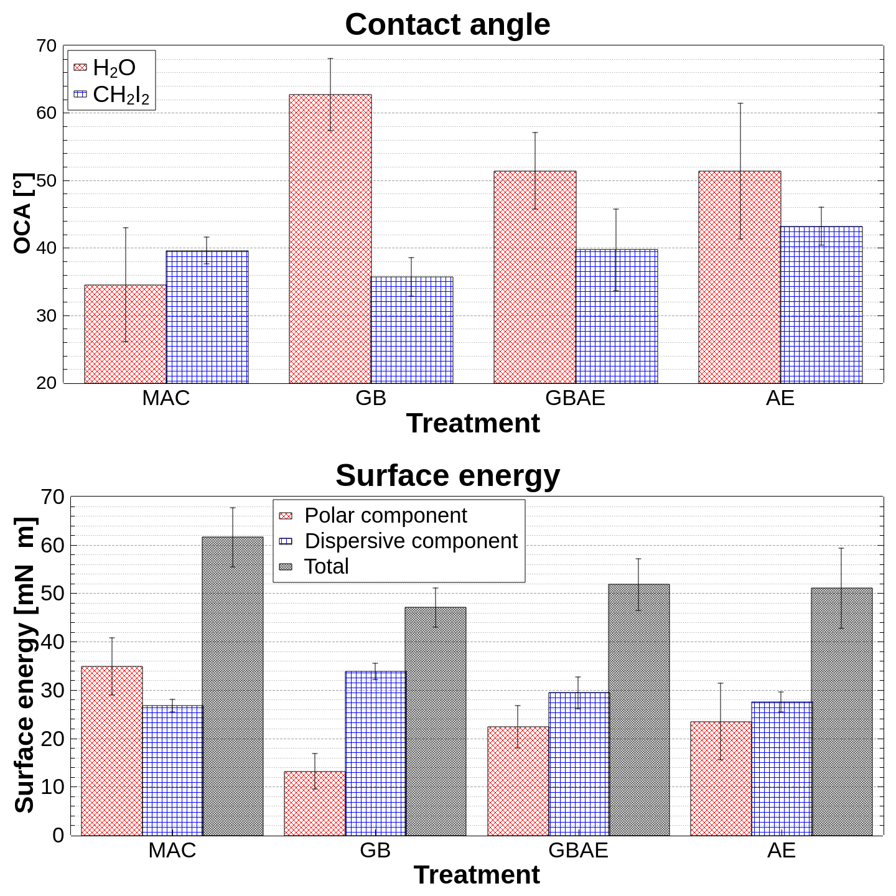
Figure 5. Water (H₂O) and diiodomethane (CH₂I₂) contact angles, measured on machined titanium (MAC), GB, GBAE and AE surfaces, and total contribution, dispersive and polar components of surface energy (SE), calculated by the Owens Wendt method. Error bars represent expanded uncertainties at 95% level of confidence.

3.3 Biological evaluations
3.3.1 Protein adsorption
The ability to adsorb proteins on different surfaces was evaluated considering collagen, fibronectin and albumin. As shown in Fig. 6, the GB surface adsorbed significantly less protein than the MAC surface. Moreover, AE and GBAE surfaces showed a better collagen adsorption.
Fig.6 Protein adsorption measured with BCA Protein Assay Kit. (A) Evaluation of Collagen adsorption; (B) Evaluation of Fibronectin adsorption. (C) Evaluation of BSA adsorption. Values represent mean ± SEM; the symbol (*) indicates a statistically significant difference versus machined Ti sample (Mac), considering a p-value < 0.05

3.3.2 Cell adhesion and proliferation
Cells showed different morphologies when were seeded on different surfaces, displaying more elongated shape and more filopodia on AE and GBAE surfaces (Fig 7A). To quantify this evidence, the interactions between cell bodies and filopodia were measured (Fig. 7B). At 24 hours, all the surfaces allowed cell viability, but GB, AE and GBAE sustained cell proliferation better than MAC. Interestingly, GB and AE appeared slightly more performing than GBAE, although not in a statistically significant way (Fig. 7C).
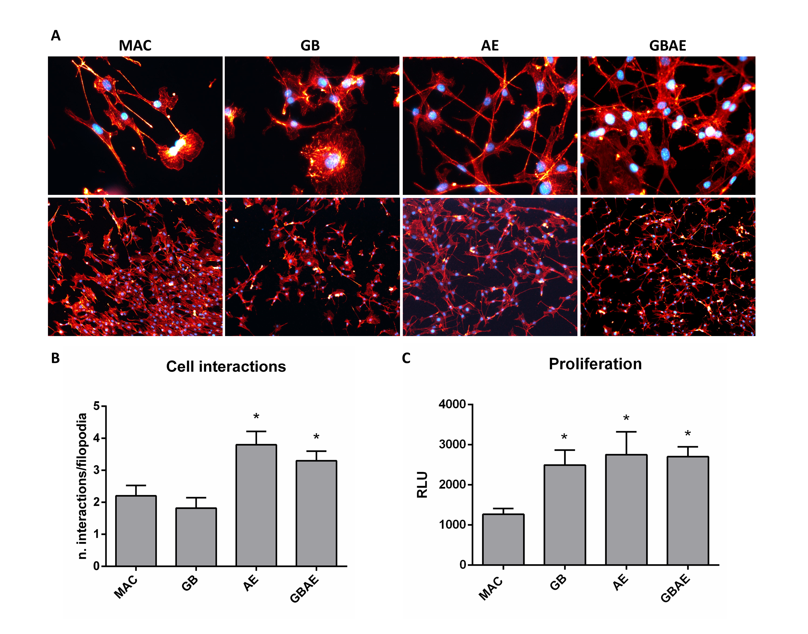
Figure 7A Representative images of adherent MC3T3 cells after 24h from seeding. Fig 7B Cell interactions measured on filopodia. 7C. Cell proliferation of MC3T3 performed through CellTiter-glo luminescent assay is shown. Data are expressed as Relative Luminescent Unit (RLU) as measured at 24 h after seeding. Values represent mean ± SEM; the symbol (*) indicates a statistically significant difference versus machined Ti sample (Mac), considering a p-value < 0.05.

3.3.3 Role of fibronectin receptor integrin alpha 5 beta 1 in cell adhesion
As depicted in Fig. 8, MC3T3 cells adherent on AE and GBAE were almost two-fold compared to MAC and GB when observed at 10’ seeding. In a subsequent rescue experiment (Fig. 8A), cell adhesion was repeated on samples previously coated with oversaturating fibronectin (FN; 10 μg/ml) leading to the complete abolition of the differential adhesion described above. Interestingly, fibronectin coating significantly enhanced cell adhesion in MAC and GB samples as compared to uncoated surfaces (Fig 8A) suggesting an involvement of α5β1 integrin. Surprisingly, no significant difference was detected in AE and GBAE surfaces.
In order to provide direct evidence for the involvement of β1-integrin in the differential response to surface topographies, we performed adhesion assays on 0.5µg/ml FN coated titanium samples preincubating cells with the β1-integrin antibody 9EG7 with Mn²⁺ that binds and stabilizes active β1-integrins [42,43]. The addition of 9EG7 and Mn²⁺ fully reverted the differential adhesion as shown in fig 8B. Next, we evaluated the expression of integrin α5 and β1 chains in cells seeded on the four different surfaces by performing quantitative real-time polymerase chain reaction (qRT-PCR) analysis. As shown in figure 8 (C,D), no significant differences were observed.

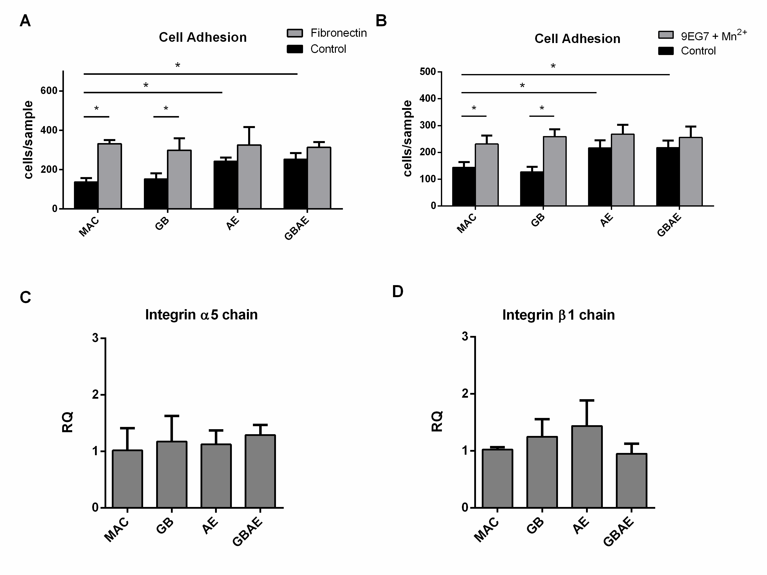
Figure 8 (A) Cell adhesion of MC3T3 on different titanium samples saturated or not with fibronectin 10ug/ml. (B) Cell adhesion of MC3T3 pretreated with 9EG7 antibody and Mg²⁺. (C, D) Expression level of integrin α5 and β1 chains in cells seeded on the four different surfaces. Values represent mean ± SEM; the symbol (*) indicates a statistically significant difference considering a p-value < 0.05.

3.3.4 Involvement of TRPV4 in the early biological response to different titanium surface topographies
TRPV4 was investigated on the base of its involvement in cytoskeletal remodeling and colocalization with β1 integrins previously demonstrated in several cell models [44]. As shown in figure 9E, TRPV4 down-regulation by means of sh-RNA, strongly inhibited MC3T3 adhesion on AE and GBAE. TRPV4 protein and functional downregulations were confirmed by western blot (Fig 9A, B) and Ca²⁺ imaging experiments (Fig 9C-D), respectively. We next investigated the potential involvement of β1 integrins in TRPV4-mediated cell adhesion by performing cell adhesion assays. Cell were pre-incubated with 9EG7 activating antibody: as shown in fig 9E, the addition of 9EG7 and Mn²⁺ fully reverted the inhibitory effect induced by TRPV4 downregulation, suggesting that TRPV4 activation acts upstream of β1 integrin and interferes with its inside-out signaling.

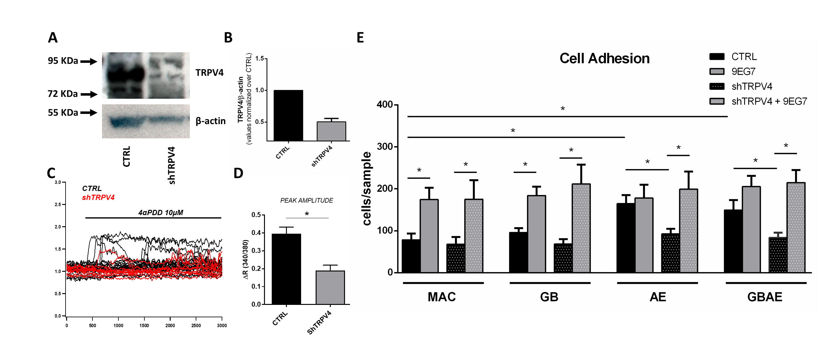
Figure 9 (A, B) Western Blot Analysis of TRPV4 expression and downregulation in MC3T3. (C, D) Ca²⁺ imaging experiments showing the calcium signals observed activating TRPV4 with 4αPDD 10 µM in CTRL and shTRPV4 MC3T3. (D) quantification of peak amplitude. (E) Cell adhesion of MC3T3 on different titanium surfaces in control condition and downregulating TRPV4 pretreated or not with 9EG7 antibody and Mn²⁺.Values represent mean ± SEM; the symbol (*) indicates a statistically significant difference considering a p-value < 0.05.

4. Discussion
It is accepted that the capability of biomaterials to osseointegrate can be preliminary tested and somehow predicted based on in vitro behavior of osteoblasts properly seeded on the material surface [45]. As pointed out above, in order to investigate cell adhesion, it is most useful to investigate the adsorption of the protein network to which cell interact [46]. Protein adsorption is regulated by some fundamental features of the material surface that may be conveniently characterized at the chemico-physical level [47]. Here, the authors focused on some of the most relevant and commercially representative surface configurations attainable subtractively, both from a topographical and physico-chemical perspective.
To this end, the four different surfaces, i.e. machined (MAC), grit blasted (GB), acid etched (AE) and large grit blasted acid etched surfaces (GBAE), were first analyzed topographically at the Scanning Electron Microscope and with a non-contact profilometer. Consistently with previous reports [48], GBAE reached Sa values greater than 1, while for GB and AE Sa values were comprised between 1 and 0.5, and MAC resulted the smoothest surface. In addition, based on their negative values of Skewness (S_{sk}), GB and GBAE samples were richer in valleys than peaks, while GBAE, which reached significantly lower values of kurtosis, resulted the bumpiest surface of all the tested ones.
As determined through the XPS, the surface chemical composition of the specimens showed Titanium (Ti), oxygen (O) and carbon (C), in accordance with the anticipated presence of these elements on titanium samples simulating dental implants [49], without any significant difference among the surfaces. The amount of C was likely due to contaminants, such as atmospheric hydrocarbons, adsorbed onto the surface. The oxygen detected, most probably, owed to the native titanium oxide layer of nanometric thickness that spontaneously forms as a consequence of the environmental exposure, which was also consistent with the presence of amorphous titania detected at the Raman spectroscopy [40,41]. Traces of other present elements, like silicon (Si), have been reported on dental implant surfaces [50].
It is not useless to point out that researchers have progressively focused their endeavor to determine which may be the most influent of the interfacial features dictating ultimately the biological outcome [51,52].
The wetting properties of the titanium surfaces are apparently among these features [53–55] and, here, they were evaluated by optical contact angle (OCA) measurements. Surface wettability is conventionally defined as hydrophilic or hydrophobic with a CA respectively lower or higher than 90°. All the surfaces tested resulted substantially hydrophilic, with an average contact angle (CA) for water of 35° in the case of MAC and CA(H₂0) of 51° for AE and GBAE, whilst a limited transition toward the hydrophobic regime was found for GB with an average CA(H₂0) of 62°. The OCA in presence of an apolar component (diiodomethane CH₂I₂) was also determined so as to calculate the surface free energy (SFE) according to the Owens-Wendt theory. Furthermore, SFE was the highest for MAC and the lowest for GB, which was the only surface to show a significant difference between H₂O and CH₂I₂ contact angles and, consequently, between the polar and dispersive components of the surface energy.
These data were particularly interesting in light of protein adsorption (albumin, collagen and fibronectin) and cell adhesion assays that clearly established a different performance of GB compared to the other roughened surfaces (AE and GBAE), notwithstanding the otherwise similar chemical parameters (XPS and Raman spectroscopy). Surface free energy is indeed a powerful driver of protein adsorption to titanium dioxide [56] and it is capable of affecting cell spreading [57–59]. The delayed cell adhesion of GB (Fig. 8), which did not hinder cell proliferation, was correlated to the reduced wettability and the altered dispersive to polar SE ratio, which was at least double-fold for GB (2.6) compared to MAC (0.8), SL (1.3) and AE (1.2). It is worth noting that only GB and GBAE samples, which showed the higher dispersive to polar SE ratios, were characterized by a negative Skewness value. Moreover, the GB sample, which had the highest dispersive to polar SE ratio, showed the highest Skewness value. These results suggest a relationship between the presence of a greater amount of valleys than peaks on the surface, and a lower contribution of the polar component to the surface energy. The latter, instead, does not seem to be affected by surface composition and microstructure, since these characteristics were very similar among the tested samples.
To better understand the biological mechanism connecting SFE and early cell adhesion, the authors focused on protein adsorption dynamics with particular interest to fibronectin, following previous literature. Indeed, fibronectin, a high molecular weight glycoprotein of the extracellular matrix, is recognized by integrin α5β1, belonging to one of the most important adhesion protein family for eukaryotic cells [21,22]. Specifically on rough surfaces, fibronectin accumulates preferentially at ridge/groove boundaries inducing in overlying cells the formation of integrin clusters, thus focal adhesions, right above these boundaries [60]. Thanks to the specific rat monoclonal antibody 9EG7 against a cryptic epitope that is exposed only in the EGF2 domain activating β1-integrin, the authors could study selectively the conformationally active β1-integrin subunit. Then, in a rescue assay, the inhibition of cell adhesion of GB and AE was reversed recurring to the activating capacity of the 9EG7 antibody against the β1integrin subunit. This suggests that the impaired osteoblast adhesion on GB surface was mediated by β1-integrins in agreement with the literature on the matter. Specific integrin heterodimers are involved according to the substrate type even on titanium surfaces [61,62]. Interestingly, we did not find any significant difference in the mRNA expression of integrin α5 and β1 chains. Nevertheless, integrin activity is mostly regulated at the level of subcellular localization.
Thus, piecing together the results from protein adsorption, cell adhesion and β1-integrin rescue experiments, we can conclude that titanium SE ratio modulates cell adhesion by strongly influencing the adsorption of proteins important for cells to adhere to their substrate. Specifically for GB, the altered dispersive-to-polar SFE ratio, likely caused by the topographical abundance in valleys, correlates with a reduced adsorption of fibronectin, the β1-integrin ligand, when compared with AE and GBAE surfaces. Given that integrins represent the cellular machinery dedicated to the adhesion of cells to a substrate, it stands to reason that a lowered β1-integrin activation significantly impairs cell adhesion to GB surfaces.
According to this explanation, surface topography should regulate β1 integrin-mediated osteoblast adhesion just via the influence on the dispersive-to-polar surface energy ratio. However, we questioned about the existence of a mechanism through which the topography of titanium surface could directly influence cell adhesion, independently of the SFE. Indeed, it was observed, for materials such as hydroxyapatite and nickel, that surfaces showing the same contact angle (thus the same SFE), but with different topography, can induce a differential protein adsorption [63] and a different degree of adhesion contacts formation in mature OBs [64]. How adhesion formation is regulated by the surface topography is not known, however, given the important role of integrins in mediating adhesive contacts, the authors decided to further investigate the role of β1-integrins, focusing on the permeable calcium channel TRPV4, which is a putative mechanoreceptor expressed in osteoblasts and MC3T3-E1 cells [65,66]. Thodeti et al. have shown that TRPV4 is responsible for β1 integrin activation in response to mechanical strain application in endothelial cells [24]. Here we demonstrated that TRPV4 downregulation strongly obliterated the cell adhesion observed in AE and GBAE in cell adhesion. To support that these differences depended on TRPV4 and were mediated by beta1 integrins, cell adhesion tests were repeated by preincubating cells with the 9EG7 antibody, fully reverting the adhesion pattern previously seen. These data strongly suggest an involvement of TRPV4 in β1 integrin activation, interfering with its inside-out signal transduction.

5. Conclusions
Among the features of the four different surfaces here studied, chemical composition as assessed per XPS and Raman spectrometry resulted poorly correlated with the protein adsorption and early cell adhesion. On the contrary, surface free energy appeared more predictive of the biological outcome. The authors showed that in presence of a marked difference between polar and dispersive component of SFE (regarding GB), due to a significant difference between H₂O and CH₂I₂ contact angles, protein adsorption was diminished and cell adhesion was delayed. As a possible mechanistic explanation of this event, the authors postulated that the lesser amount of fibronectin adsorbed on GB caused a diminished activation of integrin β1 subunit, which cooperated with TRPV4 in the adhesion of the osteoblasts tested in vitro. This paper addressed for the first time, to the authors’ knowledge, the role of β1-integrins and TRPV4 in osteoblasts adhesion on different titanium substrates. Although further research is needed to dissect better the molecular mechanism herein highlighted, the possible clinical application is promising.

Acknowledgements
The authors have no conflicts of interest to declare. The research was partly supported by FACE grant (Piedmont Region INNOVAZIONE e TRANSAZIONE PRODUTTIVA PAR-FESR). The Piedmont Region had no part whatsoever in conducting the research, during the preparation of the article, or in the decision to submit the paper for publication. Sh-TRPV4 was a kind gift from Dr. Indu Ambudkar (National Institute of Dental and Craniofacial Research, Bethesda, USA).

References
[1] P.I. Brånemark, R. Adell, T. Albrektsson, U. Lekholm, S. Lundkvist, B. Rockler, Osseointegrated titanium fixtures in the treatment of edentulousness., Biomaterials. 4 (1983) 25–8. http://www.ncbi.nlm.nih.gov/pubmed/6838955 (accessed July 3, 2017).
[2] J.Y. Martin, D.D. Dean, D.L. Cochran, J. Simpson, B.D. Boyan, Z. Schwartz, Proliferation, differentiation, and protein synthesis of human osteoblast-like cells (MG63) cultured on previously used titanium surfaces., Clin. Oral Implants Res. 7 (1996) 27–37. http://www.ncbi.nlm.nih.gov/pubmed/9002820 (accessed July 3, 2019).
[3] G.B. Schneider, H. Perinpanayagam, M. Clegg, R. Zaharias, D. Seabold, J. Keller, C. Stanford, Implant surface roughness affects osteoblast gene expression., J. Dent. Res. 82 (2003) 372–6. doi:10.1177/154405910308200509.
[4] I. Wall, N. Donos, K. Carlqvist, F. Jones, P. Brett, Modified titanium surfaces promote accelerated osteogenic differentiation of mesenchymal stromal cells in vitro., Bone. 45 (2009) 17–26. doi:10.1016/j.bone.2009.03.662.
[5] S.J. Waddell, M.C. de Andrés, P.M. Tsimbouri, E. V. Alakpa, M. Cusack, M.J. Dalby, R.O.C. Oreffo, Biomimetic oyster shell–replicated topography alters the behaviour of human skeletal stem cells, J. Tissue Eng. 9 (2018). doi:10.1177/2041731418794007.
[6] P. Mandracci, F. Mussano, P. Rivolo, S. Carossa, Surface Treatments and Functional Coatings for Biocompatibility Improvement and Bacterial Adhesion Reduction in Dental Implantology, Coatings. 6 (2016) 7. doi:10.3390/coatings6010007.
[7] A. Wennerberg, T. Albrektsson, On implant surfaces: a review of current knowledge and opinions., Int. J. Oral Maxillofac. Implants. 25 (2009) 63–74. doi:10.1111/j.1600-051X.2008.01321.x.
[8] M. Goldman, G. Juodzbalys, V. Vilkinis, Titanium surfaces with nanostructures influence on osteoblasts proliferation: a systematic review., J. Oral Maxillofac. Res. 5 (2014) e1. doi:10.5037/jomr.2014.5301.
[9] L. Salou, A. Hoornaert, G. Louarn, P. Layrolle, Enhanced osseointegration of titanium implants with nanostructured surfaces: an experimental study in rabbits., Acta Biomater. 11 (2015) 494–502. doi:10.1016/j.actbio.2014.10.017.
[10] R.A. Gittens, T. McLachlan, R. Olivares-Navarrete, Y. Cai, S. Berner, R. Tannenbaum, Z. Schwartz, K.H. Sandhage, B.D. Boyan, The effects of combined micron-/submicron-scale surface roughness and nanoscale features on cell proliferation and differentiation, Biomaterials. 32 (2011) 3395–3403. doi:10.1016/j.biomaterials.2011.01.029.
[11] N. Hori, F. Iwasa, T. Ueno, K. Takeuchi, N. Tsukimura, M. Yamada, M. Hattori, A. Yamamoto, T. Ogawa, Selective cell affinity of biomimetic micro-nano-hybrid structured TiO2 overcomes the biological dilemma of osteoblasts., Dent. Mater. 26 (2010) 275–87. doi:10.1016/j.dental.2009.11.077.
[12] P.D.H. Prowse, C.G. Elliott, J. Hutter, D.W. Hamilton, Inhibition of Rac and ROCK signalling influence osteoblast adhesion, differentiation and mineralization on titanium topographies., PLoS One. 8 (2013) e58898. doi:10.1371/journal.pone.0058898.
[13] C.H. Seo, K. Furukawa, K. Montagne, H. Jeong, T. Ushida, The effect of substrate microtopography on focal adhesion maturation and actin organization via the RhoA/ROCK pathway., Biomaterials. 32 (2011) 9568–75. doi:10.1016/j.biomaterials.2011.08.077.
[14] Y. Ogino, R. Liang, D.B.S. Mendonça, G. Mendonça, M. Nagasawa, K. Koyano, L.F. Cooper, RhoA-Mediated Functions in C3H10T1/2 Osteoprogenitors Are Substrate Topography Dependent., J. Cell. Physiol. 231 (2016) 568–75. doi:10.1002/jcp.25100.
[15] L. Canullo, T. Genova, M. Tallarico, G. Gautier, F. Mussano, D. Botticelli, Plasma of Argon Affects the Earliest Biological Response of Different Implant Surfaces, J. Dent. Res. 95 (2016) 566–573. doi:10.1177/0022034516629119.
[16] D. Buser, N. Broggini, M. Wieland, R.K. Schenk, A.J. Denzer, D.L. Cochran, B. Hoffmann, A. Lussi, S.G. Steinemann, Enhanced Bone Apposition to a Chemically Modified SLA Titanium Surface, J. Dent. Res. 83 (2004) 529–533. doi:10.1177/154405910408300704.
[17] J. Vlacic-Zischke, S.M. Hamlet, T. Friis, M.S. Tonetti, S. Ivanovski, The influence of surface microroughness and hydrophilicity of titanium on the up-regulation of TGFβ/BMP signalling in osteoblasts., Biomaterials. 32 (2011) 665–671. doi:10.1016/j.biomaterials.2010.09.025.
[18] R.A. Gittens, L. Scheideler, F. Rupp, S.L. Hyzy, J. Geis-Gerstorfer, Z. Schwartz, B.D. Boyan, A review on the wettability of dental implant surfaces II: Biological and clinical aspects., Acta Biomater. 10 (2014) 2907–18. doi:10.1016/j.actbio.2014.03.032.
[19] F. Rupp, L. Scheideler, M. Eichler, J. Geis-Gerstorfer, Wetting behavior of dental implants., Int. J. Oral Maxillofac. Implants. 26 (n.d.) 1256–66. http://www.ncbi.nlm.nih.gov/pubmed/22167431 (accessed July 3, 2019).
[20] P.J. Marie, Targeting integrins to promote bone formation and repair., Nat. Rev. Endocrinol. 9 (2013) 288–95. doi:10.1038/nrendo.2013.4.
[21] Z. Hamidouche, O. Fromigue, J. Ringe, T. Haupl, P. Vaudin, J.-C. Pages, S. Srouji, E. Livne, P.J. Marie, Priming integrin 5 promotes human mesenchymal stromal cell osteoblast differentiation and osteogenesis, Proc. Natl. Acad. Sci. 106 (2009) 18587–18591. doi:10.1073/pnas.0812334106.
[22] C. Dufour, X. Holy, P.J. Marie, Skeletal unloading induces osteoblast apoptosis and targets α5β1-PI3K-Bcl-2 signaling in rat bone, Exp. Cell Res. 313 (2007) 394–403. doi:10.1016/j.yexcr.2006.10.021.
[23] R. Fraioli, P.M. Tsimbouri, L.E. Fisher, A.H. Nobbs, B. Su, S. Neubauer, F. Rechenmacher, H. Kessler, M.-P. Ginebra, M.J. Dalby, J.M. Manero, C. Mas-Moruno, Towards the cell-instructive bactericidal substrate: exploring the combination of nanotopographical features and integrin selective synthetic ligands., Sci. Rep. 7 (2017) 16363. doi:10.1038/s41598-017-16385-3.
[24] C.K. Thodeti, B. Matthews, A. Ravi, A. Mammoto, K. Ghosh, A.L. Bracha, D.E. Ingber, TRPV4 Channels Mediate Cyclic Strain–Induced Endothelial Cell Reorientation Through Integrin-to-Integrin Signaling, Circ. Res. 104 (2009) 1123–1130. doi:10.1161/CIRCRESAHA.108.192930.
[25] F. Mussano, T. Genova, P. Rivolo, P. Mandracci, L. Munaron, M.G. Faga, S. Carossa, Role of surface finishing on the in vitro biological properties of a silicon nitride–titanium nitride (Si3N4–TiN) composite, J. Mater. Sci. 52 (2017) 467–477. doi:10.1007/s10853-016-0346-1.
[26] E.S. Gadelmawla, M.M. Koura, T.M.A. Maksoud, I.M. Elewa, H.H. Soliman, Roughness parameters, J. Mater. Process. Technol. 123 (2002) 133–145. doi:10.1016/S0924-0136(02)00060-2.
[27] L. Canullo, T. Genova, H.-L. Wang, S. Carossa, F. Mussano, Plasma of Argon Increases Cell Attachment and Bacterial Decontamination on Different Implant Surfaces, Int. J. Oral Maxillofac. Implants. 32 (2017) 1315–1323. doi:10.11607/jomi.5777.
[28] F. Mussano, T. Genova, E. Verga Falzacappa, P. Scopece, L. Munaron, P. Rivolo, P. Mandracci, A. Benedetti, S. Carossa, A. Patelli, In vitro characterization of two different atmospheric plasma jet chemical functionalizations of titanium surfaces, Appl. Surf. Sci. 409 (2017) 314–324. doi:10.1016/j.apsusc.2017.02.035.
[29] F. Mussano, T. Genova, M. Laurenti, L. Munaron, C.F. Pirri, P. Rivolo, S. Carossa, P. Mandracci, Hydrogenated amorphous silicon coatings may modulate gingival cell response, Appl. Surf. Sci. 436 (2018) 603–612. doi:10.1016/j.apsusc.2017.11.283.
[30] T. Genova, G.P. Grolez, C. Camillo, M. Bernardini, A. Bokhobza, E. Richard, M. Scianna, L. Lemonnier, D. Valdembri, L. Munaron, M.R. Philips, V. Mattot, G. Serini, N. Prevarskaya, D. Gkika, A.F. Pla, TRPM8 inhibits endothelial cell migration via a non-channel function by trapping the small GTPase Rap1, J. Cell Biol. 216 (2017) 2107–2130. doi:10.1083/jcb.201506024.
[31] F. Mussano, T. Genova, S. Petrillo, I. Roato, R. Ferracini, L. Munaron, Osteogenic Differentiation Modulates the Cytokine, Chemokine, and Growth Factor Profile of ASCs and SHED., Int. J. Mol. Sci. 19 (2018) 1454. doi:10.3390/ijms19051454.
[32] M. Bernardini, A. Brossa, G. Chinigo, G.P. Grolez, G. Trimaglio, L. Allart, A. Hulot, G. Marot, T. Genova, A. Joshi, V. Mattot, G. Fromont, L. Munaron, B. Bussolati, N. Prevarskaya, A. Fiorio Pla, D. Gkika, Transient Receptor Potential Channel Expression Signatures in Tumor-Derived Endothelial Cells: Functional Roles in Prostate Cancer Angiogenesis, Cancers (Basel). 11 (2019) 956. doi:10.3390/cancers11070956.
[33] D. Avanzato, T. Genova, A. Fiorio Pla, M. Bernardini, S. Bianco, B. Bussolati, D. Mancardi, E. Giraudo, F. Maione, P. Cassoni, I. Castellano, L. Munaron, Activation of P2X7 and P2Y11 purinergic receptors inhibits migration and normalizes tumor-derived endothelial cells via cAMP signaling, Sci. Rep. 6 (2016) 32602. doi:10.1038/srep32602.
[34] M.B. Herrera Sanchez, S. Previdi, S. Bruno, V. Fonsato, M.C. Deregibus, S. Kholia, S. Petrillo, E. Tolosano, R. Critelli, M. Spada, R. Romagnoli, M. Salizzoni, C. Tetta, G. Camussi, Extracellular vesicles from human liver stem cells restore argininosuccinate synthase deficiency, Stem Cell Res. Ther. 8 (2017) 176. doi:10.1186/s13287-017-0628-9.
[35] a Fiorio Pla, H.L. Ong, K.T. Cheng, A. Brossa, B. Bussolati, T. Lockwich, B. Paria, L. Munaron, I.S. Ambudkar, TRPV4 mediates tumor-derived endothelial cell migration via arachidonic acid-activated actin remodeling, Oncogene. 31 (2012) 200–212. doi:10.1038/onc.2011.231.
[36] T. Genova, S. Petrillo, E. Zicola, I. Roato, R. Ferracini, E. Tolosano, F. Altruda, S. Carossa, F. Mussano, L. Munaron, The Crosstalk Between Osteodifferentiating Stem Cells and Endothelial Cells Promotes Angiogenesis and Bone Formation, Front. Physiol. 10 (2019). doi:10.3389/fphys.2019.01291.
[37] E. Beneduce, A. Matte, L. De Falco, S. Mbiandjeu, D. Chiabrando, E. Tolosano, E. Federti, S. Petrillo, N. Mohandas, A. Siciliano, W. Babu, V. Menon, S. Ghaffari, A. Iolascon, L. De Franceschi, Fyn kinase is a novel modulator of erythropoietin signaling and stress erythropoiesis, Am. J. Hematol. 94 (2019) 10–20. doi:10.1002/ajh.25295.
[38] P.R. Freeman, C.F. Dietrich, Uncertainty, Calibration and Probability. The Statistics of Scientific and Industrial Measurment., J. R. Stat. Soc. Ser. A. 137 (2006) 441. doi:10.2307/2344974.
[39] JCGM100:2008, Evaluation of measurement data — Guide to the expression of uncertainty in measurement, Int. Organ. Stand. Geneva ISBN. 50 (2008) 134. doi:10.1373/clinchem.2003.030528.
[40] Y.-H. Zhang, C.K. Chan, J.F. Porter, W. Guo, Micro-Raman Spectroscopic Characterization of Nanosized TiO 2 Powders Prepared by Vapor Hydrolysis, J. Mater. Res. 13 (1998) 2602–2609. doi:10.1557/JMR.1998.0363.
[41] M. Gaintantzopoulou, S. Zinelis, N. Silikas, G. Eliades, Micro-Raman spectroscopic analysis of TiO2 phases on the root surfaces of commercial dental implants, Dent. Mater. 30 (2014) 861–867. doi:10.1016/j.dental.2014.05.030.
[42] M. Lenter, H. Uhlig, A. Hamann, P. Jeno, B. Imhof, D. Vestweber, A monoclonal antibody against an activation epitope on mouse integrin chain beta 1 blocks adhesion of lymphocytes to the endothelial integrin alpha 6 beta 1., Proc. Natl. Acad. Sci. 90 (1993) 9051–9055. doi:10.1073/pnas.90.19.9051.
[43] G. Bazzoni, D.T. Shih, C.A. Buck, M.E. Hemler, Monoclonal antibody 9EG7 defines a novel beta 1 integrin epitope induced by soluble ligand and manganese, but inhibited by calcium., J. Biol. Chem. 270 (1995) 25570–7. doi:10.1074/jbc.270.43.25570.
[44] P.D. Arora, M. Di Gregorio, P. He, C.A. McCulloch, TRPV4 mediates the Ca 2+ influx required for the interaction between flightless-1 and non-muscle myosin, and collagen remodeling, J. Cell Sci. 130 (2017) 2196–2208. doi:10.1242/jcs.201665.
[45] C.-Y. Chien, W.-B. Tsai, Poly(dopamine)-assisted immobilization of Arg-Gly-Asp peptides, hydroxyapatite, and bone morphogenic protein-2 on titanium to improve the osteogenesis of bone marrow stem cells., ACS Appl. Mater. Interfaces. 5 (2013) 6975–83. doi:10.1021/am401071f.
[46] E. Gongadze, D. Kabaso, S. Bauer, T. Slivnik, P. Schmuki, U. van Rienen, A. Iglič, Adhesion of osteoblasts to a nanorough titanium implant surface., Int. J. Nanomedicine. 6 (2011) 1801–16. doi:10.2147/IJN.S21755.
[47] M. Nikkhah, F. Edalat, S. Manoucheri, A. Khademhosseini, Engineering microscale topographies to control the cell–substrate interface, Biomaterials. 33 (2012) 5230–5246. doi:10.1016/j.biomaterials.2012.03.079.
[48] A. Wennerberg, T. Albrektsson, Effects of titanium surface topography on bone integration: a systematic review, Clin. Oral Implants Res. 20 (2009) 172–184. doi:10.1111/j.1600-0501.2009.01775.x.
[49] B.-S. Kang, Y.-T. Sul, S.-J. Oh, H.-J. Lee, T. Albrektsson, XPS, AES and SEM analysis of recent dental implants., Acta Biomater. 5 (2009) 2222–9. doi:10.1016/j.actbio.2009.01.049.
[50] X. Zhu, J. Chen, L. Scheideler, R. Reichl, J. Geis-Gerstorfer, Effects of topography and composition of titanium surface oxides on osteoblast responses., Biomaterials. 25 (2004) 4087–103. doi:10.1016/j.biomaterials.2003.11.011.
[51] J. Lincks, B.D. Boyan, C.R. Blanchard, C.H. Lohmann, Y. Liu, D.L. Cochran, D.D. Dean, Z. Schwartz, Response of MG63 osteoblast-like cells to titanium and titanium alloy is dependent on surface roughness and composition., Biomaterials. 19 (1998) 2219–32. http://www.ncbi.nlm.nih.gov/pubmed/9884063 (accessed January 24, 2015).
[52] A. Vallée, M.G. Faga, F. Mussano, F. Catalano, E. Tolosano, S. Carossa, F. Altruda, G. Martra, Alumina-zirconia composites functionalized with laminin-1 and laminin-5 for dentistry: effect of protein adsorption on cellular response., Colloids Surf. B. Biointerfaces. 114 (2014) 284–93. doi:10.1016/j.colsurfb.2013.09.053.
[53] L. Canullo, T. Genova, N. Naenni, Y. Nakajima, K. Masuda, F. Mussano, Plasma of argon enhances the adhesion of murine osteoblasts on different graft materials, Ann. Anat. - Anat. Anzeiger. 218 (2018) 265–270. doi:10.1016/j.aanat.2018.03.005.
[54] R. Pistilli, T. Genova, L. Canullo, M. Faga, M. Terlizzi, G. Gribaudo, F. Mussano, Effect of Bioactivation on Traditional Surfaces and Zirconium Nitride: Adhesion and Proliferation of Preosteoblastic Cells and Bacteria, Int. J. Oral Maxillofac. Implants. 33 (2018) 1247–1254. doi:10.11607/jomi.6654.
[55] L. Canullo, T. Genova, P. Mandracci, F. Mussano, R. Abundo, J. Fiorellini, Morphometric Changes Induced by Cold Argon Plasma Treatment on Osteoblasts Grown on Different Dental Implant Surfaces, Int. J. Periodontics Restorative Dent. 37 (2017) 541–548. doi:10.11607/prd.2916.
[56] D.E. MacDonald, N. Deo, B. Markovic, M. Stranick, P. Somasundaran, Adsorption and dissolution behavior of human plasma fibronectin on thermally and chemically modified titanium dioxide particles, Biomaterials. 23 (2002) 1269–1279. doi:10.1016/S0142-9612(01)00317-9.
[57] T.G. Ruardy, J.M. Schakenraad, H.C. van der Mei, H.J. Busscher, Adhesion and spreading of human skin fibroblasts on physicochemically characterized gradient surfaces., J. Biomed. Mater. Res. 29 (1995) 1415–23. doi:10.1002/jbm.820291113.
[58] G. Altankov, F. Grinnell, T. Groth, Studies on the biocompatibility of materials: fibroblast reorganization of substratum-bound fibronectin on surfaces varying in wettability., J. Biomed. Mater. Res. 30 (1996) 385–91. doi:10.1002/(SICI)1097-4636(199603)30:3<385::AID-JBM13>3.0.CO;2-J.
[59] K. Webb, V. Hlady, P.A. Tresco, Relative importance of surface wettability and charged functional groups on NIH 3T3 fibroblast attachment, spreading, and cytoskeletal organization., J. Biomed. Mater. Res. 41 (1998) 422–30. http://www.ncbi.nlm.nih.gov/pubmed/9659612 (accessed July 4, 2019).
[60] A.C. De Luca, M. Zink, A. Weidt, S.G. Mayr, A.E. Markaki, Effect of microgrooved surface topography on osteoblast maturation and protein adsorption, J. Biomed. Mater. Res. - Part A. 103 (2015) 2689–2700. doi:10.1002/jbm.a.35407.
[61] M. Lai, C.D. Hermann, A. Cheng, R. Olivares-Navarrete, R.A. Gittens, M.M. Bird, M. Walker, Y. Cai, K. Cai, K.H. Sandhage, Z. Schwartz, B.D. Boyan, Role of α2β1 integrins in mediating cell shape on microtextured titanium surfaces., J. Biomed. Mater. Res. A. 103 (2015) 564–73. doi:10.1002/jbm.a.35185.
[62] H.-Y. Chen, L. Pan, H. Yang, P. Xia, W. Yu, W. Tang, Y. Zhang, S. Chen, Y. Xue, L. Wang, Integrin alpha5beta1 suppresses rBMSCs anoikis and promotes nitric oxide production., Biomed. Pharmacother. 99 (2018) 1–8. doi:10.1016/j.biopha.2018.01.038.
[63] G. Yang, Z. Liu, Y. Guo, J. Zhang, H. Li, W. Shi, J. Feng, K. Wang, L. Yang, Osteoblast response to the surface topography of hydroxyapatite two-dimensional films, J. Biomed. Mater. Res. - Part A. 105 (2017) 991–999. doi:10.1002/jbm.a.35967.
[64] C. Allan, A. Ker, C.A. Smith, P.M. Tsimbouri, J. Borsoi, S. O’Neill, N. Gadegaard, M.J. Dalby, R.M. Dominic Meek, Osteoblast response to disordered nanotopography, J. Tissue Eng. 9 (2018). doi:10.1177/2041731418784098.
[65] K. Howell, The role of TRPV4 in osteogenesis and cell signaling in MC3T3-E1 ostoeoblast-like cells, (2012). http://udspace.udel.edu/handle/19716/12887 (accessed July 17, 2019).
[66] E. Abed, D. Labelle, C. Martineau, A. Loghin, R. Moreau, Expression of transient receptor potential (TRP) channels in human and murine osteoblast-like cells, Mol. Membr. Biol. 26 (2009) 146–158. doi:10.1080/09687680802612721.

