Seasonal variations in the optical characteristics of dissolved organic matter in glacial pond water

D. Vione^{a,b}, N. Colombo^{c,d,b*}, D. Said-Pullicino^{c}, D. Bocchiola^{e,b}, G. Confortola^{e}, F. Salerno^{f}, G. Viviano^{f}, S. Fratianni^{d,b}, M. Martin^{c}, D. Godone^{g}, M. Freppaz^{c,b}

ªUniversity of Turin, Department of Chemistry, Turin, Italy
^{b}Research Center on Natural Risk in Mountain and Hilly Environments, NatRisk, University of Turin, Grugliasco, Italy
^{c}University of Turin, Department of Agricultural, Forest and Food Sciences, Grugliasco, Italy
^{d}University of Turin, Department of Earth Sciences, Turin, Italy
^{e}Polytechnic University of Milan, Department of Civil and Environmental Engineering, Milan, Italy
^{f}CNR-IRSA (National Research Council - Water Research Institute), Brugherio, Italy
^{g}CNR-IRPI (National Research Council - Research Institute for Geo-Hydrological Protection), Turin, Italy
Correspondence to: nicola.colombo@unito.it (N. Colombo)
Abstract
Large amounts of dissolved organic matter (DOM) are stored in mountain glaciers. However, few researches have analysed the optical characteristics of DOM in surface waters fed by mountain glaciers and their seasonal variations. In a pond fed by a glacier we observed simultaneous decreases in the dissolved organic carbon, and increases in both absorbance at 254 nm and specific absorption coefficient (SUVA₂₅₄) during the ice-free season 2015. This behaviour differs from the typical behaviour of lake/pond water in summer, and from the trends observed in a nearby pond not fed by a glacier. The trends of DOM properties, main ions and water stable isotopes at the glacier-fed pond could be attributed to transient modifications of the subglacial hydrological system. Flushing of previously isolated pools of subglacially stored water, containing terrestrial DOM derived from glacially-overridden soil and vegetation, would be driven by intense rainfall events during the melting season. These findings suggest that heavy rainfall events during the melting season have the capability to transiently modify the characteristics of DOM in a glacial pond. These events may be further exacerbated in the future, as summer rainfall events in the Alps are predicted to increase due to global warming.

Keywords: Alps, Glacier, Water, DOM, DOC, SUVA
1 Introduction
Runoff from glaciated catchments is an important fresh water resource (Viviroli et al., 2011), and it can be significant for the headwater catchments close to glaciers (Hanzer et al., 2016), even for larger basins where glacier cover is small (Huss, 2011). During the past few decades, the majority of glaciers have been retreating and losing mass in all high-mountain regions (Zemp et al., 2015; 2019), especially in the European Alps (Beniston et al., 2018). As a consequence, glacier melting and associated changes in habitat conditions resulted in complex ecological modifications in mountain waters (Brighenti et al., 2019).
Glacial systems have recently started to be considered as active cyclers of carbon (C) (Wadham et al., 2019). Indeed, within downstream ecosystems receiving glacial input, dissolved organic carbon (DOC) may represent a highly relevant input of bioavailable carbon (Hood et al., 2009; Singer et al., 2012) and sustain aquatic foodwebs (Fellman et al., 2015). At the global scale, glacier storage of organic C has been estimated into approximately 6 Pg, most of which (77%) is in the form of DOC (Hood et al., 2015). Recently, mountain glaciers have been estimated to release approximately 0.8 Tg yr⁻¹ of DOC to downstream ecosystems, larger than previous estimates (Li et al., 2018). As glaciers continue melting, increasing DOC fluxes can reach downstream ecosystems, leading to modifications in carbon dynamics (Hood et al., 2015).
Organic carbon in glaciers can originate from recent and past incorporation of organic matter into the glacial system (Stubbins et al., 2012; Spencer et al., 2014a) through in situ primary production (Hood et al., 2009; Bhatia et al., 2013), and allochthonous terrestrial (Singer et al., 2012) and anthropogenic (Spencer et al., 2014a) sources. The lability to microbial degradation, aromaticity and origins of the dissolved organic matter (DOM) pool can in part be characterised using optical techniques (Shatilla and Carey, 2019). Optical measurements have been used to trace the sources of DOM in various ecosystems (e.g., Spencer et al., 2012; Gao et al., 2019) and in glacial environments (e.g., Fegel et al., 2016; Zhou Y. et al., 2019), since the optical properties of chromophoric DOM have been shown to be linked to its sources (e.g., terrestrial vs. aquatic) and diagenetic state (Helms et al., 2008). The lability (i.e., biodegradability) of DOM is a key regulator of ecosystem function and is primarily linked to molecular structure and environmental factors such as temperature, vegetation, oxygen and nutrient availability, as well as microbial activity (Schmidt et al., 2011). Thus, understanding the sources of DOM in glacial environments is critical for understanding how exported DOM may impact downstream ecosystems (Zhou Y. et al., 2019).
Although the number of studies that analysed concentrations and fluxes of DOC from mountain glaciers is increasing at the global (e.g., Lafrenière and Sharp, 2004; Hood et al., 2015; Li et al., 2018) and Alpine (e.g., Singer et al., 2012; Colombo et al., 2019a; 2019b) scale, few studies have analysed the optical characteristics of DOM in surface waters fed by mountain glaciers (e.g., Spencer et al., 2014b; Yan et al., 2016; Chen et al., 2019; Zhou L. et al., 2019; Zhou Y. et al., 2019). Even fewer attempts have been made to investigate the seasonal variations in the optical characteristics of DOM, since meltwater sampling is generally carried out in late summer to capture the greatest contribution of ice melt (e.g., Fegel et al., 2016; Zhou Y. et al., 2019). To overcome such research gaps, we investigated the weekly variations of DOM optical properties in a pond fed by a mountain glacier (Indren Pond, NW Italian Alps) during the ice-free season (pond surface without ice cover) in 2015. The high temporal resolution of our measurements makes this study rather unique in the framework of high-mountain and glacier-fed headwater DOM characterisation, especially in the European Alps. In addition, we analysed major ions, δ¹⁸O and δ²H stable isotopes, water temperature, climatic parameters, and glacier discharge. To further highlight the peculiar characteristics of the glacial pond, we extended the investigation to a nearby pond not fed by a glacier (Cimalegna Pond) that served as a benchmark. We selected ponds (surface area below 2 × 10⁴ m²; Hamerlík et al., 2014) as a focus of our research since, with a temporal resolution of weekly observations, these water bodies have the advantage of integrating signals over time compared to streams where residence times might be too short to adequately appreciate these temporal variations (Colombo et al., 2019a).

2 Materials and Methods
2.1 Study area
The investigated ponds (Indren Pond and Cimalegna Pond) are located in the NW Italian Alps, along the Valle d’Aosta and Piemonte regional border, close to the Monte Rosa massif (Fig. 1). The research site is a node of the Long-Term Ecological Research (LTER) network in Italy (LTER-Italia IT19-001-T).
A glacier (Indren Glacier) is located within the Indren Pond basin, in direct contact with the pond. The Indren glacier is a temperate, wet-based mountain glacier (Maggioni et al., 2009), the size of which has greatly reduced in the last century. The Indren Glacier retreated by ca. 500 m in the period 1927–2013 (Piccini, 2007; Baroni et al., 2014), and it lost ca. 45% of its surface between 1955 and 2006 (from 1.68 to 0.92 km²) (CGI-CNR, 1961). Large glacier recession rates during the last century have been reported in other areas of the NW Italian Alps, caused by atmospheric warming (Giaccone et al., 2015; Colombo et al., 2016a; 2016b). In contrast to the Indren Pond basin, there is no glacier in the Cimalegna Pond basin which is located in the middle of the Cimalegna plateau (Fig. 1). The two ponds will be named hereafter GP (Glacier Pond) and NGP (No Glacier Pond), i.e. in presence/absence of a glacier in their watersheds (Fig. 1). Morphometric and land cover characteristics of the basins are reported in Table 1. The linear distance between the ponds is ca. 2.5 km, while their elevation ranges between 2800 m a.s.l. (NGP) and 3083 m a.s.l. (GP) (Tab. 1). Neither pond has persistent surface inflows, while both ponds have surface outflows.
The bedrock of both basins is mainly characterised by metamorphic rocks with a predominance of rocks with acid composition, and displaying the secondary presence of basic and terrigenous-carbonatic rocks. The land cover of the GP basin is dominated by the glacier, while soil (often vegetated) is the main land cover type in the NGP basin (Tab. 1) (Colombo et al., 2019a). The vegetation in the NGP basin is composed of Poa laxa Haenke, Minuartia sedoides (L.) Hiern, Leucanthemopsis alpina (L.) Heywood, Salix herbacea L., and Gnaphalium supinum L. (Magnani et al., 2017).
According to recent climate series (2008–2015) obtained by the Col d’Olen AWS (Automatic Weather Station, Meteomont Service, Italian Army, 2900 m a.s.l., Fig. 1), the area is characterised by 400 mm of rainfall on average during the summer season, a mean annual air temperature of –2.6 °C, and a mean cumulative snowfall of 850 cm (Freppaz et al., 2019). The snowpack generally develops by late October to early November, and melt out occurs usually in July. The climatic classification based on the Köppen-Geiger scheme defines this area as Alpine Region, cold due to altitude (H) type (Fratianni and Acquaotta, 2017). The study area is exposed to the wet, Mediterranean air currents from S-SE, giving the presence of relatively low reliefs in-between the Po Valley and the study area. The wet conditions of the area are in agreement with the findings of Isotta et al. (2014), who reported a wet band extending along the southern rim of the Alps (towards the Po valley). Heavy (daily liquid precipitation > 10 mm) and very heavy (daily liquid precipitation > 20 mm) liquid precipitation events are relatively frequent (Freppaz et al., 2019).

2.2 Meteorological and water temperature measurements, and glacier discharge modelling
Daily air temperature, rainfall, and snow depth data were obtained by the Col d’Olen AWS. Water temperature in the ponds was continuously measured during the water sampling periods, from 9 July to 12 October 2015 in the NGP, and from 9 July to 11 September 2015 in the GP (the shorter measurement period at the GP was due to sensor malfunctioning). Miniature temperature loggers Maxim iButton® DS1922L (accuracy ±0.5°C, resolution 0.0625°C) were programmed to record every 3 hours, and collected data were averaged on a daily basis (further methodological details can be found in Colombo et al., 2018a). The loggers were installed at the pond bottom, about 3–4 m from the shoreline (Fig. 1) at ca. 1 m depth, placed at the sediment-water interface, among blocks (diameter 30–50 cm) to shield them from direct solar radiation.
A semi-distributed elevation-belt based version of the Poli-Hydro hydrological model (Bocchiola et al., 2010; Soncini et al., 2017) was used to simulate the discharge from the GP. Poli-Hydro tracks the variation of water content in the ground within one belt W (mm) in two consecutive time steps (t, t+Δt), as follows:
$W^{t+Δt}= W^{t}+R∆t+ M_{s}∆t+ M_{i}∆t-ET∆t-Q_{g}∆t$ (1)
here using the daily time step, R = rain, M_{s} = snowmelt, M_{i} = icemelt, ET = actual evapotranspiration, and Q_{g} = groundwater discharge, with all variables in mm d⁻¹. The model depicts different hydrological contributions, namely icemelt, snowmelt, and rain, estimated as the direct overland (i.e., routed on hillslope surfaces) flow deriving from each process. Further, the model provides an estimated share of groundwater flow, deriving from routing of moisture gathered into soil (W) towards the channel, whatsoever relevant depending upon the generally shallow thickness of soils in high-elevation areas. This generally includes mixed contribution from snowmelt and icemelt, leading to soil saturation soon after the onset of the melting season, plus rainfall recharge during summer storms. Groundwater flow generally reaches a highest share (up to 100%) during low melt (i.e., cold or in absence of snow cover) and dry (i.e., with no rainfall) periods, when it represents the main (only) flow contribution to the channel (e.g., Soncini et al., 2017).
Colombo et al. (2019b) applied Poli-Hydro model in the investigated area in the period 2012-2015, thus further methodological information can be found there. To depict actual flow variability of this highly glaciated catchment and to properly tune the Poli-Hydro model, Colombo et al. (2019b) installed a flow gauging station downstream of the GP, in 2012 and 2013. The pond outlet was surveyed, and modelled as a free surface weir, with outlet coefficient calibrated against flow measures. The model provided a rather good depiction of the outlet stream flows from the glacier catchment, both in terms of average flows (Bias +2%) and flow variability, as expressed by the Nash-Sutcliffe Efficiency coefficient-NSE = 0.65 (Colombo et al., 2019b).

2.3 Sampling and chemical analysis of pond water and precipitation
During the ice-free (pond surface without ice cover) season 2015 (July−October) both ponds were sampled weekly (9 July−28 September at the GP, and 9 July−12 October at the NGP) using a telescopic sampling beam from a point on the shore with no vegetation. Water samples taken from shore were assumed not to be significantly different from mid-pond samples because the investigated ponds are small and shallow (cf., Mast et al., 2011). Furthermore, a 300 cm-deep snow profile was sampled before the melting season near the Col d'Olen AWS in April 2015 (Fig. 1); six snow samples were collected at 50-cm intervals for chemical analyses. A rain collector was also installed in July 2015 at approx. 900 m from the Col d'Olen AWS (2722 m a.s.l., Fig. 1) and sampled when precipitation occurred (5 observations). In September 2012, at the Indren Glacier front (Fig. 1), a surface ice sample (0−5 cm) was collected using an ice axe directly into a new polyethylene bottle after crushing. Further information about the sampling methodology can be found in Supplementary Material (S) - Materials and Methods S1, and in Colombo et al. (2018b; 2019a).
Analyses for δ¹⁸O and δ²H were performed at the INSTAAR (Institute of Arctic and Alpine Research) Kiowa Environmental Chemistry Laboratory of the University of Colorado at Boulder (USA), by means of a cavity ring down-spectroscopy analyzer - Picarro L2130-i (Picarro Inc., Sunnyvale, California, USA). Isotopic compositions were expressed as a δ (per mil) ratio of the sample to the Vienna Standard Mean Ocean Water (VSMOW), where δ is the ratio of ¹⁸O/¹⁶O or ²H/¹H. Analytical precision was 0.05‰ for δ¹⁸O and 0.1‰ for δ²H.
Electrical conductivity (EC) at 20 °C was measured using a Crison - Micro CM 2201 conductimeter. The concentration of major anions (Cl⁻, NO₂⁻, NO₃⁻, PO₄³⁻, SO₄²⁻) was determined by ion chromatography (Dionex DX-500, Sunnyvale, California, USA), while major cations (Ca²⁺, Mg²⁺, K⁺, Na⁺) were determined by flame atomic absorption spectroscopy (Perkin Elmer AAnalyst 400, Waltham, Massachusetts, USA). Ammonium (NH₄⁺) concentrations were determined spectrophotometrically (U-2000, Hitachi, Tokyo, Japan) by a modified Berthelot method, involving reaction with salicylate in the presence of alkaline sodium dichloroisocyanurate (Crooke and Simpson, 1971). The quality of chemical analyses was determined by including method blanks, and repeated measurements of standard reference samples. Analytical precision for major anions was <10% and for major cations was <5%. Dissolved organic carbon (DOC) and dissolved inorganic carbon (DIC, here expressed as HCO₃⁻) were determined on filtered (using 0.45 μm nylon membrane filters) sample aliquots by elemental analysis. DOC was quantified by high temperature, Pt-catalysed combustion after removal of inorganic C by sample acidification and purging, while DIC was quantified by reaction with phosphoric acid followed by infrared detection of CO₂ (VarioTOC, Elementar, Hanau, Germany). Analytical precision for DOC and HCO₃⁻ was <2%. Further analytical details can be found in Materials and Methods S1. Charge balance errors (CBE), expressed as percentages, were calculated as follows:
$CBE= \frac{(\sum^{+}{- \sum^{-}{)}}}{(\sum^{+}{+ \sum^{-}{)}}}x 100\%$ (2)
where ∑⁺ is the sum of the cations (eq L⁻¹) and ∑⁻ is the sum of the anions (eq L⁻¹). The mean CBE values were: +13% for the snow, +10% for the rain, −1% for the NGP, and −11% for the GP. Among the measured physico-chemical parameters, EC, Ca²⁺ + Mg²⁺, SO₄²⁻, NO₃⁻ and DOC were particularly useful in the framework of this work, due to their peculiar and different behaviour in the two studied ponds. Therefore, these parameters will be reported and discussed further on. The surface ice sample was analysed only for SO₄²⁻, NO₃⁻ and DOC.
The optical properties of dissolved organic matter (DOM) were evaluated by UV-visible absorbance spectra, acquired in the range of 200−800 nm with a path length of 1 cm (UV-1800, Shimadzu, Tokyo, Japan). The spectra were normalised by subtracting the mean absorbance in the range 695−700 nm from scans to correct for offsets due to instrument baseline drift, temperature, scattering and refractive effects. The Naperian absorption coefficients were calculated using the following equation:
$a= \left(2.303A\right)/$L (3)
where a is the Naperian absorption coefficient (m⁻¹), A is the absorbance value, and L (m) is the path length (Green and Blough, 1994). The specific absorption coefficient at 254 nm (SUVA₂₅₄, expressed in L mg C⁻¹ m⁻¹) was calculated by dividing the absorption coefficient per meter at 254 nm (a₂₅₄ in m⁻¹) by the DOC concentration. SUVA₂₅₄ values typically represent an index of DOC aromaticity (Weishaar et al., 2003; O’Donnell et al., 2016). In addition, the linear spectral slope between 275−295 nm (S₂₇₅₋₂₉₅ in nm⁻¹) was calculated using a linear regression of the log-transformed a spectra in this range. This spectral slope coefficient was shown to be negatively correlated with the average molecular weight of DOM (Helms et al., 2008), and its use was reported as a tracer of a terrigenous DOC (Fichot and Benner, 2012).

2.4 Statistical analysis
To perform the correlation analysis between the analysed parameters for both ponds, air temperature and water temperature average values between sampling dates were considered. Regarding rain, cumulated values were calculated on the same temporal scale. Only for the GP, simulated discharge and contributions for each source modelled (rain, snowmelt, icemelt, and groundwater, expressed as percentage) were averaged between sampling dates. To include the first sampling date in the analysis, all the available parameters were calculated for the week preceding the sampling, including the sampling day (i.e., 2−9 July), since the sampling was performed on a weekly basis.
The degree of correlation among data was verified through the Pearson’s correlation coefficient (r) and the normality of residuals was assessed using the Kolmogorov-Smirnov test (Carvalho, 2015). This analysis was performed using the R software package “kolmim” with the function “ks.test”. We found that residuals followed a normal distribution. Therefore, the parametric test of Pearson was considered suitable for this set of data. Results are summarised in the Pearson's correlation matrices in Tab. S1, S2. This analysis was performed using the “cor.test” function selecting “pearson” as method (R Core Team, 2020). Henceforth we will focus upon only the correlations relevant for the discussion of parameters linked to DOM and related processes.

3 Results
3.1 Meteorological conditions, water temperatures, and simulated discharge patterns
The Col d'Olen AWS showed that the snowpack melted out before the beginning of water sampling in July, while a rather thick early-fall snowpack started developing towards the end of the sampling period, at the beginning of October (Fig. 2a). Using remote sensing techniques, Colombo et al. (2019a) reported the absence of distributed snow cover in the basins (excluding the glacial surface) during the sampling season, until the beginning of October. The air temperature showed a progressive cooling trend during the monitored period, from a mean air temperature (MAT) of +8.2 °C in July and +5.2 °C in August, to a MAT of −0.3 °C in September and during the first half of October (Fig. 2a). During the ice-free season, the main rainfall events occurred in August, with 7 days showing cumulated precipitation above 20 mm (Fig. 2a). Cumulated rain in August was 358 mm, corresponding to 67% of the cumulative liquid precipitation over the entire investigated period (533 mm). July was the driest month with 59 mm of cumulated rain.
Water temperature trends were extremely different between the two ponds. Indeed, at the GP the water temperature progressively increased during the monitored period, as opposed to the air temperature trend, showing very low average values in July (+0.6 °C), increasing in August (+1 °C), and peaking during the first half of September (+1.5 °C) (Fig. 2b). Conversely, at the NGP the water temperature progressively decreased, closely mimicking the pattern displayed by air temperature, showing high average values in July (+10.4 °C) (the ice cover on the pond disappeared between the end of June and beginning of July), progressively decreasing in August (+7.8 °C), and finally reaching the minimum average values in September and during the first half of October (+5.1 °C) (Fig. 2b).
Simulated discharge rates at the GP outlet showed a progressive decline from July to the end of the monitored period, interrupted by a discharge peak in August (Fig. 2c), corresponding to the period with the most intense rainfall events (Fig. 2b). The simulated discharge peak was reached on 10 August (0.62 m³ s⁻¹). Figure 3 reports the contribution of (four) different sources (i.e., icemelt, snowmelt, rain, and groundwater) to the GP outlet, in percentage. While icemelt progressively declined during the sampling period, groundwater contribution increased, peaking at the end of the period. Snowmelt showed three different main contribution periods, at the beginning (early July), in the middle (late August), and at the end (late September) of the sampling season. Differently, rain contribution was the most in August.

3.2 Water chemistry
Isotopic values became less negative during the ice-free season at both ponds (Fig. 4a, b), showing less negative mean values at the NGP (δ¹⁸O: –11.8‰; δ²H: –81.2‰) with respect to the GP (δ¹⁸O: –14‰; δ²H: –99‰) (Tab. 2, Fig. S1). The latter displayed a well-evident peak in August, reaching its least negative values for both δ¹⁸O (–12.6‰) and δ²H (–86.1‰). Regarding precipitation, snow was characterised by the most negative mean δ¹⁸O (−18.9‰) and δ²H (−139.3‰), while rain showed the least negative mean δ¹⁸O (−9.3‰) and δ²H (−56.3‰) (Tab. 2, Fig. S1).
At the GP, EC, Ca²⁺+Mg²⁺, and SO₄²⁻ increased during the ice-free season also showing a sudden steep increase in August, while they showed slight or no seasonal increase at the NGP, and even slight decreases in correspondence with the heaviest rain events (Fig. 4c, d, e). Mean SO₄²⁻ concentration at the GP (202 μeq L⁻¹) was ca. double that at the NGP (104 μeq L⁻¹). Nitrate trends were similar in the two ponds, showing a progressive increase during the ice-free season and a steep increase in August (Fig. 4f), although the mean NO₃⁻ concentration at the GP (14 μeq L⁻¹) was more than three times higher than the one at the NGP (4 μeq L⁻¹) (Tab. 2).
No evident seasonal trends were displayed by DOC, Abs. 254nm, a254nm, S₂₇₅₋₂₉₅, and SUVA₂₅₄ (Fig. 4g, h, i, j) at the NGP. In contrast, strong seasonal variations in all these parameters were particularly evident at the GP, and they were much higher than the measurement uncertainty that was around 10−15%. For instance, at the GP the DOC reached its lowest value in August (0.59 mg L⁻¹), which was approximately half the value measured on the first sampling day in July (1.25 mg L⁻¹). During the same time-span, DOC values at the NGP increased from 1.06 to 1.46 mg L⁻¹. Moreover, the GP water absorbance at 254 nm as well as a254nm underwent a significant increase from July (Abs. 254nm: 0.005−0.009 absorbance units, a.u.; a254nm: 1.15−2.07 m⁻¹) to the peak period in August (Abs. 254nm: 0.021−0.025 a.u.; a254nm: 3.92−4.38 m⁻¹), while the spectral slope S₂₇₅₋₂₉₅ decreased (from 0.032−0.048 to 0.010−0.014 nm⁻¹) and SUVA₂₅₄ considerably increased (from 1.08−1.66 to 3.75−5.39 L mg C⁻¹ m⁻¹). After the strong variations in all parameters evidenced in August, the last sampling dates were characterised by values roughly similar to the ones measured at the beginning of the sampling period. Similar strong variations were not displayed by the NGP (Fig. 4g, h, i, j).
On average, DOC concentrations were similar in GP (1.15 mg L⁻¹), NGP (1.29 mg L⁻¹), rain (1.26 mg L⁻¹) and surface ice (1.21 mg L⁻¹), while snow had a lower concentration (0.77 mg L⁻¹) (Tab. 2). Absorbance at 254 nm and a254nm were slightly higher, on average, at the GP (Abs. 254nm: 0.012 a.u.; a254nm: 2.36 m⁻¹) with respect to snow (Abs. 254nm: 0.010 a.u.; a254nm: 2.26 m⁻¹), NGP (Abs. 254nm: 0.009 a.u.; a254nm: 1.94 m⁻¹), and rain (Abs. 254nm: 0.008 a.u.; a254nm: 1.84 m⁻¹). The highest mean S₂₇₅₋₂₉₅ value was measured at the GP (0.027 nm⁻¹), followed by rain (0.024 nm⁻¹), NGP (0.022 nm⁻¹), and snow (0.012 nm⁻¹). Highest mean SUVA₂₅₄ was found at the snow pit (3.12 L mg C⁻¹ m⁻¹), followed by the GP (2.4 L mg C⁻¹ m⁻¹), NGP (1.59 L mg C⁻¹ m⁻¹), and rain (1.51 L mg C⁻¹ m⁻¹) (Tab. 2).

4 Discussion
We observed peculiar trends for various water parameters that quantify or characterise the DOM in the GP. DOC decreased between July and August while, at the same time, the spectral index SUVA₂₅₄ increased considerably and the spectral slope S₂₇₅₋₂₉₅ decreased. The increase of SUVA₂₅₄ was substantial and, despite the DOC decrease, both the pond water absorbance at 254 nm and the value of a254nm underwent significant increases during the same time-span. This behaviour is unusual, because most impounded surface waters show a DOC increase during summer that is connected with photosynthetic activity. Algae development may contribute to increasing DOC concentrations because the dead cells pour their contents into the surrounding water as a consequence of cell lysis (Wetzel, 2001; Minella et al., 2016). This autochthonous DOC is mostly aliphatic in nature, with relatively few aromatic groups, thus usually having relatively low values of SUVA₂₅₄ and high values of the S₂₇₅₋₂₉₅ spectral slope (Gondar et al., 2008; De Laurentiis et al., 2012). Therefore, during the ice-free season the GP organic matter had opposite features compared to what is usually observed in lake/pond water. For instance, the NGP water in the same period had a distinct minimum of SUVA₂₅₄, while its DOC value was approx. 50% higher in August-September than in early July. In order to explain these unusual findings, we used well-known and robust techniques to better characterise water chemistry and dynamics in GP, comparing them with the NGP used as a benchmark. The results are discussed below.

4.1 Effect of rainfall on DOM optical properties and chemical characteristics of the GP
High SUVA₂₅₄ combined with low S₂₇₅₋₂₉₅ values, as observed at the GP, suggest the occurrence of terrigenous compounds with high aromaticity and molecular weight, which absorb radiation considerably per unit organic carbon content, and have absorption capabilities that extend into the high-wavelength UV range (Peuravuori and Pihlaja, 1997; Laurion et al., 2000; Oliveira et al., 2006). Typical compounds with such properties belong to the class of allochthonous soil-derived humic-like substances which are usually more resistant to microbial mineralisation with respect to less absorbing compounds such as polysaccharides and proteinaceous material (Zhou L. et al., 2019). Further support to this hypothesis derives from the corresponding low values of the fluorescence index reported for the GP by Colombo et al. (2019a), which were detected at the same time as the SUVA₂₅₄ maximum and the S₂₇₅₋₂₉₅ minimum and also suggest high aromatic content (Gondar et al., 2008). This is in contrast to typical findings for glacial systems, which usually display low SUVA₂₅₄ (in general < 2.0 L mg C⁻¹ m⁻¹) (Aiken et al., 2014), as reported by different authors from a range of locations (Stubbins et al., 2012; Aiken et al., 2014; Spencer et al., 2014b; Zhou Y. et al., 2019), indicating limited terrestrial inputs (e.g., Zhou Y. et al., 2019).
The observed changes in GP water were prominent in August while conditions similar to those found in early July were reached again in September. The DOC of GP might be affected by several processes during the ice-free season, including inputs from ice/snow melting and rain, as well as in-situ chemical and biological transformation. An interesting observation is that the most intense rain events took place in August, in direct coincidence with the lowest DOC and the highest SUVA₂₅₄ levels. At the GP, we observed a statistically significant correlation between rain measured at the AWS and Abs. 254nm (r = 0.71, p < 0.01), a254nm (r = 0.64; p < 0.05), and SUVA₂₅₄ (r = 0.74; p < 0.01), suggesting that rain events may be related to changes in DOC quality. This is further confirmed by the Poli-Hydro model which displays how increases in the relative contribution of rainwater to the total outflow from the GP were significantly correlated with Abs. 254nm (r = 0.65; p < 0.05), a254nm (r = 0.57; p < 0.05), and SUVA₂₅₄ (r = 0.67; p < 0.05). No other significant correlations were found between Abs. 254nm, a254nm or SUVA₂₅₄ and the other simulated contributions, namely icemelt, snowmelt, and groundwater. This peculiar behaviour of the GP is further highlighted by the fact that no significant correlation was found between rain and Abs. 254nm, a254nm and SUVA₂₅₄ at the NGP.
In this context, the simplest hypothesis is that rainwater DOC directly contributed to the GP organic matter during rain events. Indeed, meltwaters located in wet (and forested) areas have been found to display lower abundance of protein-like components in comparison to areas with limited rainfall and probably with reduced contribution of terrestrially-derived organic substances from the surrounding environments (Hood et al., 2009; Zhou Y. et al., 2019). However, in such cases runoff from forested soil (absent in the GP basin) can be an important source of terrestrial organic matter (Vinebrooke and Leavitt, 1998), that is likely added to the mere rainwater contribution. The simple hypothesis of dilution with rainwater does not hold in our case, because rain had higher DOC and lower SUVA₂₅₄ with respect to the pond water in August. The parameters in rain were actually more similar to those in the pond water in the atmospherically dry July, compared to the pond water in the very wet August, which likely invalidates the hypothesis of mere rain - pond water mixing. In addition, if the only effect were that of rain directly contributing to DOC characteristics in pond water, one would expect a similar behaviour at the NGP, which was not observed.
As an alternative hypothesis, rainwater could operate through the mobilisation and transport of compounds from the subglacial area. Stable water isotopes can be used to trace the relative balance between water sources contributing to the pond, namely, precipitation (rain and snow), icemelt and groundwater (e.g., Marchina et al., 2020). For instance, both δ¹⁸O and δ²H values at the GP were significantly correlated with the amount of rainfall measured at the AWS (δ¹⁸O: r = 0.73, p < 0.01; δ²H: r = 0.73, p < 0.01), and with the simulated contribution of rain to discharge (δ¹⁸O: r = 0.61, p < 0.05; δ²H: r = 0.61, p < 0.05). No significant correlation was found between precipitation amount and δ¹⁸O or δ²H at the NGP. If the isotopic enrichment was only due to direct, isotopically-enriched rainfall contribution, one would expect similar patterns at the GP and NGP, which was not the case here. In addition, if snow (which showed relatively high SUVA₂₅₄ and low DOC, thus being similar to pond water in August) were an important factor in determining August pond-water characteristics, then isotopic values in surface water should have lowered (cf., Penna et al., 2016), as expected from to the highly depleted δ¹⁸O and δ²H values measured at the snow pit. Such a contribution by snowmelt could have occurred during the early ice-free season (i.e., July) when the GP water was more depleted in the heavy isotopes, as expected by higher contributions of snow and ice (cf., Dahlke et al., 2014), but not in August. In contrast, pond water became abruptly more enriched in heavy isotopes from August until the end of the ice-free season. The switch of pond water isotope values from more depleted to more enriched values coincided with the occurrence of the major rainfall events in August.
Although rain is likely the triggering factor determining the observed changes in the GP water in August, the associated increases in EC, Ca²⁺+Mg²⁺, SO₄²⁻, and NO₃⁻ require further explanations. Indeed, a direct contribution from rainwater can be excluded because it had lower values of these parameters compared to pond water, thus we would have expected at least a slight decrease in EC and solutes concentrations during the heaviest rain events. This phenomenon was actually observed at the NGP likely due to a dilution effect. The same issue holds for snowmelt that could be facilitated by the rain events but cannot contribute to the observed increase in inorganic ions and EC. We also exclude an evaporation effect on solute concentrations, since such an abrupt solute increase at the GP cannot be simply explained by increased evaporation; furthermore, the effect of evaporation can also be excluded by looking at the NGP solute trends which indeed did not show any evident increase. Therefore, a more plausible origin of these solutes could be through a subglacial flow of water stocked at the glacier base, triggered by the rain events (and potentially mixed to rain). In this case it is possible that following rainfall events, water infiltration through the glacier flushed water that was potentially stored for some time at the glacier bed, thereby flushing solute-rich meltwater from the subglacial environment (cf., Theakstone and Knudsen, 1996; Colombo et al., 2019b). The hypothesis of the occurrence of water with longer residence time during the peak discharge in August at the GP is further corroborated by the increase in the S-ratio [SO₄²⁻/(HCO₃– + SO₄²⁻)] (where units of concentrations are expressed in equivalents per litre) (Tranter et al., 1997), which shifted from 0.43 in July to 0.74 in August (Colombo et al., 2019a). The higher S-ratio highlighted an enhanced sulphide oxidation. Sulphate increase in most glacial environments is an effect of increasing residence times and rock/water interaction in the subglacial environment (Cooper et al., 2002; Wadham et al., 2010), where bedrock comminution releases highly reactive sulphide-rich minerals (common in the GP area) to meltwater (Tranter et al., 1993).

4.2 Origin of DOM in the GP catchment
The observed increases in both water absorbance and SUVA₂₅₄ at the GP in August could be explained by the inflow of water with elevated content of chromophoric, soil-derived dissolved humic-like compounds. This occurrence could be attributed to the presence of a source of terrestrially-derived organic compounds in the glacier catchment. Lafrenière and Sharp (2004), describing an increase in the input of terrestrial DOC in a mountain glacier stream after a rainfall event, attributed this occurrence to the flushing of pre-event waters from the shallow sub-surface in tills and/or soils in the proglacial part of the catchment. In that case the presence of forests and soils with developed mineral horizons (with organic matter accumulation) was reported in the glacial catchment. In contrast, in the GP catchment, developed soils and vegetal material (i.e., plant debris) were generally absent in the periglacial area with steep bedrock outcrops representing the most common land cover in the catchment (32%), apart from the glacier body (64.1%), and coarse till covering only 3.7% of the catchment area. Thus, we hypothesise that, due to the evolution of the subglacial drainage system during the melt season and variation of discharge rates, subglacially routed meltwater may gain access to different DOC pools within the glacier (cf., Barker et al., 2006; Bhatia et al., 2013; Spencer et al., 2014a), shifting from microbial to terrestrial signatures and vice versa. It might be possible that this occurrence was due to intermittent hydrologic connections between the main conduits and a residual distributed system, due to large volumes of water passing through the subglacial system (cf., Bhatia et al., 2010). This would facilitate turbulent incidental contact, and allow the flushing of previously isolated pools of subglacially stored water exporting terrestrial DOC from overridden soil and vegetation (cf., Barker et al., 2006; Singer et al., 2012; Bhatia et al., 2013).
Soil and vegetation may have been formed during the Holocene (Davis et al., 2003). Wood fragments have been found in the glacier forefields in the Swiss and Austrian Alps, pointing to long periods during the Holocene when glaciers were smaller than they were during the late 20th century, with equilibrium line altitudes that were up to about 200 m higher than they are today (Ivy-Ochs et al., 2009). Moreover, Hormes et al. (2001) reported eight Holocene phases of reduced glacier extent in the Central Swiss Alps, with the development of fen peats and trees colonization. This organic matter was eroded by the renewed glacier advances and stored within glacigenic sediments. In Alpine glaciers, sediment particles have been recorded in the basal sections of ice cores (Benn and Evans, 2010). These bedrock sediments containing organic material could be released from retreating glacier fronts, revealing old ages of 10,000 years BP or more. Finally, the source of organic carbon in subglacial sediments could be permafrost soils overridden by the advancing glacier and then finally ground by subglacial abrasion processes, and material (e.g., cryoconite deposits) brought to the glacier bed via moulins and crevasses (Bardgett et al., 2007; Kaštovská et al. 2007). This interpretation is in agreement with the findings reported by Colombo et al. (2019a; 2019b) who hypothesised that the re-arrangement and flushing of the subglacial drainage system could cause transient variations in the properties of DOC, implying the possible coexistence of sources of terrestrially- and microbially-derived DOC in the Indren Glacier environment.

4.3 Potential in-pond processes tentatively driving DOM transformation
The hypothesis of subglacial drainage is less able to explain the DOC minimum at the GP in August. Indeed, to explain the observed pattern, one would need to assume that the subglacial water contained low concentrations of highly absorbing DOC. However, several authors reported the presence of organic C in subglacial environment (Foght et al., 2004; Skidmore et al., 2005; Stibal et al., 2012), with basal ice showing higher DOC concentrations with respect to surface-englacial ice and cryoconite holes on numerous glaciers (Hood et al., 2015; Dubnick et al., 2020). In addition, one could assume that the decrease of DOC at the GP in August could be caused by the dilution effect by glacier meltwater, which usually contains very low concentrations of DOC, flushed by rainfall (cf., Chen et al., 2019). However, in our case DOC concentration in surface glacier ice was 1.21 mg L⁻¹, thus similar to the concentrations measured in the GP water in July (1.01−1.25 mg L⁻¹), in line with the average DOC concentration in rain (1.26 mg L⁻¹) and moderately higher than the DOC in snow (0.77 mg L⁻¹). Moreover, SO₄²⁻ (3.5 μeq L⁻¹) and NO₃⁻ (3 μeq L⁻¹) concentrations in surface glacier ice were greatly lower than the ones measured in the GP water in August (SO₄²⁻: 239−318 μeq L⁻¹; NO₃⁻: 13.3−22.4 μeq L⁻¹), thus pointing towards a very limited contribution of surface glacier ice to the GP water chemistry during the main rainfall event. This is also corroborated by the hydrological model, which showed a greater contribution of icemelt to discharge in July with respect to August, with DOC concentrations at the GP always above 1 mg L⁻¹ until the main August rainfall events, which caused a reduction of DOC. Thus, the occurrence of very low concentrations of highly-absorbing, terrestrially-derived DOC in meltwater seems rather unlikely.
Therefore, to explain the observed trends of water parameters one needs to make the additional, tentative hypothesis that in-pond processes consumed part of the DOC during the summer season. The most likely candidate processes are biological for which one also needs to assume that pond water in early July may have contained an important fraction of bioavailable DOC. Low water temperatures in July (∼+0.5°C) together with the limited availability of nutrients, such as for instance the low initial nitrate levels, could probably explain why such compounds would not be microbially degraded immediately after de-icing. The August rainwater and subglacial flow together with the small increase in water temperature (∼+1 °C) could have triggered biological processes by providing the limiting nutrients for microbial activity. This way microorganisms could preferentially consume the most bioavailable DOC fraction characterised by lower SUVA₂₅₄ and higher S₂₇₅₋₂₉₅ compared to humic-like substances (Gondar et al., 2008), thereby further contributing to the increase in SUVA₂₅₄ and decrease in S₂₇₅₋₂₉₅. This would bring about a decrease in DOC concentrations because the bioavailable compounds would be quickly assimilated by microorganisms and transformed into either inorganic carbon or POC (particulate organic carbon, which was removed by filtration before the DOC measurement).
In addition to biological processes and subglacial water inflows, photochemical reactions may give a contribution to the increase in SUVA₂₅₄ and the decrease in S₂₇₅₋₂₉₅. In most cases, exposure of DOM to sunlight causes photobleaching (decrease of absorbance upon irradiation), with usual decrease of SUVA₂₅₄ and more variable trends of S₂₇₅₋₂₉₅ (Zhang et al., 2009; Shank et al., 2010; Zhang et al., 2013). However, there is evidence of a peculiar behaviour of water samples that have undergone limited or no exposure to sunlight before collection (e.g., water stocked at the glacier base and/or pond water soon after ice melting). In such cases, one can see an increase in absorbance upon irradiation and a decrease in spectral slope (Berto et al., 2013). Similar photo-humification reactions of low molecular weight plant-derived biomolecules were also reported to influence the composition of DOM and enhance chromophoric DOC in surface waters (Chen and Jaffé, 2014). A possible explanation points to photoinduced oligomerisation (or oxidation) processes of some aromatic compounds contained in water, including phenolic (tyrosine) or indole-like (tryptophan) amino-acids, and phenolic carbonyls of atmospheric origin, emitted by biomass burning (the latter could also be provided by rainwater, Bianco et al., 2014; Vione et al., 2019).

4.4 Environmental implications
Although this study represents a temporal and geographic snapshot of the dynamics of the relationships between glaciers and surface water, it contributes to clarifying the little investigated, and yet very important role of fast melting cryospheric features in the European Alps (with the same phenomenon that is occurring worldwide) to shape DOM quality downstream under changing climate. In particular, heavy rainfall events during the melting season showed the capability to modify the characteristics of DOM in the investigated glacial pond, although transiently. In the North-Western Italian Alps between 1961 and 2010, mountain areas located above 1600 m a.s.l. displayed a significant increase in air temperature (Acquaotta et al., 2015). Moreover, Terzago et al. (2012; 2013) outlined a significant decrease of snow depth over seasonal (November–May) time scale, and Fratianni et al. (2015) reported significant decreases in fresh snow, causing a shift of the snowmelt in spring. Increasing air temperature and further reduction of snow cover in the European Alps are expected in the future (Gobiet et al., 2014; Beniston et al., 2018), with potential strong impacts on glaciers dynamics (Hock et al., 2019). In addition, recent regional climate model simulations indicate that summer liquid precipitation at high elevations in the Alps will increase due to global warming, despite the expected large-scale precipitation reduction (Giorgi et al., 2016). This would be even more effective on the processes studied here, in light of the potential increase in heavy precipitation and hot temperature extremes (Scherrer et al., 2016). Thus, we hypothesise further (transient) modifications in DOM characteristics in the Indren Glacier meltwater and, potentially, in other temperate glacier meltwaters in mid-latitude areas.

5 Conclusions
Mountain glaciers store large amounts of DOM and their melting could have significant implications on downstream ecosystems. In this study we investigated the seasonal variations of DOM optical properties in a pond fed by a mountain glacier during the ice-free season 2015, against the benchmark of a nearby pond not fed by a glacier. Compared to previous studies, the main steps forward carried out here are the following: (i) better time resolution of samplings during the ice-free season; (ii) qualitative as well as quantitative characterisation of DOM; (iii) integration of DOM optical data with water chemistry, isotope composition values, and glacial hydrological modelling.
The observed variations in DOM amount and optical properties in the glacier-fed pond together with variations in the contents of several ionic species and stable isotopes of water could be attributed to transient modifications of the subglacial hydrological system. In particular, intense rainfall events during the melting season (August) could flush previously isolated pools of subglacially stored water, exporting terrestrial DOM from glacially-overridden soil and vegetation. Apart from the input of chromophoric DOM with a higher relative stability to microbial degradation, rainfall events can provide nutrients that could trigger the microbial degradation of more labile, less chromophoric DOM previously occurring in the pond.
Although the observed occurrence is transient (weeks) by definition, since it seems to depend only on heavy precipitation during the melting season, future climatic modifications (i.e., increase in air temperature and heavy, liquid precipitation) may exacerbate this process. Thus, further investigations on seasonal variations of DOM exported by mountain glaciers is recommended, especially in wet, mid-latitude areas.

Acknowledgments
Davide Vione and Nicola Colombo equally contributed to this paper. We thank Andrea Soncini, Andrea Magnani, Emil Squinobal, Elena Serra, Davide Viglietti, Emanuele Pintaldi, Elisa Giaccone and Marco Prati for their help in fieldwork and laboratory activities. We also thank Michele E. D’Amico for providing us with the picture used as a background of the graphical abstract. We give special thanks to Mark Williams and Holly Hughes (Department of Geography, University of Colorado, Boulder, USA), Consorzio di Miglioramento Fondiario di Gressoney (Aosta), Monterosaski and Monterosa 2000. Fondazione Montagna Sicura is also kindly acknowledged for supporting with ice ablation data. This research was supported by the I CARE Project (Impact of Climate change on Alpine water REsources: the case of Italy and Switzerland) funded under Politecnico5xMille Scheme 2009, the PRIN 2010-11 (funded project of the Italian Ministry for Education and Research) named “Response of morphoclimatic system dynamics to global changes and related geomorphological hazards” (coord. Prof. Carlo Baroni), and partly by the European Regional Development Fund in Interreg Alpine Space project Links4Soils (ASP399): Caring for Soil-Where Our Roots Grow. Daniele Bocchiola acknowledges the support from the Climate-Lab of the Polytechnic University of Milan (https://www.climatelab.polimi.it/en/), an interdepartmental laboratory on climate change at the Polytechnic University of Milan. We are also grateful to the editor and anonymous reviewers, who provided valuable feedback and input during the review of this manuscript. We would like to dedicate this paper to the memory of our colleague Simona Fratianni, who passed away prematurely. R.I.P.

References
Acquaotta, F., et al., 2015. Temperature changes in the North-Western Italian Alps from 1961 to 2010. Theoretical and Applied Climatology 122, 619–634. https://doi.org/10.1007/s00704-014-1316-7
Aiken, G.R., et al., 2014. Influences of glacier melt and permafrost thaw on the age of dissolved organic carbon in the Yukon River basin. Global Biogeochemical Cycles 28, 525–537. https://doi.org/10.1002/2013GB004764
Bardgett, R.D., et al., 2007. Heterotrophic microbial communities use ancient carbon following glacial retreat. Biology Letters 3, 487–490. https://doi.org/10.1098/rsbl.2007.0242
Barker, J.D., et al., 2006. Abundance and dynamics of dissolved organic carbon in glacier systems. Arctic, Antarctic, and Alpine Research 38, 163–172. https://doi.org/10.1657/1523-0430(2006)38[163:AADODO]2.0.CO;2
Barker, J.D., et al., 2009. Using synchronous fluorescence spectroscopy and principal components analysis to monitor dissolved organic matter dynamics in a glacier system. Hydrological Processes 23, 1487–1500. https://doi.org/10.1002/hyp.7274
Baroni, C., et al., 2014. Report of the glaciological survey 2013. Geografia Fisica e Dinamica Quaternaria 37, 163–227. DOI 10.4461/GFDQ.2014.37.16
Beniston, M., et al., 2018. The European mountain cryosphere: a review of its current state, trends, and future challenges. The Cryosphere 12, 759–794. https://doi.org/10.5194/tc-12-759-2018
Benn, D., Evans, D.J.A., 2010. Glaciers and Glaciation. 2nd edition, Routledge, New York.
- Berto, S., et al., 2013. UV–vis spectral modifications of water samples under irradiation: Lake vs. subterranean water. Journal of Photochemistry and Photobiology A: Chemistry 251, 85–93. https://doi.org/10.1016/j.jphotochem.2012.10.019
Bhatia, M.P., et al., 2010. Molecular characterization of dissolved organic matter associated with the Greenland ice sheet. Geochimica et Cosmochimica Acta 74(13), 3768–3784. https://doi.org/10.1016/j.gca.2010.03.035
Bhatia, M.P., et al., 2013. Organic carbon export from the Greenland ice sheet. Geochimica et Cosmochimica Acta 109, 329–344. https://doi.org/10.1016/j.gca.2013.02.006
- Bianco, A., et al., 2014. Photochemical generation of photoactive compounds with fulvic-like and humic-like fluorescence in aqueous solution. Chemosphere 111, 529–536. https://doi.org/10.1016/j.chemosphere.2014.04.035
Bocchiola, D., et al., 2010. Flow prediction in high altitude ungauged catchments: a case study in the Italian Alps (Pantano Basin, Adamello Group). Advances in Water Resources 33, 1224–1234. https://doi.org/10.1016/j.advwatres.2010.06.009
Brighenti, S., et al., 2019. Ecosystem shifts in Alpine streams under glacier retreat and rock glacier thaw: a review. Science of the Total Environment 20(675), 542–559. https://doi.org/10.1016/j.scitotenv.2019.04.221
Carvalho, L., 2015. An improved evaluation of kolmogorov's distribution. Journal of Statistical Software 65, 1–8. doi: 10.18637/jss.v065.c03
CGI-CNR - Comitato Glaciologico Italiano & Consiglio Nazionale delle Ricerche, 1961. Catasto dei Ghiacciai Italiani, Anno Geofisico Internazionale 1957-1958, Ghiacciai del Piemonte, vol. 2. Comitato Glaciologico Italiano, Torino.
Chen, M., Jaffé, R., 2014. Photo- and bio-reactivity patterns of dissolved organic matter from biomass and soil leachates and surface waters in a subtropical wetland. Water Research 61, 181–190. https://doi.org/10.1016/j.watres.2014.03.075
Chen, M., et al., 2019. Immobilization of relic anthropogenic dissolved organic matter from alpine rivers in the Himalayan-Tibetan Plateau in winter. Water Research 160, 97–106. https://doi.org/10.1016/j.watres.2019.05.052
Colombo, N., et al., 2016a. Recent transition from glacial to periglacial environment in a high altitude alpine basin (Sabbione basin, north-western Italian Alps). Preliminary outcomes from a multidisciplinary approach. Geografia Fisica e Dinamica Quaternaria 39(1), 21–36. DOI 10.4461/GFDQ.2016.39.3
Colombo, N., et al., 2016b. Geomorphology of the Hohsand basin (Western Italian Alps). Journal of Maps 12(5), 975–978. https://doi.org/10.1080/17445647.2015.1105762
Colombo, N., et al., 2018a. Mechanisms linking active rock glaciers and impounded surface water formation in high-mountain areas. Earth Surface Processes and Landforms 43(2), 417–431. https://doi.org/10.1002/esp.4257
Colombo, N., et al., 2018b. Rainfall as primary driver of discharge and solute export from rock glaciers: the Col d'Olen Rock Glacier in the NW Italian Alps. Science of the Total Environment 639, 316–330. https://doi.org/10.1016/j.scitotenv.2018.05.098
Colombo, N., et al., 2019a. Influence of permafrost, rock and ice glaciers on chemistry of high-elevation ponds (NW Italian Alps). Science of the Total Environment 685, 886–901. https://doi.org/10.1016/j.scitotenv.2019.06.233
Colombo, N., et al., 2019b. High export of nitrogen and dissolved organic carbon from an Alpine glacier (Indren Glacier, NW Italian Alps). Aquatic Sciences 81, 74. doi.org/10.1007/s00027-019-0670-z
Cooper, R.J., et al., 2002. Groundwater hydrochemistry in the active layer of the proglacial zone, Finsterwalderbreen, Svalbard. Journal of Hydrology 269, 208–223. https://doi.org/10.1016/S0022-1694(02)00279-2
Crooke, W.M., Simpson, W.E., 1971. Determination of ammonium in Kjeldahl digests of crops by an automated procedure. Journal of the Science of Food and Agriculture 22, 9–10. https://doi.org/10.1002/jsfa.2740220104
Dahlke, H.E., et al., 2014. Isotopic investigation of runoff generation in a glacierized catchment in northern Sweden. Hydrological Processes 28, 1383–1398. https://doi.org/10.1002/hyp.9668
Davis, B.A.S., et al., 2003. The temperature of Europe during the Holocene reconstructed from pollen data. Quaternary Science Reviews 22, 1701–1716. https://doi.org/10.1016/S0277-3791(03)00173-2
De Laurentiis, E., et al., 2012. Photochemical production of organic matter triplet states in water samples from mountain lakes, located below or above the tree line. Chemosphere 88, 1208–1213. https://doi.org/10.1016/j.chemosphere.2012.03.071
Dubnick, A., et al., 2020. Basal thermal regime affects the biogeochemistry of subglacial systems. Biogeosciences 17, 963–977. https://doi.org/10.5194/bg-17-963-2020
Fegel, T.S., et al., 2016. The differing biogeochemical and microbial signatures of glaciers and rock glaciers. Journal of Geophysical Research: Biogeosciences 121, 919–932. https://doi.org/10.1002/2015JG003236
Fellman, J.B., et al., 2015. Evidence for the assimilation of ancient glacier organic carbon in a proglacial stream food web. Limnology and Oceanography 60(4), 1118–1128. https://doi.org/10.1002/lno.10088
Fichot, C.G., Benner, R., 2012. The spectral slope coefficient of chromophoric dissolved organic matter (S275-295) as a tracer of terrigenous dissolved organic carbon in river-influenced ocean margins. Limnology and Oceanography 57, 1453–1466. https://doi.org/10.4319/lo.2012.57.5.1453
Foght, J., et al., 2004. Culturable bacteria in subglacial sediments and ice from two Southern Hemisphere glaciers. Microbial Ecology 47(4), 329–340. https://doi.org/10.1007/s00248-003-1036-5
Fratianni, S., et al., 2015. How snow and its physical properties change in a changing climate alpine context? Engineering Geology for Society and Territory, Springer 1(11), 57–60. https://doi.org/10.1007/978-3-319-09300-0_11
Fratianni, S., Acquaotta, F., 2017. The Climate of Italy. In: Landscapes and Landforms of Italy. World Geomorphological Landscapes 1, 29–38, Springer International Publishing. https://doi.org/10.1007/978-3-319-26194-2_4
Freppaz, M., et al., 2019. Climatic and pedoclimatic factors driving C and N dynamics in soil and surface water in the alpine tundra (NW-Italian Alps). Nature Conservation 34, 67–90. https://doi.org/10.3897/natureconservation.34.30737
Gao, T., et al., 2019. Riverine dissolved organic carbon and its optical properties in a permafrost region of the Upper Heihe River basin in the Northern Tibetan Plateau. Science of the Total Environment 686, 370–381. https://doi.org/10.1016/j.scitotenv.2019.05.478
Giaccone, E., et al., 2015. Climate variations in a high altitude Alpine basin and their effects on a glacial environment (Italian Western Alps). Atmósfera 28(2), 117–128. https://doi.org/10.1016/S0187-6236(15)30004-7
Giorgi, F., et al., 2016. Enhanced summer convective rainfall at alpine high elevations in response to climate warming. Nature Geoscience 9, 584–589. https://doi.org/10.1038/ngeo2761
Gobiet, A., et al., 2014. 21st century climate change in the European Alps: a review. Science of the Total Environment 493, 1138–1151. https://doi.org/10.1016/j.scitotenv.2013.07.050
- Gondar, D., et al., 2008. Functional variability of dissolved organic matter from the surface water of a productive lake. Water Research 42, 81–90. https://doi.org/10.1016/j.watres.2007.07.006
Green, S.A., Blough, N.V., 1994. Optical absorption and fluorescence properties of chromophoric dissolved organic matter in natural waters. Limnology and Oceanography 39(8), 1903–1916. https://doi.org/10.4319/lo.1994.39.8.1903
Hamerlík, L., et al., 2014. Local, among-site, and regional diversity patterns of benthic macroinvertebrates in high altitude waterbodies: do ponds differ from lakes? Hydrobiologia 723(1), 41–52. https://doi.org/10.1007/s10750-013-1621-7
Hanzer, F., et al., 2016. Multilevel spatiotemporal validation of snow/ice mass balance and runoff modeling in glacierized catchments. The Cryosphere 10, 1859–1881. https://doi.org/10.5194/tc-10-1859-2016
Helms, J.R., et al., 2008. Absorption spectral slopes and slope ratios as indicators of molecular weight, source and photobleaching of chromophoric dissolved organic matter. Limnology and Oceanography 53, 955−969. https://doi.org/10.4319/lo.2008.53.3.0955
Hock, R., et al., 2019: High Mountain Areas. In: IPCC Special Report on the Ocean and Cryosphere in a Changing Climate [Pörtner, H-O, et al., (eds.)], in press.
Hood, E., et al., 2009. Glaciers as a source of ancient and labile organic matter to the marine environment. Nature 462, 1044−1047. https://doi.org/10.1038/nature08580
Hood, E., et al., 2015. Storage and release of organic carbon from glaciers and ice sheets. Nature Geoscience 8(2), 91–96. https://doi.org/10.1038/ngeo2331
Hormes, A., et al., 2001. The Alps with little ice: evidence for eight Holocene phases of reduced glacier extent in the Central Swiss Alps. The Holocene 11(3), 255–265. https://doi.org/10.1191/095968301675275728
Huss, M., 2011. Present and future contribution of glaciers to runoff from macroscale drainage basins in Europe. Water Resources Research 47, W07511. https://doi.org/10.1029/2010WR010299
Isotta, F.A., et al., 2014. The climate of daily precipitation in the Alps: development and analysis of a high-resolution grid dataset from pan-Alpine rain-gauge data. International Journal of Climatology 34, 1657–1675. https://doi.org/10.1002/joc.3794
Ivy-Ochs, S., et al., 2009. Latest Pleistocene and Holocene glacier variations in the European Alps. Quaternary Science Reviews 28 (21–22), 2137–2149. https://doi.org/10.1016/j.quascirev.2009.03.009
Kaštovská, K., et al., 2007. Microbial community structure and ecology of subglacial sediments in two polythermal Svalbard glaciers characterized by epifluorescence microscopy and PLFA. Polar Biology 30, 277–287. https://doi.org/10.1007/s00300-006-0181-y
Lafrenière, M.J., Sharp, M.J., 2004. The concentration and fluorescence of dissolved organic carbon (DOC) in glacial and non-glacial catchments: interpreting hydrological flow routing and DOC sources. Arctic, Antarctic, and Alpine Research 36(2), 156–165. https://doi.org/10.1657/1523-0430(2004)036[0156:TCAFOD]2.0.CO;2
- Laurion, I., et al., 2000. Attenuation of ultraviolet radiation in mountain lakes: Factors controlling the among- and within-lake variability. Limnology and Oceanography 45, 1274–1288. https://doi.org/10.4319/lo.2000.45.6.1274
Li, X., et al., 2018. Importance of mountain glaciers as a source of dissolved organic carbon. Journal of Geophysical Research: Earth Surface 123, 2123–2134. https://doi.org/10.1029/2017JF004333
Maggioni, M., et al., 2009. Snow cover effects on glacier ice surface temperature. Arctic, Antarctic, and Alpine Research 41(3), 323–329. https://doi.org/10.1657/1938-4246-41.3.323
Magnani, A., et al., 2017. Contribution of deeper soil horizons to N and C cycling during the snow-free season in alpine tundra, NW Italy. Catena 155, 75–85. https://doi.org/10.1016/j.catena.2017.03.007
Marchina, C., et al., 2020. Headwaters’ Isotopic Signature as a Tracer of Stream Origins and Climatic Anomalies: Evidence from the Italian Alps in Summer 2018. Water 12, 390. https://doi.org/10.3390/w12020390
Mast, M.A., et al., 2011. Response of lake chemistry to changes in atmospheric deposition and climate in three high-elevation wilderness areas of Colorado. Biogeochemistry 103(1–3), 27–43. https://doi.org/10.1007/s10533-010-9443-4
- Minella, M., et al., 2016. Long-term trends of chemical and modelled photochemical parameters in four Alpine lakes. Science of the Total Environment 541, 247–256. https://doi.org/10.1016/j.scitotenv.2015.08.149
O’Donnell, J.A., et al., 2016. Dissolved organic matter composition of Arctic rivers: Linking permafrost and parent material to riverine carbon. Global Biogeochemical Cycles 30, 1811–1826. https://doi.org/10.1002/2016GB005482
Oliveira, J.L., et al., 2006. Spectroscopic investigation of humic substances in a tropical lake during a complete hydrological cycle. Acta Hydrochimica Hydrobiologica 34, 608–617. https://doi.org/10.1002/aheh.200400659
Penna, D., et al., 2016. Hydrological response of an Alpine catchment to rainfall and snowmelt events. Journal of Hydrology 537, 382–397. https://doi.org/10.1016/j.jhydrol.2016.03.040
- Peuravuori, J., Pihlaja, K., 1997. Molecular size distribution and spectroscopic properties of aquatic humic substances. Analytica Chimica Acta 337, 133–149. https://doi.org/10.1016/S0003-2670(96)00412-6
Piccini, P., 2007. Ghiacciai in Valsesia. Edizioni Società Meteorologica Subalpina, Bussoleno.
R Core Team, 2020. R: A Language and Environment for Statistical Computing. R Foundation for Statistical Computing, Vienna, Austria URL. https://www.R-project.org/, Accessed date: 22 April 2020.
Scherrer, S.C., et al., 2016. Emerging trends in heavy precipitation and hot temperature extremes in Switzerland. Journal of Geophysical Research: Atmosphere 121, 2626–2637. https://doi.org/10.1002/2015JD024634
Schmidt, B.H., et al., 2011. Microbial immobilization and mineralization of dissolved organic nitrogen from forest floors. Soil Biology and Biochemistry 43, 1742–1745. https://doi.org/10.1016/j.soilbio.2011.04.021
- Shank, G.C., et al., 2010. Photobleaching kinetics of chromophoric dissolved organic matter derived from mangrove leaf litter and floating Sargassum colonies. Marine Chemistry 119, 162–171. https://doi.org/10.1016/j.marchem.2010.01.003
Shatilla, N.J., Carey, S.K., 2019. Assessing inter-annual and seasonal patterns of DOC and DOM quality across a complex alpine watershed underlain by discontinuous permafrost in Yukon, Canada. Hydrology and Earth System Sciences 23, 3571–3591. https://doi.org/10.5194/hess-23-3571-2019
Singer, G.A., et al., 2012. Biogeochemically diverse organic matter in Alpine glaciers and its downstream fate. Nature Geoscience 5, 710–714. https://doi.org/10.1038/ngeo1581
Skidmore, M., et al., 2005. Comparison of microbial community compositions of two subglacial environments reveals a possible role for microbes in chemical weathering processes in an alpine catchment. Applied and Environmental Microbiology 71(11), 6986–6997. doi:10.1128/AEM.71.11.6986–6997.2005
Soncini, A., et al., 2017. A methodology for monitoring and modeling of high altitude Alpine catchments. Progress in Physical Geography 41(4), 393–420. https://doi.org/10.1177/0309133317710832
Spencer, R.G.M., et al., 2012. Dissolved organic carbon and chromophoric dissolved organic matter properties of rivers in the USA. Journal of Geophysical Research: Biogeosciences 117, G03001. https://doi.org/10.1029/2011JG001928
Spencer, R.G.M., et al., 2014a. Seasonal variability of organic matter composition in an Alaskan glacier outflow: insights into glacier carbon sources. Environ Research Letters 9(5), 055005. https://iopscience.iop.org/article/10.1088/1748-9326/9/5/055005
Spencer, R.G.M., et al., 2014b. Source and biolability of ancient dissolved organic matter in glacier and lake ecosystems on the Tibetan Plateau. Geochimica et Cosmochimica Acta 142, 64–74. https://doi.org/10.1016/j.gca.2014.08.006
Stibal, M., et al., 2012. Methanogenic potential of Arctic and Antarctic subglacial environments with contrasting organic carbon sources. Global Change Biology 18, 3332–3345. https://doi.org/10.1111/j.1365-2486.2012.02763.x
Stubbins, A., et al., 2012. Anthropogenic aerosols as a source of ancient dissolved organic matter in glaciers. Nature Geoscience 5, 198–201. https://doi.org/10.1038/ngeo1403
Terzago, S., et al., 2012. Analysis of snow cover precipitation during the period 2000–09 and evaluation of a MSG/SEVIRI snow cover algorithm in SW Italian Alps. Geografia Fisica e Dinamica Quaternaria 35, 91–99. http://dx.doi.org/10.4461/GFDQ.2012.35.9
Terzago, S., et al., 2013. Winter precipitation in Western Italian Alps (1926–2010): trends and connections with the North Atlantic/Arctic Oscillation. Meteorology and Atmospheric Physics 704, 125–136. https://doi.org/10.1007/s00703-012-0231-7
Theakstone, W.H., Knudsen, N.T., 1996. Isotopic and ionic variations in glacier river water during three contrasting ablation seasons. Hydrological Processes 10, 523–539. https://doi.org/10.1002/(SICI)1099-1085(199604)10:4<523::AID-HYP390>3.0.CO;2-8
Tranter, M., et al., 1993. A conceptual model of solute acquisition by Alpine glacial meltwaters. Journal of Glaciology 39, 573–581. https://doi.org/10.3189/S0022143000016464
Tranter, M., et al., 1997. Variability in the chemical composition of in-situ subglacial meltwaters. Hydrologic Processes 11, 59–77. https://doi.org/10.1002/(SICI)1099-1085(199701)11:1<59::AID-HYP403>3.0.CO;2-S
Vinebrooke, R.D., Leavitt, P.R., 1998. Direct and interactive effects of allochthonous dissolved organic matter, inorganic nutrients, and ultraviolet radiation on an alpine littoral food web. Limnology and Oceanography 43, 1065–1081. https://doi.org/10.4319/lo.1998.43.6.1065
- Vione, D., et al., 2019. Formation of substances with humic-like fluorescence properties, upon photoinduced oligomerization of typical phenolic compounds emitted by biomass burning. Atmospheric Environment 206, 197-207. https://doi.org/10.1016/j.atmosenv.2019.03.005
Viviroli, D., et al., 2011. Climate change and mountain water resources: overview and recommendations for research, management and policy. Hydrology and Earth System Sciences 15, 471–504. https://doi.org/10.5194/hess-15-471-2011
Wadham, J.L., et al., 2010. Hydro-biogeochemical coupling beneath a large polythermal Arctic glacier: implications for subice sheet biogeochemistry. Journal of Geophysical Research: Earth Surface 115, F04017. https://doi.org/10.1029/2009JF001602
Wadham, J.L., et al., 2019. Ice sheets matter for the global carbon cycle. Nature Communications 10, 3567. https://doi.org/10.1038/s41467-019-11394-4
Weishaar, J.L., et al., 2003. Evaluation of specific ultraviolet absorbance as an indicator of the chemical composition and reactivity of dissolved organic carbon. Environmental Science & Technology 37, 4702–4708. https://doi.org/10.1021/es030360x
Wetzel, R.G., 2001. Limnology: Lake and River Ecosystems. Academic Press: Third Edition. https://doi.org/10.1016/C2009-0-02112-6
Yan, F., et al., 2016. Concentration, sources and light absorption characteristics of dissolved organic carbon on a medium-sized valley glacier, northern Tibetan Plateau. The Cryosphere 10, 2611–2621. https://doi.org/10.5194/tc-10-2611-2016
Zemp, M., et al., 2015. Historically unprecedented global glacier decline in the early 21st century. Journal of Glaciology 61(228), 745–762. https://doi.org/10.3189/2015JoG15J017
Zemp, M., et al., 2019. Global glacier mass balances and their contributions to sea‐level rise from 1961 to 2016. Nature 568(7752), 382–386. https://doi.org/10.1038/s41586‐019‐1071‐0
Zhang, Y., et al., 2009. Photochemical degradation of chromophoric-dissolved organic matter exposed to simulated UV-B and natural solar radiation. Hydrobiologia 627, 159–168. https://doi.org/10.1007/s10750-009-9722-z
Zhang Y., et al., 2013. Photobleaching response of different sources of chromophoric dissolved organic matter exposed to natural solar radiation using absorption and excitation-emission matrix spectra. Plos One 8, e77515. https://doi.org/10.1371/journal.pone.0077515
- Zhou, L., et al., 2019. Microbial production and consumption of dissolved organic matter in glacial ecosystems on the Tibetan Plateau. Water Research 160, 18–28. https://doi.org/10.1016/j.watres.2019.05.048
Zhou, Y., et al., 2019. Variability in Dissolved Organic Matter Composition and Biolability across Gradients of Glacial Coverage and Distance from Glacial Terminus on the Tibetan Plateau. Environmental Science & Technology 53(21), 12207–12217. https://doi.org/10.1021/acs.est.9b03348
Figures and Tables
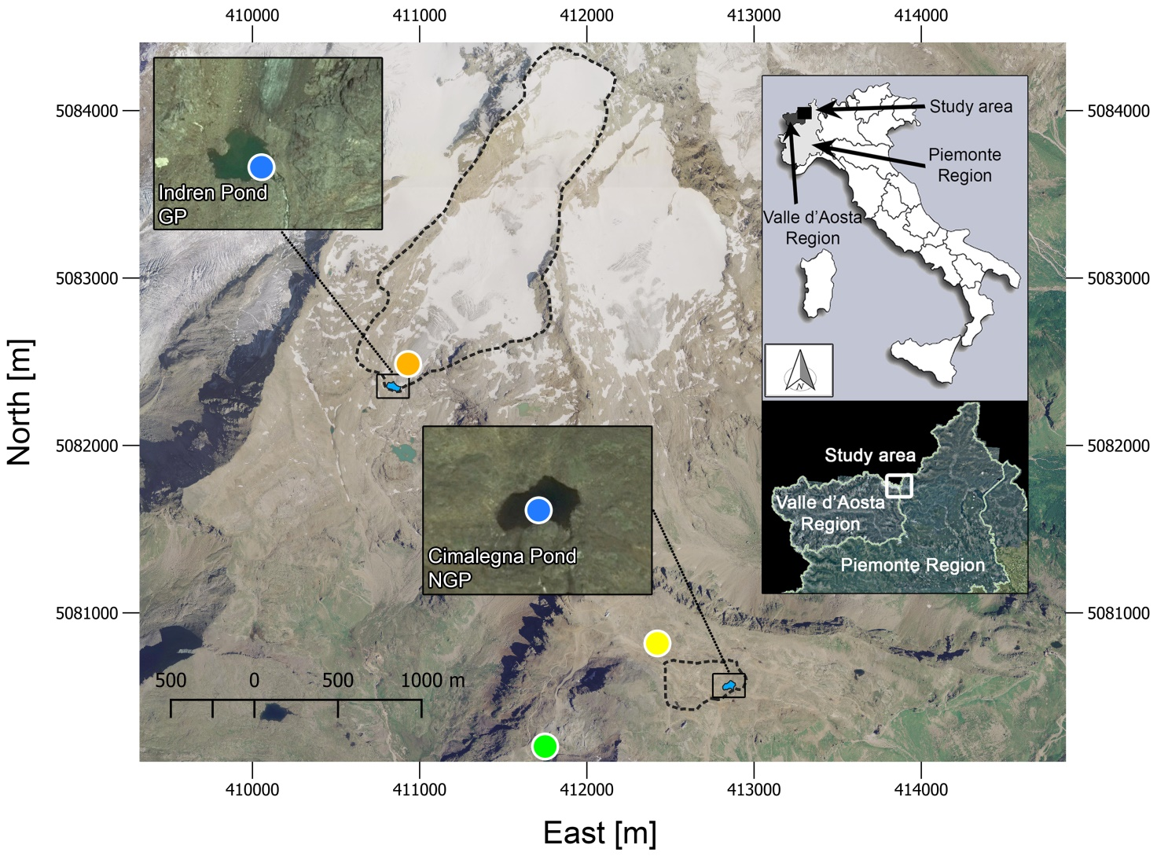
Figure 1. Location of the study area in Italy and in the NW Italian Alps (www.pcn.minambiente.it), aerial overview of the study area (orthoimage year 2006) (coordinate system WGS84/UTM 32N), and details of each pond (Google Earth, Image©2018 DigitalGlobe). Black dashed lines indicate the hydrographic basin borders, blue circles refer to the water chemistry sampling and temperature measurement locations, the yellow circle refers to the Col d'Olen AWS and the snow-profile site, the green circle refers to the rain collector location, and the orange circle refers to the surface ice sample location. GP is Glacier Pond and NGP is No Glacier Pond.
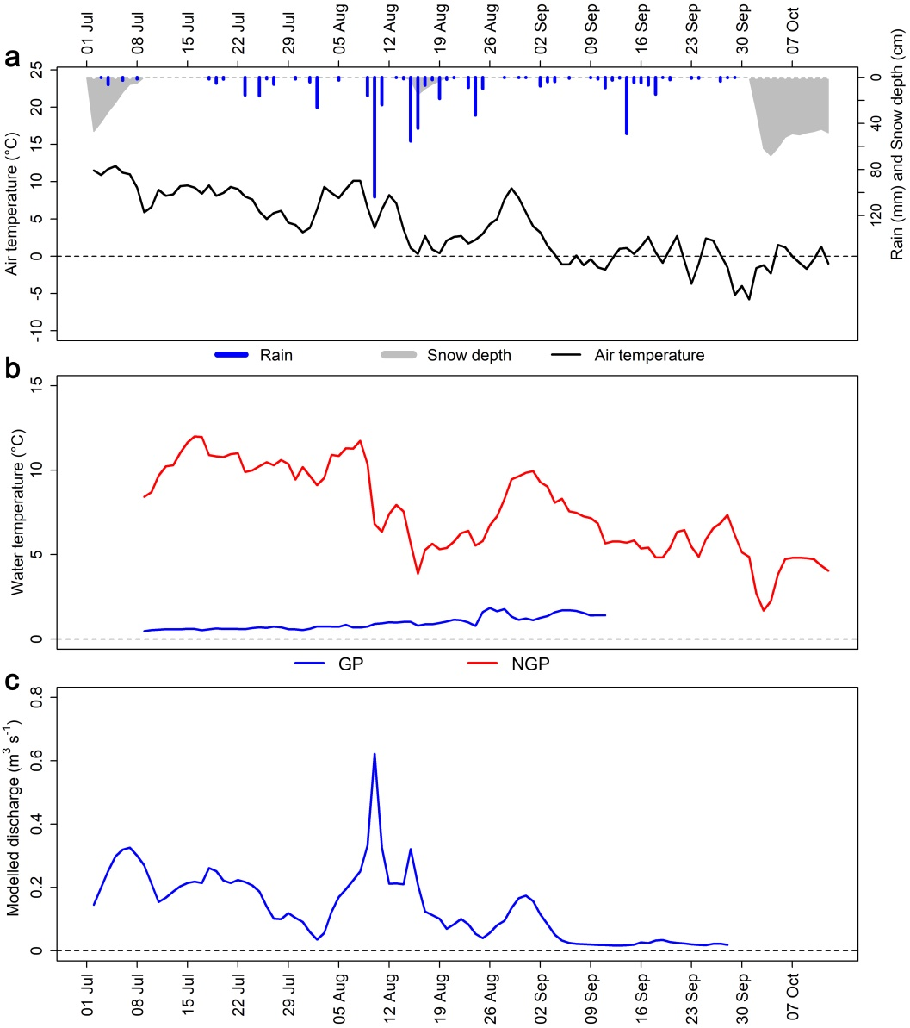
Figure 2. (a) Mean daily air temperature, snow depth, and rain (Col d’Olen AWS). (b) Pond water temperatures (measurement sites are reported in Figure 1). (c) Modelled glacier discharge at the GP outlet.
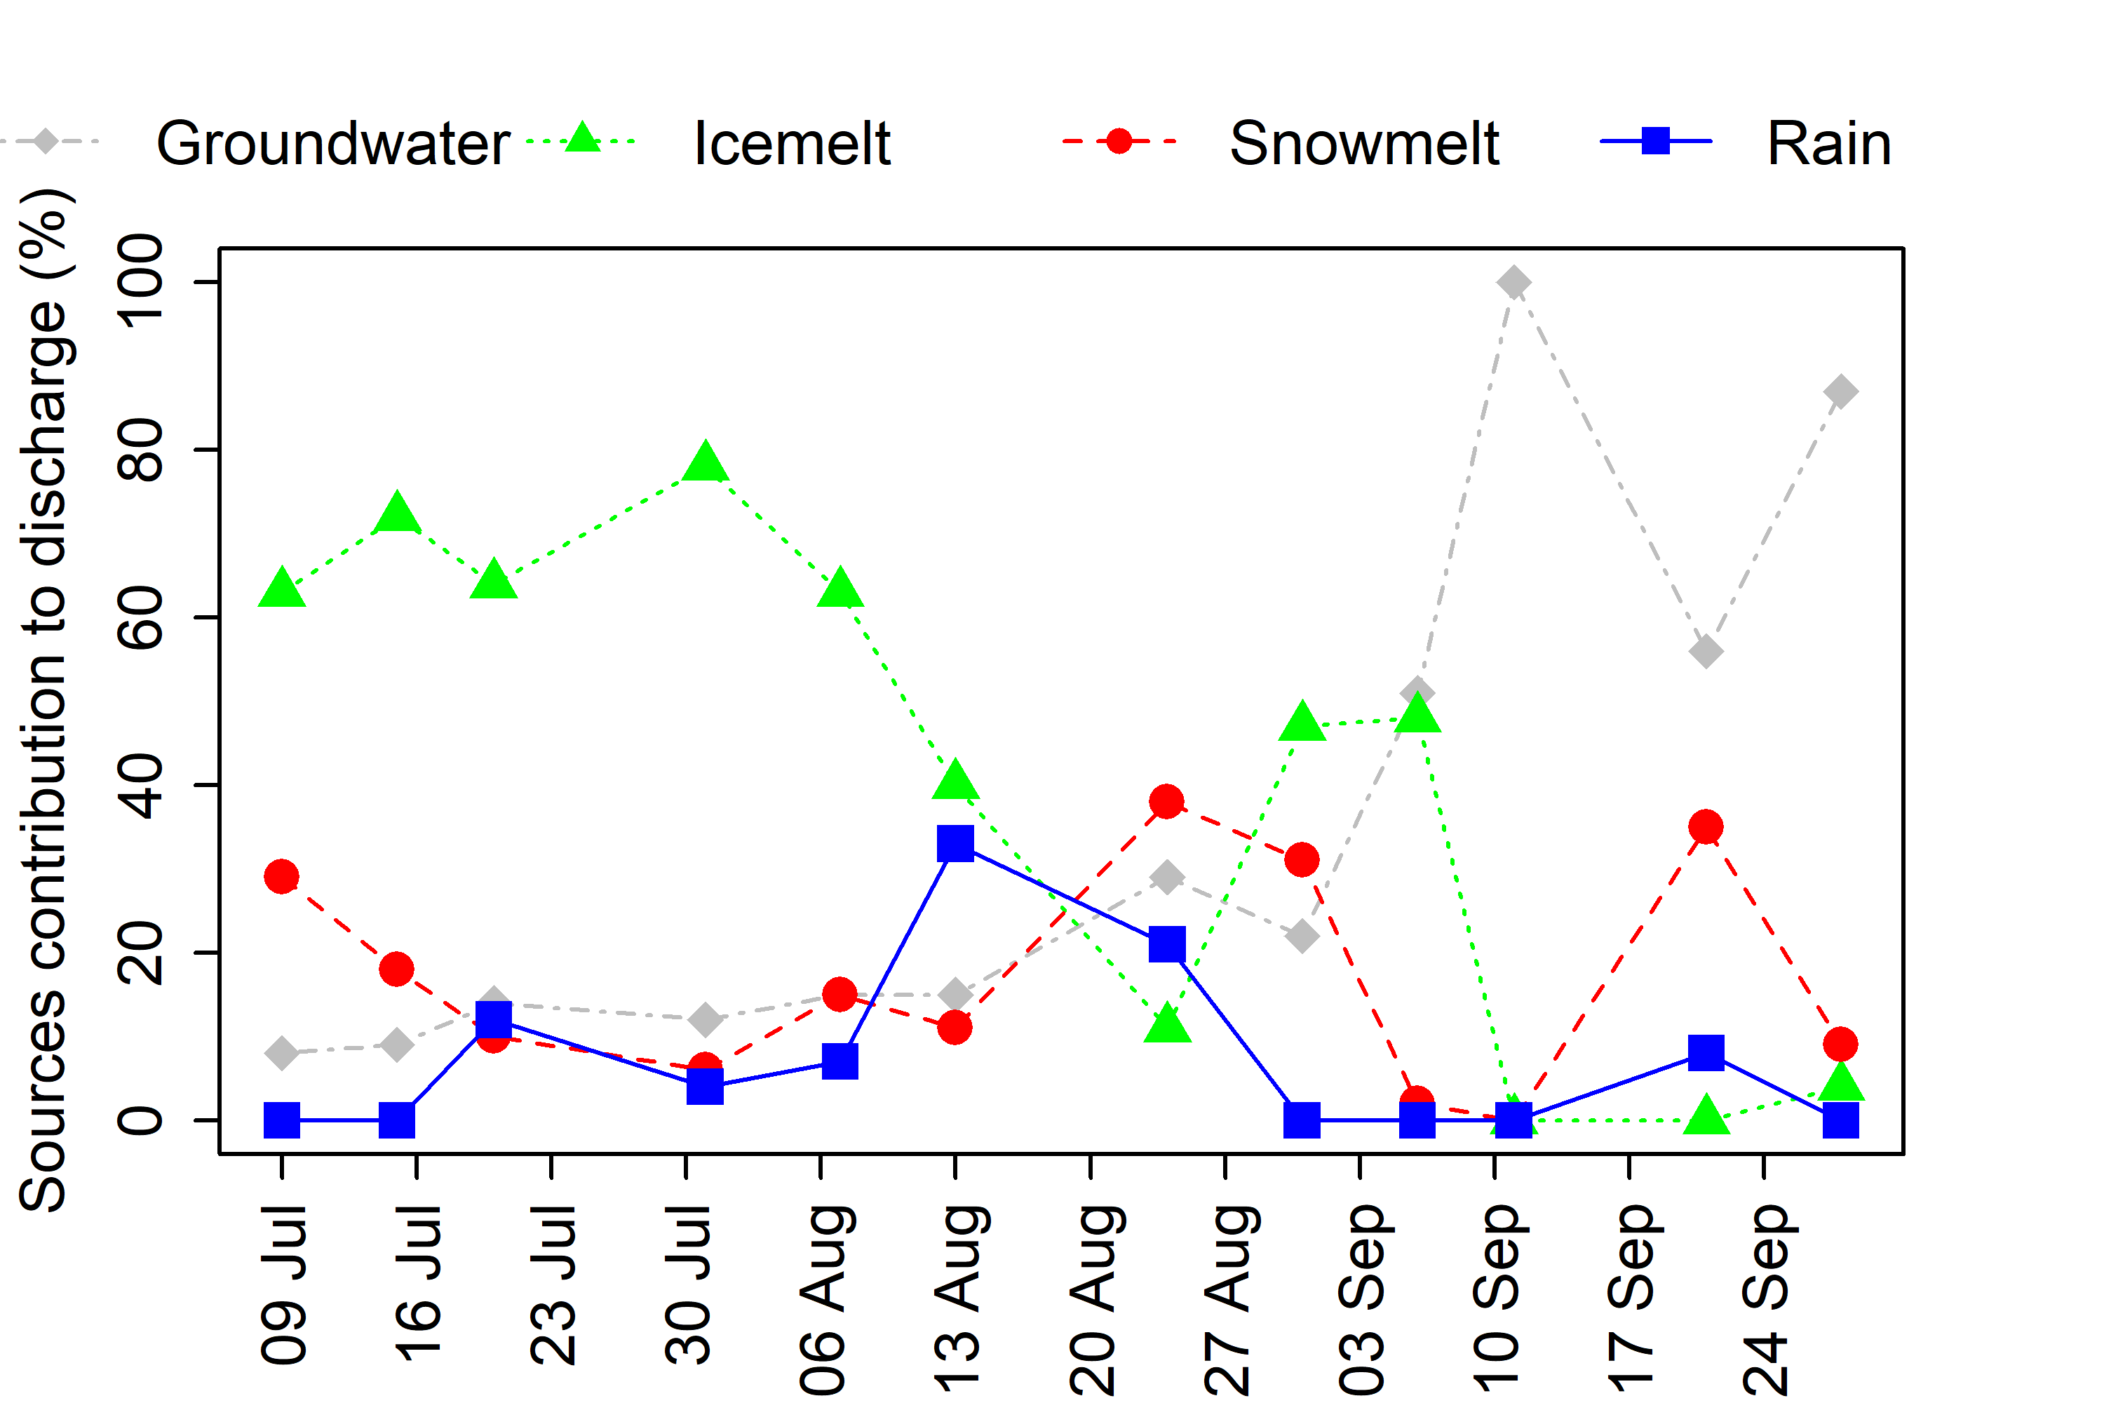
Figure 3. Ice-free season 2015 trends of simulated source contribution to discharge at the GP outlet, averaged in the week preceding the first sampling (2–9 July) and in the periods preceding each sampling date.
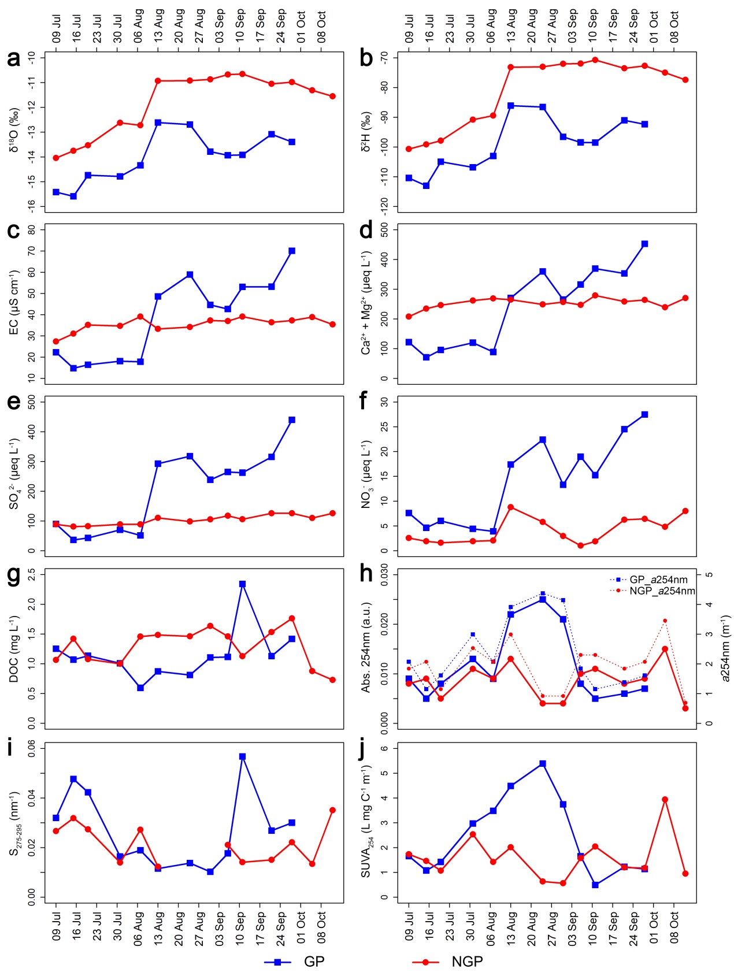
Figure 4. Ice-free season 2015 trends of (a) δ¹⁸O, (b) δ²H, (c) EC, (d) Ca²⁺+Mg²⁺, (e) SO₄²⁻, (f) NO₃⁻, (g) DOC, (h) Abs. 254nm and a254nm, (i) S₂₇₅₋₂₉₅, and (j) SUVA₂₅₄ at both ponds. It was not possible to calculate S₂₇₅₋₂₉₅ at the NGP on 24 and 31 August sampling dates.

Feature | GP | NGP
Pond elevation (m a.s.l.) | 3083 | 2800
Pond area (m²) | 3230 | 2708
Basin area (km²) | 1.43 | 0.11
Basin mean elevation (m a.s.l.) | 3503 (3083 – 4166) | 2839 (2800 – 2898)
Basin mean slope (°) | 29 (0 – 84) | 16 (0 – 48)
Basin mean aspect (°) | 191 | 128
Basin land cover | Bedrock: 32%  Coarse sediment: 3.7%  Soil: 0%  Glacier: 64.1%  Water surface: 0.2% | Bedrock: 31%  Coarse sediment: 6%  Soil: 60%  Water surface: 3%

Table 1. Morphometric and land cover characteristics of the investigated pond basins. Where reported, the range is in brackets. Morphometric characteristics for the GP basin were analysed using a 2mx2m-cell DEM (produced by Regione Valle d'Aosta) while for the NGP basin a 5mx5m-cell DEM was used (produced by Regione Piemonte). The land cover characteristics of the basins were mapped by photointerpretation of digital orthoimages (years 2006, 2012, and 2015) (sources: www.pcn.minambiente.it and www.geoportale.piemonte.it). Morphometric and land cover characteristics of the NGP basin differ from what reported by Colombo et al. (2019a) (there defined as NoPermafrost_pond) due to additional analyses performed thanks to new data availability (Piemonte Region digital orthoimage 2015) and further field-site investigations performed during the summer 2019. However, these modifications did not affect the previous and current discussions.
Parameter | GP | NGP | Snow | Rain
 | Median | Mean | St. Dev. | Median | Mean | St. Dev. | Median | Mean | St. Dev. | Median | Mean | St. Dev.
δ¹⁸O (‰) | −13.9 | −14 | 1 | −11.2 | −11.8 | 1.2 | −18.3 | −18.9 | 2.5 | −8.8 | −9.3 | 1.5
δ²H (‰) | −98.5 | −99 | 8.9 | −74.2 | −81.2 | 11.6 | −135.3 | −139.3 | 21 | −53 | −56.3 | 11.2
EC (μS cm⁻¹, 20 °C) | 44 | 38 | 19 | 36 | 36 | 3 | 4 | 4 | 1 | 6 | 7 | 4
Ca²⁺ (μeq L⁻¹) | 219 | 186 | 103 | 211 | 209 | 18 | 9 | 9 | 3 | 7 | 5 | 2
Mg²⁺ (μeq L⁻¹) | 49 | 54 | 34 | 43 | 45 | 8 | < LOD | < LOD
SO₄²⁻ (μeq L⁻¹) | 251 | 202 | 137 | 106 | 104 | 16 | 6 | 6 | 2 | 6 | 8 | 7
NO₃⁻ (μeq L⁻¹) | 14 | 14 | 8 | 3 | 4 | 3 | 4 | 5 | 2 | 12 | 10 | 6
DOC (mg L⁻¹) | 1.11 | 1.15 | 0.43 | 1.45 | 1.29 | 0.31 | 0.78 | 0.77 | 0.14 | 1.25 | 1.26 | 0.27
Abs. 254nm (a.u.) | 0.009 | 0.012 | 0.007 | 0.009 | 0.009 | 0.004 | 0.010 | 0.010 | 0.002 | 0.007 | 0.008 | 0.003
a254nm (m⁻¹) | 1.96 | 2.36 | 1.19 | 2.07 | 1.94 | 0.8 | 2.3 | 2.26 | 0.49 | 1.61 | 1.84 | 0.69
S₂₇₅₋₂₉₅ (nm⁻¹) | 0.023 | 0.027 | 0.015 | 0.022 | 0.022 | 0.008 | 0.010 | 0.012 | 0.004 | 0.023 | 0.024 | 0.007
SUVA₂₅₄ (L mg C⁻¹ m⁻¹) | 1.65 | 2.4 | 1.57 | 1.44 | 1.59 | 0.87 | 2.82 | 3.12 | 1.26 | 1.64 | 1.51 | 0.58
Table 2. Statistical summary of water chemistry and optical characteristics of DOM analysed for ponds, snow, and rain. Only four observations are available for δ¹⁸O and δ²H at the rain sampling site. Where present, limit of detection (LOD) Mg²⁺ > 0.8 μeq L⁻¹.

