Volatile components of Pelaverga red wines from Piedmont (Italy)
Elisabetta Bonometti, Lorenza Operti, Roberto Rabezzana*, Giorgio Volpi
Chemistry Department, University of Turin, Via Giuria 7, 10125 Turin, Italy
Abstract
Background: The characterization of a typical red wine from Piedmont (north-west Italy), Pelaverga, was performed by means of headspace solid phase microextraction coupled to gas chromatography-mass spectrometry. Two different kinds of Pelaverga are known, historical and Verduno, differing for the area of production. The main volatile compounds of the wine were identified and semi-quantified. Principal components analysis (PCA) was performed in order to identify possible clusters among the different samples analysed.
Results: Forty-eight volatile compounds were unambiguously identified in the wines sampled. The two types of Pelaverga analysed displayed a very similar volatile profile. The most abundant volatile compounds were two esters, ethyl octanoate and diethyl succinate, and two alcohols, isoamyl alcohol and ethyl phenyl alcohol. Few varietal compounds were detected, probably due to their low concentration; among these, we were not able to detect rotundone, which is reported to impart characteristic spicy notes to this kind of wine. Application of PCA did not allow to differentiate the two types of Pelaverga on the basis of their volatile profile.
Conclusion: The present work is, to the best of our knowledge, the first complete report about the volatile profile of Pelaverga wines, and represents the first step of a research project aiming at characterizing food products from Piedmont on the basis of chemical parameters. Differentiation among the two types of Pelaverga will likely require the determination of different chemical parameters in conjunction with volatile compounds.

Keywords: Pelaverga; volatile organic compounds; HS-SPME; GC/MS; PCA

INTRODUCTION
Worldwide, the wine industry is aiming at obtaining better products in terms of quality and safety in order to satisfy an increasing number of consumers. To this purpose, the certification of the geographical origin of wine is growing in importance, due to European regulations issued to protect the denomination of origin of agricultural products. Therefore, it is important to develop methods for the characterization of wines according to chemical parameters linked to the vine and territory origins, in order to get the Denomination of Controlled Origin trademark.¹⁻⁴ Piedmont is a region situated in the north-western area of Italy, and is renowned for the production of several wines of excellent quality. Apart from the most famous wines, such as Barolo, Barbaresco and Barbera, the wine producers are nowadays addressing growing attention to wine varietals less common but that represent an important ‘cultural heritage’ of the region, since they are known from ancient times but whose production was severely reduced in the past years. Nowadays, the need to offer a wide variety of products to the wine consumers is driving the producers to exploit local wine varieties. Among the local products of Piedmont, Pelaverga wine represents an interesting case. In the Italian national Catalogue of Vines, there is just one Pelaverga vine registered, and is referred to a vine cultivated in Bronda valley, near the town of Saluzzo.⁵ The first reports on the production of this wine in this area date back to the VI century. However, in the nearby area of the small village of Verduno, a wine also named Pelaverga is produced starting from the 80’s of the last century, even if the ampelographic origin of the vine seems to be different with respect to that cultivated in the area of Saluzzo. This latter is therefore named ‘historical Pelaverga’, and the one of Verduno ‘Pelaverga piccolo’. The Verduno Pelaverga has more commercial interest, while the historical Pelaverga is mainly consumed in the region where it is produced. Gerbi et al.⁶ reported that a panel of assayers tasted the two wines, and found a remarkable difference in terms of aroma: the historical Pelaverga is described to show fruity notes, while the Verduno Pelaverga features a peculiar spicy, pepper taste. Petrozziello et al.⁷ attributed the spicy taste mainly to the presence of the sesquiterpene rotundone, and studied the winemaking practices that could affect the concentration of this compound in the wine. Motta et al.⁸ studied the effect of different dealcoholization techniques on the typical wine parameters of three different wines, among which Verduno Pelaverga was included. Among the factors investigated, the authors identified 23 main different volatile organic compounds (VOCs) in the wines studied by means of GC-FID, and they found that the aromatic compounds content markedly decreased due to the dealcoholization practices. The papers reported here are, to the best of our knowledge, the only reports in the literature regarding the Pelaverga wine. The objective of the present work was the attempt to identify the main volatile compounds associated with the quality of the studied wines. Moreover, we investigated whether it is possible to find differences among the two Pelaverga wines from the aromatic profile point of view, as outlined by the panel of assayers in the paper of Gerbi et al.⁶
The volatile compounds profile may be easily achieved by gas-chromatography – mass spectrometry (GC-MS), following an extraction-pre-concentration step. Solid phase micro extraction (SPME) is an extraction technique developed in the early 1990s by Pawliszyn and coworkers and represents a valuable and highly reproducible tool for extraction of volatile and semi-volatile analytes from aqueous matrixes.⁹ It needs a small sample volume and the coupling with gas chromatography and mass spectrometry (GC-MS) provides high sensitivity. It has been used to study the volatile profile of many vegetable varieties and beverages, including grapes and wines. In the headspace mode (HS-SPME) analytes are extracted from the gas phase which is in equilibrium with the liquid sample. This avoids contamination of the fiber by non-volatile substances without lowering the sensitivity of the method.

MATERIAL AND METHODS
Sample preparation and solid phase micro extraction
Twenty-two bottles of wines were purchased from different vineries and shops, belonging to the two different Pelaverga typologies: historical Pelaverga (4 wines) and Verduno Pelaverga (18 wines). Despite our efforts, we were not able to collect a higher number of samples due to the low number of cellars that produce this kind of wine. In 2021, 33 farmers of Verduno Pelaverga vine are reported, together with 18 winemakers.¹⁰ The annual production is of 1569 hL, with an increase with respect to the previous year of 16%. No data are available for historical Pelaverga since, as already outlined, it is mainly consumed in the area of production. The vintage is the same for all the wines studied: 2021. 3,4-dimethylbenzaldehyde as internal standard and n-alkane mixture (C₈–C₂₀) for determination of retention indexes were purchased at analytical purity degree from Sigma Aldrich (St Louis, MO) and used as received. Wine samples were extracted according to the following procedure: 5 mL of wine were placed in a 20 mL glass vial (headspace volume 15 mL) with 0.5 g of sodium chloride and 1 µL of an ethanolic solution (19.83 mg/L) of 3,4-dimethylbenzaldehyde as internal standard (3.97 μg/L in the sample). The vial was sealed with an aluminum-coated silicone rubber septum. The vial was conditioned at 40°C for 45 minutes before sampling. Headspace extraction was performed with a 2 cm CAR/PDMS/DVB 50/30 µm fiber (Supelco Bellefonte PA). In order to determine the best extraction time, preliminary tests were performed at different extraction times of 15, 30, 45, 60 and 75 minutes (data non shown). We found out that after 60 minutes at 40°C under continuous stirring equilibrium was reached and hence the repeatability of the extraction procedure was achieved. The extraction temperature of 40°C was chosen after consideration of different values reported in the literature for similar systems. Fast and efficient desorption of the analytes was achieved by inserting and exposing the fibre in the GC inlet kept at 200°C; the split line was closed for the initial 3 minutes of analysis and the carrier gas flow was of 1.2 ml/min.
GC-MS
A Focus GC Thermo Electronic gas chromatograph with quadrupole mass spectrometer operated in electron ionization (EI) mode was used for measurements. The GC system was equipped with a 30 m fused silica capillary column (0.25 mm ID; 1 μm film thickness) (Supelco Bellefonte PA). The temperature program was set according to Revi et al.¹¹ with some modifications: oven initial temperature: 40°C (3 min) then to 160°C at a rate of 2.0°C/min (1 min hold), then to 200°C at a rate of 10°/min (2 min hold). GC-MS transfer line at 250°C; carrier He (5.5 grade of purity) at 1.2 mL/min. The MS ion source temperature was kept at 250 °C. The ionization occurred with an electron kinetic energy of 70 eV. Mass spectra and reconstructed chromatograms (total ion chromatograms [TICs]) were obtained by automatic scanning in the mass range 35–750 u. GC–MS data were processed with the Excalibur 1.4 software. For each analyte, the relative peak area Q_{i} was calculated according to the formula Q_{i} = A_{i}/A_{IS}, where A_{i} is the peak area of the analyte and A_{IS} is the peak area of the internal standard. Although these values are not based on absolute concentrations of aroma compounds, they may be used as basis for differentiation of wines.
Statistical methods
Multivariate analysis was performed by the software CAT (Chemometric Agile Tool).¹² Principal component analysis (PCA) was performed with the aim to identify clusters among the samples and to distinguish between the two types of Pelaverga.
RESULTS AND DISCUSSION

Figure 1 shows a typical chromatogram of a Pelaverga wine sample. A total of 48 compounds were unambiguously identified in the volatile fraction of Pelaverga wines, either by NIST library search (reverse match index higher than 800) or by calculation of retention indexes. These were the only methods employed to attempt peak identification, since we did not purchase external standards. Wine aroma is the result of a harmonic blending of several aromatic compounds. Among these, three main categories may be identified, namely: 1) primary or varietal aromas, directly coming from the grape or from pre-fermentation processes; 2) secondary or fermentation aromas, stemming from vinification, and 3) tertiary aromas, which may be considered as the offspring of the evolution of the former ones, or deriving from aging process in wood barrels. Identified aroma compounds are listed in Table 1, where they are grouped according to their category. The present results are compared with those reported by Motta et al.,⁸ which is the only paper, as far as we know, reporting the aromatic profile of Pelaverga wines. However, the comparison is only partial since our analysis are semiquantitative, while Motta et al.⁸ determined absolute concentrations of the analytes. The wines sampled showed a similar volatile profile, with minor differences in the overall concentration for most classes of substances. The most abundant compounds identified in all types of Pelaverga were two alcohols, namely isoamyl alcohol and phenylethyl alcohol, and two esters, diethyl succinate and ethyl octanoate. These results agree only in part with those of Motta et al.,⁸ who found high abundances for the same two alcohols, but are quite different as far as the esters are concerned. In fact, the most abundant ester was monoethyl- rather than diethyl succinate, and ethyl octanoate was present only in traces.
Terpenes represent the main class of varietal compounds: they are useful to differentiate a variety of wine from the others and supply floral nuances to the wine.¹³ They display low olfactory threshold and are therefore perceived during wine tasting even in low concentrations. Terpenes are present in the grape both in free form, thus contributing to the aroma, and in glycosylated form. The free fraction increases during ripening mainly because of hydrolysis reactions, but if ripening lasts too long the concentrations of some terpenes such as terpineol and linalool decrease, due to oxidation.¹⁴ However, their presence depends on viticulture practices, soil and climate, and they are not greatly modified by fermentation process. Therefore, their presence in wine is directly related to their presence in the must. Citronellol is one of the most odoriferous terpenes, with a typical scent of rose, and it was present in almost half of the samples of Pelaverga, as well as nerolidol (wood scent). α-Calacorene is a sesquiterpene with herbal aroma, which was already reported as a component of Syrah wine from Brazil.¹⁵ The presence of sesquiterpenes in wine is a positive factor since they are related to antibacterial activity.¹⁶ α-Calacorene was present only in 7 out of 22 samples, and hence could not be considered as a marker for Pelaverga. Among varietal compounds, rotundone is a sesquiterpene which has been reported as a possible source of the spicy aroma of some variety of wines, among which Pelaverga is included.⁷ The authors report an average rotundone concentration of 40 ng/L determined by multidimensional gas chromatography mass spectrometry following liquid-phase extraction. However, we did not detect this compound, probably because its concentration was lower than our detection threshold. Conversely, Motta et al.⁸ did not report any terpene among the main aromatic compounds detected in Pelaverga.
The presence in wines of norisoprenoids is considered a quality factor, since they provide aromatic nuances even in very low concentrations. The oxidative degradation of carotenoids gives yield, among the others, to isoprenoids compounds, which display odoriferous properties.¹⁷ We detected β-damascenone belonging to the family of megastigmanes, which are oxygenated C₁₃-norisoprenoids. It has a complex smell of flowers and a very low perception threshold. It is present in almost all varieties of grapes, and its abundance is higher in red than in white wines.
The six-carbon atoms alcohols and aldehydes confer to the wine an herbaceous scent, which may be unpleasant at high concentrations.¹⁸ 1-Hexanol is produced from lipoxygenases acting on linoleic or linolenic acid in crushed berry tissue.¹⁹ It was found at low and comparable amounts in more than half of the samples studied here. Despite we did not determine absolute concentrations, we assume that the concentration values are much lower with respect to the odour detection threshold (ODT) reported by Guth²⁰ as 8000 μg/L. Hexanoic (caproic) acid belongs to the series of fatty acids. The C₆ fatty acids are formed by yeast and are considered as inhibitors of fermentation, even at concentration of few ng/L.¹⁸ In the present study, caproic acid was detected in almost all the samples. Bothe the C₆ compounds were also found in Pelaverga by Motta et al.,⁸ who also identified cis-3-hexenol among this class of compounds.
Fermentation aromas represent the largest group of aromatic compounds in wine. They derive from both esterification reactions and yeasts metabolism.²¹ Among esters, ethylic esters of fatty acids and acetates of higher alcohols play the major role in determining wine aroma, since they provide fruity scents and are characterized by low odour thresholds.²² The content of esters changes during aging of wine according to storage temperature and pH of wine. In fact, both hydrolysis reactions, which decrease the ester concentration, and esterification reactions occur depending on the factors mentioned. According to some authors,²³ esters of dicarboxylic acids increase in concentration during storage due to esterification, while esters of monocarboxylic acids decrease because of hydrolysis. The most abundant esters were diethyl succinate (diethyl butanedioate) and ethyl octanoate, which provide fruit and must odour, respectively. Diethyl succinate is formed by the activity of lactic bacteria during malolactic fermentation.²⁴ The occurrence of this kind of fermentation, which sometimes occurs spontaneously and is not induced, is confirmed by the presence of ethyl lactate (propanoic acid, 2-hydroxy-, ethyl ester). Among acetates, the most abundant was ethyl acetate. This compound is formed partly by yeast during fermentation; however, the largest portion derives from activity of aerobic bacteria during aging in barrels. It is responsible of acescence, an olfactic feature linked to vinegar odour. Therefore, it confers a sour taste to the wine and contributes to its hardness, which are both positive features provided that the acetate concentration is not too high. However, its contribution to the overall wine flavour is controversial since, even if both synergism and suppression in odour intensity occur because of the presence in wine of several esters, some authors concluded that ethyl acetate generally leads to odour suppression.²⁵ The other acetates detected were isoamyl acetate (banana scent) and ethyl acetate (pineapple) and, at lower concentrations, hexyl acetate (fruity) and phenyl-ethyl acetate (rose, honey, tobacco). Hexyl acetate is likely formed from hexanol as precursor, via alcohol acetyl transferase (AAT), as reported by some authors.²⁶ Overall, we detected a much higher number of esters with respect to Motta el al.,⁸ and all the esters found by this author are also present in our study, with the exception of monoethyl succinate.
Higher alcohols are formed from sugars during yeast fermentation, or from amino acids through a catabolic pathway.²⁷ Aliphatic alcohols contribute to the wine aroma with different nuances, going from ‘whiskey’ or ‘burnt’ for isoamyl alcohol, to ‘chemical’ or ‘metal’ for C₇ and C₈ alcohols, to ‘fat’ or ‘waxy’ for dodecanol. Instead, phenylethyl alcohol (floral, rose) and benzyl alcohol (floral, balsamic) confer sweeter odours. According to some authors,²⁸ higher alcohols contribute positively to the wine aroma complexity if their overall concentration does not exceed 300 mg/L. The most abundant alcohol detected was isoamyl alcohol, followed by phenyl ethyl alcohol. Lower concentrations were found for the C₇-C₁₀ aliphatic alcohols, and for benzyl alcohol. These results are in good agreement with those of Motta et al.;⁸ however, they also detected isobutanol at high concentrations, while we did not find this compound.
Pelaverga wines analysed displayed a low content of aldehydes, the most abundant ones being benzaldehyde, with a typical almond scent, benzaldehyde 4-methyl and decanal. Benzaldehyde 4-methyl is rather uncommon in wines but it has been found to be a component of kiwi juice.²⁹ Decanal is quite often detected especially in white wines; it is reported to display an intense petrol, plastic, green aroma.³⁰ Aldehydes are considered to be formed by oxidation of the corresponding alcohols.³¹ Motta et al.⁸ did not report any aldehyde and the only carbonyl compounds detected were acetoin (3-hydroxy-2-butanone) and γ-butyrolactone, which we did not detect.
Fatty acids derive from lipidic metabolism of yeasts. They represent the volatile acidity of wines. With wine aging, they react mainly with ethanol to yield ethyl esters with nuances of fruit and flower. The most abundant was decanoic acid, which provides an unpleasant odour of rancid and fat. Its odour threshold is 1000 μg/L, as reported by some authors;²² despite we did not perform quantitative measures, we did not perceive its characteristic unpleasant odour in Pelaverga wines analyzed, and therefore we assume that its concentration was below the odour threshold. Nonanoic acid is described to have a nutty odour, and is one of the VOCs whose concentration increases when grapes are subjected to withering. It was reported as a possible marker for Amarone wines produced from Corvinone and Rondinella grapes.³² It is worth noting that the presence of C₆ and C₈-C₁₀ fatty acids in grapes was reported as the conceivable impact of the Aspergillus carbonarius fungus.³³ This fungus can produce a possibly carcinogenic mycotoxin named ochratoxin A (OTA). However, these authors reported that vinification of red grapes leads to a marked reduction (more than 67%) of OTA. Overall, the presence of fatty acids in wine is controversial. It is largely accepted that a too high concentration is detrimental due to unpleasant odours; however, in low concentrations they represent an important factor contributing to the aromatic equilibrium of wines.³⁴ Isovaleric acid (isopentanoic acid) was the most abundant fatty acid detected by Motta et al.⁸ (not found in the present paper), followed by octanoic and decanoic acid.
Two hydrocarbon molecules, namely p-cymene and 1,2-dihydro-1,1,6-trimethyl-naphthalene (TDN) were found in low concentrations in Pelaverga wines. The first one is reported as a molecular marker of shelf-life of wines³⁵ and of improper shipping conditions, even if the effect is higher in white than in red wines.³⁶ High concentrations of p-cymene are also reported in botryzed wines.³⁷ TDN features a characteristic kerosene odour and plays a major role in the bouquet of old Riesling wines.¹⁸ It is also indicated to be the consequence of high temperature storage in white wines.³⁸
The only volatile phenol found in Pelaverga wines was 4-ethylphenol (horse stable, medicinal scent). It is produced by decarboxylation of hydroxycinnamic acids present in must by some microorganisms (Brettanomyces yeasts and bacteria).^{18,39} These microorganisms are winery contaminants, and the production of the above-mentioned phenol represents a wine defect. The odour threshold reported in the literature is 440 μg/L for 4-ethyl phenol.⁴⁰ Again, we assume that its concentration in the wines analysed here was below this limit, since we did not perceive unpleasant odours. 4-Ethyl phenol was also reported by Motta et al.⁸ in concentration below the odour threshold (0.13 mg/L).
Tertiary aromas are rather complex, since they derive form a long evolution of wine both in contact with air and in the bottle. Traditionally, Pelaverga wines are consumed young, and hence these aromas cannot reach considerable amounts; indeed, we did not detect any analyte belonging to this class of compounds.
Piedmont is a rich area in terms of wine production, nevertheless very few papers are reported in the literature, to the best of our knowledge, concerning characterization of aromatic profile of Piedmontese wines. Marengo et al.⁴¹ determined the aromatic content of five different wines, namely Barolo, Barbaresco and three DOCs of Nebbiolo, all stemming from the Nebbiolo grape. By means of chemometric tools, the authors were able to differentiate the wines according to aging and, partly, to the type of wine. The aromatic content of the wines was almost completely devoid of primary aromas, as expected for aged wines. In fact, only cymene and hexanol were detected. By contrast, Pelaverga exhibits terpenes such as citronellol and nerolidol, as it is typical for wines which are consumed young. On the other hand, wines analysed by Marengo et al.⁴¹ display a higher number of esters with respect to Pelaverga. Comparison may only be qualitative, since concentrations are not reported in the paper of Marengo et al.;⁴¹ however, this result agree with the different features of the wines compared, since those studied by Marengo et al.⁴¹ are traditionally consumed after aging both in barrels and in bottles. Moreover, Bonino et al.⁴² identified the primary aroma compounds present in Ruché wine, another typical Piedmontese wine, although being produced in a restricted area. The aim of the work was to unravel the mechanisms leading to a wine such as Ruché, which displays some similarities with aromatic wines such as Malvasia, although Ruché is produced from non-aromatic vine. The authors found a considerable number (59) of primary aroma compounds in Ruché, much higher than those identified in Pelaverga in the present paper.
One of the aims of the present work was to investigate whether it is possible to distinguish among historical (Saluzzo) and Verduno Pelaverga, on the basis of the respective volatile profiles. To this purpose, principal component analysis (PCA) was applied to the set of relative concentrations of aromatic compounds detected in the samples studied. Data resulted to be quite spread, since 5 components explain 71% of the total variance. Our discussion will be limited to three components, which explain 55% of total variance (Figure 2). The figure does not highlight any clustering among the two different types of Pelaverga. Therefore, the two wines could not be distinguished on the basis of their aromatic profile. Unfortunately, the very low number of historical Pelaverga samples that we were able to find was an unfavourable factor for our purpose. Moreover, we selected only wines from the same vintage, and the areas of production of the two kinds of wine are not very far from each other. The biplot of both loading and scores allows to find correlations between the different wines and the aromatic compounds detected (Figure 3). Two graphs are reported, which indicate the correlations among samples and variables in the PC1/PC2 plane (figure 3a) and in the PC1/PC3 plane (figure 3b). It is interesting to note that five samples, namely wines 9, 10, 11, 14 and 16, appear in both graphs in the second and third quadrants. These samples do not show correlations with most of the variables, which all fall in the first and fourth quadrants. These five wines indeed display low concentration values for most of the volatile compounds, probably due to a different wine making procedure adopted by the corresponding cellars. The authors of the present paper are not professional assayers and hence are not able to distinguish the five wines from the others on the basis of the assay. On the other hand, it is possible to highlight positive correlations among samples and variables: as an example, Figure 3a shows that sample 4 has a strong positive correlation with variable E13, and indeed the concentration of this compound in wine 4 is much higher than in the other samples.
CONCLUSION
The present paper represents the first work regarding identification and semiquantification of volatile compounds present in Pelaverga wine, which is a product typical of Piedmont region in north-west of Italy. The aim of the work was to start a systematic characterization of some typical wines of Piedmont on the basis of their aromatic profile. Moreover, on thew same basis we tried to distinguish among two areas of production of Pelaverga in the same region, but it was not possible, probably because the differences which may attributed to soil and climate and to the wine making procedures are too small. The volatile profiles were determined by HS-SPME-GC-MS, and very little differences were found among the various samples. The volatile profiles were dominated by the presence of esters and alcohols. Low concentrations of other classes of substances were found, in particular with regard to varietal compounds such as terpenes. This fact could be expected since Pelaverga is not an aromatic vine; however, it cannot be ruled out that some compounds were present in such low concentrations that we could not detect them. Principal component analysis was applied to the set of data but no particular clustering among the samples was observed; however, a little group of five wines displayed negative correlations with almost all the variables. Possible evolutions of this work may therefore include the involvement of a panel of professional assayers that may confirm the different taste of the less aromatic samples detected. Moreover, the investigation of different chemical parameters apart from volatile compounds may be useful to characterize Pelaverga wines and possibly distinguish among historical and Verduno Pelaverga varieties.
ACKNOWLEDGEMENTS Authors acknowledge support from the Project CH4.0 under the MUR program "Dipartimenti di Eccellenza 2023-2027" (CUP: D13C22003520001).
CONFLICT OF INTEREST
None declared.
REFERENCES
- Alves RF, Nascimento AMD and Nogueira JMF, Characterization of the aroma profile of Madeira wine by sorptive extraction techniques. Anal Chim Acta 546:11–21 (2005).
- Cabredo-Pinillos S, Cedròn-Fernandez T and Saenz-Barrio C, Differentiation of ‘‘Claret’’, Rose´, Red and Blend wines based on the content of volatile compounds by headspace solid-phase microextraction and gas chromatography. Eur Food Res Technol 226:1317–1323 (2008).
- de Andrade MF, Santos da Silva IJ, Pimentel MF, Paim APS, Cervera ML and de la Guardia M, Ultrasonic nebulization inductively coupled plasma optical emission spectrometry method for wine analysis Spectrochimica Acta Part B 170:105924-105932 (2020).
- Mandrile L, Zeppa G, Giovannozzi AM and Rossi AM, Controlling protected designation of wine by Raman spectroscopy. Food Chem 211:260-267 (2016).
- Mannini F, Oberto P, Schneider A and Vergano G, Ricerche ampelografiche sui vitigni «Pelaverga» e «Cari: un complesso esempio di sinonimie ed omonimie. Quad. Vitic. Enol. Univ Torino 15:97-115 (1991).
- Gerbi V and Zeppa G, Individuation of wine descriptors: application to Pelaverga wines. Quad Vitic Enol Univ Torino 17:86-102 (1993).
- Petrozziello M, Espada‑Rodriguez L, Bonello F, Asproudi A, Cravero MC, Motta S, Panero L and Lopez R, Effect of some winemaking factors on rotundone levels of Pelaverga di Verduno wines. Eur Food Res Technol 247:1645–1653 (2021).
- Motta S, Guaita M, Petrozziello M, Ciambotti A, Panero L, Solomita M and Basso A, Comparison of the physicochemical and volatile composition of wine fractions obtained by two different dealcoholization techniques. Food Chem 221:1-10 (2017).
- Pawliszyn J, Applications of solid phase microextraction. Ed by The Royal Society of Chemistry, Cambridge, UK (1999).
- Valoritalia Annual Report. In: Valoritalia annual report 2022. https://www.valoritalia.it/annual- report/.
- Revi M, Badeka A, Kontakos S and Kontominas MG, Effect of packaging material on enological parameters and volatile compounds of dry white wine. Food Chem 152:331–339 (2014).
- Leardi R, Melzi C and Polotti G, CAT (Chemometric Agile Tool), freely downloadable from http://gruppochemiometria.it/index.php/software.
- Marais J, Wine aroma composition. Food Rev Dec 90/Jan 91:18–21 (1991).
- Barbera D, Avellone G, Filizzola F, Monte LG, Catanzaro P and Agozzino P, Determination of terpene alcohols in Sicilian Muscat wines by HS-SPME-GC-MS. Nat Product Res 27:541-547 (2013).
- Vieira da Mota R, Peregrino I, Teran Rivera S-P, Hassimotto NMA, de Souza AL and de Souza CR, Characterization of Brazilian Syrah winter wines at bottling and after ageing. Sci Agric 78:e20190233 (2021).
- Boussaada O, Ammar S, Saidana D, Chraif I, Mahjoub MA, Helal AN and Mighri Z, Volatile Constituents of Evax pygmaea from Tunisia. Jeobp 11:171 – 178 (2008).
- Winterhalter P and Rouseff RL, Carotenoid-derived aroma compounds, in: ACS Symposium Series 802, American Chemical Society, Washington, DC (2002).
- Riberéau-Gayon P, Glories Y, Maujean A and Dubourdieu D, Alcohols and other volatile compounds. In Handbook of Enology: The Chemistry of Wine. Stabilization and Treatments, 2nd ed.; John Wiley & Sons Ltd: Chichester, UK, Volume 2, pp. 51–64 (2006).
- Tressl R and Drawert F, Biogenesis of banana volatiles. J Agric Food Chem 21:560–565 (1973).
- Guth H, Quantitation and sensory studies of character impact odorants of different white wine varieties. J Agric Food Chem 45:3027–3032 (1997).
- Panighel A and Flamini R, Applications of solid-phase microextraction and gas chromatography/mass spectrometry (SPME-GC/MS) in the study of grape and wine volatile compounds. Molecules 19:21291–21309 (2014).
- Francis IL and Newton JL, Determining wine aroma from compositional data. Austr J Grape and Wine Res 11:114–126 (2005).
- Carlin S, Vhrovsek U, Franceschi P, Lotti C, Bontempo L, Camin F, Toubiana D, Zottele F, Toller G, Fait A and Mattivi F, Regional features of northern Italian sparkling wines, identified using solid-phase micro extraction and comprehensive two-dimensional gas chromatography coupled with time-of-flight mass spectrometry. Food Chem 208:68-80 (2016).
- Issa-Issa H, Guclu G, Noguera-Artiaga L, López-Lluch D, Poveda R, Kelebek H, Selli S and Carbonell-Barrachina ÁA, Aroma-active compounds, sensory profile, and phenolic composition of Fondillón. Food Chem 316:126353 (2020).
- Piggott JR and Findlay AJF, Detection thresholds of ester mixtures. Proceedings of Flavour Research of Alcoholic Beverages (Foundation for Biotechnical and Industrial Fermentation Research: Helsinki) pp. 189–197 (1984).
- Dennis EG, Keyzers RA, Kalua CM, Maffei SM, Nicholson EL and Boss PK, (2012). Grape contribution to wine aroma: Production of hexyl acetate, octyl acetate, and benzyl acetate during yeast fermentation is dependent upon precursors in the must. J Agric Food Chem 60:2638-2646 (2012).
- Swiegers JH, Bartowsky EJ, Henschke PA and Pretorius IS, Yeast and bacterial modulation of wine aroma and flavour. Aust J Grape Wine Res 11:139–173 (2005).
- Rapp A and Versini G, Influence of nitrogen compounds in grapes on aroma compounds in wine. In Proceedings of the International Symposium on Nitrogen in Grapes and Wine, Seattle, DC, USA, 18–19 June 1991; American Society of Enology and Viticulture: Davis, CA, USA, 1991; pp. 156–164.

Young H and Paterson VJ, Characterization of bound flavour components in kiwifruit. J Sci Food Agric 68:257-260 (1995).
- Bowen AJ and Reynolds AG, Odour potency of aroma compounds in Riesling and Vidal blanc table wines and icewines by gas chromatography−olfactometry−mass spectrometry. J Agric Food Chem 60:2874−2883 (2012).
- Liu J, Zhao W, Li S, Zhang A, Zhang Y and Liu S, Characterization of the key aroma compounds in Proso millet wine using headspace solid-phase microextraction and gas chromatography-mass spectrometry. Molecules 23:462-477 (2018).
- Bellincontro A, Matarese F, D’Onofrio C, Accordini D, Tosi E and Mencarelli F, Management of postharvest grape withering to optimise the aroma of the final wine: a case study on Amarone. Food Chem 213:378–387 (2016).
- Dachery B, Cardoso Hernandes K, Fonseca Veras F, Schmidt L, Rossini Augusti P, Manfroi V, Alcaraz Zini C and Welke JE, Effect of Aspergillus carbonarius on ochratoxin a levels, volatile profile and antioxidant activity of the grapes and respective wines. Food Res Int 126:108687-108696 (2019).
- Shinohara T, Gas chromatographic analysis of volatile fatty acids in wines. Agric Biol Chem 49:2211–2212 (1985).
- Nasi A, De Gennaro T, Avara V, Nicolella V, Monaco A, Mercurio V, Addimanda G, Granato TM, Chianese L and Ferranti P, Determination of varietal volatiles as quality and shelf-life markers/origin and typicalness tracers in southern Italian wines. Ital J Food Sci 22:41-46 (2010).
- Robinson AL, Mueller M, Heymann H, Ebeler SE, Boss PK, Solomon PS and Trengove RD, Effect of simulated shipping conditions on sensory attributes and volatile composition of commercial white and red wines. Am J Enol Vitic 61:337-347 (2010).
- Furdíková K, Bajnociová L, Malík F and Špánik I, Investigation of volatile profile of varietal Gewürztraminer wines using two-dimensional gas chromatography. J Food Nutr Res 56:73–85 (2017).
- Cejudo-Bastante MJ, Hermosin-Gutierrez I and Perez MS, Accelerated aging against conventional storage: effects on the volatile composition of Chardonnay white wines. J Food Sci 78:C507-C513 (2013).
- Baumes R, Wine Aroma Precursors. In Wine Chemistry and Biochemistry; Victoria Moreno-Arribas, M., Carmen Polo, M., Eds.; Springer Science + Business Media, LLC: New York, NY, USA, pp. 251–274 (2009).
- Carillo JD, Garrido-Lòpez A and Tena MT, Determination of oak volatile compounds in wine by headspace solid-phase microextraction and gas chromatography-mass spectrometry. J. Chromatogr. A 1102:25–36 (2006).
- Marengo E, Aceto M and Maurino V, Classification of Nebbiolo-based wines from Piedmont (Italy) by means of solid-phase microextraction–gas chromatography–mass spectrometry of volatile compounds J. Chromatogr. A 943:123–137 (2001).
- Bonino M, Schellino R, Rizzi C, Aigotti R, Delfini C and Baiocchi C, Aroma compounds of an Italian wine (Ruche´) by HS–SPME analysis coupled with GC–ITMS. Food Chem 80:125-133 (2003).
Table 1. HS-SPME-GC-MS volatile composition of Pelaverga wines.
Compound | relative peak areaª(mean ± standard deviation) | Calculated Kovats retention index (RI) | Theoretical RI
Varietal compounds
Terpenes and norisoprenoids
Citronellol (T2) | 0.0404 ± 0.055 | 1229 | 1228
α-Calacorene (T3) | 0.0480 ± 0.076 | 1546 | 1542
Nerolidol (T4) | 0.0909 ± 0.131 | 1565 | 1564
β-Damascenone (L1) | 0.0187 ± 0.050 | 1385 | 1386
Total | 0.198
C₆ compounds
1-Hexanol (A2) | 0.656 ± 0.78
Hexanoic acid (AC1) | 0.245 ± 0.28 | 988 | 990
Total | 0.901
Fermentative compounds
Esters
Ethyl acetate (E1) | 3.788 ± 1.95
Butanoic acid, ethyl ester (E2) | 0.172 ± 0.093
Propanoic acid, 2-hydroxy-, ethyl ester, (E3) | 0.0240 ± 0.050
Butanoic acid, 3-methyl-, ethyl ester (E4) | 0.454 ± 0.30
1-Butanol, 3-methyl-, acetate (E5) | 5.050 ± 3.0
Hexanoic acid, ethyl ester (E6) | 8.585 ± 9.3 | 998 | 1000
Acetic acid, hexyl ester (E7) | 0.0909 ± 0.15 | 1013 | 1011
2-Hexenoic acid, ethyl ester (E8) | 0.0530 ± 0.053 | 1042 | 1037
2-Furancarboxylic acid, ethyl ester (E9) | 0.00530 ± 0.012 | 1051 | 1047
Pentanoic acid, 2-hydroxy-4-methyl-, ethyl ester (E10) | 0.139 ± 0.15 | 1057 | 1060
Heptanoic acid, ethyl ester (E11) | 0.0884 ± 0.23 | 1089 | 1097
Octanoic acid, methyl ester (E12) | 0.124 ± 0.11 | 1124 | 1126
Butanedioic acid, diethyl ester (E13) | 11.1 ± 6.3 | 1181 | 1182
Octanoic acid, ethyl ester (E14) | 45.4 ± 25 | 1198 | 1196
Benzeneacetic acid, ethyl ester (E15) | 0.182 ± 0.15 | 1244 | 1246
Isopentyl hexanoate (E16) | 0.101 ± 0.096 | 1249 | 1252
Acetic acid, 2-phenylethyl ester (E17) | 0.758 ± 0.45 | 1256 | 1258
Nonanoic acid, ethyl ester (E18) | 0.303 ± 0.35 | 1296 | 1296
Decanoic acid, methyl ester (E19) | 0.0159 ± 0.03 | 1324 | 1325
Octanoic acid, isobutyl ester (E20) | 0.0197 ± 0.035 | 1348 | 1348
Ethyl 9-decenoate (E21) | 0.303 ± 0.91 | 1387 | 1387
Decanoic acid, ethyl ester (E22) | 8.08 ± 4.3 | 1396 | 1396
Butanedioic acid, ethyl 3-methylbutyl ester (E23) | 0.581 ± 0.33 | 1429 | 1436
Octanoic acid, 3-methylbutyl ester (E24) | 0.0656 ± 0.17 | 1446 | 1446
Dodecanoic acid, ethyl ester (E25) | 0.252 ± 0.25 | 1594 | 1595
Tetradecanoic acid, ethyl ester (E27) | 0.182 ± 0.25
Total | 85.8
Fusel and higher alcohols
Isoamyl alcohol (A1) | 35.4 ± 12
1-Heptanol (A3) | 0.199 ± 0.19 | 969 | 970
Benzyl alcohol (A4) | 0.0379 ± 0.12 | 1032 | 1036
1-Octanol (A5) | 0.505 ± 0.17 | 1070 | 1071
Phenylethyl Alcohol (A6) | 21.7 ± 9.6 | 1113 | 1116
1-Nonanol (A7) | 0.136 ± 0.16 | 1172 | 1173
1-Decanol (A8) | 0.0404 ± 0.071 | 1268 | 1273
Total | 58.1
Aldehydes
Benzaldehyde (AL1) | 0.0429 ± 0.16 | 956 | 962
Benzaldehyde, 4-methyl- (AL2) | 0.126 ± 0.45 | 1078 | 1079
Decanal (AL3) | 0.0404 ± 0.093 | 1204 | 1206
Total | 0.210
Fatty acids
Octanoic acid (AC2) | 0.379 ± 0.81 | 1186 | 1180
Nonanoic acid (AC3) | 0.159 ± 0.45 | 1274 | 1273
Decanoic acid (AC4) | 0.631 ± 0.68 | 1371 | 1373
Total | 1.16
Hydrocarbons
p-cymene (H1) | 0.0156 ± 0.035 | 1022 | 1025
Naphthalene, 1,2-dihydro-1,1,6-trimethyl- (H2) | 0.167 ± 0.16 | 1353 | 1354
Total | 0.182
Phenols
Phenol, 4-ethyl- (PH1) | 0.0252 ± 0.086 | 1169 | 1169
ªCalculated as the ratio A_{i}/A_{IS} (see experimental section).
Figure 1. Typical chromatogram (total ion current) obtained from HS-SPME–GC/MS analysis of a Pelaverga wine.
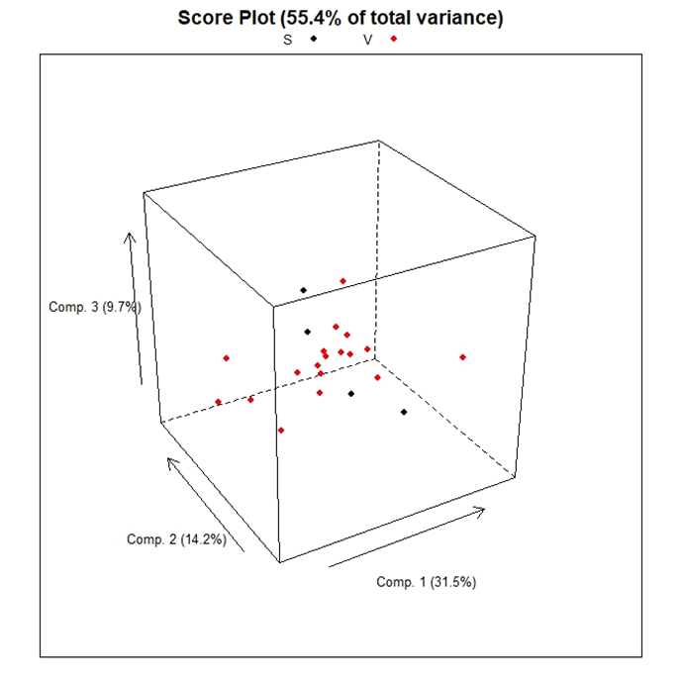
Figure 2. PCA score 3D plot of Pelaverga wines. Black dots: historical (Saluzzo) Pelaverga wines; red dots: Verduno Pelaverga wines.

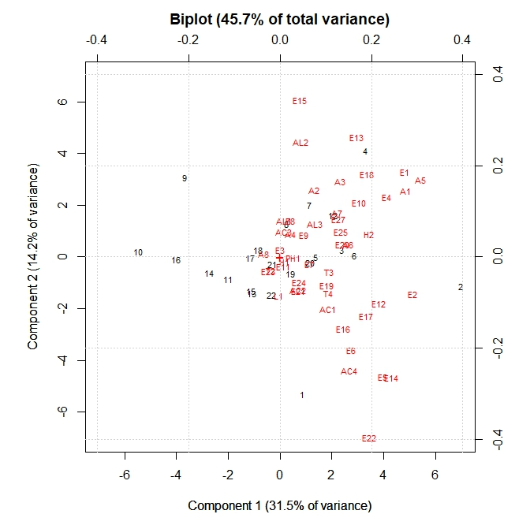
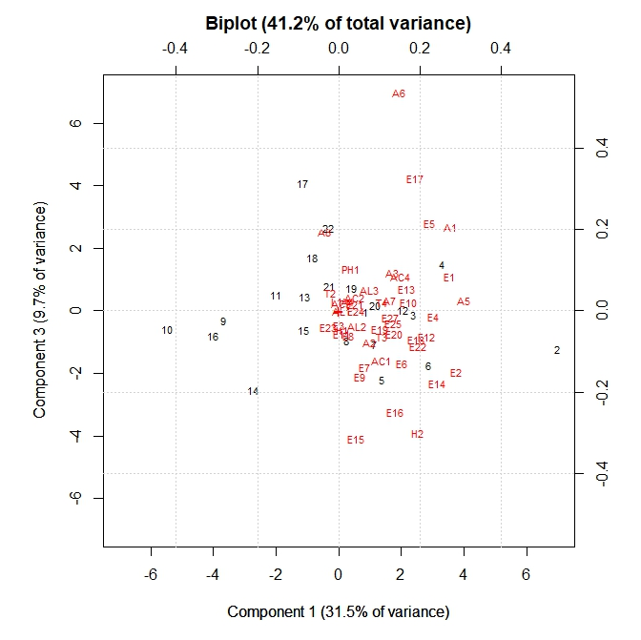
3b
Figure 3. PCA biplots in the PC1/PC2 plane (figure 3a) and in the PC1/PC3 plane (figure 3b) combining score plots to loadings plots of the different Pelaverga wines. The black numbers represent the 22 wines sampled, while the red labels indicate the different volatile compounds detected as reported in Table 1.

