Squaraine Dyes as selective probes for mucin detection
Cosmin Butnarasuª, Carlotta Pontremoli^{b}, Valentina Garberoª, Alex Affricanoª, Maria Jesus Moran Plata^{b}, Sonja Visentinª, Nadia Barbero^{b}
ª Department of Molecular Biotechnology and Health Science, University of Turin, Torino, Italy; ^{b} Department of Chemistry, NIS Interdepartmental and INSTM Reference Centre, University of Torino, Torino, Italy
E-mail: carlotta.pontremoli@unito.it
Mucins are a family of long polymeric glycoproteins which can be overexpressed in several types of cancers, and over recent years, great attention was addressed to identify mucins as an important biomarker of adverse prognosis. In this context, the use of fluorogenic and chromogenic probes able to undergo a change in their spectroscopic properties, such as a colour shift or an enhancement in fluorescence emission (turn on) in response to specific biological target (e.g., proteins) could represent a winning strategy in the early diagnosis of different pathologies. Among promising biological fluorescent probes, squaraines are gaining particular attention, thanks to their sharp and intense absorption and emission in the NIR region.[1] In this contribution, squaraine dyes bearing different substituents and with different lipophilicity have been investigated for their ability to detect mucin. The turn-on or color change response upon the addition of mucin has been investigated by means of absorbance and fluorescence spectroscopy. After a preliminary screening, the squaraine bearing bromine as a substituent and C4 aliphatic chains (Fig. 1) showed the highest fluorescence turn-on and highest affinity for mucin than albumin.[2] To further highlight the selectivity of this squaraine for mucin, the fluorescence response has been evaluated in the presence of serum and site-specific proteins different than albumin. Absorption spectroscopy was used to characterize the binding mechanism of squaraine to mucin.

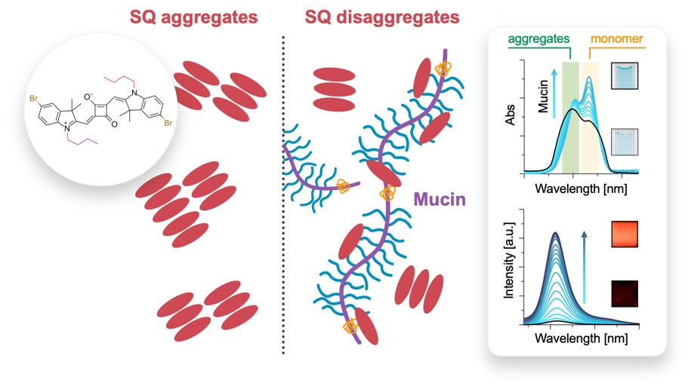
Fig. 1. Mucin induces disaggregation of squaraine aggregates.

Authors acknowledge support from the Project CH4.0 under the MUR program "Dipartimenti di Eccellenza 2023-2027" (CUP: D13C22003520001) and from the University of Torino (Ricerca Locale ex‐60%, Bando 2022).
References:
[1] C. Butnarasu, N. Barbero, C. Barolo, S. Visentin, Dyes and Pigments, 2021, 184, 108873.
[2] C. Butnarasu, C. Pontremoli, M. J. Moran Plata, N. Barbero, S. Visentin, Photochemistry and Photobiology, 2023, 99, 562-569.

