Supported metal nanoparticles-based catalysts and their interactions with H₂: insights from inelastic neutron scattering spectroscopy
Eleonora Vottero,^{[a]} Elena Groppo,^{[a]} Andrea Piovano
[a] Department of Chemistry, NIS Centre and INSTM, University of Turin, Via G. Quarello15/A, Turin I-10135, Italy
[b] Institut Laue-Langevin (ILL), 71 Avenue des Martyrs, CS 20156, 38042 Grenoble Cedex 9, France
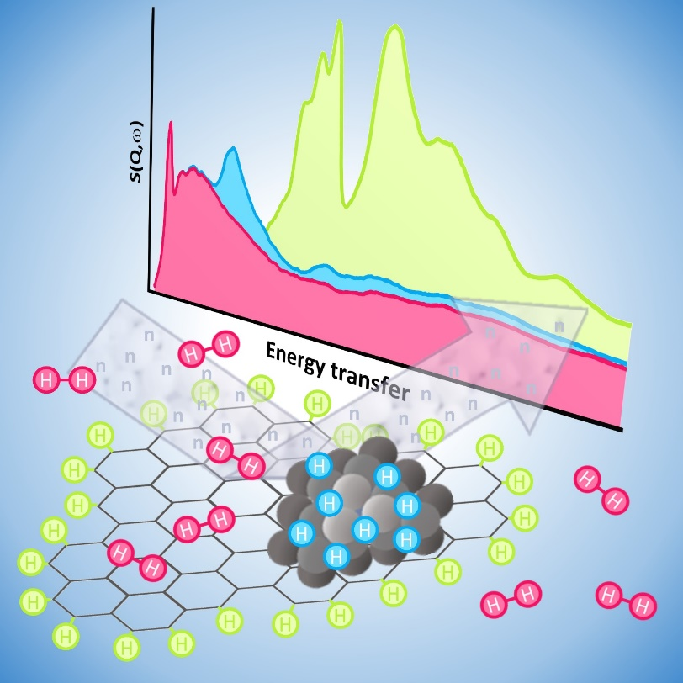

Abstract
The investigation of supported metal nanoparticle in the presence of H₂ is fundamental to better understand their behavior as hydrogenation catalysts. In this respect, this review will focus on the main recent results obtained by Inelastic Neutron Scattering (INS) spectroscopy, which is of particular interest thanks to its ability to provide very detailed vibrational spectra of the H-containing species in the sample. The review will cover the main results concerning the characterization of the H-species already present in the pristine catalyst, with a particular focus on carbon-based materials and their modification upon the interaction with metal nanoparticles. Successively, the forms in which H₂ interacts with the catalysts will be examined, starting from H₂ physisorption, to then pass to the metal hydride species formed through the splitting of dihydrogen upon the active metallic phase, and finally to the migration of atomic hydrogen from the metal nanoparticles onto the support as a result of hydrogen spillover. The aim of the review is to present an overview of all the hydrogenous species identifiable by INS spectroscopy in hydrogenation catalysts, focusing on the specific case of supported metal nanoparticles systems.

Table of Contents:
- Introduction
- Metal nanoparticles on carbon-based materials
  - Carbon-based supports: insights from INS
  - Effect of the metal nanoparticles deposition on the C-H terminations of the carbonaceous supports
- H₂ adsorption on catalysts based on supported metal nanoparticles
  - H₂ physisorption
  - H-chemisorption: formation of metal hydrides
    - Pd hydrides
    - Pt hydrides
  - Hydrogen spillover
- Summary and outlook

- Introduction
Several transition metals, in the form of metal nanoparticles supported on different materials, such as carbon-based materials or metal oxides, constitute one of the main classes of heterogeneous catalysts employed for hydrogenation and dehydrogenation reactions.^{[1-2]} They are employed for fine chemicals production,^{[2]} while more specific examples include the hydrogenation of edible oils on supported Ni nanoparticles,^{[1]} Pt on alumina for naphtha reforming,^{[3]} or Pt on carbonaceous supports as electrode for fuel cells.^{[4]} Albeit this category of catalysts has been routinely employed for several decades, many details regarding the effect of the metal nanoparticles dimension and morphology, the effect of the support and of its interaction with the metal phase, or the nature of the reactive intermediates still need to be better understood at the microscopic level. The final target will be the rationalization of the relationship between the preparation procedure, the physico-chemical properties of the obtained catalyst, and the resulting catalytic activity and selectivity, aiming to tailor the best catalyst for the target reaction.^{[5-7]} In order to reach this result, a throughput characterization of the catalysts is fundamental. In this regard, in the last decades the trend has been directed towards the investigation of the catalytic system under realistic reaction conditions, in order to retrieve the information related to the nature of the reaction intermediates and the modifications underwent by the catalyst itself under such conditions.^{[8-9]}
For the specific case of hydrogenation catalysts, the ability to probe the system’s changes in the presence of H₂ is of particular interest. In this respect, Inelastic Neutron Scattering (INS) spectroscopy stands out as one of the most promising methods, thanks to its very high sensibility to all hydrogenous species present in a sample.^{[10]} INS spectroscopy is a neutron-based technique that relies on the measurement of the energy and/or momentum exchanged between the incoming neutrons and the sample, providing information regarding vibrations in solids and molecules, molecular rotations and diffusion, Compton scattering, and so on.^{[10]} A whole overview of the theoretical background on which the technique is based is beyond the scope of the current review and thus, in the following, we will provide only the basic principles required to understand the potential application of INS in the investigation of catalysts based on supported metal nanoparticles. More detailed coverage of the topic can be found in other excellent resources present in the literature.^{[10-11]}
When applied to the study of catalysts, INS spectroscopy is mostly used for collecting the vibrational spectrum of the system, thus providing complementary information to the more commonly employed FT-IR or Raman spectroscopies. The results obtained by INS spectroscopy are distinct from those obtained by optical spectroscopies because of the absence of selection rules, and because the intensity of the spectra is proportional to the incoherent neutron scattering cross section and to the atomic displacement of the atoms involved.^{[10]} So that ¹H presents both a large neutron scattering cross section (80 barn, about one order of magnitude larger than for other nuclei) and large displacement (because of its light weight), the vibrational modes involving this isotope tend to dominate INS spectra. This makes the technique suited for the investigation of the H-containing species already present in the sample, because the resulting spectra will be dominated by their vibrational modes. For instance, the spectra of metal oxide such as Al₂O₃ tend to exhibit clear signals associated with the OH groups exposed at their surfaces.^{[12-13]} Interestingly, in the last few years it was also demonstrated that the modern instrumental resolution is sufficient to investigate also non-hydrogenous materials and to focus on other elements with a sufficiently high neutron scattering cross section. One example is chlorine (total neutron scattering cross section = 16.8 barn) in the MgCl₂ support employed in the Ziegler-Natta catalysts, for which it was possible to detect the effect of the decrease in particles dimension and of the increase of disorder as a function of the ball-milling time.^{[14]} On the other hand, INS is also extremely powerful to investigate the species formed under in situ conditions in the presence of a H-donor, among all H₂. This is particularly valuable when investigating hydrogenation catalysts, as the methodology provides a unique perspective over the hydrogenous species active for the hydrogenation process.^{[15-17]}
INS spectroscopy also presents a few drawbacks when compared to techniques such as FT-IR or Raman spectroscopies. First of all, an INS experiment cannot generally be performed at a laboratory scale, as large-scale neutron sources are required to obtain the necessary neutron flux. For this reason, INS spectroscopy is generally less accessible than optical spectroscopies. Moreover, the neutron fluxes obtained are weaker compared the photon fluxes obtainable by other large-scale facilities such as synchrotrons. This factor, together with the relatively weak interaction of neutrons with matter, results in the necessity of performing experiments over larger amounts of samples and longer acquisition times. In order to collect spectra with a low signal-to-noise ratio, the employment of grams of sample and acquisition times of 8-12 hours are still the most common operating procedure to this day. However, in the last decade, a positive trend in the development of instruments and equipment able to work with lower amounts of sample, with a better time resolution and over a more extended range of temperature and gas pressure conditions is being observed.^{[11, 16, 18-19]}
The majority of the INS spectra described in this review have been measured with indirect geometry INS filter spectrometers. Indirect geometry filter spectrometers are designed to scan over a precise path of exchanged momentum and energy values, and provide high-resolution spectra easily comparable with FT-IR and Raman, reporting the value of the scattering function S(ω) as a function of the exchanged energy. Examples include the IN1/Lagrange instrument at the ILL (France),^{[20]} Tosca at ISIS (UK),^{[21]} or VISION at SNS (US).^{[22]} Alternatively, direct geometry instruments, such as MAPS at ISIS,^{[23]} Panther at the ILL,^{[24]} SEQUOIA at SNS^{[25]} and 4SEASONS at J-Parc (Japan) ^{[26]} can be also employed. These instruments can provide bidimensional S(Q,ω) spectra expressed as a function of both transferred momentum and energy, and in catalysis they have been particularly useful to precisely detect signals at energy transfer values higher than 1600 cm⁻¹ (200 meV).^{[15]} It will be shown that INS spectra are generally rich of peaks, whose assignment is not always trivial. In this respect, the complementary use of DFT simulation was demonstrated to be a powerful tool for the analysis. The simulation of INS spectra is simpler than that of FT-IR or Raman spectra, as it does not require to compute dipoles nor polarizability, but only to calculate the vibrational frequencies and the associated atomic displacements, for each type of atom involved. These data are readily available in the output of frequency calculations performed with the most commonly employed DFT simulation software packages. Some packages, such as Crystal17 and following releases,^{[27]} allow to directly calculate the neutron-weighted density of states, directly comparable with the results obtained with direct geometry spectrometers. Otherwise, many external programs, such as a-CLIMAX,^{[28]} AbINS,^{[29]} and OCLIMAX,^{[30]} are also able to elaborate the outputs of the frequency calculation performed by the most common DFT software packages, and then calculate simulated spectra readily comparable with the experimental ones.
The relevance of INS spectroscopy in catalysis is highlighted by several papers and reviews on the topic that have been published in the last years. In this respect, Yu et al recently published a very extensive review covering the main applications of neutron techniques in catalysis,^{[31]} Polo-Garzon et al summarised the findings related to the species formed upon interaction with H₂ of supported metal nanoparticles and oxides.^{[32]} The present review will focus on the specific case of supported metal nanoparticles catalysts, aiming to provide a comprehensive overview of the information that INS experiments can provide regarding their composition and their behaviour in the presence of H₂, posing special attention to the most recent results of interest for the understanding of such catalytic systems.
Section 2 is devoted to the application of INS to the study of metal nanoparticles on carbonaceous supports, which are by far the most widespread in the field of hydrogenation catalysis, with emphasis on the information related to the hydrogenous species intrinsically present in the support and in the effects of the metal nanoparticles. In Section 3 we will discuss what INS spectroscopy can tell us regarding the interaction of H₂ with these catalysts, focusing on dihydrogen physisorption (Section 3.1), the formation of metal hydrides on metal nanoparticles (Section 3.2), and the (possible) migration of atomic hydrogen from the nanoparticles to the support in the so-called H-spillover process (Section 3.3).

- Metal nanoparticles on carbon-based materials
  - Carbon-based supports: insights from INS
Carbon-based materials, such as activated carbons, carbon black, graphite oxide, reduced graphene oxide, or carbon nanotubes, constitute a class of materials largely employed and investigated both as catalytic supports for metal nanoparticles and as catalysts on their own.^{[33]} The advantages of their employment include the very high levels of surface area and porosity obtainable, the possibility to finely tune their physico-chemical properties, and the ease of recovery of the metal from the spent catalyst. ^{[34-35]} Materials belonging to this class have in common a basal structure of sp² carbon domains generally terminated by H atoms, and present differences in terms of structural defectivity and on the chemical composition (i.e. the concentration of heteroatoms-containing functional groups). Differences in morphology, porosity and composition of carbon-based supports can strongly affect the activity and selectivity of the resulting catalysts for specific reactions, making the characterization of said supports down to the atomic scale fundamental for a rational choice of the best catalytic support for each target reaction.^{[36-39]}
The complex and heterogeneous nature if carbon-based materials, however, hinders an easy characterization. Techniques such as X-ray Diffraction or Raman spectroscopy have been employed to study their structural properties,^{[40-41]} while FT-IR spectroscopy, X-ray Photoemission spectroscopy, or Temperature Programmed Desorption could provide very important details about the typology and amount of heteroatoms-containing functionalities.^{[42-43]} Instead, few techniques are able to provide information regarding the C-H terminations in the aromatic domains constituting these materials. In this regard, INS spectroscopy stood out the most as a promising technique to directly probe such terminations. Indeed, the detailed analysis of the INS spectra of carbon-based materials provided fundamental insights regarding the amount and morphology of aromatic domains’ terminations, as well as about their interaction with the metal nanoparticles.
Figure 1 compares the INS spectra of several types of carbonaceous materials differing in the extension of their graphene-like domains and in their level of defectivity. Figure 1A shows the spectrum of an activated carbon obtained by physical activation of a wood precursor,^{[12]} while Figure 1B those of a hydrogenated graphene^{[44]} (blue circles) and of a hydrogenated micrographite^{[44]} (black crosses). The three spectra are dominated by the signals due to the out-of-plane bending vibrations of the C-H terminations of the aromatic domains (750-1000 cm⁻¹ range) and by the corresponding in-plane modes (1000-1600 cm⁻¹ range). The low frequency region (ca. 400-700 cm⁻¹ range) is dominated by the so called riding modes (i.e. deformation modes of the aromatic platelets enhanced in intensity by the presence of bonded H atoms at their borders).^{[45]} Similar spectra were reported for other activated carbon samples in refs ^{[45-48]}, carbon blacks,^{[46, 49]} coal samples,^{[46, 50]} and other sp² carbon-based materials^{[44, 51-52]} Figure 1C instead reports the INS spectra of two highly graphitic samples, i.e. a reduced graphene oxide^{[51]} (brown) and neat graphite (black).^{[51]} Both materials present a very low H concentration, and this explains why the two spectra are similar to one another but differ from the previously discussed ones. It was found that their spectral profiles show a very remarkable similarity with the calculated phonon dispersion for a single graphene layer.^{[51]}

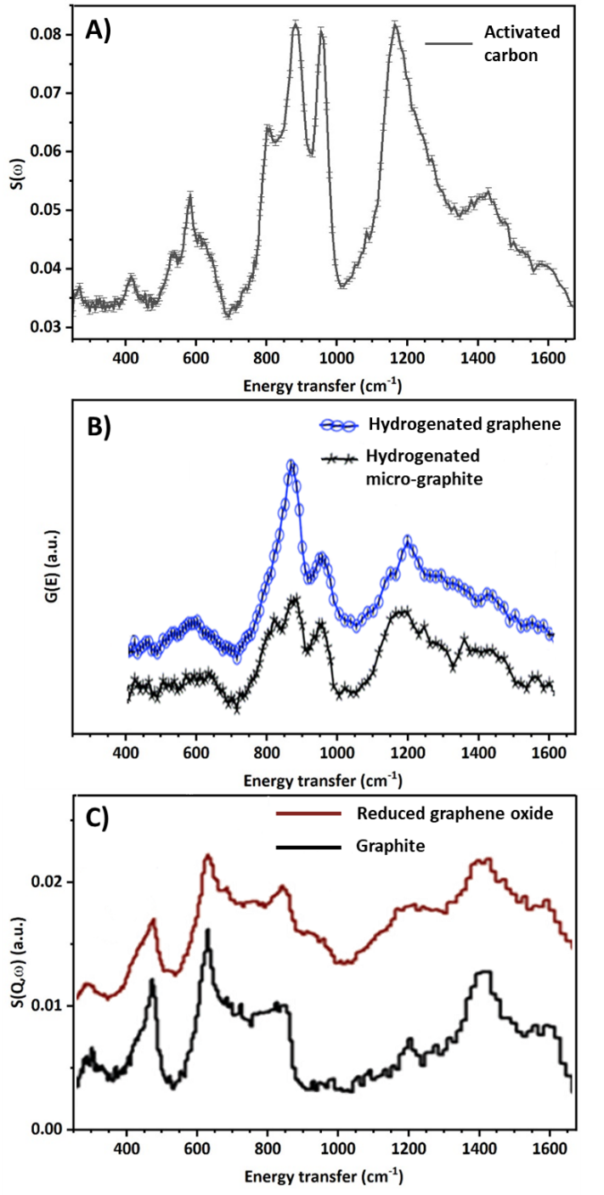
Figure 1: A) INS spectrum of an activated carbon prepared by physical activation from a wood precursor, replotted from reference^{[12]}. B) INS spectra of hydrogenated graphene (blue circles) and of micro-graphite (black crosses). Adapted from reference^{[44]} C) INS spectra of a reduced graphene oxide sample characterized by a high degree of graphitization (brown) and of neat graphite (black), adapted from reference^{[51]}.

Both the intensity and the profile of an INS spectrum provide important information about the sample. The first is intuitively related to the concentration of the scattering centers in the sample, and in particular of ¹H (whose scattering cross section is one order of magnitude higher than for other nuclei). Albers et al experimentally demonstrated that a linear relation exists between the integrated area of the spectra in the C-H bending modes region of activated carbon samples and their hydrogen concentration (as determined by elemental analysis).^{[45]} This means that it is possible to compare quantitatively the hydrogen content of different samples measured under the same experimental conditions.
Variations in the spectral profile, instead, reflect differences in the morphology of the aromatic domains constituting the sample, and in particular of the terminal C-H groups.^{[45-46, 48, 53]} However, in order to retrieve this information it is necessary to precisely assign each specific sample morphology to a certain spectral feature. For at least two decades the most solid approach employed to fulfill this task came from DFT simulations.^{[44-46, 48, 51-53]} In this respect, the most critical aspect is the choice of a suitable model, as it is imperative to find a compromise between the intrinsic high heterogeneity and complexity of the aromatic domains constituting real carbonaceous supports and what it is feasible to simulate in silico. Three main approaches to this problem from recent literature will be presented in the following.
For the simulation of the INS spectrum of hydrogenated graphene reported in Figure 1A, Cavallari et al^{[44, 52]} opted for the two models shown in Figure 2A’: i) an aromatic model with hexagonal shape and stoichiometry C₉₆H₂₄, and ii) a 2D graphene model containing a H-saturated intraplanar hole. A linear combination of the simulated spectra of the two models (red in Figure 2A) was the best description of the experimental spectrum, indicating that both the external C-H terminations and the C-H groups facing inner voids in the graphitic platelets are important for reproducing the INS spectrum of hydrogenated graphene. Furthermore, the authors extended their study by repeating the measurement upon heating of the sample up to 300 K, observing modifications that have been interpreted as a migration of H atoms onto adjacent vacant sites.
Later on, Albers et al^{[46, 51]} simulated the INS spectrum of a glass carbon (Figure 2B) with a combination of the Γ-point spectra of the two models shown in Figure 2B’, i.e. 1D graphenic ribbons terminating with benzene rings either exposing one or two adjacent C-H groups. An analogous model exposing an alternation of the two typologies of sites was also simulated, but showed a worse matching with the experimental result. Focusing the attention on the most informative part of the spectrum (i.e. the C-H out-of-plane bending region), the peak at 880 cm⁻¹ was assigned to the benzene ring exposing a single C-H termination, while the doublet at 785 and 935 cm⁻¹ to benzene rings exposing two adjacent C-H terminations. The ratio between the two types of terminations was different depending on the samples.^{[46]}
In a more recent paper, we pointed to a slightly different approach.^{[48]} Instead of analyzing the whole spectral range, we decided to focus on the 750-1000 cm⁻¹ region only. This choice was made for two main reasons: i) this is the spectral region showing the greatest variations both in experimental spectra of different samples and in simulated spectra of different models,^{[45, 48]} and ii) the vibrational modes in this spectral region are the most localized ones, meaning that the spectral features are representative of the vibration of a small and simple portion of the terminations of the aromatic platelets and not of the whole graphitic platelet.^{[45, 48]} We simulated 27 aromatic models differing in geometry, regularity and defectivity, we identified 16 C-H terminal moieties repeating along their terminations, and we associated them to a characteristic fingerprint in the INS spectrum. The simulated spectra of each model were then used to fit the experimental ones, in order to identify and quantify the main contributions. Figure 2C-C’ shows the result of this approach applied to the spectrum of the activated carbon reported in Figure 1A. We demonstrated that benzene rings exposing a single or two adjacent C-H groups are indeed the two main components contributing to the spectrum, but also that other contributions arising from disordered terminations and from hydrogenated single vacancies are required.^{[48]} A small contribution at about 920 cm⁻¹ was not yet fully described, but preliminary measures and calculations strongly suggest that may be associated by the perturbation of some functional groups on the vibrations of vicinal C-H.^{[36]}
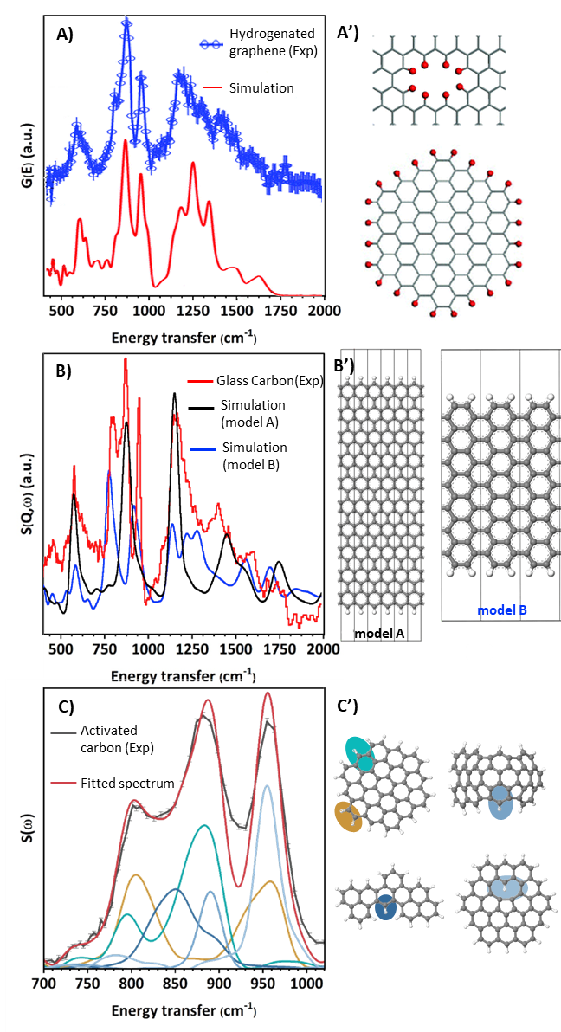
Figure 2: A) INS spectrum of hydrogenated graphene (blue) compared with the linear combination of the simulated spectra for the two models reported in part A’, namely an intra-platelet hole and an hexagonal aromatic model. Adapted from reference^{[44]}. B) Experimental INS spectrum of glass carbon (red) compared with the simulated spectrum of a 1D nanoribbon only exposing zigzag terminations (model A in part B’, black) and of a nanoribbon exposing only armchair terminations (model B in part B’, blue). Adapted from reference^{[46]}. C) Experimental INS spectrum of an activated carbon fitted by a linear combination of simulated INS spectra corresponding to specific C-H terminal geometries. The models utilised are schematised in part C’ with the same color code. Replotted from reference^{[48]}.

  - Effect of the metal nanoparticles deposition on the C-H terminations of the carbonaceous supports
The INS spectra of carbon-based supports change significantly after the deposition of metal nanoparticles. Figure 3A-D shows the spectral variation in the C-H out-of-plane bending region for four different activated carbons obtained via physical activation of either wood (Figure 3A-B) or peat (Figure 3C-D) upon deposition of either Pd or Pt nanoparticles via a deposition-precipitation method.^{[48]} A systematic decrease in the intensity of the spectra is observed, and the central signal of the three observed in this spectral region is systematically the most affected by the phenomenon. Such a loss in spectral intensity indicates a decrease in the concentration of sp² C-H terminations upon interaction with the metal nanoparticles. Figure 3E-E’ shows the change in the integrated area below the three peaks as a function of the metal dispersion. It is clear that Pd has a stronger effect on the support than Pt. Moreover, in the case of Pt a linear trend is observed between the decrease in integrated area (i.e. in the concentration of C-H terminations) and the metal nanoparticles dispersion as determined by CO chemisorption:^{[48]} larger the dispersion (i.e. smaller the nanoparticles), more affected is the support. An analogous decrease in the spectral intensity was also observed in the past by Albers et al., when comparing the spectrum of an activated carbon to that of the corresponding catalyst obtained via impregnation with a Pt precursor.^{[45]} This effect has been further investigated by means of DFT simulations and linear combination fits. It was found that the species mostly affected by deposition of metal nanoparticles are benzene rings exposing a single C-H termination.^{[48]} Supports presenting a higher percentage of this typology of C-H terminations showed are the most affected but, at the same time, bring to a higher dispersion of the Pt nanoparticles
These observations imply a close interplay between the morphology of the C-H terminations in the activated carbons and the location and dispersion of the deposited metal nanoparticles, but a definitive explanation for this relation has not yet been presented. Nevertheless, it is possible to speculate that a possible reason lies in the peculiar electronic structure of zigzag terminations in graphenic structures. Indeed, according to DFT simulations, extended borders with this geometry are characterized by a localization of unpaired p electrons,^{[54-55]} which may result in a stronger bonding with the metal nanoparticles.^{[56]}
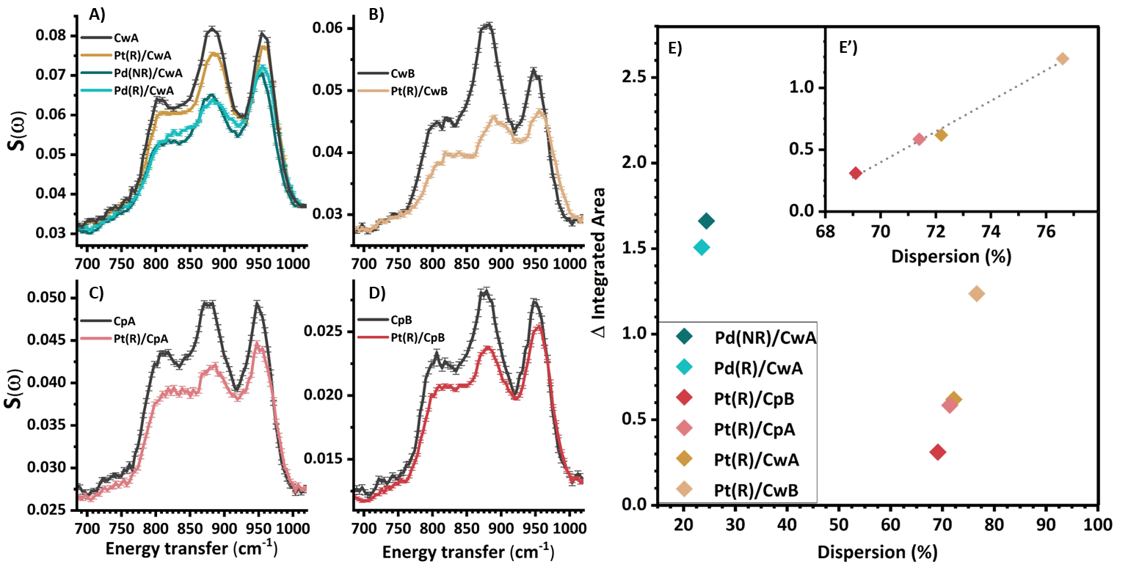
Figure 3: Parts A-D: detail over the out-of-plane C-H bending region of the INS spectra of four physically activated carbons and of the corresponding catalysts with supported Pd and Pt nanoparticles. Part E: difference in the integrated area below the C-H out-of-plane bending region by moving from the bare support to the corresponding catalyst versus the metal dispersion (as measured by means of CO chemisorption). The detail over the points related to Pt containing samples is shown in part E’, a linear trend is observed. All data are from reference^{[48]}.

- H₂ adsorption on catalysts based on supported metal nanoparticles
  - H₂ physisorption
One of the greatest potentials of INS spectroscopy in the studies of hydrogenation catalysts lies in the possibility to investigate the changes in the sample upon dosing H₂ on the catalyst under in situ conditions. First of all, during these experiments it is possible to investigate the interaction of dihydrogen physisorbed onto both the supports and the active phase, providing important information about H₂ physisorption, the sample nanoporosity, and about their hydrogen storage potential. ^{[57-59]} The H₂ molecule presents a few peculiarities, that we here briefly summarise. First of all, it is important to remember that H₂ exists as two distinguished spin isomers, namely para-H₂ (the two H atoms have opposite nuclear spins) and ortho-H₂ (the two H atoms have parallel nuclear spins). Due to the fact that the singlet state (quantum number J = 0) has degeneracy equal to 1 and the triplet state (J =1) has degeneracy equal to 3, at room temperature the normal ratio between para and ortho hydrogen is 1:3. However, upon cooling to cryogenic temperatures a slow conversion to the lower energy para-H₂ is observed, and the process can be significantly speeded up in the presence of metal centers or paramagnetic species able to catalyze the process.^{[10, 60]} Very often INS experiments are performed on predominantly para-H₂ mixtures, and this is the situation which will be considered for the rest of this section.
Dihydrogen in the condensed state has very characteristic signals in INS spectra, which are mainly attributed to transitions among the rotational energy levels. In this respect, the symmetry of the H₂ molecule and the fermionic nature of the ¹H atoms impose some restrictions on the overall wavefunction. In accordance with the Pauli’s exclusion principle, the wavefunction of the H₂ molecule has to be antisymmetric with respect to the exchange of the two atoms. In order to respect this condition, only rotational levels with even J values are permitted for para-H₂ (which has an antisymmetric nuclear wavefunction), while only odd J values are permitted for ortho-H₂ (which has a symmetric nuclear wavefunction). When H₂ is free to move isotropically, the rotational transition between the ground (J=0, M_{J}=0) and the first excited (J=1, M_{J}=0, ±1) rotational states falls at 118 cm⁻¹, as observed in the INS spectrum of solid para-H₂ reported in Figure 4A-A’.^{[60]} In principle, all the rotational transitions are permitted in INS spectroscopy. However, the intensity of the signal is proportional to the incoherent scattering cross section of ¹H (with the very high value of 80 barn) only when the transition is associated with a flip in the nuclear spin (i.e. in a para–ortho transition), with the result that practically only these transitions tends to be visible in the experimental spectra.^{[10]}
Beside the sharp peak at at 118 cm⁻¹, the INS spectrum of solid para-H₂ reported in Figure 4A-A’ shows a series of very broad oscillations, which are due to the so called molecular recoil. This phenomenon is due to the fact that the H₂ molecules are weakly interacting with one another, and the scattering event with a neutron results in a significant exchange of kinetic energy and momentum. The broad oscillations are centered at the values of the J(1←0), J(3←0), J(5←0), J(7←0) rotational transitions summed to the translational energy acquired upon recoil.^{[10, 60]} The recoil effect dominates the INS spectrum of liquid H₂ (Figure 4B), where the interaction among the molecules is even weaker.^{[10, 60]}

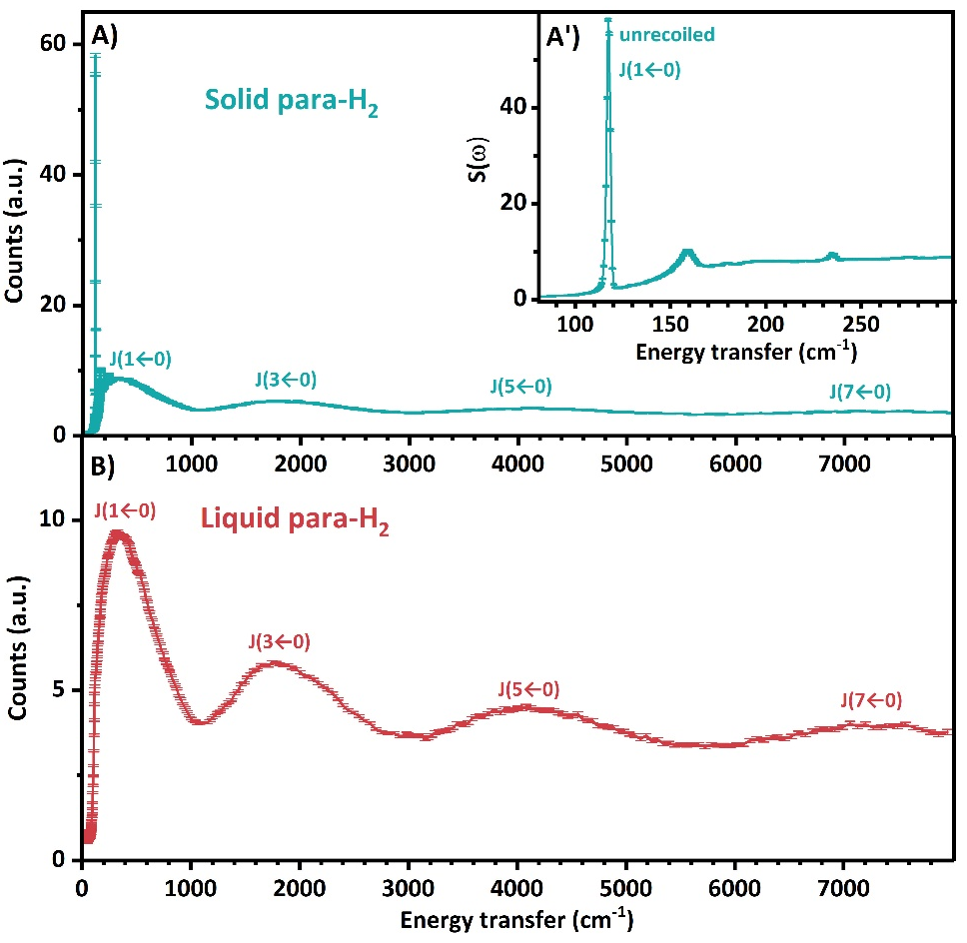
Figure 4: A) INS spectrum of solid para-H₂ collected at 12.2 K. A’) Detail over the low energy transfer region of spectrum A. B) INS spectrum of liquid para-H₂ collected at 17.2 K. The spectra were retrieved from the ISIS INS spectra database^{[61]} and originally published and commented in reference^{[60]}.

The INS spectra of H₂ adsorbed on catalysts based on supported metal nanoparticles and on their supports contain contributions very similar to those observed in the INS spectrum of solid para-H₂. As a case study, Figure 5A reports the difference INS spectra of H₂ adsorbed on an activated carbon (grey) and on the corresponding Pt catalyst (blue).^{[12, 62]} Both spectra are dominated by the recoiled J(1←0) and J(3←0) signals. In the spectrum of H₂ adsorbed on the catalyst, a small increase in intensity is observed above 400 cm⁻¹, which is due to the presence of chemisorbed H₂ (vide infra). Focusing the attention on the low energy transfer region, a sharp signal split in three components is observed in both the spectra (Figure 5A’). The central peak, centered at about 120 cm⁻¹, is attributed to H₂ weakly adsorbed within the micropores of the carbon. The fact that this signal, typical for solid para-H₂, is observed at a temperature above the H₂ triple point has been one of the indicators that H₂ can form a solid-like phase when trapped inside pores of a few nanometers of diameter. ^{[10, 12, 57-58, 63]} The other two peaks observed at 107 and 132 cm⁻¹, instead, were attributed to H₂ molecules trapped inside sub-nanometric slit pores and experiencing a strong anisotropic potential.^{[10, 12, 57-58, 63]} Under these conditions the degeneracy between the (J=1, M_{J}=0) and (J=1, M_{J}=±1) rotational energy levels is lost, resulting in a split of the signal. This is shown in the simplified scheme in Figure 5B comparing the rotational energy levels of unhindered H₂ molecules in the middle, side-on adsorbed molecules on the left and end-on adsorbed ones on the right. In the free rotor case, the three rotational energy levels associated with the quantum number M_{J} of the first excited state are degenerate. When H₂ is in the presence of a potential, this will hinder the rotation in either 1 or 2 dimensions. The hindered M_{J} state(s) shift to a higher energy, giving a rotational transition peak at an energy above the free rotor, while unhindered M_{J} state(s) are stabilized and give rise to a peak below this energy. The position of the two peaks relative to the free rotor line and the ratio between their intensities provide information about the adsorption mode, since the degenerate energy peak has twice the intensity of the single state peak. In the case of H₂ physisorbed on the activated carbon reported in Figure 5A’, the peak at lower energy is twice more intense than that at higher energy. This indicates that the (J=1, M_{J}=±1) levels are more stabilized than the (J=1, M_{J}=0) one, which is typical of a side-on adsorption geometry.^{[10]} This kind of signal splitting has been observed for several carbon-based samples, and the detailed analysis of the obtained spectra provided important insights regarding the process of H₂ physisorption on their surface, the strength of the interaction, and their potentiality as hydrogen storage materials.^{[57-59]}
The spectrum of H₂ adsorbed on the corresponding Pt/C catalyst is also shown in Figure 5A’. Two very weak additional satellite peaks, not present in the spectrum of H₂ adsorbed on the bare carbon support, are observed at about 90 and 150 cm⁻¹. The larger split between the two peaks with respect to what was observed for the bare carbon indicates that physisorbed dihydrogen is experiencing a stronger adsorption potential, and has been interpreted as a physisorption of H₂ upon hydrides-covered Pt nanoparticles.^{[12]}

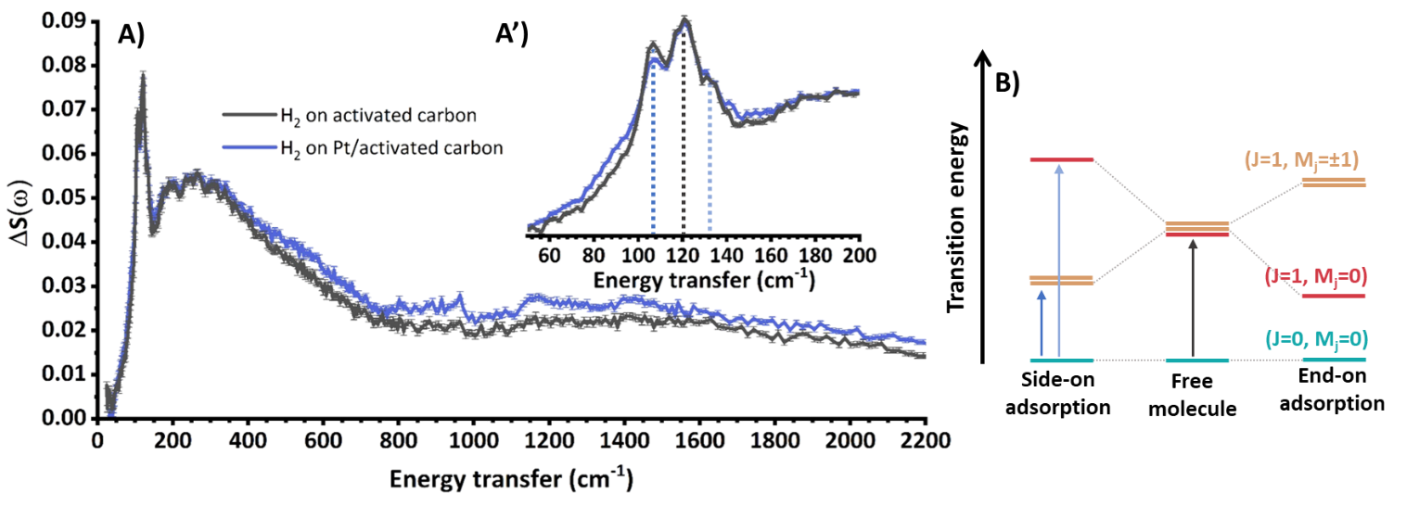
Figure 5: A) Difference INS spectra, measured at 24 K, for H₂ adsorbed on an activated carbon and on the corresponding Pt/C catalyst. The observed features are mostly ascribed to the rotational transitions and the recoil profile of free and physisorbed H₂. The data are from references^{[12, 62]}. A’) Detail over the peak of the J(1 ← 0) rotational transition and its components. B) Simplified representation of the loss in degeneracy in the rotational energy levels upon physisorption over a surface, resulting in the split of the J(1 ← 0) transition.

  - H-chemisorption: formation of metal hydrides
    - State of the art
Some metals, such as Ni, Pd or Pt, do not simply interact with dihydrogen by physisorption, as commented in section 3.1, but are able to activate and split the H₂ molecule to form chemisorbed metal hydride species. Their reactivity makes them very active catalysts for hydrogenation and dehydrogenation processes, in particular in the form of supported metal nanoparticles.^{[1-2]} The discovery of their catalytic activity dates back to a long time ago,^{[64]} but many details regarding the nature of the reaction intermediates, the effect of shape and dimension of the nanoparticles, the contributions arising from the support and from the metal-support interaction and so forth are still object of debate to these days. In this respect, INS spectroscopy is a powerful tool able to provide fundamental information regarding the active species for the hydrogenation reaction, i.e. the metal hydride species.^{[15, 17, 62, 65]} When a catalyst containing Ni, Pd or Pt nanoparticles is warmed in the presence of H₂ prior to the measure, a strong decrease in intensity of the spectral features associated to physisorbed H₂ is observed, if not their complete disappearance. This behavior is symptomatic of the desorption and, at higher temperature, of the dissociation of molecular hydrogen at the surface of the active metal phase, and may be accompanied by the appearance of new signals attributed to the chemisorption of atomic hydrogen onto the metal nanoparticles and the support.^{[12, 62, 66-67]}
Over the last few decades, the improvement of the instrumentation sensitivity allowed to obtain more detailed results on smaller levels of metal loading and sample amounts. At the same time, the steadily increasing level of computational capacity allowed to simulate progressively more complex models, reducing the gap between the real system and the computational model.^{[16, 65]}
The INS investigation of the metal hydride species formed upon interaction with H₂ with Au,^{[68]}, Ru,^{[69]} Pt/Ru alloy,^{[70]} Ni^{[71]} or Co^{[71]} based catalysts have been reported in the literature, but the most complete INS studies are from Pd and Pt based systems. They will thus be the focus of sections 3.2.2 and 3.2.3, respectively.

    - Pd hydrides
Catalysts based on supported Pd nanoparticles are largely employed in the chemical industry, for instance in the purification of terephthalic acid,^{[72]} for the chemoselective hydrogenation of acetylene to ethylene,^{[73-74]} and for many hydrogenation processes of interest in the production of fine chemicals.^{[75]} This metal can easily split the H₂ molecule into atomic H, which then migrates into the bulk of the material. Two main PdH phases are known: i) α-PdH, observed at very low H concentrations and corresponding to an occupation of the octahedral interstices of the Pd fcc lattice without a significant change in the lattice parameters, and ii) β-PdH, corresponding to a further filling of the octahedral interstices accompanied by an expansion in the cell parameters. At 25°C, the maximum hydrogen concentration observed for α-PdH corresponds to a H/Pd ratio equal to 0.017, the β phase is observed at a ratio larger than 0.60, and in the intermediate concentration range the two phases coexist.^{[76]} Significant changes in the PdH phase diagram are observed when reducing the particle size down to the nanoscale, which may be summarised by an increase in the H solubility in the α phase and a decrease for the β one, a narrowing in the miscibility gap between the two phases, and by a more marked hysteresis in the removal of H upon outgassing.^{[77-78]} The understanding of the modifications undergone by the PdH system when passing from macroscopic to nanometric systems is of pivotal importance for catalysis, but is also hindered by the experimental difficulties associated with the investigation of complex catalytic systems.
INS spectroscopy has been applied to the study of the PdH system since the early years of the technique.^{[79]} Early studies mainly focused on pure Pd, in the form of single crystals, foils or coarse powders, in the presence of varying amounts of H₂.^{[79-80]} Figure 6 shows the INS spectra of bulk α-PdH (part A) and β-PdH (part B), respectively. The main signal, corresponding to the optical phonon modes, is observed at 556 cm⁻¹ for α-PdH^{[15, 80-82]}and in the 460-480 cm⁻¹ range for β-PdH. The signals above 850 cm⁻¹ corresponds to their first overtones.^{[15, 81]} In both cases the main band is characterized by an asymmetric broadening, appearing as a shoulder at higher energy transfer values in the spectra. However, the nature of this broadening is not yet fully explained. Both the experimental and the simulated phonon dispersion are not fully able to describe this profile,^{[15, 83]} and phenomena such as a Franck-Condon transition have been hypothesized to justify this signal.^{[84]}
Later on, the methodology was progressively employed on catalytic systems such as Pd black,^{[81, 85-86]} Raney palladium,^{[87]} the Lindlar catalyst,^{[88]} and metal nanoparticles.^{[15, 17, 62, 81-82, 88-89]} Most experiments conducted on catalysts were performed under an H₂ equilibrium pressure of several mbar (i.e. conditions at which the β-PdH phase is generally observed). Under these experimental conditions the INS spectra of nanometric PdH show very similar features to those measured for bulk PdH. This is the case of the INS spectrum of PdH species formed on a 5 wt% Pd/Al₂O₃ catalyst (Figure 6C).
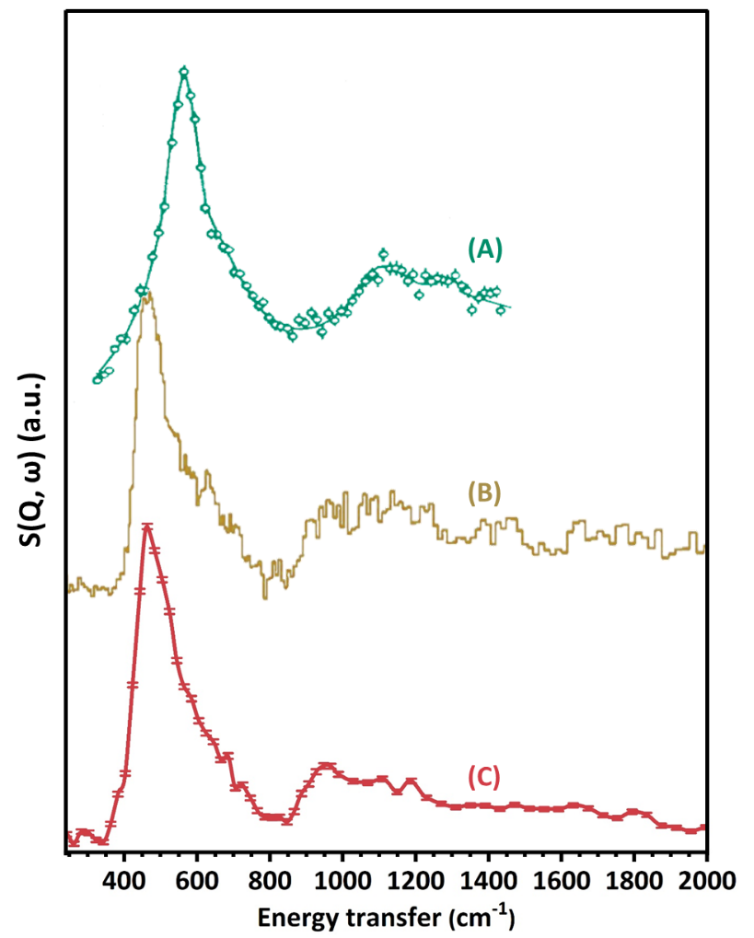
Figure 6: A) INS spectrum of α-PdH in Pd foil, adapted from reference^{[80]} B) INS spectrum of β-PdH in cold-rolled hydrogenated Pd foil, adapted from reference^{[90]} C) INS spectrum of PdH species formed in a 5 wt% Pd/Al₂O₃ sample at a H₂ equilibrium pressure of 430 mbar (red spectrum, replotted from reference^{[62]}).

In metal nanoparticles, the percentage of surface and sub-surface hydrides greatly increases with respect to the bulk. These species can be very relevant for catalysis, yet their characterization is becoming more prominent in research only in recent years. Albeit the INS spectra of nanometric Pd in the presence of H₂ tend to be dominated by the vibrational modes of bulk β-PdH, many literature works showed that a more detailed data treatment can also provide new insight into sub-surface and surface species. A weak signal attributed to the stretching modes of surface Pd-H species in linear configuration has been individuated at 2150 cm⁻¹ by Parker et al^{[15]} on a sample 20 w/w% Pd/carbon black sample in the presence of 700 mbar of H₂, by measuring the INS spectrum. In the same work, the authors also simulated the spectrum of 3-fold surface Pd-H species on the Pd(111) surface, corresponding to signals at 815 and 1035 cm⁻¹, and of the sub-surface species formed right below the first atomic layer of the same surface, resulting in a series of signals around 500 cm⁻¹. Experimental signals in reasonable agreement with the simulated frequency of surface and sub-surface Pd-H species became visible in the spectra of Pd black and supported Pd samples after evacuation (i.e. after strongly reducing the intensity of the β-PdH signal).
Signals ascribable to sub-surface PdH species in Pd nanoparticles were also independently observed in the form of an unusual increase in intensity of the shoulder in the INS spectra at about 650 cm⁻¹ by us^{[62]} and by Albers et al, ^{[81]} while a general increase of the signal above 660 cm⁻¹ was observed by Kofu et al.^{[17]} As an example, the difference in spectral profile observed between bulk PdH_{0.73} and nanometric PdH_{0.42} measured in the latter study are reported in Figure 7. In the first two instances, the phenomenon was not systematically observed: in particular, in reference^{[62]} the signal was not present during the first measurement performed with an equilibrium H₂ pressure of 230 mbar and appeared only during the second measurement, performed upon further dosing of H₂ up to an equilibrium pressure of 430 mbar, while in reference^{[81]} the signal disappeared after several hydrogenation-outgassing cycles. These observations suggested that this signal may be related to strain in the Pd nanoparticles, which may relax upon the subsequent removal and/or insertion of H. Further investigations were brought on by Kofu and colleagues,^{[17]} who pointed out that the observed signal was compatible with H atoms within an anharmonic and trumpet-like energy potential well. The calculated fundamental vibrational energy of 983 cm⁻¹ did not appear compatible with the expected value for H in octahedral interstices, and the occupation of the narrower tetrahedral interstices was thus considered. This assignment was also corroborated by parallel Rietveld analysis on neutron diffraction data, indicating the occupation of tetrahedral sites in the most external shell of the Pd nanoparticles,^{[91]} and of computational simulations indicating that the occupation of tetrahedral sites in the sub-surface region is less unfavored than for the bulk.^{[92]} Albeit the nature of surface and sub-surface PdH species is not yet fully clarified, INS spectroscopy demonstrated to have the potential to shade new light in this direction.
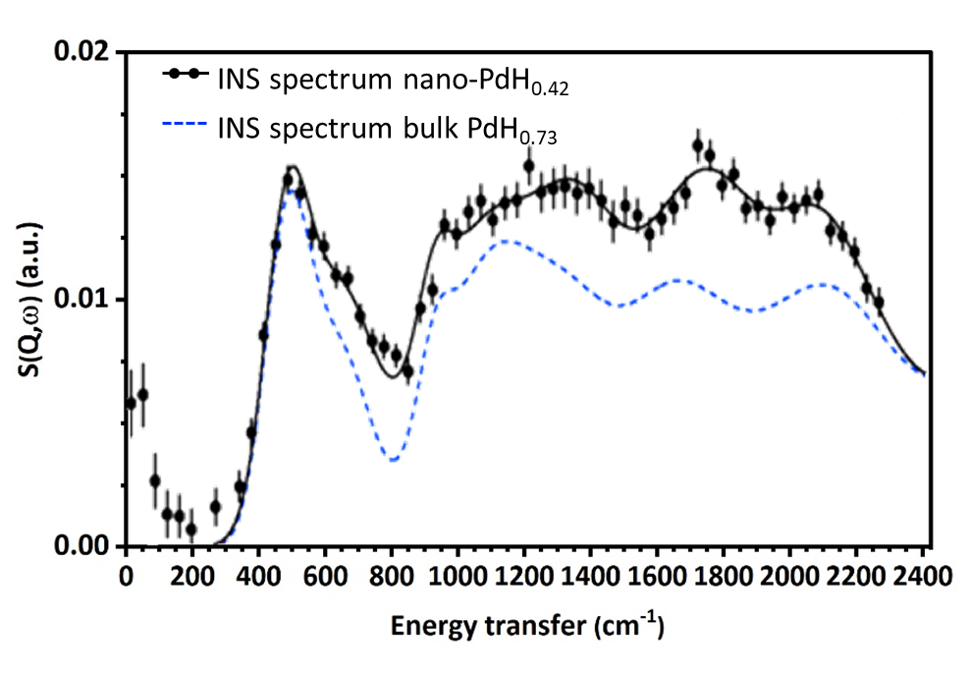
Figure 7: Comparison between the INS spectra measured at 10 K on the 4SEASONS instrument with an incident energy of 331 meV for hydrogenated 8 nm Pd nanoparticles (black dots) and bulk Pd powder (blue broken line), as measured by Kofu et al.^{[17]} The Pd nanoparticles were stabilised by capping with polyvinylpyrrolidone, whose contribution was subtracted from the reported spectrum. Plot adapted from reference^{[17]}.

    - Pt hydrides
Pt-based supported catalysts constitute another traditionally employed class of hydrogenation catalysts, and are for instance employed in the naphtha reforming process,^{[93-94]} or as fuel cells catalyst.^{[4]} Unlike Pd, Pt presents a very low solubility for H₂ and only surface Pt-H species can be formed, where the H atom can be linearly bonded to a single Pt atom, or form 2-fold bridge and 3-fold hollow species by bonding to two or three Pt atoms, depending on the exposed facets. Their identification is not trivial, and INS spectroscopy provided fundamental insights into the matter.^{[12, 16, 62, 66, 95-98]} The first INS spectra of supported Pt nanoparticles in the presence of H₂ were measured on high metal-loading fuel cell catalysts, under H₂ pressures between a few hundred mbar up to 1 bar, and at cryogenic temperatures.^{[66, 95-96]} As an example, the INS spectra measured on three Pt/carbon black samples with a 40% w/w metal loading and differing in their dispersion are shown in Figure 8.^{[96]} Upon interaction with H₂, a broad and intense signal appears in the 400-750 cm⁻¹ range, together with a series of less intense signals at higher energy transfer. Interestingly, a narrowing of the 400-750 cm⁻¹ signal was observed upon increasing the dimension of the Pt nanoparticles (i.e. by moving from Figure 8A to C).^{[96]} A further signal, usually too weak to be reliably observed with indirect geometry instruments, has been observed at 2080 cm⁻¹.^{[66]}
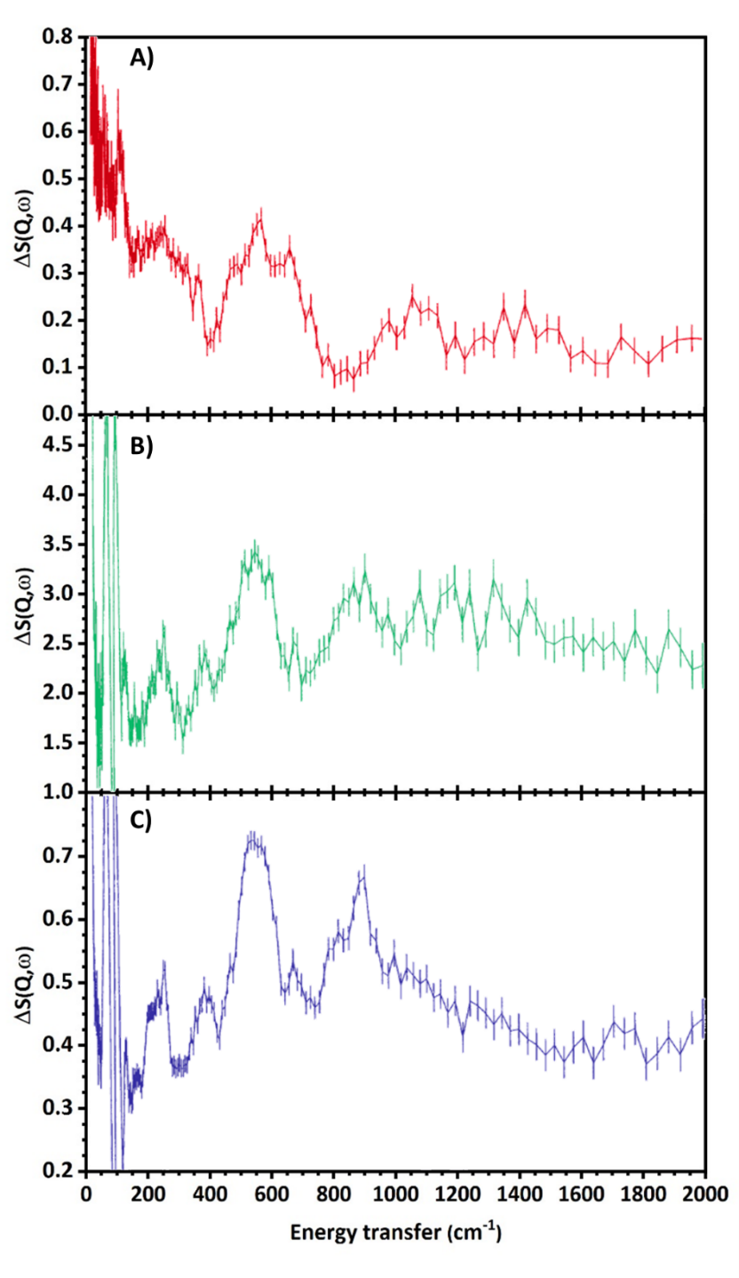
Figure 8: Differential INS spectra of three Pt/Carbon black fuel cell catalysts (Pt loading: 40% w/w) differing in their metal dispersion. The average particle sizes determined by TEM are 2.8 nm (panel A), 3.4 nm (panel B) and 4.5 (panel C). The difference spectra are calculated subtracting the spectrum of the sample collected after prolonged evacuation to those of the catalysts measured in the presence of a H₂ equilibrium pressure between 800 and 1000 mbar. Plots adapted from reference^{[96]}.

All the signals observed in these spectra are attributed to Pt-H species formed upon the interaction of H₂ with the catalyst, but the exact assignment of these species was not trivial. Early on, the signals have been assigned on the basis of the previous data obtained for H on extended Pt surfaces^{[99-100]} which, however, were not able to account for the heterogeneity present in supported nanoparticles. A turning point was reached by simulating the theoretical INS spectra of hydrogenated Pt nanoparticles, which became feasible only in recent years due to its high computational cost. The first example in the literature was reported by Parker et al in 2019,^{[65]} with the simulation of the INS spectrum of a Pt₄₄H₈₀ tetradecahedron. This simulation demonstrated the occurrence of a high degree of coupling among the vibrational modes of different Pt-H sites at a time, with 2-fold bridge species dominating the spectra. More in details, the band observed in the 400-800 cm⁻¹ was attributed to the coupling of the bending modes of linear and two-fold bridge Pt-H species with the asymmetric stretching of 3-fold sites, the bands in the 900-1100 cm⁻¹ region to the coupling of the asymmetric stretching of 2-fold Pt-H sites and the symmetric stretching of 3-fold ones, and those in the 1385-1585 cm⁻¹ range to the symmetric stretching of 2-fold sites. Finally, the contribution at 2080 cm⁻¹ was attributed to the stretching mode of linear Pt-H species, in agreement with FT-IR results.^{[97, 101-102]}
INS spectroscopy also proved to be useful to shade new light into another challenging aspect of the chemistry of a few nanometers large supported Pt nanoparticles, which is their tendency to undergo a morphological reconstruction in the presence of H₂. Computational simulations over Pt₁₃H_{x} clusters supported over the dehydroxylated γ-Al₂O₃(100) surface^{[103]} and the partially hydroxylated (110) one^{[104]} predicted that the Pt clusters tend to reconstruct from a drop-shape in strong interaction with the support in the absence of H₂, into cuboctahedral structures detached from the support upon rising the H₂ pressure and/or decreasing the temperature (i.e. under conditions that favour a higher hydrogen coverage on the Pt clusters). Similar results were obtained by considering the effect of the H coverage on isolated clusters^{[105]} or on different supports,^{[106]} and the experimental observations confirming the occurrence of the phenomenon are increasing over time.^{[12, 104]}
INS spectroscopy, to this date, does not allow to follow this kind of process in a time-resolved experiment (as, for example, it is possible to do with FT-IR spectroscopy ^{[97]} or by XAS spectroscopy^{[97, 104]}), yet interesting results were obtained by performing in situ experiments under different H₂ pressures and temperatures. In particular, a Pt/Al₂O₃ sample was measured after dosing an excess of H₂ at room temperature up to an equilibrium pressure of 160 mbar, and after dosing H₂ to reach a H:Pt ratio of 0.76 at 180°C.^{[16]} The spectra of the new hydrogenous species formed in the two cases, obtained by subtracting the spectrum of the sample under vacuum from the H₂-dosed one, are shown in Figure 9A and B, respectively. The resulting spectral features exhibit significant differences, and have been interpreted on the basis of a systematic comparison with the simulated spectra obtained from 26 different Pt_{x}H_{y}/γ-Al₂O₃ models, differing in their dimension, morphology, degree of H coverage, and facets exposed by the γ-Al₂O₃ support. The results of the simulations confirmed that the vibrational modes of the surface Pt-H species present a very large degree of coupling, resulting in complex spectral profiles strongly depending on both the morphology of the Pt_{x} nanoparticle and the typology of Pt-H species. By fitting the high H-coverage profile in Figure 9A with a linear combination of simulated spectra, the authors clearly identified that the main contributions to the spectrum correspond to highly hydrogenated Pt₅₅ models with a mainly cuboctahedral shape and in very weak interaction with the support, followed by more disordered structures and by smaller Pt₁₃ cuboctahedral models. This result, together with the very poor matching of the spectral profile with different cluster morphologies and lower levels of H-coverage, confirmed the tendency of the supported Pt nanoparticles to assume a cuboctahedral morphology under excess H₂ pressure. Very similar profiles were also later individuated for an analogous catalyst on an activated carbon.^{[62]} The spectrum collected under low H-coverage conditions instead (Figure 9B) presents a broad feature centered at about 800 cm⁻¹, which has been attributed to a small increase in the concentration of -OH groups at the surface of the Al₂O₃ support following a limited H-spillover effect (which will be better discussed in section 3.3). The low energy transfer shoulder centered at about 450 cm⁻¹, instead, shows a remarkable resemblance with the Pt-H bending modes simulated for models exhibiting a low H-coverage level and a stronger degree of interaction with the support (see the simulated spectrum in Figure 9B). These results are a clear example of the potential of INS spectroscopy in recognizing morphological variations in supported metal nanoparticles system upon interaction with H₂, which is of great interest for a better understanding of the functioning of hydrogenation catalysts under different operational conditions.

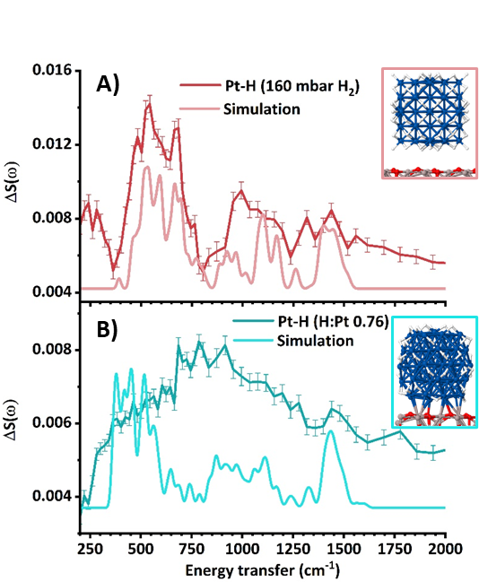
Figure 9: A) Difference INS spectrum of the Pt-H species formed upon a Pt/Al₂O₃ catalyst in the presence of excess pressure of H₂ (equilibrium pressure 160 mbar), compared with the simulated spectrum of the cuboctahedric model Pt₅₅H₉₁/γ-Al₂O₃ reported in the inset. B) Difference INS spectrum of the hydrogenous species formed on the same Pt/Al₂O₃ catalyst at lower amounts of H₂ (H:Pt ratio equal to 0.76), compared with the simulated spectrum of the Pt₅₅H₄₄/γ-Al₂O₃ model reported in the inset. The experimental spectra were obtained by subtracting the spectrum of the catalyst before H₂ dosage to that measured in the presence of H₂. Replotted from reference ^{[16]}.

  - Hydrogen spillover
The spillover process consists in the migration of active species formed upon the active phase onto its support. Particular interest arose around the process of hydrogen spillover, involving the migration of the metal hydrides formed at the surface of the supported nanoparticles onto the underlying support.^{[107]} The phenomenon immediately appealed to the experts of catalysis, as it may provide a reservoir of reactive species,^{[108-109]} but also to those working in the field of hydrogen storage, as it can increase the storage capacity of the material.^{[109]} The investigation of the spillover process posed several challenges, related (and not limited) to the quantification of spiltover species, the different behavior of reducible and non-reducible supports, and the chemical nature of the species resulting from spillover.^{[109-110]} INS spectroscopy was particularly applied to elucidate this latter point, thanks to its ability to provide the vibrational fingerprint of any hydrogenous species.
INS studies mentioning H-spillover on oxidic supports are scarce. Non-reducible supports are known to undergo limited or no H-spillover,^{[110]} and only a very limited increase in the concentration of surface -OH groups in a Pt/Al₂O₃ sample activated at high temperature was measured by INS (see the signal at 800 cm⁻¹ in Figure 9B).^{[16]} This effect was attributed to an H-spillover effect limited to the close proximity of the Pt nanoparticles, favored by the high initial level of dehydroxylation of the support.
The majority of INS studies regarding H-spillover focus instead on carbon-supported samples.^{[12, 15, 62, 81, 111-112]} H-Spillover onto perfect graphenic planes is deemed unlikely because of the high activation barrier of the process,^{[113-114]}however the likelihood of the process was found to increase in the presence of defects such as the domains terminations, dopants and heteroatoms, holes or curved regions in the aromatic structure.^{[115-116]} In many studies regarding metal nanoparticles supported on carbon-based materials in the presence of H₂ a slight increase in the intensity of the INS signals in the 750-1600 cm⁻¹ range was reported. This is shown in Figure 10, reporting the INS spectra of a Pd/C catalyst before and after reaction with H₂ (equilibrium pressure of 430 mbar) at room temperature, and the difference between the two.^{[62]} On the other hand, the same increment was not observed when feeding H₂ to the bare carbon support, indicating that an active metal phase is required and that the observed phenomenon is indeed H-spillover. So that the position of these increasing signals is typical of sp² C-H moieties and no new signals ascribable to sp³ clearly arise, INS spectroscopy also indicates that H-spillover on carbonaceous supports does lead to a significant loss in aromaticity of the support.
Various results have been obtained regarding the degree of reversibility of the C-H species formed via spillover upon outgassing. Contescu et al observed on a Pd sample supported on activated carbon fibers that the increased C-H signals arose upon spillover would not decrease even upon evacuation at 300°C. Furthermore, they also noticed a reduced H₂ uptake during the second adsorption cycle, which indicates a decrease in the available sites for bonding H atoms upon spillover.^{[111]} On the other hand, Parker et al observed the restoration of the original C-H signals intensities upon outgassing on an activated carbon-supported Pd sample, but not on the more graphitic carbon-black supported ones.^{[15]}
Overall, INS spectroscopy demonstrated to be able to provide significant results in the identification of the species formed upon H-spillover on carbon-based supports, and further studies may have the potential to clarify better their role in catalysis and in the H₂-storage field.
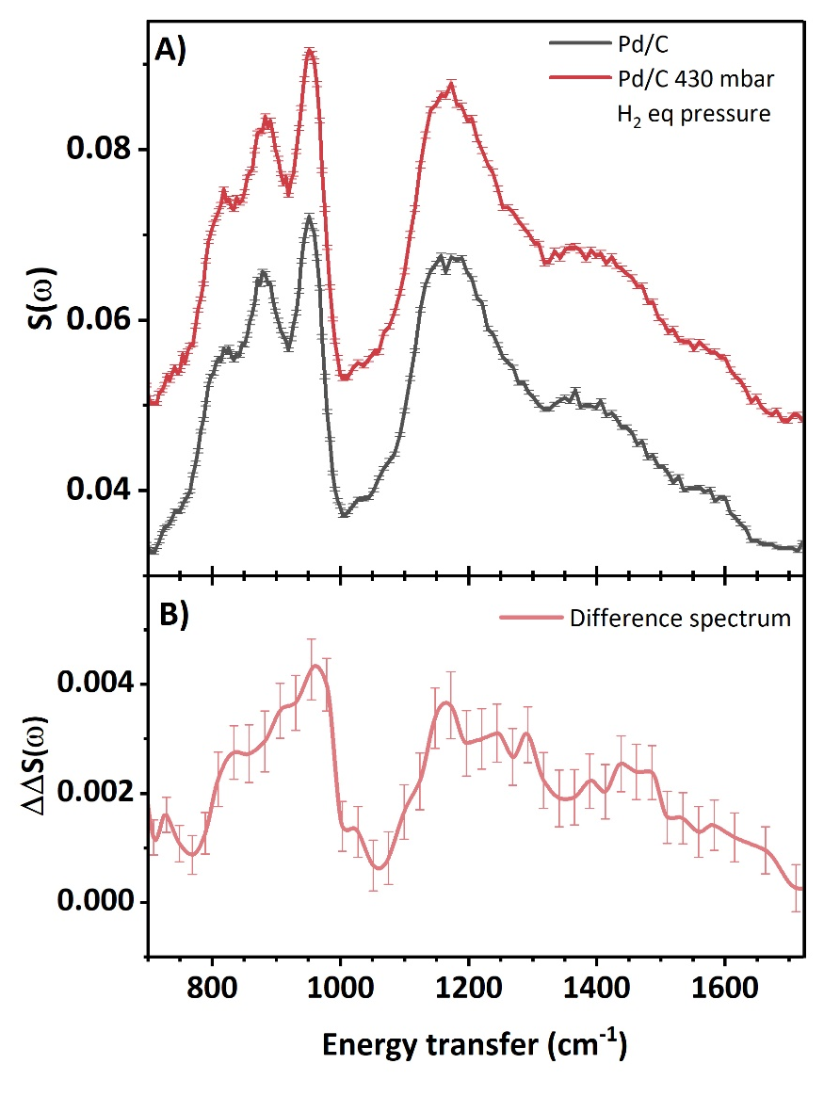
Figure 10: A) Detail over the C-H bending modes region of the INS spectrum of a Pd/activated carbon catalysts under vacuum (grey line) and after dosing H₂ up to an equilibrium pressure of 430 mbar (red line). B) Increase in the spectral intensity due to H-spillover. The spectrum was obtained by subtracting to the spectrum of the catalyst exposed to H₂ the contribution of the same sample under vacuum and that of physisorbed H₂. Replotted from reference^{[62]}.

- Summary and outlook
This review proposed an overview of the very varied information that INS spectroscopy can provide about hydrogenation catalysts, with a particular focus on catalysts based on supported metal nanoparticles. INS is well known for its very high sensitivity to vibrational modes involving H atoms, and consequently the measure of the catalyst as such provides remarkable information regarding the nature of the hydrogenous species intrinsically present in it (most commonly, in its support). Additionally, the spectra measured in the presence of H₂ provide fundamental details about its interaction with the catalysts both via physisorption and chemisorption, in a way hardly obtainable with any other technique.
A detailed understanding of the nature of catalytic supports is fundamental, as they are nowadays well known to affect the properties of the active phase and/or participate in the catalyzed reaction,^{[7]} and INS spectroscopy can provide very detailed information on components hardly detectable with other techniques, such as the H terminations in carbonaceous supports and oxides. Carbonaceous supports like activated carbons, carbon blacks or reduced graphene oxides were to this date the most widely investigated with this technique, providing extremely detailed spectra profiles describing the morphology of the C-H terminations in the aromatic domains, how they change from one sample to the other, and the modifications they undergo upon functionalization or metal nanoparticles deposition. The approach can be in principle extended to other systems, and it was also recently demonstrated that it is nowadays possible to investigate the vibration of other elements presenting a sufficient neutron scattering cross section such as Cl in MgCl₂.^{[14]}
Of even greater interest for catalysis is the capability of INS to investigate the sample in the presence of H₂ under in situ conditions, providing in the same spectrum information about H₂ physisorption, splitting of the H₂ molecule occurring at the surface of the supported metal nanoparticles and the consequent formation of the metal hydrides, and also about the possible spillover of atomic hydrogen onto the support. The characterization of physisorbed and spiltover hydrogen species is of great interest for catalysis, as they constitute possible reservoir or active species. The same typology of investigation is also of interest in the field of hydrogen storage, as INS spectroscopy can help in the identification of the interaction mechanism between H₂ and the material (physisorption or chemisorption), and in principle it can also provide quantitative details regarding the amount of hydrogen stored from each path.^{[45]}
The characterization of the metal hydride species was instead fundamental for a better understanding of hydrogenation catalysts. INS is one of the few techniques able to distinguish among the numerous surface and bulk hydride species that may be formed at the surface and/or in the bulk of the metal nanoparticles. The most investigated systems with this methodology are based on Pd, and albeit their investigation started decades ago very recent research works still managed to provide new highlights on the distribution of the occupancy of H atoms in the bulk, in the subsurface and at the surface of the nanoparticles.^{[15, 17, 62]} The second most investigated system is instead Pt, where recent DFT simulations and experiments performed under different environmental conditions allowed to shade new light concerning the preferred bonding geometry of H at the surface of the Pt nanoparticles, of the H:Pt stoichiometry, and of the reconstruction phenomena occurring when modifying the H₂ pressure and temperature.^{[16, 65]} Some experiments on metals such as Au,^{[68]} Ru,^{[69]} Ni^{[71]} or Co^{[71]} have been reported, but clearly there is still a large potential for application to other supported metal nanoparticles systems, for instance, by focusing on less noble metals, following the current trends in the development of heterogeneous catalysts.
The fundamental contribution provided by the complementary use of computational simulations for a detailed assignment of the signals observed in the experimental INS spectra was also addressed in this review. In this respect, the huge increase in the available computational capacity is already reflected in many recent examples demonstrating the possibility to simulate complex and heterogeneous systems (such as supported metal nanoparticles catalysts) and to use the corresponding simulated spectra to obtain very detailed assignments for the interpretation of the experimental INS spectra.^{[16, 65]}
INS spectroscopy in the characterization of heterogeneous catalysts is currently limited by the very long acquisition time (generally several hours) and the fact often only measurements at cryogenic temperatures are possible. Thus, the typical measure is performed under static conditions after quenching of the sample. However, following the general trend observed for the characterization of heterogeneous catalysts, evident efforts are made in developing new sample environment devices and instruments able to explore larger ranges of temperature and gas pressures to approach real reaction conditions,^{[11, 16, 19]} or to follow the modifications undergone by the catalyst during time-resolved experiments by shortening the measurement times.^{[18]}
To conclude, over the years INS spectroscopy demonstrated several times its capability to provide fundamental insights into the physico-chemical properties of heterogeneous catalysts, with a particular emphasis on hydrogenation catalysts and supported metal nanoparticles systems. Considering the increase in the potentialities of the technique over time, the investigation of a wider range of systems and the use of more varied experimental conditions will become feasible in the next years. Overall, INS spectroscopy still has a significant potential to provide cutting-edge results in the field of catalysis in the future.

Acknowledgments
The support from Project CH4.0 under MUR (Italian Ministry for the University) program "Dipartimenti di Eccellenza 2023-2027" (CUP: D13C22003520001) is acknowledged.

References
[1] L. Lloyd, in Handbook of Industrial Catalysts (Ed.: L. Lloyd), Springer US, Boston, MA, 2011, pp. 73-117. https://doi.org/10.1007/978-0-387-49962-8_3
[2] L. Zhang, M. Zhou, A. Wang, T. Zhang, Chemical Reviews, "Selective Hydrogenation over Supported Metal Catalysts: From Nanoparticles to Single Atoms" Chemical Reviews 2020, 120, 683-733. https://doi.org/10.1021/acs.chemrev.9b00230
[3] Catalytic Naphtha Reforming, Revised and Expanded (2nd ed.), 2nd ed., CRC Press, Boca Raton, 2004. https://doi.org/10.1201/9780203913505
[4] X. Ren, Q. Lv, L. Liu, B. Liu, Y. Wang, A. Liu, G. Wu, Sustainable Energy & Fuels, "Current progress of Pt and Pt-based electrocatalysts used for fuel cells" Sustainable Energy & Fuels 2020, 4, 15-30. https://doi.org/10.1039/C9SE00460B
[5] R. M. Mironenko, O. B. Belskaya, V. A. Likholobov, Catalysis Today, "Approaches to the synthesis of Pd/C catalysts with controllable activity and selectivity in hydrogenation reactions" Catalysis Today 2020, 357, 152-165. https://doi.org/10.1016/j.cattod.2019.03.023
[6] J. Libuda, ChemPhysChem, "Molecular Beams and Model Catalysis: Activity and Selectivity of Specific Reaction Centers on Supported Nanoparticles" ChemPhysChem 2004, 5, 625-631. https://doi.org/10.1002/cphc.200400049
[7] M. Ahmadi, H. Mistry, B. Roldan Cuenya, The Journal of Physical Chemistry Letters, "Tailoring the Catalytic Properties of Metal Nanoparticles via Support Interactions" The Journal of Physical Chemistry Letters 2016, 7, 3519-3533. https://doi.org/10.1021/acs.jpclett.6b01198
[8] R. Schlögl, Angewandte Chemie International Edition, "Heterogeneous Catalysis" Angewandte Chemie International Edition 2015, 54, 3465-3520. https://doi.org/10.1002/anie.201410738
[9] F. Zaera, Journal of Catalysis, "In-situ and operando spectroscopies for the characterization of catalysts and of mechanisms of catalytic reactions" Journal of Catalysis 2021, 404, 900-910. https://doi.org/10.1016/j.jcat.2021.08.013
[10] P. C. H. Mitchell, S. F. Parker, A. J. Ramirez-Cuesta, J. Tomkinson, Vibrational Spectroscopy with Neutrons, Vol. Volume 3, WORLD SCIENTIFIC, 2005. https://doi.org/10.1142/5628
[11] A. S. Ivanov, P. A. Alekseev, Crystallography Reports, "Neutron Spectroscopy: Principles and Equipment" Crystallography Reports 2022, 67, 18-35. https://doi.org/10.1134/S1063774522010072
[12] M. Carosso, A. Lazzarini, A. Piovano, R. Pellegrini, S. Morandi, M. Manzoli, J. G. Vitillo, M. J. Ruiz, C. Lamberti, E. Groppo, Faraday Discussions, "Looking for the active hydrogen species in a 5 wt% Pt/C catalyst: a challenge for inelastic neutron scattering" Faraday Discussions 2018, 208, 227-242. https://doi.org/10.1039/C7FD00214A
[13] A. R. McInroy, D. T. Lundie, J. M. Winfield, C. C. Dudman, P. Jones, S. F. Parker, D. Lennon, Catalysis Today, "The interaction of alumina with HCl: An infrared spectroscopy, temperature-programmed desorption and inelastic neutron scattering study" Catalysis Today 2006, 114, 403-411. https://doi.org/10.1016/j.cattod.2006.02.041
[14] M. D’Amore, A. Piovano, E. Vottero, A. Piovano, S. Rudić, A. Erba, E. Groppo, B. Civalleri, ACS Applied Nano Materials, "Inelastic Neutron Scattering Investigation of MgCl2 Nanoparticle-Based Ziegler–Natta Catalysts for Olefin Polymerization" ACS Applied Nano Materials 2020, 3, 11118-11128. https://doi.org/10.1021/acsanm.0c02296
[15] S. F. Parker, H. C. Walker, S. K. Callear, E. Grünewald, T. Petzold, D. Wolf, K. Möbus, J. Adam, S. D. Wieland, M. Jiménez-Ruiz, P. W. Albers, Chemical Science, "The effect of particle size, morphology and support on the formation of palladium hydride in commercial catalysts" Chemical Science 2019, 10, 480-489. https://doi.org/10.1039/C8SC03766C
[16] E. Vottero, M. Carosso, A. Ricchebuono, M. Jiménez-Ruiz, R. Pellegrini, C. Chizallet, P. Raybaud, E. Groppo, A. Piovano, ACS Catalysis, "Evidence for H2-Induced Ductility in a Pt/Al2O3 Catalyst" ACS Catalysis 2022, 12, 5979-5989. https://doi.org/10.1021/acscatal.2c00606
[17] M. Kofu, N. Hashimoto, H. Akiba, H. Kobayashi, H. Kitagawa, K. Iida, M. Nakamura, O. Yamamuro, Physical Review B, "Vibrational states of atomic hydrogen in bulk and nanocrystalline palladium studied by neutron spectroscopy" Physical Review B 2017, 96, 054304. https://doi.org/10.1103/PhysRevB.96.054304
[18] S. F. Parker, Chemical Communications, "The role of hydroxyl groups in low temperature carbon monoxide oxidation" Chemical Communications 2011, 47, 1988-1990. https://doi.org/10.1039/C0CC04991C
[19] S. Tan, Y. Cheng, L. L. Daemen, D. A. Lutterman, Review of Scientific Instruments, "Design of a facility for the in situ measurement of catalytic reaction by neutron scattering spectroscopy" Review of Scientific Instruments 2018, 89, 014101. https://doi.org/10.1063/1.4991523
[20] M. Jiménez-Ruiz, A. Ivanov, S. Fuard, Journal of Physics: Conference Series, "LAGRANGE - the new neutron vibrational spectrometer at the ILL" Journal of Physics: Conference Series 2014, 549, 012004. https://doi.org/10.1088/1742-6596/549/1/012004
[21] S. F. Parker, F. Fernandez-Alonso, A. J. Ramirez-Cuesta, J. Tomkinson, S. Rudic, R. S. Pinna, G. Gorini, J. Fernández Castañon, Journal of Physics: Conference Series, "Recent and future developments on TOSCA at ISIS" Journal of Physics: Conference Series 2014, 554, 012003. https://doi.org/10.1088/1742-6596/554/1/012003
[22]
[23] R. A. Ewings, J. R. Stewart, T. G. Perring, R. I. Bewley, M. D. Le, D. Raspino, D. E. Pooley, G. Škoro, S. P. Waller, D. Zacek, C. A. Smith, R. C. Riehl-Shaw, Review of Scientific Instruments, "Upgrade to the MAPS neutron time-of-flight chopper spectrometer" Review of Scientific Instruments 2019, 90, 035110. https://doi.org/10.1063/1.5086255
[24] B. Fåk, S. Rols, G. Manzin, O. Meulien, EPJ Web Conf., "Panther — the new thermal neutron time-of-flight spectrometer at the ILL" EPJ Web Conf. 2022, 272. https://doi.org/10.1051/epjconf/202227202001
[25] G. E. Granroth, A. I. Kolesnikov, T. E. Sherline, J. P. Clancy, K. A. Ross, J. P. C. Ruff, B. D. Gaulin, S. E. Nagler, Journal of Physics: Conference Series, "SEQUOIA: A newly operating chopper spectrometer at the SNS" Journal of Physics: Conference Series 2010, 251. https://doi.org/10.1088/1742-6596/251/1/012058
[26] R. Kajimoto, M. Nakamura, Y. Inamura, F. Mizuno, K. Nakajima, S. Ohira-Kawamura, T. Yokoo, T. Nakatani, R. Maruyama, K. Soyama, K. Shibata, K. Suzuya, S. Sato, K. Aizawa, M. Arai, S. Wakimoto, M. Ishikado, S.-i. Shamoto, M. Fujita, H. Hiraka, K. Ohoyama, K. Yamada, C.-H. Lee, Journal of the Physical Society of Japan, "The Fermi Chopper Spectrometer 4SEASONS at J-PARC" Journal of the Physical Society of Japan 2011, 80, SB025. https://doi.org/10.1143/JPSJS.80SB.SB025
[27] R. Dovesi, A. Erba, R. Orlando, C. M. Zicovich-Wilson, B. Civalleri, L. Maschio, M. Rérat, S. Casassa, J. Baima, S. Salustro, B. Kirtman, WIREs Computational Molecular Science, "Quantum-mechanical condensed matter simulations with CRYSTAL" WIREs Computational Molecular Science 2018, 8, e1360. https://doi.org/10.1002/wcms.1360
[28] A. J. Ramirez-Cuesta, Computer Physics Communications, "aCLIMAX 4.0.1, The new version of the software for analyzing and interpreting INS spectra" Computer Physics Communications 2004, 157, 226-238. https://doi.org/10.1016/S0010-4655(03)00520-4
[29] K. Dymkowski, S. F. Parker, F. Fernandez-Alonso, S. Mukhopadhyay, Physica B: Condensed Matter, "AbINS: The modern software for INS interpretation" Physica B: Condensed Matter 2018, 551, 443-448. https://doi.org/10.1016/j.physb.2018.02.034
[30] Y. Q. Cheng, L. L. Daemen, A. I. Kolesnikov, A. J. Ramirez-Cuesta, Journal of Chemical Theory and Computation, "Simulation of Inelastic Neutron Scattering Spectra Using OCLIMAX" Journal of Chemical Theory and Computation 2019, 15, 1974-1982. https://doi.org/10.1021/acs.jctc.8b01250
[31] X. Yu, Y. Cheng, Y. Li, F. Polo-Garzon, J. Liu, E. Mamontov, M. Li, D. Lennon, S. F. Parker, A. J. Ramirez-Cuesta, Z. Wu, Chemical Reviews, "Neutron Scattering Studies of Heterogeneous Catalysis" Chemical Reviews 2023, 123, 8638-8700. https://doi.org/10.1021/acs.chemrev.3c00101
[32] F. Polo-Garzon, S. Luo, Y. Cheng, K. L. Page, A. J. Ramirez-Cuesta, P. F. Britt, Z. Wu, ChemSusChem, "Neutron Scattering Investigations of Hydride Species in Heterogeneous Catalysis" ChemSusChem 2019, 12, 93-103. https://doi.org/10.1002/cssc.201801890
[33] Y. Qiu, S. Ali, G. Lan, H. Tong, J. Fan, H. Liu, B. Li, W. Han, H. Tang, H. Liu, Y. Li, Carbon, "Defect-rich activated carbons as active and stable metal-free catalyst for acetylene hydrochlorination" Carbon 2019, 146, 406-412. https://doi.org/10.1016/j.carbon.2019.01.102
[34] E. Auer, A. Freund, J. Pietsch, T. Tacke, Applied Catalysis A: General, "Carbons as supports for industrial precious metal catalysts" Applied Catalysis A: General 1998, 173, 259-271. https://doi.org/10.1016/S0926-860X(98)00184-7
[35] F. Rodríguez-reinoso, Carbon, "The role of carbon materials in heterogeneous catalysis" Carbon 1998, 36, 159-175. https://doi.org/10.1016/S0008-6223(97)00173-5
[36] A. Lazzarini, R. Pellegrini, A. Piovano, S. Rudić, C. Castan-Guerrero, P. Torelli, M. R. Chierotti, R. Gobetto, C. Lamberti, E. Groppo, Catalysis Science & Technology, "The effect of surface chemistry on the performances of Pd-based catalysts supported on activated carbons" Catalysis Science & Technology 2017, 7, 4162-4172. 10.1039/C7CY01005B
[37] M. R. A. Arcanjo, M. Paniagua, G. Morales, J. Iglesias, J. Melero, I. da Silva, Jr., E. Rodríguez-Castellón, R. S. Vieira, Industrial & Engineering Chemistry Research, "Temperature Effect on Pretreatment of the Activated Carbon Support (Pt/AC and Pd/AC) for Glycerin into Lactic Acid" Industrial & Engineering Chemistry Research 2020, 59, 14643-14657. https://doi.org/10.1021/acs.iecr.0c01588
[38] M. F. R. Pereira, J. J. M. Órfão, J. L. Figueiredo, Colloids and Surfaces A: Physicochemical and Engineering Aspects, "Influence of the textural properties of an activated carbon catalyst on the oxidative dehydrogenation of ethylbenzene" Colloids and Surfaces A: Physicochemical and Engineering Aspects 2004, 241, 165-171. https://doi.org/10.1016/j.colsurfa.2004.04.001
[39] R. F. Bueres, E. Asedegbega-Nieto, E. Díaz, S. Ordóñez, F. V. Díez, Catalysis Today, "Performance of carbon nanofibres, high surface area graphites, and activated carbons as supports of Pd-based hydrodechlorination catalysts" Catalysis Today 2010, 150, 16-21. https://doi.org/10.1016/j.cattod.2009.05.020
[40] A. C. Ferrari, J. Robertson, Physical Review B, "Interpretation of Raman spectra of disordered and amorphous carbon" Physical Review B 2000, 61, 14095-14107. https://doi.org/10.1103/PhysRevB.61.14095
[41] G. A. Zickler, B. Smarsly, N. Gierlinger, H. Peterlik, O. Paris, Carbon, "A reconsideration of the relationship between the crystallite size La of carbons determined by X-ray diffraction and Raman spectroscopy" Carbon 2006, 44, 3239-3246. https://doi.org/10.1016/j.carbon.2006.06.029
[42] F. Herold, O. Leubner, K. Jeschonek, C. Hess, A. Drochner, W. Qi, B. J. M. Etzold, Carbon Trends, "Methodology for the identification of carbonyl absorption maxima of carbon surface oxides in DRIFT spectra" Carbon Trends 2021, 3, 100020. https://doi.org/10.1016/j.cartre.2020.100020
[43] J. L. Figueiredo, M. F. R. Pereira, M. M. A. Freitas, J. J. M. Órfão, Carbon, "Modification of the surface chemistry of activated carbons" Carbon 1999, 37, 1379-1389. https://doi.org/10.1016/S0008-6223(98)00333-9
[44] C. Cavallari, D. Pontiroli, M. Jiménez-Ruiz, M. Johnson, M. Aramini, M. Gaboardi, S. F. Parker, M. Riccó, S. Rols, Physical Chemistry Chemical Physics, "Hydrogen motions in defective graphene: the role of surface defects" Physical Chemistry Chemical Physics 2016, 18, 24820-24824. https://doi.org/10.1039/C6CP04727K
[45] P. W. Albers, J. Pietsch, J. Krauter, S. F. Parker, Physical Chemistry Chemical Physics, "Investigations of activated carbon catalyst supports from different natural sources" Physical Chemistry Chemical Physics 2003, 5, 1941-1949. https://doi.org/10.1039/B212210N
[46] P. W. Albers, W. Weber, K. Möbus, S. D. Wieland, S. F. Parker, Carbon, "Neutron scattering study of the terminating protons in the basic structural units of non-graphitising and graphitising carbons" Carbon 2016, 109, 239-245. https://doi.org/10.1016/j.carbon.2016.08.007
[47] A. Lazzarini, A. Piovano, R. Pellegrini, G. Leofanti, G. Agostini, S. Rudić, M. R. Chierotti, R. Gobetto, A. Battiato, G. Spoto, A. Zecchina, C. Lamberti, E. Groppo, Catalysis Science & Technology, "A comprehensive approach to investigate the structural and surface properties of activated carbons and related Pd-based catalysts" Catalysis Science & Technology 2016, 6, 4910-4922. https://doi.org/10.1039/C6CY00159A
[48] E. Vottero, M. Carosso, M. Jiménez-Ruiz, R. Pellegrini, E. Groppo, A. Piovano, Carbon, "How do the graphenic domains terminate in activated carbons and carbon-supported metal catalysts?" Carbon 2020, 169, 357-369. https://doi.org/10.1016/j.carbon.2020.07.033
[49] P. Albers, K. Seibold, G. Prescher, B. Freund, S. F. Parker, J. Tomkinson, D. K. Ross, F. Fillaux, Carbon, "Neutron spectroscopic investigations on different grades of modified furnace blacks and gas blacks1Parts of this paper were presented at the 23rd Biennial Conference on Carbon, July 13–18 1997 at the Pennsylvania State University, State College, USA, Extended Abstracts pp. 590–591.1" Carbon 1999, 37, 437-444. https://doi.org/10.1016/S0008-6223(98)00210-3
[50] F. Fillaux, R. Papoular, A. Lautié, J. Tomkinson, Carbon, "Inelastic neutron-scattering study of the proton dynamics in carbons and coals" Carbon 1994, 32, 1325-1331. https://doi.org/10.1016/0008-6223(94)90119-8
[51] P. W. Albers, V. Leich, A. J. Ramirez-Cuesta, Y. Cheng, J. Hönig, S. F. Parker, Materials Advances, "The characterisation of commercial 2D carbons: graphene, graphene oxide and reduced graphene oxide" Materials Advances 2022, 3, 2810-2826. 10.1039/D1MA01023A
[52] C. Cavallari, D. Pontiroli, M. Jiménez-Ruiz, A. Ivanov, M. Mazzani, M. Gaboardi, M. Aramini, M. Brunelli, M. Riccò, S. Rols, Journal of Physics: Conference Series, "Hydrogen on graphene investigated by inelastic neutron scattering" Journal of Physics: Conference Series 2014, 554, 012009. https://doi.org/10.1088/1742-6596/554/1/012009
[53] A. Piovano, A. Lazzarini, R. Pellegrini, G. Leofanti, G. Agostini, S. Rudić, A. L. Bugaev, C. Lamberti, E. Groppo, Advances in Condensed Matter Physics, "Progress in the Characterization of the Surface Species in Activated Carbons by means of INS Spectroscopy Coupled with Detailed DFT Calculations" Advances in Condensed Matter Physics 2015, 2015, 803267. https://doi.org/10.1155/2015/803267
[54] S. Horn, F. Plasser, T. Müller, F. Libisch, J. Burgdörfer, H. Lischka, Theoretical Chemistry Accounts, "A comparison of singlet and triplet states for one- and two-dimensional graphene nanoribbons using multireference theory" Theoretical Chemistry Accounts 2014, 133, 1511. https://doi.org/10.1007/s00214-014-1511-8
[55] T. Wassmann, A. P. Seitsonen, A. M. Saitta, M. Lazzeri, F. Mauri, Journal of the American Chemical Society, "Clar’s Theory, π-Electron Distribution, and Geometry of Graphene Nanoribbons" Journal of the American Chemical Society 2010, 132, 3440-3451. https://doi.org/10.1021/ja909234y
[56] C. Poidevin, P. Paciok, M. Heggen, A. A. Auer, The Journal of Chemical Physics, "High resolution transmission electron microscopy and electronic structure theory investigation of platinum nanoparticles on carbon black" The Journal of Chemical Physics 2018, 150, 041705. https://doi.org/10.1063/1.5047666
[57] L. R. Terry, S. Rols, M. Tian, I. da Silva, S. J. Bending, V. P. Ting, Nanoscale, "Manipulation of the crystalline phase diagram of hydrogen through nanoscale confinement effects in porous carbons" Nanoscale 2022, 14, 7250-7261. https://doi.org/10.1039/D2NR00587E
[58] P. A. Georgiev, D. K. Ross, A. De Monte, U. Montaretto-Marullo, R. A. H. Edwards, A. J. Ramirez-Cuesta, M. A. Adams, D. Colognesi, Carbon, "In situ inelastic neutron scattering studies of the rotational and translational dynamics of molecular hydrogen adsorbed in single-wall carbon nanotubes (SWNTs)" Carbon 2005, 43, 895-906. https://doi.org/10.1016/j.carbon.2004.11.006
[59] V. P. Ting, A. J. Ramirez-Cuesta, N. Bimbo, J. E. Sharpe, A. Noguera-Diaz, V. Presser, S. Rudic, T. J. Mays, ACS Nano, "Direct Evidence for Solid-like Hydrogen in a Nanoporous Carbon Hydrogen Storage Material at Supercritical Temperatures" ACS Nano 2015, 9, 8249-8254. https://doi.org/10.1021/acsnano.5b02623
[60] M. Celli, D. Colognesi, M. Zoppi, Physical Review E, "Direct experimental access to microscopic dynamics in liquid hydrogen" Physical Review E 2002, 66, 021202. https://doi.org/10.1103/PhysRevE.66.021202
[61] "https://www.isis.stfc.ac.uk/Pages/INS-database.aspx , accessed on July 3rd, 2023".
[62] E. Vottero, M. Carosso, R. Pellegrini, M. Jiménez-Ruiz, E. Groppo, A. Piovano, Catalysis Today, "Inelastic neutron scattering study of the H2 interaction with carbon-supported Pt and Pd catalysts" Catalysis Today 2023, In press. https://doi.org/10.1016/j.cattod.2023.01.016
[63] F. Fernandez-Alonso, F. J. Bermejo, C. Cabrillo, R. O. Loutfy, V. Leon, M. L. Saboungi, Physical Review Letters, "Nature of the Bound States of Molecular Hydrogen in Carbon Nanohorns" Physical Review Letters 2007, 98, 215503. https://doi.org/10.1103/PhysRevLett.98.215503
[64] P. Sabatier, J.-B. Senderens, Comptes rendus de l'Académie des Sciences, "Action du nickel sur l’éthylène. Synthèse de l’éthane" Comptes rendus de l'Académie des Sciences 1897, 124, 1358-1360.
[65] S. F. Parker, S. Mukhopadhyay, M. Jiménez-Ruiz, P. W. Albers, Chemistry – A European Journal, "Adsorbed States of Hydrogen on Platinum: A New Perspective" Chemistry – A European Journal 2019, 25, 6496-6499. https://doi.org/10.1002/chem.201900351
[66] S. F. Parker, C. D. Frost, M. Telling, P. Albers, M. Lopez, K. Seitz, Catalysis Today, "Characterisation of the adsorption sites of hydrogen on Pt/C fuel cell catalysts" Catalysis Today 2006, 114, 418-421. https://doi.org/10.1016/j.cattod.2006.02.043
[67] C.-S. Tsao, Y. Liu, H.-Y. Chuang, H.-H. Tseng, T.-Y. Chen, C.-H. Chen, M.-S. Yu, Q. Li, A. Lueking, S.-H. Chen, The Journal of Physical Chemistry Letters, "Hydrogen Spillover Effect of Pt-Doped Activated Carbon Studied by Inelastic Neutron Scattering" The Journal of Physical Chemistry Letters 2011, 2, 2322-2325. https://doi.org/10.1021/jz2010368
[68] I. P. Silverwood, S. M. Rogers, S. K. Callear, S. F. Parker, C. R. A. Catlow, Chemical Communications, "Evidence for a surface gold hydride on a nanostructured gold catalyst" Chemical Communications 2016, 52, 533-536. 10.1039/C5CC06118K
[69] P. C. H. Mitchell, S. F. Parker, J. Tomkinson, D. Thompsett, Journal of the Chemical Society, Faraday Transactions, "Adsorbed states of dihydrogen on a carbon supported ruthenium catalyst Inelastic neutron scattering study" Journal of the Chemical Society, Faraday Transactions 1998, 94, 1489-1493. https://doi.org/10.1039/A708207J
[70] P. W. Albers, W. Weber, K. Kunzmann, M. Lopez, S. F. Parker, Surface Science, "Characterisation of carbon supported platinum-ruthenium fuel cell catalysts of different degree of alloying" Surface Science 2008, 602, 3611-3616. https://doi.org/10.1016/j.susc.2008.10.006
[71] A. L. Davidson, D. Lennon, P. B. Webb, P. W. Albers, M. Berweiler, R. Poss, M. Roos, A. Reinsdorf, D. Wolf, S. F. Parker, Topics in Catalysis, "The Characterisation of Hydrogen on Nickel and Cobalt Catalysts" Topics in Catalysis 2021, 64, 644-659. https://doi.org/10.1007/s11244-021-01425-0
[72] N. Pernicone, M. Cerboni, G. Prelazzi, F. Pinna, G. Fagherazzi, Catalysis Today, "An investigation on Pd/C industrial catalysts for the purification of terephthalic acid" Catalysis Today 1998, 44, 129-135. https://doi.org/10.1016/S0920-5861(98)00183-7
[73] H. Lindlar, Helvetica Chimica Acta, "Ein neuer Katalysator für selektive Hydrierungen" Helvetica Chimica Acta 1952, 35, 446-450. https://doi.org/10.1002/hlca.19520350205
[74] N. Cherkasov, D. Y. Murzin, C. R. A. Catlow, A. Chutia, Catalysis Science & Technology, "Selectivity of the Lindlar catalyst in alkyne semi-hydrogenation: a direct liquid-phase adsorption study" Catalysis Science & Technology 2021, 11, 6205-6216. https://doi.org/10.1039/D1CY01016F
[75] H.-U. Blaser, A. Indolese, A. Schnyder, H. Steiner, M. Studer, Journal of Molecular Catalysis A: Chemical, "Supported palladium catalysts for fine chemicals synthesis" Journal of Molecular Catalysis A: Chemical 2001, 173, 3-18. https://doi.org/10.1016/S1381-1169(01)00143-1
[76] F. D. Manchester, A. San-Martin, J. M. Pitre, Journal of Phase Equilibria, "The H-Pd (hydrogen-palladium) System" Journal of Phase Equilibria 1994, 15, 62-83. https://doi.org/10.1007/BF02667685
[77] R. Griessen, N. Strohfeldt, H. Giessen, Nature Materials, "Thermodynamics of the hybrid interaction of hydrogen with palladium nanoparticles" Nature Materials 2016, 15, 311-317. https://doi.org/10.1038/nmat4480
[78] T. Kuji, Y. Matsumura, H. Uchida, T. Aizawa, Journal of Alloys and Compounds, "Hydrogen absorption of nanocrystalline palladium" Journal of Alloys and Compounds 2002, 330-332, 718-722. https://doi.org/10.1016/S0925-8388(01)01597-3
[79] J. Bergsma, J. A. Goedkoop, Physica, "Thermal motion in palladium hydride studied by means of elastic and inelastic scattering of neutrons" Physica 1960, 26, 744-750. https://doi.org/10.1016/0031-8914(60)90064-1
[80] J. J. Rush, J. M. Rowe, D. Richter, Zeitschrift für Physik B Condensed Matter, "Direct determination of the anharmonic vibrational potential for H in Pd" Zeitschrift für Physik B Condensed Matter 1984, 55, 283-286. https://doi.org/10.1007/BF01304078
[81] P. W. Albers, J. G. E. Krauter, D. K. Ross, R. G. Heidenreich, K. Köhler, S. F. Parker, Langmuir, "Identification of Surface States on Finely Divided Supported Palladium Catalysts by Means of Inelastic Incoherent Neutron Scattering" Langmuir 2004, 20, 8254-8260. https://doi.org/10.1021/la040054c
[82] H. Jobic, A. Renouprez, Journal of the Less Common Metals, "Formation of hydrides in small particles of palladium supported in Y-zeolite" Journal of the Less Common Metals 1987, 129, 311-316. https://doi.org/10.1016/0022-5088(87)90066-X
[83] C. J. Glinka, J. M. Rowe, J. J. Rush, A. Rahman, S. K. Sinha, H. E. Flotow, Physical Review B, "Inelastic-neutron-scattering line shapes in PdD0.63" Physical Review B 1978, 17, 488-493. https://doi.org/10.1103/PhysRevB.17.488
[84] M. Kemali, J. E. Totolici, D. K. Ross, I. Morrison, Physical Review Letters, "Inelastic Neutron Scattering Measurements and Ab Initio Calculations of Hydrogen in Single-Crystal Palladium" Physical Review Letters 2000, 84, 1531-1534. https://doi.org/10.1103/PhysRevLett.84.15311
[85] J. Howard, T. C. Waddington, C. J. Wright, Chemical Physics Letters, "The vibrational spectrum of hydrogen adsorbed on palladium black measured using inelastic neutron scattering spectroscopy" Chemical Physics Letters 1978, 56, 258-262. https://doi.org/10.1016/0009-2614(78)80234-6
[86] J. M. Nicol, J. J. Rush, R. D. Kelley, Surface Science, "Inelastic neutron scattering studies of the interaction of hydrogen with palladium black" Surface Science 1988, 197, 67-80. https://doi.org/10.1016/0039-6028(88)90573-0
[87] H. Jobic, J.-P. Candy, V. Perrichon, A. Renouprez, Journal of the Chemical Society, Faraday Transactions 1: Physical Chemistry in Condensed Phases, "Neutron-scattering and volumetric study of hydrogen adsorbed and absorbed on Raney palladium" Journal of the Chemical Society, Faraday Transactions 1: Physical Chemistry in Condensed Phases 1985, 81, 1955-1961. https://doi.org/10.1039/F19858101955
[88] P. W. Albers, K. Möbus, C. D. Frost, S. F. Parker, The Journal of Physical Chemistry C, "Characterization of β-Palladium Hydride Formation in the Lindlar Catalyst and in Carbon-Supported Palladium" The Journal of Physical Chemistry C 2011, 115, 24485-24493. https://doi.org/10.1021/jp205951c
[89] U. Stuhr, H. Wipf, T. J. Udovic, J. Weissmuller, H. Gleiter, Journal of Physics: Condensed Matter, "The vibrational excitations and the position of hydrogen in nanocrystalline palladium" Journal of Physics: Condensed Matter 1995, 7, 219. https://doi.org/10.1088/0953-8984/7/2/002
[90] P. Albers, M. Poniatowski, S. F. Parker, D. K. Ross, Journal of Physics Condensed Matter, "Inelastic neutron scattering study on different grades of palladium of varying pretreatment" Journal of Physics Condensed Matter 2000, 12, 4451-4463. https://doi.org/10.1088/0953-8984/12/20/301
[91] H. Akiba, M. Kofu, H. Kobayashi, H. Kitagawa, K. Ikeda, T. Otomo, O. Yamamuro, Journal of the American Chemical Society, "Nanometer-Size Effect on Hydrogen Sites in Palladium Lattice" Journal of the American Chemical Society 2016, 138, 10238-10243. https://doi.org/10.1021/jacs.6b04970
[92] T. Ishimoto, M. Koyama, The Journal of Chemical Physics, "Theoretical study of tetrahedral site occupation by hydrogen in Pd nanoparticles" The Journal of Chemical Physics 2018, 148, 034705. https://doi.org/10.1063/1.5005976
[93] T. Gjervan, R. Prestvik, A. Holmen, in Basic Principles in Applied Catalysis (Ed.: M. Baerns), Springer Berlin Heidelberg, Berlin, Heidelberg, 2004, pp. 125-158. https://doi.org/10.1007/978-3-662-05981-4_4
[94] P.-Y. le Goff, W. Kostka, J. Ross, in Springer Handbook of Petroleum Technology (Eds.: C. S. Hsu, P. R. Robinson), Springer International Publishing, Cham, 2017, pp. 589-616. https://doi.org/10.1007/978-3-319-49347-3_18
[95] P. Albers, E. Auer, K. Ruth, S. F. Parker, Journal of Catalysis, "Inelastic Neutron Scattering Investigation of the Nature of Surface Sites Occupied by Hydrogen on Highly Dispersed Platinum on Commercial Carbon Black Supports" Journal of Catalysis 2000, 196, 174-179. https://doi.org/10.1006/jcat.2000.3021
[96] P. W. Albers, M. Lopez, G. Sextl, G. Jeske, S. F. Parker, Journal of Catalysis, "Inelastic neutron scattering investigation on the site occupation of atomic hydrogen on platinum particles of different size" Journal of Catalysis 2004, 223, 44-53. https://doi.org/10.1016/j.jcat.2003.12.018
[97] M. Carosso, E. Vottero, A. Lazzarini, S. Morandi, M. Manzoli, K. A. Lomachenko, M. J. Ruiz, R. Pellegrini, C. Lamberti, A. Piovano, E. Groppo, ACS Catalysis, "Dynamics of Reactive Species and Reactant-Induced Reconstruction of Pt Clusters in Pt/Al2O3 Catalysts" ACS Catalysis 2019, 9, 7124-7136. https://doi.org/10.1021/acscatal.9b02079
[98] S. Yamazoe, A. Yamamoto, S. Hosokawa, R. Fukuda, K. Hara, M. Nakamura, K. Kamazawa, T. Tsukuda, H. Yoshida, T. Tanaka, Catalysis Science & Technology, "Identification of hydrogen species on Pt/Al2O3 by in situ inelastic neutron scattering and their reactivity with ethylene" Catalysis Science & Technology 2021, 11, 116-123. https://doi.org/10.1039/D0CY01968B
[99] D. Y. Zemlyanov, M. Y. Smirnov, V. V. Gorodetskii, Catalysis Letters, "HREELS characterization of hydrogen adsorption states on the Pt(100)-(hex) and (1×1) surfaces" Catalysis Letters 1997, 43, 181-187. https://doi.org/10.1023/A:1018903009117
[100] L. J. Richter, W. Ho, Physical Review B, "Vibrational spectroscopy of H on Pt(111): Evidence for universally soft parallel modes" Physical Review B 1987, 36, 9797-9800. https://doi.org/10.1103/PhysRevB.36.9797
[101] W. A. Pliskin, R. P. Eischens, "Infrared Spectra of Hydrogen and Deuterium Chemisorbed on Platinum" 1960, 24, 11-23. https://doi.org/10.1524/zpch.1960.24.1_2.011
[102] M. Primet, J. M. Basset, M. V. Mathieu, M. Prettre, Journal of Catalysis, "Infrared investigation of hydrogen adsorption on alumina-supported platinum" Journal of Catalysis 1973, 28, 368-375. https://doi.org/10.1016/0021-9517(73)90129-2
[103] C. Mager-Maury, G. Bonnard, C. Chizallet, P. Sautet, P. Raybaud, ChemCatChem, "H2-Induced Reconstruction of Supported Pt Clusters: Metal–Support Interaction versus Surface Hydride" ChemCatChem 2011, 3, 200-207. https://doi.org/10.1002/cctc.201000324
[104] A. Gorczyca, V. Moizan, C. Chizallet, O. Proux, W. Del Net, E. Lahera, J.-L. Hazemann, P. Raybaud, Y. Joly, Angewandte Chemie International Edition, "Monitoring Morphology and Hydrogen Coverage of Nanometric Pt/γ-Al2O3 Particles by In Situ HERFD–XANES and Quantum Simulations" Angewandte Chemie International Edition 2014, 53, 12426-12429. https://doi.org/10.1002/anie.201403585
[105] G.-F. Wei, Z.-P. Liu, Chemical Science, "Restructuring and Hydrogen Evolution on Pt Nanoparticle" Chemical Science 2015, 6, 1485-1490. https://doi.org/10.1039/C4SC02806F
[106] L.-L. Wang, D. D. Johnson, Journal of the American Chemical Society, "Shear Instabilities in Metallic Nanoparticles: Hydrogen-Stabilized Structure of Pt37 on Carbon" Journal of the American Chemical Society 2007, 129, 3658-3664. https://doi.org/10.1021/ja068750h
[107] W. C. Conner, Jr., J. L. Falconer, Chemical Reviews, "Spillover in Heterogeneous Catalysis" Chemical Reviews 1995, 95, 759-788. https://doi.org/10.1021/cr00035a014
[108] M. Xiong, Z. Gao, Y. Qin, ACS Catalysis, "Spillover in Heterogeneous Catalysis: New Insights and Opportunities" ACS Catalysis 2021, 11, 3159-3172. https://doi.org/10.1021/acscatal.0c05567
[109] M. Li, W. Yin, J. Pan, Y. Zhu, N. Sun, X. Zhang, Y. Wan, Z. Luo, L. Yi, L. Wang, Chemical Engineering Journal, "Hydrogen spillover as a promising strategy for boosting heterogeneous catalysis and hydrogen storage" Chemical Engineering Journal 2023, 471, 144691. https://doi.org/10.1016/j.cej.2023.144691
[110] W. Karim, C. Spreafico, A. Kleibert, J. Gobrecht, J. VandeVondele, Y. Ekinci, J. A. van Bokhoven, Nature, "Catalyst support effects on hydrogen spillover" Nature 2017, 541, 68-71. https://doi.org/10.1038/nature20782
[111] C. I. Contescu, C. M. Brown, Y. Liu, V. V. Bhat, N. C. Gallego, The Journal of Physical Chemistry C, "Detection of Hydrogen Spillover in Palladium-Modified Activated Carbon Fibers during Hydrogen Adsorption" The Journal of Physical Chemistry C 2009, 113, 5886-5890. https://doi.org/10.1021/jp900121k
[112] J. L. Blackburn, C. Engtrakul, J. B. Bult, K. Hurst, Y. Zhao, Q. Xu, P. A. Parilla, L. J. Simpson, J.-D. R. Rocha, M. R. Hudson, C. M. Brown, T. Gennett, The Journal of Physical Chemistry C, "Spectroscopic Identification of Hydrogen Spillover Species in Ruthenium-Modified High Surface Area Carbons by Diffuse Reflectance Infrared Fourier Transform Spectroscopy" The Journal of Physical Chemistry C 2012, 116, 26744-26755. https://doi.org/10.1021/jp305235p
[113] M. Blanco-Rey, J. I. Juaristi, M. Alducin, M. J. López, J. A. Alonso, The Journal of Physical Chemistry C, "Is Spillover Relevant for Hydrogen Adsorption and Storage in Porous Carbons Doped with Palladium Nanoparticles?" The Journal of Physical Chemistry C 2016, 120, 17357-17364. https://doi.org/10.1021/acs.jpcc.6b04006
[114] G. M. Psofogiannakis, G. E. Froudakis, The Journal of Physical Chemistry C, "DFT Study of the Hydrogen Spillover Mechanism on Pt-Doped Graphite" The Journal of Physical Chemistry C 2009, 113, 14908-14915. https://doi.org/10.1021/jp902987s
[115] D. S. Pyle, E. M. Gray, C. J. Webb, International Journal of Hydrogen Energy, "Hydrogen storage in carbon nanostructures via spillover" International Journal of Hydrogen Energy 2016, 41, 19098-19113. https://doi.org/10.1016/j.ijhydene.2016.08.061
[116] V. B. Parambhath, R. Nagar, K. Sethupathi, S. Ramaprabhu, The Journal of Physical Chemistry C, "Investigation of Spillover Mechanism in Palladium Decorated Hydrogen Exfoliated Functionalized Graphene" The Journal of Physical Chemistry C 2011, 115, 15679-15685. https://doi.org/10.1021/jp202797q

Keywords
Carbon support, DFT, Hydrides, Inelastic neutron scattering, Spillover, Supported catalysts

Table of Contents graphical abstract
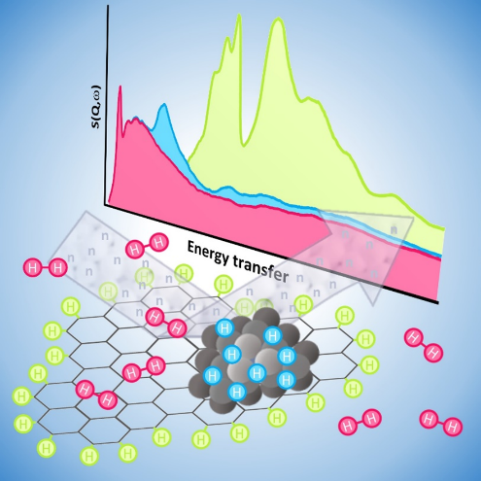
“Inelastic Neutron Scattering (INS) spectroscopy of supported metal nanoparticles catalyst provides fundamental details about the nature of the H-containing species present in the support, H₂ physisorption, the formation of metal hydride and spillover. This review proposes an overview over the results obtained by INS on this class of hydrogenation catalysts”

Authors Biographies
 | Eleonora Vottero is Post-Doc in the Physical Chemistry group at the Department of Chemistry of the University of Torino. She was a PhD student in co-tutorship between the University of Torino and the Institut Laue-Langevin, and defended her thesis in 2020. Her scientific interests are centred around the understanding of the physical-chemical properties of metal nanoparticles-based heterogeneous catalysts and their supports, and which she investigates by means of advanced spectroscopies (most notably INS and FT-IR) and computational simulations.
 | Elena Groppo is associate professor in Physical Chemistry at the Department of Chemistry of the University of Torino. Her main scientific interest is the understanding of the physical-chemical working principles of heterogeneous catalysts, through the development and application of advanced spectroscopic methods, including in-house, synchrotron- and neutron-based techniques. In particular, she has been concentrated on two fields of research, strategic in the chemical industry: 1) heterogeneous catalysts for olefin polymerization, 2) catalysts based on supported metal nanoparticles for selective hydrogenation and oxidation reactions. She is Editor of Catalysis Today since 2022.
 | Andrea Piovano is scientist and instrument first responsible in the Spectroscopy group at Institut Laue-Langevin, the European neutron source. He has many scientific interests spanning from the understanding of the physical-chemical working principles of metal-supported heterogeneous catalysts, to the investigation of physical phenomena associated to high-T superconductors, to the characterization of materials for energy applications like fuel cells. In all these fields, he is concentrated to push the limit of neutron spectroscopy to elucidate samples properties so far inaccessible.

