Assessing Anthropogenic Impacts on River Morphodynamics : A GIS-Based Analysis of three alpine water basins (NW of Turin, Italy)
Évaluation des impacts anthropiques sur la morphodynamique fluviale: une analyse basée sur SIG de trois bassins hydrographiques alpins (NO de Turin, Italie)

Arianna Paschetto¹, Chiara Caselle¹, Sabrina Bonetto¹

1-Università di Torino, Via Valperga Caluso 35, 10133, Torino

RÉSUMÉ
Cette étude évalue les pressions anthropiques sur trois bassins hydrographiques à partir de cartes topographiques et d’images satellites couvrant la période de 1880 à 2024, analysées via une interface SIG. Une procédure automatisée de vectorisation a été développée pour extraire les principales caractéristiques, notamment les lits fluviaux, les zones urbaines/industrielles et les barrières fluviales (p. ex., barrages et ponts), malgré les défis liés à la variabilité cartographique. Des méthodes basées sur MATLAB ont soutenu l’extraction des données, permettant d’évaluer les modifications des lits fluviaux d’origine naturelle par rapport à celles d’origine anthropique. Deux indices spatiaux, l’indice de divagation (Anabranching Index) et une version modifiée de l’indice de taux de migration agrégée, ont été utilisés pour quantifier ces changements. Les résultats montrent des impacts anthropiques significatifs dans les bassins de la Dora Riparia et du Sangone, où l’expansion urbaine a entraîné une transition vers des morphologies confinées à un seul chenal. En revanche, le bassin du torrent Stura di Lanzo présente des schémas de migration relativement naturels, sauf dans certaines zones localisées. Dans l’ensemble, tous les bassins montrent un rétrécissement des chenaux actifs et une mobilité sédimentaire réduite, liés à une augmentation des barrières fluviales et à l’empiètement des zones urbaines, particulièrement marqués entre 1990 et 2024. Ces résultats soulignent l’interaction critique entre le développement anthropique et les dynamiques morphologiques fluviales.

ABSTRACT
This study evaluates anthropogenic pressures on three water basins using topographic maps and satellite images spanning 1880 to 2024, analyzed through a GIS interface. A novel automated vectorization procedure was developed to extract key features, including riverbeds, urban/industrial areas, and river barriers (e.g., dams and bridges), despite challenges arising from cartographic variability. MATLAB-based methods supported data extraction, facilitating assessments of natural versus anthropogenic riverbed changes. Two spatial indices—the Anabranching Index and a modified Aggregate Migration Rate Index—quantified these changes. Results reveal significant anthropogenic impacts in the Dora Riparia and Sangone basins, with urban expansion driving a shift toward single-thread, confined morphologies. By contrast, the Stura di Lanzo basin showed relatively natural migration patterns, except in localized areas. Across all basins, narrowing channels and reduced sediment mobility were linked to increasing barriers and urban expansion, particularly between 1990 and 2024. These findings highlight the critical interplay between anthropogenic development and riverine morphodynamics.

KEYWORDS
Human pressure, river barriers, river dynamics, historical maps, GIS

INTRODUCTION

The network of Italian rivers is undergoing an increasing degree of artificialization due to extensive exploitation for irrigation, hydroelectric energy production, and the creation of navigation routes. To support this exploitation, more and more lateral and longitudinal barriers have been built, which have primarily degraded priority river habitats and caused deviations from the natural evolution of the watercourses.
As a result of these factors, combined with the growing incidence of extreme rainfall and subsequent flood events, this increasing artificialization of watercourses can represent both a hydrogeological and ecological risk.
In the basins of the Stura di Lanzo, Sangone, and Dora Riparia rivers (west of Turin, Italy), an initial assessment has been conducted to evaluate the changes in the hydrographic network caused by anthropogenic expansion and water usage over the past 140 years.

METHODOLOGY

River channel changes
To evaluate anthropogenic pressure on the three water basins, topographic maps and satellite images from 1880 to 2024 were analysed using a GIS interface. From 1880 to 1960 it was used a black and white topographic map, for 1980 black and white aerial photo and for 2024 Google Earth and RGB aerial photo. The various components of interest, such as the riverbed (including water, bars, and islands), were manually digitised due to the differences of maps used (Figure 1). The obtained data were then used to quantitatively assess changes in the riverbed over time, distinguishing between natural morphological modifications and anthropogenic deviations from natural evolution.
To quantify the morphologic variability of the riverbed they were calculated: the spatial mobility with the Aggregate Migration Index (a re-elaborated version of Jautzy et al., 2022), the Anabranching Index (Bridge, 2003) and variability in active channel width. To calculate this parameters variability some procedures leveraging MATLAB interfaces were tested.

Anthropic components
Always through the same maps were digitised as polygon urban/industrial areas using the GIS Zonal Statistics, and manually digitised as points the different types of river barriers (dams, weirs, bridges, canals and existing hydroelectric plants). Additionally, an automated calculation was performed to evaluate the growth density and directional expansion of urban/industrial areas relative to the riverbed. The methods applied distributed the data spatially, capturing the extension and distribution anthropogenic pressure on rivers (Figure 1).
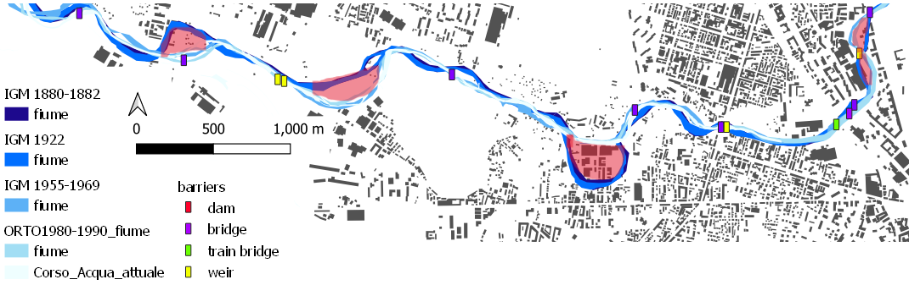
Figure 1. Sangone River last reach with anthropic elements and morphological variation of active channel. In red the areas with migration of river channels.

RESULTS and discussion

The evaluation of past anthropic pressures, starting from the selected temporal points (1880, 1920, 1960, 1990, and 2024), highlighted several key findings:
Regarding watercourse modifications (as evidenced by Migration indices, Figure2B, C), significant changes were observed in the Dora Riparia and Sangone basins, particularly in lowland areas. These changes are primarily attributed to the expansion of urban areas in Turin and its surrounding built-up regions. Notable examples include the modifications of the Sangone River in Nichelino (Figure 1) and the Dora Riparia near Turin's monumental cemetery and Pellerina Park. In these two basins, there has been a marked trend toward a reduction in the number of active channels and a shift to a singol-thread morphology, very often confined (highlighted applying Anabranching Index). In contrast, the Stura di Lanzo Torrent has largely maintained its natural riverbed migration, with exceptions in isolated areas such as Germagnano and the industrial zone between Ponte Stura and Turin. The variations became especially pronounced between 1920 and 1960 (Figure2A).
Overall, all three basins exhibit a general trend of narrowing active channels and reduced sediment mobility. This is due to an increase in river barriers, particularly pronounced between 1990 and 2024, as well as the expansion of urban areas, road networks, and agricultural land, which increasingly encroach upon available space.
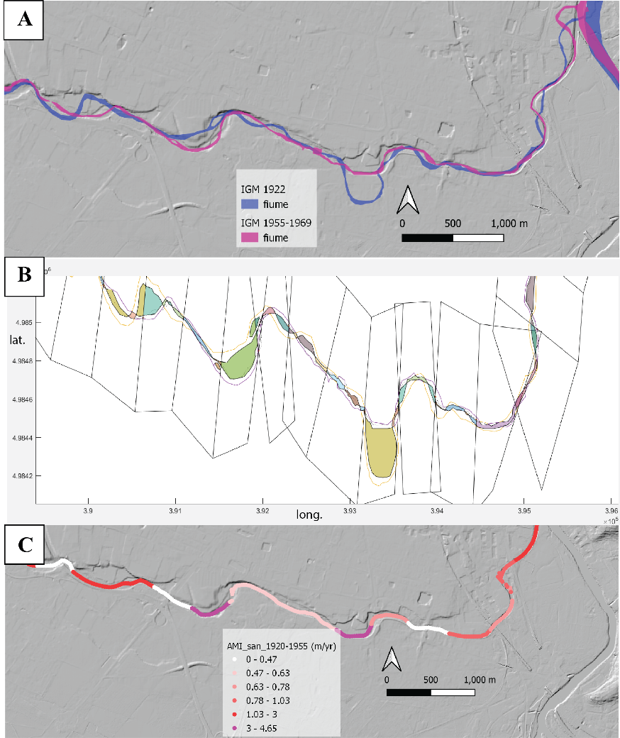
Figure 2. Sangone River last reach A) active channel in 1922 and 1960, B) MATLAB elaboration for Aggregate Migration Index, C) output of the Aggregate Migration Index

conclusion
The metrics employed highlighted and localized the segments of the watercourse exhibiting the greatest variation in terms of the number of channels, annual displacement of the active channel, and alterations in the riverbed. These variations are primarily attributed to anthropogenic expansion, particularly in the vicinity of the city of Turin, and have been notably pronounced since the 1950s, coinciding with urban and industrial expansion following the economic recovery of that period.
Understanding the area’s most significantly altered over time can be instrumental for planning and risk prevention purposes. Additionally, it identifies critical locations for maintaining the longitudinal continuity of the watercourse, which is essential for fluvial habitats dependent on this continuity (European Parliament and Council, 1992).

LIST OF REFERENCES
Bridge JS. Rivers and Floodplains: Forms, Processes, and Sedimentary Record. Oxford: Blackwell Science, 2003
European Parliament and Council. Directive 92/43/EEC of the Council of 21 May 1992 on the conservation of natural habitats and of wild fauna and flora. Official Journal of the European Communities, L 206/7, 22 July 1992.
Jautzy T., Schmitt L., Rixhon G. Historical geomorphological adjustments of an Upper Rhine sub-tributary over the two last centuries (Bruche River, France). Géomorphologie : relief, processus, environnement, 2022, 28 (1), pp.53-72. DOI 10.4000/geomorphologie.16661

