In Vivo MRI of Breast Cancer Using Carbonic Anhydrase IX Proteoglycan-like Domain -Targeting liposomes.
Claudia Quattrociocchi¹, Sergio Padovan¹, Sharmila Fagonee², Silvio Aime³, Valeria Menchise^{2*} and Daniela Delli Castelli¹
¹ University of Turin, Department of Molecular Biotechnology and Health Sciences, Molecular Biotechnology Centre “Guido Tarone”, I-10126 Turin, Italy;;
² Institute of Biostructure and Bioimaging, Molecular Biotechnology Centre “Guido Tarone”, I-10126 Turin, Italy;
³ IRCCS SDN SYNLAB, Via Gianturco 113, Napoli, Italy;
* Correspondence : valeria.menchise@cnr.it

Abstract: Molecular imaging of breast cancer is increasingly recognized as a valuable tool for optimizing therapeutic interventions. Among potential targets for molecular imaging reporters, Carbonic Anhydrase IX (CAIX) stands out for its overexpression in tumors characterized by large hypoxic areas and aggressive phenotypes. CAIX, a transmembrane glycoprotein involved in pH regulation, displays a unique proteoglycan-like (PG) domain, not present in other isoforms, that could represent a specific target for imaging and therapy. While existing high sensitivity imaging techniques such as Positron Emission Tomography (PET) and optical imaging have been applied for CAIX targeting, no in vivo study utilizing Magnetic Resonance Imaging (MRI) to target CAIX has yet been reported. Herein, we address this gap by applying CAIX PG-targeting liposomes in the first in vivo MRI study on a murine model of breast cancer. TS/A cells were subcutaneously injected to generate primary tumors in mice, and targeted liposomes were delivered intravenously after 15 days. Internalization of the targeted liposomes by receptor-mediated endocytosis led to an enhanced MRI signal in the tumor region. Cytoplasmic and endosomal distribution of the liposomes’ payload was observed. On the other hand, unfunctionalized liposomes and liposomes bearing a scrambled peptide, while entering tumor cells in smaller amounts, localized only to endosomes as expected through macropinocytosis. The specificity towards the CAIX PG domain not only offers improved diagnostic capabilities but also opens avenues for targeted therapeutic delivery. The findings reported herein suggest that liposomal formulations exploiting receptor-mediated endocytosis are promising tools for the diagnosis and treatment of tumors overexpressing CAIX, particularly in breast cancer.
Key words: MRI; Molecular Imaging; CAIX; Breast cancer; Gd-contrast agent; liposomes; Receptor Mediated Endocytosis.

1. Introduction
Molecular Imaging of breast cancer is emerging as a promising tool for optimizing therapeutic treatments in oncological patients[1]. Ideal targets for the design of Molecular Imaging tracers are membrane-bound proteins, overexpressed as the tumor growth slightly overcomes the initial stages. Recent studies assign a central role to pH gradient inversion in reinforcing various fundamental traits of cancer, including metabolic adaptation, immune evasion, and drug resistance, making it an attractive target for early diagnosis and therapy[2][3]. The molecular mechanisms underlying pH gradient reversal described so far include the overexpression of several ion pumps, channels on the plasma membrane along with overexpression of some isoforms of carbonic anhydrase as well as an increase in the glycolitic metabolic pathway[4][5].
Among these hallmarks, the expression of Carbonic Anhydrase IX (CAIX) is associated to tumors characterized by large hypoxic areas exhibiting an aggressive phenotype more resistant to radiotherapy and chemotherapy. CAIX thus represents an intrinsic reporter of hypoxia and an important prognostic marker[6][7].
CAIX is a transmembrane glycoprotein that catalyses the hydration of carbon dioxide into bicarbonate ions and protons. CAIX is normally expressed in intestinal epithelial tissue and it is upregulated in various forms of cancer, including breast cancer [8][9]. Its structure differs from other CA isoforms due to the presence of a unique proteoglycan-like domain (PG) protruding from the globular catalytic domain of the enzyme[10][11].
To date, several inhibitors and monoclonal antibodies (mAbs) directed against human CAIX have been extensively investigated[12]. The development of CAIX inhibitors as anticancer agents has also fostered the development of specific probes for diagnostic purposes for in vitro and in vivo Molecular Imaging of different types of solid tumors (with particularly robust results observed in the case of renal carcinoma)[13].
A new 99mTc-SPET tracer has been developed to detect Renal cell carcinoma (RCC) cells expressing CAIX in vivo [14]. It is based on acetazolamide, a clinically approved pan-CA inhibitor [15]. The authors demonstrated that the radiotracer is able to accumulate within the tumor, with a visibly higher signal inside the RCC xenograft compared to kidneys. Furthermore a fluorescent nanobody directed against CAIX has been reported for surgical application in orthotopical murine models of ductal carcinoma in situ (DCIS)[16].
The chimeric mAb G250, known under the commercial names of RENCAREX® or GIRENTUXIMAB, is in phase III clinical trials for the treatment of metastatic renal tumors[17][18], and their radiolabeled analogues have been proven to be highly effective in a combined targeted radiopharmaceutical therapy and immune checkpoint inhibition for RCC treatment[19]. The conjugation of G250 with superparamagnetic iron oxide (SPIO) nanoparticles led to a Molecular MRI nanoprobe that has been successfully used for the detection of RCC in vitro[20].
In vivo imaging currently offers a number of probes for CAIX targeting utilizing PET and OI techniques[21][22]. However, from the best of our knowledge, there are not yet found in vivo imaging strategies for systems suitable for MRI. The advantages for a MRI probe would be several, namely
a high anatomical resolution, a decreased invasiveness in respect to PET and an enhanced penetration in biological tissues in respect to OI. Additionally, current in vivo targeting approaches have solely focused on the enzyme's catalytic site, which shares high sequence homology with other CA isoforms[23], thus limiting the potential for an improved specificity.
Furthermore, targeting the PG domain of CAIX holds significant promise for designing efficient breast tumor theranostics [24]. Besides offering greater specificity, PG targeting boasts considerable therapeutic potential as the PG appears to be involved in cell-cell adhesion and pH homeostasis in cancer cells, thereby a key role in promoting tumor invasion [11][25][26].
Recently, we carried out an in vitro study on a breast cancer cell line employing a targeting strategy based on the use of a liposome encapsulating a “quenched” solution of gadolinium-based contrast agent[27]. The liposomes were functionalized with a peptide that specifically recognizes the PG domain of CAIX[28]. Liposomes are a widely used drug delivery system [29] due to their biocompatibility and versatile ability to encapsulate active components in their aqueous core or incorporate them into their phospholipidic bilayer [30][31][32]. The results of our work showed a good internalization of the probe into the tumor cells, accompanied by the release of the liposome payload in the cytoplasmatic compartment, thus yielding a marked increase in the MRI signal.
On the basis of the promising in vitro results, we deemed it of interest to translate this targeting approach to the PG domain of CAIX from cells to in vivo breast cancer murine models.

2. Experimental section
2.1 Materials
Phospholipids and chemicals for the preparation of liposomes were purchased from Sigma-Aldrich Co. (Merck, St. Louis, MO, USA). GdHPDO3A injectable solution was kindly provided by Bracco Imaging S.p.A. (Colleretto Giacosa (TO), Italy). The culture medium RPMI 1640, the biological buffers, fetal bovine serum (FBS), glutamine, penicillin–streptomycin mixture, and trypsin were purchased from Euroclone S.p.A. Rhodamine was purchased from Sigma-Aldrich (St Louise, MO, USA). Immunofluorescence reagents, including DAPI and Phalloidin were purchased from Sigma-Aldrich Co. All Fmoc-protected amino acids were purchased from Novabiochem®, and N,N-diisopropylcarbodiimide (DIC), OxymaPure®, and Fmoc-H-Rink Amide ChemMa-trix resin (0.4 mmol/g) were purchased from Sigma-Aldrich Co. (Merck, St. Louis, MO, USA). Solvents for synthesis, deprotection reagents and cleavage reagents were of synthesis grade and purchased from Sigma-Aldrich Co. (Merck, St. Louis, MO, USA). Solvents and other chemicals used for high-performance liquid chromatography (HPLC) were purchased from VWR International. Peptides were synthesized using a Liberty Blue™ automated microwave peptide synthesizer purchased from CEM, following a standard Fmoc protocol. The H-Rink Amide ChemMatrix resin was used as solid support.

2.2 Preparation and characterization of Liposomes
The lipid mixture chosen for liposome synthesis consisted of DPPC (1, 2-Dipalmitoyl-sn-glycero-3- phosphocholine), DSPE-PEG 2000 MeO (1,2-Distearoyl-sn-glycero-3-phosphoethanolamine N-[methoxy(polyethyleneglycol)-2000], ammonium salt), and DSPE-PEG 2000 Mal (1,2- distearoyl-sn-glycero-3-phosphoethanolamine-N-[maleimide(polyethylene glycol)-2000] ammonium salt) at a 95:4:1 molar ratio, respectively. Liposomes were prepared using the thin-film hydration method[33]. Briefly: the MRI probes (herein named Lip_Pep and LiP_SCR) were prepared by dissolving the lipid components in chloroform (20 mg lipid/mL). The organic solvent was removed in vacuum until a thin film was formed. Then, the film was hydrated at 55 °C with a solution of GdHPDO3A 300 mM at pH 7.4. The suspension was progressively extruded at 55 °C through polycarbonate filters of decreasing pore size: 400 nm (two times), and 200 nm (three times). Liposomes suspension was split in three parts. One of these parts was let to react with a controlled excess of the specific peptides (Pep) to functionalize the maleimide residues present on the liposomal surface (Lip_Pep). The second part was let to react with a controlled excess of the non-specific peptides (SCR) to functionalize the maleimide residues present on the liposomal surface (Lip_SCR) and control liposome (LIP) left as it is. Non-encapsulated GdHPDO3A and unbound peptide were removed by extensive dialysis carried out against an isotonic HEPES buffer (5 mM HEPES, 0.15 M NaCl, pH 7.4) at 4 ◦C using a dialysis cellulose membrane with 14 KDa molecular weight cut-off purchased from Sigma-Aldrich, St. Louis, MO, USA. Additional liposomes (with the same membrane composition) were prepared, containing Rhodamine B 0.1 mM in Hepes buffer 300 mOsm (herein named RLip_Pep; RLip_SCR; RLIP, respectively), for confocal studies. The mean hydrodynamic diameter of liposomes was determined by means of dynamic light scattering measurements (Malvern ZS Nanosizer, Malvern Instrumentation, UK) at 25 °C and a scattering angle of 90°. 10 μL of liposome suspension was diluted in 1 mL of filtered isotonic HEPES buffer (pH 7.4). Triplicate measurements were performed. The final concentration of Gd-HPDO3A in the liposome suspensions was determined by NMR magnetic susceptibility measurement (the Evans assay), on a Bruker 600 MHz spectrometer (AVANCE 600, 14 T).
Rhodamine B concentration was determined fluorimetrically (λex = 553 nm, λem = 579 nm , Fluoromax-4 spectrofluorimeter (Horiba Jobin Yvon)) after complete degradation of liposomes upon the application of several cycles of sonication using a tip at 70% power.
Relaxivity measurements were performed at 21.5 MHz on liposome suspensions diluted to a Gd³⁺ concentration of 1 mM before and after 40-second cycles of sonication using a tip at 70% power.
To verify the binding of the peptide on the surface of the liposome, measurements were performed using Nanodrop (NanoDrop One/OneC UV-Vis, Thermo Fisher Scientific Inc.). The NanoDrop spectrophotometer provides a comprehensive UV-Vis spectroscopic analysis and has a wide spectral range (190-850 nm) suitable for the measurement of peptides, DNA, and RNA. The absorbance of the peptide backbone at 205 (recommended for peptides that lack or have few Trp and Tyr residues as in Pep and SCR cases) was measured.

2.3 Solid phase peptide synthesis
Targeting peptides were prepared as described in ref (pharmaceutical). Briefly: Standard couplings of amino acids were carried out in DMF using DIC/OxymaPure® activation and piperidine deprotection. After completing the synthesis, the resin with the bound peptide was moved into a reactor for washings and then cleavage. Washings were done with 100 mL of Dimethylformamide (DMF) first, then with 100 mL of Dimethyl carbonate (DMC), and finally with 25 mL x 2 of EtOEt. For drying, the reactor was connected to the vacuum pump for 1 hour. The peptide was cleaved from the resin manually by using Trifluoroacetic acid (TFA) under gentle agitation for 2 hours at room temperature in the presence of scavengers (standard cleavage solution: TFA/Phenol/MilliQWater/Triisopropyl silane (TIPS) 88:5:5:2) to avoid oxidation. After filtration, the crude peptides were precipitated by the addition of cold diethyl ether, centrifuged, washed with cold Et2O five times, dried and dissolved in ultrapure water. Analyses of synthesized peptides were carried out by UPLC-MS Acquity H-Class Plus, on an Acquity UPLC Peptide BEH C18 column (300 Å, 1.7 µm, 2.1 mm x 100 mm), both purchased from Waters, with solvent B (acetonitrile with 0.05% TFA) versus solvent A (water with 0.05% TFA) using a 5%–95% to a 100%-0% gradient, at a flow rate of 0.4 mL/min for 13 min. Purification was performed through an HPLC AKTA purifier 10 on an X Terra Perp MS C18 OBDTM (5 µm, 19 mm x 100 mm) column in order to recover a fraction that would ensure the highest purity, and a new UPLC-MS analysis was performed. Finally, peptides were frozen, lyophilized, and stored at -20°C.

2.4 Cells culture
TS/A cells were grown in a L-GLUT RPMI 1640 medium supplemented with 10% FBS, 4 mM glutamine, 100 U/ml penicillin and 100 µg/ml streptomycin as previously described. These cells were maintained in a 5% CO2 incubator at 37 °C until 80% confluency and further use for the in vitro and in vivo experiments.

2.5 Murine models
Mice were bred and maintained in the animal facility of the Molecular Biotechnology Center “Guido Tarone”, and treated in accordance with institutional and EU guidelines (Direzione Generale della sanità animale e dei farmaci veterinari) (project identification: 298/2022-PR, date of approval: 13/05/2022). Mice were kept in standard housing with standard rodent chow and water available ad libitum, and a 12 h light/dark cycle.3 × 10⁵ TS/A cells were subcutaneously injected in the right and left flanks of N=15 10-week-old male BALB/c mice in order to obtain murine models. For the experiments, mice were analyzed 15 days after cell injection.

2.6 MRI experiments
7 T MRI scans were acquired on a Bruker Avance 300 spectrometer. T_{1W} images were acquired using a T1W _MSME_TESHORT sequence with the following parameters (TR = 200.000 ms, TE = 3.00 ms, NA = 6, FOV = 29 × 29 mm, slice thickness = 1 mm, matrix size 128 × 128). The mean signal intensity (SI) was determined on T_{1W} images by drawing regions of interest (ROIs) on tumors, liver and kidneys of mice with ImageJ software. Each SI value was normalized with the SI value of the same region in the image acquired before contrast-agent injection. The signal enhancement (SE%) was monitored for 72h after injection, using the following formula:
SE% = $\frac{{SI}_{post}-{SI}_{pre}}{{SI}_{pre}}$ x 100
The probe (LIP_Pep, Lip_SCR, LIP) was thus intravenously administered by catheter after the first acquisition, without removing the mouse from the instrument for time 0. Mice were then checked after 1, 8, 24, 48 and 72 hours after the injection.

2.7 Inductively Coupled Plasma (ICP)- mass spectrometry (MS) analysis
Mice divided into three groups (N=5 mice per group) and three different probes were injected intravenously: 0.1 mmol/kg Gd of Lip_PEP (group 1), Lip_SCR (group 2) and LIP (group 3). Eight and 72 hours after the injection, following MRI acquisitions, one mouse per group was sacrificed and cancer tissues, liver and kidneys were removed, weighed and processed for ICP-MS analysis[34].
The tissues were added to 1 mL of concentrated HNO₃ (70%). Upon dissolution of the tissues, samples were further digested through microwave heating (MicroSYNTH, Microwave labstation, Microsynth, Balgach, Switzerland). After digestion, 2 mL of bidistillate water was added to each sample, then samples were filtered with 0.45 µm filter and analysed using ICP-MS for quantification of Gd³⁺, using a Thermo Scientific ELEMENT 2 ICP-MS-Finnigan, Rodano, Italy. A calibration curve obtained by using four gadolinium absorption standard solutions (Sigma-Aldrich, Burlington, MA, USA) in the range 0.005–0.1 µg/mL was used for the quantification.
The total mass of Gd³⁺ retained in each specimen was calculated with respect to the weight of the tumor tissue (as µg of Gd³⁺/g of tissue).

2.8 Rhodamine-labeled liposomes injection in vivo and analysis
Rhodamine-labeled liposomes were administered intravenously. Eight hours post-injection, the mice were sacrificed, and organs collected, fixed in 4% PFA, followed by immersion in a 30% aqueous sucrose solution prior to inclusion in OCT (Optimal Cutting Temperature compound, VWR PROLABO CHEMICALS, product: 361603E) and storage at -80°C until sectioning. Sections of 5 µm thickness were cut using a cryostat microtome and stained for confocal analysis.

2.9 Confocal microscopy analysis
For the in vitro fluorescent cell-binding experiments, 2 × 10⁴ cells were seeded in Ibidi µ-Slide 8 well. After 24 h, the cells were incubated with the binding solution consisting of a medium solution containing the fluorescent probes (i.e. RLip_Pep, RLip_SCR, RLIP) for 4 h at 37°C and 5% CO₂. Cells were then fixed in 10% formalin, followed by incubation in Perforation Buffer and incubation in blocking buffer. Finally, the cytoskeleton and nucleus were stained with Phalloidin-FITC (green) and DAPI (red), respectively, followed by analysis on a SP5 confocal microscope (Leica, Wetzlar, Germany). Z-stack images were acquired and fluorescent images were processed using ImageJ Fiji freeware software (http://rsb.info.nih.gov/ij/).
To evaluate the presence of rhodamine-loaded liposomes (red) in the tumors in vivo and to analyse their distribution within the cells, cryostat sections of tumors and organs were stained with DAPI for nuclei, and Phalloidin-FITC for cytoskeleton. On separate sections, to assess the differential fate of functionalized and non-functionalized liposomes, macrophage cells were marked in green using an antibody against F4/80 (Invitrogen™) followed by an Alexa Fluor 488-labeled secondary antibody (Invitrogen™) and imaging on SP8 confocal microscope.
Z-stack images were acquired and fluorescent images were processed using ImageJ Fiji freeware software (http://rsb.info.nih.gov/ij/)
Z-stack images were acquired using laser scanning confocal microscopy (Leica SP8, Leica Microsystems, Wetzlar, Germany). Fluorescent images were processed using ImageJ Fiji freeware software.

3. Results and discussion
3.1 Gd- loaded Liposomes
Liposomes with a membrane composition made of DPCC, DSPE-PEG 2000 and DSPE-PEG 2000 Mal in the 95:4:1 molar ratio, respectively, were loaded with 300 mM of GdHPDO3A. An aliquot of the Liposomes’ suspension was let to react at room temperature with a controlled excess of a CAIX-specific peptide, synthesized as previously described [35], to functionalize all maleimide residues present on the liposomal surface. A liposome functionalized with a scrambled peptide (LIP_SCR) was also prepared following the same procedure, as well as an unfunctionalized control liposome (LIP), where the DSPE-PEG 2000 Mal phospholipid was replaced with DSPE-PEG 2000. The concentration of Gd-HPDO3A in the suspensions, determined by NMR magnetic susceptibility measurements [36], enabled the estimation of the concentration of the liposome suspension.
The occurrence of the binding between the peptide and the liposomal membrane was assessed by the Nanodrop spectrophotometric technique, using unfunctionalized liposome (LIP) as a control. The absorbance data of the liposomal suspensions confirmed the successful conjugation between the maleimide groups on the liposome surface and the peptides (Figure S1a). The liposomes stability in serum has been assessed through DLS and relaxometric analysis at 37 °C, showing that all the liposomal preparations retain the same dimensions and relaxation rate upon time (Figure S1b).
In a previous in vitro work[35], the same type of CAIX targeting liposomes were succefully tested on a mouse mammary adenocarcinoma cell line (TS/A). This approach exploited the process of “quenching/de-quenching” of the Gd complex, consisting in silencing the probe relaxation enhancing ability on bulk water resonance as long as it is entrapped in the inner core of the nanovesicle and in recovering the relaxation enhancement capability once the payload is released from the nanocarrier.
The “quenching/de-quenching” efficacy of the newly prepared liposomal probes were tested by carrying out a relaxometric study at 20 MHz. The millimolar relaxivity (r1p) of liposomes suspensions subjected to different sonication cycles was measured and reported in Figure 1, where the curve shows its gradual increase, from 0.1 mM⁻¹s⁻1 (intact vesicle) to the relaxivity value of free GdHPDO3A(4.5 mM⁻¹s⁻¹)[37]. The “de-quenching” process led to an increase in relaxivity of more than 40-fold. DLS measurements indicated that, upon the application of the sonication cycles, the phospholipids reorganized themselves in smaller vesicles with the concomitant release of the paramagnetic payload.
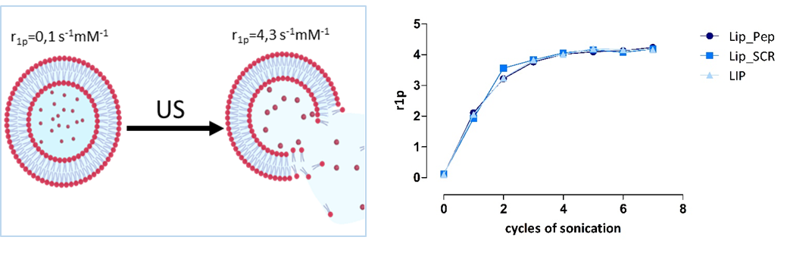

Figure 1 Relaxometric characterization of liposomes upon the application of ultrasound cycles. Illustrative diagram of liposome rupture with the corresponding millimolar relaxivities (left). Graph reporting r_{1p} values of the three different probes (right), measured after each sonication cycle (from 1 to 7 cycles, each lasting one minute at 70% power). The curve highlights the partial and then complete rupture of the liposomes (plateau) and consequently, the full “dequenching” of the system.

3.2 MRI analysis
Syngeneic breast cancer mouse models were prepared by subcutaneously injection of a suspension of murine adenocarcinoma cells (TS/A) in BALB/c mice. Two weeks after inoculation, when the tumor masses had grown to a palpable size, mice were subjected to MRI analysis on a 7T Bruker Avance 300 spectrometer. T1-wighted images were acquired on three groups of mice (five mice for each group) before and after the iv injection of 0,1 mmol/kg Gd of Lip_Pep (group 1), Lip_SCR (group 2) and LIP (group 3), respectively. The Signal Enhancement (SE) evolution in the tumor region was followed over time within the three groups of mice (Figure 2A). At 1 hour after injection, Lip_Pep and Lip_SCR probes elicit an immediate and significant increase in tumor signal intensity compared to LIP. This increase continues only for Lip_Pep, reaching a maximum value at 8 hours post-injection. After the first hour, SE values started to decrease for both Lip_SCR and LIP without a significant difference between them. After the 8-hour peak, the SE of Lip_Pep begins to decline likely as a consequence of the wash out from the tumor, stabilizing at an average values around 18%, a value that appears significantly higher than those of the other two groups of mice. Figure 2B shows representative T1-weighted MRI images of mice before and 8 hours after injection of probes, when the Lip_Pep SE reaches its maximum value.
The biodistribution of Gd-containing species has been evaluated through MRI on tumor, liver and kidney for the three choorts of mice (Figure S2).
The histograms in Figure 3A report the nanomoles of Gd per g of tissue in the tumors of the three groups of mice, sacrificed 8 hours after injection and immediately after MRI image acquisition, measured by ICP-MS. The corresponding SE values are reported in Figure 3B.
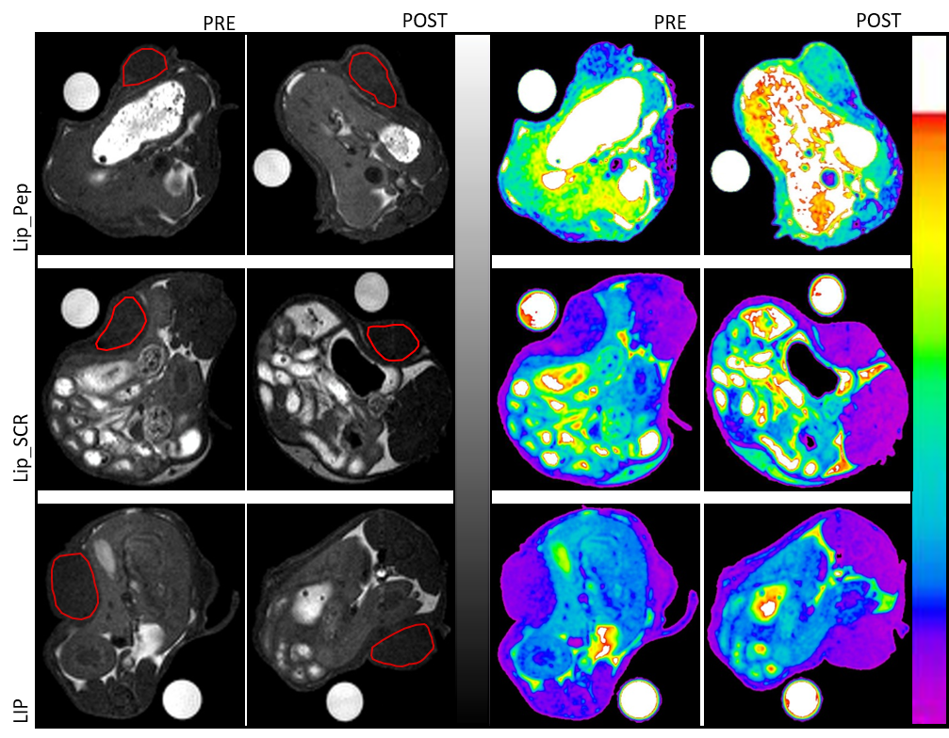
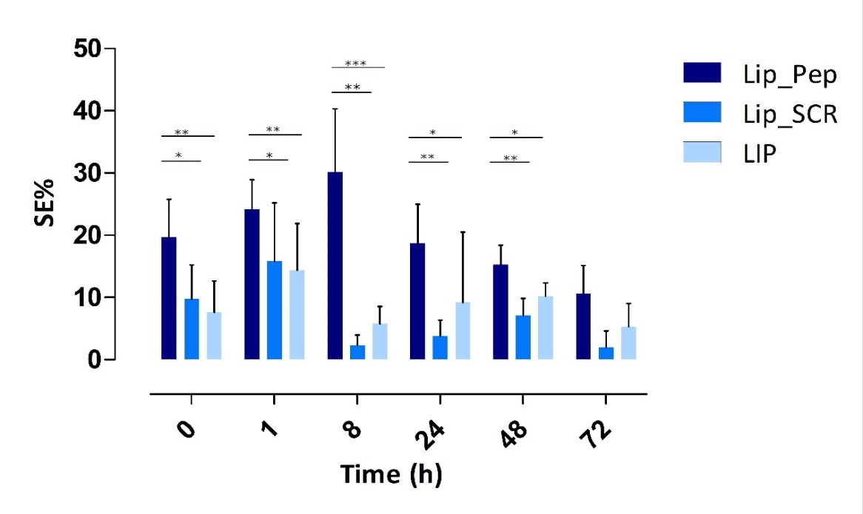
A
B

Fig. 2 MRI analysis. A) The graph shows the signal enhancement (see paragraph 2.7) in the tumor ROIs over time. Values are the mean ± SD (at t=0, 1 and 8h, n = 5 for Lip_Pep and Lip_SCR; n=4 for LIP; at t=24, 48, 72h, n = 3 for Lip_Pep and Lip_SCR; n=2 for LIP. *p < 0.05, ** p < 0.01, *** p < 0.001). B) Representative T1-weighted axial MRI images of mice before (pre) and 8 hours after (post) injection of Lip_Pep, Lip_Scr, and LIP. The hand-drawn polygonal area indicates the regions of interest (ROIs) where the MRI signal was measured. Images are shown both in gray scale (on the left) and using a false-colour look-up table (on the right) on Bruker Paravision software.

The comparison between the Gd content and the related SE observed in the MR images appears quite interesting. In fact, using the values of Lip_SCR and LIP as controls, the percentage difference in SE measured for the mice treated with Lip_Pep is much greater than the percentage difference observed when the Gd content values are considered. Specifically, the average SE of the mice treated with Lip_Pep is more than 10 times higher than that measured for Lip_SCR and LIP, while the average nmol/g value of Gd in the tumors, assessed immediately after the MRI analysis, is only slightly more than doubled for Lip_Pep compared to Lip_SCR and LIP. In other words, the difference in the enhancement of the MRI signal appears to be not only related to the overall amount of Gd content but likely to the occurrence of different relaxivities for the Gd-containing species in the two cases. As highlighted in our work on TS/A cells in vitro[35], the Lip_Pep targeting probe undergoes a different cellular fate compared to the aspecific probes. In particular, the significant increase in enhancement for mice treated with Lip_Pep suggests a release of the liposome content within the cytoplasm, resulting in the “de-quenching” of the contrast agent, as described in paragraph 3.1. To get more insight into the observed behaviour, further confocal investigations were carried out on both TS/A cells and murine breast cancer models.
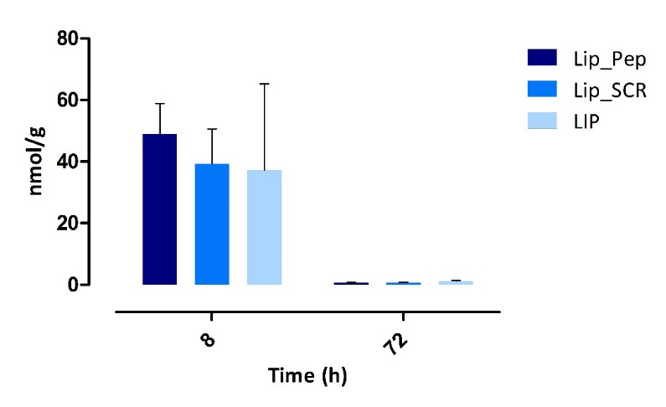
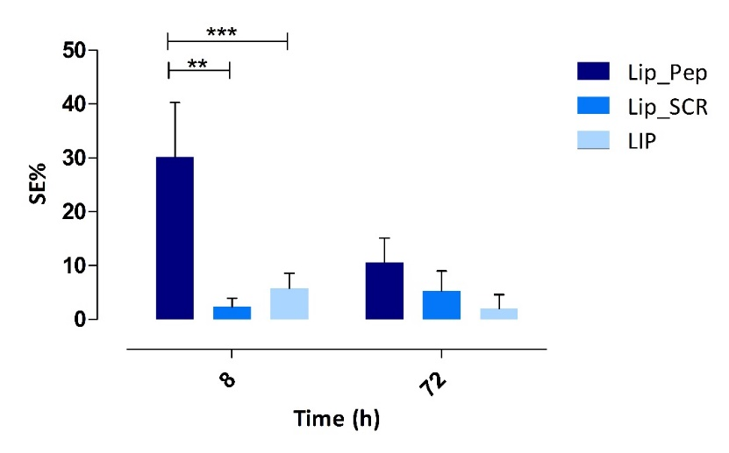
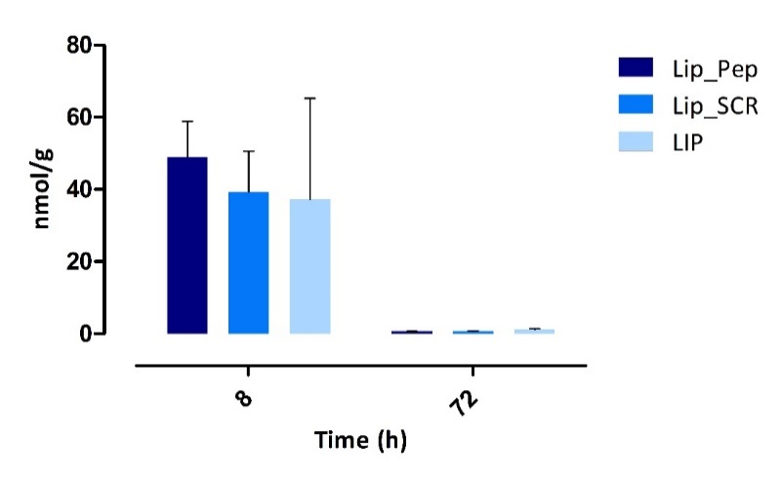
A
B

Fig. 3 Analysis of probes accumulation in tumors. (A) Quantification of Gd retained in the tumor by inductively coupled plasma mass spectrometry (ICP-MS) at 8h and 72h after injection of Lip_Pep, Lip_SCR and LIP. (B) T1-weighted MR signal enhancement in the tumor region for the three probes at 8h after injection. Values are the mean ± SD (at t=8, n = 5 for Lip_Pep and Lip_SCR; n=4 for LIP; * p < 0.05, ** p < 0.01, *** p < 0.001).

3.3 Confocal microscopy analysis
For this study, new sets of liposomes, analogous to those loaded with Gd-HPDO3A, were prepared by maintaining the same phospholipid formulation and replacing the Gd probe with a 10 μM solution of Rodamine B, named RLip_Pep, RLip_SCR and RLIP, respectively. Confocal microscopy images of TS/A cells treated with each set of fluorescence probes in vitro revealed that the rhodamine signal from the liposomes was located in the intracellular space for all the probes, confirming the occurrence of a cell internalization process (Figure 4). However, the fluorescent signals observed for the TS/A cells incubated with RLip_Pep appeared in two distinct forms, namely as discrete intense spots and as a diffuse distribution of fluorescence within the cytoplasm. Conversely, cells incubated with RLip_SCR and RLip showed the rhodamine signal only as concentrated intracellular spots.

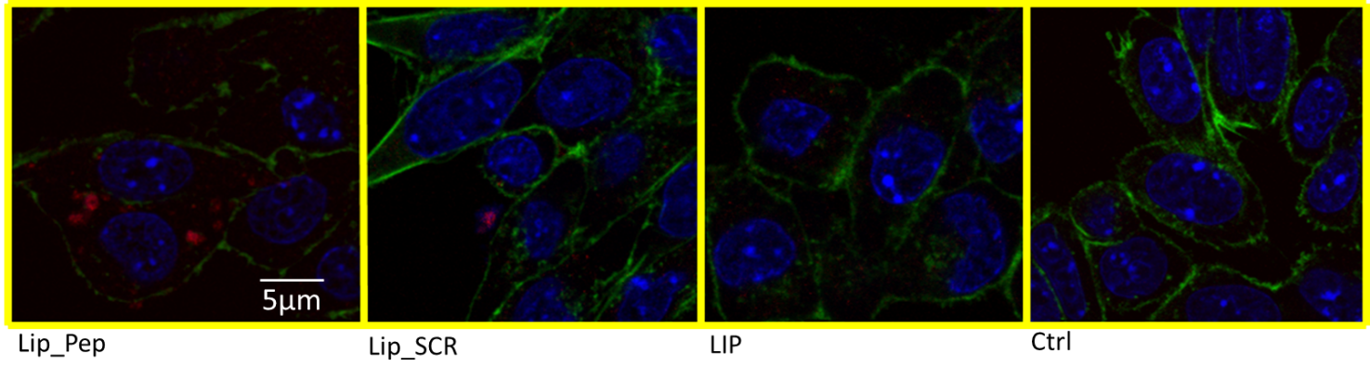
Figure 4 In vitro confocal microscopy images of probe internalization. TS/A cells were imaged using Leica Sp8 confocal microscope 24 hrs after incubation with Lip_Pep, Lip_Scr and LIP as well as culture medium as control. The nuclei and cytoskeleton were stained with DAPI (blue) and Phalloidin-FITC (green), respectively. The Rhodamine encapsulated in the liposomes is shown in red.

This finding suggests that the latter two probes are internalized via non-specific phagocytosis, as expected for nanoparticles incubated at 37°C[38]. However, alongside this internalization pathway, RLip_Pep appears to utilize also an alternative route that enables the rhodamine solution to diffuse throughout the cytoplasm, likely due to the binding with CAIX which activates a Receptor Mediated Endocytosis (RME)[39]. Conversely, all the contrast agent contained in RLip_SCR and RLIP appeared to be confined in endosome-like vesicles. On this basis have drawn the conclusion that the observed cytoplasmatic release of the fluorescent payload suggests an analogous distribution of GdHPDO3A that leads to its “dequenching”, responsible for the observed increase of the signal enhancement in MR images. These observations suggest that the TS/A cells can internalize the liposomes containing probes either by phagocytosis and by RME with the interesting corollary that, in the case of the liposomes bearing the targeting peptide, the release from the endosomal vesicles is much more efficient than the one occurring for systems entrapped in endosomes generated by phagocytosis.
To better investigate this aspect in its in vivo translation, confocal microscopy analysis was extended to the explanted tumor tissue obtained from breast cancer Balb/c murine models, threated with RLip_Pep or RLIP. Tumors have been explanted 8 h after injection, i.e. at the time where the peak in MRI signal was observed (Figure 2A). In a first set of experiments, after explantation and fixation, tumor slices nuclei have been stained with DAPI and cytoskeleton with Pholloidin.
The confocal images showed a similar staining trend in the allografts as observed with the TS/A cells in vitro (Figure 5)
A
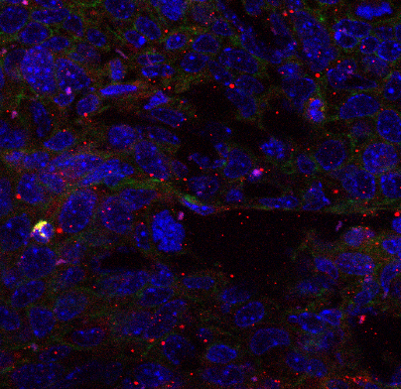
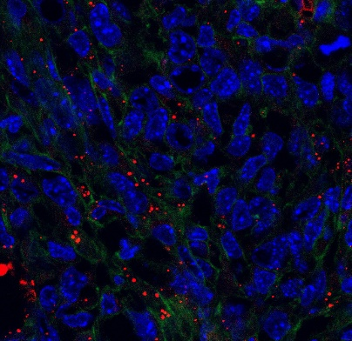
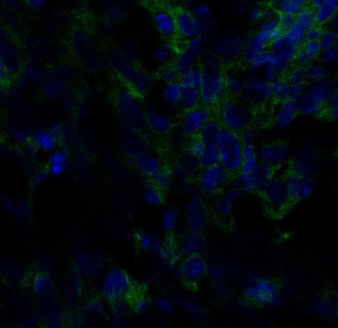
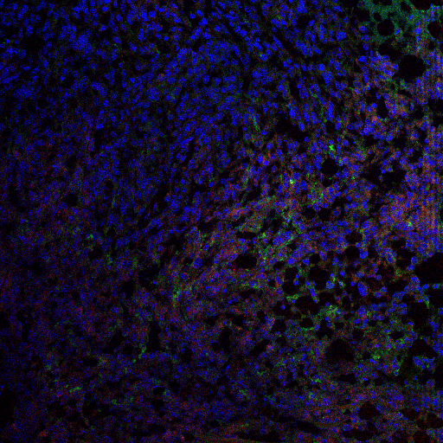
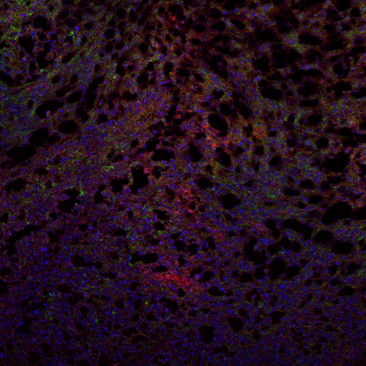
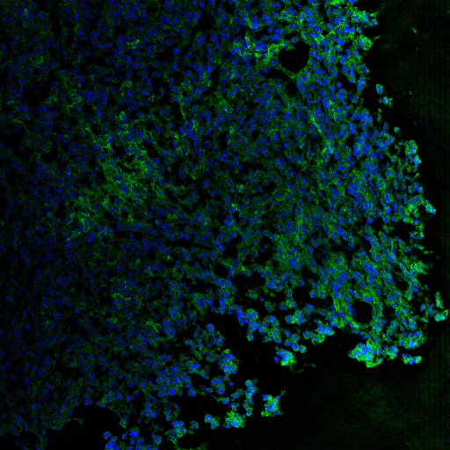
RLip_Pep
RLIP
Ctrl
B
Ctrl
RLip_Pep
RLIP

Figure 5 Confocal analysis on tumor tissue resected from breast cancer Balb/c murine models. Representative confocal microscopy images of tumor slices, prepared and mounted 8 hours after intravenously administration of RLip_Pep and RLIP. Rhodamine corresponds to the red signal. A) Cytoskeleton and nuclei were stained with phalloidin-FITC (green) and DAPI (blue), respectively; B) Macrophage cells and nuclei were marked with antibody F4/80 (green) and DAPI (blue), respectively (n = 2, biological replicates).

In fact, the distribution of the rhodamine B signal showed clear differences between the three groups of mice, namely in the form of spots for RLIP cases and both spots and diffuse fluorescence for RLip_Pep (Figure 5A). This supports the view that the percentage difference in Gd amount among the mice cohorts (as measured by ICP) is much lower than that observed in MRI signal enhancement. The increase in MRI signal is only partially due to the accumulation of Gd in the endosomes, being the major responsible for the observed MRI SE the GdHPDO3A “dequenching” effect that takes place in the cytoplasm.
Next, slices of the same tissues were stained with Dapi and anti-F4/80 antibodies to label cell nuclei and tissue macrophages, respectively. Figure 5B clearly shows how the Rhodamine signal is concentrated, in the case of RLIP, almost exclusively in the macrophage cells, confirming non-specific liposome transport within the cells. In contrast, in the case of incubation with RLip_Pep, the contrast agent, in addition to being captured by macrophages, accumulated within the tumor cells, likely due to the specific recognition of CAIX that promotes RME internalization[40].
Several studies have demonstrated a significantly more efficient release of cargo from endosomal vesicles in cases where liposomes are internalized through Receptor Mediated Endocytosis (RME), especially when the nanoparticles bear a targeting peptide [41][42]. In fact, RME has been shown to be a highly selective process that facilitates the uptake of specific ligands via receptor recognition and internalization. This pathway not only ensures the efficient delivery of therapeutic agents to targeted cells but also influences the subsequent intracellular trafficking and release of these agents[43]. This finding has emerged from several studies in the context of different targeting strategies, including anti-HER2 immunoliposomes and transferrin-conjugated liposomes [44][45].
In the case of anti-HER2 immunoliposomes, it has been demonstrated that the binding of immunoliposomes to HER2 receptors on cancer cells triggers endocytosis, leading to their internalization and subsequent trafficking to early endosomes. Histological studies have demonstrated that the targeting strategy did not increase the levels of liposomes in tumor cells but instead promoted more efficient intracellular drug delivery via the RME pathway, which is associated with enhanced antitumor activity[46][47].
Similarly, transferrin receptors have been widely exploited for targeted drug delivery using transferrin-conjugated liposomes. Transferrin, a glycoprotein responsible for iron transport, binds to its receptor and undergoes endocytosis, facilitating the delivery of liposomal cargo into the cell[48]. The high expression of transferrin receptors on rapidly dividing cells, such as cancer cells, makes this approach particularly effective [49].
Regarding CAIX, a study by Zatovicova et al. utilized antibodies against this enzyme found that this molecule is capable of inducing CAIX-mediated internalization[40]. Our findings are well consistent with literature and further highlight that targeting peptides, which facilitate receptor recognition and endocytosis, are crucial for improving intracellular delivery outcomes. The evidence of the specificity and cellular localization shown by Lip_Pep suggests a possible therapeutic use of the probe as a carrier for the delivery of chemotherapeutic agents, through CAIX, that exercise their action in the cytosolic space of tumor cells, also considering that early endosomal escape allows a drug to avoid degradation and inactivation within the lysosomal compartment.
As it has been shown for the Her2 receptor[44], the composition of the Lip_Pep membrane and its degree of pegylation could also influence the delivery mechanism of the liposome content. By leveraging RME, it would be possible to increase the efficacy of our strategy optimizing both targeting peptide and liposomal formulation.
Furtheremore, the MRI “quenching/dequenching” strategy applied in this work not only offers diagnostic advantages but could also serve as a powerful tool for in vivo evaluating the mechanism of liposomal drug delivery.

4. Conclusions
In conclusion, using an allograft breast cancer murine model, this is the first in vivo MRI study which shows that CAIX PG-targeting liposomes can be employed as effective diagnostic tool for tumors overexpressing this enzyme. The Lip_Pep probe selectively recognizes the CAIX isoform, due to the absence of the PG domain in all other carbonic anhydrase isoforms. This selectivity endows Lip_Pep with a high diagnostic value as the CAIX overexpression is strongly associated with poor prognosis.
Moreover, our study brought to light the ability of the PG domain of CAIX to promote internalization
of the targeting liposomes through a receptor-mediated endocytosis mechanism (RME) and a cargo release through endosomal escape. As a result of this mechanism, the liposomal content is released into the cytosol from endosome-like vesicles much efficiently compared to the phagocytic pathway. This finding suggests that Lip_Pep based probes could be considered for the design of effective theranostic agents, given its target specificity and its favorable intracellular behavior. Future research is warranted to refine and optimize these targeting strategies in order to maximize the diagnostic/therapeutic potential of liposome-based systems.

Acknowledgments
The authors acknowledge the financial support of the Italian Ministry of Research (FOE contribution) to the EuroBioImaging MultiModal Molecular Imaging Italian Node (www.mmmi.unito.it) coordinated by the Department of Molecular Biotechnology and Health Sciences at the University of Turin and the Institute of Biostructures & Bioimages of National Research Council.

References
[1] D. Miladinova, «Molecular Imaging in Breast Cancer», Nucl. Med. Mol. Imaging, vol. 53, fasc. 5, pp. 313–319, ott. 2019, doi: 10.1007/s13139-019-00614-w.
[2] T. Zheng, M. Jäättelä, e B. Liu, «pH gradient reversal fuels cancer progression», Int. J. Biochem. Cell Biol., vol. 125, p. 105796, ago. 2020, doi: 10.1016/j.biocel.2020.105796.
[3] R. Hamaguchi, M. Isowa, R. Narui, H. Morikawa, e H. Wada, «Clinical review of alkalization therapy in cancer treatment», Front. Oncol., vol. 12, p. 1003588, set. 2022, doi: 10.3389/fonc.2022.1003588.
[4] S. Fais e Y. Marunaka, «The Acidic Microenvironment: Is It a Phenotype of All Cancers? A Focus on Multiple Myeloma and Some Analogies with Diabetes Mellitus», Cancers, vol. 12, fasc. 11, p. 3226, nov. 2020, doi: 10.3390/cancers12113226.
[5] T. Todenhöfer et al., «Evaluation of carbonic anhydrase IX as a potential therapeutic target in urothelial carcinoma», Urol. Oncol. Semin. Orig. Investig., vol. 39, fasc. 8, p. 498.e1-498.e11, ago. 2021, doi: 10.1016/j.urolonc.2021.04.011.
[6] C. Ward et al., «New strategies for targeting the hypoxic tumour microenvironment in breast cancer», Cancer Treat. Rev., vol. 39, fasc. 2, pp. 171–179, apr. 2013, doi: 10.1016/j.ctrv.2012.08.004.
[7] C.-L. Chen, J.-S. Chu, W.-C. Su, S.-C. Huang, e W.-Y. Lee, «Hypoxia and metabolic phenotypes during breast carcinogenesis: expression of HIF-1α, GLUT1, and CAIX», Virchows Arch., vol. 457, fasc. 1, pp. 53–61, lug. 2010, doi: 10.1007/s00428-010-0938-0.
[8] S. A. K. Shamis, J. Edwards, e D. C. McMillan, «The relationship between carbonic anhydrase IX (CAIX) and patient survival in breast cancer: systematic review and meta-analysis», Diagn. Pathol., vol. 18, fasc. 1, p. 46, apr. 2023, doi: 10.1186/s13000-023-01325-9.
[9] Y. Lou et al., «Targeting Tumor Hypoxia: Suppression of Breast Tumor Growth and Metastasis by Novel Carbonic Anhydrase IX Inhibitors», Cancer Res., vol. 71, fasc. 9, pp. 3364–3376, mag. 2011, doi: 10.1158/0008-5472.CAN-10-4261.
[10] V. Alterio et al., «Crystal structure of the catalytic domain of the tumor-associated human carbonic anhydrase IX», Comput. Biol..
[11] S. Ames, S. Pastorekova, e H. M. Becker, «The proteoglycan-like domain of carbonic anhydrase IX mediates non-catalytic facilitation of lactate transport in cancer cells», Oncotarget, vol. 9, fasc. 46, pp. 27940–27957, giu. 2018, doi: 10.18632/oncotarget.25371.
[12] C. T. Supuran, «Carbonic anhydrases: novel therapeutic applications for inhibitors and activators», Nat. Rev. Drug Discov., vol. 7, fasc. 2, pp. 168–181, feb. 2008, doi: 10.1038/nrd2467.
[13] J. Brynda et al., «Carborane‐Based Carbonic Anhydrase Inhibitors», Angew. Chem. Int. Ed., vol. 52, fasc. 51, pp. 13760–13763, dic. 2013, doi: 10.1002/anie.201307583.
[14] O. C. Kulterer et al., «A Microdosing Study with ^{99m} Tc-PHC-102 for the SPECT/CT Imaging of Primary and Metastatic Lesions in Renal Cell Carcinoma Patients», J. Nucl. Med., vol. 62, fasc. 3, pp. 360–365, mar. 2021, doi: 10.2967/jnumed.120.245530.
[15] S. Kalinin et al., «Carbonic Anhydrase IX Inhibitors as Candidates for Combination Therapy of Solid Tumors», Int. J. Mol. Sci., vol. 22, fasc. 24, p. 13405, dic. 2021, doi: 10.3390/ijms222413405.
[16] A. S. A. Van Brussel et al., «Hypoxia-Targeting Fluorescent Nanobodies for Optical Molecular Imaging of Pre-Invasive Breast Cancer», Mol. Imaging Biol., vol. 18, fasc. 4, pp. 535–544, ago. 2016, doi: 10.1007/s11307-015-0909-6.
[17] K. Chamie et al., «Adjuvant Weekly Girentuximab Following Nephrectomy for High-Risk Renal Cell Carcinoma: The ARISER Randomized Clinical Trial», JAMA Oncol., vol. 3, fasc. 7, p. 913, lug. 2017, doi: 10.1001/jamaoncol.2016.4419.
[18] N. B. Haas et al., «Adjuvant Treatment for High-Risk Clear Cell Renal Cancer: Updated Results of a High-Risk Subset of the ASSURE Randomized Trial», JAMA Oncol., vol. 3, fasc. 9, p. 1249, set. 2017, doi: 10.1001/jamaoncol.2017.0076.
[19] S. C. Kleinendorst, E. Oosterwijk, J. Bussink, H. Westdorp, M. W. Konijnenberg, e S. Heskamp, «Combining Targeted Radionuclide Therapy and Immune Checkpoint Inhibition for Cancer Treatment», Clin. Cancer Res., vol. 28, fasc. 17, pp. 3652–3657, set. 2022, doi: 10.1158/1078-0432.CCR-21-4332.
[20] C. Lu et al., «Fabrication of mAb G250-SPIO Molecular Magnetic Resonance Imaging Nanoprobe for the Specific Detection of Renal Cell Carcinoma In Vitro», PLoS ONE, vol. 9, fasc. 7, p. e101898, lug. 2014, doi: 10.1371/journal.pone.0101898.
[21] J. Courcier, A. De La Taille, M. Nourieh, I. Leguerney, N. Lassau, e A. Ingels, «Carbonic Anhydrase IX in Renal Cell Carcinoma, Implications for Disease Management», Int. J. Mol. Sci., vol. 21, fasc. 19, p. 7146, set. 2020, doi: 10.3390/ijms21197146.
[22] C. H. J. Muselaers et al., «Optical Imaging of Renal Cell Carcinoma with Anti–Carbonic Anhydrase IX Monoclonal Antibody Girentuximab», J. Nucl. Med., vol. 55, fasc. 6, pp. 1035–1040, giu. 2014, doi: 10.2967/jnumed.114.137356.
[23] M. Aggarwal, C. D. Boone, B. Kondeti, e R. McKenna, «Structural annotation of human carbonic anhydrases», J. Enzyme Inhib. Med. Chem., vol. 28, fasc. 2, pp. 267–277, apr. 2013, doi: 10.3109/14756366.2012.737323.
[24] E. Langella, M. Buonanno, G. De Simone, e S. M. Monti, «Intrinsically disordered features of carbonic anhydrase IX proteoglycan-like domain», Cell. Mol. Life Sci., vol. 78, fasc. 5, pp. 2059–2067, mar. 2021, doi: 10.1007/s00018-020-03697-3.
[25] H. M. Becker e J. W. Deitmer, «Proton Transport in Cancer Cells: The Role of Carbonic Anhydrases», Int. J. Mol. Sci., vol. 22, fasc. 6, p. 3171, mar. 2021, doi: 10.3390/ijms22063171.
[26] A. Innocenti, S. Pastorekova, J. Pastorek, A. Scozzafava, G. D. Simone, e C. T. Supuran, «The proteoglycan region of the tumor-associated carbonic anhydrase isoform IX acts as anintrinsic buffer optimizing CO2 hydration at acidic pH values characteristic of solid tumors», Bioorg. Med. Chem. Lett., vol. 19, fasc. 20, pp. 5825–5828, ott. 2009, doi: 10.1016/j.bmcl.2009.08.088.
[27] J. Guenoun, G. N. Doeswijk, G. P. Krestin, e M. R. Bernsen, «Compartmentalization of Gd liposomes: the quenching effect explained», Contrast Media Mol. Imaging, vol. 11, fasc. 2, pp. 106–114, mar. 2016, doi: 10.1002/cmmi.1669.
[28] A. John, M. Sivashanmugam, S. K. Natarajan, e V. Umashankar, «Computational modeling of novel inhibitory peptides targeting proteoglycan like region of carbonic anhydrase IX and in vitro validation in HeLa cells», J. Biomol. Struct. Dyn., vol. 38, fasc. 7, pp. 1995–2006, mag. 2020, doi: 10.1080/07391102.2019.1623075.
[29] P. Liu, G. Chen, e J. Zhang, «A Review of Liposomes as a Drug Delivery System: Current Status of Approved Products, Regulatory Environments, and Future Perspectives», Molecules, vol. 27, fasc. 4, p. 1372, feb. 2022, doi: 10.3390/molecules27041372.
[30] N. Kostevšek et al., «Magneto-Liposomes as MRI Contrast Agents: A Systematic Study of Different Liposomal Formulations», Nanomaterials, vol. 10, fasc. 5, p. 889, mag. 2020, doi: 10.3390/nano10050889.
[31] V. P. Torchilin, «Recent advances with liposomes as pharmaceutical carriers», Nat. Rev. Drug Discov., vol. 4, fasc. 2, pp. 145–160, feb. 2005, doi: 10.1038/nrd1632.
[32] S. Aime, A. Barge, E. Gianolio, R. Pagliarin, L. Silengo, e L. Tei, «High Relaxivity Contrast Agents for MRI and Molecular Imaging», in Molecular Imaging, vol. 49, A. A. Bogdanov e K. Licha, A c. di, in Ernst Schering Research Foundation Workshop, vol. 49. , Springer Berlin Heidelberg, 2005, pp. 99–121. doi: 10.1007/3-540-26809-X_6.
[33] L. Šturm e N. Poklar Ulrih, «Basic Methods for Preparation of Liposomes and Studying Their Interactions with Different Compounds, with the Emphasis on Polyphenols», Int. J. Mol. Sci., vol. 22, fasc. 12, p. 6547, giu. 2021, doi: 10.3390/ijms22126547.
[34] E. Di Gregorio et al., «The Issue of Gadolinium Retained in Tissues: Insights on the Role of Metal Complex Stability by Comparing Metal Uptake in Murine Tissues Upon the Concomitant Administration of Lanthanum- and Gadolinium-Diethylentriamminopentaacetate», Invest. Radiol., vol. 53, fasc. 3, pp. 167–172, mar. 2018, doi: 10.1097/RLI.0000000000000423.
[35] C. Quattrociocchi, A. Mangia, S. Aime, V. Menchise, e D. Delli Castelli, «Molecular Resonance Imaging of the CAIX Expression in Mouse Mammary Adenocarcinoma Cells», Pharm. Basel Switz., vol. 16, fasc. 9, p. 1301, set. 2023, doi: 10.3390/ph16091301.
[36] D. M. Corsi, C. Platas‐Iglesias, H. V. Bekkum, e J. A. Peters, «Determination of paramagnetic lanthanide(III) concentrations from bulk magnetic susceptibility shifts in NMR spectra», Magn. Reson. Chem., vol. 39, fasc. 11, pp. 723–726, nov. 2001, doi: 10.1002/mrc.922.
[37] E. di Gregorio, L. Lattuada, A. Maiocchi, S. Aime, G. Ferrauto, e E. Gianolio, «Supramolecular adducts between macrocyclic Gd(III) complexes and polyaromatic systems: a route to enhance the relaxivity through the formation of hydrophobic interactions», Chem. Sci., vol. 12, nov. 2020, doi: 10.1039/d0sc03504a.
[38] T. B. Gandek, L. Van Der Koog, e A. Nagelkerke, «A Comparison of Cellular Uptake Mechanisms, Delivery Efficacy, and Intracellular Fate between Liposomes and Extracellular Vesicles», Adv. Healthc. Mater., vol. 12, fasc. 25, p. 2300319, ott. 2023, doi: 10.1002/adhm.202300319.
[39] P. Stahl e A. L. Schwartz, «Receptor-mediated endocytosis», J. Clin. Invest., vol. 77, fasc. 3, pp. 657–662, mar. 1986, doi: 10.1172/JCI112359.
[40] M. Zatovicova et al., «Novel humanized monoclonal antibodies for targeting hypoxic human tumors via two distinct extracellular domains of carbonic anhydrase IX», Cancer Metab., vol. 10, fasc. 1, p. 3, dic. 2022, doi: 10.1186/s40170-022-00279-8.
[41] Y. Fidan, S. Muçaj, S. S. Timur, e R. N. Gürsoy, «Recent advances in liposome-based targeted cancer therapy», J. Liposome Res., vol. 34, fasc. 2, pp. 316–334, giu. 2024, doi: 10.1080/08982104.2023.2268710.
[42] Y. Alhamhoom et al., «Recent advances in the liposomal nanovesicles based immunotherapy in the treatment of cancer: A review», Saudi Pharm. J., vol. 31, fasc. 2, pp. 279–294, feb. 2023, doi: 10.1016/j.jsps.2022.12.008.
[43] M. Ritchie, L. Tchistiakova, e N. Scott, «Implications of receptor-mediated endocytosis and intracellular trafficking dynamics in the development of antibody drug conjugates», mAbs, vol. 5, fasc. 1, pp. 13–21, gen. 2013, doi: 10.4161/mabs.22854.
[44] E. Canato et al., «Anti-HER2 Super Stealth Immunoliposomes for Targeted-Chemotherapy», Adv. Healthc. Mater., vol. 12, fasc. 29, p. e2301650, nov. 2023, doi: 10.1002/adhm.202301650.
[45] Y. Guo, L. Wang, P. Lv, e P. Zhang, «Transferrin-conjugated doxorubicin-loaded lipid-coated nanoparticles for the targeting and therapy of lung cancer», Oncol. Lett., vol. 9, fasc. 3, pp. 1065–1072, mar. 2015, doi: 10.3892/ol.2014.2840.
[46] K. Liang, S. Mei, X. Gao, S. Peng, e J. Zhan, «<p>Dynamics of Endocytosis and Degradation of Antibody-Drug Conjugate T-DM1 in HER2 Positive Cancer Cells</p>», Drug Des. Devel. Ther., vol. 15, pp. 5135–5150, dic. 2021, doi: 10.2147/DDDT.S344052.
[47] A. Rodallec et al., «Docetaxel-trastuzumab stealth immunoliposome: development and in vitro proof of concept studies in breast cancer», Int. J. Nanomedicine, vol. Volume 13, pp. 3451–3465, giu. 2018, doi: 10.2147/IJN.S162454.
[48] C. Zheng, C. Ma, E. Bai, K. Yang, e R. Xu, «Transferrin and cell-penetrating peptide dual-functioned liposome for targeted drug delivery to glioma».
[49] S. Mojarad-Jabali et al., «Transferrin receptor-mediated liposomal drug delivery: recent trends in targeted therapy of cancer», Expert Opin. Drug Deliv., vol. 19, fasc. 6, pp. 685–705, giu. 2022, doi: 10.1080/17425247.2022.2083106.

Supplementary Material

Liposome characterization. Probes were assessed for diameter, polydispersity, and zeta potential using Dynamic Light Scattering. The average diameter of liposomes is 180 nm.

Figure S1. Table reporting liposomes parameters. Gd concentration was measured using an Evans assay on a 600 MHz Bruker spectrometer.

Biodistribution of Lip_Pep. SE after iv injection over time has been measured in liver, kidney and tumor.
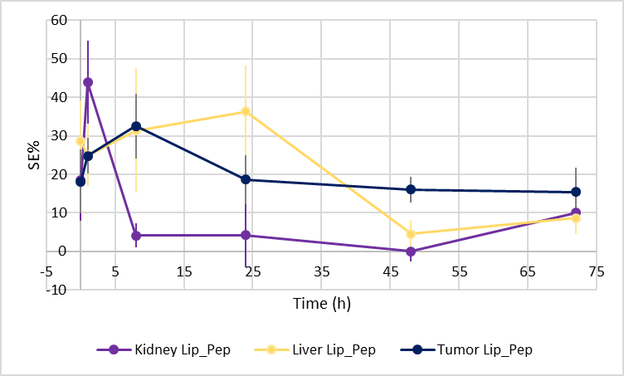

Figure S2 Lip_Pep Biodistribution . Graph shows the SE% measured in kidney, liver and tumor over time. Values are the mean ± SD (at t=0, 1 and 8h, n = 5; at t=24, 48, 72h, n = 3).

