Supplementary material

Clinical report and neuroimaging of ADLD patients not included in the Italian cohort.

ASYM
A duplication of chromosome 5 was identified as incidental finding in a 40-year-old woman who had a chromosome microarray to segregate a different copy number variant identified in her affected child. The microarray (Illumina Infinium Global Screening Array-24 v1.0) identified an 4,35Mb duplication encompassing the LMNB1 gene [ chr5:(121,833,008-126,180,013)x3; GRCh37/hg19]. Whole genome sequencing (NEBNext® Ultra™ II DNA Library Prep Kit, NEB) was performed to further characterize the CNV (sequencing outsourced to Personal Genomics srl, Italy). The library was sequenced on a Novaseq X Plus (Illumina; PE-150 bp). Illumina sequencing reads were mapped to the GRCh37/hg19 genome of reference with Isaac-align (ver. 04.18.11.09). For CNVs calling we exploited Manta (ver. 1.6.0) and CNVnator (ver. 0.4), improving the resolution of the CNV to <1Kb [chr5:(121,813,001-126,177,000)x3; GRCh37/hg19]. Further segregation analysis of the duplication in the family (parents of the 40-year-old carrier) showed the same CNV in the 68-year-old mother.

Overview of the duplication characterized by WGS analysis. A zoom of the two breakpoints (BPs) called by CNVnator (ver. 0.4) is shown (Resolution <1Kb). The LMNB1 gene (chr5:126,112,315-126,172,712) is fully duplicated even if located in close proximity to the telomeric BP. Interestingly, whole-blood RNA-seq data showed that none of the genes encompassed by the duplication is overexpressed, including LMNB1 which seems to be downregulated compared to the control (Supplementary Fig.6).

Neither of the people with the LMNB1 duplication had symptoms suggestive of ADLD. The 40-year-old individual had an MRI scan that was normal with no suggestion of white matter abnormality. The 68-year-old had an MRI and this revealed white matter changes consistent with small vessel ischemia rather than changes expected from ADLD (see below).
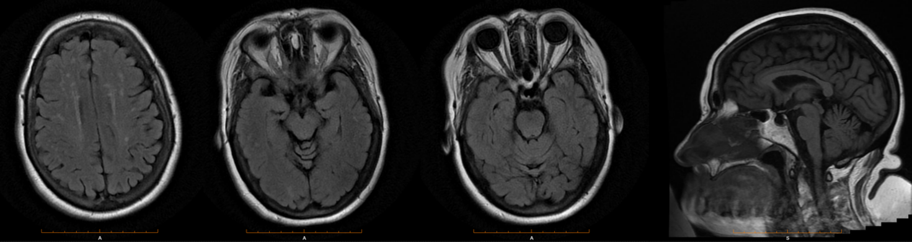
Axial and sagittal fluid attenuated inversion recovery (FLAIR) images of the 68-years-old asymptomatic subject carrying an inter-TAD LMNB1 duplication (ASYM).

