[Ag(PPh3)4][(PPh3)CdCl3], the first monomeric trichlorocadmate complex bonded to a phosphorous ligand: a structural and spectroscopic study in solution and solid state.

.

Emanuele Priola *a*, Elisabetta Bonometti *a*, Roberto Rabezzana *a*, Roberto Buscaino *a*, Lorenza Operti *a*, Eliano Diana *a* *

*a* Chemistry Department, University of Turin, Via Pietro Giuria 7, 10125, Turin

b CrisDi, Interdepartmental Center for Crystallography,

Head Office: Chemistry Department, Via Pietro Giuria 7, 10125, Turin

(*)[eliano.diana@unito.it](mailto:eliano.diana@unito.it)

ABSTRACT

The complex [Ag(PPh3)4][(PPh3)CdCl3] was synthesized and the crystal structure was determined. The structure of this complex in the solid state was confirmed by 31P SS-NMR, Raman and Ir spectroscopy. This compound presents one of the rare cases of monomeric trichlorocadmate, the first reported with a phosphorus ligand and the second with a soft donor. The absorption and emission properties of this compound in the solid state was analyzed by computational modeling, and some interpretations has been done. For the rarity of the complex, we use the ESI-MS technique to check the existence of this anion and to analyze the speciation for the Ag+ and Cd2+ in ethanolic solution in presence of chloride and PPh3. The results indicate the instability in solution of [(PPh3)CdCl3]- and the role of silver- PPh3 system to organize the crystal structure during the crystal growth.

Cadmium has a really versatile chemistry. This metal is intermediate in his softness, and for this reason it can bond both soft and hard donor, with a multiplicity of coordination geometries. The interest in this chemistry is not only due to its structural peculiarities, but also for the properties its compounds can exhibit that are of great deal in material science: catalytic properties, luminescence and second harmonic generation . Cadmium complexes have been also used as starting materials for the synthesis of typical semiconductor materials like CdS and CdSe and for the improvement of light absorption of solar cell. The chloride anion is intriguing in this context because is one of the most usual ligand in the chemistry of this metal, especially for the anionic complexes formed, and for his possibility to form coordination polymers. This is clear in a CCSD search, that found 1620 entries with Cd-Cl bond in the 12677 structure deposited with cadmium, only 732 of that not polymeric in nature (but 189 of those are at least dimeric) and 481 not charged. In this large amount of compound structurally analyzed, most of the anionic species are CdCl42- or multiple of this unit (189 entries). For monoanionic CdCl3-, the situation is much more peculiar: only 10 molecular results are obtained, and the inorganic results consist in coordination polymers. This can be considered strange, because of the large stability in solution of free CdCl3- and of its multiple. This 10 structures consist in C,N or S- donors and consist in a RCdCl3 more or less distorted tetrahedral ( it can be seen a tendency to have one bond shorter that the others, but for the little amount of data it cannot be seen if this is an effect of packing forces or some more specific effect). In this contest, it can be considered strange the absence of some complex of phosphine ligands: phosphines are one of the oldest family of cadmium ligands, the complex (PPh3)2CdCl2 is known for a long time and very stable in solution and solid state, but solution studies demonstrates that PPh3 complexes can dissociate in solution and undergo ligand redistribution. In this Communication we present the heterobimetallic compound [Ag(PPh3)4][(PPh3)CdCl3] (**1**), obtained associating the Cadmium chloride and triphenylphosphine in excess of chloride. This compound is the first trichlorocadmiate anion bonded to a phosphorous ligand, the first cadmate complex with phosphine ligand and one of the rare cases of RCdCl3- bonded to a soft donor. The synthesis consists in the preparation of two 10 ml equimolar ethanolic solution of the anion [(PPh3)CdCl3]- and the cation [Ag(PPh3)4]+ using CdCl2, NaCl, AgNO3 and PPh3. The two solution need to be maintained at boiling point in reflux for 5 hour to be sure of obtaining the equilibrium, and to dissolve NaCl it is necessary to add 1 ml of distilled H2O to the ethanol . After that, they can be mixed without any perturbation with a Pasteur and maintained in a warm condition to obtain a very slow cooling, if it is possible Schlenk tube immersed in hot water in a Dewar flask. After 2 days, very big prismatic colourless crystals of **1** start to growth, that are stable in air and humidity. The nature of this product has been identified by single crystal X-ray diffraction, Ir, Raman and 31P NMR in the solid state. The crystal structure reveal the nature of bimetallic complex dominated by Van der Vaals forces, maximized by the correspondence of each phosphine with another phosphine of the other counterpart. The cadmium atom present a distorted tetrahedral environment with the three chloride anions at similar distances(2.4376(18), 2.4414(15) and 2.4477(12)) and the phosphorous at 2.6594(9) Å for the bigger dimensions. This distance is a little longer that the usual Cd-PPh3 distance, that is 2.59-2.60 Å, and this can be a clue of the weakness of this bond. The other techniques confirm the structure obtained: the Ir and Raman spectra are dominated by PPh3 signals with minor modifications for the coincidence of Cd-Cl modes with phosphine modes, while the NMR spectrum shows the coupling of 31P with the two isotopes of Cd (s= ½) that generate a triplet and the coupling of 31P with Ag (s=1/2) and 3 31P (s=1/2) that generate a multiplet with J1(Ag-P)= 233 Hz, coherent with the literature. However, there is no signal of fluxional behavior of the ligands and of disorders in the crystal structure, so the two fragments are stable in the solid state.

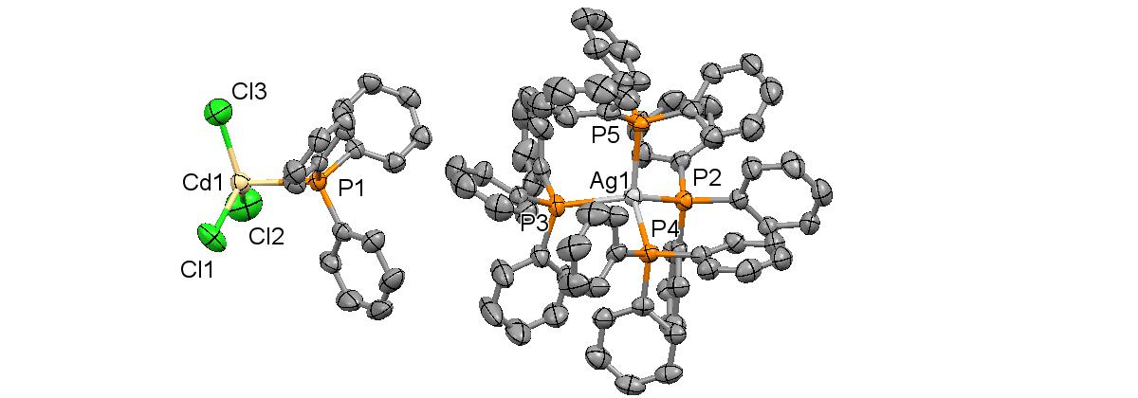With the aim of obtaining new possible combination of cations that can cocrystallize with [(PPh3)CdCl3]- we tried to obtain the salts of this anion with MCln (M= all the alkaline and alcaline-earth elements, n=1,2), but no one crystallize, while we obtained the stable (PPh3)2CdCl2 and M[CdCl3], as it is clear by checking the crystal obtained and by Ir and Raman measurements on the products. In the same time, measuring the Uv-Vis properties of the ethanolic solution of this complex, we discover a strong correlation of the spectra with the concentration and the aging time, so we decided to analyze the solution behavior of the anion in solution and the possibility of a deep role of

a b

1) 31P SSNMR spectrum and crystal structure of **1**

the silver cation in the stability of this peculiar system. We use ESI-MS spectrometry to analyze three ethanolic solution at 10-3, 10-6 and 10-7 M of **1,** Na[(PPh3)CdCl3] ( hypothetical formula for the equimolar solution of CdCl2, NaCl and PPh3) and [Ag(PPh3)4]NO3, prepared just before the measurements and 9 hour before. This techniques clarify a little the situation of the solution: 1) it is clear from the negative spectra at every concentration and at every ageing time, for **1** and the equimolar solution of CdCl2, NaCl and PPh3, that there is no presence of [(PPh3)CdCl3]- (m/z = 470 ua) in solution, and that this anion is stable only in solid state. 2) the cationic part is dominated by [Ag(PPh3)2]+, and the presence of cadmium chloride alter only few the equilibria by the appearance of polinuclear complexes like [Cl(Ag(PPh3)2]+. 3) The solutions of cadmium chloride at every concentration tend to polymerize through chloride anion more that to form mononuclear complexes with PPh3 with species like CdCl3-, Cd2Cl5- etc. 4) The presence of the silver cation, however, tend to reduce the tendency of cadmium cloride to aggregate in solution. 5) there aren’t great differences between the fresh solution and the aged solution, probably because the equilibria are quite fast. This considerations are very interesting to consider the rarity of system analogous of this one: the anionic part does not exist in solution, and is stabilized only by a cation that allow the reduction of the aggregation and that can cover the anion in the solid structure. For this reason, probably the [Ag(PPh3)4]+ cationic complex is perfect, because it can maximize the Van der Vaals forces and at the same time isolates the anions, allowing the separation of the clusters.



a b



c d

2) ESI-MS spectra of (a) an ethanolic solution 10-2M of (CdCl2 +NaCl+PPh3) (negative charge) (b) an ethanolic solution 10-3M of (AgNO3+4 PPh3)( positive charge) (c and d) an ethanolic solution 10-6M of **1** (positive and negative charge)

In summary, the complex [Ag(PPh3)4][(PPh3)CdCl3] has been synthesized and characterization at the solid state with SCXRD, Ir, Raman and 31P-SSNMR. This complex represent the first example of a monomeric trichlorocadmate with a phosphorous ligand and one of the rare example of molecular monomeric RCdCl3- complexes. We studied the stability of this specie in ethanolic solution and we discovered that it does not exist in solution. Our hypothesis is that during the crystal growth the cationic part allows the stabilization of this anion.