Structural and spectroscopic study of the asymmetric 2-(2’-pyridyl)-1,8-naphthyridine ligand with closed-shell metals
Alessia Giordana,ª Emanuele Priola,ª Elisabetta Bonometti,^{a,b} Paola Benzi, ª Lorenza Operti,ª Eliano Diana ^{a,b*}
^{[a]} Department of Chemistry, University of Turin, Via Pietro Giuria 7, 10125 Turin, Italy
^{[b]} CrisDi- Interdepartmental Center for Crystallography, University of Turin
* eliano.diana@unito.it
Abstract: Herein, we report the synthesis and characterization of a series of complexes of the asymmetric ligand 2-(2’-pyridyl)-1,8-naphthyridine (pyNP, 1) with different closed-shell metals. For the first time ligand pyNP has been structurally and vibrationally characterized. The geometry of the pyNP ligand, with 3 N donor sites, can favor metallophilic interaction in complexes, so we performed a study on its coordination chemistry with different metals (Ag(I), Hg(II) and Pb(II)). Twelve new complexes, namely [Ag₂(pyNP)₂(NO₃)₂] (2), [Hg(pyNP)X₂](X=Cl(3), Br(4), I(5), CN(6), SCN(7, 8)), [Pb(pyNP)₂(NO₃)₂] (9), [Pb(pyNP)(NO₃)₂]₂ (10), [Cu(pyNP)Cl₂(H₂O)] (11), [Cu(pyNP)₂(H₂O)][Hg₂(CN)₄Cl₂]∙H₂O (12) and [Cu(pyNP)(H₂O)₂(μ-CN)Hg₂(CN)₃Cl₂]∙H₂O (13), have been synthesized and characterized by single crystal X-Ray diffraction, Raman, FTIR and electronic spectroscopies. Structure of complex 2 shows a supported argentophilic interaction, and is the first structure in which pyNP bonds two previously unbounded metal centers.
Keywords: naphthyridine • d¹⁰ metals • coordination complexes • luminescence • metallophilic interactions
Introduction
Molecular and polymeric complexes of transition metals with N-heterocyclic polyaromatic Schiff base ligands have been widely studied because of their stability in different conditions, and their luminescence, electrochemical and catalytic properties.[] Naphthyridines consist of a group of diazanaphthalenes with one nitrogen in each ring but none at the bridgehead position. Among the six possible isomers, the 1,8-naphthyridine(NP) and its derivatives have shown the most interesting properties. They exhibit biological activity: nalidixic acid (1-ethyl-7-methyl-4-oxo-1,8-naphthyridine-3-carboxylic acid) was the first NP approved as an antibacterial drug.[] This molecule is active against gram-negative and gram-positive bacteria. It prevents the DNA repetition in prokaryotes by exclusion of several bacteriophages,[] and his derivativeshave led to a new set of powerful antibiotics, alone and in the form of silver complexes.[, , ] Some oxadiazole and triazole derivatives have shown recently a very strong HIV-1 integrase inhibitor activity.[, ] 1,8-Naphthyridin–BF₂ complexes are known to be fluorescent dyes with high chemical stability, high fluorescence quantum yields, high extinction coefficients and sharp fluorescence peaks.[,] Starting from 1970, NP has been regularly used as a ligand in the field of coordination chemistry.[] A great number of mononuclear molecular complexes of transition metals and lanthanide has been reported.^{[4]} In these compounds NP can act as unidentate or bidentate chelating ligand. The small distance between N atoms promotes the formation of four-member chelate rings that allow high coordination for the metals involved. The syn disposition of two N lone pairs of NP favours the formation of binuclear systems by means oof a bridging coordination.^{[2]} The pliability of NP bite allows it to bridge a range of preformed dimetals cores,like the singly bonded dirhodium(II)[] or the quadruply bonded dimolybdenum(II)[] systems, and to stabilize mixed valence complexes.[ ] The formation of weakly interacting dimetal cores, such as Cu(I)···Cu(I)[] and Ag(I)···Ag(I)[], bridged by supported metallophilic interactions, has also been reported, while the only reportedAu(I) complex doesn’t show this behavior.[] Incorporation of coordinating substituent in position 2 and 7 (like pyridyl and dicarboxylate) favours the formation of polydentate, cavity-shaped molecules. Symmetric 2,7-bis(2’-pyridyl)-1,8-naphthyridine (bpNP) can act as bridging and chelating ligands,and the “double chelation” Specular chelation strongly stabilizes dimetallic cores, like in complexes of the type [M₂(μ-bpNP)( μ-O₂CMe)₂] (M=Rh, Ru)[] in which the bpNP ligand occupies the axial position, trans to the metal–metal bond. Asymmetric substituted derivatives of NP can be interesting systems. Among them, one of the less studied is 2-(2’-pyridyl)-1,8-naphthyridine(pyNP, 1) which, in addition to the syn N atom of the naphthyridinyl rings, has a pyridyl substituent. This molecule doesn’t have a strong dipole (calculated 4.56 D) or hydrogen donor groups.
(a)(b)
Figure 1. Bridging bimetallic (a) and chelating monometallic (b) coordination modes of 2-(2’-pyridyl)-1,8-naphthyridine (pyNP, 1) with metal centres.
The Cambridge Structural Database (CSD, February 2017), reports 35 structures of complexes with pyNP, and two different coordination modes can be observed (Figure 1): the most arechelate monometallic complexes, and some are bridged bimetallic compounds. In the former, pyNP acts like the 2,2’-bipyridine (bipy) ligand, and in the latter, it stabilizes binuclear metal salts. Most of the monometallic chelating complexes reported are based on Ru and Ir, useful for processes like water oxidation and H₂ production, thanks to their electrochemical and photochemical properties.[,,,] The electronic properties of complexes with general formula [M₂(pyNP)₂(OAc)₂]X₂ have been investigated, and the series of Rh, Ru, Mo complexes shows redox activitywith until four one-electron reversible reductions.[] Structural and reactivity studies of pyNP unit have been done for Ru[] and Re[]. Ru forms paddlewheel complexes, while with Re a trans planar disposition of ligands is obtained. No studies have been reported about coordination with closed-shell d¹⁰ and s²d¹⁰ metals. This family of metals shows unique features: (i) the presence of strong metallophilic interactions in coinage metals[] or mercury[]; (ii) the tendency for mercury to give linear coordination [], gold[] or silver; (iii) the presence of stereochemically active lone pairs in post transition metals like lead[] and bismuth[]. All these features can give interesting structural and photochemical properties, useful both for LED[] and sensor[] production. We performed a study on the coordination chemistry of pyNP with closed-shell metals, alone or in competition with other ions, in order to analyze the behavior of this ligand. Its geometry and the presence of three N atoms can favour the formation of metallophilic interactions and affect the luminescence properties. Metals with differing dimension and metallophilic behaviour have been employed: Ag(I) (covalent radius(c.r.) 1.45 Å[], with a tendency to metallophilic interanctions^{[26]}), Hg(II) (c.r 1.32 Å^{[34]}, low metallophilic interactions^{[27]}) and Pb(II) (c.r. 1.46 Å^{[34]}, very low metallophilic interaction[]). We reported the synthesis and the structural and vibrational study of the ligand itself (pyNP, 1) and of 12 new molecular complexes: [Ag₂(pyNP)₂(NO₃)₂] (2), [Hg(pyNP)X₂] (X=Cl(3), Br(4), I(5), CN(6), SCN(7, 8)), [Pb(pyNP)₂(NO₃)₂] (9), [Pb(pyNP)(NO₃)₂]₂ (10), [Cu(pyNP)Cl₂(H₂O)] (11), [Cu(pyNP)₂ (H₂O)] [Hg₂(CN)₄Cl₂]∙H₂O (12) and [Cu(pyNP)(H₂O)₂(μ-CN) Hg₂(CN)₃Cl₂]∙H₂O (13). The electronic properties of all compounds in the solid state have been investigated.
Materials and methods
General methods. All reagents and solvents are commercial products. The ligand pyNP (1) was synthesized according to the published method ^{[23, 24]} (yield 79%; orange crystals were obtained from water solution). The ¹H-NMR solution spectrum has been measured, and it is perfectly comparable to the reported one^{[24]} ('H NMR 300 MHz (CDCl₃) δ ppm: 7.36 (m, 1H), 7.48 (m, 1H), 7.87 (m, 1H), 8.21 (m, 1H), 8.30 (m, 1H), 8.72 (d, 2H), 8.86 (m, 1H), 9.13 (m, 1H)). Anal. Calc. for C₁₃N₃H₉: C 75.3; H 4.4; N 20.3. Found: C 75.6; H 4.1; N 20.5. All products have been characterized by means of Single Crystal X-Ray Diffraction (SC XRD), vibrational and electronic spectroscopy. Single crystals were generally obtained directly from synthetic procedures. Correspondence between the bulk and SC XRD structures as well as sample purity were checked for the compounds 2-13 by comparison of experimental and calculated powder XRD (PXRD) patterns (see Supplementary Information). The elemental analyses (C, H, N and S) were carried out using a Thermo FlashEA 1112 CHNS-O analyzer.
X-Ray crystallography. Single crystal data have been collected on a Gemini R Ultra diffractometer (Agilent Technologies UK Ltd., Oxford, U.K.) using graphite-monochromatic Mo Kα radiation (λ=0.71073 Å) with the ω-scan method. CrysAlisPro software[] has been used for retrieving cell parameters, for performing data reduction and for absorption correction (with multi-scan technique). All structures were solved by direct methods using SHELXS-97[] and refined with full-matrix least-squares on F² using the SHELXL-97^{[37]}. All non-hydrogen atoms have been anisotropically refined. Hydrogen atoms have been placed at calculated positions and refined with a riding model on the corresponding C atoms. Crystal data and refinement, selected bonds lengths and angles amplitudes and asymmetric units of compound 1-13 are reported in Supplementary Information. In the structure of compound 9, the nitrate anion show a positional disorder resolved in two different positions. For the non-centrosymmetric structures (1 and 12) the enantiomorph has been checked by means of the Flack parameter[] but for 1 no meaningful value has been obtained (there are only light atoms in the molecule)[]. As expected, the highest peaks and deepest holes for the mercury and lead complexes are slightly high, but the residual densities are close to heavy atoms. Powder data have been collected with the same instrument, using a Cu Kα radiation (λ=1.5418 Å) on the milled samples.
Vibrational Spectroscopy. Spectra were recorded for all products, on crystalline or powder samples. FT-Raman spectra were obtained with a Bruker Vertex 70 spectrometer, equipped with the RAMII accessory, by exciting with a 1064 nm laser, with a resolution of 4 cm⁻¹. FTIR spectra were obtained with a Bruker Vertex 70 spectrophotometer equipped with the Harrick MVP2 ATR cell. FIR spectra were obtained with the same instrument, using a DTGS detector. Micro Raman spectra were recorded on single crystals with a Horiba Jobin Yvon HR800 spectrometer, by exciting with a 532 nm laser.
Electronic Spectroscopy. The UV-VIS spectra of the samples in the solid state were recorded on KBr pellets and on pure solid powders by employing a Perkin Elmer Lambda 900 spectrophotometer in reflectance mode. Comparison of spectra of pure and diluted samples makes possible to clearly identify visible and UV bands, and to check possible mechanochemical reactions. The photoluminescence measurements were recorded on KBr pellets using a Fluorolog F2 Horiba/ Jobin-Yvon spectrofluorimeter.
Computational analysis. DFT calculations on pyNP (1) were carried out by employing the B3LYP hybrid functional and 6-311G(d, p) basis set. The molecular geometry has been optimized to an energy minimum and harmonic vibrational frequencies computed. The electronic transitions have been obtained from TD-DFT method with the same base set and hybrid functional.
Synthesis of [Ag₂(pyNP)₂(NO₃)₂] 2. AgNO₃ (25.5 mg, 0.150 mmol) was dissolved in water and mixed under heating with an aqueous solution of 1 (31.1 mg, 0.150 mmol). The resultant yellow solution was boiled and concentrated, changing color into red. From slow evaporation of the solvent, after a week red crystals were obtained, that were collected and washed with cold water. Yield: 95%. Anal. Calc. for Ag₂C₂₆N₈H₁₈O₆: C 41.4; H 2.4; N 14.8. Found: C 41.1; H 2.8; N 14.7. Raman (cm⁻¹): 1609 s, 1593 w, 1576 s, 1510 m, 1473 w, 1454 m, 1432 vw, 1382 sh, 1366 vs, 1309 s, 1290 m, 1238 w, 1054 vw, 1043 w, 1007 m, 796 w, 545 vw. FTIR (cm⁻¹): 3051 s, 3014 m, 3004 m, 1747 w, 1608 s, 1591 m, 1551 s, 1508 m, 1469 m, 1378 vs, 1364 s, 1322 vs, 1301 vs, 854 m, 826 m, 797 m, 780 s.
Synthesis of [Hg(pyNP)X₂] (X=Cl 3, Br 4, I 5, CN 6, SCN 7-8). Solution of ligand 1 in 5 ml of MeCN and solution of HgX₂ in the minimal amount of MeCN (15 ml for HgI₂ and Hg(SCN)₂ and 5 ml for the other salts) were mixed at ambient temperature and allowed to evaporate slowly. After few days crystals were formed on the bottom of the vials, which were collected and washed with cold MeCN. Different molar ratios (salt: ligand =1:1, 2:1 and 1:2) were attempted but identical products were obtained, except with Hg(SCN)₂ for which two different complexes (7 and 8) were collected. The major product is 8, obtained from molar ratio salt: ligand =1:1 and 1:2, while compound 7 crystallizes in excess of mercury salt. By stirring the solutions, there was immediate precipitation of powder products; so the solutions were simply blended and in this way the products crystallized. With chloride and bromide salts a flocculant precipitate is immediately formed, and crystals were obtained by dissolving the products in DMSO for 3 and in CH₂Cl₂ for 4. Yield: 94%(3); 96%(4); 93%(5); 98%(6); 80%(7); 85%(8). Anal. Calc. for HgC₁₃N₃H₉Cl₂(3):C 32.6; H 1.9; N 8.8. Found: C 33.0; H 1.8; N 8.6. Calc. for HgC₁₃N₃H₉Br₂(4):C 27.5; H 1.6; N 7.4. Found: C 27.1; H 1.4; N 7.4. Calc. for HgC₁₃N₃H₉I₂(5):C 23.6; H 1.4; N 6.4. Found: C 24.0; H 1.7; N 6.6. Calc. for HgC₁₅N₅H₉(6):C 39.2; H 2.0; N 15.2. Found: C 38.9; H 1.9; N 14.8. Calc. for HgC₁₅N₅H₉S₂(7,8):C 34.4; H 1.7; N 13.4; S 12.2. Found: C 34.5; H 1.6; N 13.0 S 12.5.
Raman (3, cm⁻¹): 3079 s, 1603 vs, 1576 s, 1505 m, 1469 m, 1457 m, 1425 m, 1387 s, 1313 s, 1296 m, 1236 m, 1054 vw, 1035 w, 1008 m, 796 m-s, 546 m, 303 s, 287 s, 178 m-s. FTIR(3, cm⁻¹): 3049 s, 1591 s, 1557 s, 1503 vs, 1467 m, 1455 vs, 1425 m, 1007 m-w, 857 s, 795 s, 782 vs. Raman (4, cm⁻¹): 3078 s, 1606 vs, 1575 m-s, 1504 m-s, 1467 w, 1456 w, 1424 m, 1384 s, 1309 m-s, 1289 m, 1232 m, 1056 w, 1034 w, 1009 s, 792 w, 544 w, 180 m, 167 w. FTIR(4, cm⁻¹): 3048 s, 3005 m, 1603 s, 1553 s, 1501 s, 1466 m, 1452 s, 1421 m, 1305 m-w, 1009 m, 847 s, 800 m, 789 m, 774 vs. Raman (5, cm⁻¹): 3074 s, 3064 s, 3045 s, 1606 vs, 1575 m-s, 1504 m, 1470 w, 1456 w, 1423 m, 1383 s, 1312 m-s, 1288 w, 1231 w, 1054 vw, 1032 vw, 1008 m, 998 sh, 790 w, 543 w, 139 vvs. FTIR(5, cm⁻¹): 3045 s, 3006 m, 1603 s, 1591 m, 1552 s, 1503 s, 1458 m, 1451 s, 1420 m, 1006 m-w, 847 s, 798 s, 791 s, 774 vs. Raman (6, cm⁻¹): 3087 s, 3073 m-s, 3059 m-s, 2173 m, 1608 vvs, 1596 m, 1576 m-s, 1506 m-s, 1473 w, 1456 m, 1427 m, 1385 s, 1314 s, 1292 m-s, 1234 m, 1059 w, 1034 w, 1008 m-s, 789 m, 543 w. FTIR(6, cm⁻¹): 3071 m, 3057 s, 2158 w, 1602 s, 1594 s, 1553 s, 1504 s, 1470 m, 1453 s, 1424 m, 1032 m, 1007 m, 844 s, 798 vs, 787 m, 711 vs, 639 m. Raman (7, cm⁻¹): 3083 s, 3067 m, 3056 m, 2122 s, 2116 s, 1607 vs, 1573 m, 1510 m, 1461 w, 1431 w, 1391 s, 1384 s, 1317 s, 1301 m, 1237 w, 1058 vw, 1033 vw, 1009 m, 793 m, 714 w, 547 w, 268 m. FTIR(7, cm⁻¹): 3081 s, 3057 s, 2122 s, 2112 vs, 1606 s, 1594 s, 1556 s, 1508 m, 1476 m, 1457 s, 1425 m, 1008 w, 1002 w, 861 m, 792 s, 779 s. Raman (8, cm⁻¹): 3080 s, 3050 m, 2120 s, 1608 vs, 1576 m, 1505 m, 1473 vw, 1459 w, 1427 w, 1387 s, 1314 m-s, 1295 m, 1231 w, 1058 vw, 1033 vw, 1010 w, 995 vw, 792 w, 718 vw, 544 vw. FTIR(8, cm⁻¹): 3079 s, 2117 vs, 1596 s, 1554 s, 1504 s, 1471 m, 1456 s, 1424 m, 1008 w, 845 s, 799 s, 790 m, 776 vs.
Synthesis of [Pb(pyNP)₂(NO₃)₂] 9 and [Pb(pyNP)(NO₃)₂] 10. Water solutions of Pb(NO₃)₂ (32 mg, 0.075 mmol) and 1 (20 mg, 0.075 mmol) were mixed. The solution was boiled and concentrated, becoming yellowish. From slow evaporation, red-brown crystals were obtained. As verified by PXRD (Figure S9c), the sample is a mixture of the two forms, difficult to separate. R(cm⁻¹): 3075 m, 3063 m, 1656 vs, 1571 m, 1509 m, 1473 w, 1464 w, 1430 w, 1385 s, 1322 s, 1288 m, 1035 w, 998 m, 786 m. IR(cm⁻¹): 3057 s, 1748 vw, 1729 vw, 1603 m, 1552 w, 1455 m, 1386 s, 1287 s, 1263 s, 1031 s, 780 vs, 715 s.
Synthesis of [Cu(pyNP)Cl₂(H₂O)] 11, [Cu(pyNP)₂(H₂O)][Hg₂(CN)₄Cl₂]∙H₂O 12 and [Cu(pyNP)(H₂O)₂(μ-CN)Hg₂(CN)₃Cl₂]∙H₂O 13. Equimolar water solutions of ligand 1 and Hg(CN)₂ were mixed, then an equimolar aqueous solution of CuCl₂∙2H₂O was added. The resulted solution was boiled and concentrated. From slow evaporation, two different crystalline products were found and collected: one formed of green crystals (compound 11) and one of light blue crystals (compound 13) (as shown by PXRD, Figure S11a). The same procedure, with a 1:2 molar ratio between reagents - CuCl₂∙2H₂O, Hg(CN)₂ and 1- gave two different kinds of blue crystals: an adduct between the cationic copper complex and the anionic mercury double salt (12); and the complex 11 (as shown by PXRD, Figure S11b). Raman (11, cm⁻¹): 1612 s, 1582 m, 1520 m, 1480 m-w, 1470 w, 1431 w, 1387 sh, 1374 vs, 1330 vs, 1314 sh, 1295 vw, 1246 w, 1036 m-w, 803 w, 794 sh, 516 vw, 258 vw, 206 vw. Raman (12, cm⁻¹): 2177 w, 1607 s, 1578 m, 1525 m, 1517 m, 1485-1467 w, 1382 vs, 1332 s, 1318 m, 1034 w, 1013 w, 819 sh, 807 w, 550 vw. Raman (13, cm⁻¹): 2227 s, 2194 s, 2187 m, 1614 m, 1610 sh, 1580 m, 1529 m, 1488 w, 1469 w, 1438 vw, 1375 vs, 1364 sh, 1330 s, 1057 vw, 1038 s, 812 m, 804 m, 724 m, 664 w, 553 w, 411 m, 351 w, 332 w, 305 m.
Results and Discussion
For the first time, the crystal structure of pyNP (1) has been determined. The ligand crystallizes in the monoclinic Bieberback space group P2₁ and the asymmetric unit is formed by 3 molecules, two parallel and one orthogonal. The pyNP shows a trans planar disposition of the N-sites (Figure 2a). The non-centrosymmetric space group was rather unexpected, since the compound does not have any chiral center. For this reason, we attempted the solution of the structure both in a subgroup of symmetry lower than monoclinic, and in the centrosymmetric monoclinic P2₁/m, but no acceptable solution was found. Besides, the R value was rather good in P2₁ and the correlation coefficients and the thermal factor didn’t show anomalies, observed typically in the case of a wrong space group. However, a non-centrosymmetric group is observed in other non-chiral heteroaromatic compounds.[] The herringbone solid structure is stabilized by weak interactions, in particular there are C−H···N hydrogen interactions (in the range 2.574-2.727 Å) and π–π staking (Figure 2b).
(a)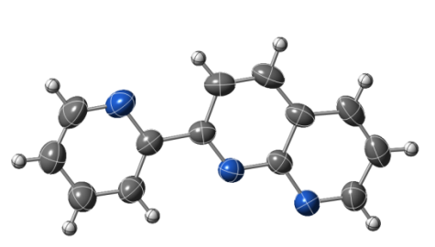(b)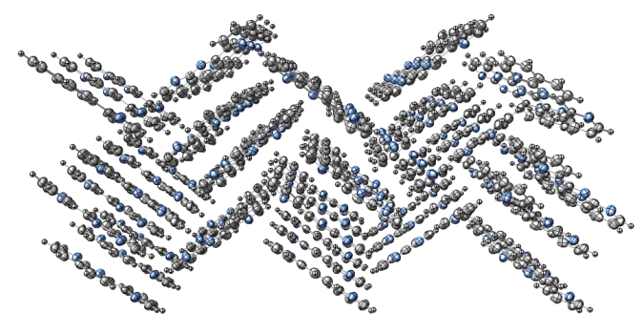
Figure 2. Molecular configuration (a) and crystal packing (b) of the ligand pyNP (1) (Blue: nitrogen; grey: carbon; white: hydrogen − ORTEP plot 50%).
Compound 2 is a binuclear silver complex with a pair of pyNP adopting a bridging coordination mode on the two silver centers (See Figure 3a and Figure S2a). Each silver atom is four-coordinated, bonded to three nitrogen atoms of the aromatic ligand (Ag(1)−N(2), Ag(1)−N(3), Ag(1)−N(4)’, ’=-x+1,-y+1,-z+1), and to an unidentate nitrate ion (Ag(1)−O(1)). The structure is quite similar to those reported for the naphthiridyl (NP) complexes of Ag(I) with nitrate^{[16]} and perchlorate[] anions, but differs for the coordination mode of the anion and for the Ag···Ag distance. The monodentate nature of nitrate ion in 2, compared to the bidentate behaviors in analogous complexes with NP ligand, can be explained by considering the energetic contribution of the chelate effect of py substituent and the preference of silver for low coordination numbers. The Ag(1)−N bonds have distances comparable with NP analogous complexes^{[16,41]}, while the Ag(1)−O(1) distance of 2.679(3) Å is longer, probably because of the steric hindrance. The Ag(1)···Ag(1)’ (’=-x+1,-y+1,-z+1) distance of 2.8309(5) Å, shorter than the distance in metallic silver (∼2.88 Å), is indicative of a supported argentophilic interaction. The distance is longer than the ligand “bite” measured as the distance between the nitrogen atoms of NP fragments (2.323(3) Å), but pyNP is known to bridge dimetallic unit with bond order from one to four without great influence on M−M distance. Thus, the lateral chelating bite brings a longer distance by respect to the unsubstituted NP, where the average distance for three analogous reported structures^{[16, 41, ]} is 2.760 Å. This is the first structural example in which pyNP bridges two previously unbounded metal atoms. The planar molecules are oriented along slipped planes forming a paddlewheel pattern similar to that of the free ligand (Figure 3b). There are O···H interactions (from 2.371(5) for O(2)···H(1A)’−C(1)’, ‘=-x,-y+1,-z+1, to 2.695(5) Å for O(2)···H(3A)’’−C(3)’’, ‘’=x, ¼-y, 1-z), and very weak π– π stacking, with a centroid-to-centroid distance of 3.762(10) Å.
(a)(b)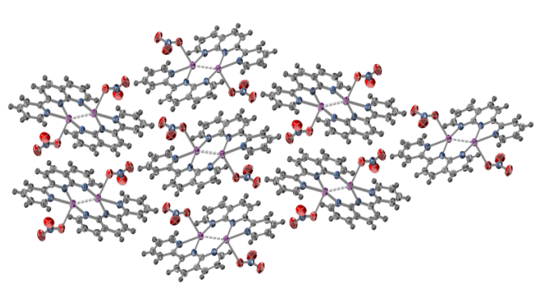
Figure 3. Molecular structure (a) and crystal packing (b) of complex [Ag₂(pyNP)₂(NO₃)₂] (2). (Blue: nitrogen; grey: carbon; red: oxygen; violet: silver; white: hydrogen − ORTEP plot 50%).
The complexes with halides and pseudohalides of Hg(II), [Hg(pyNP)X₂] (X=Cl(3), Br(4), I(5), CN(6), SCN(7, 8)) are almost isostructural: the metal has a distorted tetrahedral environment formed by two X atoms and two nitrogens; pyNP acts as a bidentate chelating ligand, analogously to bipy[] and 2,2’-bpym[] (Figure 4a). The average Hg−X and Hg−N distances are comparable with literature data.^{[43 -]} In all structures, the bond with the N atom of NP fragment is shorter than that with pyridine. Distances with the N1 atom of pyNP is too long to suggest any interactions (see Table S3b and S3c).The smaller angle is due to the chelate ligand, while the bigger one (X−Hg−X) is due to the tendency of Hg to have linear coordination.^{[28]} The molecules arrange in layered structures along parallel planes and are head-to-tail oriented. In literature, dimeric compounds are reported (for iodide^{[43]} and bromide^{[45]}) while the intermolecular Hg···X distance of 4.023(5) Å in 4 and 4.400(6) Å in 5 are too long to suggest any interaction.
(a)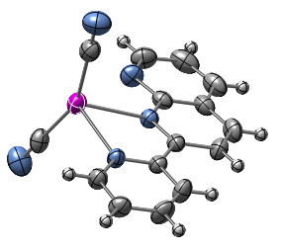(b)
(c)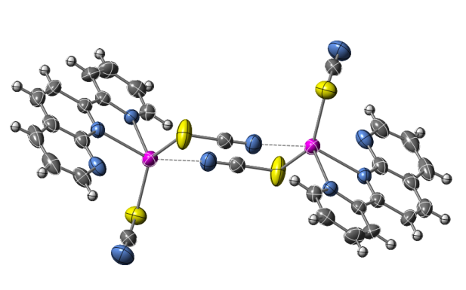
Figure 4. (a) Molecular structure of [Hg(pyNP)(CN)₂] (6); (b) dimers in β-[Hg(pyNP)(SCN)₂] (7) and (c) dimers in α-[Hg(pyNP)(SCN)₂] (8). (Blue: nitrogen; grey: carbon; violet: mercury, yellow: sulphur; white: hydrogen − ORTEP plot 50%).
In complexes 6 and 7 the CN and SCN are terminal groups, and in the crystal structure the N atoms at the end of the two anions are involved in weak hydrogen interactions.[] In 7 a strong interaction N(1)···H(9)’ (‘= x+½, ½-y, z+½, see Figure S7a) is observed, with a distance of 2.433(10) Å and N(1)···H(9)’–C(9)’ angle of 170.09(15)°, that can be responsible of the distortion from planarity of the ligand (the torsional angle between the two rings is 8.8(4)°). In the reaction between Hg(SCN)₂ and pyNP two polymorphic crystal structures of the same complex have been obtained. Starting from molar ratio 1:1 and 1:2 between the salt and the ligand a red form (8) has been crystallized, while a colorless one (7) has been obtained with an excess of mercury salt. In compound 8 Hg(II) is 4+1 coordinate, according to Grdenić ^{[28]}: the SCN groups act as bridging ligands between two different metal centers. The bond distance with terminal N atoms of adjacent molecules is 2.836(10) Å, less than the sums of Van der Walls radii, suggesting a weak interaction. In the CSD an average distance of 2.689 Å is reported for the dimeric complexes of mercury(II) thiocyanate. The major difference between the structures of thiocyanate complexes 7 and 8 is the orientation of SCN group by respect to the ligand, allowing or not a bridging coordination: in 7 there is no direct interaction between molecules generated by the inversion center, unlike 8 (Figure 4b and 4c).

(a)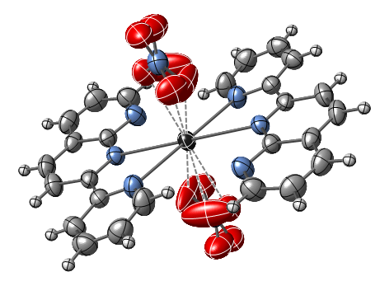(b)
(c)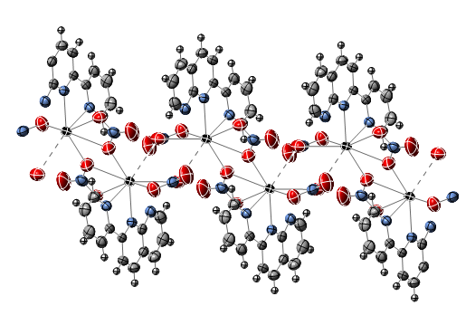
Figure 5. Molecular structures of (a) [Pb(pyNP)₂(NO₃)₂] (9), (b) [Pb(pyNP)(NO₃)₂]₂ (10); (c) polymeric chain in 10. (Blue: nitrogen; grey: carbon; red: oxygen; black: lead; white: hydrogen − ORTEP plot 50%).
The reaction of Pb(NO₃)₂ and pyNP gives a mixture of two complexes, 9 and 10, which are very similar in composition and appearance. However, for all the attempted stoichiometries, a quantitative separation of the two species was not possible. Nevertheless, we were able to select manually single crystals for both species, and the composition of the mixture is confirmed by the correspondence between experimental PXRD and the calculated patterns obtained from SC data of 9 and 10 (see Figure S6c). In complex 9 Pb(1) is 8-coordinated, bonded to four N atoms of pyNP and to four O atoms of nitrate ions (see Figure 5a and Figure S6a). The former acts as a chelating ligand analogous to bipy, and the latter has a bidentate coordination. The geometry of this complex is octahedral, considering the nitrate ion as a monodentate ligand which occupies the axial positions while pyNP ligands are equatorial, and angles reflect the regular geometry. The Pb(1)−N distances (Pb(1)−N(1) 2.6917(16) and Pb(1)−N(3) 2.7680(19) Å) are slightly longer than in the analogous complexes with bipy ligand.[] Distance with N(2) is too long to suggest any bonds. The average Pb(1)−O distance of 2.667 Å, shorter than in analogous complexes^{[48]}, is indicative of the chelating coordination of nitrate. The symmetrical disposition of ligands suggests that the lone pair is not stereoactive, so the coordination of Pb(II) can be described as holodirected.[] This trans holodirected disposition of two Schiff base ligands is not common in lead complexes.[,] This co-planar configuration for the two pyNP is observed also in the complex 2, and has been reported before only with rhenium.^{[25]} In the crystal packing, molecules arrange along slipped parallel planes built by sequences of two nitrate groups and a plane formed by pyNP ligands and lead. This arrangement is stabilized by weak hydrogen interactions (O(3)···H(5)–C(5) 2.541(10) Å, O(2)···H(10)–C(10) 2.599(9) Å and O(2)···H(6)–C(6) 2.596(9) Å). In 10 Pb(1) is 7-coordinated, bonded with two N of the ligand, four O of the chelating nitrate and one oxygen of a proximal nitrate. In this complex one nitrate group acts like a bridging ligand between two metal center, giving a dimer (Figure 5b and Figure S6b ). Bond distances are slightly shorter than in 9, both for nitrogen and oxygen; bridging distance Pb(1)−O(1)’ (‘= -x, ½-y, -z) is similar to the coordination distance in in 10, and is indicative of a strong interaction between molecules. The coordination of Pb(II) can be described as partially hemidirected.^{[49]} In the void of coordination sphere, the presence of the lone pair is visible thanks to the weak interactions with O atoms (~3.064 Å) that promote the formation of chains of molecules (Figure 5c). We tried also to obtain hetero bimetallic compounds between Cu(II) and Hg(CN)₂. With different molar ratios of pyNP (1) and CuCl₂∙2H₂O, two different complexes have been found, analogous to that reported by Leznoff with similar ligand.[,] With an equimolar ratio of Hg(CN)₂, CuCl₂ and pyNP the monosubstituted complex [Cu(pyNP)Cl₂(H₂O)] (11) is obtained, whereas with a minor ratio of copper salt there is a bisubstitution on the metal center with the formation of a ionic compound, [Cu(pyNP)₂(H₂O)] [Hg₂(CN)₄Cl₂]∙H₂O (12). In 11 Cu(II) is five-coordinated, bonded with two Cl atoms, two nitrogen of the ligand and a solvent molecule (water) (Figure 6a and Figure S10a). It adopts a distorted trigonal bipyramidal geometry, as highlighted by the τ parameter[]. For 11 the τ parameter is calculated from the two major angles (O(1)−Cu(1)−N(1) 173.31(5)° and N(2)−Cu(1)−Cl(3) 135.23(3)°, - see Figure S10a) and has a value of 0.67. Cu(1)−N(2), Cu(1)−Cl(1) and Cu(1)−Cl(2) form the equatorial plane; while Cu(1)−N(1) and Cu(1)−O(1) are the main axis. In the crystal packing the molecules arrange in layered structures along parallel planes and are head-to-tail oriented, as in HgX₂ complexes. The water molecule coordinated to Cu centers plays an important role in the crystal packing, giving intra/intermolecular hydrogen bonds that lead to the formation of dimers. The H(1B) atom is directed towards the uncoordinated N(3) atom of pyNP, while H(1A) gives a weak intermolecular hydrogen bond with Cl(2). The structure of the ionic compound 12 consists in insulated [Hg₂(CN)₄Cl₂]²⁻ anionic dimers and in the cation [Cu(pyNP)₂(H₂O)]²⁺ (Figure 7b). Each Hg(II) center has a seesaw effective coordination based upon the characteristic linear coordination (2+2)^{[28]}: chloride atoms bridge between two mercury cyanide units. In the solid state, the [Hg(CN)₂Cl]₂²⁻ dimers with similar structure parameters, have been reported in a series of mixed complexes like [PPN][Hg(CN)₂Cl]∙H₂O, [nBu₄N][Hg(CN)₂Cl]∙0.5H₂O, [Ni(tpy)₂][Hg(CN)₂Cl]₂ and [Cu(dien)Cl][Hg(CN)₂Cl] (PPN=bis(triphenylphosphoranylidene) ammonium; nBu₄N= tetrabutylammonium)^{[52, 53} . However, IR and polarographic studies demonstrate that in solution Hg(CN)₂ forms this anionic [Hg(CN)₂Cl]⁻ moiety by adding a chloride to the unsaturated Hg(II) center.[,] In 12 Cu(1) is 5-coordinate and is bonded with 4 N atoms from two pyNP and with one O atom of the crystallization water (Figure 6b and Figure S10b). Cu atom adopts a distorted square pyramidal geometry. The apical position is occupied by a N atom which has a Cu(1)−N distance longer than the other (2.218(4) Å for Cu(1)−N(4) compared to 1.996(3) for Cu(1)−N(1), 1.998(3) for Cu(1)−N(5) and 2.039(3) Å for Cu(1)−N(2) in equatorial positions). The τ parameter^{[54]} is calculated from basal angles (N(5)−Cu(1)−N(2) 175.04(15) and O(1)−Cu(1)−N(1) 164.97(15) deg) and resulted 0.17. It can be supposed that the distorted square pyramidal geometry in 12 is due to the formation of two different five-member chelating rings. Also in 12 the water molecule coordinated to the Cu(1) is involved in two hydrogen bonds. The H(1A) atom is directed to uncoordinated N(3) atom of one ligand (N(3)···H(1A)−O(1) 2.573(9) Å), and the other hydrogen is directed to the water of crystallization. In the crystal packing molecules arrange in alternate layers of anionic and cationic moieties.
(a)(b)
(c) 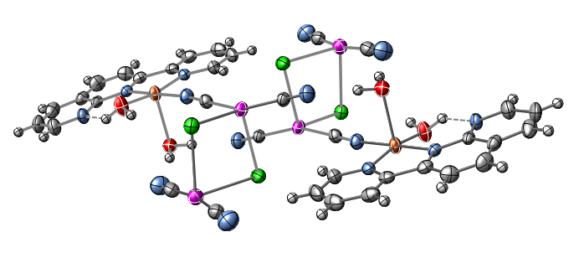
Figure 6. Molecular structure of (a) [Cu(pyNP)Cl₂(H₂O)] (11), (b) [Cu(pyNP)₂(H₂O)][Hg₂(CN)₄Cl₂]∙H₂O (12) and (c) [Cu(pyNP)(H₂O)₂(μ-CN)Hg₂(CN)₃Cl₂]∙H₂O (13). (Blue: nitrogen; grey: carbon; red: oxygen; orange: copper; violet: mercury; green: chloride; white: hydrogen − ORTEP plot 50%).
The compound [Cu(pyNP)(H₂O)₂(μ-CN)Hg₂(CN)₃Cl₂]∙H₂O (13) is a hetero-trimetallic complex (Figure 6c and Figure S10c) obtained from two differing stoichiometries (CuCl₂: pyNP = 1:1 or 1:2), and it can be observed the complete migration of the chloride group from the harder Cu center to the softer Hg, with the formation of the double-salt moiety [Hg₂(CN)₄Cl₂]²⁻, as in 12. In 13 the Cu(1) is 5-coordinate, adopting a square pyramidal geometry. Cu is bonded to two N atoms from pyNP, two O atoms from water molecule and one N atom from the cyanide group of the mercury double salt. Bonds in equatorial position (Cu(1)−N(6), Cu(1)−N(7), Cu(1)−N(2) and Cu(1)−O(2)) have similar distances (average 1,9817(3) Å) while bond Cu(1)−O(3) in apical position is longer (2.401(3) Å). Basal angles of 176.16(13)° (N(2)−Cu(1)−N(6)) and 169.60(13)° (O(2)−Cu(1)−N(7)) confirm the square pyramidal geometry (τ=0.11)^{[54]}. Each Hg(II) center has a seesaw effective coordination based upon the linear coordination, and is analogous to 12. The two moieties of the molecule, unlike the ionic product, are linked by one CN group which bridges between Cu(1) and Hg(1), and this structural pattern is similar to that of {[Cu(bipy)Hg(CN)₂Cl₂]₂Hg(CN)₂}, where there is a polymeric fragment bridging the metal centers.[] [Hg₂(CN)₄Cl₂]²⁻ is distorted if compared with other similar structures, probably because the terminal N(3) of a terminal cyanide forms an hydrogen bond with O(3).

Infrared and Raman Spectroscopy Characterization
Table 1. Comparison of Raman signal of ligand pyNP (1, L) and complexes 2, 3, 4 ,5 ,6, 7, 8, 11, 12, 13.
Compound | ν CN | ν _{C=N} + ν _{C=C} | ν _{C9-C10} (np) | ν _{(py-np)} | ν _{CC} (py) | ν _{CC}(np) | ν Hg−X
pyNP (=L (1)) |  | 1604 s  1590 vs  1569 m | 1371 vvs | 1314 s | 997 m | 775 m
Ag₂L₂(NO₃)₂ (2) |  | 1609 m  1576 m | 1365 s | 1309 m  1289* m | 1007 m | 796w
HgLCl₂ (3) |  | 1603 vs  1576 s | 1387 s | 1313 s  1296 m | 1008 m+sh | 769 m-s | 303 m  287 m
HgLBr₂ (4) |  | 1606 vs  1575 m-s | 1384 s | 1309 m-s  1289 m | 1009 s | 792 w  783 sh | 180 s
HgLI₂ (5) |  | 1606 vs  1575 m-s | 1383 s | 1312 m-s  1288 w | 1008 s  998 sh | 790 w  778 vw | 139 vvs
HgL(CN)₂ (6) | 2173 m | 1608 vvs  1596 m  1576 m-s | 1385 s | 1314 s  1292 m-s | 1008 s | 789 w  778 vw
β−[HgL (SCN)₂] (7) | 2123 s  2117 s | 1608 vs  1574 m | 1391 s  1385 s | 1317 s  1301 m | 1009 w | 795 w, br
α−[HgL(SCN)₂] (8) | 2120 s | 1607 vvs  1576 m | 1387 s | 1314 s  1295 m | 1010 w  995 vvw | 792 w
CuLCl₂(H₂O) (11) |  | 1613 s  1582 m | 1374 vs | 1328 vs | 1036 m | 803 m-w
[CuL₂(H₂O)] [Hg₂(CN)₄Cl₂] (12) | 2162-2175 w | 1607 s  1579 m | 1381 vs | 1332 s  1316 m | 1034 m  1012 m | 807 m
[CuL(H₂O)₂Hg₂(CN)₄Cl₂] (13) | 2227 m  2194 m | 1614 m  1581 m | 1377 vs | 1329 s | 1037 s | 811 m  804 m

For the first time the assignment of the vibrational modes of 1 has been done according to the computed frequencies calculated with a DFT method, by using the hybrid B3LYP functional (Table S6). Below 1600 cm⁻¹ stretching (ν), bending (δ) and deformation (γ) modes of aromatic rings can be observed, while around 3000 cm⁻¹ there are stretching modes of C−H. At low frequencies appear the torsional modes (τ).Raman spectrum of pyNP is simpler, so it is used for the comparison with the spectra of the metal complexes. The complexation can be confirmed by the shift of the breathing modes at higher wavenumbers (Table 1). In the silver complex 2 the analysis of the vibrational modes can confirm the unidentate coordination of the nitrate group. It has been suggested that the number and position of combination frequencies in the 1700-1800 cm⁻¹ region of the infrared spectrum, can be diagnostic of the coordination mode.[] Following the coordination, the in-plane bending mode splits into two bands, and the same is found for the mixed mode at higher frequency. The magnitude of this splitting is expected to be larger for bidentate than for unidentate ligands. In the FTIR-ATR spectrum of the complex 2 there is a large peak at 1746 cm⁻¹, that is the convolution of two signals very close (1746 and 1739 cm⁻¹), and is indicative of unidentate coordination in axial position. It’s difficult to assign the Hg−N stretching, in complex 3, 4, 5, 6, 7 and 8, because of the presence of many signals at low wavenumbers, including those of pyNP and Hg−X. Attribution of symmetric Hg−X and cyanide stretching, based on literature data of solid mercury salt[], is reported in Table 1. Both vibrational spectra of complex 7 show a double peak for the cyanide stretching which can be explained by the presence of two not symmetrical thiocyanate groups in the molecule. The interring vibration in Cu(II) compounds shows the greatest shift compared to other metal complexes. In 11 the Cu−N stretching can be supposed at 258 cm⁻¹, according to the literature assignment obtained from isotopic substitution on copper bipyridyl complex[]. For the ionic complex 12 the cyanide salt signal splits in a multiplet, and it’s only slightly shifted: this can be explained with the formation of a [Hg₂(CN)₄Cl₂]²⁻ moiety.^{[52]} The ν_{CN} bands are consistent with terminal cyanide groups on nonlinear Hg(II) units, with coordination numbers greater than two. In the spectrum of 13 there are two different signals for the cyanide, confirming the presence in the crystal structure of terminal and bridging units (Figure 7).

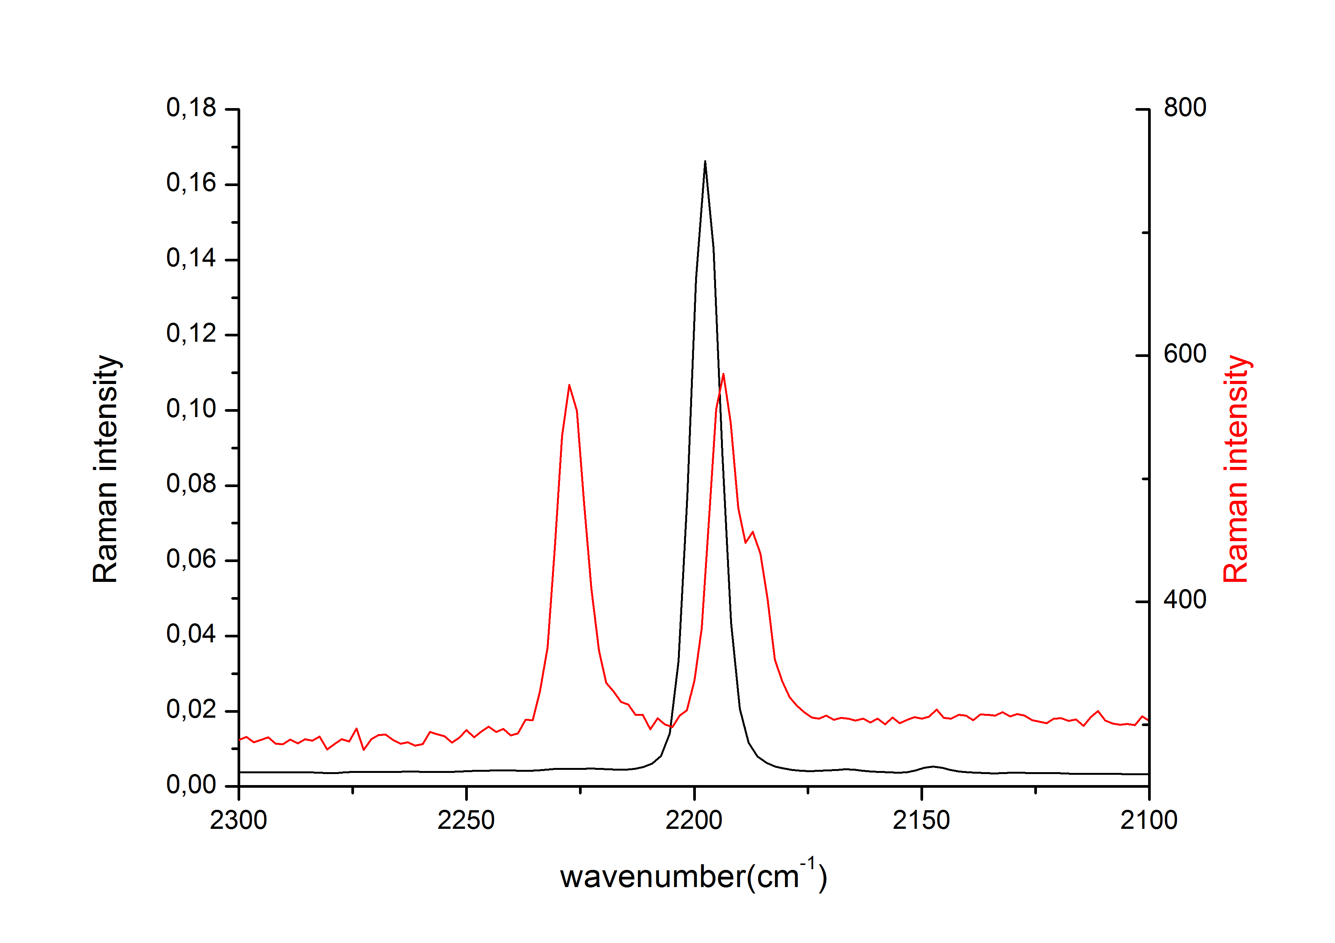

Figure 7. Comparison of cyanide signal between [Cu(pyNP)(H₂O)₂(μ-CN)Hg₂(CN)₃Cl₂]∙H₂O (13) (red) and Hg(CN)₂ (black).
Luminescence Measurement
The electronic transitions of the organic ligand pyNP 1 have been assigned by means of a TD-DFT modelling with a B3LYP functional. We adopted the cis planar configuration that is not the minimum energy configuration of 1, but is that assumed during the complexation. The different signals in the solid state can be assigned to π- π * and n- π* transitions, assuming a purely molecular nature of the crystal electronic structure, as confirmed by comparing solid and solution absorption spectra (Table S7). This approach, although approximate, can predict quite accurately the wavelength of transitions and allows to consider the influences of the complexation on the different molecular orbitals and thus on the positions of the absorptions. The MOs described as n are different combinations of the nitrogen lone pair orbitals, which are involved into the complexation of the metals, and thus can be expected to be the most influenced. In general d¹⁰ metals don’t influence strongly the electronic transitions of the bonded organic molecules, and this is especially found in the electronic spectra of Hg(II) complexes.^{[44]} In fact, the ligands are weakly perturbed from this metal center, and this is due to the relativistic tendency to linear coordination.^{[28]}
(a) 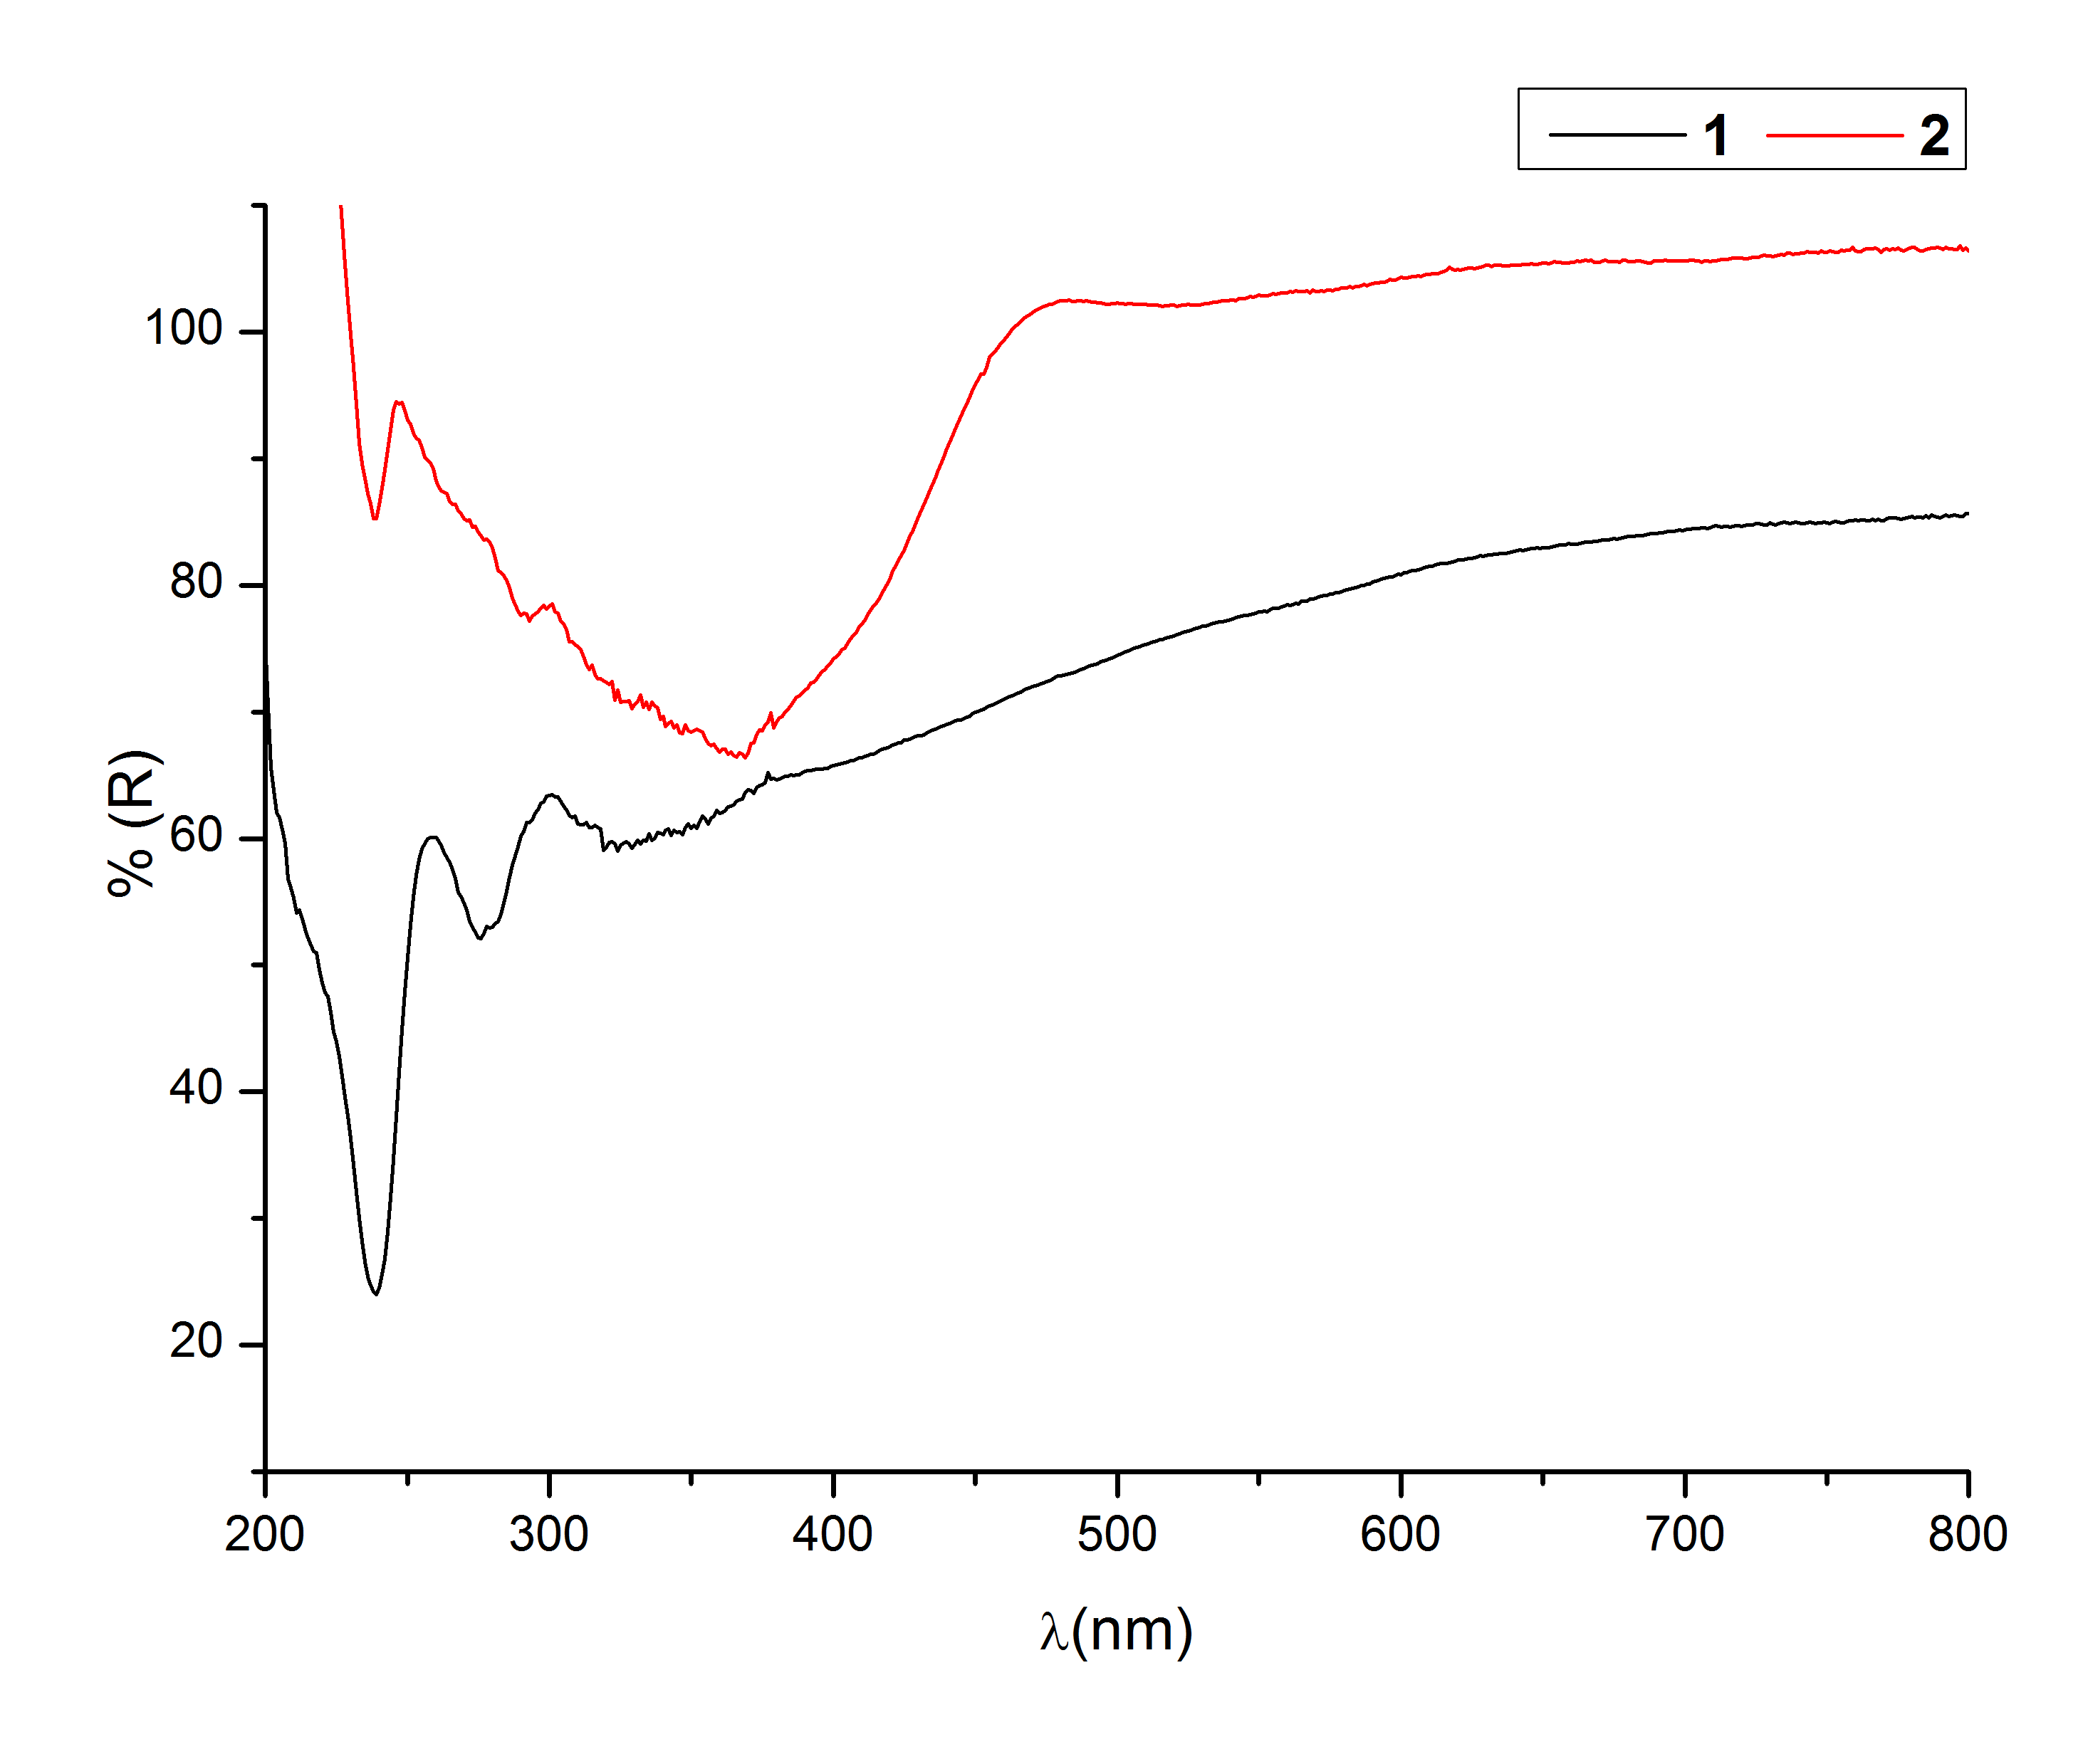(b) 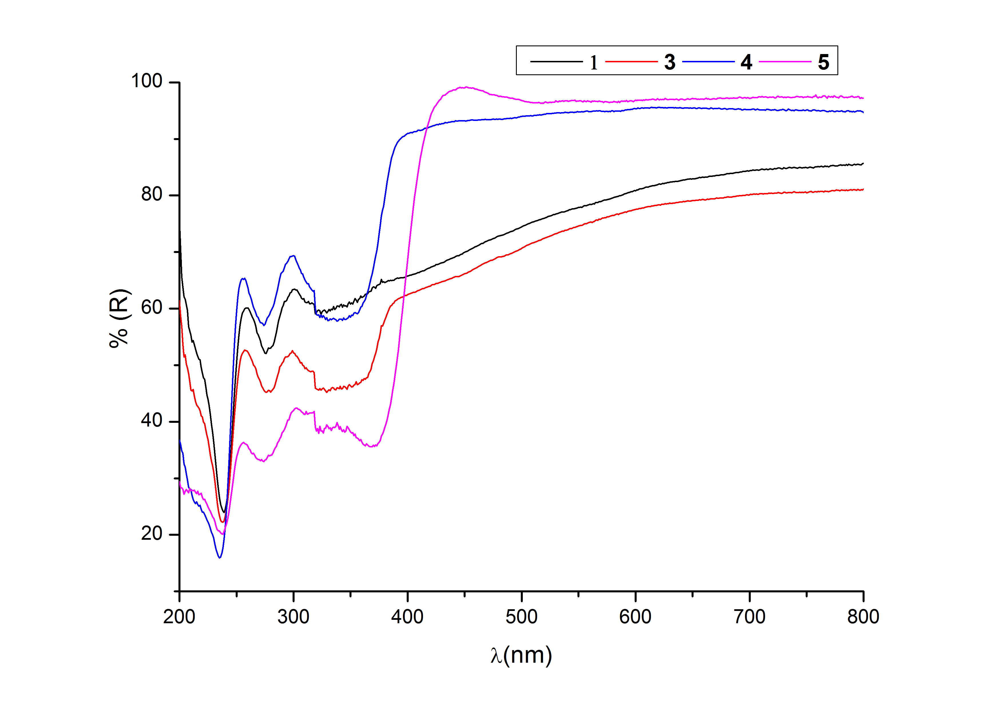
(c)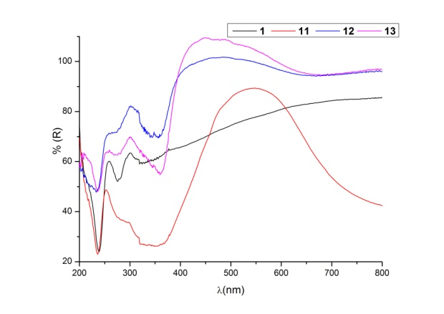(d)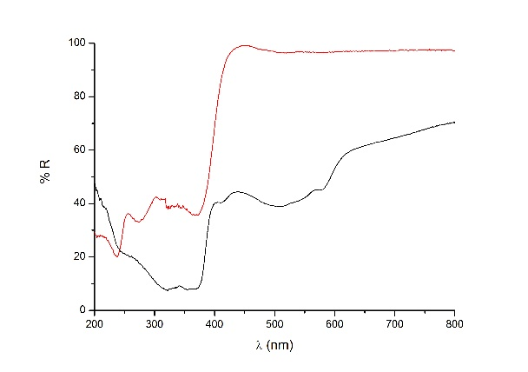
Figure 8. Solid state reflectance UV-Vis spectra of (a) [Ag₂(pyNP)₂(NO₃)₂] (2) compared to pyNP (1); (b) [Hg(pyNP)X₂] (X= Cl (3), Br (4), I (5)) compared to 1; (c) [Cu(pyNP)Cl₂(H₂O)] (11), [Cu(pyNP)₂(H₂O)][Hg₂(CN)₄Cl₂]∙H₂O (12) and [Cu(pyNP)(H₂O)₂(μ-CN)Hg₂(CN)₃Cl₂]∙H₂O (13) compared to 1; (d) comparison of spectra of [Hg(pyNP)I₂] (5) as pure solid (black) and in KBr pellet (red).
The broadening or sharpening of some of the peaks can be explained with the involvement of a charge-transfer. In the spectrum of 2, compared to the ligand adsorptions (Figure 8a), it is present a very broad band with a maximum at 366 nm, clearly different from the usual band at 319 nm of 1. This transition is expected to be generated from the Ag···Ag metallophilic interaction, that is claimed to allow some ligand-to metal-metal CT transitions by multicenter metallic molecular orbitals.[,] Considering the compounds 3, 4 and 5 (Figure 8b), it is clear the difference of the iodide complex by respect to the other, in particular for the red shift of the low energy band from 357 to 374 nm and a broadening of this absorption. Our results on similar systems^{[44]} demonstrate the stronger tendency of Hg−I complexes with heteroaromatic nitrogen donors, by respect to smaller halogenides, to present ligand-to-ligand CT in the solid state. On Cu(II) compounds there is a strong band at 800 nm for 11 and at 648 nm for 12 and 13 that is responsible for the strong color of the crystals. The three different colors (green for the monometallic complex, different shade of blue for the other two) can be explained with the change of the coordination spheres of this cation in the compounds, that change its electronic levels.[]
By analyzing the emission spectra in the solid state of the complexes by respect to the ligand alone (Table S9), we can confirm the ligand centered nature of the transition for the similarity of the emission peaks of most of the compounds synthesized.
Conclusions
The analysis of the different complexes synthesized and the ligand itself through XRD, vibrational and electronic spectroscopies can be indicative of trends in the coordination chemistry and properties of the asymmetric 2-(2’-pyridyl)-1,8-naphthyridine (pyNP, 1) ligand. We checked the formation of metal complexes with differing closed-shell metals: a big 5d¹⁰s² non-metallophilic cation (Pb(II)), a 5d¹⁰ metallophilic ion (Hg(II)) and a 4d¹⁰ metallophilic ion (Ag(I)). Results clearly demonstrate that the absence of interactions between metal centers doesn’t allow the formation of bimetallic dimers, like in the case of lead. However, it is interesting to notice that 1 in presence of Pb(II) can produce complexes with holodirected or hemidirected geometry, probably because of its intermediate hardness^{[49]}. The synthesis of 2 demonstrates that also in presence of non-preformed bimetallic core (like the multiple bonded M–M units reported in literature) this ligand can bridge a dimeric structure. This is stabilized by chelation of the first metal center by the pyridyl lateral group that forms a five-member ring, while the second metal center is coordinated by a single bond. However, it is interesting to consider that metallophilic interactions seem to be weakened by the lateral chelating substitutions: by comparing the average Ag(I)···Ag(I) distance reported for NP and bpNP complexes in literature with that of 2, it can be seen an elongation passing from NP to bpNP.In the case of mercury, despite a smaller covalent radius^{[34]}, the lower tendency to metallophilic interactions is against the formation of bimetallic compounds: all the obtained mercury complexes are monomeric in nature. . The simultaneous presence of Cu(II) and Hg(II) brings to the formation of products copper bonded to the organic ligand, and a chloride metathesis from the copper to the mercury. The reported results demonstrate that the dimerization is possible only in presence of strongly metallophilic centers, despite of the dimensions.The packing of all the crystal structures are dominated by weak interactions, and this can explain the presence of polymorphs, that were difficult to crystallize separately. The electronic spectra of the complexes are dominated by the ligand transitions, with some contribution from the anions in the more polarizable systems. These results can be interesting for the convenient formation of new supramolecular entities from this asymmetric ligand.

Supplementary data

Crystallographic data for all the structures reported in the paper have been deposited with the Cambridge Crystallographic Data Centre, CCDC nos. 1538701-1538713. These data can be obtained free of charge via http://www.ccdc.cam.ac.uk/conts/retrieving.html, or from the Cambridge Crystallographic Data Centre, 12 Union Road, Cambridge CB2 1EZ, UK; fax: (+44) 1223-336-033; or e-mail: deposit@ccdc.cam.ac.uk.

[] V. Balzani, A. Juris, Coord. Chem. Rev. 211(1) (2001) 97-115.
[] J. K. Bera, N. Sadhukhan, M. Majumdar, Eur. J. Inorg. Chem. (2009) 4023-4038.
[] a) A. M. Emmerson, A.M. Jones, J. Antimicrob. Chemother. 51 (2003) 13–20; b) Y. Pommier, E. Leo, H. Zhang, C. Marchand, Chem. Biol. 17 (2010) 421–433.
[] M.A. Ciriano, L.A. Oro in: J.A. McCleverty, T.J. Meyer(Eds.) Comprehensive Coordination Chemistry II, Elsevier, 2003, pp 55-61.
[] S. Ghamami, A. Lashgari, M.J. Golzani, Incl. Phenom. Macrocycl. Chem. (2017) 1–14.
[] A. Rusu, G. Hancu, A.C. Munteanu, V. Uivarosi, J. Organomet. Chem. (2017) 1-12.
[] S. Basheerulla, A. Vijay, P.G. Satya, M. Urvana, Lett Drug Des Discov 14(1) (2017) 10-27.
[] B.A. Johns, J.G. Weatherhead, S.H. Allen, J.B. Thompson, E.P. Garvey, S.A. Foster, J.L. Jeffrey, W.H. Miller, Bioorg. Med. Chem. Lett. 19(6) (2009) 1802-1806.
[] I.S. Tamgho, A. Hasheminasab, J.T. Engle, V.N. Nemykin, C.J. Ziegler, J. Am. Chem. Soc. 136 (2014) 5623–5626.
[] H.J. Li, W.F. Fu, L. Li, X. Gan, W.H. Mu, W. Chen, X.M. Duan, H.B. Song, Org. Lett. 12 (2010) 2924–2927.
[] R. Ziessel, Coord. Chem. Rev. 216–217 (2001) 195–223.
[] A.T. Baker, W.R. Tikkanen, W.C. Kaska, P.C. Ford, Inorg. Chem. 23(20) (1984) 3254–3256.
[] M. Majumdar, S.M.W. Rahaman, A. Sinha, J.K. Bera, Inorg. Chim. Acta 363 (2010) 3078-3087.
[] W.Z. Wang, S.B. Geng, S. Liu, D. Zhao, X.G. Jia, H.L. Wei, R.H. Ismayilov, C.Y. Yeh, G.H. Lee, S.M. Peng, J. Mol. Struc. 1138 (2017) 222-226.
[] H. Araki, K. Tsuge, Y. Sasaki, S. Ishizaka, N. Kitamura, Inorg. Chem. 46 (2007) 10032-10034.
[] W.P. Griffith, T.Y. Koh, A.J.P. White, D.J. Williams, Polyhedron 14 (1995) 2019-2025.
[] M. Munakata, S.G. Yam, M. Maekawa, M. Akiyama, S. Kitagawa, J. Chem. Soc., Dalton Trans. (1997) 4257-4262
[] E. Binamira-Soriaga, N.L. Keder, W.C. Kaska, Inorg. Chem. 29(17) (1990) 3167-3171.
[] D. Oyama, T. Hamada, T. Takase, J. Organomet. Chem. 696 (2011) 2263-2268.
[] J.L. Boyer, D.E. Polyansky, D.J. Szalda, R. Zong, R.P. Thummel, E. Fujita, Angew. Chem. Int. Ed. 50 (2011) 12600–12604.
[] K.T. Prasad, B. Therrien, K.M. Rao, J. Organomet. Chem. 693 (2008) 3049–3056.
[] M. Hirahara, M. Yagi, Dalton Trans. (2017) Advance Article.
[] C.S. Campos-Fernández, L.M. Thomson, J.R. Galán-Mascarós, X. Ouyang, K.R. Dunbar, Inorg. Chem. 41 (2002) 1523-1533.
[] S.K. Patra, V. Sadhukhan, J.K. Bera, Inorg. Chem. 45 (2006) 4007-4015.
[] J.K. Bera, E.J. Schelter, S.K. Patra, J. Bacsa, K.R. Dunbar, Dalton Trans. (2006) 4011–4019.
[] H. Schmidbaur, A. Schier, Chem. Soc. Rev. 41 (2012) 370–412.
[] M.J. Katz, K. Sakaib, D.B. Leznoff, Chem. Soc. Rev. 37 (2008) 1884–1895.
[] D. Grdenić, Q. Rev. Chem. Soc. 19 (1965) 303-328.
[] P. Schwerdtfeger, P.D.W. Boyd, A.K. Burrell, W.T. Robinson, M.J. Taylor, Inorg. Chem. 29 (1990) 3593-3607.
[] A. Walsh, G.W. Watson, J. Solid State Chem. 178 (2005) 1422–1428.
[] L.A. Olsen, J. Lopez-Solano, A. Garcıa, T. Balic-Zunic, E. Makovicky, J. Solid State Chem. 183 (2010) 2133–2143.
[] V.W.W. Yam, V.K.M. Au, S.Y.L. Leung, Chem. Rev. 115(15) (2015) 7589-7728
[] O.S. Wenger, Chem. Rev. 113 (2013) 3686-3733
[] B. Cordero, V. Gòmez, A.E. Platero-Prats, M. Revés, J.Echeverrìa, E. Cremades, F. Barragàn, S. Alvarez, Dalton Trans. (2008) 2832-2838
[] R. Echeverria, J.M. Lòpez-De-Luzuriaga, M. Monge, S. Moreno, M.E. Olmos, Inorg. Chem. 55 (2016) 10523-10534
[] Agilent Technologies, CrysAlisProSoftare system, version 1.171.35.11, Agilent Technologies UK Ltd.: Oxford, U.K, 2012.
[] G. M. Sheldrick, SHELX97: Program for Crystal Structure Solution and Refinement, University of Göttingen, Göttingen, 2004.
[] H.D. Flack, Acta Cryst. A39 (1983) 876-881
[] E.C. Escudero-Adàn, J. Benet-Buchholz, P. Ballester, Acta Cryst. B70 (2014) 660-668
[] a) G. Volpi, C. Garino, E. Conterosito, C. Barolo, R. Gobetto, G. Viscardi, Dyes Pigm. 128 (2016) 96-100; b) G. Volpi, G. Magnano, I. Benesperi, D. Saccone, E. Priola, V. Gianotti, M. Milanesio, E. Conterosito, C. Barolo, G. Viscardi, Dyes Pigm. 137 (2017) 152-164.
[] T. Tsuda, S. Ohba, M. Takahashi, M. Ito, Acta Cryst. C45 (1989) 887-890.
[] T. Koizumi, K. Tanaka, Inorg. Chim. Acta 357 (2004) 3666–3672.
[] E. Freire, S. Baggio, R. Baggio, L. Suescun, J. Chem. Crystystallogr. 29(7) (1999) 825-830.
[] E. Priola, E. Bonometti, V. Brunella, L. Operti, E. Diana, Polyhedron 104 (2016) 25-36.
[] a) W.T. Chen, M.S. Wang, X. Liu, G.C. Guo, J.S. Huang, Cryst. Growth Des. 6(10) (2006) 2289-2300; b) A.J. Canty, C.L. Raston, B.W. Skelton, A.H. White, J. Chem. Soc., Dalton Trans. (1982) 15-18.
[] a) R. Taylor, Cryst. Growth Des. 16(8) (2016) 4165-4168; b) A. Gavezzotti, L. Lopresti, Cryst. Growth Des. 16(8) (2016) 2952-2962.
[] a) F. Marandi, I. Pantenburg, G. Meyer, Z. Anorg. Allg. Chem. 635 (2009) 2558–2562; b) A. Bhunia, E. Zangrando, S. Garcia-Granda, S.C. Manna, Inorg. Chim. Acta 409 (2014) 528–537.
[] L. Shimoni-Livny, J.P. Glusker, C.W. Bock, Inorg. Chem. 37 (1998) 1853–1867.
[] F. Marandi, M. Mottaghi, G. Meyer, I. Pantenburg, Z. Anorg. Allg. Chem. 635 (2009) 165-170.
[] J. Burt, W. Grantham, W. Levason, M. E. Light, G. Reid, Polyhedron 85 (2015) 530-536.
[] N.D. Draper, R.J. Batchelor, D.B. Leznoff, Cryst. Growth Des. 4(3) (2004) 621-632.
[] N.D. Draper, R.J. Batchelor, P.M. Aguiar, S. Kroeker, D.B. Leznoff, Inorg. Chem. 43(21) (2004) 6557–6567.
[] A.W. Addison, T.N. Rao, J. Reedijk, J. Van Rijn, J. Verschoor, Dalton Trans. (1984) 1349.
[] L. Newman, D.N. Hume, J. Am. Chem. Soc. 83(8) (1961) 1795-1797
[] R.A. Penneman, L.H. Jones, J. Inorg. Nucl. Chem. 20 (1961) 19-31.
[] D.B. Leznoff, N.D. Draper, R.J. Batchelor, Polyhedron 22 (2003) 1735-1743.
[] K. Nakamoto, Infrared and Raman Spectra of Inorganic and Coordination Compounds, Part B, Applications in Coordination, Organometallic, and Bioinorganic Chemistry, 6th Edition, Wiley 2009.
[] J. R. Ferraro, Low frequency vibration of Inorganic and coordination compounds, Plenum Press:, New York, 1971.
[] R.E. Wilde, T.K.K. Srinivasan, J. Inorg. Nucl. Chem. 36 (1974) 323-328.
[] J.S. Ovens, D.B. Leznoff, ChemPlusChem 81 (2016) 842-849.
[] H. Schmidbaur, A. Schier, Angew. Chem., Int. Ed. 54 (2015) 746-784.
[] R.A. Palmer, T.S. Piper, Inorg. Chem.5(5) (1966) 864–878.

