**Electronic Supplementary Information**

**Role of citrate on the formation of enamel-like calcium phosphate oriented nanorod arrays**

Francesca Carella,a Lorenzo Degli Esposti,a Davide Barreca,b Gian Andrea Rizzi,c Gianmario Martra,d Pavlo Ivanchenko,d Guillermo Escolano Casado,d Jaime Gomez Morales,e José Manuel Delgado-López,f Anna Tampieri,a and Michele Iafisco*,a

*a Institute of Science and Technology for Ceramics (ISTEC), National Research Council (CNR), Faenza (Italy). E-mail: michele.iafisco@istec.cnr.it*

*b CNR-ICMATE and INSTM, Department of Chemical Sciences, Padova University, Padova (Italy)*

*c Department of Chemical Sciences and INSTM, Padova University, Padova (Italy)*

*d Department of Chemistry and Interdepartmental Centre “Nanostructured Interfaces and Surfaces – NIS” of the University of Torino, Torino (Italy)*

*e Laboratorio de Estudios Cristalográficos. IACT, CSIC-UGR, Armilla (Spain)*

*f Department of Inorganic Chemistry, University of Granada, Granada (Spain)*

***Materials and Methods***

*Materials*

Calcium chloride dihydrate (CaCl2·2H2O, BioXtra, ≥99,0% pure), sodium citrate tribasic dihydrate (Na3(C6H5O7)·2H2O, ACS reagent, ≥99,0% pure), sodium phosphate dibasic (Na2HPO4, ACS reagent, ≥99,0% pure), sodium carbonate monohydrate (Na2CO3·H2O, ACS reagent, 99.5% pure), hydrochloric acid (HCl, ACS reagent, ≥99,0% pure), dibasic potassium phosphate (K2HPO4,ACS reagent, ≥98,0% pure), monobasic potassium phosphate (KH2PO4, ACS reagent, ≥98,0% pure), sodium acetate (CH3COONa, ReagentPlus®, ≥99.0% pure), acetic acid (CH3COOH, ReagentPlus®, ≥99.0% pure), sodium fluoride (NaF, ACS reagent, ≥99,0% pure) were supplied by Sigma-Aldrich. All the solutions were prepared with ultrapure water (0.22 μS, 25 °C, MilliQ, Millipore).

*Powder preparation*

Cit-ACP powder was synthesized according to the procedure reported by Iafisco et al.1, mixing two solutions (1:1 v/v) at room temperature of (i) 100 mM CaCl2 + 400 mM Na3(C6H5O7) and (ii) 120 mM Na2HPO4 + 200 mM Na2CO3. The pH was adjusted to 8.5 with an HCl solution. When the mixture became milky (approximately 30 seconds after mixing), the particles were repeatedly washed with ultrapure water by centrifugation (5000 rpm, 15 min, 4°C), freeze-dried overnight at −50 °C at a pressure of 3 mbar, and stored at -20 °C. ACP powder was synthesized according to the procedure reported by Onuma et al.2 with some modifications. Two solutions (1:1 v/v) of (i) 20 mM CaCl2 and (ii) 20 mM Na2HPO4 were mixed at 4°C and the precipitate was washed twice by centrifugation (12500 rpm, 4 min, 0°C), the first one with water and then with a solution of ethanol-water (70:30 v/v). Finally, the particles were freeze-dried overnight at -30 °C under a vacuum of 3 mbar and stored at -20°C.

*Powder characterization*

Powder X-ray diffraction (PXRD) patterns of the samples were recorded on a D8 Advance diffractometer (Bruker, Karlsruhe, Germany) equipped with a Lynx-eye position sensitive detector using Cu Kα radiation (λ = 1.54178 Å) generated at 40 kV and 40 mA. Spectra were recorded in the 2θ range from 10 to 60° with a step size (2θ) of 0.02 and a counting time of 0.5 s. Fourier transform infrared spectroscopy in the attenuated total reflection mode (FTIR-ATR) spectroscopy analyses were carried out using a Nicolet iS5 spectrometer (Thermo Fisher Scientific Inc., Waltham, MA, USA) with a resolution of 2 cm−1 by accumulation of 64 scans covering the 4000 to 400 cm−1 range, using a diamond ATR accessory model iD7.

*Substrates preparation*

150 mg of Cit-ACP or ACP powders were molded to form substrates of 1 cm in diameter and 0.5 mm in thickness substrates by hydraulic pressing at 1300 MPa for 10 minutes. Substrate were then immersed in a growing solution at 37°C for different times from 30 minutes to 24 hours. At scheduled times, the substrates were removed from the solution, cleaned first water and ethanol-water (70:30), and dried at room temperature. The growing solution was prepared according to a slight modification of the procedure reported by Onuma *et al*.,2 involving three consecutive steps. The first one consists in the preparation of a phosphate solution by mixing 2 mM K2HPO4, 2 mM KH2PO4 and 50 mM CH3COONa. The solution pH was adjusted to 6.3 using a 1 M CH3COOH solution. In the second step, a 1 M CaCl2 solution was added to the previously prepared phosphate one at a volume ratio of 1:249. Finally, a 52.6 mM NaF solution was mixed with the previously prepared calcium and phosphate containing one, at a volume ratio of 1:99.

*Substrates characterization*

Substrates were analyzed before and after immersion in the growing solutions. PXRD and FTIR-ATR analyses were carried out similarly as described for powders. Field emission-scanning electron microscopy (FE-SEM) and Energy-dispersive X-ray spectroscopy (EDXS) analyses were performed with a ΣIGMA (ZEISS NTS Gmbh, Oberkochen, Germany) coupled to an energy-dispersive X-ray microanalyzer (mod. INCA Energy 300, Oxford Instruments, Abingdon- on-Thames, UK). Samples were fixed on aluminum stubs using graphitic glue. Micro-Raman spectra were acquired with a DXR Raman microscope (Thermo Fisher Scientific Inc., Waltham, MA, USA) using a 532 nm laser (5 mW), focused on the sample with a 50x objective (Olympus) obtaining a spot size of ≈1 μm. X-ray photoelectron spectroscopy (XPS) analyses were performed using a MgKα radiation on a custom-built UHV chamber (base pressure = 5 × 10-10 mbar) equipped with a non-monochromatized double-anode X-ray source (Omicron DAR-400), a hemispherical electron analyzer (Omicron EA-125) and a 5-channeltrons detection assembly. The electron analyzer had an acceptance angle of ± 4° and the diameter of the analyzed area was 3 mm. All binding energies (BEs; standard deviation = ± 0.1 eV) were referenced to the adventitious C 1s signal at 285.0 eV 3,4 in order to correct for charging effects. The sample composition was evaluated after background removal (iterated Shirley) using calculated sensitivity factors.5

IR spectra were collected with spectrometer Bruker IFS66 equipped with a DRIFT cell (Spectra Tech, KBr windows) permanently connected to a vacuum line (residual pressure = 5×10-4 mbar), allowing desorption/adsorption experiments to be carried out in situ, and with a MCT detector. Spectra were collected at 4 cm-1 resolution and averaging 128 scans for obtaining a good signal/noise ratio. A blank spectrum was obtained using highly pure KBr powder as a background. After insertion in the cell, the ACP and Cit-ACP disks in the bare form or with nanorods overgrown for 24 h, were outgassed at beam temperature (b.t., ca. 50ºC) for 12h. Such a long time of outgassing resulted from the small inner diameter of the metal coil connecting the cell to the vacuum line (≈1 mm). For sake of comparison, the spectrum of the hydroxyapatite nanoparticles, in the form of the self-supporting pellet, collected in a transmission mode in a previous work6 was also considered. In this case, the connection between the cell, equipped with KBr windows and the vacuum line had an inner diameter wide enough (≈1 cm) to achieve the complete outgassing after 1 h. After outgassing at b.t., all samples underwent H/D exchange by admission of D2O vapor at 22,5 mbar for 15 min, followed by outgassing at b.t. for 15 min. The admission/outgassing sequence was repeated until invariance of the spectra. The final outgassing lasted in the range 1-12 h, depending on the cell. Further, bare ACP and Cit-ACP and overgrown (24 hours) samples were outgassed at beam temperature over 12 hours with subsequent H/D exchange (admission/outgassing of 22,5 mbar of D2O vapors until invariance of the spectra in presence of D2O vapors followed by 12 h of outgassing at beam temperature).

The spectra of nanorods overgrown on the supports collected after H/D exchange, shown in Figure 1 in the main text, are reported in reflectance, having used the spectra of the corresponding bare supports treated with an equivalent H/D exchange procedure, as reference. The spectrum of H/D exchanged HA nanoparticles shown in the same figure is reported in transmittance, having used the spectrum of the empty cell as reference.

**Results**



**Figure S1.** (a) PXRD patterns and (b) FTIR-ATR spectra of Cit-ACP and ACP powders.

PXRD patterns of Cit-ACP and ACP powders (Fig. S1A) are characterized only by a broad band at ≈30° (2θ), confirming the lack of long-range periodicity and excluding the presence of crystalline phases. In line with these findings, ATR spectra (Fig. S1B) display the broad bands typical of amorphous calcium phosphate phase. In particular, the absorption bands at ≈550 and 1010 cm−1 are associated to the bending and stretching modes of phosphate groups, respectively, while the band at ≈875 cm−1 is associated to the stretching mode of HPO42−. 7 In the Cit-ACP sample, signals in the range 1400–1500 cm−1 are attributed to the carbonate ions and the band at ≈1590 cm−1 can be assigned to the stretching of citrate -COO− moieties.1



**Figure S2.** (a) PXRD patterns, (b) FTIR-ATR and (c) Raman spectra of Cit-ACP and ACP substrates before immersion in the growing solution.

PXRD patterns and ATR spectra of the substrates before the immersion in the growing solution (Figs. S2A and S2B) are similar to those of the respective powders, revealing that no significant modification occurred during compression-molding. Raman spectra of the substrates (Fig. S2C) revealed that in both samples the most intense peak is related to phosphate symmetric vibration (ν1PO4) at ≈960 cm-1. In addition to the main peak, spectra of the ACP samples present minor signals that were also assigned to vibrational modes of phosphate groups (ν2) double degenerate bending mode at 428 cm−1; ν4 triply degenerate bending mode at 586 cm−1). In a different way, in the Cit-ACP sample, besides the signals related to vibrational modes of phosphate groups, other peaks were assigned to the COO bending of citrate (845 cm−1), νCH2 of citrate (2930 cm−1) ν1CO3 of carbonate (1070 cm−1), and ν3CO3 (1430 cm−1).7,8

**

**Figure S3.** Cross sectional FE-SEM images of (a) Cit-ACP and (b) ACP samples after 24 h of immersion in the growing solution. Arrows indicate the overgrown and the intermediate layer.

*Evaluation of the Lotgering orientation factor and shape of the crystals of the overgrown layer*

The estimation of the Lotgering orientation factor and crystal shape of the overgrown layer was performed using the intensity of the peaks of the PXRD spectra.

The Lotgering orientation factor *f* was calculated as:9

where of the sample and $P_{0}={\sum{I_{0}(00l)}}/{\sum{I_{0}(hkl)}}$ of the standard (Hydroxyapatite JCPDS file #09-0432).

**Table S1.** Lotgering orientation factor of the crystals of the overgrown layers on ACP and Cit-ACP substrates as a function of time in the growing solution.

|  |  |  |  |  |  |
| --- | --- | --- | --- | --- | --- |
| **Sample** | **30 min** | **1 h** | **5 h** | **10 h** | **24 h** |
| Cit-ACP | - | - | 0.62 | 0.92 | 0.92 |
| ACP | 0.71 | 0.67 | 0.88 | 0.89 | 0.92 |

The shape of the crystals of the overgrown layer was estimated by the intensity ratios of the peaks (002) and (112) of the samples.



**Figure S4.** Intensity ratios of (002) and (112) peaks of the crystals of the overgrown layer on ACP and Cit-ACP substrates as a function of time in the growing solution.



**Figure S5.** Fluoride content of ACP and Cit-ACP samples as a function of time in the growing solution.



**Figure S6.** Representative XPS signals for the overgrown ACP substrate soaked in the growing solution for 30 min.



**Figure S7.** Raman spectra of overgrown (a) ACP and (b) Cit-ACP substrates as a function of time in the growing solution.



**Figure S8**. Citrate containing in the growing solution enriched with Cit-ACP sample as a function of time. Citrate content was measured using a Citrate Assay Kit (Abcam, ab83396) according to manufacturer instructions (www.abcam.com/citrate-assay-kit-ab83396.html).

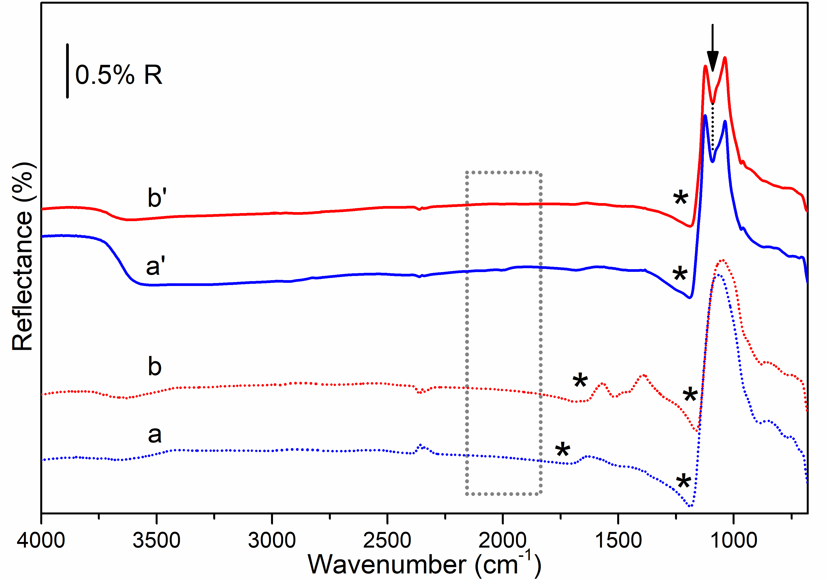

**Figure S9.** IR-spectra, collected in the diffuse reflectance mode of: (a) bare ACP and (b) bare Cit-ACP substrates; nanorods overgrown for 24 h on (a’) ACP and (b’) Cit-ACP. All the samples were outgassed for 12 h at b.t. (residual pressure = 5×10-4 mbar). The region marked by the dotted rectangle is enlarged in Figure S11.

Curves a and b: the shape of the spectra below 1750 cm1 are typical of a specular reflection regime, as indicated by the anomalous dispersion features, labeled with the asterisk, accompanied by the absorption due to carbonates (signal at ≈1600 cm-1 in spectrum a) or citrates (signals in the 1600-1300 cm-1 range in spectrum b) and by the absorption due to phosphate groups (main signal in the 1200-900 cm-1 range in both spectra). Note that in spectra obtained in specular reflection regime, absorption features are pointing upwards.10

Signals around 2340 cm-1 are due to unbalanced CO2 presence along the IR beam path when collecting the reference and the sample spectra. Finally, the features in the 3400-3800 cm-1 resulted from the lack of linearity of the response of the MCT detector in that range.

Curves a’ and b’: the new downward-pointing spectral features evidenced by the arrow witness for the occurrence of a diffuse reflectance regime.11 The difference with respect to the previous cases is the overgrowth of nanorods, which are apparently responsible for the diffuse reflection of IR light. The new signals are due to PO4 of nanorods.



**Figure S10.** IR spectra in the 2200-1900 cm1 range collected in the diffuse reflectance mode of: nanorods overgrown for 24 h on (a) ACP and (b) Cit-ACP; bare (a’) ACP and (b’) Cit-ACP outgassed for 12 h at b.t. (residual pressure = 5×104 mbar). (c) IR spectrum of hydroxyapatite nanoparticles in a form of self-supporting pellet collected in transmittance after outgassing for 60 min at b.t.

The absence of significant anomalous dispersion and absorption from the substrates in the 2200-1900 cm-1 range (curves a’,b’) resulted in the prevalence of a diffuse reflectance regime in the presence of the overgrown layers the detection of the spectra curves a, b. Thus, weak bands related to PO4 overtone and combination modes,6 in positions corresponding to those for hydroxyapatite nanoparticles (curve c6) were clearly detected.

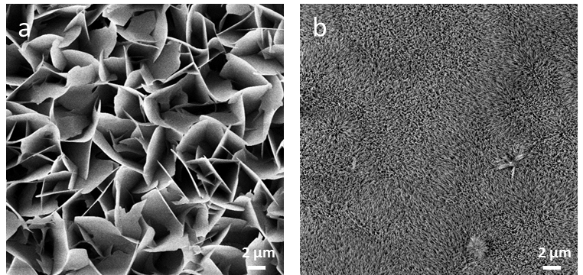

**Figure S11**. Top-view FE-SEM images of overgrown Cit-ACP samples after 20 hours of immersion in the growing solution (a) without and (b) with fluoride.

**References**

1 M. Iafisco, L. Degli Esposti, G. B. Ramírez-Rodríguez, F. Carella, J. Gómez-Morales, A. C. Ionescu, E. Brambilla, A. Tampieri and J. M. Delgado-López, *Sci. Rep.*, 2018, **8**, 17016.

2 K. Onuma and M. Iijima, *Sci. Rep.*, 2017, **7**, 2711.

3 M. P. Seah and D. Briggs, *Practical Surface Analysis: Auger and X-ray Photoelectron Spectroscopy*, John Wiley & Sons, 1990.

4 J. F. Moulder, W. F. Stickle, P. E. Sobol and K. D. Bomben, *Handbook of X-ray Photoelectron,* Perkin-Elmer Corp. Eden Prairie, MN, USA, 1992.

5 J. J. Yeh and I. Lindau, *At. Data Nucl. Data Tables*, 1985, **32**, 1–155.

6 Y. Sakhno, P. Ivanchenko, M. Iafisco, A. Tampieri and G. Martra, *J. Phys. Chem. C*, 2015, **119**, 5928–5937.

7 J. M. Delgado-López, M. Iafisco, I. Rodríguez, A. Tampieri, M. Prat and J. Gómez-Morales, *Acta Biomater.*, 2012, **8**, 3491–3499.

8 K. Chatzipanagis, T. Roncal-Herrero, R. Kröger, J. M. Delgado-López, M. Bilton, A. Tampieri and M. Iafisco, *CrystEngComm*, 2016, **18**, 3170–3173.

9 F. K. Lotgering, *J. Inorg. Nucl. Chem.*, 1960, **16**, 100–108.

10 M. Claybourn, in *Handbook of Vibrational Spectroscopy*, ed. J. M. Chalmers, John Wiley & Sons, Ltd, Chichester, UK, 2006.

11 P. R. Griffiths and J. M. Olinger, in *Handbook of Vibrational Spectroscopy*, ed. P. R. Griffiths, John Wiley & Sons, Ltd, Chichester, UK, 2006.