THE CREATIVE RESPONSE AND INTERNATIONAL TRADE

CRISTIANO ANTONELLI
Dipartimento di Economia e Statistica Cognetti de Martiis, Università di Torino and Collegio Carlo Alberto (BRICK)

ABSTRACT. In the standard Hecksher-Ohlin (HO) model, the specialization of countries is exogenous and static. This work elaborates the hypothesis that the specialization of countries is the endogenous outcome of the creative response of firms caught in out-of-equilibrium conditions by the changing conditions of factor and product markets. It presents three models. In the basic Schumpeter-Hecksher-Ohlin (SHO) model, countries try and react by means of the introduction of technological change to increase their productivity levels and to contrast the wage reducing effects of the factor cost equalization. The extended SHO models show how i) countries can react with the selective introduction in their specialized sector of activity of new technologies localized by the pervasive role of learning and ii) identify technological knowledge as the locally most abundant and idiosyncratic input so as to direct the introduction of knowledge intensive technological change.

KEY WORDS: HECKSHER-OHLIN; CREATIVE RESPONSE; INNOVATION; INDUCED TECHNOLOGICAL CHANGE; TECHNOLOGICAL KNOWLEDGE.

JEL CODES: O33, F12, F43

1. INTRODUCTION

The Hecksher-Ohlin (HO) model of international trade is the pillar of standard international economics. Its limitations have been discussed and implemented by a variety of contributions that have been able to include in its framework the effects of trade on internal factor markets, the analysis of the mobility of production factors, the variety of tastes and preferences across countries. The limits of the basic assumptions about the determinants of specialization of trading countries have not been, yet, addressed. The HO model rests upon the assumption that the specialization of trading countries is given and exogenous. Several stylized facts that have characterized the evolution of international trade in the last decades cannot be explained by the simple version of the HO model.

Since the early contribution of Leontief (1953) the evidence suggests that capital abundant countries specialize and export labor abundant products and import capital intensive ones. The role of knowledge as a qualifying input and its effects on the international division of labor is not easily accommodated by the HO model. It is also difficult to reconcile the impressive growth of intra-industrial trade with the HO model that stresses interindustrial trade. The stylized facts of the evolution of factor costs also do not fit into the simple HO model. The evidence shows the resilience of both nominal and real wages in advanced countries coupled with the fast increase of labor costs in newcomers, as much as capital user costs exhibit a secular decline that does not match the expectations based upon the HO model about their accelerated increase after the entry of labor-abundant newcomers. The HO model does not provide tools to grasp the determinants of the structural change that follows the integration into international product markets.

Finally, and most important, the HO model assumes that technological change is exogenous. The hypothesis that the introduction of new technologies takes place because of the evolution of international trade, the entry of new competitors and the consequent changes in both product and factor markets is not taken into account as much as the hypothesis, supported by much empirical evidence, that the specialization of countries and even their relative factor costs can be determined endogenously. The analysis of the globalization of product and factor markets that has been taking place since the end of the 20° century provides large evidence on the crucial role of technological change and the laws of accumulation of the technological knowledge that enables its introduction that need to be integrated into the basic framework of the HO model (Meliciani, 2002; Montobbio, Rampa, 2005; Urraca-Ruiz, 2013; Bloom, Draca, Van Reenen, 2016; Baldwin, 2016).

The integration of the notions of creative response elaborated by Schumpeter (1947) and of technological congruence (Antonelli, 2017) makes it possible to overcome these limitations and understand the specialization of trading partners, at each point in time, as the result of an endogenous process of technological change stirred by the creative response to the challenges raised by the integration into the international markets of new trading partners and based upon the generation of technological knowledge as an endogenous input. The integration of the Schumpeterian legacy into the HO model enables to articulate a Schumpeter-Hecksher-Ohlin framework (SHO) that can accommodate the analysis of the dynamics of knowledge accumulation.

The SHO framework provides the tools to understand the dynamics of the specialization of countries, the evolution of relative factor costs and the structural changes of advanced countries shaped by the rapid decline of the manufacturing industries and their progressive substitution with the new knowledge intensive business service (KIBS) industries, as the endogenous outcome of the creative response of firms that try and cope with the changing conditions of international product and factor markets brought by the globalization.

The radical changes in the specialization of both advanced and industrializing countries that has been taking place since the last decades of the XX century can be regarded as the consequence of the radical technological and structural changes introduced to cope with the globalization of product and factor markets (Freeman, 1996; Perez, 2002).

The rest of the paper is organized as it follows. Section 2 summarizes the foundations of Schumpeterian creative response. Section 3 elaborates its application to implement a Schumpeterian approach of the HO elaborating a (SHO) model of international trade with three versions that show how the out-of-equilibrium conditions of product and factor markets triggered by the entry of new (large) labor abundant countries can respectively stir: i) the introduction of neutral and homogeneous technological change as the outcome of a creative response; ii) the selective introduction of technological change as shaped by the role of learning in the mechanisms of accumulation and generation of knowledge; iii) the direction of technological change biased towards the use of knowledge as the most abundant input in advanced countries. The conclusions summarize the main results.

2. INNOVATION AS AN EMERGENT SYSTEM PROPERTY
Schumpeter (1947) elaborated the notion of innovation as a creative reaction stirred by a mismatch between expected and actual product and factor markets conditions. The eventual reaction of firms can be either adaptive or creative. Reaction can be simply adaptive and consist just in traditional price/quantity technical (as opposed to technological) adjustments. The reaction is adaptive when firms are not able to generate appropriate amount of new technological knowledge and cannot actually innovate. The creative reaction of firms is, in fact, possible only when and where pecuniary knowledge externalities make possible the recombinant generation of new technological knowledge at costs that are below equilibrium level. Such relevant pecuniary knowledge externalities are available in economic systems where technological knowledge is the result of the active participation and interaction of a myriad of innovators (Antonelli, 2017).

The recent advances of the economics of knowledge that regard technological knowledge as a collective activity with strong systemic characteristics contribute the implementation of the Schumpeterian approach. This literature draws from the Arrovian analysis of the limited appropriability, cumulability, complementarity and non-exhaustibility of knowledge and explores their consequences on the generation knowledge. In this literature knowledge spillovers and in general external knowledge to each firm are indispensable to the generation of new knowledge. Because of the sticky and tacit content of knowledge, dedicated and intentional efforts and localized interactions between producers and users are necessary to use external knowledge into the generation of new knowledge. Knowledge externalities are pecuniary rather than pure. The organization of the system in terms of access conditions to the external pool of technological knowledge is the crucial and complementary ingredient, together with the quality and intensity of internal research efforts, that makes the endogenous introduction of innovations possible (Antonelli, 2008; Antonelli and David, 2015).

Agents succeed in their creative reactions when a number of contingent external conditions apply at the system level. Innovation is the result of the collective economic action of agents: innovation is a path dependent, collective process that takes place in a localized context, if, when and where a sufficient number of creative reactions are made in a coherent, complementary and consistent way. As such innovation is one of the key emergent properties of an economic system that takes place when complexity is ‘organized’, i.e. when a number of complementary conditions enable the creative reaction of agents and makes it possible to introduce innovations that actually increase their efficiency. The amount of knowledge externalities and interactions available to the firms embedded in the system, influences their capability to generate new technological knowledge and, consequently, the actual possibility to make their reaction creative as opposed to adaptive and to actually introduce technological changes (Antonelli, 2011, 2017).

The response of firms can be creative when pecuniary knowledge externalities enable firms to generate new technological knowledge at costs that are below equilibrium levels. The creative response in these conditions accounts for the increase of the levels of total factor productivity.

Because of the Schumpeterian emphasis on the mismatches between expected and actual factor -and not only product- market conditions, the localized technological change framework accommodates the analytical core of the induced technological change literature. This literature recognizes that the rate and the direction of technological change are induced by the changing conditions of factor markets (Ruttan, 2001). The larger are the changes of the factor markets and the higher the rates of introduction of innovations. Technological change is intrinsically biased, i.e. it is either capital intensive and hence labor saving, or labor intensive and hence capital saving, as it is the result of the attempt of innovators to cope with the opportunities and constraints of the factor markets. The relative abundance of a production factor, such as skilled labor or technological knowledge, induces the introduction of innovations biased towards more skill-intensive, or knowledge-intensive, technologies (Acemoglu, 2002; Acemoglu, Zilibotti, 2001).

The notion of technological congruence plays a central role in the localized technological change approach. Technological congruence consists in the matching between locally abundant inputs and their output elasticity. Technological congruence is high when the output elasticity of an input, say knowledge, is large in a country where knowledge is abundant. High levels of technological congruence lead to high levels of total factor productivity. The increase in the levels of technological congruence triggers positive bias effects, that next to the shift ones, enables to increase the levels of total factor productivity. All changes in factor markets and in the relative costs of inputs induce new attempts to increase the technological congruence of the production process (Feder, 2018).

In countries where the stock of knowledge is abundant and the costs of accessing and using it as an input in the recombinant generation of new technological knowledge, the response of firms to changing product and factor markets triggered by the augmented levels of the twin globalization has larger chances to be creative and, at the same time to be directed towards knowledge intensive activities with a twin positive effect on the levels of total factor productivity (Antonelli, 2017).

3. GRAFTING THE SCHUMPETERIAN CREATIVE RESPONSE ON HO
This section elaborates the grafting of the innovation as an emergent system property approach based upon the Schumpeterian notion of creative response to analyze the dynamics of international trade. We assume as a starting point that unexpected events have brought the international economy in an out-of-equilibrium condition and we explore how endogenous and localized technological change can be integrated into the traditional HO approach. For the sake of historic likelihood, we shall assume that the pre-existing equilibrium in international markets has been upset in the last decades of the XX century by the augmented globalization brought about by the entry of new large labor abundant countries and the parallel liberalization of international capital markets. We shall analyze with special attention the consequences on the knowledge abundant (OECD) countries.

3.1. GLOBALIZATION AND FACTOR MARKETS
The well-known HO model provides the classic framework to analyze the effects of the entry of new labor abundant countries in international product markets. The integration of new labor abundant countries in international product markets can be portrayed as an increase in the size of the production possibility frontier of labor-intensive products. The consequence is straightforward as it consists in the change in slope of the isorevenue, that reflects the reduction of the relative price of labor intensive products and the increase of the relative price of capital intensive products, and a new international division of labor with the reduction of the equilibrium output of labor intensive products manufactured in capital abundant countries and their higher levels of specialization in capital intensive products. The prices of the labor intensive goods decrease sharply and the price of capital intensive goods exhibits a minor increase. Because of factor cost equalization, wages in advanced countries should decline while capital user costs should increase towards a global average.

Figure 1 represents the classical overlapping of the production possibility frontiers of two trading countries or groups of countries before and after globalization. Note that there are two production possibility frontiers, one for the capital abundant countries and one for the labor abundant countries and that the intercepts on the vertical and horizontal axis identify respectively the maximum amount of capital intensive and labor intensive goods that can be produced by the two groups of countries.
On the vertical axis the intercept of the production possibility frontier of capital abundant countries identifies the maximum amount of capital intensive Y goods that can be produced while the intercept on the horizontal axis identifies the maximum amount of labor intensive X goods that labor abundant countries, named T, can produce; the intercept of the production possibility frontier of labor abundant countries identifies the maximum amount of capital intensive Y goods that can be produced. The intercepts on the horizontal axis identify the maximum amount of labor intensive X goods that labor abundant countries and capital abundant countries respectively can produce. The tangency with the isorevenue identifies the equilibrium conditions for the two trading countries: before globalization they are S and R.

Figure 1 shows the standard effects of the entry of new labor abundant countries in international product markets that reshapes of the production possibility frontier of the group of labor intensive countries and consequently the slope of the isorevenue: the new equilibrium solutions F and V replace the old equilibrium solutions R and S, respectively in the capital and labor abundant countries.

INSERT FIGURE 1 ABOUT HERE

GLOBALIZATION AND THE CREATIVE RESPONSE: THE HO MODEL

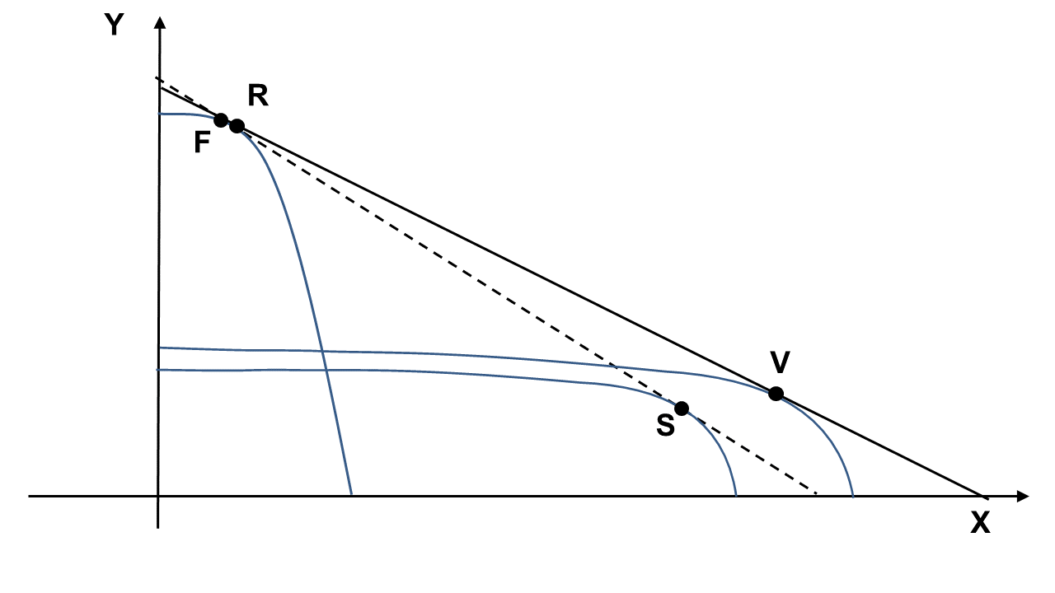
This graphical representation is the result of the following steps. Let us assume that the two overlapping frontiers of possible production are identified by 4 simple Cobb-Douglas production functions in two trading entities. The first two represent the frontier of possible production of the Z country; the second couple identifies the frontier of possible production of the T country. The current version of the HO model accommodate exogenous technological differences of the production functions with the inclusion of differentiated levels of output elasticity and total factor productivity across sectors and countries:

(1) Y_{Z} = A_{ZY} (K_{z})^{aY} (L_{z})^{bY}
(2) X_{Z} = A_{ZX} (K_{z})^{aX} (L_{z})^{bX}
(3) Y_{T} = A_{TY} (K_{T})^{cY} (L_{T})^{dY}
(4) X_{T} = A_{TX} (K_{T})^{cX} (L_{T})^{dX}

where Y_{Z} and X_{Z} are respectively the output of Y and X goods in Z countries; K_{Z} and L_{Z} are capital and labor in countries Z engaged in the production of Y goods, K_{z} and L_{z} are capital and labor in countries Z engaged in the production of X goods; where Y_{T} and X_{T} are respectively the output of Y and X goods in T countries; K_{T} and L_{T} are capital and labor in countries T engaged in the production of Y goods; K_{t} and L_{t} are capital and labor in countries T engaged in the production of X goods; aY, bX, cY, dX measure the output elasticity of the production factors.

A_{ZY} and A_{ZX} measure the levels of total factor productivity in the Z countries in the production of capital intensive goods Y and labor intensive goods X. A_{TY} and A_{TX} measure the levels of total factor productivity in the T countries respectively in the production of capital intensive goods Y and labor intensive goods X.

The following cost functions apply:
(5) C _{Z} = w_{Z}L _{Z} + r_{Z} K_{Z}
(6) C _{T} = w_{T}L _{T} + r_{T} K_{T}
where w_{Z} measures the unit wage in countries Z and w_{T} measures the unit wage of the T countries that interact in the globalized international product markets. For the same token r_{Z} stands for the capital user costs in countries Z and r_{T} for the capital user costs in the T countries.

The standard assumption is that the trading countries are characterized by their diverse endowment of capital and labor so that (w/r)_{Z} >(w/r)_{T.} .The updates of the received theory also assume -quite implicitly- that technological congruence applies: i) the production function of Y is capital intensive so that aY>bY and more capital intensive than the production function of X so that aY>aX in Z countries and ii) the production function of Y is labor intensive so that cY<dX and the production of X even less capital intensive so that cY<dX.

According to the standard -updated- assumptions A_{ZY} > A_{ZX} : Z countries are better able to produce Y goods than X goods. For the same token the standard theory assumes that T countries are better able to produce X rather than Y goods A_{TX} > A_{TY} . These assumptions make possible the overlapping of the two different possible production frontiers so as to yield gains from trade and international specialization but are fully exogenous and static. Moreover, no analysis is provided in the advanced versions of the HO model to justify them.

Following the standard procedure for the construction of the frontiers of possible production:
(7) X_{Z} = n(Y_{Z} )
(8) X_{T} = m(Y_{T})

Their slopes identify the two Marginal Rates of Transformation, respectively MRT_{Z} and MRT_{T} . The isorevenue, describing the maximum production combination of goods X and Y for the two countries, is defined as it follows:
(9) TR = Py Y + Px X

The equilibrium conditions are easily identified as it follows:
(10) Px / Py = MRT_{Z} = MRT_{T}

The entry of new large, low wage, labor abundant competitors makes the supply of X_{T} larger in global markets. This reduces the slope of the isorevenue, i.e. the conditions for the international division of labor and the specialization of countries and changes the relative conditions of the domestic factor markets in real terms, according to the factor costs equalizations theorem.

In the HO model capital abundant countries face these relative changes in the new globalized product (and factor) markets only by means of textbook substitution, moving upon the existing maps of isoquants towards higher levels of capital intensity. The position of the production possibility frontier cannot be changed by the intentional conduct of firms. Firms can cope with the new conditions of international product markets only moving on the existing frontier so as to reach the new equilibrium point identified by the tangency between the MRT and the slope of the new isorevenue. Capital abundant countries specialize further in the production of Y goods and labor abundant countries in the production of X goods. The factor cost equalization theorem applies and the wages of capital abundant countries are driven towards the lower levels of labor abundant ones, as much as capital user costs increase.

When the Schumpeterian hypothesis of an endogenous and directed technological change induced by the mismatch between expected and actual factor markets conditions is taken into account, instead, firms can cope with the new conditions of international product and factor markets by means of the introduction of new technologies that change the production possibility frontier.

3.2 THE BASIC SHO MODEL WITH TWO INPUTS
In the basic SHO approach firms, and, at the aggregate level, countries, can react to the effects of globalization by means of the introduction of neutral and homogeneous technological innovations across all the sectors of the economy so as to change the position of the production possibility frontier (Antonelli, 2017). The basic SHO model rests upon the integration of three basic ingredients: a) firms caught in out-of-equilibrium conditions try and react; b) their reaction can be creative when appropriate levels of pecuniary knowledge externalities are available in the system; c) technological change is endogenous and driven by international trade.

The analysis elaborated so far can be usefully framed with an approach based upon a Cobb-Douglas production function. In a standard -two basic inputs- production function, the SHO model allows to explore the effects of the possible introduction of endogenous technological change.

The setting for the Schumpeterian creative reaction and the search for technological congruence is now ready. The disequilibrium conditions of product and factor markets trigger the creative reaction of Z firms. If and when pecuniary knowledge externalities are available and large enough to make the recombinant generation possible, at costs that are below equilibrium, firms try and cope with the out-of-equilibrium conditions by means of the generation of new technological knowledge that leads to the introduction of a new superior technology represented by a new aggregate production function in Z countries with higher levels of efficiency. Technological change takes place in the production of both X and Y goods and yields the same increase of total factor productivity. After the introduction of the new technologies the new aggregate production function in Z countries can be represented in formal terms as it follows:

(11) Q_{Z}= A_{Z Z} (K _{Z})^{α} (L _{Z})^{β}

where Q_{Z}= (Y_{Z})*+ (X_{Z})*; (Y_{Z})*is the equilibrium output of Y in Z countries and (X_{Z})* is the equilibrium output of X good in Z countries. Note that α and β are the average output elasticity.

We assume that A_{Z Z} >A_{Z} . The new total factor productivity, measured by A_{Z Z} applies both to the production of Y and X goods and is larger than the former A_{Z} because of the introduction of productivity enhancing technological change.

In the basic SHO model, the endogenous introduction of technological change changes with a parallel shift the position of the production possibility frontier of the innovating countries and the international division of labor.

Figure 2 represents the basic SHO model and shows how the production possibility frontier of the Z countries changes position because of the endogenous introduction of productivity enhancing technological change across both sectors. The changes to the production possibility frontier do have direct effects on the international division of labor. The slope of the isorevenue is indeed affected by the changes of the production possibility frontier introduced in the Z countries. As a consequence, the equilibria are no longer found respectively in F and V, but in H1 (or H2) for the Z countries and in G for the T countries.

Note that Figure 2 provides two possible production possibility frontiers as the outcome of the introduction of homogeneous technological change. Their position depends on the extent to which the efficiency levels of the production processes in incumbent countries have been augmented by the introduction of new technologies. Two equilibria are found on two isorevenues. Figure 2 makes clear how the slope of the isorevenue is directly shaped by the position of the production possibility frontier and how the equilibrium position is consequently affected. Equilibrium is found in H2 if technological change is radical and the shift of the frontier is larger and in H1 when the shift of the frontier is smaller as technological change is incremental.

INSERT FIGURE 2 ABOUT HERE

GLOBALIZATION AND THE CREATIVE RESPONSE: THE BASIC SHO MODEL

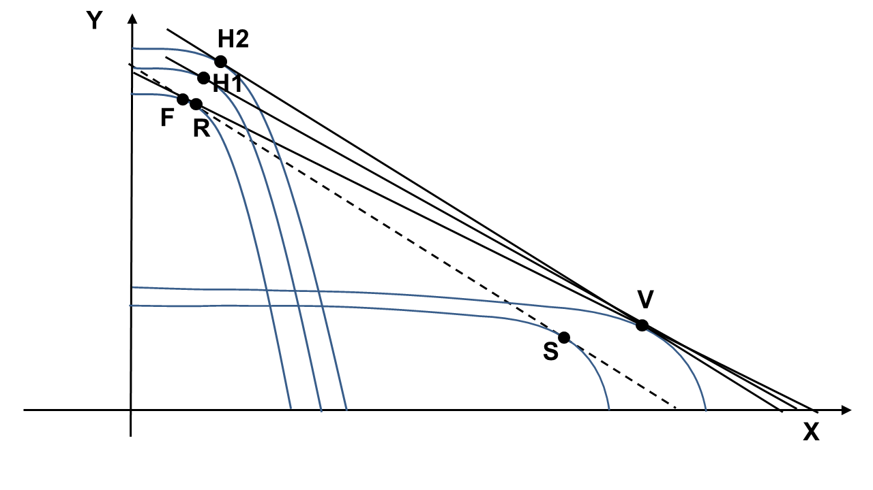

Countries able to support the creative response of their firms, with the availability of substantial pecuniary knowledge externalities that make the recombinant generation of knowledge possible at costs below equilibrium level, can cope with the out-of-equilibrium effects brought about the globalization of product markets by means of the introduction in all the system of new productivity enhancing technologies with major effects:

i) specialization is endogenous. It is clear, in fact, from Figure 2, that the specialization of Z countries in Y goods, after the introduction of technological change, is actually stronger. Stronger than before globalization and stronger than after passive globalization. The introduction of endogenous technological change enhances the specialization based upon the differences in factor abundance.

ii) wages (and capital user costs) are endogenous. The introduction of technological innovations contrasts effectively the decline of wages triggered by the factor cost equalization. The level of wages is directly affected by the increase of total factor productivity. The larger is the increase of the efficiency in Z countries (A_{ZZ}/A_{Z}) and the steeper is the new isorevenue, hence the equilibrium isocost within the Edgeworth box and hence the larger are wages and lower the capital user costs.

The introduction of technological change is the best antidote to the negative effects of the factor cost equalization process triggered by the entry in the global product markets of large labor abundant countries that would lead the wages of trading countries to align towards lower average levels (Helpman, 2019).

3.3 THE SHO MODEL WITH LOCALIZED LEARNING
The basic version of the SHO model can be enriched by the hypothesis that the introduction of new technologies requires the accumulation of competence as an indispensable input in the recombinant generation of technological knowledge. Competence is acquired by means of learning processes: learning by doing, learning by using and learning by interacting. Learning is directly influenced by the size of the stock of output and it is intrinsically localized as it can take place only in the limited technical space that firms have been actually practicing (Antonelli, 2008; Acemoglu, 2015). Countries specializing in capital intensive Y products had the opportunity to learn about these techniques more than about the production of X goods. Their existing specialization, prior to globalization, was based on a far larger production of Y rather than X goods. Hence the recombinant of new technological knowledge can take place only in the production of Y goods and not in the production of X goods.

Because of the crucial role of learning, firms based in Z countries who had the opportunity to specialize and produce a larger stock so as to accumulate more experience and competence based upon learning processes in Y goods than in X goods, can introduce technological change as the outcome of their creative response only in the production of Y goods.

As a consequence, technological change in incumbent countries Z, because of the creative response triggered by globalization, concerns only the production function of Y goods while the production function of X goods is not affected. The system of equations that shapes the production possibility frontier takes the following form:

(12) Y_{Z} = A_{ZZY} (K_{z})^{aY}(L_{z})^{bY}
(13) X_{Z} = A_{ZX} (K_{Z})^{aX} (L_{z})^{bX}

where A_{ZZY} is now larger than A_{ZX}.
The average level of total factor productivity of the Z economy is now larger by composition as determined by the increase of the total factor productivity of its largest sector.

INSERT FIGURE 3 ABOUT HERE
GLOBALIZATION AND THE CREATIVE RESPONSE: THE SHO MODEL WITH LOCALIZED LEARNING

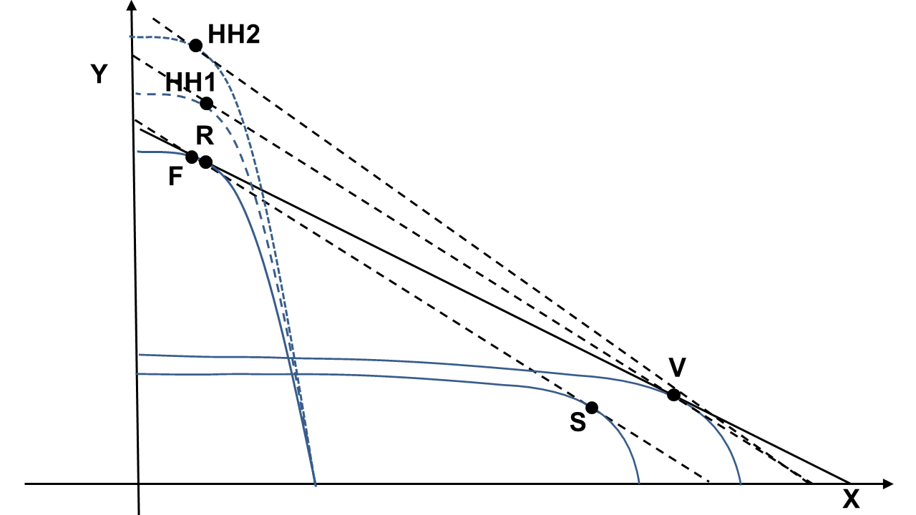
Figure 3 exhibits the outcomes of the introduction of selective technological change based and shaped by the localized constraints and opportunities of the learning processes. Equilibrium in now found in HH1 and HH2 according to the extent of the shift of the production possibility frontier itself engendered by the increase of the efficiency of the production of Y goods made possible by the localized creative response of incumbents.

The integration of the endogenous introduction of technological change localized by learning processes hypothesis provides a consistent analytical foundation to the hypothesis of differentiated rates of increase of efficiency levels within the incumbent country introduced in the literature by Maskus and Nishioka (2009) and Trefler (1993) who implement the HO model with factor-specific productivities and factor-augmenting technological differences differentiated across sectors and countries. Their analysis suggests that the inclusion of factor-augmenting productivity gaps make the HO framework compatible with the empirical evidence. They do not explain, however, how and why factor abundance guides the introduction of factor augmenting productivity gaps.

In this version of the SHO model, the specialization of Z countries in Y products is augmented and is fully endogenous. The characteristics of the learning process and its effects on the recombinant generation of knowledge account for the selective introduction of innovations as the outcome of the creative response in the production of Y goods but not in the production of X goods. Because of the creative response and the consequent introduction of innovation, as in the previous version, globalization does not affect wages (and capital user costs). Incumbent countries can retain the previous levels of wages and capital rental costs provided they are able to introduce localized technological changes that, changing both the shape and the position of the production possibility frontier, engender a steeper isorevenue (and isocost within the Edgeworth box) that identify a new equilibrium condition that make the original factor costs compatible with the post-globalization conditions. The stronger the extent of the creative and localized response and the stronger its effects of the productivity levels of Y goods and the stronger the likelihood that Z countries can actually increase their wage levels above the pre-globalization levels.

3.4 THE SHO MODEL WITH KNOWLEDGE AS AN INPUT AND AN OUTPUT
The basic SHO model can be further enriched by the achievements of the economics of knowledge with respect to the analysis of technological knowledge as an input in the production function of all the goods -the technology production function- and an output of a dedicated activity, the knowledge generation function, and its effects in terms of the endogenous direction of technological change.

The parallel globalization of product and financial markets in place since the last decades of the XX century undermined the opportunities for Z countries to cope with the changes in the international division of labor by means of the introduction of new capital-intensive technologies. Major institutional changes affected the working of the system dynamics deepening the out-of-equilibrium conditions for firms in Z economies. The globalization of financial markets played here a central role. The new international mobility of capital via both the flows of foreign direct investment of multinational companies and the international finance managed by international banks provided industrializing companies with large capital supply, undermining the profitability of a capital intensive induced technological change in –formerly- capital abundant countries (Perez, 2002 and 2010).

The globalization of financial markets provided available and cheap capital to newcomers. The competitive advantage of Z economies could no longer be restored by means of capital-intensive technological changes and increased specialization in capital intensive products. The introduction of radical technological changes became even more necessary. In countries where knowledge externalities were available, firms could cope with the entry in international product and capital markets of new, huge, labor abundant ad low wage countries in the global economy only with a major effort to identify the input that was actually and specifically abundant in their local factor markets so as to be able to direct their new technologies towards its use and to increase its intensity in their production processes.

The search for technological congruence led to identify technological knowledge as the key abundant factor in Z economies exposed to the international mobility of goods and capital. The strong collective and systemic character of technological knowledge localizes it in the specific and highly idiosyncratic features of each economic system. Technological knowledge does not spill freely in the ‘international’ atmosphere as suggested by the extensions of the new growth theory to international economics, but has a strong localized content based upon its tacit and sticky content that roots it in learning countries endowed with a strong knowledge base and advanced knowledge governance mechanisms (Romer, 1994; Branstetter 2001; Montobbio and Kataishi, 2015).

Knowledge is abundant in Z countries because they are characterized by a complex web of networks that make knowledge user-producer interactions possible and effective (Breschi, Lissoni, 2001) and high-quality knowledge governance mechanisms that favor the dissemination of knowledge spillovers and their actual use by third parties in the generation of new technological knowledge (Antonelli and Link, 2015). For these reasons Z countries could discover technological knowledge as a relatively abundant resource upon which a new competitive advantage could be built.

The relative abundance of technological knowledge in advanced countries activated and supported, at the same time, the mechanisms of knowledge congruence that led to the introduction of biased technological changes directed to increase the output elasticity of technological knowledge as an input and the complementary decline of the output elasticity of low-skilled labor (and fixed capital).

The technology production function and the knowledge generation function elaborated by Zvi Griliches (1979 and 1992) provide very effective tools to analyzing knowledge as an input and output. Knowledge is an input into the technology production function and the output of a knowledge generation function. The explicit integration of knowledge as a production factor into the production function enables to grasp the effects of the central role of knowledge, characterized by high levels of skilled labor intensity, and its substitution to standard labor and fixed capital, as a key production factor. The inclusion of the knowledge generation function enables to explore the characteristics of knowledge as the intentional output of an economic activity.

The inclusion of knowledge as an input and an output is reflected by the new system of equations where technological knowledge is an input in the production of Y and X goods and the output of a third sector that accounts for the role of the knowledge generation activities:

(14) Y_{Z} = A_{ZY} (K_{z})^{α} (L_{z})^{β} (TK_{z})^{γ}
(15) X_{Z} = A_{ZX} (K_{z})^{α} (L_{z})^{β} (TK_{z})^{γ}
(16) TK_{Z} = A_{ZTK} ((TK_{z})_{t-n} R&D&L_{Z})
(17) Y_{T} = A_{TY} (K_{T})^{δ} (L_{T})^{ε} (TK_{T})^{χ}
(18) X_{T} = A_{TX} (K_{T})^{δ} (L_{T})^{ε} (TK_{T})^{χ}
(19) TK_{T} = A_{TTK} ((TK_{T})_{t-n} R&D&L_{T})

The c.r.s. Cobb-Douglas technology production functions include on the l.h.s. the standard goods Y and X and on the r.h.s., next to the standard capital (K), labor (L) and (TK) the stock of technological knowledge, each with its respective output elasticity α, β, γ, δ, ε, χ. TK is -also- the output of the knowledge generation function where the very same TK -properly lagged- is an input together with R&D&L, the flows of research, development and learning activities. Each production function accommodates the respective total factor productivity (A).

In the knowledge generation function, TK can be thought of as the output of the new key sectors of the knowledge-intensive-business services (KIBS). Equations (16) and (19) are the recombinant knowledge generation functions respectively in Z and T countries and show that at each point in time the stock of technological knowledge is re-generated by means of the stock of existing technological knowledge at time t-1 and the flows of research, development and learning activities (R&D&L) consisting primarily of human capital and skilled labor. The stock and the flow of technological knowledge coincide as at each point in time the stock of knowledge resides in the brain of human beings and in the routines of organizations. Forgotten knowledge is useless. In order to use knowledge, at each point in time, it is necessary to allocate dedicated resources to access and absorb the existing knowledge and implement it by means of research, development and learning activities.

The following cost equations apply:

(19) C _{Z} = w_{Z}L _{Z} + r_{Z} K_{Z} + m_{Z} R&D&L_{Z}+ s_{Z} TK _{t-1}
(20) C _{T} = w_{T}L _{T} + r_{T} K_{T} m_{T} R&D&L_{T} + s_{T} TK _{t-1}
where w are relative wages, r the user costs of capital and (m and s) are respectively the cost of the research, development and learning activities and to access and absorb the stock of the existing knowledge; the subscripts indicate the country.

Following the HO model, we assume that in the T countries (w/r) is smaller than in the Z countries. The basic assumption of this version of the SHO model is that the cost of knowledge as an input in the technology production function, and an output in of the knowledge generation function is lower in Z than in T countries. More specifically we assume that knowledge generation activities – respectively m -i.e. the cost of research, development and learning (R&D&L)- and s -i.e. -the cost of search and use of the existing stock of knowledge as an input in the recombinant generation of new technological knowledge- are lower in Z countries with respect to T countries: m_{T}>m_{Z} and s_{T}>s_{Z} . Z countries can rely on the relative abundance of skilled labor with higher levels of human capital larger stock. Moreover, the search activities that are necessary to access the existing stock of knowledge have lower unitary costs in Z countries because of the higher quality of their knowledge governance.

The new input TK technological knowledge of the downstream technology production function displaces both standard labor and fixed capital. The new technology is skilled-labor intensive and fixed capital saving.

Finally, we can assume consistently that that A_{ZZZ} >A_{ZZ}: the aggregate (average) levels of total factor productivity in the innovating countries Z increase along with the levels of TK used in the production process because of its cost below equilibrium levels as determined by the relevant pecuniary knowledge externalities available in the system and by the higher levels of technological congruence made possible by the introduction of biased technological changes directed at increasing the output elasticity γ of the input locally most abundant and cheaper technological knowledge (TK).

The introduction of TK, as both an input and an output, stems directly from the Schumpeterian hypothesis that the intensive use of the locally cheaper technological knowledge (TK) favors the likelihood of the creative reaction and helps supporting the increase of total factor productivity. Following Warde (1973) the new equilibrium can be found with the extension of the basic HO model to three goods and three inputs.

Now the SHO model can take into account the effects of the twin globalization and the discovery of technological knowledge as the most abundant production factor in countries Z, so as to explaining the introduction of induced technological change biased towards the increased output elasticity of the new input technological knowledge, as an endogenous reaction that changes the shape of the production possibility frontier and the radical structural change that has been taking place in advanced countries with the decline of the manufacturing industry and its progressive substitution with the new knowledge intensive business service industries.

In order to cope with the twin globalization of the last decades of the XX century countries Z introduced a wave of biased technological changes directed towards a more intensive use of technological knowledge, while the rest of the international economy specialized in technologies with higher levels of capital output elasticity. Because of technological congruence, in fact, countries Z found it convenient to increase as much as possible the intensity of the production factor that was locally relatively more abundant (Antonelli, 2008, 2017).

The SHO framework elaborated so far is quite consistent with the results of Nishioka (2005) who had shown that the inclusion of knowledge as an input and output in the analysis of international trade flow helps increasing the viability of the HO model. The SHO framework implemented so far, however, pretends to explain the process by means of which such changes take place. The SHO approach shows that the introduction of biased technological changes directed at increasing the output elasticity of the input locally cheaper is the result of an out-of-equilibrium conditions determined by changes in international product markets. The strength of the SHO model consists in the endogenous account of the specialization of the trading countries. From this viewpoint the SHO framework differs from the Nishioka approach as it stresses the process that underlies the endogenous definition of both the rate and the direction of technological change.

After the endogenous introduction of the new directed technologies, the two economies will be far more different, than before. The specialization of countries Z in the generation, use and exploitation of technological knowledge will be even stronger than before as the substitution process on the existing map of isoquants is enhanced and reinforced by the introduction of biased technologies that favor the more intensive use of technological knowledge. The introduction of endogenous and biased technological change modifies both the position and the slope of the production possibility frontier and helps increasing the specialization of innovating –knowledge abundant- countries in the use of knowledge as both a key production factor and a key product (Abramovitz, David, 1996; Antonelli and Colombelli, 2011; Antonelli and Fassio, 2011).

In the SHO approach Z countries could face the relative changes of the new globalized factor markets by means of creative responses consisting in the introduction of new knowledge intensive technologies that helped them to cope with the new conditions of both product and factor international markets.

Advanced countries discovered that the high quality of their knowledge governance mechanisms, that made the exploitation of knowledge indivisibility and limited appropriability possible so as to favoring its use and dissemination as a collective resource localized in their own economic systems, could become the base of a new knowledge-intensive comparative advantage (Guerrieri and Meliciani, 2005).

The effects on the flows of goods among trading partners are clear. Knowledge abundant countries became the specialized providers of knowledge intensive products to the rest of the world exporting both knowledge intensive tangible goods and intangible knowledge intensive business services. Knowledge abundant countries rely more and more on the rest of the worlds for the imports of both capital and labor-intensive products. The introduction of the new technological system based upon new information and communication technologies was the cause and the consequence of the new specialization in the generation and exploitation of technological knowledge (Guerrieri, Luciani, Meliciani, 2011).

The ultimate effect of the endogenous technological and structural change was the reshaping of their specialization in international product markets with the decline and exit from manufacturing sectors and the attempt to found a new competitive advantage on and in the new knowledge intensive service industries. (Evangelista, Lucchese, Meliciani, 2013; Antonelli and Fassio, 2014).

The extended SHO framework accommodates the Leontief paradox as well as the resilience of wages in advanced countries and their fast increase in industrializing countries. An apparent paradox that finds its explanation in the long-standing knowledge abundance of the advanced economies and in a theoretical explanation centered upon the endogenous introduction of technological change biased towards the intensive use of knowledge as the most abundant local input.

4. CONCLUSIONS
The HO model is the pillar of international economics but suffers the limits of its static assumptions. Yet the dynamics of international trade provides clear evidence about the constant changes in the international division of labor, in the market shares and in the specialization and economic structure of competing partners. This evidence is especially strong after the twin globalization of product and capital markets that has been taking place since the last decades of the XX century.

This work has elaborated the SHO, a Schumpeterian version of the HO model, based upon the hypothesis that innovation is the endogenous outcome of the creative response of firms caught in out-of-equilibrium conditions provided that substantial pecuniary knowledge externalities are available in the system. Firms try and cope with the changes in their product and factor markets by means of the introduction of innovations when and if they may access existing knowledge and use it in the recombinant generation of new knowledge at costs below equilibrium. The new understanding of knowledge as an economic product and of the knowledge generation process enriches the Schumpeterian approach and enables to grasp the systemic determinants of the endogenous introduction of technological change.

The relative abundance of technological knowledge plays a twin role in this analysis. First it makes it possible to firms to support their creative response and introduce technological innovations: without a strong knowledge base their reaction could fail and be just adaptive. Second, because of the mechanisms of technological congruence, the very same strong knowledge base favors the new specialization in knowledge intensive products. The two roles reinforce each other with positive feedbacks. The larger is the knowledge abundance, in fact, the more creative can be the response of firms and countries in international markets, and the faster will be the introduction of new technologies and the stronger their direction towards the most intensive use of knowledge as the key production factor upon which a new international specialization can be built.

Changes in international trade interact with endogenous and directed technological change biased towards the most intensive use of the production factors that are locally most abundant in comparative terms. Changes in international product and factor markets and changes in technology do interact and feed each other, shaping the specialization and the economic structure of trading countries.

The SHO model, elaborated by this essay with three progressive versions, helps understanding the endogenous determinants of: i) the specialization of countries, ii) their productivity levels, iii) the relative cost of their production factors, and iv) the structure of their economic systems. These basic elements assumed as static and exogenous by the HO model are now fully endogenized.

The integration of the Schumpeterian legacy into the HO framework shows how and why innovation triggered by the creative response can be the best remedy to the negative effects of globalization.

REFERENCES
Abramovitz, M., David, P.A. (1996), Technological change and the rise of intangible investments: The US economy growth path in the twentieth century, in OECD, Employment and Growth in the Knowledge Based Economy, pp. 35-60. Paris.

Acemoglu, D. K. (2002), Directed technical change, Review of Economic Studies 69, 781-809.

Acemoglu, D.K. (2015), Localised and biased technologies: Atkinson and Stiglitz’s new view, induced innovations, and directed technological change, Economic Journal 125, 443-463.

Acemoglu, D., Zilibotti, F. (2001), Productivity differences, Quarterly Journal of Economics 116, 563–606.

Antonelli, C. (2008), Localized Technological Change. Towards the Economics of Complexity, London, Routledge.

Antonelli, C. (ed.) (2011), Handbook on the Economic Complexity of Technological Change, Edward Elgar, Cheltenham.

Antonelli, C. (2017), Endogenous Innovation. The Economics of an Emergent System Property, Edward Elgar, Cheltenham.

Antonelli, C., Colombelli, A. (2011), Globalization and directed technological change at the firm level. The European evidence, in Libecap, G. (ed.), Advances in the Study of Entrepreneurship, Innovation and Economic Growth, Volume 22 Emerald Publishing, Cambridge, pp.1-20

Antonelli, C., Fassio, C. (2011), Globalization and innovation in advanced economies, in Libecap, G. (ed.) Advances in the Study of Entrepreneurship, Innovation and Economic Growth. Volume 22 Emerald Publishing, Cambridge, pp. 21-46.

Antonelli, C., Fassio, C. (2014), The economics of the light economy. Globalization, skill biased technological change and slow growth, Technological Forecasting & Social Change 87, 89-107.

Antonelli, C., Link, A. (eds.) (2015), Handbook of the Economics of Knowledge, Routledge, London.

Antonelli, C., David, P.A. (eds.) (2015), The Economics of Knowledge and Knowledge Driven Economy, Routledge, London.

Baldwin, R. (2016), The Great Convergence Information Technology and the New Globalization, Harvard University Press, Cambridge.

Bloom, N., Draca, M., Van Reenen, J. (2016), Trade induced technical change? the impact of Chinese imports on innovation, IT and productivity, Review of Economic Studies 83 (1) 87-117.

Branstetter, L. (2001), Are knowledge spillovers international or intranational in scope?, Journal of International Economics 53, 53-79.

Breschi, S., Lissoni, F. (2001), Knowledge spillovers ad local innovation systems: A critical survey, Industrial and Corporale Change 10, 975-1005.

Evangelista, R., Lucchese, M., Meliciani, V. (2013), Business services innovation and sectoral growth, Structural Change and Economic Dynamics 25, 119-132

Feder, C. (2018), A measure of total input productivity with biased technological change, Economics of Innovation and New Technology 27 (3), 243-253.

Freeman, C. (ed.) (1996), The Long Wave in the World Economy, International Library of Critical Writings in Economics, Edward Elgar, Aldershot.

Griliches, Z. (1979), Issues in assessing the contribution of research and development to productivity growth, Bell Journal of Economics 10, 92-116.

Griliches, Z. (1992), The search for R&D spillovers, Scandinavian Journal of Economics 94, Supplement: 29-47.

Guerrieri, P., Meliciani, V. (2005), Technology and international competitiveness: The interdependence between manufacturing and producer services, Structural Change and Economic Dynamics 16, 489-502.

Guerrieri, P., Luciani, M., Meliciani, V. (2011), The determinants of investment in information and communication technologies, Economics of Innovation and New Technology 20, 387-403.

Helpman, E. (2019), Globalization and Inequality, Harvard University Press, Cambridge.

Karabarbounis, L., Neiman, B. (2014), The global decline of the labor share, Quartely Journal of Economics 129, 61-103.

Laursen, K. (1999), The impact of technological opportunity on the dynamics of trade
performance, Structural Change and Economic Dynamics 10, 341–357

Leontief, W. (1953), Domestic production and foreign trade. The American capital position re-examined, Proceedings of the American Philosophical Society 97 (4) 332–349

Maskus, K. E., Nishioka, S. (2009), Development-related biases in factor productivities and the HOV model of trade, Canadian Journal of Economics 42, 519-553

Meliciani,V. (2002), The impact of technological specialization on national performance in a balance-of-payments-constrained growth model. Structural Change and Economic Dynamics 13, 101–118.

Montobbio, F., Rampa, F. (2005), The impact of technology and structural change on export performance in nine developing countries. World Development 33 (4), 527–547.

Montobbio, F., Kataishi, R. (2015), The international dissemination of technological knowledge, in Antonelli, C., Link, A. (eds.) (2015), Handbook of the Economics of Knowledge, Routledge, London, pp.165-188.

Nishioka, S. (2005), An Explanation of OECD Trade with Knowledge Capital and the HOV Model, Dept. of Economics, University of Arizona.

Perez, C. (2002), Technological Revolutions and Financial Capital: The Dynamics of Bubbles and Golden Ages. Edward Elgar, Cheltenham.

Perez, C. (2010), Technological revolutions and techno-economic paradigms, Cambridge Journal of Economics 34, 185-202.

Romer, P. M. (1994), New goods old theory, and the welfare costs of trade restrictions,
Journal of Development Economics 43: 5–38

Rybczynski, T. M. (1955), Factor endowment and relative commodity prices, Economica 22, 336–341.

Ruttan, V.W. (2001), Technology Growth and Development. An Induced Innovation Perspective, Oxford University Press, Oxford.

Schumpeter, J.A. (1947), The creative response in economic history, Journal of Economic History 7, 149-159.

Trefler, D. (1993), International factor price differences: Leontief was right! Journal of Political Economy 101, 961-87.

Urraca-Ruiz, A. (2013), The ‘technological’ dimension of structural change under market integration, Structural Change and Economic Dynamics 27, 1-18.

Zeira, J. (1998), Workers, machines and economic growth, Quarterly Journal of Economics, 113, 1091-1113.

Warne R.D. (1973), Factor intensity and the Heckscher-Ohlin theorem in a three-factor, three-good model, Canadian Journal of Economics 6, (3) 369-375.

The comments of the anonymous referees and the editor are gratefully acknowledged. The funding of my Department are acknowledged. .
Attempts have been made to elaborate a more inclusive version of the standard HO model allowing for the mobility of inputs and more specifically for both labor and capital flows among countries. Even in this version of the HO model, however, firms are not allowed to change their technologies: technological change is exogenous (Rybczynski, 1955).

