This is the author's final version of the contribution published as:

[Belwal, T.; Chemat, F.; Venskutonis, P.R.; Cravotto, G.; Jaiswal, D.K.; Bhatt, I.D.; Devkota, H.P.; Luo, Z. Recent advances in scaling-up of non-conventional extraction techniques: learning from successes and failures, TRAC. TRENDS IN ANALYTICAL CHEMISTRY 127, 115895, 1-25, DOI: 10.1016/j.trac.2020.115895]

The publisher's version is available at:
[https://www.sciencedirect.com/science/article/pii/S0165993620301242?via=ihub]

When citing, please refer to the published version.

Link to this full text:
[http://hdl.handle.net/2318/1737959]

This full text was downloaded from iris-Aperto: https://iris.unito.it/

Recent advances in scaling-up of non-conventional extraction techniques: learning from successes and failures
Tarun Belwalª*, Farid Chemat^{b}, Petras Rimantas Venskutonis^{c}, Giancarlo Cravotto^{d}, Durgesh Kumar Jaishwal^{e}, Indra Dutt Bhatt^{f}, Hari Prasad Devkota^{g}, Zisheng Luoª*

AUTHOR AFFILIATION(S):
ª Zhejiang University, College of Biosystems Engineering and Food Science, Zhejiang Key Laboratory for Agri-Food Processing, Key Laboratory of Agro-Products Postharvest Handling of Ministry of Agriculture and Rural Affairs, Hangzhou, 310058, People’s Republic of China
^{b} Avignon University, INRAE, UMR408, GREEN Team Extraction, F-84000 Avignon, France
^{c} Department of Food Technology, Kaunas University of Technology, Radvilėnų pl. 19, Kaunas LT-50254, Lithuania
^{d} Department of Drug Science and Technology, University of Turin, via P. Giuria 9, 10125 Turin, Italy
^{e} Institute of Environmental and Sustainable Development, Banaras Hindu University, Varanasi, India
^{f} G.B. Pant National Institute of Himalayan Environment & Sustainable Development, Kosi- Katarmal, Almora 263643, India
^{g} Department of Instrumental Analysis, Graduate School of Pharmaceutical Sciences, Kumamoto University, Kumamoto, Japan

* Corresponding Authors:

Zisheng Luo

College of Biosystems Engineering and Food Science, Zhejiang University, Hangzhou 310058, People’s Republic of China; Phone: +86-571-88982175; E-mail: luozisheng@zju.edu.cn

Tarun Belwal

College of Biosystems Engineering and Food Science, Zhejiang University, Hangzhou 310058, People’s Republic of China; Phone: +86-14758166086; E-mail: tarungbpihed@gmail.com

Table of contents:
- Introduction
- Scale-up studies: learning from successes and failures
  - Ultrasonic-assisted extraction (UAE)
  - Microwave-assisted extraction (MAE)
  - Supercritical fluid extraction (SFE)
  - Other less commonly explored green extraction techniques for extraction scale-up
    - Negative pressure cavitation extraction (NPCE)
    - Pressurised liquid extraction (PLE)
    - Pulsed electric field extraction (PEF)
    - Enzyme-assisted extraction (EAE)
  - Hybrid/combined reactors technologies
  - From batch to flow mode
- Factors affecting extraction-process scalability
  - Analytical factors
  - Instrumentation design
  - Energy consumption and economy efficiency
- Extraction scale-up strategies: mass transfer, kinetics and optimisation models
- Trends, challenges and future recommendations

Abstract
The impact of the extraction technologies on product yield and analytical profile is relevant. This review is aiming to discuss recent experiences of successes and failures in non-conventional extraction scaling-up, to better understand the challenges and designing of existing and new techniques. Understanding the crucial extraction factors at laboratory and pilot scale is of paramount value for the work of scaling-up engineering. Besides, a careful analysis and modelling of heat and mass transfer and energy consumption, the design of industrial extraction plants driven by economic and environmental factors, are well covered in the present review. Current trend strongly favors scaling-up of green approaches that consumes less organic solvent(s), involves minimal operational steps, provides high throughput capability and assures highest yield at lower costs. Current and future challenges in scaling-up extraction of bioactive compounds require a parallel development of suitable analytical methods to monitor the process and ensure high yield and quality.
Keywords: extraction scale-up; ultrasonic-assisted extraction; supercritical fluid extraction; microwave-assisted extraction; batch to flow; bioactive compounds

Abbreviations
AED: absorbed energy density; APD: absorbed power density; ASE: accelerated fluid extraction; BBD: Box–Behnken designs; BIC: broken plus intact cells; CCD: central composite design; CO₂: carbon dioxide; COM: cost of manufacturing; EAE: enzyme-assisted extraction (EAE); ESE: enhanced solvent extraction; HNPCE: Homogenization assisted negative pressure cavitation extraction; HSPE: high-pressure solvent extraction; LDF: linear driving force; MAE: microwave-assisted extraction; MHG: microwave hydrodiffusion and gravity; NPCE: negative pressure cavitation extraction; PEFE: pulsed electric field extraction; PHWE: pressurised hot water extraction; PLE: pressurised liquid extraction; RSM: response surface methodology; SC-CO₂: supercritical carbon dioxide; SFE: supercritical fluid extraction; SFME: solvent-free microwave extraction; TRLs: technology readiness levels; UAE: ultrasonic-assisted extraction; UAM: ultrasonic-assisted maceration; US: ultrasonic
      - Introduction
Extraction is an important step in the chemical analysis of plant samples for sample preparation and the recovery of bioactive compounds from plant tissue. Several conventional extraction methods, such as percolation, maceration and Soxhlet, have made use of simple techniques for the extraction of specific compounds and the preparation of whole extracts. These extracts can either be used directly or added to formulations as herbal drugs, nutraceuticals in food supplements and ingredients for cosmetics. A number of enabling technologies can provide high quality extracts, well suited for the disease treatment and the improvement of health conditions. Conventional extraction techniques, generally require long time and higher solvent volumes consumption. Non-conventional extraction techniques have higher and more selective product recovery [1]. These non-conventional techniques include, microwaves, ultrasound, supercritical fluid, high pressure liquid, pulsed electric field and enzyme-assisted extraction techniques. The use of green solvents also makes these processes primarily green extraction techniques [2]. In recent years, a larger number of experiments have been conducted on the lab-scale using these green extraction techniques and have obtained high value extracts from plant samples [3]. The increasing intensity of lab scale research clearly highlights the importance of these non-conventional extraction techniques and their ability to provide superior quality extracts with economic benefits, while also emphasising the importance of the development of scaled-up/industrial methods [4-6]. For any technique to be sustainable in meeting increasing industrial demand, the development of scale-up methods is necessary and analytical criteria/factors must be considered.
The scale-up of extraction techniques is not a trivial task and it is not simply a case of increasing the volume and the amount of biomass. A more scientific and analytical approach is required. Furthermore, it is worth noting that the terms ‘upscaling’, ‘laboratory scale’ and ‘pilot scale’ have been applied to a wide range of extraction volumes, and upscaling levels should therefore be understood rather conditionally. For instance, in some studies, the term ‘upscaling’ may indicate the testing of parameters, which were optimized using approximately 10-200 mL extractors, in 500-1000 mL extractors, while other studies have optimized parameters in 500-1000 mL extractors to then further scale-up the process to a 10-50 L pilot scale and even larger, industrial volume vessels. In general, scale-up should secure both the economic and quality parameters of the extract. While lab-scale extractions require small quantities (up to a few grams) of raw material and solvent, and entail relatively limited overall process times, pilot/industrial scale extractions require substantial consideration of both economy and productivity.
A large amount of research has been conducted on the scale-up of extraction methods from lab to pilot/industrial scale, and several factors have been considered, including instrumentation, batch/flow process, kinetics, economics and energy consumption. The success or failure of any scale-up process depends on these factors. From the perspective of analytical chemistry, extraction affects the quality of the extract along with its yield, as has been extensively critically discussed in previous reviews that mainly focus on lab-scale extraction [1,2]. These techniques have also been tested for scale-up in order to meet industrial needs and the higher demand of natural products. However, no review has yet critically examined and discussed the success and failures of scale-up process and the consequent effects on the quality attributes of the extract etc. The idea of the present review is thus to critically discuss the analytical approach to the scale-up of non-conventional extraction methods in order to extract higher volumes of bioactive compounds from plant samples. Around 20 years of scientific literature have been selected for a comprehensive survey on the main non-conventional extraction techniques. Furthermore, factors that are crucial to the success of scale-up processes are also discussed together with scale-up strategies. Available industrial extraction methods and their applicability are also discussed. Finally, the review highlights the current trends and challenges in the scale-up of these non-conventional extraction techniques and provides recommendations for better process and product efficiency.

- Scale-up studies: learning from successes and failures
A great deal of effort has been invested in the lab-to-pilot, and, in some cases, industrial scale, scale-up of extraction processes. Green extraction concepts have seen extensive study and development thanks to non-conventional extraction techniques [1,2]. Numerous studies have been conducted on extraction process intensification and scale-up (Table 1) using non-conventional extraction techniques such as, microwaves, ultrasonic, supercritical fluid, negative cavitation, pressurized fluid, etc.. Various considerations have been made in the development of scale-up processes for these methods, including the modification of instruments, batch/flow processes, kinetics and criteria-based studies, and combined extraction, which have had profound effects on large volume extractions. Although an optimal solid-liquid extraction should be carried out with a continuous countercurrent multistage process, the non-conventional technologies herein reported enable to maximise extraction yields even in a single equilibrium stage.

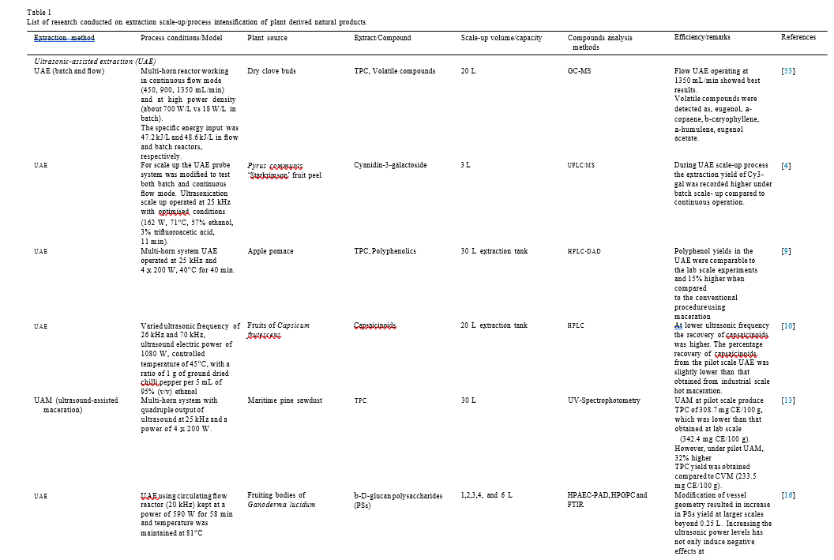
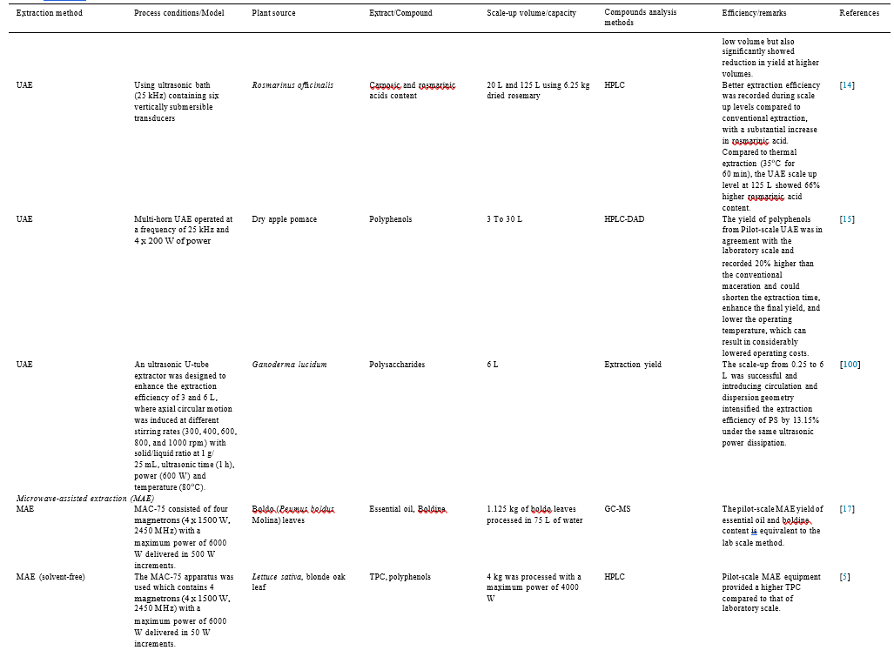
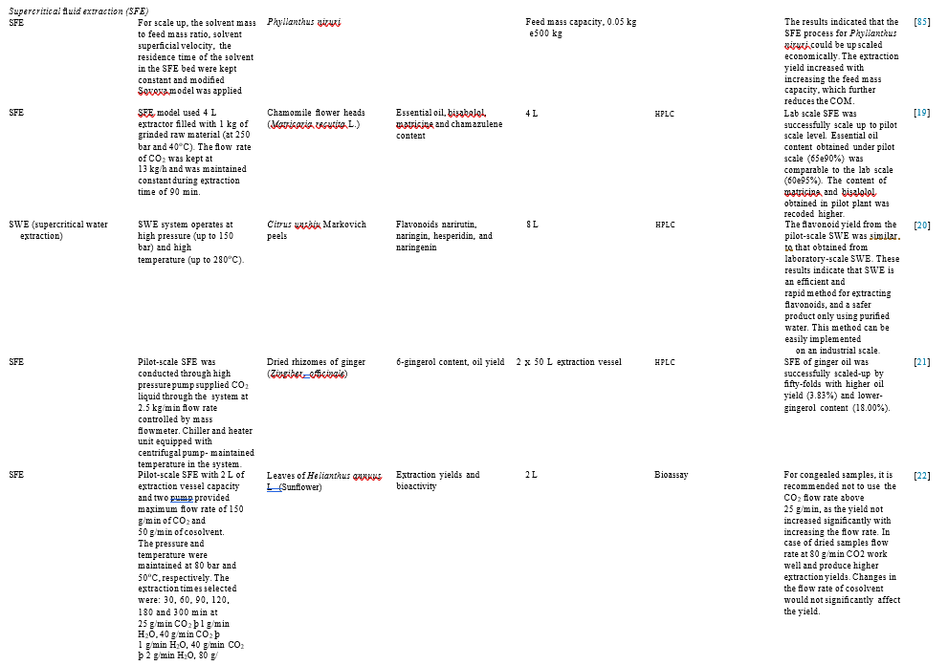
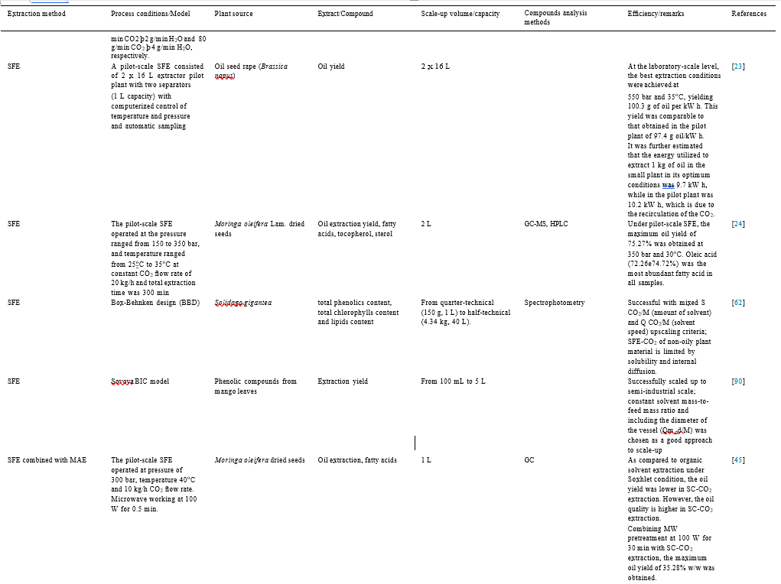
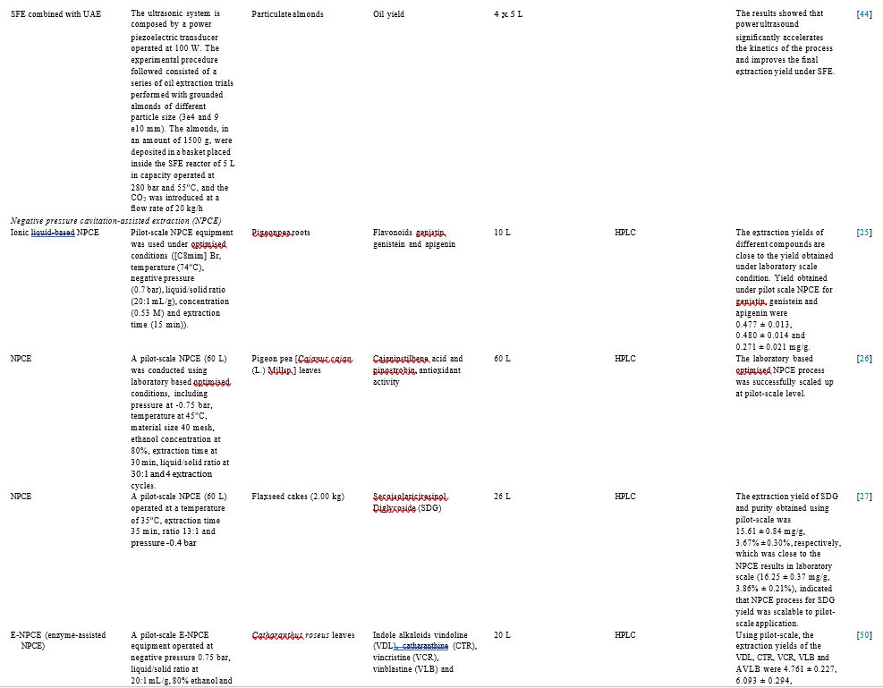
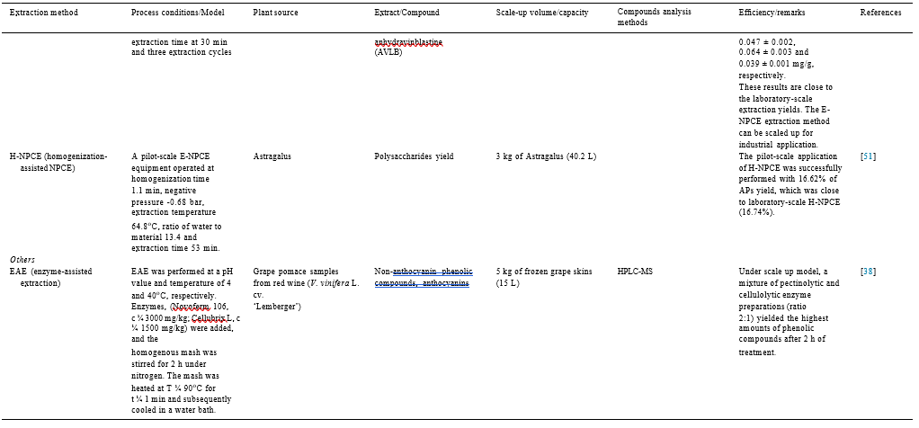

  - Ultrasonic-assisted extraction (UAE)
The ultrasound technique has been used in various food-processing operations, such as extraction, filtration, freezing, packaging, cutting and nano-formulations. Furthermore, its use in the extraction of bioactive compounds from plant matrices has been extensively studied on the lab-scale [7,8].
All ultrasonic systems are composed of a transducer, which generates ultrasound by converting electrical energy (or mechanical energy, in the case of the liquid whistle) into sound energy via mechanical vibrations at ultrasonic frequencies. Although a wide range of transducer types are available, the purpose is always the same. The piezoelectric transducer is based on a crystalline ceramic material that responds to electrical energy. This transducer type is the most common, and is used in most ultrasonic processors and reactors as it has been cited as the most efficient, achieving higher than 95% efficiency. Ultrasound equipment has been developed for both laboratory and industrial scales. Two different types of ultrasound equipment are commonly used in both applications: bath and probe systems. However, the intrinsic differences between the systems should be taken into account when choosing which is most suitable for the desired final purpose. Recently, some continuous-flow apparatuses have also been developed for both laboratory and pilot scales. Some advances in the coupling of ultrasonic equipment to analytical instruments are expected soon, and these could considerably reduce costs by avoiding sample preparation steps such as concentration, filtration and derivatisation before analysis.
On the laboratory scale, numerous extracts, such as carotenoids, antioxidants, essential oils, flavours etc., have been obtained using ultrasound [7,9]. A correct design of the ultrasonic reactor is fundamental to optimize the extraction process and minimize the energy consumption. The ultrasonic cleaning bath, which is used to disperse solids into a solvent (solubility of solid particles is increased as particles size is reduced), degas solutions and clean small materials by immersion, was the first batch equipment to be developed. This type of equipment is easy to handle and has very low implementation costs. The probe system is more suitable for smaller volumes and is considered to be more powerful since there is less dispersion of ultrasonic energy. Ultrasonic intensity is delivered by a small surface (the tip of the probe), and the immersion of the probe directly into the reaction flask avoids attenuation.

Probe and bath systems are used on pilot/industrial scales, depending on the application, and several types of ultrasonic device have been developed for industrial use and the scale-up of laboratory experiments by a large number of companies, such as Weber (Germany), Hielscher (Germany), Branson (Switzerland), Vibracell (USA) and REUS (France), among others. The positioning of the ultrasound transducer varies by device and some also include an agitation system. Some continuous flow devices have also been developed for both probe and batch systems. REUS has developed reactors, from 30 to 1000 L, to which pump systems are coupled to fill the ultrasonic bath, stir the mixture and empty the system at the end of the procedure (Figure 1A). Hielscher produces devices with a wide range of power; from 50 W to 400 W for analytical scales and from 500 W to 16000 W for industrial scales (Figure 1B).

A number of lab-scale investigations have shown that UAE is one of the best non-thermal green extraction techniques as it can provide better extraction yields, lower process times and lower solvent and energy consumption [7,10]. Studies have also been conducted on process intensification and the development of scale-up processes for higher-volume extraction using ultrasound (Table 1). In fact, a large scale (30 L) UAE method for polyphenolic extraction from apple pomace has been developed using four 200W ultrasonic extraction tanks operating at 25KHz and 40 °C for 40 min [11]. The operation conditions were first optimised on the lab-scale level and then used to scale-up the process. The polyphenolic yield of the scale-up process was found to be comparable to that of the lab-scale experiments, giving a yield that was 15% higher than that of conventional extraction [11]. Ultrasonic frequency played an important role in determining extraction efficiency during ultrasonication as it directly affects the formation of cavitation bubbles. As such, a variety of ultrasonic bath frequencies were tested during process intensification for the extraction of capsaicinoids from the fruit of Capsicum frutescens in a 20L extraction tank [12]. In the pilot-scale study, the ultrasonic bath operated at 1080 W power and a frequency of 26 kHz was found to extract capsaicinoids at higher concentrations than the higher frequency used (70 kHz). As a general rule, increases in frequency lead to reductions in bubble size, which result in decreases in the energy released during bubble implosion [13]. However, higher frequencies also generate a large number of cavitation bubbles, which may also increase the formation of reactive oxygen species [14], and hence destroy oxidation-prone compounds in the extract. The study also revealed that, although UAE gave promising results, the yield was slightly lower in pilot-scale UAE than in industrial-scale hot maceration [12].
Ultrasound techniques are highly likely to be developed for use as green extraction methods on the industrial scale using green solvents. In fact, a pilot-scale (30 L) ultrasonic-assisted maceration (UAM) process using four 200 W ultrasonic baths at 25 kHz has been used to extract phenolic compounds from maritime pine sawdust using water as a green solvent [15]. The results showed that a lower extraction yield was achieved on the pilot-scale than in lab-scale extraction. However, the yield was 32% higher than conventional maceration extraction, which clearly highlights the impact that ultrasound can have in obtaining higher compound extraction yields, even under scaled-up conditions.
In a high-volume (125 L) extraction of carnosic and rosmarinic acid from 6.25 kg of dried rosemary, an ultrasonic bath (25 kHz) was operated with 6 vertical transducers [16]. The batch scale-up process consisted of the extraction being initially conducted at 20 L and then at 125 L. Both scale-up models gave good compound extraction yields at 125L, and the rosemarinic acid content was found to be 66% higher than in the thermal process [16]. Ultrasonic extraction is said to be a non-thermal process, unlike conventional heat extraction, and thus has a lesser negative impact on heat-sensitive compounds. However, a thermostat should be attached to control and maintain the temperature during extraction processes for thermolabile compounds using UAE.
A scaled-up UAE method has also been developed to increase the extraction volume from 3 L to 30 L for the extraction of polyphenols from dry apple pomace using four 200 W ultrasound transducers in one 30L extraction tank operated at 25 kHz [17]. The extraction parameters were initially optimised on the lab scale and then applied to the pilot scale. The extraction yield was found to be the same in the scaled-up model as in the lab-scale UAE process, while the yield was 20% higher than that of conventional maceration. This model was also recommended for use in industrial-scale extraction due the lower extraction time, ultrasonic temperature and higher extraction yield (overall operation cost was lower) that it provides [17].
A scale-up UAE model to increase extraction volumes to 3 L and 6 L from 0.25 L has made use of an ultrasonic U-type extractor (600W) designed to provide circulatory motion at different stirring rates (300 to 1000 rpm) and to increase polysaccharide extraction efficiency from Ganoderma lucidum [18]. The geometry of the extraction vessel was improved/modified by introducing a conical funnel which reduced the cross-sectional area of the flow path, thus meaning that the mushroom powder was more highly exposed to the cavitation zone. Furthermore, the radiation distance varied from 2 to 8 cm in the experiment. In the unmodified ultrasonic reactor, the extraction yield of PS was found to decrease by 40% from 0.25 L to 6 L during scale-up. However, with the modified geometry of the U-type ultrasonic reactor, a significant increase in polysaccharide yield, by 13.15%, was recorded compared to the lower-volume extraction process. Moreover, an 88% increase in polysaccharide extraction yield was recorded, compared to conventional extraction, at a stirring rate of 600 rpm and a radiation distance of 4 cm. The axial circulation flow was found to exert a positive effect on extraction yield at a variety of rpm settings. In fact, 300 and 600 rpm circulation flow at 3 L and 6 L of scale up volumes, respectively, were found to provide maximum contact between the mushroom powder and the ultrasonic tip [18].
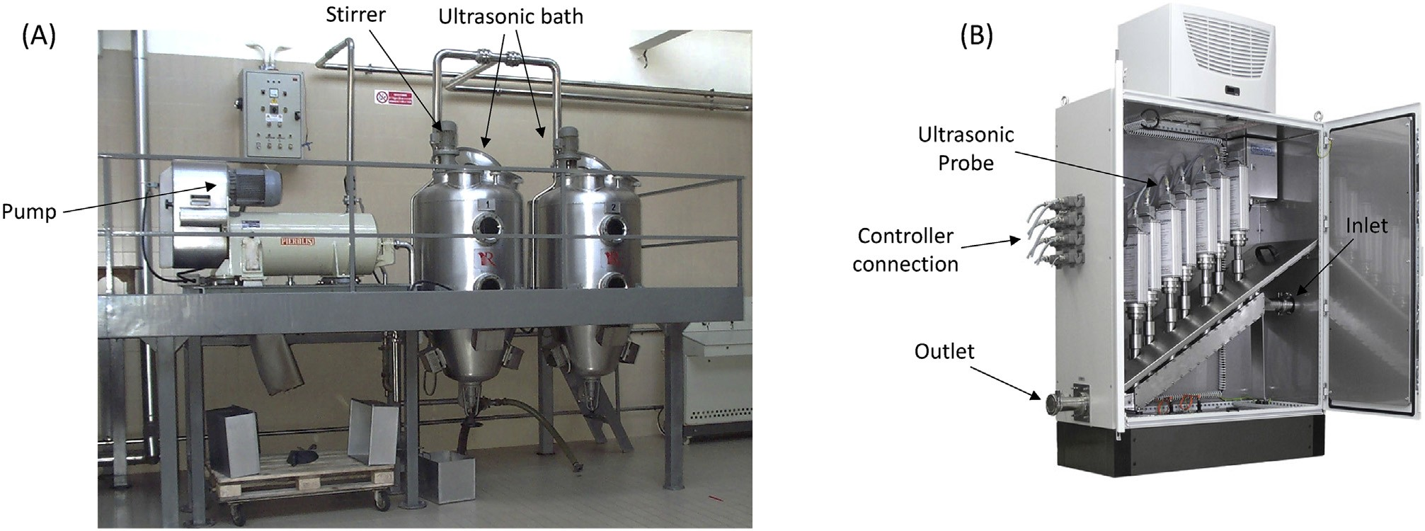
Fig. 1. Industrial scale Ultrasonic (A) batch extraction process 2 x 500 L (Reus - www.etsreus.com) and (B) continuous extraction process 1000e10,000 L/h (Hielscher- http://www. hielscher.com/).

Most of the compounds extracted on scaled-up and industrial scales by ultrasound have immediate uses (for instance in liquor production) or can be used as food and cosmetic additives (in the case of essential oil and molecules with special activity). Several companies are listed as being practical users of ultrasound on industrial scales. In fact, GMC (www.gmariani.it), an Italian-based company that specialises in aromatic-herb extraction has adapted innovative extraction systems for the extraction of compounds. GIOTTI (www.giotti.it) is another Italian company that uses ultrasound assistance in the extraction of food, pharmaceutical additives and also for the production of alcoholic drinks. This company works with four continuous batch systems equipped with ultrasound on each side of the tanks and an agitation system. Moliserb s.r.l (www.moliserb.com) is a company that specialises in the UAE of thermolabile compounds with alimentary and cosmetic applications. The only industrial application of ultrasound in a continuous process has been reported by Cavitus (www.cavitus.com), an Australian based company which uses ultrasound to enhance maceration during wine making, increasing the content of tannins, anthocyanins and aromas.
  - Microwave-assisted extraction (MAE)
MAE has been used in the extraction of several compounds from natural products (citrus, aromatic plants, cereals, etc.) [1]. Numerous classes of compounds, such as aromas, antioxidants, colours, bio-phenols, and other secondary and primary metabolites, have been efficiently, in terms of rapidity and reproducibility, extracted using MAE from a variety of matrices. Microwave reactors, available for both the lab- (Figure 2A) and pilot/industrial-scales (Figure 2B), vary in terms of magnetron numbers, reaction volumes, geometry, etc. Lab scale microwave reactors, Multiwave 3000 (Anton Paar, GmbH, Germany), usually consisted of extraction chamber, extraction vessels, sensors and controllers (Figure 2A). The vessel volume varies depending on the manufacture and type of applications. The sensors comprise of vessel mark sensor, IR sensor and PT sensor for controlling the vessel position and oscillation, temperature and inside vessel pressure and temperature, respectively. It can be run either in microwave power mode or temperature mode under irradiation of magnetrons fitted below the chamber.
Various microwave-absorbing solvents have been used with MAE. However, the non-solvent extraction, especially of oils, is also possible using microwaves [3]. The ability to extract compounds under green extraction conditions (without solvent) is an advantage of MAE over other techniques. Typically, plant material is immersed in a non-absorbing solvent, such as vegetable oil, and irradiated by microwave energy. When the oil glands of the plant are subjected to severe thermal stress and localised high pressures, as in the case of dielectric heating, the pressure build-up within the glands exceeds their capacity for expansion, and causes their rupture more rapidly than in conventional extraction. Using this concept, the Milestone company (www.milestonesrl.com) performs microwave extraction from laboratory (Ethos X) to pilot-industrial scales (MAC-75) (Figure 2B).
The MAC-75 pilot plant has been widely used in order to develop MAE scale-up methods. It was built to treat higher quantities of biomass with microwave energy and has already been successfully used for a number of applications, including the flavouring of oil with aromatic plants. The MAC-75 apparatus is a multimode microwave reactor, which contains 4 magnetrons (4 x 1500 W, 2450 MHz) with a maximum power of 6000 W delivered in 500 W increments. The stainless-steel microwave cavity has a capacity of 150 L and possesses a removable, rotating PTFE drum that can treat up to 75 L of plant material. To ensure that the microwaves are homogeneously distributed to the material inside the drum, the MAC-75 is fitted with a rotation system. The circumference of the drum, which is perforated throughout, allows vapour and liquid to circulate. The device is controlled by an industrial touch-screen control terminal and possesses sensors, placed on wave guides, to measure microwaves absorption, which allows the delivered power to be adjusted if absorption is too low. The temperature is monitored by a temperature detector (PT-100) that is inserted into the cavity, which is able to work in a deep vacuum or as an open vessel. This industrial microwave reactor could be used even for solvent-free microwave extraction of essential oils, microwave hydrodiffusion and gravity for extraction of volatiles and non-volatiles compounds, but also for extraction of herbs and spices with non-flammable solvents such as water, glycerine, vegetable oils. This system is used by the company PELLAS (http://pellasnature.com/) for the aromatisation of olive oil with aromatic herbs and spices (Figure 2B).
Solvent-Free Microwave Extraction (SFME) is based on a relatively simple principle, this method involves placing plant material in a microwave reactor, without any organic solvent or water. The internal heating of the in situ water within the plant material distends the plant cells and leads to rupture of the glands and oleaginous receptacles. Thus, this process frees essential oil which is evaporated by the in situ water of the plant material. A cooling system outside the microwave oven condenses the distillate continuously. The water excess is refluxed to the extraction vessel in order to restore the in situ water to the plant material. Microwave Hydrodiffusion and Gravity (MHG) is an original “upside down” microwave alembic combining microwave heating and earth gravity at atmospheric pressure. MHG was conceived for laboratory and industrial scale applications for the extraction of food ingredients from different kind of fruits, vegetables and aromatic plants. Microwaves induce warming of the water contained in the matrix, which allows the destruction of cells containing volatiles and non-volatiles compounds.
Although very few MAE scale up experiments have been conducted, those that have shown promising results. As such, using green solvents and extraction methods, a solvent free MAE has been developed using 4 magnetrons (1500 W and 2450 MHz) in a scaled-up (75 L) pilot microwave reactor (MAC-75) [4]. The reactor was designed to extract essential oil from 3 kg of fresh rosemary plant. It was reported that the microwave reactor was able to efficiently extract essential oil in scale-up mode, and that the yield (0.50%) was comparable to that of the lab-scale (0.54%) microwave reactor. In a similar green-extraction scale-up study, the 75 L-scale MAE of essential oil (containing boldine) from Peumus boldus leaves was conducted using a MAC-75 (4x1500 W, 2450 MHz) [19]. The power was increased to 6000 W and delivered with 500 W of increments. The lab-scale extraction was conducted at 200 W using 500 mL of water, whereas, 6000 W of power was applied for 15 L of total volume in the 75 L-scale experiment. It was reported that the microwave extraction scale-up was successfully conducted and the oil yield (1.4%) and boldine content (129 ppm) was found to be comparable to that of the lab scale extraction [19].
In another microwave hydrodiffusion gravity (MHG) extraction scale-up method under green extraction (solvent free) conditions, 4 kg of lettuce was extracted using a maximum power of 4000 W in a multimode microwave reactor (MAC-75) [6]. The yield (6.71 mg/100g FW) of the polyphenolic content in pilot-scale was found higher than the lab scale MHG (3.13 mg/100g FW). However, more effective hydrodiffusion takes place during scale-up, thanks to the mechanical stirring of the sample, which ultimately increased the yield [6].
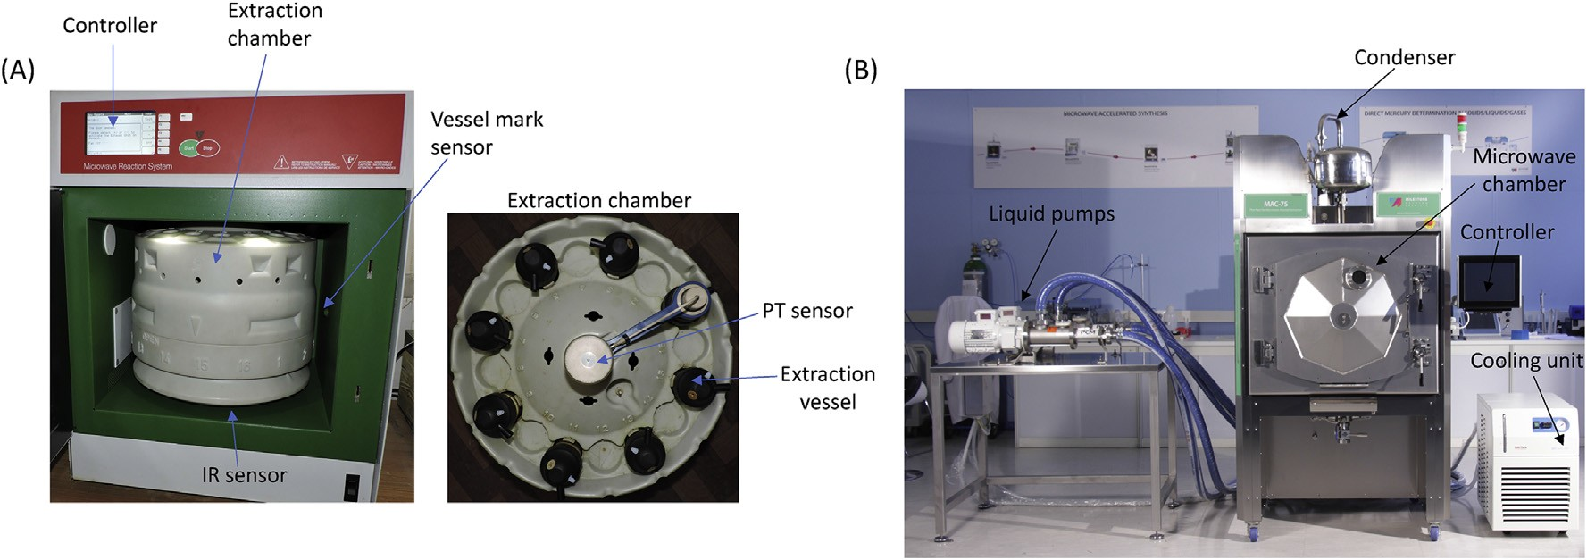
Fig. 2. (A) Lab-scale (Multiwave 3000) and (B) Industrial scale (Mac 75) microwave reactor for extraction of bioactive compounds from plant samples.

  - Supercritical fluid extraction (SFE)
Supercritical fluid extraction (SFE) is the most common non-conventional technique used industrially on a large scale, especially in combination with the use of carbon dioxide (CO₂) as a green solvent. The efficiency of CO₂ comes from its gas-like mass transfer properties and liquid-like solvating characteristics, with diffusion coefficients that are higher than those of a liquid. CO₂ is non-toxic, non-flammable, cheap, easily eliminated after extraction and endowed with a high solvating capacity for non-polar molecules. When the temperature and pressure of any substance is raised above their critical point, distinct liquid and gas phases cease to exist and such substances are called supercritical fluids. Since their discovery in 1822 by Baron Charles Cagniard de la Tour, supercritical fluids have found numerous applications in various fields, including extraction. The work of J.B. Hannay and J.Hogarth in 1879 on the solubility of solids in gases can be considered a starting point for SFE, while the German Patent (1493,190) for the decaffeination of coffee using SFE filed by K. Zosel was an important benchmark in the industrial application and commercialisation of this technology. Since then, SFE has become an important technique in numerous engineering and technology fields.
The majority of studies into SFE have been performed using laboratory-scale equipment (Figure 3A) for various purposes, mainly the optimising of extraction parameters for various materials to obtain the highest total extract yields or, more specifically, for the recovery of target groups of compounds or individual constituents, most frequently natural bioactive compounds [20]. Many of these studies, which are based on applied models and statistical/mathematical tools, theoretically assumed that the extraction processes and parameters that were elaborated at the laboratory levels could be scaled-up to higher volume extractors or even adapted to industrial SFE equipment (Figure 3B). The models and the experimental studies that used these models have been comprehensively reviewed in previous articles [1,20,21]. Therefore, this section will focus selectively on reports that practically performed and discussed the scale-up of SFE using various approaches.
The laboratory-scale SFE equipment (Figure 3A) consisted of four main parts: (i) a volumetric pump, to ensure a correct pumping of the fluid, the pump can be preceded by a cooler which brings gaseous component in a liquid state (ii) a heat exchanger, (iii) an extractor, where pressure is established and maintained by a back pressure regulating valve, (iv) a separator. Up to two separators can be put in series, to achieve multiple fractioning of the molecules contained in the extracts. The industrial-scale SFE equipment (Figure 3B) consisted of a high-pressure cylinder for SC-CO₂ circulation and the switchboard for conditions setup and parameters monitoring.
In terms of SFE products, the process can be optimised for the highest total extract yield, the highest concentration of target-group compounds and/or individual constituents in the extracts or their fractions, and the highest possible recovery of such compounds from the raw material. Examples of such scale-up attempts are given in Table 1. In one of the pilot scale studies, a 4 L extractor was filled with 1kg of chamomile flower heads for essential-oil extraction of bisabolol, matricine and chamazulone content under SFE conditions [22]. The process conditions were: a temperature of 40 ºC, 250 bar pressure and a flow rate of 13 kg CO₂/h for 90 min. The results revealed that the parameters, which were optimal on the lab scale, were successfully applied on the pilot-scale, and a percentage (65-90%) of essential-oil content that was close to lab-scale experiment (60-95%) was recovered. Moreover, the content of matricine and bisabolol obtained on the pilot scale was found to be higher than that of the lab scale experiment [22]. In another SFE scale-up experiment using water as a green solvent, flavonoids (narirutin, naringin, hesperidin and naringenin) were extracted from citrus peel using an 8 L extraction vessel [23]. The process was operated at high pressure and high temperature, of 150 bar and 280 ºC, respectively, with a solute/solvent ratio that was kept at 1:34. The results showed that the flavonoid yield on the pilot scale (113.4 mg/g) was similar to that of the lab-scale experiment (117.8 mg/g). Furthermore, SFE was found to be a rapid and scalable method of extraction [23].
In another large-scale SFE, two 50 L extraction vessels were used to extract oil and 6-gingerol content from dried 20 kg ginger rhizome in a pilot-plant study that followed conditions that were optimised on the lab scale [24]. The CO₂ flow rate was maintained at 2.5 kg/h during the scale-up of the SFE process. The results showed that the optimum conditions for SFE on the lab scale were successfully scaled-up to provide higher oil yield (3.83%). However, lower 6-gingerol content (18%) was obtained [24].
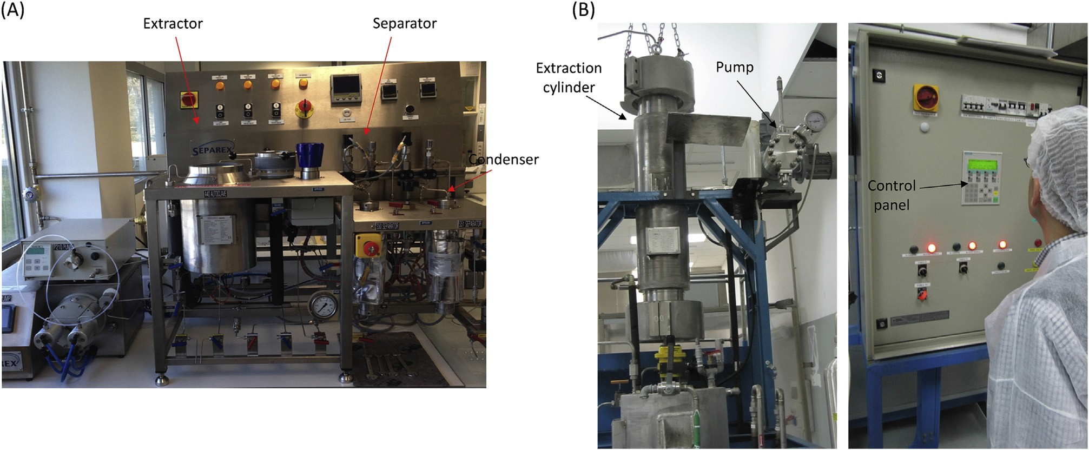
Fig. 3. (A) Lab-scale and (B) Industrial scale (25 L high-pressure cylinder) supercritical CO₂ reactor for extraction of bioactive compounds from plant samples.

A 2 L pilot-plant SFE from the leaves of Helianthus annuus (sunflower) has been conducted [25]. The pilot-plant SFE has maximum flow rate of 150 g/min of CO₂ and 50 g/min of cosolvent (H₂O) flow. Various flow rates of CO₂ and the cosolvent were tested at a constant pressure of 380 bar at 50 ºC. From the results of the pilot plant study, it was suggested that a CO₂ flow rate of above 25 g/min would not work well for congealed samples. However, for dry samples, the optimum flow rate of CO₂ was found to be 80 g/min. The CO₂ flow rate played an important role during SFE and the optimum rate was found to vary according to the matrix and compound of interest. For dry samples, the CO₂ flow rate was found to be comparably higher than for congealed samples, whereas the effect of cosolvent flow rates did not have an influence on the extraction yield [25].
In another SFE pilot scale study, two 16 L extractor plant were used for the production of oil from oil seed rape (Brassica napus) [26]. The process was optimised to determine the best conditions. At a pressure of 550 bar and a temperature of 35 ºC, the oil yield under pilot-scale conditions was found to be 100.3 g per kWh, which was quite close to the lab scale yield of 97.4 g oil per kWh. It was found that 10.2 kWh of energy was required to obtain a yield of 1 kg of oil in the pilot plant, which is quite close to the value of the small plant (9.7 kWh). The study also calculated the energy distribution/consumption parameters and found that energy consumption for the pilot plant was higher than that of the small-scale plant, which was due to the recirculation of CO₂. Moreover, it was believed that high energy and operation costs would be required to maintain high pressure during SFE, but it was found that they made up only 17% of the total cost in this study. The author clearly stated that energy consumption during the SFE pilot-scale process was satisfactory relative to the extraction yield and that this system could thus be considered for industrial-scale extraction [26].
SFE is largely used for oil extraction and is one of the most convenient green extraction techniques. In a pilot-scale (2 L) oil extraction from Moringa oleifera dried seeds using SFE, the pressure was varied from 150 to 350 bar, temperature from 25 to 35 ºC and the CO₂ flow rate was kept constant at 20 kg/h for a total extraction time of 30 min. The separator temperature and pressure were kept at 40 ºC and 60 bar, respectively. It was found that the maximum yield of oil extracted during the pilot-scale process was around 75% at 350 bar pressure and 30 ºC [27].

  - Other less commonly explored green extraction techniques for extraction scale-up
    - Negative pressure cavitation extraction (NPCE)
NPCE is yet another novel and non-conventional extraction technique. Cavitation is used in this technique to destroy and weaken the surface of the sample under the negative pressure generated by a vacuum pump. Under these conditions the violent collision/friction between the sample and the solvent result in higher mass transfer and compound extraction. NPCE has been widely used in lab-scale experiments for extract preparation. However, only a few experiments have been conducted on a pilot scale. For example, the green solvent ionic-liquid based NPCE of flavonoids (genistin, genistein and apigenin) has been conducted in a 10 L extractor [28]. In the pilot-scale extraction, 0.5 kg of Pigeon pea roots were put into the extractor and optimised conditions were applied: 74 ºC temperature, 0.7 bar negative pressure, 20:1 v/w liquid-to-solid ratio, 0.53 M ionic solvent concentration and 15 min extraction time. It was reported that the extraction yield of flavonoids, at the pilot-scale level using the optimised lab-scale conditions, was comparable to the lab-scale extraction yield, which justifies the success of the NPCE method during scale up [28]. In a similar experiment, NPCE was scaled-up to 60 L, using extraction conditions that were optimised on the lab-scale, for the extraction of cajaninstilbene acid and pinostrobin from pigeon pea leaves [29]. For 2 kg of sample, the optimised extraction conditions were: pressure of 0.75 bar, temperature of 45 ºC, sample particle size of 40 mesh, ethanol concentration of 80%, extraction time 30 min, liquid-to-solid ratio of 30:1 v/w and a total of 4 extraction cycles. Under these conditions, it was found that the extraction yield of the scaled-up process was comparable to that of the lab scale, and that, hence, the NCPE process is scalable for the extraction of valuable components [29].
Conditions that have been optimised in lab-scale experiments have been used and tested in various scale-up models. In fact, the NPCE of secoisolariciresinol diglucoside (SDG) from flaxseed cake has been performed on a lab scale and was then scaled-up using lab-scale optimised NPCE conditions: temperature 35 ºC, time 35 min, liquid-to-solid ratio 13:1 (v/w) and pressure 0.4 bar for the extraction of 2 kg of flaxseed (26 L of extract). The extraction yield and SDG purity obtained in the pilot-scale study were 15.61 mg/g and 3.67%, respectively, which are close to the lab-scale extraction process values (16.25 mg/g and 3.86%). The results clearly showed that the conditions optimised at lab-scale could be successfully scaled to obtain higher volumes [30]. When optimising extraction conditions with many levels of factors, it is recommended that several lab-scale experiments are performed, which was not feasible on the pilot-scale level because of economic and process constrains. Therefore, factors should be optimised on a small-scale level and then scaled-up for higher volumes/levels, while taking into consideration process kinetics and other factors. On the base of published data, the NPCE applied on batch reactors enable energy saving, while in flow mode it requires to work in suction with some technical complications. Despite the encouraging results achieved at pilot scale [30] the industrial application still requires further investigation.

2.4.2. Pressurised liquid extraction (PLE)
PLE was first described as a method for analytical sample preparation in 1995 and 1996 by B. E. Richter and co-workers [31]. Although PLE is the most commonly used name, it is also known as accelerated fluid extraction (ASE), enhanced solvent extraction (ESE) and high-pressure solvent extraction (HSPE). The concept of PLE is based on the application of high pressure to keep the substance used as a solvent in a liquid state at temperatures higher than their atmospheric boiling point. PLE provides several advantages over conventional extraction with the same solvent at atmospheric pressure, namely, in many cases, better analyte solubility at higher temperature, increased mass transfer rate, lower viscosity and solvent surface tension [32]. As a result, better extraction rates and higher extract yields can be achieved. Another advantage can be found in the opportunities provided by automation that were implemented in Dionex ASE 200/300 units, which had been used as the only available commercial PLE systems in many studies since 1995 [31] until Büchi and Fluid Management Systems developed and launched their own extractors onto the market [33].
Various organic solvents can be and have been used for PLE, however pressurised hot water extraction (PHWE) has become a popular green extraction method for different classes of compounds present in numerous kinds of matrices, including environmental, food and botanical samples [34]. Moreover, this technique was also recommended for large-scale extractions. For instance, the highest recoveries of all bioactive compounds (except for carotenoids) from Stevia rebaudiana leaves at 103.4 bar in PHWE were obtained at 160 °C, and it was concluded that the technique would be suitable for scale-up to industrial applications [35]. PLE was demonstrated to be a useful tool for the valorisation of juice processing by-products via the feasible downstream recovery of strong antioxidants from chokeberry [36], raspberry [37], and black current [38] pomace residues that remain after SFE as well as for the biorefining of botanical and other materials [39]. PLE with selected parameters and solvents showed remarkably higher efficiency in the recovery of cafestol and kahweol diterpenes from green coffee than conventional extraction techniques [40]. Although these results clearly show the effectiveness of PLE and its applications on the industrial level, the scale-up of this process is currently at an embryonic stage and more effort needs to be invested if the technique is to progress.

2.4.3. Pulsed electric field extraction (PEF)
As an innovative extraction method, high intensity PEF is a comparatively new (the first study was reported in 1999), but quickly developing green technique. It is particularly attractive for food and pharmaceutical industries. PEF applies short (μs to ms) and moderate electric voltage (typically 0.5–20 kV/cm) pulses and, in case of extraction, is based on the electroporation of cells, which destroys cell membranes and significantly intensifies extraction process. The dipolar nature of membrane molecules means that they are separated by electric potential according to their charge and, after exceeding a critical value, the pores are formed in weak membrane areas causing an increase in permeability. The method requires only a few microseconds of processing time, provides higher extraction yields, and can be applied both in batch and continuous flow modes. Jemai and Vorobiev [41] successfully illustrated the benefits of using moderate electric field pulses in solid-liquid leaching from sugar beet cossettes and also described the possibility of using continuous electrical conductivity measurements to monitor the extraction process. Kempkes et al. [42] discussed the interrelationships between pulsed power and PEF processing, and presented examples of system designs and configurations. A more detailed description of the method and its applications in the extraction of bioactives can be found in the reviews published on this topic [43,44].
The majority of PEF-assisted extractions have been performed in laboratory-scale equipment and have demonstrated process intensification and the improved recovery of various valuable substances. Moreover, pre-treatment with PEF is a possible means to increase the extraction rate of compounds. In fact, PEF pre-treatment has been found to increase the recovery of raspberry juice during mechanical pressing by 9-25%, while press-cake extracts contained significantly higher amounts of phenolics and were stronger antioxidants [45]. Carbonell-Capella [46] have reported that PEF was the most efficient method for the recovery of the principle compounds from Stevia rebaudiana leaves, stevioside and rebaudioside A, using 50% ethanol-water and suggested that PEF extraction technologies may be able to improve some processing steps (grinding, downstream purification, etc.). Shorstkii and Koshevoi [47] have reported that the modulation of kinetic parameters increased the extraction diffusion coefficient from D=9.8943E⁻¹² to 1.5504E⁻¹¹m²/s in the PEF pre-treatment of sunflower seeds, and that the technique might be an attractive means to intensify the process on the industry scale. The scale-up of PEF-assisted extractors to pilot plant and industrial levels is rather scarce, and this is most likely due to the comparative novelty of the technique and some technical issues that have been found when designing higher capacity equipment. Inulin content has been extracted from chicory root juice in a pilot-scale PEF extraction process [48]. The best PEF conditions were found at an electrical field intensity of 600 V/cm and a 10 min duration. The differential temperature decreased after the PEF treatment of the sample. Inulin content increased from 10.68 to 12.18 g/100mL after PEF treatment. PEF showed better extraction yields and lower electric energy consumption and temperature, and the scale-up process thus provided economical profit [48].
Sack and Mueller [49] have discussed the design of the scale-up of PEF treatment reactors for electroporation-assisted extraction processes. The authors noted that the challenges in transferring the pulse parameters obtained in the laboratory-scale studies to industrial-scale equipment arise from electric-field inhomogeneity in PEF reactors that are intended for continuous flow. Their work presented a novel method for the evaluation of the electric field distribution inside the PEF treatment reactor with respect to energy efficiency. The energy-savings and better product quality benefits that PEF can provide to electroporation-assisted extraction may be an important driving force for industrial applications. Pulse power systems that can fulfil the processing requirements of small and large wineries (from 10 to 50 t/h) have been developed recently for the food industry. The total treatment and investment costs for the process were estimated to be between 0.03-0.005 €/L of wine, respectively (https://www.tasteofscience.com/articles/1297/pef-facilitates-polyphenol-extraction-during-red-wine-making.html, accessed on 19 August, 2019). Moreover, Pulsemaster manufactures PEF pilot-scale continuous systems, under the brand name ‘Liquidus’, for research purposes, with capacities that range from 30 L/h to 200 L/h (https://www.pulsemaster.us/pulsemaster-launches-liquidus-pef-equipment, accessed on 19 August, 2019).

2.4.4. Enzyme-assisted extraction (EAE)
In principle, EAE is based on the enzymatic pretreatment of raw materials to release substances that are bound to the cell walls and thus increase the total yield of extracts and recover target constituents. EAE includes the following main steps: (1) selection and preliminary preparation of raw materials; (2) drying, size reduction, powdering, homogenisation; (3) adjustment of temperature and pH; (4) enzyme addition and incubation; (5) enzyme inactivation; (6) centrifugation and/or filtration; (7) collecting the aqueous phase of the enzymatic extract; (8) other treatments depending on the product requirements (pH adjustment, partial or complete water removal, etc.). Pectinases, cellulases, hemicellulases and ligninases have been the most frequently used enzymes, while, in some specific cases, proteinases may also be used. Gligor et al. [50] have recently comprehensively reviewed the EAE of polyphenols, and included scientific studies on applications on small scales, large scales and finally industrial uses. Another recent review, written by Marathe and co-workers [51], focuses on the improvement of enzymatic extraction techniques for various bioactives. Both batch and continuous bioreactors, which have been developed and used for various biotechnological processes, can be used in the scale-up of EAE processes [52].
The production of fruit juice is currently one of the most important industrial fields. Enzymatic treatment with pectinolytic enzymes has been used for this task to degrade cellular walls and increase juice-extraction rate, product yield and some quality characteristics. The potential of scale-up processes has also been tested for other plant materials. For instance, ten years ago, an aqueous EAE process was developed for 2 kg of flaked and extruded soybeans [53]. The process was later scaled-up from using soy flour on a laboratory level with only 0.025 kg of material to a pilot-plant scale with 75 kg of material [54]. Finally, a proof-of-concept for the integrated, counter-current, two-stage aqueous EAE processing of soybeans was demonstrated in a pilot-plant scale with 75 kg of extruded flaked soybeans [55]. Li et al. [56] have demonstrated that EAE with cellulase was efficient in the degradation of the cell-wall polysaccharides of Hypericum perforatum. They suggested that the process could be scaled-up to a large scale for the extraction of important bioactives, i.e., hypericin and pseudohypericin. EAE seems to be an attractive process with which to obtain strongly bound valuable substances from agro-food processing by-products. In EAE with a commercial preparation of Viscozyme L and optimised parameters (enzyme/substrate ratio, temperature, pH and time 1–8 h), the yield of water-soluble fraction, monosaccharide and total phenolic content from chokeberry pomace increased to 113, 140 and 4%, respectively [57]. It may be reasonable to expect that similar results could be obtained in a higher volume batch bioreactor.
In one such scale-up process, non-anthocyanin phenolic compounds and anthocyanins were extracted using enzymes (novoferm 106 and cellubrix L) from 5 kg of frozen grape skin with an extraction volume of 15 L [58]. The process was first optimised on the lab scale and the optimised conditions were then applied to the scale-up process. The extraction conditions included: pH 4.0, temperature 40 ºC, enzyme concentration 3000 mg/kg and 1500 mg/kg of novoferm 106 and cellubrix L, respectively. The mixing time was kept at 2 h under nitrogen and the mixture was heated at 90 ºC for 1 min and then cooled. Based on the results obtained, the pilot-scale extraction yield was comparable to the lab scale yield. Moreover, the results showed that the economic feasibility of the process was significantly enhanced when using a lower enzyme dose, giving a higher extraction yield [58].
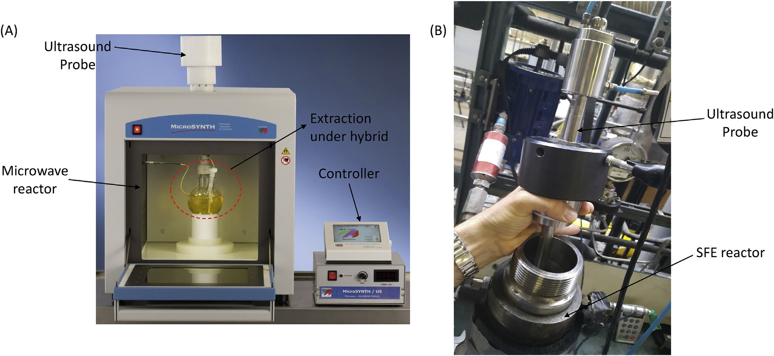
Fig. 4. Extraction under (A) simultaneous ultrasound and microwave irradiation (University of Turin and Milestone srl, Bergamo) and (B) simultaneous ultrasound and supercritical CO₂ extraction (Weber Ultrasonics AG, Germany e FeyeCon, The Netherlands).

2.5. Hybrid/combined reactors technologies
The synergistic effects of hybrid technologies on extraction processes have been widely proven on the lab scale [59], where simultaneous and sequential ultrasound and microwave irradiation are able to accelerate extraction processes and improve yields. Although much more experimental work has been carried out on the activation of chemical reactions [60], hybrid/combined technologies have been also used in the preparation of plant extracts and/or compound extraction.
Besides the high economic and environmental impact of common organic solvents, conventional extraction processes require up to 50% of industrial investment for the required facilities and more than 70% of total energy. Moreover, the need to improve extract flavour, product appearance, and organoleptic and analytical properties, mean that several classic and non-conventional technologies have been used in combination in hybrid reactors and sequential operations. In industrial-level extractions, pre-treatments are particularly attractive as they shorten and improve extraction processes. Pre-treatments with high-shear homogenisers, rotor/stator hydrodynamic cavitators, fast microwaves and ultrasonic irradiation, even in the presence of enzymes, can dramatically improve extraction yields by weakening biomass surface and structure.
Simultaneous irradiation with ultrasound and microwaves is one of the most efficient hybrid techniques for fast extraction procedures. Since the pioneering experiments by Lagha et al. [61], several reports have described its success in analytical chemistry, although sample preparation can take much longer than the analysis itself. A typical hybrid reactor for lab-scale applications is equipped with a non-metallic horn inserted into a professional microwave oven (Figure 4A) [62]. The large scale extraction of olive oil using a combination of microwaves and megasound has been developed [63]. The megasound reactor includes four transducers (400/600 kHz) that consume 2kW of power and are positioned in a parallel manner in the reactor. The continuous sonication of the sample provided maximum contact with the olive paste. The microwave treatment was carried out before the megasonic process and it was found that the post-megasonic treatment significantly improved oil extraction and its phenolic content, thereby improving its commercial value. However, both the processes were conducted in batch mode, and thus further research is required, from an industrial point of view, to develop a microwaves and megasonic technology continuous process. The mechanical ultrasonic effect promotes the release of soluble compounds from the plant matrix by disrupting cell walls, enhancing mass transfer and facilitating solvent access to cell content. Meanwhile, microwaves heat the entire sample very quickly, inducing the migration of dissolved molecules [64]. Simultaneous irradiation increases solvent penetration into the matrix, facilitates analyte solvation and usually increases the solubility of the target compounds.
The combination of extraction processes to improve extraction yields and lower the consumption of energy and solvent has been given great importance in the past few years. In fact, the combination of supercritical CO₂ extraction and low-frequency ultrasound strongly enhances mass transfer from the solid phase to the supercritical fluid (Figure 4B) [65]. In one hybrid scale-up process, SFE and a power ultrasonic transducer were used together to extract a large volume of oil from almonds [66]. The ground almonds of different particle sizes first underwent ultrasonic treatment at 100 W and 20 kHz. The treated almonds (1.5 kg) were then deposited inside the 5 L-capacity SFE reactor, and CO₂ was introduced as the solvent at 20 kg/h and the conditions were maintained at 280 bar and 55 ºC. With the introduction of ultrasound to pilot-scale extraction, it was found that the extraction yield significantly increased and the ultrasound treatment was found to accelerate the kinetics and mass transfer. This is a promising scale-up process experiment using combined techniques, and further supports its use in industrial-scale extraction [66]. In another SFE pilot scale-up (1 L) study on oil extraction from dried Moringa oleifera seeds, a pressure of 300 bar, temperature of 40 ºC and CO₂ flow rate of 10 kg/h were tested along with microwave pretreatment. Pilot-plant SFE was compared with Soxhlet extraction with an organic solvent. It was reported that microwave pretreatment at 100 W for 30 s resulted in a maximised SFE oil yield of 35.28%. Although the Soxhlet extraction yield was higher than that of SFE, the quality of the oil from SFE was significantly higher than that of the Soxhlet extraction [67].
An investigation that obtained β-glucan-enriched extracts in high yields is one of several studies on combinations of different extraction technologies that have been reported. Subcritical water extraction was successfully combined with the sub/supercritical CO₂ extraction of Ganoderma lucidum in a specific pressurised reactor [68]. Combined ultrasonic/microwave extractions have also been found to be more effective than simple extractions in water in giving bioactive polysaccharides from Inonotus obliquus [69], while an even better improvement has been observed when combining suitable enzymes [70]. Results from extractions from Shiitake mushrooms have confirmed that the combinations of ultrasound and subcritical water, and supercritical CO₂ followed by ultrasound extraction were the most effective methods in giving β-glucan-enriched fractions than the individual extractions with the same techniques [71].
Now turning to non-thermal extraction technologies [72], PEF has been shown to be an excellent pre-treatment for plant extraction and food processing. Impressive synergistic effects have been observed by combining pulsed electric fields and ultrasound [73]. These combined technologies have been used to enhance the extraction yield and nutritional quality of red raspberry (flavonoids +20 %) and blueberry (anthocyanins +30 %) purees [74].
Other extraction techniques have also been combined with NPCE to increase extraction efficiency. In fact, extraction scale-up enzyme-assisted NPCE has been conducted to extract indole alkaloids (vindoline, catharanthine, vincristine, vinblastine and anhydravinblastin) from 1 kg of Catharanthus rose leaves [75]. The operating conditions for pilot scale NCPE were: 80% ethanol concentration, negative pressure 0.75 bar, liquid/solid ratio 20:1 mL/g, extraction time 30 min and 3 extraction cycles. Pilot-scale enzyme-assisted NCPE was found to successfully extract indole alkaloids, and the yield was comparable to small-scale extraction, meaning that the method can thus be recommended for industrial-scale extraction [75].
In another combined extraction method using a homogenisation process in NPCE, pilot-scale (40.2 L) HNPCE (Homogenization assisted NPCE) was performed to extract 3 kg of Astragalus for their polysaccharide content [76]. The conditions were optimised on the lab scale and were then scaled-up to the pilot scale, and included a homogenisation time of 1.1 min, negative pressure of -0.68 bar, extraction temperature of 64.8 ºC, water-to-sample ratio of 13.4:1 mL/g and extraction time of 53 min. It was found that the polysaccharide yield of the pilot-scale study was about 16.62%, which was very close to the lab-scale extraction yield (16.74%), hence confirming it as a successful scalable HNPCE process [76].

  - From batch to flow mode
Emerging continuous manufacturing technologies and methodologies may be able to fully address the new-millennium challenges of process intensification with lower environmental impact and carbon emissions. The smart application of ultrasound-, hydrodynamic cavitation- and microwave- assisted extractions in flow mode can be leveraged to maximise existing facilities, throughput and downstream process.
Large-scale ultrasonic applications require flow-through reactors as the penetration depth of ultrasound waves in liquid–solid systems is limited and the solution cannot be efficiently sonicated even under powerful mechanical stirring in large vessels. The phase-transfer and cavitation phenomena mean that a simple equation for the calculation of penetration depth in liquids cannot be given. All reported experimental results [77,78], indicate penetration depths in the range of a few centimetres. This is because the propagation of ultrasound in liquids is affected by reflection, diffraction and, of course, attenuation as some energy is dissipated as heat. While the penetration depth of ultrasound strongly decreases with increasing frequency, other factors, such as reactor geometry and resonance effects, also play an important role. When extraction requires longer residence times, ultrasonic flow reactors can recirculate the plant material suspension. In fact, in one study [79], flow-ultrasound assisted extraction was conducted using a multi-horn reactor in continuous flow-mode with a maximum flow of 1350 mL/min and a power density of 700 W/L to extract phenolic and volatile compounds from dry clove buds with an extended volume of 20 L. During UAE process intensification from batch to flow mode, it was reported that superior extract quality was obtained under flow-mode extraction. Moreover, considering the huge amount of dry clove buds used in this study, a total of 20 L of extract preparation, it is fair to state that the continuous flow mode is suitable for the development of a scale-up method [79]. We have also seen, in one of our recent scale-up studies [5], that continuous flow mode is more suited to process scaling, when using an ultrasonic horn for the extraction of anthocyanins from Pyrus communis var. starkrimson fruit peel, than the batch process because of the advantages of continuous sample rotation during exposure to ultrasonic waves. The modification of the extraction vessel in this study, by operating it in continuous flow mode, greatly affect the extraction of the compounds and continuous recovery of the extract (Figure 5A). Moreover, the viscosity of the extract during the extraction process was studied and was found to provide a suitable means to observe the substantial changes in extraction yield under different ultrasonic conditions [5]. Higher viscosity during ultrasonication generally resulted in lower extraction yields as the cavitation effect was lessened/restricted. The biomass needed to be in continuous contact with the ultrasonic effect during scale-up, and the continuous flow mode would likely provide a suitable means of extraction with viscosity regulation. Similarly, a scaling up study from lab to pilot and semi-industrial application of flow mode has been reported for wheat straw delignification in the BBI project US4GREENCHEM (Figure 5B).
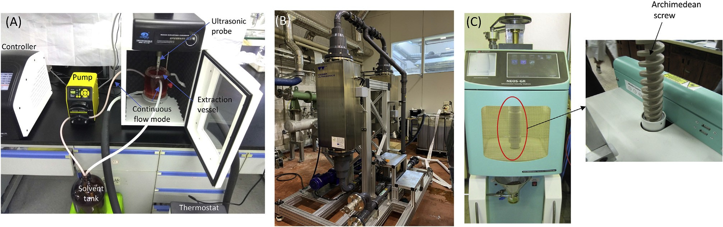
Fig. 5. (A) Flow-mode UAE with improved extraction vessel design (Zhejiang University, Hangzhou, China), (B) Flow-mode UAE in loop with two 25 kHz units (3 kW each to treat 40 kg dry material) (Grant Agreement Number 669055 - https://www.us4greenchem.com), (C) Flow-mode MAE with Archimedean screw (University of Turin, Turin, Italy).

It was interesting to observe that the geometry of the extraction vessel in a circulating flow reactor was found to exert a major influence on the β-D glucan polysaccharide extraction yield, specifically at 3L and 6L volumes [18]. Moreover, higher ultrasonic power had a negative impact on extraction yield. It is also worth mentioning that the geometry of extraction vessel needs to be considered during scale-up. It is clear that, during the scale-up process, a large amount of raw material was used, which meant that circulating flow was required to ensure proper contact between the solvent and cavitation bubbles, and to provide the maximum extraction yield. This need can be better satisfied in a circulating flow ultrasonic reactor during a scale-up process and this system is thus recommended for high volume extractions.
Hydrodynamic cavitation has been successfully used in the intensification of a number of processes including the improvement of mass transfer rates and effective cell-wall rupture during extraction processes [80].
Hydrodynamic cavitation, with last generation rotor/stator units [81], provides the fast and efficient recovery of valuable compounds from plants and biomass. It is a simple method with high energy efficiency that shows great potential for large-scale operations. Rotor–stator homogenisers, which are characterised by their highly localised energy dissipation, are widely used for the size reduction of dispersed phases and reactive mixing [82]. Rotor/stator units can be easily scaled-up, from producing a few hundred to thousands of litres/hour, and simultaneously avoid the risk of orifices clogging with oil impurities, which may occur in conventional hydrodynamic reactors. Furthermore, they require minimal installation space due to their compact design, which enhances overall security.
The mechanical processing of materials in the liquid-phase, such as the dismantling of vegetal fibrous structure, plant cell-wall disruption and the emulsification of immiscible liquids with hydrodynamic reactors, is attributed to the combined effects of cavitation and high shear stress when the substrates are exposed in narrow channels between the rotor and the stator. Turbulence at the micro level, created by HC, provides a significant intensification in mass transfer in a heterogeneous system and increases the number of contacts between the component particles [83].
In MAE [64], the low penetration depth in water and common organic solvents is even worse as it is only 1.6 cm in water at room temperature (water >ethanol >acetonitrile >acetone). The depth of penetration of microwaves is dependent on the dielectric properties of the material and the frequency, with lower frequencies being more penetrating. A large penetration depth indicates that radiation is poorly absorbed, while short penetration depths mean that surface heating predominates. Similarly, to sound waves, high frequencies have a short wavelength, which corresponds to a smaller penetration depth. The use of lower frequencies, typically 915 MHz, allows for a higher penetration depth and a further increase in energy efficiency. Despite the consolidated industrial use of microwave flow reactors in chemical synthesis [84], flow-mode extraction is still only performed on the lab scale [85]. Current pilot-scale microwave flow reactors are not well suited to the processing of extraction mixtures with suspended plant material. Figure 5C shows the versatility of a small reactor equipped with an Archimedean screw to regularly move viscous suspensions through the microwave cavity.
With the growing consumer demand for natural products, greener extraction techniques are becoming potential alternatives, especially for the pharmaceutical, nutraceutical, and cosmetic manufacturing industries [86]. In this context we have successfully tested a number of pilot-scale cavitational reactors for the design of industrial polyphenol recovery [87]. Thanks to the excellent performance of the multihorn ultrasonic reactors in flow mode [79], industrialisation was easily achieved by means of tubular reactors with dozens of transducers fixed around the walls [7,70]. Different types of plant material and biomass can inform the selection of the most suitable cavitational technology, acoustic or hydrodynamic cavitation, and even a sequential combination of both.
Market, business and environmental pressures are driving the industry towards more efficient and effective manufacturing processes in which several enabling technologies, applied in flow mode, will rapidly change conventional production schemes. Owing to the enormous volumes of natural materials that are extracted daily in large industrial plants, currently available technologies may have huge beneficial impact on both productivity and extract quality.

3. Factors affecting extraction-process scalability

3.1. Analytical factors
The effectiveness of any extraction process depends on a number of intrinsic and extrinsic factors. A huge body of literature results has been generated over the past decades of studies, and these data have also been reviewed in many articles (see section 2.1.3). Searching for and evaluating the criteria for scale-up processes has also been the focus of many research teams working on this topic. Many of these studies have looked for universal criteria that can be applied for various raw materials and different capacities and types of extraction system. These commonly include the ratio between the masses of solvent and biomass, solvent concentration and the use of flow or batch mode. However, the criteria that determine the success of scale-up processes differ according to the extraction methods used. For instance, in UAE, the ultrasonic power/density, vessel geometry and batch/flow mode are some of the important criteria for scale-up, whereas, for MAE, microwave power, solvent type and its dissipation factor are important criteria. Similarly, for SFE, the criteria for scaling extraction processes include the ratio between the solvent flow rate and biomass weight, and the Reynolds number [88]. Reynolds number is a dimensionless value, which define the flow rate as turbulent or steady. Studies have shown that keeping these ratios, or at least some of them constant, could provide similar extraction results. For instance, in one SFE scale-up model, three different criteria were applied, constant S CO₂/M (kg kg⁻¹) (ratio of solvent mass passed through the feedstock to mass of the feedstock), constant Q CO₂/M (kg h⁻¹ kg⁻¹) (ratio of the solvent flow rate to the mass of the feedstock) and both [89]. The highest product yield was obtained when both criteria were kept constant, which signifies that both played an important role in the success of the SFE scale-up process.
Solvent-to-feed ratio is one of the crucial criteria for extraction scale-up processes. As such, the ratio was kept constant during the extraction of bioactive components from grapes during the scale-up of SFE [90], which increased the yield 17 times from bench to pilot scale at 39.85 ºC/35 M Pa, 240 min of extraction time and ratio of 6.6. The same author performed another SFE scale-up study using clove and sugarcane residues and the mass-to-feed ratio was kept constant at 3.6 and 15 in the lab- and pilot-scale procedures, respectively [91]. It was found that keeping the ratio constant at this level during scale-up would increase the extraction yield 15-fold for both the residues, while the yield was found to be higher than in the laboratory experiments. To select the best criteria for scale-up process and optimize their levels different modelling approaches were tested and these were discussed in section 4.

3.2. Instrumentation design
The design and production of systems for non-conventional extraction techniques are well established, and there are currently many companies in the world that produce a wide range of equipment, from laboratory to pilot and industrial scales. However, serial production is implemented for small size laboratory and higher capacity pilot (usually containing extractors up to 10 L capacity) equipment. Higher capacity pilot and particularly industrial equipment is produced according to specific designs that cater to the customer’s needs. So far as the proper selection of models and criteria provide reliable information for scaling up processes, adequately designed optimisation and kinetics experiments for the laboratory-scale extraction of selected material(s) are sufficient to design industrial equipment. However, the inclusion of pilot-scale testing after laboratory studies may serve as an additional guarantee for the correct design of industrial systems. On the other hand, numerous literature sources (also cited in this review) have reported a huge number of theoretical and experimental results that may be efficiently used to reduce the need for experimental work and pre-testing procedures, which are usually expensive and time consuming. For instance, important aspects about the criteria used for geometry shift and scale-up in SFE processes have been summarised by Zabot et al. [92] for rosemary and several other botanicals. In some cases (ginger, fennel, grape, clove, black sage, annatto) the criteria were suitable, while for others (rosemary, sugarcane bagasse, clove, lemon verbena, peach, pepper, macela) the criteria were not suitable. It is interesting to note that in the case of the SFE of cloves, the solvent mass flow rate was not a suitable criteria [93], while the indicated S/F ratio and extraction time were found to be suitable [94] for different bed geometries.
More sophisticated SFE systems include extra pumps for co-solvents, mainly CO₂ flow to increase mixture polarity and the solubility of higher polarity substances, and separators, which pre-fractionate crude extracts by changing the pressure, temperature and solubility of various substances. SFE extraction/fractionation processes become more complex when higher purity target groups and individual compounds are required. Various methods, such as the use of columns with absorbents and combinations of SFE with chromatographic methods, have been used for this purpose, mainly on the laboratory scale for analytical and, in some cases, preparative purposes. Another trend in SFE development is the use of an assisting procedure for process intensification, increasing of product yields and recoveries.
Lagadec et al. [95] have reported the design of pilot and industrial pressurised hot water extraction (PHWE) equipment and presented data on quality and the determination of scale-up factors. The authors concluded that, under optimised conditions, PHWE may be a suitable technique for scale-up to larger sample sizes for industrial applications.
An innovative industrial-scale ultrasound instrument that combines a heat exchanger with ultrasonic probes has been constructed with the aim of producing high quality olive oil [96]. A total of three ultrasonic transducers were used, including two rod style transducers of 30-1500 W (30 kHz) inside the pipe, and one 30-1400 W power transducer that was introduced downstream of the heat exchanger. The transducers inside the pipe are mainly responsible for the production of the cavitation effect on the olive paste. The ultrasound and the heat exchanger provided the perfect mechanism for the extraction of the oil by increasing cell-wall rupture and providing continuous industrial-scale efficiency. Controlling the pressure drops and velocity during ultrasonication were found to ensure the best conditions for the extraction of higher amounts of tocopherol, carotenoids and phenolics.

3.3. Energy consumption and economy efficiency
Fractionation and purification in conventional and modern extractions (UAE, MAE, SFE, EAE, PLE, PEF), that use water and organic solvents require comparatively large amounts of solvent, in most cases, which must then be removed from the extracts. Excess solvent is usually evaporated in a vacuum or in a freeze-drying process (mainly in the case of water). Reduced pressure enables the process to be performed faster and at lower temperatures, which is particularly important for heat-sensitive bioactive compounds. However, solvent evaporation requires large amounts of energy. Conventional extraction processes are frequently performed at elevated temperatures to increase the solubility of target substances and intensify mass transfer processes, which also require energy input. The means of energy consumption vary according to the mode of extraction. For instance, in SFE, CO₂ evaporates after the system is depressurised at ambient temperature. Consequently, the energy in SFE is mainly used to heat extractors/separators and to operate the solvent pump(s). In MAE, the heating of the solvent and sample depends on the solvent’s dissipation factor, which may thus increase or decrease the total extraction time and energy inputs.
The techno-economic and environmental indicators for extraction methods depend on the processes used and its products. For instance, Mocada et al. [97,98] have compared SFE, solvent, and water distillation in the recovery of essential oil and determined that, for oregano, SFE provided the lowest production costs in the case of full energy integration (6.71 USD/kg), while, for rosemary, citronella and lemongrass, water distillation was the cheapest (6.48, 7.50, and 6.57 USD/kg, respectively). Additionally, water distillation was found to have the lowest potential environmental impact and carbon footprint. Todd and Baroutian [99] have since compared PHWE, SFE-CO₂ and the organic solvent extraction of bioactives from grape marc and concluded that SFE-CO₂ was the least attractive technique in terms of energy consumption and cost of manufacturing (COM).
High equipment costs have always been considered a limiting factor in the wider industrial applications of SFE [100], while more detailed economic evaluations of SFE scale-up in the scientific literature are rather scarce. Several studies have estimated the COM using commercial process simulators, including the SuperPro Designer® version 8.5 from Intelligen Inc., Scotch Plains, USA [101], and some other tools, which mainly consider the fixed cost of investment, the costs of operational labour, utilities, waste treatment and raw materials [90, 102,103]. Economic aspects of SFE, as a green-solvent-using technology, have also been comprehensively reviewed [104]. Regarding the economic efficiency of SFE, a quite simple rule is valid; the higher the extraction volumes, the lower the extraction costs. In fact, there is a linear dependency between SF unit price index, on a logarithmic scale, and the log of the product total volume [100]. Núñez and del Valle [105] established a function of CO₂ mass flow rate (the cost of the solvent cycle) and extraction vessel volume (the cost of extraction section); in the SFE-CO₂ of oilseed in a 2000 L multi-vessel plant, the capital cost represented 35-40 and 28-32% of the total production cost when 6000 and 3000 kg/h of CO₂ were used, respectively. According to an overall estimation, the lowest production cost was USD 7.8/kg oil in a 4-vessel plant using 6000 kg/h of CO₂. Based on these and other techno-economic principles and calculations, many industrial SFE-CO₂ plants have been built and successfully operated over the last 4 decades, including for the decaffeination of coffee and tea, the extraction of hops and various other botanicals, and the detoxification of rice, etc.
SFE is particularly attractive for the conversion of cheap raw materials into higher added value products such as specialty oils and lipophilic micronutrients (tocols, carotenoids, phytosterols, squalene, etc.), which have been gaining popularity in the growing functional health food, nutraceutical, natural cosmetic and even pharmaceuticals markets. For instance, Prado et al. [90] have analysed the scale-up economy of a SFE-CO₂ model with assumptions of FCI and zero raw-material value (grape seed, as an industrial processing by-product), and concluded that the time of investment return decreased from 21.88 years for a 50 L extraction vessel to 1.49 years for a 500 L vessel. The same analysis model can be applied for other laboratory-scale studies that use very cheap or zero-value by-products [36,37,57]. In another scale-up simulation model, the SFE conditions to obtain solvent-free cupuassu butter from the by-product of cupuassu (Theobroma grandiflorum) seeds were optimised on the lab scale and applied to simulate industrial-scale production [106]. The scale-up process was simulated in a semi-continuous mode using 1, 10 and 100 L extractors, by assuming that the efficiency was the same as lab-scale SFE and by keeping the sample-to-solvent ratio, temperature, pressure, bed density and porosity at constant level. Under these conditions, the COM was estimated to be between 38.38 and 155.58 USD/kg.
A more detailed economic assessment of the integrated SFE and PLE of phytonutrients has recently been proposed by Viganó et al. [107], who performed economic simulations and sensitivity studies for plants that contain two extraction vessels of 1, 5, 50 and 500 L. The extract COM (in US$/kg) from sequential multi and single-stage processes decreased from 220.51/kg to 26.33/kg, and 71.03/kg to 11.96/kg, respectively, when the system capacity was increased from 2 × 1 L to 2 × 500 L. The authors concluded that both SFE processes are economically promising, particularly for large-scale production. Although this study used passion fruit by-products, the principles can be applied to other raw materials as well. Some other recent studies may also be very helpful for economic calculations, particularly in the scale-up of the production of more specific products. Thus, Zabot et al. [108] have discussed an economic approach and intensified processes for the production of powdered extracts that are rich in bioactive compounds. Additionally, Prado et al. [91] have discussed rapid methods to estimate the COM of extracts obtained by SFE and UAE, with an emphasis on scale-up issues.
The solid-to-solvent ratio, true substrate density and operational conditions have been kept constant in an estimation of the COM for the large-scale UAE of antioxidant compounds from jabuticaba skin [109]. The process was designed for a total of 330 days per year with 24 h of work in a day’s shift. The study considered the scale-up of the UAE process at 50, 100 and 300 L levels. It was estimated that the COM decreased subsequently with increasing extractor volume. When increasing the volume from 50 to 100 L, the COM decreased from 67% to 50%. Similarly, the COM decreased from 50% to 25% when the volume increased from 50 to 300 L. Following the study by Santos and co-workers, another study was performed to determine the COM of increasing the extractor (two) volume from 50 to 500 L under PLE conditions for the extraction of curcuminoids from de-flavoured turmeric rhizomes [110]. The study considered laboratory-scale optimized PLE conditions and designed operation for 7920 h per year. It was found that the COM substantially decreased from USD 94.92 per kg to 88.26 per kg during scale-up, which makes PLE an economically viable method for extracting compounds.
In estimating investment costs, ultrasonic reactors induce 25% more investment than conventional reactors during extraction operation. However, ultrasound extraction times are shorter than conventional extraction by a factor of 10- to 100-times, and US enables energy savings and reduces pollution by a factor of 10. Moreover, if one considers the whole production chain, in conventional extraction and UAE, the production line consists of around five-unit operations: preparation, extraction, separation, concentration and drying. Thus, the use of ultrasound generates an increase in investment of only 5% (25 % / 5 = 5%). Considering these results, the use of ultrasound favours energy savings, leading to cost reductions for the industrial production of high-quality extracts. Moreover, if we focus on the global process, the unit operation "extraction" is not the one that generates the largest expenses. In terms of cost, solid-liquid separation and drying are the most expensive steps [10,111].
Environmental concerns about extraction techniques principally focus on the use of green solvents to reduce environmental toxicity and economic losses. A number of green solvents have been formulated and applied, according to their extraction efficiency under a particular set of extraction conditions. Supercritical CO₂ (SC-CO₂) is safe, non-toxic, easily available, cheap, food friendly, suitable for green processes and has comparatively low critical point (31 °C and 74 bar), which contribute to making it the far most frequently used solvent in SFE. Other gasses have also been tested, e.g. compressed propane for the extraction of kiwifruit seed oil (Actinidia deliciosa) [112]. Due to the fact that numerous special phytochemicals are either destroyed or lost during distillation, or are very difficult to extract, resulting in a low yield, the use of herbal infused oils as green solvents is indispensable for obtaining such compounds. The solvent properties of vegetable oils and their applications in innovative techniques (UAE, MAE, SFE, etc.) have therefore been explored in bioactive phytochemical extractions from natural bio-resources helping to create greener extraction procedures and novel value-added end products with great potential in the food, nutraceutical and cosmetic industries. Chevereau [113] has used microwaves to improve the extraction efficiency of bioactive extracts in vegetable oils without lipid degradation and product contamination. Furthermore, Rossignol-Castera [114] have proposed a greener extraction procedure that is intensified by both microwaves and ultrasound and that could improve the solvent power of oils in order to ensure good reproducibility in the produced extracts, high yields and optimal organoleptic properties. These newly developed techniques have already been put into use in the production of infused extracts on an industrial scale.

4. Extraction scale-up strategies: mass transfer, kinetics and optimisation models
Several well-known and widely described mathematical models have been proposed for the scale-up of extraction methods. There are several approaches to the modelling of extraction behaviour for, including kinetics-based approaches and solubility-based approaches. There are four primary kinetics models: the linear driving force (LDF) model, the broken plus intact cells (BIC) model, the shrinking core model, and a combined model with features of both the LDF and BIC models. Of these, Sovová’s Broken plus Intact Cell (BIC) model [115] and its modifications have been most frequently used to evaluate the extraction kinetics of botanicals and other biomaterials, both at laboratory and scale-up volumes. Del Valle and de la Fuente [116] have reviewed mass transfer models, for the SFE-CO₂ of vegetable oils, that may facilitate the scale-up of laboratory data for industrial design purposes. It is usually assumed that the same processing conditions, temperature, pressure, solvent-to-feed (S/F) ratio and bed porosity will result in similar product yields and composition on the laboratory and pilot/industrial scales [107,110]. Hassim et al. [117] have recently applied the solubility determination modification for the Sovová mass transfer model to the overall yield curves of SFE of Phyllanthus niruri, and concluded that S/F was be the best scale-up criterion for model verification and economic analysis, as it produced consistent yields at larger scale capacities. In most cases this assumption, and the existing optimisation and kinetics models, are also valid for simple batch-type SFE, i.e. when the system consists of one extractor and uses a single solvent.
Numerous mass transfer and kinetic investigations have been performed for SFE and these studies have significantly assisted the scale-up of processes to pilot and industrial scales [116,118]. In general, there are no technical and modelling problems in the scale-up of SFE for comparatively simple processes, such as the extraction of total lipophilic substances from various plant materials. Fewer studies have been performed on various coupled extraction techniques, such as UA-SFE and MAE-SFE. The mechanisms and effects of UA-SFE-CO₂, including the effects of ultrasound on the scale-up feasibility of SFE-CO₂, have recently been reviewed by Dassoff and Li [119]. Several well-known and some less frequently used models have been used in this combined method, with varying degrees of accuracy. The authors of the review have critically discussed the results obtained using these models and concluded that maximising the yields of the scale-up processes is important, and noted that the number of costly empirical studies on a large scale is also important. Scale-up strategies will therefore be more focused on innovative, hyphenated and integrated extraction technologies, in the future, which would be feasible alternatives to more conventional processes [1].
A model has been developed to evaluate the extraction efficiency of industrial scale SFE (three extractors in counter-current mode) of grape seed oil and by-products [120]. The model predicted that the extraction efficiency would increase from 83 to 86% upon changing from single mode to counter-current mode using three subsequent extractors. Moreover, the SFE process cost was estimated to be 5.9 USD /kg for the supercritical extracted oil.
In an interesting study, the authors have tried to build a relationship between extraction kinetics and the scale-up process in the extraction of rosehip seed oil under SFE [121]. The laboratory-scale parameters that were the best fit for the extraction kinetics were simulated for process scale up, and it was found that the extraction had a slower rate on the pilot scale than the laboratory scale. The three main causes of this lower extraction rate were assumed to be: flow heterogeneity, increases in solute dispersion and the entrainment of oil droplets in recycled CO₂. It was usually assumed that the mass-transfer coefficient controlled extraction-process scale-up, however one should also consider the above factors during process scale-up, especially in SFE.
Three extraction methods, namely SFE, PLE and enhanced solvent extraction (ESE), have been examined in a scale-up study, from lab scale (0.1 L) to pilot scale (5 L), of the extraction of phenolic compounds from mango leaves using the Sovová mathematical model [122]. It was observed that PLE and ESE processes provided a high-quality extract when operated with an increased flow rate. However, a longer extraction time was required to achieve a similar extract quality in the scaled-up process. The solid-to-solvent ratio and vessel diameter criteria were found to be most suitable for the scale-up process. The diffusion mechanism was found to play a greater role in SFE, while solubility played a significant role in obtaining a high-quality extract in PLE and ESE.
The Sovová model has also been applied to test the SFE kinetics for oleoresin and capsaicinoid extraction from Capsicum frutescens pepper on a large scale [123]. It was found that keeping the sample-to-solvent ratio at a constant level during the scale-up led to unsatisfactory results being achieved and the author suggested that the bed geometry and its packaging might influence the results.
In another SFE scale-up study of Eucalyptus globulus bark extraction, three modes, namely, lab (0.5 L) intermediate (5 L) and pilot-scale (80 L) were applied [88]. The ratio between the CO₂ flow rate and biomass weight was used as a criterion for the scale-up of the process. The extraction curves obtained in different scale-up processes revealed that this approach was well applied during scale up, giving a good extraction yield and triterpenic acid contents. Additionally, the differences in the yields of the different scale-up processes was thought to be due to the differences in the geometry of the extraction vessels.
A kinetic study has been designed to determine the SFE scale-up parameters for the extraction of almond oil [124]. These parameters include extraction pressure, CO₂ flow rate and particle size. Various mass transfer models were used, including logistic, diffusion and the Sovová model, and it was found that the Sovová model provided the best fit. Of the various criteria studied, the ratio of solvent flow rate to mass was the best for predicting the scale-up process. Similarly, the solvent flow rate was found to be the best scale-up criteria for the extraction of higher kaempferide contents from Baccharis dracunculifolia under SFE [125].
In a scale up study, two 5 L SFE plants have been used to extract polyphenols and volatile compounds from Aloysia citrodora (Lemon Verbena) leaves. When the solvent-to-feed ratio was maintained at a constant value, a 14-fold scale-up in the extraction yield was recorded. The extraction yield obtained from SFE was quite low (1.8%) compared to Soxhlet (7.1%). However, the chemical composition revealed that different extraction procedures affect the composition. In SFE extraction, the volatile compounds were more prominent, while, in Soxhlet extraction, the flavonoid content was higher. Moreover, it was found that pilot-plant extraction using SFE was economical with an estimated minimum manufacturing cost (COM) of about USD 1070/Kg with a payback time of 2 years [126].
In case of MAE kinetics two energy-based parameters, namely absorbed power density (APD) and absorbed energy density (AED) were taken into account [127]. These parameters could be used to scale-up MAE process. APD indicates the heating efficiency of the extraction system and could be calculated as the amount of absorbed heating power per unit volume of the solvent (W/mL). The volume of solvent and applied microwave power influenced the overall APD and these are important parameters to scale-up the MAE process. In one of the experiments, Chan [128] has noticed that with increasing the applied microwave power, APD increased exponentially, while the opposite is true for increasing solvent volume. APD affected the extraction kinetics and it has been seen that each APD condition has optimum extraction time [129]. With large volume of solvent during scale-up process, a higher APD value is of significance as to reduce the total extraction time, thus reduces the total cost as well as negative effect of overheating. AED on the other hand determine the amount of absorbed energy in the solvent which can be used to see the MAE progress towards equilibrium yield. The equilibrium yield determines the highest yield obtained during the MAE process, which is depends on the AED. It has been noted that at lower AED value (0 to 100 J/mL), all the bioactive compounds from cocoa leaves were reflecting a steady diffusion, which upon increasing the AED value (100 to 300 J/mL) approaches towards equilibrium yield [128]. A higher AED value beyond 300 J/mL resulted in overheating and loss of components. Empirical models, such as film theory model have been used for predicting and simulating the MAE behaviour. However, the energy based parameters (APD and AED) could be incorporated into empirical model to better predict and simulate the MAE behaviour beyond the conditions. As such, simple, predictive and generalized energy-based models were developed [128,129].
Response Surface Methodology (RSM), based on Central Composite design (CCD) and Box–Behnken designs (BBD), has been widely used for the optimisation of various extraction parameters for laboratory-scale extractions. These models were used to scale-up processes, and, in many cases, proved to be valid for higher volume extractors and production (some of them are mentioned in Table 1). For instance, SFE has recently been tested for the recovery of valuable lipophilic fractions from various berry pomaces, including raspberry [37], black currant [38], chokeberry [36], sea-buckthorn [57] and guelder-rose berry [130]. Process parameters in these studies were optimised using a 0.1 L laboratory-scale extractor and were then scaled-up to a 10 L extractor. Extraction kinetics studies showed that CCD-based and theoretically calculated optimal parameters for practical applications can be remarkably upgraded in some cases. Maier et al. [58] have optimised the temperature, pH and enzyme dosage for the EAE of 0.2 kg of grape using a D-optimal design and RSM, and have successfully applied elaborated parameters for 5 kg of material. The process was suggested as an alternative to conventional pigment extraction with sulfite. EAE was recently been applied to the residual material of black currant pomace after optimised SFE-CO₂ and PLE [38]; sea-buckthorn [57] and Cacahuacintle purple corn still possessed an intense colour after maceration extraction, UAE, and MAE using xylanases, celluclast, and depol [131]. In all of these cases, EAE gave some additional soluble extracts that contained various constituents and demonstrated antioxidant properties.
The existing optimisation methods and kinetics models that are discussed above may provide sufficiently precise process parameters for pilot plant and industrial scale-up and can be efficiently applied for the extraction of any material at any required volume. However, the development of extraction processes for new materials requires some technical experimentation, such as to determine optimal particle sizes, the optimal values for the ratios between the mass of solvent spent and biomass, and between the solvent flow rate and biomass weight, extraction temperature, frequency, pressure, time, etc.. Economic and commercialisation aspects also depend on various extrinsic factors, mainly the costs and availability of raw materials, the demand and the price of the products, among others.

- Trends, challenges and future recommendations
With increasing market demand for the plant-based bioactive compounds, and the request of green extraction procedures, there has been a constant growth in the number of publications related to scale-up of non-conventional extraction techniques. To get an idea about the trends of research on scale-up of non-conventional extraction techniques, a Scopus (www.scopus.com) search was performed including the publications after year 2000. A search on number of publications related to non-conventional techniques are shown in Supplementary Table 1 and most of them were published only after 2008 (Figure 6A). Related to the scale-up of non-conventional methods of extraction, Spain was the leading country followed by China, Brazil, US and others (Figure 6B). Trends of publications on scale-up of non-conventional extraction techniques also revealed that most of the research (60%) was carried out with SFE followed by UAE (15%) and MAE (14%) (Figure 6C). A huge numbers of investigations on SFE may be due to its suitability and feasibility for the industrial scale and its wide applications due to non-destructive nature of extraction. With the increasing market demand for bioactive compounds and the advances of non-conventional extraction methods over conventional extraction methods, it can be speculated that there will be increased research interest in this area for industrial applications.

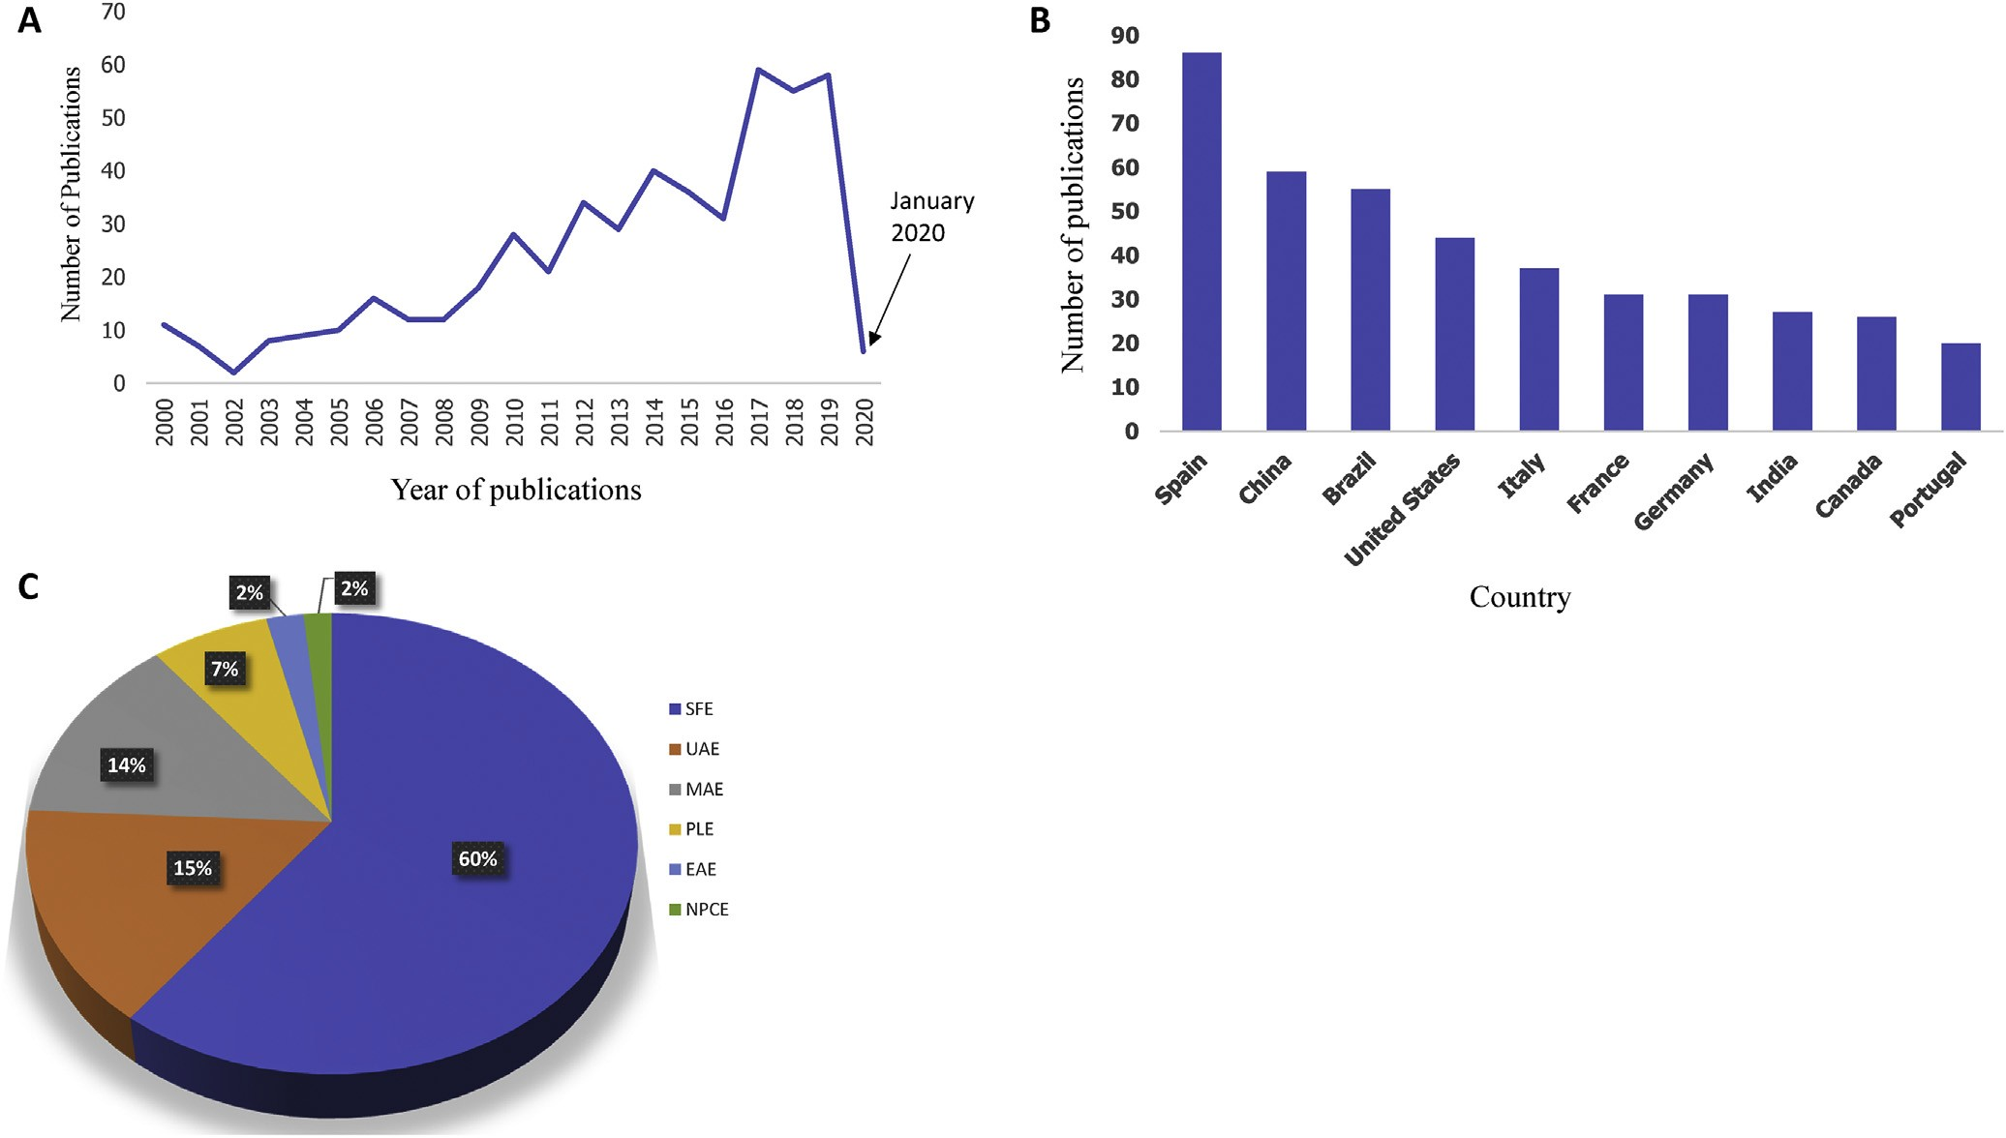
Fig. 6. Trends on the research related to scale-up of non-conventional extraction techniques from year 2000e2020. (A) Number of publications verses year of publication, (B) Top ten countries working on scale-up of non-conventional extraction techniques (based on the countries of author's afﬁliation), (C) Percentage of publications on scale-up research shared by non-conventional techniques (Source: www.scopus.com, accessed on January 25, 2020).

The trends in the scale-up of non-conventional extraction methods have clearly demonstrated the increasing interest from lab to industrial scale. Consequently, some future challenges and recommendations can be highlighted for multistep and hyphenated extraction processes, which are particularly important in development of ‘zero waste’ biorefining processes. Working on a number of parameters can be useful to the efficient design of instruments and process conditions to achieve improved results. For instance, in the case of industrial SFE-CO₂, process time is a critical parameter that affects extraction costs, while ultrasound and microwave-assisted SFE-CO₂ can achieve maximal yields in shorter times. This hybrid-technique phenomenon can be beneficial to increasing yields without the need to increase extraction time, thus achieving improved yields without a subsequent decrease in annual production volume. The development of hybrid mode EAE for scaled-up processes would be highly beneficial as it may not only provide higher yields of various constituents with fewer side products, but also improve their bioavailability, which is one of the limiting factors in providing effective pharmacological activities. Including co-solvents and the fractionation of crude extracts in separators in SFE options raises more complicated tasks when designing industrial systems. In this case, the tuning of pump capacities and separator volumes are very important issues; they should be adequately selected and designed to fit the extraction capacities of the main extraction vessels, particularly solvent flow rates and debits.
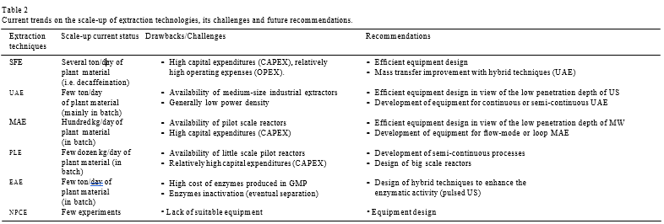

Aiming to guarantee high-quality extracts and highly efficient processes in term of energy consumption and costs, the open challenges are the optimization of operative conditions at industrial level and the development of suitable analytical methods for online parameters monitoring. Meantime, fast analytical methods have to constantly monitor the extraction rate showing when the equilibrium state is reached, typically by online UV detection. A multistep extraction scheme is depicted in Supplementary Figure 1, where each batch is at least extract twice, 1st with solvent deriving from the extraction of a previous batch and 2nd with pure solvent. In this way the equilibrium of exhaustive extraction can be obtained with much less solvent in a shorter time and an easier analytical detection.
Various methods, such as high-speed counter-current chromatography (HSCCC) showed promising results [132]. While these methods were tested more than 10 years ago, the demand for industrial production of purified natural compounds has been increasing due to the increasing importance of functional foods and nutraceuticals in human nutrition. Remarkably difficult challenges will therefore be faced during extraction scale-up and purification, which require special attention in the future.
UAE and MAE have also been tested in several studies, most of them on the laboratory scale. The scale-up of such methods to industrial level is at an embryonic phase and raises many different challenges for the future (Table 2). In such cases, scale-up includes extra work on the optimisation of UAE and MAE, while, in the case of batch production, the same scale-up principles and models can be applied to SFE. The development and scale-up of continuous and even semi-continuous integrated processes raises additional challenges.
All these non-conventional extraction technologies are “mature” with great opportunities of intellectual properties for specific applications, nevertheless underused because the lack of data on investments return. Among challenges and barriers we can list: the poor availability of appropriate pilot facilities; the weak competitive position of equipment suppliers; the lack of technical specialists and start-up companies in the field.
Technically, the scaling of PLE to pilot-plant and industrial levels does not appear to be very complicated. Theoretically, SFE scaling principles and models can be applied with the necessary adjustments for solvent, pressure and other parameters. It is highly likely that scaling studies are in an embryonic phase as PLE is quite a lot younger than other techniques. Some other technical problems may also hamper the faster industrial implementation of PLE. The necessity for solvent removal after extraction might be one of these issues. For instance, remarkable amounts of energy would be required to remove water from PHWE extracts, while in SFE-CO₂, solvent-free extracts are obtained without any extra effort. Solvent evaporation becomes a particularly important issue when extracting natural bioactive compounds that might be heat sensitive. In such cases, vacuum evaporation, or better, freeze drying, which is rather expensive, should be used. PLE with organic solvents, except for ethanol, is not environmentally friendly and is also not suitable for the production of ingredients for human consumption.
Nevertheless, the possibilities and feasibility of scaling up EAE for the above-mentioned materials need to be experimentally validated using higher volume bioreactors/extractors. The costs of EAE are currently comparatively high, which raises economic feasibility problems in the scale-up of processes for their industrial applications and commercialisation. Additionally, some enzymes are not able to completely hydrolyse cells, and this disadvantage leads to lower extraction yields. Some innovative approaches have been suggested and tested to mitigate these hampering issues, for instance, microwave irradiation during EAE has therefore been acknowledged as having good prospects. In general, the integration of different extraction methods, including EAE, has been gaining popularity in recent years. It is reasonable to expect that multistep biorefining processes may be able to increase the overall economic feasibility of extractions by adding an extra valuable product, with different composition and properties, and therefore that it may be more flexible for a number of applications, including in foods, nutraceuticals and cosmetics, etc.

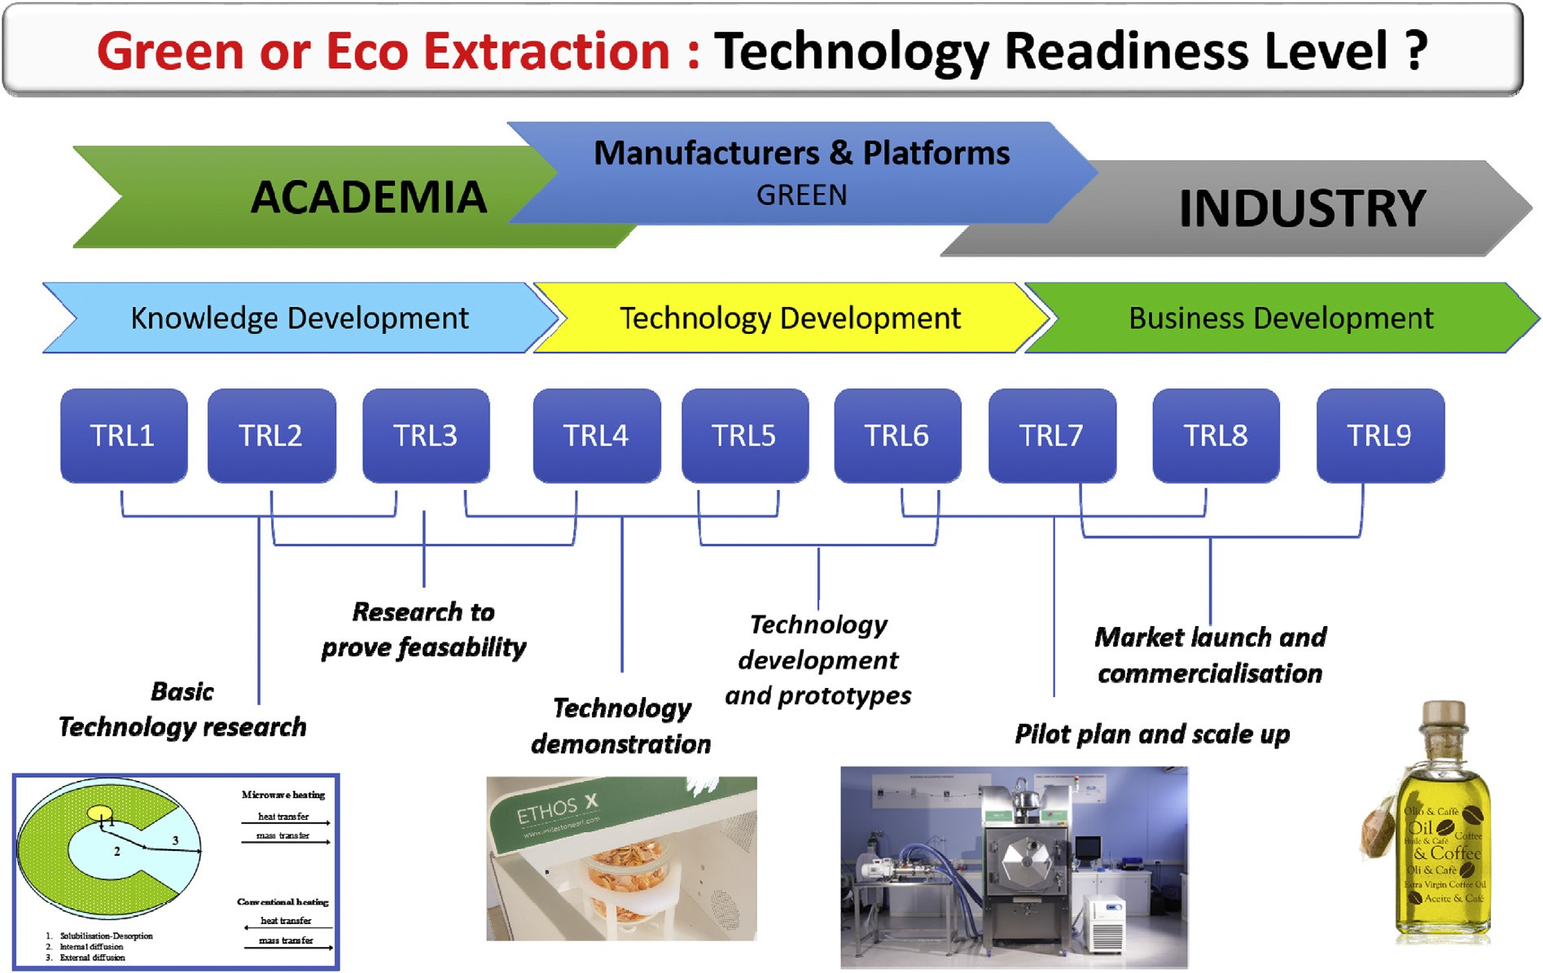
Fig. 7. A possible strategy for the green or eco extraction scale-up involving different technology readiness levels (TRLs) and approaches.

Several recommendations have been made for the effective use of non-conventional extraction techniques for scale-up (Table 2). There is concern about the insufficient involvement of academia, which may potentially result in future skill gaps. Scale-up requires a holistic effort over a number of steps, including process design, instrument design and bioanalyticals, etc. Additionally, the development of multidisciplinary skills is considered to be important for a future in which the integration/understanding of several technologies will become important. Equipment suppliers have limited resources for innovation and the view has been expressed that creating alliances between industry and institutes/universities to encourage innovation in both would be desirable and improve their competitive positions. We could estimate the maturity of green extraction techniques by using technology readiness levels (TRLs) (Figure 7). TRL’s have been developed at NASA during the 1970s. The use of TRLs enables consistent, uniform discussions of technical maturity across different types of technologies, and are based on a scale from 1 to 9 with 9 being the most mature technology. We could directly notice that there is a gap between academic innovations and industrial applications. This gap is the main problem for all technologies, academic labs (scale 1L) need platforms (scale 100-1000 L) to test the equipment with help of manufacturers, and in the same time industry (scale 1000-10000 L) need to test both the technique and the product to be sure of the application and to have enough samples for marketing studies.

Acknowledgements
The research was financially supported by the Key Research and Development Program of Zhejiang Province (2018C02049), China, Technology Innovation Programme of Zhejiang Province (ZJWR0102001), China and China Postdoctoral Science Foundation (2018M642443), China.

Figures
Figure 1: (A) Industrial scale Ultrasonic batch extraction process 2 X 500 L (Reus - www.etsreus.com ) and (B) industrial scale continuous extraction process 1000 to 10000 L/h (Hielscher- www.hielscher.com).
Figure 2: (A) Lab-scale (Multiwave 3000) and (B) Industrial scale (Mac 75) microwave reactor for extraction of bioactive compounds from plant samples
Figure 3 : (A) Lab-scale and (B) Industrial scale (25L high-pressure cylinder) supercritical CO₂ reactor for extraction of bioactive compounds from plant samples
Figure 4. (A) Extraction under simultaneous ultrasound and microwave irradiation (University of Turin and Milestone srl, Bergamo) and (B) Simultaneous ultrasound and supercritical CO₂ extraction (Weber Ultrasonics AG, Germany – FeyeCon, The Netherlands)
Figure 5. (A) Flow-mode UAE with improved extraction vessel design (Zhejiang University, Hangzhou, China), (B) Flow-mode ultrasound-assisted extraction in loop with two 25 kHz units (3 kW each to treat 40 kg dry material) (Grant Agreement Number 669055 - https://www.us4greenchem.com/), (C) Flow-mode MAE with Archimedean screw (University of Turin, Turin, Italy)
Figure 6. Trends on the research related to scale-up of non-conventional extraction techniques from year 2000 to 2020. (A) Number of publications verses year of publication, (B) Top ten countries working on scale-up of non-conventional extraction techniques based on the countries of author’s affiliation, (C) Percentage of publications on scale-up research shared by non-conventional techniques (Source: www.scopus.com, accessed on January 25, 2020).
Figure 7. A possible strategy for the green or eco extraction scale-up involving different technology readiness levels (TRLs) and approaches.

References

- Belwal, T., Ezzat, S.M., Rastrelli, L., Bhatt, I.D., Daglia, M., Baldi, A., Devkota, H.P., Orhan, I.E., Patra, J.K., Das, G., Anandharamakrishnan, C., Gomez-Gomez, L., Nabavi, S.F., Nabavi, S.M., Atanasov, A.G. (2018). A critical analysis of extraction techniques used for botanicals: Trends, priorities, industrial uses and optimization strategies. TrAC Trends in Analytical Chemistry, 100, 82-102. https://doi.org/10.1016/j.trac.2017.12.018
- Chemat, F., Vian, M.A., & Cravotto, G. (2012). Green extraction of natural products: concept and principles. International journal of molecular sciences, 13, 8615-8627. https://doi.org/10.3390/ijms13078615
- Chemat, F., Abert-Vian, M., Fabiano-Tixier, A.S., Strube, J., Uhlenbrock, L., Gunjevic, V., & Cravotto, G. (2019). Green extraction of natural products. Origins, current status, and future challenges. TrAC Trends in Analytical Chemistry, 118, 248-263. https://doi.org/10.1016/j.trac.2019.05.037
- Filly, A., Fernandez, X., Minuti, M., Visinoni, F., Cravotto, G., & Chemat, F. (2014). Solvent-free microwave extraction of essential oil from aromatic herbs: from laboratory to pilot and industrial scale. Food chemistry, 150, 193-198. https://doi.org/10.1016/j.foodchem.2013.10.139
- Belwal, T., Huang, H., Li, L., Duan, Z., Zhang, X., Aalim, H., & Zisheng, L. (2019). Optimization model for ultrasonic-assisted and scale-up extraction of Anthocyanins from Pyrus communis ‘Starkrimson’fruit peel. Food Chemistry, 297, 124993. Doi: 10.1016/j.foodchem.2019.124993
- Périno, S., Pierson, J. T., Ruiz, K., Cravotto, G., & Chemat, F. (2016). Laboratory to pilot scale: Microwave extraction for polyphenols lettuce. Food chemistry, 204, 108-114. https://doi.org/10.1016/j.foodchem.2016.02.088
- Fu, X., Belwal, T., Cravotto, G., & Luo, Z. (2019). Sono-physical and sono-chemical effects of ultrasound: primary applications in extraction and freezing operations and influence on food components. Ultrasonics Sonochemistry, 60, 104726. Doi: 10.1016/j.ultsonch.2019.104726
- Chemat, F., Zill-e-Huma, M. Kamran Khan (2011), Applications of ultrasound in food technology: Processing, preservation and extraction. Ultrasonics Sonochemistry, 18, 813-835. https://doi.org/10.1016/j.ultsonch.2010.11.023
- Pandey, A., Belwal, T., Chandra Sekar, K., Bhatt, I.D., & Rawal, R.S. (2018). Optimization of ultrasonic-assisted extraction (UAE) of phenolics and antioxidant compounds from rhizomes of Rheum moorcroftianum using response surface methodology (RSM). Industrial Crops and Products, 119, 218-225. https://doi.org/10.1016/j.indcrop.2018.04.019
- Chemat, F., Rombaut, N., Sicaire, A-G., Meullemiestre, A., Fabiano-Tixier, A-S., & Abert-Vian, M. (2017). Ultrasound assisted extraction of food and natural products. Mechanisms, techniques, combinations, protocols and applications. A review. Ultrasonics Sonochemistry, 34, 540–60. doi: 10.1016/j.ultsonch.2016.06.035.
- Pingret, D., Fabiano-Tixier, A. S., Le Bourvellec, C., Renard, C. M., & Chemat, F. (2012). Lab and pilot-scale ultrasound-assisted water extraction of polyphenols from apple pomace. Journal of Food Engineering, 111(1), 73-81. https://doi.org/10.1016/j.jfoodeng.2012.01.026
- Boonkird, S., Phisalaphong, C., & Phisalaphong, M. (2008). Ultrasound-assisted extraction of capsaicinoids from Capsicum frutescens on a lab- and pilot-plant scale. Ultrasonics Sonochemistry, 15(6), 1075-1079. https://doi.org/10.1016/j.ultsonch.2008.04.010
- Fuchs, F. J. (2015). Ultrasonic cleaning and washing of surfaces. In Power Ultrasonics (pp. 577-609). Woodhead Publishing. https://doi.org/10.1016/B978-1-78242-028-6.00019-3
- Yasuda, J., Yoshizawa, S., & Umemura, S-I. (2016). Efficient generation of cavitation bubbles and reactive oxygen species using triggered high-intensity focused ultrasound sequence for sonodynamic treatment. Japanese Journal of Applied Physics, 55, Number 7S1. https://doi.org/10.7567/JJAP.55.07KF24
- Meullemiestre, A., Petitcolas, E., Maache-Rezzoug, Z., Chemat, F., & Rezzoug, S. A. (2016). Impact of ultrasound on solid–liquid extraction of phenolic compounds from maritime pine sawdust waste. Kinetics, optimization and large-scale experiments. Ultrasonics sonochemistry, 28, 230-239. https://doi.org/10.1016/j.ultsonch.2015.07.022
- Paniwnyk, L., Cai, H., Albu, S., Mason, T. J., & Cole, R. (2009). The enhancement and scale up of the extraction of anti-oxidants from Rosmarinus officinalis using ultrasound. Ultrasonics Sonochemistry, 16(2), 287-292. https://doi.org/10.1016/j.ultsonch.2008.06.007
- Virot, M., Tomao, V., Le Bourvellec, C., Renard, C. M., & Chemat, F. (2010). Towards the industrial production of antioxidants from food processing by-products with ultrasound-assisted extraction. Ultrasonics sonochemistry, 17(6), 1066-1074. https://doi.org/10.1016/j.ultsonch.2009.10.015
- Alzorqi, I., Singh, A., Manickam, S., & Al-Qrimli, H. F. (2017). Optimization of ultrasound-assisted extraction (UAE) of β-D-glucan polysaccharides from Ganoderma lucidum for prospective scale-up. Resource-Efficient Technologies, 3(1), 46-54. https://doi.org/10.1016/j.reffit.2016.12.006
- Petigny, L., Périno, S., Minuti, M., Visinoni, F., Wajsman, J., & Chemat, F. (2014). Simultaneous microwave extraction and separation of volatile and non-volatile organic compounds of boldo leaves. From lab to industrial scale. International journal of molecular sciences, 15(5), 7183-7198. https://doi.org/10.3390/ijms15057183
- Gallego, R., Bueno, M., & Herrero, M. (2019). Sub- and supercritical fluid extraction of bioactive compounds from plants, food-by-products, seaweeds and microalgae - An update. Trends in Analytical Chemistry, 116, 198-213. https://doi.org/10.1016/j.trac.2019.04.030
- Zoccali, M., Donato, P., & Mondello, L. (2019). Recent advances in the coupling of carbon dioxide-based extraction and separation techniques. Trends in Analytical Chemistry, 116, 158-165. https://doi.org/10.1016/j.trac.2019.04.028
- P. Kotnik, M. Skerget, Z. Knez, Supercritical fluid extraction of chamomile flower heads: Comparison with conventional extraction, kinetics and scale-up. Journal of Supercritical Fluids, 43, 2 (2007) 192-198 DOI: 10.1016/j.supflu.2007.02.005
- Ko, M.J., Kwon, H-L., & Chung, M-S. (2016). Pilot-scale subcritical water extraction of flavonoids from satsuma mandarin (Citrus unshiu Markovich) peel. Innovative Food Science & Emerging Technologies, 38, Part A, 175-181. https://doi.org/10.1016/j.ifset.2016.10.008.
- Salea, R., Veriansyah, B., & Tjandrawinata, R.R. (2017). Optimization and scale-up process for supercritical fluids extraction of ginger oil from Zingiber officinale var. Amarum. Journal of Supercritical Fluids, 120, 285-294. DOI: 10.1016/j.supflu.2016.05.035
- Casas, L., Mantell, C., Rodríguez, M., Torres, A., Macías, F.A., & Martínez de la Ossa, E.J. (2008). Supercritical fluid extraction of bioactive compounds from sunflower leaves: comparison of analytical and pilot-scale extraction. Proceedings of European Congress of Chemical Engineering (ECCE-6) Copenhagen, 16-20 September 2007
- Martin, L., Skinner, C., & Marriott, R.J. (2015). Supercritical extraction of oil seed rape: Energetic evaluation of process scale. Journal of Supercritical Fluids, 105, 55-59 DOI: 10.1016/j.supflu.2015.04.017
- Ruttarattanamongkol, K., Siebenhandl-Ehn, S., Schreiner, M., Petrasch, A.M. (2014). Pilot-scale supercritical carbon dioxide extraction, physico-chemical properties and profile characterization of Moringa oleifera seed oil in comparison with conventional extraction methods. Industrial Crops and Products, 58, 68-77. https://doi.org/10.1016/j.indcrop.2014.03.020.
- Duan, M-H., Luo, M., Zhao, C-J., Wang, W., Zu, Y-G., Zhang, D-Y., Yao, X-H., & Fu, Y-J. (2013). Ionic liquid-based negative pressure cavitation-assisted extraction of three main flavonoids from the pigeonpea roots and its pilot-scale application. Separation and Purification Technology, 107, 26–36. DOI: 10.1016/j.seppur.2013.01.003
- Kong, Y., Wei, Z-F., Fu, Y-J., Gu, C-B., Zhao, C-J., Yao, X-H., Efferth, T. (2011). Negative-pressure cavitation extraction of cajaninstilbene acid and pinostrobin from pigeon pea [Cajanus cajan (L.) Millsp.] leaves and evaluation of antioxidant activity. Food Chemistry, 128(3), 596-605. DOI: https://doi.org/10.1016/j.foodchem.2011.02.079.
- Tian, H., Li, W-Y., Xiao, D., Li, Z-M., & Wang, J-W. (2015). Negative-Pressure Cavitation Extraction of Secoisolariciresinol Diglycoside from Flaxseed Cakes. Molecules, 20(6), 11076-11089. https://doi.org/10.3390/molecules200611076
- Björklund, E., Nilsson, T., & Bøwadt, S. (2000). Pressurised liquid extraction of persistent organic pollutants in environmental analysis. Trends in Analytical Chemistry, 19(7), 434-445. https://doi.org/10.1016/S0165-9936(00)00002-9
- Ibanez, E., Herrero, M., Mendiola, J.A., & Castro-Puyana, M. (2012). Extraction and characterization of bioactive compounds with health benefits from marine resources: Macro and micro algae, cyanobac-teria, and invertebrates, Chapter 2. In: Hayes, M. (Ed.). pp 55–98. https://doi.org/10.1007/978-1-4614-1247-2_2
- Kettle, A. (2013). Recent advances in pressurized fluid extraction, LC GC North America 31, 28-33.
- Teo, C.C., Tan, S.N., Yong, J.W.H., Hew, C.S., & Ong, E.S. (2010). Pressurized hot water extraction (PHWE). Journal of Chromatography A, 1217, 16, 2484-2494. DOI: 10.1016/j.chroma.2009.12.050
- Kovačević, D.B., Barba, F.J., Granato, D., Galanakis, C.M., Herceg, Z., Dragović-Uzelac, V., & Putnik, P. (2018). Pressurized hot water extraction (PHWE) for the green recovery of bioactive compounds and steviol glycosides from Stevia rebaudiana Bertoni leaves. Food Chemistry, 254, 150-157. DOI: 10.1016/j.foodchem.2018.01.192
- Grunovaitė, L., Pukalskienė, M., Pukalskas, A., & Venskutonis, P.R. (2017). Fractionation of black chokeberry pomace into functional ingredients using high pressure extraction methods and evaluation of their antioxidant capacity and chemical composition. Journal of Functional Foods, 24, 85-86. https://doi.org/10.1016/j.jff.2016.03.018
- Kryževičiūtė, N., Kraujalis, P., & Venskutonis, P.R. (2016). Optimization of high pressure extraction processes for the separation of raspberry pomace into lipophilic and hydrophilic fractions. J. Supercrit Fluids, 108, 61–68. https://doi.org/10.1016/j.supflu.2015.10.025
- Oktay Basegmez, H.I., Povilaitis, D., Kitrytė, V., Kraujalienė, V., Šulniūtė, V., Alasalvar, C., & Venskutonis, P.R. (2017). Biorefining of blackcurrant pomace into high value functional ingredients using supercritical CO₂, pressurized liquid and enzyme assisted extractions. Journal of Supercritical Fluids, 124, 10–19. https://doi.org/10.1016/j.supflu.2017.01.003
- Kraujalienė, V., Pukalskas, A., Kraujalis, P., & Venskutonis, P.R. (2016). Biorefining of Bergenia crassifolia L. roots and leaves by high pressure extraction methods and evaluation of antioxidant properties and main phytochemicals in extracts and plant material. Industrial Crops and Products, 89,390-398. https://doi.org/10.1016/j.indcrop.2016.05.034.
- Belandria, V., de Oliveira, P.M.E., Chartier, A., Rabi, J.A., de Oliveira, A.L., & Bostyn, S. (2016). Pressurized-fluid extraction of cafestol and kahweol diterpenes from green coffee. Innovative Food Science & Emerging Technologies, 37, Part A,145-152. DOI: https://doi.org/10.1016/j.ifset.2016.07.022.
- Jemai, A.B., & Vorobiev, E. (2003). Enhanced leaching from sugar beet cossettes by pulsed electric field. Journal of Food Engineering, 59(4), 405-412. DOI: https://doi.org/10.1016/S0260-8774(02)00499-5.
- Kempkes, M., Gaudreau, M., Hawkey, T., & Petry, J. (2007). Scaleup of PEF systems for food and waste streams, IEEE2007 IEEE Pulsed Power Conference, 1-4, 1064-1067. DOI: 10.1109/PPPS.2007.4652372
- Wang, Q.J., Li, Y.F., Sun, D.W., Zhu, Z.W. (2018). Enhancing food processing by pulsed and high voltage electric fields: principles and applications, Critical Reviews in Food Science and Nutrition, 58(13), 2285-2298. DOI: 10.1080/10408398.2018.1434609
- Kumari, B., Tiwari, B.K., Hossain, M.B., Brunton, N.P., & Rai, D.K. (2018). Recent advances on application of ultrasound and pulsed electric field technologies in the extraction of bioactives from agro-industrial by-products. Food and Bioprocess Technology, 11(2), 223-241. DOI: 10.1007/s11947-017-1961-9
- Lamanauskas, N., Pataro, G., Bobinas, Č., Šatkauskas, S., Viškelis, P., Bobinaitė, R., Ferrari, G. (2016). Impact of pulsed electric field treatment on juice yield and recovery of bioactive compounds from raspberries and their by-products. Zemdirbyste-Agriculture, 103(1), 83-90. DOI: 10.13080/z-a.2016.103.011
- Carbonell-Capella, J.M., Buniowska, M., Cortes, C., Zulueta, A., Frigola, A., & Esteve, M.J. (2017). Influence of pulsed electric field processing on the quality of fruit juice beverages sweetened with Stevia rebaudiana. Food and Bioproducts Processing, 101, 214-222. DOI: https://doi.org/10.1016/j.fbp.2016.11.012.
- Shorstkii, I., & Koshevoi, E. (2019). Extraction Kinetic of Sunflower Seeds Assisted by Pulsed Electric Fields. Iranian Journal of Science and Technology, Transactions A: Science, 43(3), 813–817. https://doi.org/10.1007/s40995-018-0591-z
- Zhu, Z., Luo, J., Ding, L., Bals, O., Jaffrin, M.Y., & Vorobiev, E. (2013). Chicory juice clarification by membrane filtration using rotating disk module. Journal of Food Engineering, 115 (2), 264-271. DOI: https://doi.org/10.1016/j.jfoodeng.2012.10.028.
- Sack, M., & Mueller, G. (2016). Scaled design of PEF treatment reactors for electroporation-assisted extraction processes. Innovative Food Science & Emerging Technologies, 37, Part C, 400-406. https://doi.org/10.1016/j.ifset.2016.09.005.
- Gligor, O., Mocan, A., Moldovan, C., Locatelli, M., Crișan, G., & Ferreira, I.C.F.R. (2019). Enzyme-assisted extractions of polyphenols – A comprehensive review. Trends in Food Science & Technology, 88, 302-315. https://doi.org/10.1016/j.tifs.2019.03.029.
- Marathe, S.J., Jadhav, S.B., Bankar, S.B., Dubey, K.K., & Singhal, R.S. (2019). Improvements in the extraction of bioactive compounds by enzymes, Current Opinion in Food Science, 25, 62-72. https://doi.org/10.1016/j.cofs.2019.02.009.
- Conner, J., Wuchterl, D., Lopez, M., Minshall, B., Prusti, R., Boclair, D., Peterson, J., & Allen, C. (2014). The Biomanufacturing of Biotechnology Products, in ed. C. Shimasaki, Biotechnology Entrepreneurship, Starting, Managing, and Leading, Elsevier, pp. 351-385. https://doi.org/10.1016/B978-0-12-404730-3.00026-9
- Johnson, L.A. (2009). Scale-up of enzyme-assisted aqueous extraction processing of soybeans. Journal of the American Oil Chemists Society, 86(8), 809-815. DOI: 10.1007/s11746-009-1406-3
- Towa, L.T., Kapchie, V.N., Hauck, C., Wang, H., & Murphy, P.A. (2011). Pilot plant recovery of soybean oleosome fractions by an enzyme-assisted aqueous process. Journal of the American Oil Chemists Society, 88(5), 733-741. DOI: 10.1007/s11746-010-1716-5
- de Moura, J.M.L.N., Maurer, D., Jung, S., & Johnson, L.A. (2011). Pilot-plant proof-of-concept for integrated, countercurrent, two-stage, enzyme-assisted aqueous extraction of soybeans. Journal of the American Oil Chemists Society, 88(10), 1649-1658. DOI: 10.1007/s11746-011-1831-y
- Li, Z.Z., Wang, X.H., Shi, G.L., Bo, Y.H., Lu, X.H., Li, X.H., Shang, R.F., Tao, L., Liang, & J.P. (2012). Enzyme-assisted extraction of naphthodianthrones from Hypericum perforatum L. by C-12(6+)-ion beam-improved cellulases, Separation and Purification Technology, 86, 234-241. DOI: 10.1016/j.seppur.2011.11.009
- Kitrytė, V., Kraujalienė, V., Šulniūtė, V., & Venskutonis, P. R. (2017). Chokeberry pomace valorization into food ingredients by enzyme-assisted extraction: process optimization and product characterization, Food and Bioproducts Processing, 105, 36-50. https://doi.org/10.1016/j.fbp.2017.06.001
- Maier, T., Goppert, A., Kammerer, D.R., Schieber, A., & Carle, R. (2008). Optimization of a process for enzyme-assisted pigment extraction from grape (Vitis vinifera L.) pomace. European Food Research and Technology, 227(1), 267-275. DOI: 10.1007/s00217-007-0720-y
- Cravotto, G., Boffa, L., Mantegna, S., Avogadro, M., Perego, P., & Cintas, P. (2008). Improved extraction of vegetable oils under high-intensity ultrasound and/or microwaves Ultrasonics Sonochemistry, 15, 898-902. https://doi.org/10.1016/j.ultsonch.2007.10.009
- Cravotto, G., Bonrath, W., Tagliapietra, S., Speranza, C., Calcio Gaudino, E., & Barge, A. (2010). Intensification of organic reactions with hybrid flow-reactors. Chemical Engineering and Processing: Process Intensification, 49, 930-935. doi:10.1016/j.cep.2010.07.004
- Lagha, A., Chemat, S., Bartels, P.V., & Chemat, F. (1999). Microwave-ultrasound combined reactor suitable for atmospheric sample preparation procedure of biological and chemical products. Analusis, 27, 452-457. https://doi.org/10.1051/analusis:1999124
- Cravotto, G., & Cintas, P. (2007). The Combined Use of Microwaves and Ultrasound: New Tools in Process Chemistry and Organic Synthesis. Chemistry European Journal, 13, 1902-1909. https://doi.org/10.1002/chem.200601845
- Leone, A., Romaniello, R., Tamborrino, A., Urbani, S., Servili, M., Amarillo, M., Grompone, M.A., Gambaro, A., & Juliano, P. (2018). Application Of Microwaves and Megasound to Olive Paste in an Industrial Olive Oil Extraction Plant: Impact on Virgin Olive Oil Quality and Composition. European Journal of Lipid Science and Technology, 120, 1700261. Doi: 10.1002/ejlt.201700261
- Microwave-assisted extraction for bioactive compounds: Theory and practice. Editors: Chemat F., Cravotto G. (2013), XII, 238 pp. Series: Food Engineering Series, Vol. 4 Springer Science, 233 Spring Street, New York, U.S.A.
- Balachandran, S., Kentish, S.E., Mawson, R., & Ashokkumar, M. (2006). Ultrasonic enhancement of the supercritical extraction from ginger. Ultrasonics Sonochemistry, 13, 471-479. https://doi.org/10.1016/j.ultsonch.2005.11.006
- Riera, F., et al. (2004). Separation or extraction method using supercritical fluids assisted by high-intensity ultrasound. European Patent EP1547679
- Porto, C.D., Decorti, D., & Natolino, A. (2016). Microwave pretreatment of Moringa oleifera seed: Effect on oil obtained by pilot-scale supercritical carbon dioxide extraction and Soxhlet apparatus. The Journal of Supercritical Fluids, 107, 38-43. https://doi.org/10.1016/j.supflu.2015.08.006.
- Benito-Roman, O., Alonso, E., Cocero, M.J., & Goto, M. (2016). β-Glucan recovery from Ganoderma lucidum by means of pressurized hot water and supercritical CO2. Food and Bioproducts Processing, 98, 21-28. https://doi.org/10.1016/j.fbp.2015.12.007
- Chen, Y., Huang, S.Q., Li, J., Wang, X., & Tang, J. (2010). Optimization of ultrasonic/microwave assisted extraction (UMAE) of polysaccharides from Inonotus obliquus and evaluation of its antitumor activities. International Journal of Biological Macromolecules, 46, 429-435. https://doi.org/10.1016/j.ijbiomac.2010.02.003
- Yin, C., Fan, X., Fan, Z., Shi, D., & Gao, H. (2018). Optimization of enzymes-microwave-ultrasound assisted extraction of Lentinus edodes polysaccharides and determination of its antioxidant activity. International Journal of Biological Macromolecules, 111, 446-454. https://doi.org/10.1016/j.ijbiomac.2018.01.007
- Morales, D., Smiderle, F.R., Villalva, M., Abreu, H., Rico, C., Santoyo, S., Iacomini, M., & Soler-Rivas, C. J. (2019). Testing the effect of combining innovative extraction technologies on the biological activities of obtained β-​glucan-​enriched fractions from Lentinula edodes. Functional Foods, 60, 103446. https://doi.org/10.1016/j.jff.2019.103446
- Lorenzo, J., Barba, Cravotto, G., F., Saraiva, A. (2019). Innovative Thermal and Non-Thermal Processing, Bioaccessibility and Bioavailability of Nutrients and Bioactive. 1st Edition (2019). Editors: F. Barba, J. Manuel, A. Saraiva, G. Cravotto, J. Lorenzo. Woodhead Publ. Elsevier.
- Manzoor, M.F., Zeng, X.-A., Rahaman, A., Siddeeg, A., Aadil, R.M., Ahmed, Z., Li, J., & Niu, D. (2019). Combined impact of pulsed electric field and ultrasound on bioactive compounds and FT-​IR analysis of almond extract. Journal of Food Science and Technology, 56(5), 2355-2364. https://doi.org/10.1007/s13197-019-03627-7
- Medina-Meza, I.G., Boioli, P., & Barbosa-Cánovas, G.V. (2016). Assessment of the Effects of Ultrasonics and Pulsed Electric Fields on Nutritional and Rheological Properties of Raspberry and Blueberry Purees. Food and Bioprocess Technology, 9(3), 520-531. https://doi.org/10.1007/s11947-015-1642-5
- Luo, M., Yang, L-Q., Yao, X-H., Mu, F-S., Zhang, D-Y., Song, Z-Y., Qiao, Q., Fu, Y-J., & Zu, Y-G. (2014). Optimization of enzyme-assisted negative pressure cavitation extraction of five main indole alkaloids from Catharanthus roseus leaves and its pilot-scale application. Separation and Purification Technology, 125, 66-73. https://doi.org/10.1016/j.seppur.2013.12.034.
- Jiao, J., Wei, F-Y., Gai, Q-Y., Wang, W., Luo, M., Fu, Y-J., & Ma, W. (2014). A pilot-scale homogenization-assisted negative pressure cavitation extraction of Astragalus polysaccharides. International Journal of Biological Macromolecules, 67, 189-194. https://doi.org/10.1016/j.ijbiomac.2014.03.018.
- Horst, C., Kunz, U., Rosenplätter, A., & Hoffmann, U. (1999). Activated Solid-Fluid Reactions in Ultrasound Reactors. Chemical Engineering Science, 54, 2849-2858. https://doi.org/10.1016/S0009-2509(98)00316-9
- Keil, F.J., & Swamy K.M. (1999). Reactors for Sonochemical Engineering -Present Status. Reviews in Chemical Engineering, 15 (2), 85-155.
- Alexandru, L., Cravotto, G., Giordana, L., Binello, A., & Chemat, F. (2013). Ultrasound-assisted extraction of clove buds using batch-and flow-reactors: A comparative study on a pilot scale. Innovative Food Science & Emerging Technologies, 20, 167-172. https://doi.org/10.1016/j.ifset.2013.07.011
- Wu, Z., Ferreira, D.F., Crudo, D., Bosco, V., Stevanato, L., Costale, A., & Cravotto, G. (2019). Plant and biomass extraction and valorisation under hydrodynamic cavitation. Processes, 7(12), 965. https://doi.org/10.3390/pr7120965
- Rinaldi, L., Wu, Z., Giovando, S., Bracco, M., Crudo, D., Bosco, V., & Cravotto, G. (2017). Oxidative polymerization of waste cooking oil with air under hydrodynamic cavitation. Green Processing and Synthesis, 6, 425–432.
- Zhang, J., Xu, S., & Li, W. (2012). High shear mixers: A review of typical applications and studies on power draw, flow pattern, energy dissipation and transfer properties. Chemical Engineering and Processing: Process Intensification, 57-58, 25–41. https://doi.org/10.1016/j.cep.2012.04.004.

- Morschhäuser, R., Krull, M., Kayser, C., Boberski, C., Bierbaum, R., Püschner, P.A., Glasnov, T.N., Kappe, C.O. (2012). Microwave-assisted continuous flow synthesis on industrial scale. Green Processing and Synthesis, 1, 281–290. https://doi.org/10.1515/gps-2012-0032
- Tremblay, J.F. (2016). Microwaving by the ton: could industrial-scale microwaves transform chemical manufacturing? Chemical Engineering News, 94 (36) 24-25.
- Microwave Chemistry Ed. Cravotto, G. and Carnaroglio, D.; 2017 De Gruyter (Berlin, Germany), ISBN 978-3-11-047993-5.

- Panda, D., & Manickam, S. (2019). Cavitation Technology—The Future of Greener Extraction Method: A Review on the Extraction of Natural Products and Process Intensification Mechanism and Perspectives. Applied Science, 9(4), 766. https://doi.org/10.3390/app9040766
- Cravotto, G., Mariatti, F., Gunjevic, V., Secondo, M., Villa, M., Parolin, J., & Cavaglià, G. (2018). Pilot Scale Cavitational Reactors and Other Enabling Technologies to Design the Industrial Recovery of Polyphenols from Agro-Food By-Products, a Technical and Economical Overview. Foods, 7, 130. https://doi.org/10.3390/foods7090130
- De Melo, M. M. R., Domingues, R. M. A., Sova, M., Lack, E., Seidlitz, H., Lang Jr, F., ... & Silva, C. M. (2014). Scale-up studies of the supercritical fluid extraction of triterpenic acids from Eucalyptus globulus bark. The Journal of Supercritical Fluids, 95, 44-50. https://doi.org/10.1016/j.supflu.2014.07.030
- Wrona, O., Rafińska, K., Moźeński, C., & Buszewski, B. (2019). Supercritical carbon dioxide extraction of Solidago gigantea Ait.: Optimization at quarter-technical scale and scale up the process to half-technical plant, Industrial Crops and Products,130, 316-324. DOI: 10.1016/j.indcrop.2018.12.050
- Prado, J. M., Dalmolin, I., Carareto, N. D., Basso, R. C., Meirelles, A. J., Oliveira, J. V., ... & Meireles, M. A. A. (2012). Supercritical fluid extraction of grape seed: Process scale-up, extract chemical composition and economic evaluation. Journal of Food Engineering, 109(2), 249-257. https://doi.org/10.1016/j.jfoodeng.2011.10.007
- Prado, J.M., Veggi, P.C., & Meireles, M.A.A. (2017). Scale-up issues and cost of manufacturing bioactive compounds by supercritical fluid extraction and ultrasound assisted extraction. In: Barbosa-Cánovas G. et al. (eds), Global Food Security and Wellness, Springer, New York, NY, pp. 377-433. https://doi.org/10.1007/978-1-4939-6496-3_20
- Zabot, G. L., Moraes, M. N., & Meireles, M. A. A. (2014). Supercritical technology applied to the production of bioactive compounds: research studies conducted at LASEFI from 2009 to 2013. Food and Public Health, 4(2), 36-48. https://doi.org/10.5923/j.fph.20140402.04
- Martínez, J., Rosa, P.T.V., & Meireles, M.A.A. (2007). Extraction of clove and vetiver oils with supercritical carbon dioxide: modeling and simulation, The Open Chemical Engineering J. 1, 1–7. https://doi.org/10.2174/1874123100701010001
- Zabot, G.L., Moraes, M.N., Petenate, A.J., & Meireles, M.A.A. (2014). Influence of the bed geometry on the kinetics of the extraction of clove bud oil with supercritical CO2. The Journal of Supercritical Fluids, 93, 56-66. http://dx.doi.org/10.1016/j.supflu.2013.1010.1001.
- Lagadec, A.J.M., Miller, D.J., Lilke, A.V., & Hawthorne, S.B. (2000). Pilot-scale subcritical water remediation of polycyclic aromatic hydrocarbon- and pesticide-contaminated soil. Environental Science & Technology, 34, 1542. https://doi.org/10.1021/es990722u
- Clodoveo, M.L., Moramarco, V., Paduano, A., Sacchi, R., Di Palmo, T., Crupi, P., Corbo, F.F.R., Pesce, V., Distaso, E., Tamburrano, P., & Amirante, R. (2017). Engineering design and prototype development of a full scale ultrasound system for virgin olive oil by means of numerical and experimental analysis. Ultrasonics Sonochemistry, 37, 169-181. https://doi.org/10.1016/j.ultsonch.2017.01.004
- Moncada, J., Tamayo, J.A., & Cardona, C.A. (2016). Techno-economic and environmental assessment of essential oil extraction from oregano (Origanum vulgare) and rosemary (Rosmarinus officinalis) in Colombia. Journal of Cleaner Production, 112, 172−181. https://doi.org/10.1016/j.jclepro.2015.09.067
- Moncada, J., Tamayo, J.A., & Cardona, C.A. (2014). Techno-economic and environmental assessment of essential oil extraction from Citronella (Cymbopogon winteriana) and lemongrass (Cymbopogon citrus): A Colombian case to evaluate different extraction technologies, Industrial Crops and Products, 54, 175-184. DOI:10.1016/j.indcrop.2014.01.035
- Todd, R., & Baroutian, S. (2017). A techno-economic comparison of subcritical water, supercritical CO2 and organic solvent extraction of bioactives from grape marc. Journal of Cleaner Production, 158, 349-358. https://doi.org/10.1016/j.jclepro.2017.05.043.
- Perrut, M. (2000). Supercritical fluid applications: Industrial development and economic issues. Industrial & Engineering Chemistry Research, 39, 4531–4535. https://doi.org/10.1021/ie000211c
- Vardanega, R., Carvalho, P.I.N., Santos, D.T., & Meireles, M.A.A. (2017). Obtaining prebiotic carbohydrates and beta-ecdysone from Brazilian ginseng by subcritical water extraction. Innovative Food Science & Emerging Technologies, 42, 73-82. DOI: 10.1016/j.ifset.2017.05.007
- Rosa, P.T.V., & Meireles, M.A.A. (2005). Rapid estimation of the manufacturing cost ofextracts obtained by supercritical fluid extraction, Journal of Food Engineering, 67, 235–240. https://doi.org/10.1016/j.jfoodeng.2004.05.064
- Duba, K., & Fiori, L. (2019). Supercritical CO2 extraction of grape seeds oil: scale-up and economic analysis, International. Journal of Food Science and Technology, 54, 1306-1312. DOI: 10.1111/ijfs.14104
- Clarke, C.J., Tu, W.-C., Levers, O., Bröhl, A., Hallett, J.P. (2018). Green and sustainable solvents in chemical processes. Chemical Reviews, 118 (2), 747-800. DOI: 10.1021/acs.chemrev.7b00571
- Núñez, G.A., & del Valle, J.M. (2014). Supercritical CO2 oilseed extraction in multi-vessel plants. 2. Effect of number and geometry of extractors on production cost. The Journal of Supercritical Fluids, 92, 324-334. https://doi.org/10.1016/j.supflu.2014.05.017.
- Cavalcanti, R. N., Albuquerque, C. L., & Meireles, M. A. A. (2016). Supercritical CO2 extraction of cupuassu butter from defatted seed residue: Experimental data, mathematical modeling and cost of manufacturing. Food and bioproducts processing, 97, 48-62. https://doi.org/10.1016/j.fbp.2015.10.004
- Viganó, J., Zabot, G.L., & Martínez, J. (2017). Supercritical fluid and pressurized liquid extractions of phytonutrients from passion fruit by-products: Economic evaluation of sequential multi-stage and single-stage processes. The Journal of Supercritical Fluids, 122, 88–98. https://doi.org/10.1016/j.supflu.2016.12.006
- Zabot, G.L., Moraes, M.N., Carvalho, P.I.N., & Meireles, M.A.A. (2015). New proposal for extracting rosemary compounds: Process intensification and economic evaluation. Industrial Crops and Products, 77, 758-771. https://doi.org/10.1016/j.indcrop.2015.09.053.
- Santos, D. T., Veggi, P. C., & Meireles, M. A. A. (2010). Extraction of antioxidant compounds from Jabuticaba (Myrciaria cauliflora) skins: Yield, composition and economical evaluation. Journal of Food Engineering, 101(1), 23-31. https://doi.org/10.1016/j.jfoodeng.2010.06.005
- Osorio-Tobón, J.F., Carvalho, P.I.N., Rostagno, M.A., Meireles, M.A.A. (2016). Process integration for turmeric products extraction using supercritical fluids and pressurized liquids: economic evaluation, Food and Bioproducts Processing, 98, 227–235. https://doi.org/10.1016/j.fbp.2016.02.001
- Chemat, F., Abert Vian, M., Ravi, H. K., Khadhraoui, B., Hilali, S., Perino, S., & Tixier, A. F. (2019). Review of Alternative Solvents for Green Extraction of Food and Natural Products: Panorama, Principles, Applications and Prospects. Molecules (Basel, Switzerland), 24(16), 3007. doi:10.3390/molecules24163007
- Coelho, R., Kanda, L.R.S., Hamerski, F., Masson, M.L., Corazza, M.L. (2016). Extraction of kiwifruit seed (Actinidia deliciosa) oil using compressed propane. Journal of Food Process Engineering, 39(4), 335-344 DOI: 10.1111/jfpe.12225
- Chevereau, P. (1998). Method for extracting and fixing aromas on non-aqueous substrate, machine for implementing the method, and product thereby. U.S. patent 5853726, December 1998.
- Rossignol-Castera, A. (2010). Methods for extracting non-volatile compounds. International patent WO 2010112760 A1, October 2010.
- Sovova, H., Komers, R., Kucera, J., & Jez, J. (1994). Supercritical carbon dioxide extraction of caraway essential oil. Chemical Engineering Science, 49, 2499–2505. https://doi.org/10.1016/0009-2509(94)E0058-X
- Del Valle, J.M., & De La Fuente, J.C. (2006). Supercritical CO2 extraction of oilseeds: Review of kinetic and equilibrium models, Critical Reviews in Food Science and Nutrition 46(2), 131-160. DOI: 10.1080/10408390500526514
- Hassim, N., Markom, M., Rosli, M.I., & Harun, S. (2019). Scale-up criteria and economic analysis for supercritical fluid extraction of Phyllanthus niruri. Chemical Engineering and Processing-Process Intensification, 139, 14-22. DOI: 10.1016/j.cep.2019.03.011
- Huang, Z., Shi, X.H., & Jiang, W.J. (2012). Theoretical models for supercritical fluid extraction. Journal of Chromatography A, 1250, 2-26. DOI: 10.1016/j.chroma.2012.04.032
- Dassoff, E.S., & Li, Y.O. (2019). Mechanisms and effects of ultrasound-assisted supercritical CO2 extraction. Trends in Food Science & Technology, 86, 492-501. https://doi.org/10.1016/j.tifs.2019.03.001
- Fiori, L., Basso, D., & Costa, P. (2009). Supercritical extraction kinetics of seed oil: A new model bridging the “broken and intact cells” and the “shrinking-core” models. The Journal of Supercritical Fluids, 48, 131–138. https://doi.org/10.1016/j.supflu.2008.09.019
- del Valle, J. M., Rivera, O., Mattea, M., Ruetsch, L., Daghero, J., & Flores, A. (2004). Supercritical CO2 processing of pretreated rosehip seeds: effect of process scale on oil extraction kinetics. The Journal of supercritical fluids, 31(2), 159-174. https://doi.org/10.1016/j.supflu.2003.11.005
- Fernández-Ponce, M. T., Parjikolaei, B. R., Lari, H. N., Casas, L., Mantell, C., & de la Ossa, E. J. M. (2016). Pilot-plant scale extraction of phenolic compounds from mango leaves using different green techniques: Kinetic and scale up study. Chemical Engineering Journal, 299, 420-430. https://doi.org/10.1016/j.cej.2016.04.046
- Silva, L. P., de Aguiar, A. C., Barbero, G. F., & Martínez, J. (2013). Scale-up of SFE from capsicum pepper using supercritical carbon dioxide. In III Iberoamerican Conference on Supercritical Fluids.
- Mezzomo, N., Martínez, J., & Ferreira, S. R. (2009). Supercritical fluid extraction of peach (Prunus persica) almond oil: kinetics, mathematical modeling and scale-up. The Journal of Supercritical Fluids, 51(1), 10-16. https://doi.org/10.1016/j.supflu.2009.07.008
- Paula, J.T., Aguiar, A.C., Sousa, I.M., Magalhães, P.M., Foglio, M.A., & Cabral, F.A. (2016). Scale-up study of supercritical fluid extraction process for Baccharis dracunculifolia. The Journal of Supercritical Fluids, 107, 219-225. https://doi.org/10.1016/j.supflu.2015.09.013
- Prado, J.M., Veggi, P.C., & Meireles, M.A.A. (2014). Supercritical fluid extraction of lemon verbena (sf Aloysia triphylla): Process kinetics and scale-up, extract chemical composition and antioxidant activity, and economic evaluation. Separation Science and Technology, 49 (4), 569-579. DOI: 10.1080/01496395.2013.862278
- Chan, C. H., Yusoff, R., & Ngoh, G. C. (2017). An Energy-Based Approach to Scale Up Microwave-Assisted Extraction of Plant Bioactives. In Ingredients Extraction by Physicochemical Methods in Food (pp. 561-597). Academic Press.
- Chan, C. H., Yusoff, R., & Ngoh, G. C. (2013). Modeling and prediction of extraction profile for microwave-assisted extraction based on absorbed microwave energy. Food chemistry, 140(1-2), 147-153.
- Chan, C. H., Lim, J. J., Yusoff, R., & Ngoh, G. C. (2015). A generalized energy-based kinetic model for microwave-assisted extraction of bioactive compounds from plants. Separation and Purification Technology, 143, 152-160.
- Kraujalis, P., Kraujalienė, V., Kazernavičiūtė, R., & Venskutonis, P. R. (2017). Supercritical carbon dioxide and pressurized liquid extraction of valuable ingredients from Viburnum opulus pomace and berries and evaluation of product characteristics. The Journal of Supercritical Fluids, 122, 99–108. https://doi.org/10.1016/j.supflu.2016.12.008
- Fernandez-Aulis, F., Hernandez-Vazquez, L., Aguilar-Osorio, G., Arrieta-Baez, D., & Navarro-Ocana, A. (2019). Extraction and identification of anthocyanins in corn cob and corn husk from cacahuacintle maize. Journal of Food Science, 84 (5), 954-962. DOI: 10.1111/1750-3841.14589
- Wang, D., Bai, A., Lin, X., Fang, L., Shu, X., Shi, X., Sun, Q., & Wang, X. (2012). Efficient method for extraction and isolation of shionone from Aster tataricus L. f. by supercritical fluid extraction and high-speed counter-current chromatography. Acta Chromatographica, 24(4), 615-625. DOI: 10.1556/AChrom.24.2012.4.8
- Alzorqi, I., & Manickam, S. (2015). Effects of Axial Circulation and Dispersion Geometry on the Scale-up of Ultrasonic Extraction of Polysaccharides. AIChE Journal, 61(5). DOI: 10.1002/aic.14776
- Riera, E., Blanco, A., García, J., Benedito, J., Mulet, A., Gallego-Juárez, J.A, & Blasco, M. (2010). High-power ultrasonic system for the enhancement of mass transfer in supercritical CO2 extraction processes. Physics Procedia, 3(1), 141-146. https://doi.org/10.1016/j.phpro.2010.01.020.167.
- Woźniak, Ł., Szakiel, A., Pączkowski, C., Marszalek, K., Skąpska, S., Kowalska, H., & Jędrzejczak, R. (2018). Extraction of triterpenic acids and phytosterols from apple pomace with supercritical carbon dioxide: Impact of process parameters, modelling of kinetics, and scaling-up study. Molecules, 23, 2790. DOI: 10.3390/molecules23112790
- Hall, R.M., Mayer, D.A., Mazzutti, S., & Ferreira, S.R.S. (2018). Simulating large scale SFE applied to recover bioactive compounds from papaya seeds. Journal of Supercritical Fluids, 140, 302-309. DOI: 10.1016/j.supflu.2018.07.013
- López-Padilla, A., Ruiz-Rodriguez, A., Reglero, G., & Fornari, T. (2018). Supercritical extraction of solid materials: A practical correlation related with process scaling. Journal of Food Engineering, 222, 199-206. DOI: 10.1016/j.jfoodeng.2017.11.027
- López-Padilla, A., Ruiz-Rodriguez, A., Flórez, C.E.R., Barrios, D.M.R., Reglero, G., & Fornari, T. (2016). Vaccinium meridionale Swartz supercritical CO2 extraction: Effect of process conditions and scaling up. Materials, 9, 519. DOI: 10.3390/ma9070519

