Reticular chemistry applied on coordination polymers of Copper(I) cyanide with tridentate ligands: effect of the ligand flexibility and donor properties on topology, dimensionality and reaction behavior in solvothermal conditions

**Alessia Giordana*1, Emanuele Priola1,2, Giacomo Gariglio1, Elisabetta Bonometti1,2, Lorenza Operti1, Eliano Diana*1,2**

1. Department of Chemistry, University of Turin. Via Pietro Giuria 7, 10125 Turin, Italy.
2. CrisDi, InterDepartemental Center for Crystallography, University of Turin.

**\*** Correspondence: [eliano.diana@unito.it](mailto:eliano.diana@unito.it); [alessia.giordana@unito.it](mailto:alessia.giordana@unito.it)

**Abstract:** A study of the effect of flexibility of tri-chelating ligands on the overall topology of CuCN derivatives is reported. In particular, we selected two ligands with different degree of aromatic condensation: 2,2’:6’,2’’-terpyridine (tpy) and 2-(2’-pyridyl)-1,8-naphthyridine (pyNP). We obtained a new coordination polymer of pyNP [(CuCN)3(pyNP)]n (**1**), three coordination polymers of tpy ([(CuCN)3(tpy)]n (**2**), [(CuCN)(tpy)]n (**3**) and {[Cu(tpy)][Cu(CN)3]}n (**4**)), and one molecular compound, [Cu2Cl(CN)(pyNP)] (**5**). All products have been characterized by SC-XRD and Raman/IR spectroscopies. Results indicate that an hexagonal net can be obtained, but the two ligands show different effects on the topological fragments of cyanocuprate. An accurate vibrational analysis demonstrated to be diagnostic of the structural patterns in these systems, especially for cyanide stretching modes. We observed different behavior between tpy and pyNP in solvothermal condition. In the first case it was not possible to obtain a pure product, and Cu(II) derivatives have been identified; while using pyNP a pure phase was obtained, that suggests a preference toward Cu(I) coordination. It was also observed that the addition of CN ions promotes CuCN solubilization, increasing products yields, with effects on the nature and crystallinity of the obtained products.

**Keywords:** CuCN; coordination polymers; terpyridine; naphthyridine; topology

1. Introduction

The chemistry of cyanide-bridged compounds has undergone relevant advances in the last decades, especially with regard to one-, two-, and three-dimensional coordination polymers. Syntheses of oligonuclear cyanide-bridged complexes and investigation of electronic interactions between their metal centers have been pursued by several research groups [1-4]. Cyanide ligand can interact with different modes with almost all metals of the periodic table. By far the two most probable modes are the terminal C-bound mode and the ambidentate μ2-bridging mode, which are due to a donor electron pair both at C and N terminals [5]. Other bridging disposition (μ3-C:C:N and μ4-C:C:N:N) are possible but rare [6].

Systems with a great structural variety of cyanide ligands are copper(I) derivatives. This soft metal can interact with almost all kind of ligands, although the preference for N and S donor is strong [7]. Several works have been dedicated to pyridine and its derivatives [8-10], especially bridging (4,4’-bipyridine [11-12] and pyrazine [13]) or chelating (2,2’-bipyridine and 1,10-phenantroline [14-16]), and also with multichelating sites [17-18]. Nevertheless, other nitrogen donors like nitriles [19] and amines [20-22] have been used as ligand. Main sulfur donors that have been employed are organic sulfides [23-24] and tioureas [25-26], while phosphines are common P-donor ligands that have been reported both in molecular and polymeric complexes [27-29].

A general structural trends in Copper(I) cyanide derivatives can be obtained by analyzing CCSD(2020) data (Figure S1 and S2, Table S1), extracted from the database using ConQuest software by choosing different structural fragments. It is important to consider that results related to nitrogen bonded copper could be underestimated due to the absence of charge information in crystallographic files [30-31]. This information is important because nitrogen can be coordinated both to copper(I) or copper(II). Charge information is not relevant for carbon bonded copper because this site is usually too soft for Cu(II). The statistical analysis of obtained data evidences these structural trends:

1) When bonded to C side, Cu(I) presents a very strong preference for linear coordination (around 75% of results lie between 170 and 180 degree), while when bonded to N side the analogous percentage decreases to 41% and Cu–N–C angle values have very left skewed distribution.

2) Cu–C distance is centered to 1.87 Å, while the Cu(I)–N distance is slightly longer (1.95 Å).

3) A scatterplot of angles vs distances for Cu–CN fragment gives two clusters: one containing linear, single bonded cyanide, and one less dense made of systems that presents µ2 cyanides between two Cu(I) centers. The second one shows a strong correlation between the angle and the distance, while the first is quite insensitive to the variations of distance (see Figure S1c).

4) Cyanide coordination is mainly bridging through the C atom. Terminal coordination is not common, and there are not results for a nitrogen bonded terminal cyanide, probably for the stronger basicity of the carbon side [5].

5) Around 10% of results correspond to polymeric and molecular mixed metal complexes in which cyanide is bridging ligand between Cu(I) and other metals (both transition and non-transition ones).

These results underline the complexity of the CN behavior; furthermore, similarly to other d10 metal centers, copper(I) coordination sphere is not often predictable [32]. Crystallographic data point out that copper coordination geometries defined by cyanide can be: (i) linear (although the preference for this coordination geometry is not common as with Hg, Au or Ag, because of the lack of s orbital relativistic contraction effects [33]), (ii) trigonal planar and (iii) tetrahedral. As shown in Table S1, tetrahedral coordination is only 3%, suggesting a preference for (i) and (ii), respectively 64.5% and 32.5%. Another characteristic is the possibility of cuprophilic interactions: this interaction, although weaker that the argentophilic and aurophilic counterpart, has been demonstrated, by computational and experimental charge density studies, to be one of the driving forces in the crystal packing of Cu(I) compounds and can participate to the construction of quite complex architectures, like pseudorotaxane [34-37]. In addition, the co-presence of mixed Cu(I)/Cu(II) sites increases system complexity by changing radically the coordination polyhedron preference and modifying the structure and topology of the complexes [38-39]. This variability could make it difficult to predict the result of a synthesis and the effect of an external ancillary ligand, but the results can be very interesting and some complex topologies have been obtained: interpenetration [40], chiral 3D net with 2D Cairo pentagonal tiling [39] and multiple topological families (due usually to templating agents) [41].

CuCN coordination polymers have some common topological themes, like 1D wavy chains in which the ancillary ligand completes the coordination sphere of the planar trigonal or tetrahedral coordination of Cu(I) sites. This is found both for monodentate (like pyridine and its derivatives [8-10]) and bidentate chelating ligands (like 2,2’-bipyridine or 1,10-phenantroline [14-16]). These chains can be also connected each other to form 2D polymers in presence of bridging polydentate ligands, like 4,4’-bipyridine [11-12], pyrazine derivatives [13] or quaterpyridine ligands [17-18], to form 2D and 3D nets. Derivatives of terpyridine [42-44] form 2D hexagonal nets based on CuCN framework with topology (6,3). This topology has been found also in other 8 compounds involving templated anionic [45-46] or neutral [47] frameworks. Square [48], pentagonal [42, 49], heptagonal [50] or octagonal nets [51] are less common.

These layers of rings with different geometries can form 3D architecture. However, the complexity of the framework is incremented by the formation of 4- or 6-connected Cu2(CN)6 nodes with 4 terminal cyanides and 2 µ2-cyanides; this tecton demonstrated to be able to create complex 3D patterns, especially in ionic frameworks [42]. This node is potentially interesting for the formation of cuprophilic interactions: 17 systems have Cu(I)⋅⋅⋅Cu(I) distances less than the VdW sum (with a variation between 2.624 Å and 2.307 Å).

By considering all these data:

1) **Terminal ancillary ligands** (mono-chelating or not) usually do not modify the structure of the chain in CuCN [52] and K[Cu(CN)2] [53] structures.

2) **Bridging ligands** usually connect simple chains to form rings of different dimension, depending on the geometry and steric hindrance of the organic molecule.

3) **Templating molecules** (neutral or cationic) bring about the number of Cu nodes in the rings which usually constitute 3D architectures. The presence or absence of hydrogen bonds or other directional interactions does not seem to influence the enveloping framework, but only the shape of the host.

Terminal nitrogen donor chelating polyaromatic ligands, like 2,2’-bipyridine or 1,10-phenantroline, form zig-zag chains [14-16] while tri-chelating polyaromatic ligand like 2,2′∶6′,2′′-terpyridines derivatives form hexagonal 2D pattern [42]. Terpyridine ligand chelates one Cu(I) atom and coordinates an ulterior Cu(I) atom through the remaining pyridyl group. Previous works documented that terpyridine ligand can simultaneously chelate two coin metal ions (Ag(I) or Cu(I)) and form metal complexes with interesting helical structures [54-59]. In these compounds, the helical structure is driven by the lateral pyridyl group of the ligand, free to rotate. It is interesting to study the effect on CuCN frameworks of a more rigid tri-chelating ligand, like substituted naphthyridines (see Scheme 1). Among the six possible isomers, 1,8-naphthyridine (NP) and its derivatives have shown the most interesting properties. For example, nalidixic acid was the first NP approved as an antibacterial drug [60], and further modifications have led to a new set of strong antibiotics, the quinolones [61]. Starting from 1970, NP has been regularly used as ligand in the field of coordination chemistry. Several mononuclear molecular complexes of transition metals and lanthanide have been reported [62]. In these compounds NP can act as unidentate or bidentate chelating ligand. The small bite of 2.2 Å and the distance between N atoms promote the formation of four-member chelate rings that allow high coordination for metals involved. The syn- disposition of two N lone pairs is favorable to the formation of binuclear system with bridging coordination. The pliability of NP bite lets it to bridge a range of preformed dimetals cores, like singly bonded dirhodium(II) [63] or quadruply bonded dimolybdenum(II) [64] systems, and to stabilize mixed-valence complexes. The formation of weakly interacting dimetal cores has been reported, for examples Cu(I)···Cu(I) [65] and Ag(I)···Ag(I) [66], bridged by supported metallophilic interactions. Incorporation of coordinating substituent in positions 2 and 7 (as pyridyl and dicarboxylate) results in polydentate, cavity-shaped molecules. One of the less studied derivatives of NP is the asymmetric 2-(2’-pyridyl)-1,8-naphthyridine (pyNP). A bimetallic core can be stabilized in case of two interacting/small metals by the chelating effect of py substituent. Otherwise monometallic complexes, with chelate coordination, are expected for bigger metals. In a previous study, our group analyzed the coordination of pyNP with d10 metals in molecules, and we detected the possibility for this ligand to stabilize Ag(I)‧‧‧Ag(I) contacts [67]. However, no study has been focused on the field of coordination polymers.



Scheme 1. The employed tri chelating ligands: on the left 2,2′∶6′,2′′-terpyridine (tpy) and on the right the most rigid 2-(2’-pyridyl)-1,8-naphthyridine (pyNP).

We have investigated the effect of two three-nitrogen donor ligands on the topology of CuCN coordination polymers, trying to systematize the formation of (6,3) nets. The choice of undecorated 2,2′∶6′,2′′-terpyridine and 2-(2’-pyridyl)-1,8-naphthyridine makes possible to study the effect of the different degree of ring condensation on crystal structure predictability.

2. Materials and Methods

General methods. All reagents and solvents are commercial products. pyNP was synthesized according to the published method [68-69]. Sodium cyanide must be handled with care as it is highly toxic (*can affect the body through ingestion, inhalation, skin contact, or eye contact*). All products have been characterized by means of Single Crystal X-Ray Diffraction (SC XRD) and vibrational spectroscopy. Single crystals were obtained directly from synthetic procedures. Correspondence between the bulk and SC XRD structures, when pure samples could be obtained, were checked for compounds by comparison of experimental and calculated powder XRD (PXRD) patterns.

X-Ray crystallography. Single crystal data for 1-5 products have been collected on a Gemini R Ultra diffractometer (Agilent Technologies UK Ltd., Oxford, U.K.) using graphite-monochromatic Mo Kα radiation (λ=0.71073 nm) with the ω-scan method. CrysAlisPro [CrysAlis PRO 1.171.38.46 (Rigaku OD, 2015)] software has been used for retrieving cell parameters, for data reduction and absorption correction (with multi-scan technique). All structures were solved by direct methods (or Patterson function in the case of 4) using ShelXS-14 [70] and refined with full-matrix least-squares on F2 using SHELXL-14 [71] with Olex2 program [72]. All non-hydrogen atoms have been anisotropically refined. Hydrogen atoms have been calculated and riding on the corresponding atom. Crystal data and refinement, selected bonds lengths, angles amplitudes and asymmetric units of 1-5 are reported in Crystallographic Tables. The crystallographic data for 1-5 have been deposited within the Cambridge Crystallographic Data Centre as supplementary publications under the CCDC numbers 2048548-2048552. Powder data have been collected with the same instrument using a Cu Kα radiation. All the topological simplifications and analysis have been obtained through ToposPro (Version: 5.3.3.4) program [73] using coordination bonds as defining interaction.

Vibrational Spectroscopy. Spectra were recorded for all products, on crystalline or powder samples. FT-Raman spectra were obtained with a Bruker Vertex 70 spectrometer, equipped with the RAMII accessory, by exciting with a 1064 nm laser. ATR spectra were recorded on the same instrument, equipped with the Harrick MVP2 ATR cell. Micro Raman spectra were recorded on single crystal of compound 1-5 with a Horiba Jobin Yvon HR800 spectrometer, equipped with an Olimpus BX41 microscope, by exciting with a 532 nm laser. MicroIR spectra were recorded on single crystals by means of an anvil cell on a Bruker Vertex 70 FTIR, equipped with a Hyperion 2000 microscope. Resolution was 4 cm-1 in all cases.

Synthesis of [(CuCN)3(pyNP)]n (1). This complex has been prepared by means of three different procedures.

(a) Solvothermal synthesis, a modification of the strategy used for the preparation of [(CuCN)3(ttpy)]n (ttpy= 4’-p-tolyl-2,2’:6’,2’’-terpyridine) [43]. Acetonitrile solutions of CuCN (38.9 mg, 0.434 mmol) and pyNP (30.0 mg, 0.145 mmol) were mixed and transferred in a Teflon-lined reactor, which was successively heated in an oven for 72 hours at 100°C and then slowly cooled at room temperature. Red crystals were collected and washed with MeCN. There is a yellowish powder in concomitance with the product, that vibrational characterization indicates to be unreacted CuCN reagent (as shown in Figure S3), therefore crystals for structural characterization were manually selected.

(b) Solvothermal synthesis, similar to procedure (a), but adding NaCN as reagent to promote CuCN solubilization*,* as suggest by literature studies [25, 74]. Acetonitrile solutions of CuCN (64.8 mg, 0.724 mmol), NaCN (35.5 mg, 0.724 mmol) and pyNP (50.0 mg, 0.241 mmol) were mixed and transferred in a Teflon-lined reactor, which was successively heated in an oven for 72 hours at 100°C and then slowly cooled at room temperature. A heterogeneous red crystalline powder was collected and washed with MeCN. Vibrational and structural characterizations (shown in Figure S4 and S5) suggest that it is composed by a mixture of product 1 and at least another product, but co-products crystals are not suitable for SC XRD.

(c) CuCN (86.4 mg, 0.965 mmol), NaCN (23.7 mg, 0.4 3 mmol) and pyNP (50.0 mg, 0.241 mmol) were dissolved in water and heated to reflux overnight, under nitrogen atmosphere. The precipitate, in form of red crystalline powder, was collected by filtration and washed with water (yield 57%). PXRD confirms the correspondence with product 1 (Figure S5).

Synthesis of [(CuCN)3(tpy)]n (2). This complex has been obtained by means of a solvothermal synthesis. Acetonitrile solutions of CuCN (19.2 mg, 0.214 mmol), NaCN (10.5 mg, 0.214 mmol) and ligand tpy (50 mg, 0.214 mmol) were mixed and transferred in a Teflon-lined reactor, which was successively heated in an oven for 15 hours at 100°C and then slowly cooled at room temperature. Product was collected by filtration and washed with MeCN. From optical observation it is possible to recognize yellow platelets crystals of compound 2 in concomitance with a heterogeneous powder (Figure S6). Crystals suitable for SC XRD analysis were manually selected.

Synthesis of [(CuCN)(tpy)]n (3). This complex has been prepared similarly to 2, but in absence of NaCN and changing stoichiometric ratio [3:1= CuCN (14.0 mg, 0.156 mmol):tpy (13.0 mg, 0.0557 mmol)] and reaction time (136 h). Crystals were collected by filtration and washed with MeCN. It is possible to recognize two different kind of crystals that were manually selected for SC XRD. Yellow platelets crystals resulted to be [(CuCN)3(tpy)]n (2) and orange platelets crystals resulted to be [(CuCN)(tpy)]n(3), as confirmed by PXRD (Figure S7).

Synthesis of {[Cu(tpy)][Cu(CN)3]}n (4). This complex has been prepared similarly to 2, changing stoichiometric ratio [3:1.5:1= CuCN(56.0 mg, 0.625 mmol):NaCN(15.0 mg, 0.313 mmol):tpy(49.0 mg, 0.210 mmol)], reaction time (72 h) and temperature (110°C). Crystals were collected by filtration and washed with MeCN. It is possible to recognize two different kind of crystals that were manually selected for SC XRD. Dark green platelets crystals resulted to be {[Cu(tpy)][Cu(CN)3]}n (4), and the yellow platelets crystals are [(CuCN)3(tpy)]n (2), as confirmed by PXRD (see Figure S8).

Synthesis of [Cu2Cl(CN)(pyNP)] (5). Acetonitrile solutions of CuCN (35.8 mg, 0.430 mmol), CuCl2⋅2H*2*O (34.1 mg, 0.215) and pyNP (41.4 mg, 0,215 mmol) were mixed and transferred in a Teflon-lined reactor, which was successively heated in an oven for 64 hours at 120°C and then slowly cooled at room temperature. The obtained solution was filtered and let to slowly evaporate at room temperature. Dark brown crystalline powder was obtained (yield 31%), and purity was confirmed by PXRD (see Figure S9).

3. Results

3.1 Structural characterization

The structures of [(CuCN)3(pyNP)]n (**1**) and [(CuCN)3(tpy)]n (**2**) are quite similar: both crystallize in the centrosymmetryc triclinic P-1 space group and are 2D coordination polymers with an hexagonal ring underlying net. The role of tri-chelating ligand on the formation of this kind of 2D hexagonal topology (Figure 1) was still visible in [(CuCN)3(ttpy)]n and [(CuCN)5(ttpy)]n complexes [43], but the bulky substituent on the terpyridine has been demonstrated to deeply modify the pattern of the overall network by improving the interpenetration of the structure [44]. To study the effect of the ring-ligand rigidity on the structure it was necessary to compare the pyNP derivative with an unsubstituted terpyridine compound.

a)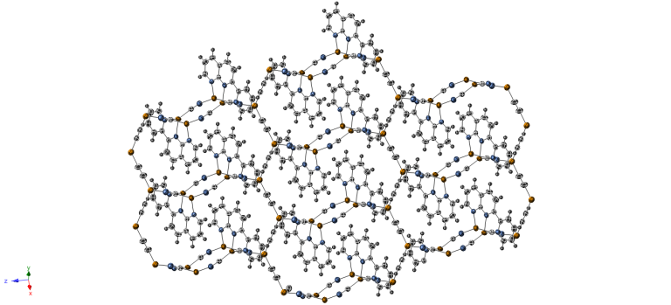b)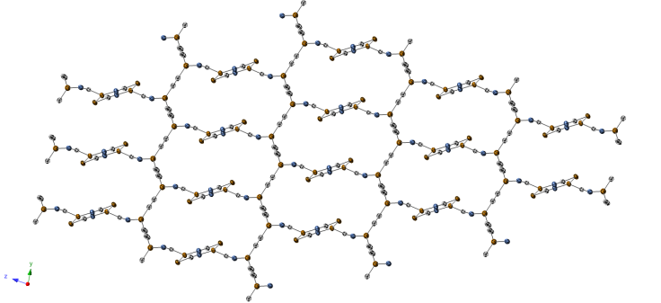

c)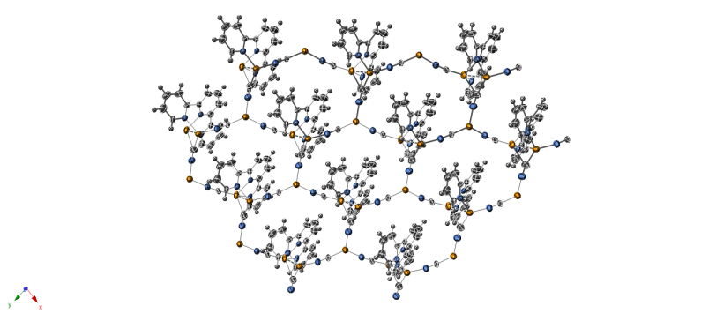d)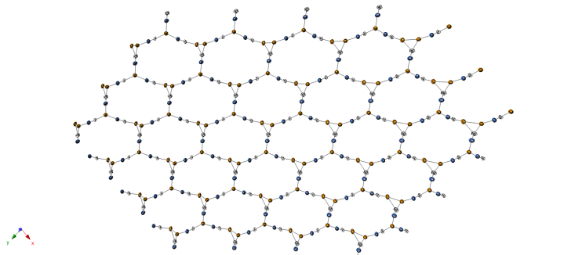

e)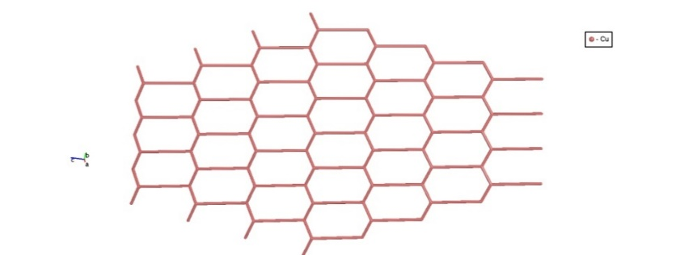f)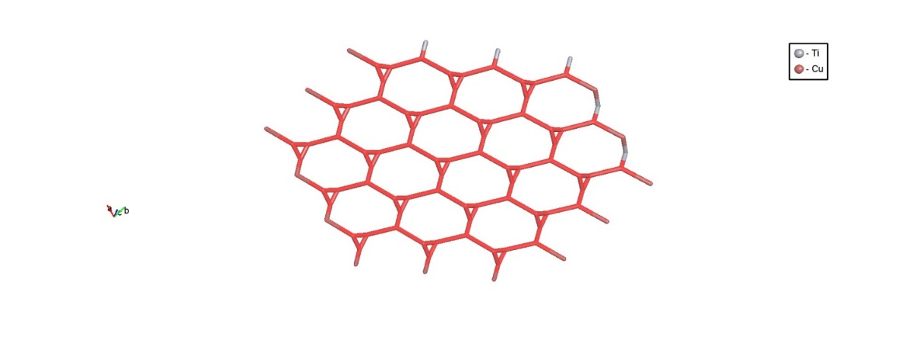

Figure 1. 2D polymeric structure of (a) [(CuCN)3(pyNP)]n (1) and (c) [(CuCN)3(tpy)]n (2). The Cu-CN layers, omitting organic ligand, are shown in (b) and in (d), while the underlying nets in (e) and (f), respectively for 1 and 2. (Blue: nitrogen; grey: carbon; orange: copper; white: hydrogen −ORTEP plot 50%).

The more rigid ligand pyNP, that is asymmetric and has two fused rings, in its planar conformation stabilizes the interaction between two Cu(I) centers (2.694(1)Å). Tetranuclear dimers are formed through μ2 cyanide, that form small chair-like hexagonal rings through μ3 cyanide (see Figure 2a). One copper (Cu1, red circles in Figure 2a) is three-coordinated by nitrogen, while the other forms a distorted tetrahedron. Cu1 can be considered the prolongation of the chain generated from the three-coordinate copper sites at the basis of the hexagonal net (Cu3, green circles in Figure 2a). The chelated metal center (Cu2, blue circles in Figure 2a) is coordinated only laterally by a µ2-bridging cyanide (d(Cu2–C14)=2.595(4)Å respect to d(Cu1–C14)=1.887(4) Å). We may attribute the parallel disposition of the two chain to the coordination of pyNP, in which the chelating lateral pyridine has the effect of a terminal site for the fragment (Figure 2b). It is interesting to notice that the two NP nitrogen sites N1 and N2 prefer to coordinate two metal centers, probably for the very small bite angle.

a)b)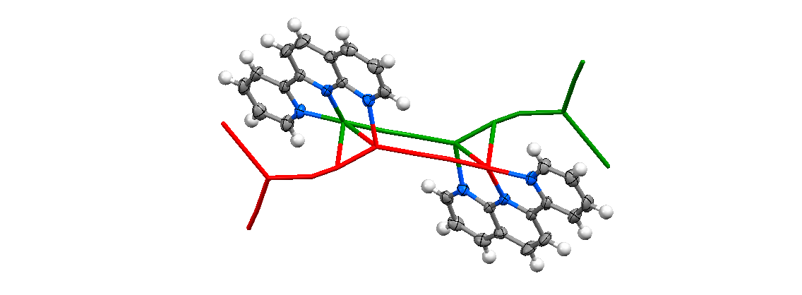

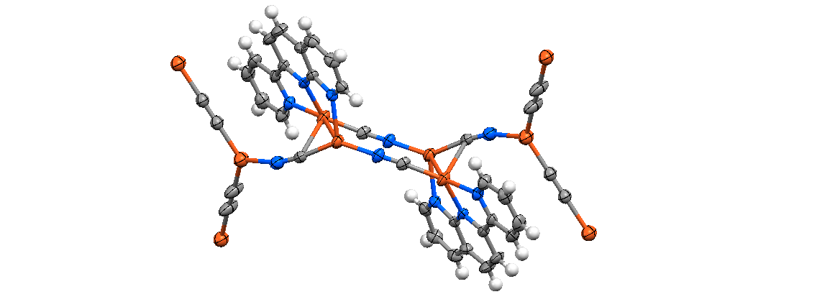

Figure 2. (a) Square-shape dimer due to chelating pyNP in [(CuCN)3(pyNP)]n (1): red circle=three coordinated copper (Cu1) in prolongation of the main chain, blue circle=tetrahedral copper (Cu2) that stops the chain, green circle=three coordinated coppers (Cu3) in the main chain generated by the prolongation (the cyanides in the main chains are represented only by carbon because of the end-to-end disorder). (b) Role of the ligand in the connection of the two previously separated chains. (Blue: nitrogen; grey: carbon; orange: copper; white: hydrogen − ORTEP plot 50%).

The symmetric ligand tpy can rotate about each of the two axes between the three rings and can chelate laterally both interacting metal centers (d(Cu2⋅⋅⋅Cu3)=2.630(1)Å). This unit is a distorted form of Cu2CN6, a typical connector of CuCN derivatives seen in the introduction, but with three sites blocked by three py rings (see Figure 3a-c).

A single molecule can modify the topological role of a tecton by blocking some specific sites that could be expansion sites for the polymer. This selective coordination generates three connected nodes (clusters, see Figure 3a) with a T-shape that can be inserted in a distorted and expanded form of the usual hexagonal net (Figure 1f). However, by comparing this structure with the only similar system, [(CuCN)3(ttpy)]n, we noticed that the big substituent influences the coordination capability of the tpy: ttpy has a coordination mode more similar to that of pyNP, through lateral coordination, and approaching two parallel chains (Figure 3). With the use of ToposPRO program [73] we defined the topology of the underlying nets. The point symbols of the two structures are {63} for the 2-nodal net of **1** (that is the Shubnikov hexagonal plane net) and {3.92}3{93} for the 3-nodal net of **2** after the simplification procedure. The simplification procedure demonstrates that the two ligands do not have the same topological effect on the underlying net after the elimination of 0,1 and 2-nodes, because the pyNP ligand maintains the basic graph structure unchanged, while in the case of tpy the net is more complex by an augmentation of the basic pattern. [(CuCN)3(ttpy)]n has the same point symbol of **1**({63}): the overall topology is not significantly influenced by the presence of a big lateral substituent but the topology obtained is more similar to that of pyNP than to unsubstituted tpy.

a)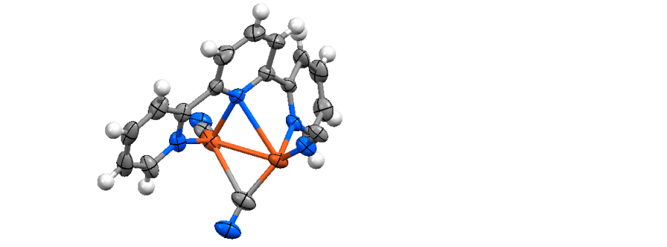b)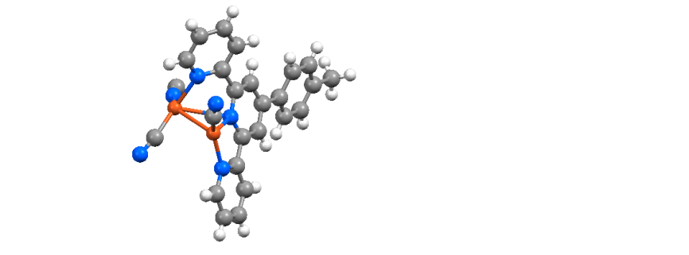c)

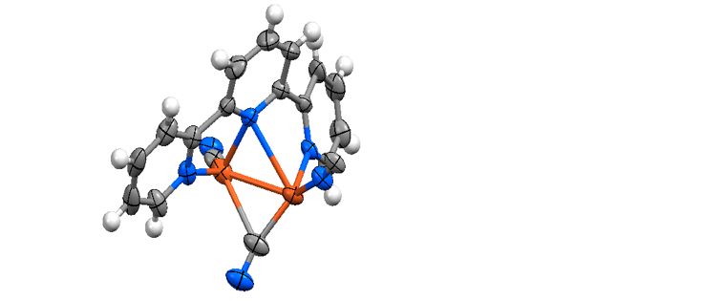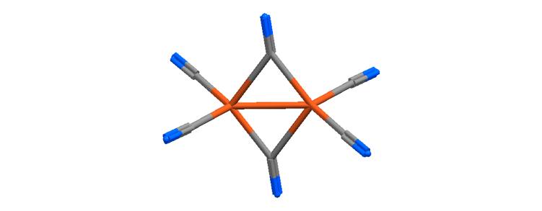

Figure 3. (a) Coordination environment around Cu2 dimer in [(CuCN)3(tpy)]n (2), (c) site occupation in 2 respect to Cu2(CN)6 unit and (b) coordination environment around Cu2 dimer in [(CuCN)3(ttpy)]n. (Blue: nitrogen; grey: carbon; orange: copper; white: hydrogen − ORTEP plot 50%).

From tpy, two other coordination polymers have been obtained: [(CuCN)(tpy)]n (**3**) and {[Cu(tpy)][Cu(CN)3]}n (**4**). Compound **3** is an 1D coordination polymer in which the tpy ligand behaves like a mono-chelating ligand, leaving the third py ring free from coordination (Figure 4a). This behavior of tpy ligand generates a wavy chain, that is typical of 2,2’-bipyridine or 1,10-phenantroline derivatives [14-15]. However, the copper(I) tetrahedron is deeply distorted by the steric hindrance of the pendent substituent, that causes the strong difference between Cu1–N4 and Cu1–N3 distances (2.368(10) Å and 2.054(10) Å respectively). The other effect of this steric hindrance is the non-coplanarity of the two coordinated py rings (interplanar angle of 26.3(2)°) that makes the chain helicoidal, and makes non-centrosymmetric the crystal structure (space group Pna21).

a)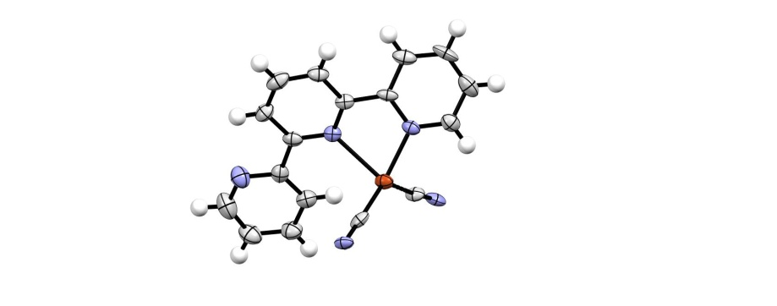b)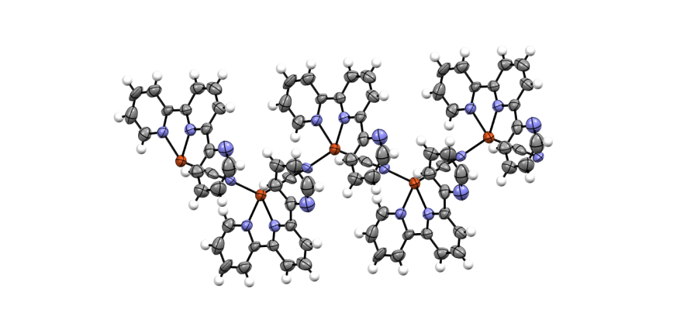

**Figure 4.** (a) Coordination environment around Cu in [(CuCN)(tpy)]n (**3**) and (b) chain forming 1D polymeric structure (Blue: nitrogen; grey: carbon; orange: copper; white: hydrogen − ORTEP plot 50%).

The last tpy product, {[Cu(tpy)][Cu(CN)3]}n(**4**), has a more complex architecture due to the concurrent presence of Cu(I) and Cu(II) sites. The atoms coordinated to tpy (Cu5 and Cu6) can be identified as Cu(II) sites for their distorted square pyramid coordination polyhedron formed by five nitrogen donor, three belonging to planar tpy and two to cyanides. These harder ions are connected to each other with CuCN chains along *a* axis with CN prolongations (Figure 5a), similar to those in K[Cu(CN)2] crystal structure [53]. Bridging Cu(CN)3 forms 4 members rings with boat conformation and hexagonal rings (Figure 5b), generating a 2D coordination polymer with a complex binodal underlying net with {6.102}{62.8}2 point symbol (Figure 5c).

a)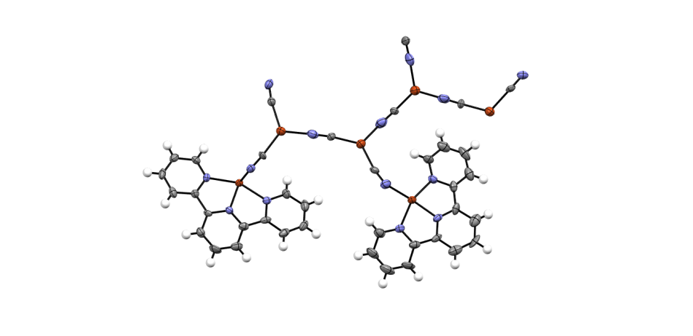b)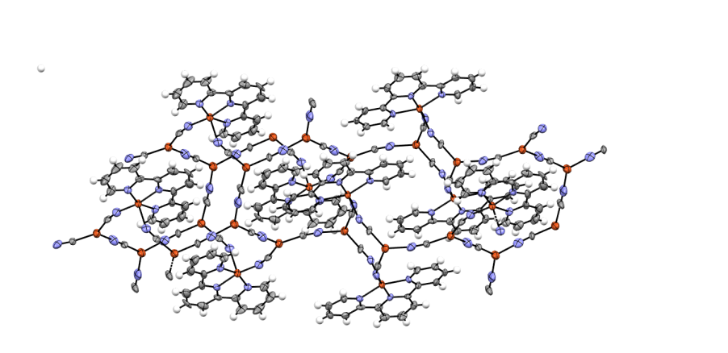

c)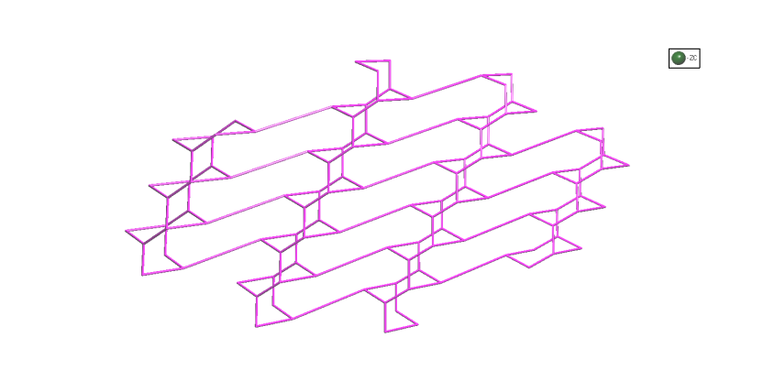

**Figure 5.** (a) Asymmetric unit, (b) 2D polymeric structure and (c) underlying nets of {[Cu(tpy)][Cu(CN)3]}n (**4**).(Blue: nitrogen; grey: carbon; orange: copper; white: hydrogen − ORTEP plot 50%).

By trying to obtaina Cu(I)/Cu(II) product with pyNP ligand, a molecular centrosymmetric dimer has been found with formula [Cu2Cl(CN)(pyNP)] (**5**) (Figure 6). In this complex, two Cu(I) centers are bonded at the pyNP ligand, with a tetrahedral and a tricoordinate coordination sphere, interacting through a weak Cu(I)‧‧‧Cu(I) contact (2.612(1) Å). This pattern is very similar to that found in **1** and in similar compounds [75] and suggest a similar supramolecular aggregation in solvothermal media. The four metal centers are connected by bridging Cl and CN, forming a boat conformation hexagonal ring.

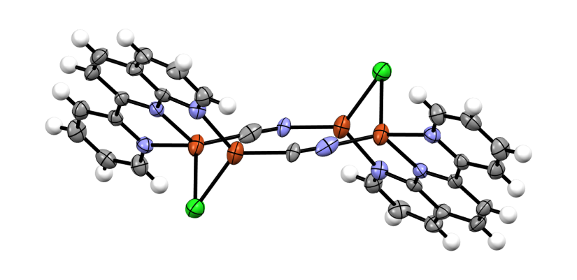

Figure 6. Molecular structure of [(CuClCN(pyNP)]n (5). (Blue: nitrogen; grey: carbon; orange: copper; white: hydrogen; green: chloride − ORTEP plot 50%).

**3.2 Vibrational analysis**

The vibrational features of compounds **1**-**5** have been investigated by Raman and IR spectroscopies and relative spectra are depicted in Figure S10–S13. Spectra present signals related to aromatic ligand modes in the fingerprint range (1650-700 cm-1, Table S2-S3) and to cyanide modes around 2100 cm-1 (see Table 1). The use of microRaman and microIR permits to characterize single crystals of the various products identified in the heterogeneous mixture obtained by solvothermal syntheses. Raman spectra of reagents and products present less signals compared to IR ones, and show intense and isolated peaks that allow an easier structure-spectrum correlation.

The complexation can be confirmed by comparison of Raman spectrum of ligands with the spectra of the complexes. The most significant frequencies are reported in Table S2-S3. Generally, it can be observed a shift at higher wavenumbers, and in particular the shift of the breathing modes of py and NP rings [67, 76] is due to the major rigidity induced by metal coordination. Even if pyNP derivatives have a very different reticular organization, copper atoms in compound **1** and **5** have the same coordination environment and a similar shift of these peculiar signals [67]. Comparing the spectrum of **2** with that of ligand tpy, the complexation is confirmed by the shift at high wavenumbers of the most intense signal attributable to ring stretching [76], that splits in two signals at 1017 and 1002 cm-1. This mode splits also in the other tpy derivatives, but it is observed at lower wavenumbers in compound **3** in which the ligand is bicoordinated (the structure is less rigid) and at higher wavenumbers in compound **4** due to an increase in the charge of the metal center.

Cyanide groups originate intense and well defined signals at higher wavenumbers (between 2000-2200 cm-1). Bridging cyanide groups are very sensible to the environments [77, 78], but the structure-spectrum correlation is intricate because of different possible cyanide environments. It is not often easy to correlate the spectral features to the number of inequivalent CN groups in the solid-state structures [79]. It has been reported a correlation between the number of ν(CN) bands and the number of inequivalent cyanide groups in the structure [7], and the ν(CN) frequencies have been interpreted mainly as a function of Cu–C/N bond strength. The vibrational behavior of bridging cyanide ligands has been rationalized recently [38, 80]: the position and intensity of related signals can be correlated to structural motifs (see Table 1).

Compounds **1** and **2** have three cyanide ligands in the asymmetric unit, that form a 2D polymeric structure composed of linked Cu(CN)32- units. In their Raman and IR spectra two bands are observed, the strongest at higher frequency, as shown in Figure 7. The intensity pattern is coherent with the symmetry component of a weakly coupled cyanide ligand in triangular unit [38]. In the asymmetric unit of compound **4** there are 8 inequivalent CN groups that formed linked Cu(CN)32- units that connect Cu(II)-tpy complex. So there are two different structural motifs: Cu(I)–CN–Cu(I) and Cu(I)–CN–Cu(II). Signals at higher wavenumbers are attributable to the second structural motif, due to the presence of Cu at higher oxidation number. The signal of each fragment splits: in IR and Raman spectra it is possible to observe four and three signals respectively. This splitting can be associated to the presence of planar and not-planar motifs in compound **4:** the signals at 2132 and 2107 cm-1 (more intense in IR) could be attributable to the not-planar group. The asymmetric units of compound **3** and **5** have only one CN– ligand with structural motif Cu(I)–CN–Cu(I). The first compound has two signals at ~2125 and ~2110 cm-1, the strongest at lower frequency, while for **5** only one peak can be observed at 2114 cm-1. This different multiplicity can be associated to the polymeric nature of **3** and to the bent coordination of cyanide around each copper center [78].

|  |  |  |  |
| --- | --- | --- | --- |
| Table 1. Raman and IR signals of cyanide in 1-5. | | | |
|  | Raman | IR | Structural motif |
| [(CuCN)3(pyNP)]n(**1**) | 2125 s  2095 m | 2123 vs  2095 m | Cu(CN)32- unit |
| [(CuCN)3(tpy)]n(**2**) | 2127 vs  2109 s | 2125 vs  2113 vs | Cu(CN)32- unit |
| [CuCN(tpy)]n(**3**) | 2121 m  2107 s | 2125 s  2112 m | Cu(I)–CN–Cu(I) chain |
| [Cu(tpy) (CuCN)3]n(**4**) | 2124 s  2109 w  2098 vw | 2132 sh  2122 m  2107 s  2096 sh | Cu(CN)32- unit: Cu(II)–CN–Cu(I)  Cu(CN)32- unit: Cu(I)–CN–Cu(I) |
| [Cu2Cl(CN)(pyNP)] (**5**) | 2114 s | 2109 s | Cu(I)–CN–Cu(I) unit |

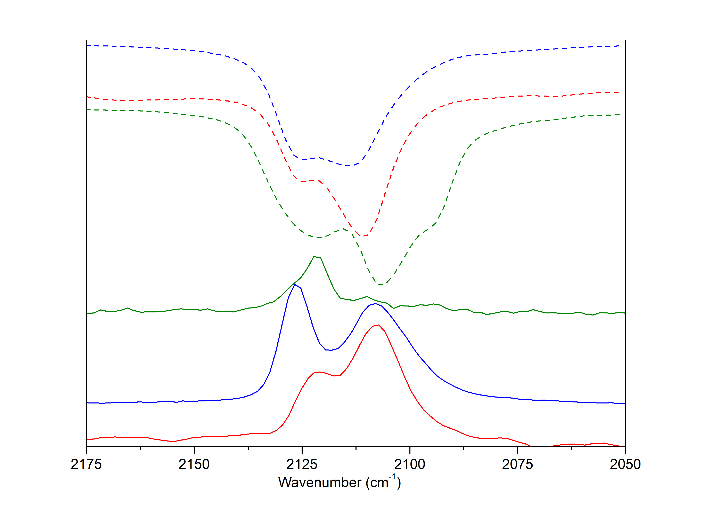

Figure 7. Raman (solid line) and IR (dot line) spectra (in cyanide spectral region)of [(CuCN)3(tpy)]n(2) in blue, [(CuCN)(tpy)]n(3) in red and {[Cu(tpy)][Cu(CN)3]}n(4) in green.

The previous analysis of Raman spectra of compound 1-5 allows us to better investigate the composition of the mixtures of products obtained in the attempted syntheses, in order to discriminate the influence of synthetic parameters. In the syntheses of coordination polymer with pyNP ligand it can be noticed the positive effect of the addition of NaCN: in the same solvothermal condition the vibrational characterizations of the products indicate the presence of CuCN, on the contrary there is not unreacted reagent when an excess of cyanide ion is added (as shown in Figure S4). Copper cyanide is poorly soluble and an excess of cyanide ions in solution lead to the formation of the more soluble [Cu(CN)4]3– [74] favoring the formation of 1. However the addition of NaCN seems to disadvantage the formation of large crystals of product 1 in favor of formation of a crystalline powder. The characterization of the powder obtained from synthetic procedure (b) suggests that a co-product is obtained in concomitance with compound 1. In particular in the Raman spectrum it is possible to observe a greater number of signals associated to pyNP breathing modes (at 1009, 951, 801, 788 cm-1, as shown in Figure S4). The formation of an additional co-products is confirmed by PXRD, in which it is possible to recognize peaks not identifiable with those of compound 1 (see Figure S5). We decided to modify the synthetic strategy, trying to obtain a pure product, changing solvent into water and using reflux procedure. The synthesis was conducted under inert atmosphere to avoid copper oxidation and a pure crystalline powder of 1 was obtained (see Figure S5). Using tpy as ligand, in each attempted solvothermal syntheses at least two products were identified and not separated because of similar chemical properties. At shorter reaction time (15 hours) the addition of NaCN seems to favor the formation of large single crystals of 2, in concomitance with a heterogeneous powder. Raman spectrum of this powder presents multiple bands for cyanide stretching modes, attributable to the presence of Na[Cu(CN)2] (characteristic signals are at 2124 and 2112 cm-1 [79]), and the diffractogram corroborate this hypothesis (see Figure S6 and S14). We tried to modify stoichiometric ratio and reaction time but it was not possible to obtain isolated products, but only a mixture with different proportion of 2-3-4, as suggested by the multiple band of cyanide modes in their Raman spectra and by PXRD (see SI). Syntheses in water, in solvothermal and reflux conditions (analogous to procedure (c) previously described for pyNP derivatives) give heterogeneous mixtures. In fact in the diffractogram there are peaks attributable to [Cu(tpy)][(CuCN)3]⋅H2O [81], as supported also by Raman signal at 2135 cm-1 (see Figure S12 and S15). In this compound one of the metal center is Cu(II), not present in reagents and that we suppose to be formed because of the presence of oxygen during the reaction, as observed for other nitrogen chelating donor [82]. Solvothermal behavior is very different for the two employed ligands and we hypothesized that is correlated to the different structure of the two molecules, that permits a different flexibility. The higher rigidity of pyNP seems to favor the formation of 1, while the higher flexibility of tpylead to the formation of three different coordination polymers (2, 3 and 4) being py rings free to rotate in solution. In addition products with Cu(II) (4 and [Cu(tpy)][(CuCN)3]⋅H2O) were found only using tpy as ligand.

We decided to attempt an ulterior trial in presence of both Cu(I) and Cu(II) salts to investigate the coordination preference of the two ligands. For pyNPthe presence of copper(II) dichloride in solution leads to the formation of a solid Cu(I) complex (5), in which polymeric expansion is prevented by chloride coordination. In the same synthetic condition using tpy as ligand it has been obtained an heterogeneous greenish powder, difficult to characterize. Crystals of [CuLCl2]⋅nH2O complexes (L=tpy,pyNP) have been obtained by slow evaporation of water solution [67, 83], but these complexes have not been found in our solvothermal syntheses. Cu(II) seems not to be the preferential coordination site for pyNP in presence of Cu(I): no product containing Cu(II) was found in solid products obtained from the attempted syntheses. This could be related to the peculiar geometry of pyNP ligand that can accommodate two Cu(I) center bridged in a dimeric structure, stabilized by metallophilic interaction, similar to the silver complex [67]. On the contrary, for the more flexible tpy, even in presence of an excess of Cu(I), it has been found compounds in which the ligand is coordinated to Cu(II) center.

4. Conclusion

Results indicate that the different degree of aromatic condensation of tpy and pyNP influences the topology of the final systems. Coordination polymers 1 and 2, respectively from pyNP and tpy, present similar hexagonal underlying net, but the ligands have a different role on the overall topology. In the first case pyNP has a connecting role between CuCN chains, while in 2 tpy acts as a capping ligand to the hexa-connecting Cu2(CN)6 fragment, generating a three-connected nodes. Compound 1 is the second coordination polymers presenting pyNP as ligand reported in literature [84]. Raman and IR confirmed to be very sensible to cyanide environment and this study evidenced their utility in recognizing structural pattern.

The different degree of aromatic condensation of tpy and pyNP seems also to influence the behavior in solvothermal condition: two other coordination polymers (3 and 4) were obtained with the most flexible ligand. Modification of solvothermal parameters (solvent, time, temperature and stoichiometric ratio) leads to different ratio between the various products but no pure product can be collected. On the contrary for the most rigid pyNP it was possible to obtain 1 as single product, by using proper synthetic parameters. Surprisingly in 4, Cu(II) sites are identified, even if no Cu(II) reagents were used. The oxidation of copper(I) by oxygen was previously observed for nitrogen donor complexes, but in our study was detected only in syntheses involving tpy ligand. Raman spectroscopy resulted to be a powerful tools in the identification of the products in the obtained mixtures.

The behavior of tpy and pyNP in presence of Cu(I) and Cu(II) reagents was finally investigated, in order to obtain pure 4 and an analogous system for pyNP. At least two Cu(II) derivatives (4 and [Cu(tpy)][(CuCN)3]⋅H2O) were obtained using tpy, while for pyNP only Cu(I) derivative 5 was identified. This experimental evidence suggests for pyNP a coordination preference toward Cu(I) sites, that could be related to the geometry of this ligand that favor the formation of cuprophilic interactions.

We observed that the addition of an excess of cyanide ions increase yields, thanks to the solubilization of the highly insoluble CuCN, but the effect on final speciation depends strongly on the employed ligand.

Appendix

Appendix A. Supporting Information

Appendix B. Crystallographic Tables

Appendix C. Supplementary data CCDC 2048548-2048552 contains the supplementary crystallographic data for 1-5. These data can be obtained free of charge via http://www.ccdc.cam.ac.uk/conts/retrieving.html, or from the Cambridge Crystallographic Data Centre, 12 Union Road, Cambridge CB2 1EZ, UK; fax: (+44) 1223-336-033; or e-mail: deposit@ccdc.cam.ac.uk.

Acknowledgments

We thank Dr. T. Polifor his technical support in microIR measurements.

This research did not receive any specific grant from funding agencies in the public, commercial, or not-for-profit sectors.

References

[1] Obora Y, Ohta T, Stern CL, Marks TJ. Organolanthanide-Catalyzed Imine Hydrogenation. Scope, Selectivity, Mechanistic Observations, and Unusual Byproducts. J. Am. Chem. Soc. 1997; 119: 3745–3755.

[2] Zhu N, Vahrenkamp H. Cyanid‐Isocyanid‐Isomeriebei CN‐verbrücktenmetallorganischenKomplexen. Angew. Chem. 1994; 106: 2166–2167.

[3] Vahrenkamp H, Gei A, Richardson GN. Cyanide-bridged oligonuclear complexes: features and attractions. Chem. Soc., Dalton Trans. 1997: 3643–3652.

[4] Zhu N, Vahrenkamp H. Synthesis, Redox Chemistry, and Mixed‐Valence Phenomena of Cyanide‐Bridged Dinuclear Organometallic Complexes. Chem. Ber. 1997**;** 130: 1241–1251.

[5] Shriver DF. The ambident nature of cyanide. In: *Structure And Bonding. Structure and Bonding, vol 1.* Springer, Berlin: 1966. p.32–58.

[6] Qin YL, Sun H, Jing Y, Jiang XP, Wang GF, Qin JF. A novel three-dimensional copper(I) cyanide coordination polymer constructed from various bridging ligands: synthesis, crystal structure and characterization. Acta Cryst. 2019; C75: 1517–1523.

[7] Pearson RG. Hard and soft acids and bases, HSAB, part 1: Fundamental principles. J. Chem. Educ. 1968; 45(9): 581–587.

[8] Bowmaker GA, Lim KC, Skelton BW, White AH. Syntheses, structures and vibrational spectroscopy of some adducts of copper(I) cyanide with pyridine bases Z. Naturforsch. 2004; 59(b): 1264–1276.

[9] Cai JB, Chen TT, Xie ZY, Deng H. catena-Poly [[(3-methylpyridine)copper(I)]-μ-cyanido-copper(I)-μ-cyanido] Acta Cryst. 2011; E67: m1136–m1137.

[10] Dembo MD, Dunaway LE, Jones JS, Lepekhina EA, McCullough SM, Ming JL, Li X, Robert FB, Patterson HH, Bayse CA, Pike RD. Structure and luminescence of copper(I) cyanide–amine and–sulfide networks. Inorg. Chim. Acta 2010; 364: 102–114.

[11] Zhang XM, Hao ZM, Wu HS. Cuprophilicity-Induced Cocrystallization of [Cu2(4,4'-bpy)(CN)2]n Sheets and [Cu(SCN)]n Chains into a 3-D Pseudopolyrotaxane. Inorg. Chem. 2005; 44: 7301–7303.

[12] Hibble SJ, Chippindale AM. The Threading of [(CuCN)2(μ‐4,4′‐bpy)] Sheets by CuCN Chains. Z. Anorg. Allg. Chem. 2005; 631: 542–545.

[13] Chesnut DJ, Plewak D, Zubieta J. Solid state coordination chemistry of the copper(I)–cyano–organodiimine system. Two- and three-dimensional copper cyanide phases incorporating linear dipodal ligands. J. Chem. Soc. Dalton Trans. 2001: 2567–2580.

[14] Chesnut DJ. Solid state coordination chemistry of the copper cyanide–organoamine system: hydrothermal syntheses and structural characterization of [{Cu2(bpy)2(CN)}Cu5(CN)6] and [Cu4(CN)4(biquin)]. Chem. Commun 1998: 1707–1708.

[15] Morpurgo GO, Dessy G, Fares V. Crystal structures and spectroscopic properties of the polymeric adducts formed from Cu(CN) and Cu(NCS) with 2, 9-dimethyl-1,10-phenanthroline J. Chem. Soc. Dalton Trans. 1984: 785–791.

[16] Chesnut DJ, Kusnetzow A, Birge R, Zubieta J. Solid state coordination chemistry: ligand influences on the structures of one-dimensional copper(I) cyanide–organodiimine solids. J. Chem. Soc. Dalton Trans. 2001: 2581–2586.

[17] Chi YN, Cui FY, Xu YQ, Hu CW. The Tuning Effect of 2‐Amino‐4,6‐dipyridylpyrimidine Isomers on the Structural Dimensionalities and Motifs of Copper(I) Cyanide Complexes. Eur. J. Inorg Chem. 2007: 4375–4384.

[18] Ni J, Wei KJ, Min Y, Chen Y, Zhan S, Li D, Liu Y. Copper(I) coordination polymers of 2,2′-dipyridylamine derivatives: syntheses, structures, and luminescence. Dalton Trans. 2012; 41: 5280–5293.

[19] Bowmaker G; Lim KC, Somers N, Skelton BW, White AH. Syntheses, structures and vibrational spectroscopy of some adducts of copper (I) cyanide with unidentate organic nitriles. Z. Naturforsch. 2004: 1301–1306.

[20] Dyason JC, Healy PC, Engelhardt LM, Pakawatchai C, Patric VA, White AH. Lewis-base adducts of Group 1B metal (I) compounds. Part 17. Synthesis and crystal structures of adducts of copper (I) cyanide with nitrogen bases. J. Chem. Soc. Dalton Trans. 1985: 839–844.

[21] Lim MJ, Murray CA, Tronic TA, deKrafft KE, Ley AN, deButts JC, Pike RD, Lu H, Patterson HH. Copper(I) Cyanide Networks: Synthesis, Structure, and Luminescence Behavior. Part 2. Piperazine Ligands and Hexamethylenetetramine. Inorg.Chem. 2008; 47: 6931–6938.

[22] Ley AN, Dunaway LE, Brewster TP, Dembo MD, Harris TD, Baril-Robert F, Li X, Patterson HH, Pike RD. Reversible luminescent reaction of amines with copper(I) cyanide. Chem. Commun. 2010; 46: 4565–4567.

[23] Zhou XP, Li D, Wu T, Zhang X. Syntheses of supramolecular CuCN complexes by decomposing CuSCN: a general route to CuCN coordination polymers? Dalton Trans. 2006: 2435–2443.

[24] Dembo MD, Dunaway LE, Jones JS, Lepekhina EA, McCullough SM, Ming JL, Li X, Baril-Robert F, Patterson HH, Bayse CA, Pike RD. Structure and luminescence of copper(I) cyanide–amine and –sulfide networks. Inorg. Chim. Acta 2010; 364: 102–114.

[25] Grifasi F, Chierotti MR, Garino C, Gobetto R, Priola E, Diana E, Turci F. Solvent-Free Synthesis of Luminescent Copper(I) Coordination Polymers with Thiourea Derivatives. Cryst. Growth Des. 2015; 15(6): 2929–2939.

[26] Stocker FB, Troester MA, Britton D. Crystal Structures of a Family of New Copper(I) Cyanide Complexes of Thiourea and Substituted Thioureas. Inorg. Chem. 1996**;** 35(11): 3145–3153.

[27] Evariste S, Khalil AM, Moussa ME, Chan AKW, Hong EYH, Wong HL, Le Guennic B, Calvez G, Costuas K, Yam VWW, Lescop C. Adaptive Coordination-Driven Supramolecular Syntheses toward New Polymetallic Cu(I) Luminescent Assemblies. J. Am. Chem. Soc. 2018; 140(39): 12521–12526.

[28] Di Nicola C, Effendy E, Pettinari C, Skelton BW, Somers N, White AH. Syntheses and structures of adducts of stoichiometry MX:dpex (2:1)(n), M = CuI, AgI, X=(pseudo-)halogen, dppx=Ph2E(CH2)xEPh2, E=P,As. Inorg. Chem. Acta 2006; 259: 53–63.

[29] Lin YY, Lai SW, Che CM, Fu WF, Zhou ZY, Zhu N. Structural Variations and Spectroscopic Properties of Luminescent Mono- and Multinuclear Silver(I) and Copper(I) Complexes Bearing Phosphine and Cyanide Ligands. Inorg. Chem. 2005; 44(5): 1511–1524.

[30] Reeves MG, Wood PA, Parsons S. Automated oxidation-state assignment for metal sites in coordination complexes in the Cambridge Structural Database. Acta Cryst. 2019; B75: 1096–1105.

[31] Shield PG, Raithby PR, Allen FH, Motherwell WDS. The assignment and validation of metal oxidation states in the Cambridge Structural Database. Acta Cryst. 2000; B56: 455–465.

[32] Carvajal MA, Novoa JJ, Alvarez S. Choice of Coordination Number in d10 Complexes of Group 11 Metals. J. Am. Chem. Soc. 2004; 126(5): 1465–1477.

[33] Pyykkӧ P. Relativistic effects in structural chemistry. Chem. Rev. 1988; 88(3): 563–594.

[34] Zhang XM, Hao ZM, Wu HS. Cuprophilicity-Induced Cocrystallization of [Cu2(4,4'-bpy)(CN)2]n Sheets and [Cu(SCN)]n Chains into a 3-D Pseudopolyrotaxane. Inorg. Chem. 2005; 44(21): 7301–7303.

[35] Pobleta JM, Benard M. Cuprophilicity, a still elusive concept: a theoretical analysis of the ligand-unsupported CuI–CuI interaction in two recently reported complexes. Chem. Commun. 1998: 1179–1180.

[36] Dinda S; Samuelson AG. The nature of bond critical points in dinuclear copper (I) complexes. Chem. Eur. J. 2012; 18: 3032–3042.

[37] Harisomayajula NVS, Makovetskyi S, Tai YC. Cuprophilic interactions in and between Molecular Entities. Chem. Eur. J. 2019; 25: 8936–8954.

[38] Grifasi F, Priola E, Chierotti MR, Diana E, Garino C, Gobetto R. Vibrational–Structural Combined Study into Luminescent Mixed Copper(I)/Copper(II) Cyanide Coordination Polymers. Eur. J. Inorg. Chem. 2016: 2975–2983.

[39] Liu YY, Wang ZX, He X, Shao M, Li MX. One unexpected mixed-valence Cu(I,II)-cyanide coordination polymer in situ originating from the cleavage of acetonitrile, Inorg.Chem.Commun. 2017; 80: 46–48.

[40] Liu C, Ding YB, Shi XH, Zhang D, Hu MH, Yin YG, Li D. Interpenetrating Metal−Organic Frameworks Assembled from Polypyridine Ligands and Cyanocuprate Catenations. Cryst. Growth Des. 2009; 9(3): 1275–1277.

[41] Lin SH, Li M, Luo D, Zhang DX, Wen T, Zhou XP, Li D. A Chiral 3D Net with 2D Cairo Pentagonal Tiling Projection in Site‐Modified CuCN/CuSCN Networks. ChemPlusChem 2016; 81: 724–727.

[42] Qin YL, Hou JJ, Lv J, Zhang XM. Organic Templated Cuprous Cyanide Open Frameworks Based on Cu2(CN)6 Dimer with Strong and Long-Lived Luminescence. Cryst. Growth Des. 2011; 11: 3101–3108.

[43] Zhou XP, Lin SH, Li D, Yin YG. Two CuCN hybrid networks with unusual topology tuned by terpyridine ligands. Cryst.Eng.Comm. 2009; 11: 1899–1903.

[44] Li XZ, Zhou XP, Li D, Yin YG. Controlling interpenetration in CuCN coordination polymers by size of the pendant substituents of terpyridine ligands. Cryst.Eng.Comm. 2011; 13: 6759–6765.

[45] Pretsch T, Hartl HZ. Der strukturdirigierendeEinfluß von α,ω‐Alkandiammoniumionen auf die Bildung von Cyanocupraten(I). Anorg. Allg. Chem. 2004; 630: 1581–1586.

[46] Liu S, Meyers EA, Shore SG. An Inclusion Complex with [Gd(dmf)8]3+ Ions Encapsulated in Pockets of an Anionic Array of [{Cu6(CN)9}3−]∞ Units; A Cyanide‐Bridged Cu–Gd Layer Structure. Angew. Chem., Int. Ed. 2002; 41: 3609–3615.

[47] Geiser U, Wang HH, Carlson KD, Williams JM, Charlier HA, Heindl JE, Yaconi GA, Love BJ, Lathrop MW, Schirber JE, Overmyer DL, Ren J, Whangbo MH. Superconductivity at 2.8 K and 1.5 kbar in. kappa.-(BEDT-TTF)2Cu2(CN)3: the first organic superconductor containing a polymeric copper cyanide anion. Inorg. Chem. 1991; 30: 2586–2588.

[48] Hou YL, Li SX, Sun RWY, Liu XY, Ng SW, Li D. Facile preparation and dual catalytic activity of copper (I)–metallosalen coordination polymers. Dalton Trans. 2015; 44: 17360–17369.

[49] Xu XY, Chen QC, Yu, YD, Huang XC. Ligand induced anionic cuprous cyanide framework for cupric ion turn on luminescence sensing and photocatalytic degradation of organic dyes. Inorg.Chem. 2016; 55: 75–82.

[50] Pretsch T, Brudgam I, Hartl H. Synthese und Kristallstruktur von [N(Hex)4][Cu2(CN)3]. Z. Anorg. Allg. Chem. 2003; 629: 942–956.

[51] Liu S, Plecnik CE, Meyers EA, Shore SG. Two Distinct Ln(III)−Cu(I) Cyanide Extended Arrays: Structures and Synthetic Methodology for Inclusion and Layer Complexes. Inorg. Chem. 2005; 44: 282–295.

[52] Bowmaker GA, Kennedi BJ, Reid JC. Crystal structures of AuCN and AgCN and vibrational spectroscopic studies of AuCN, AgCN, and CuCN. Inorg. Chem. 1998; 37: 3968–3974.

[53] Cromer DTJ. The Crystal Structure of KCu(CN)2. J. Phys. Chem. 1957; 61: 1388–1392.

[54] Hou L, Li D. A new ligand 4′-phenyl-4,2′:6′,4″-terpyridine and its 1D helical zinc(II) coordination polymer: syntheses, structures and photoluminescent properties. Inorg. Chem. Commun. 2005; 8: 128–135.

[55] Potts KT, Keshavarz-K M, Tham FS, Abruna HD, Arana C. Metal ion-induced self-assembly of functionalized 2,6-oligopyridines. 4. Metal-metal interaction in double-stranded, dicuproushelicates derived from terpyridine derivatives. Inorg. Chem. 1993; 32: 4450–4460.

[56] Constable EC, Kulke T, Neuburger M, Zehnder M. Diastereoselective formation of P and M dicopper(i) double helicates with chiral 2,2′:6′,2″-terpyridines. Chem. Commun. 1997: 489-495

[57] Baum G, Constable EC, Fenske D, Housecroft CE, Kulke T, Neuburger M, Zehnder M. Regio- and diastereo-selective formation of dicopper(I) and disilver(I) double helicates with chiral 6-substituted 2,2′∶6′,2′′-terpyridines. J. Chem. Soc., Dalton Trans. 2000: 945–959.

[58] Hannon MJ, Painting CL, Plummer EA; Childs LJ, Alcock NW. Competing Supramolecular Interactions Give a New Twist to Terpyridyl Chemistry: Anion‐ and Solvent‐Induced Formation of Spiral Arrays in Silver(I) Complexes of a Simple Terpyridine. Chem Eur. J. 2002; 8: 2225–2235

[59] Cui Y, He C. Efficient aziridination of olefins catalyzed by a unique disilver (I) compound J. Am. Chem. Soc. 2003; 125: 16202–16215.

[60] Bera JK, Sadhukhan N, Majumdar M. 1,8-Naphthyridine Revisited: Applications in Dimetal Chemistry. Eur. J. Inorg. Chem. 2009: 4023–4038.

[61] Ciriano MA, Oro LA. Pyridopyridines. In: McCleverty JA, Meyer TJ. (eds.) *Comprehensive Coordination Chemistry II*. Elsevier; 2003. p. 55–61.

[62] Ziessel R. Schiff-based bipyridine ligands. Unusual coordination features and mesomorphic behaviour. Coord. Chem. Rev. 2001; 216-217: 195–223.

[63] Baker AT, Tikkanen WR, Kaska WC, Ford PC. Observation of both bridging and chelating modes of the 2-(2’-pyridyl)-1,8-naphthyridine ligand (pynp) in a single dirhodium(II) complex: x-ray structure of [Rh2(pynp)3Cl2][PF6]2.CH3CN. Inorg. Chem. 1984; 23(20): 3254–3256.

[64] Majumdar M, Rahaman SMW, Sinha A, Bera JK. Mixed-ligand compounds incorporating quadruply bonded dimolybdenum (II) core: Syntheses, structures and reactivity studies. Inorg. Chim. Acta 2010; 363: 3078–3087.

[65] Araki H, Tsuge K, Sasaki Y, Ishizaka S, Kitamura N. Synthesis, Structure, and Emissive Properties of Copper(I) Complexes [CuI2(μ-X)2(μ-1,8-naphthyridine)(PPh3)2] (X = I, Br) with a Butterfly-Shaped Dinuclear Core Having a Short Cu−Cu Distance. Inorg. Chem. 2007; 46: 10032–10034.

[66] Griffith WP, Koh TY, White AJP, Williams DJ. Two new complexes of 1,8-naphthyridine (napy): The X-ray crystal structures of [OsO4(napy)] (1) and of [Ag2(μ-napy)2(NO3)2] (2). Polyhedron. 1995; 14: 2019–2025.

[67] Giordana, A, Priola E, Bonometti E, Benzi P, Operti L, Diana E. Structural and spectroscopic study of the asymmetric 2-(2′-pyridyl)-1,8-naphthyridine ligand with closed-shell metals. Polyhedron. 2017**;** 138: 239–248.

[68] Campos-Fernández CS, Thomson LM, Galán-Mascarós JR, Ouyang X, Dunbar KR. Homologous Series of Redox-Active, Dinuclear Cations [M2(O2CCH3)2(pynp)2]2+ (M=Mo, Ru, Rh) with the Bridging Ligand 2-(2’-Pyridyl)-1,8-naphthyridine (pynp). Inorg. Chem. 2002; 41: 1523–1533.

[69] Patra SK, Sadhukhan V, Bera JK. Effects of Axial Coordination on the Ru−Ru Single Bond in Diruthenium Paddlewheel Complexes. Inorg. Chem. 2006; 45: 4007–4015.

[70] Sheldrick GM. A short history of SHELX. Acta Crystallogr. Sect. A. 2008; 64: 112–122

[71] Sheldrick GM. SHELXT - Integrated Space-Group And Crystal-Structure Determination. Acta Crystallogr. Sect. A. 2015; 71: 3–8.

[72] Dolomanov OV, Bourhis LJ, Gildea RJ, Howard JAK, Puschmann H. OLEX2: A Complete Structure Solution, Refinement And Analysis Program. J. Appl. Crystallogr. 2009; 42: 339–341

[73] Blatov VA, Shevchenko AP, Proserpio DM. Applied Topological Analysis of Crystal Structures with the Program Package ToposPro. Cryst. Growth Des. 2014; 14: 3576–3586

[74] Volpi G. Demonstrating the Presence of cyanide in bitter seeds while helping students visualize metal–cyanide reduction and formation in a copper complex reaction. Chem. Educ. 2016; 93(5): 891–897.

[75] Sarkar M, Pandey P, Bera JK. Chiral 1,8-naphthyridine based ligands: Syntheses and characterization of Di-and tetranuclear copper (I) and silver (I) complexes. Inorg. Chim. Acta 2019**;** 486: 518–528.

[76] Burger K, Wagner FE, Vértes A, Bencze É, Mink J, Labàdi I, Nemes-Vetéssy Z. Structural study of terpyridine and *o*-phenanthroline complexes of iridium(III). J. Phys. Chem. Solids 2001; 62: 2059–2068.

[77] Shorrock CJ, Xue BYP, Kim B, Batchelor RJ, Patrick BO, Leznoff DB. Heterobimetallic Coordination Polymers Incorporating [M(CN)2]- (M=Cu,Ag) and [Ag2(CN)3]- Units: Increasing Structural Dimensionality via M-M’ and M⋅⋅⋅NC Interactions. Inorg. Chem. 2002; 41: 6743–6753.

[78] Chippindale AM, Hibble SJ, Cowley AR. Bending, Twisting, and Breaking CuCN Chains to Produce Framework Materials: The Reactions of CuCN with Alkali-Metal Halides. Inorg. Chem. 2004; 43: 8040–8048.

[79] Kappenstein C, Hugel RP. Crystal Structure and Spectral Properties of Sodium Dicyanocuprate(I) Dihydrate. A Planar Polymeric Three-Coordinated Copper(I) Anion. Inorg. Chem. 1977; 16: 250–254.

[80] Kettle SFA, Diana E, Marchese EMC, Boccaleri E, Croce G, Sheng T, Stanghellini PL. The Vibrational Spectra of the Cyanide Ligand Revisited: Terminal Cyanides. Eur. J. Inorg. Chem. 2010: 3920–3929.

[81] Pickardt J, Staub B, Schäfer KO. Kristallstrukturen der Terpyridin-Komplexe [Cd(terpy)Cl2], [Cu(terpy)(CN)Cl] und [Cu(terpy)][Cu(CN)3]⋅H2O. Z. Anorg. Allg. Chem. 1999; 625: 1217–1224.

[82] Pecht I, Anbar M. The oxidation of bis(bipyridyl)copper(I) ions by oxygen and by hydrogen peroxide. J. Chem. Soc. A. 1968: 1902–1904.

[83] Henke W, Kremer S, Reinen D. Cu2+ in Five-Coordination: A Case of a Second-Order Jahn-Teller Effect. 1. Structure and Spectroscopy of the Compounds Cu(terpy)X2·H2O. Inorg. Chem. 1983; 22: 2858–2863.

[84] Priola E, Volpi G, Rabezzana R, Borfecchia E, Garino C, Benzi P, Martini A, Operti L, Diana E. Bridging Solution and Solid-State Chemistry of Dicyanoaurate: The Case Study of Zn–Au Nucleation Units. Inorg. Chem. 2020; 59(1): 203–213.