mReceived 00th January 20xx,
- Department of Chemistry, Università di Torino, Via Pietro Giuria 7, 10125 Torino, Italy
- Department of Earth Sciences, Università di Torino, Via Valperga Caluso 35, 10125 Torino, Italy
- BCMaterials, Basque Center for Materials, UPV/EHU Science Park, 48940 Leioa, Spain
- Departamento de Física, Universidade Federal do Ceará, C.P. 6030, Campus do Pici, 60455‐760, Fortaleza‐CE, Brazil
‡ CriSDi, Interdepartmental Center for Crystallography, Via Pietro Giuria 7, 10125, Torino, Italy.
Electronic Supplementary Information (ESI) available: See DOI: 10.1039/x0xx00000x
Accepted 00th January 20xx
DOI: 10.1039/x0xx00000x

Crystal engineering of aurophilic supramolecular architectures and coordination polymers based on butterfly-like Copper-dicyanoaurate complexes: vapochromism, P-T behaviour and multi-metallic cocrystal formation.
Emanuele Priola,*^{a‡} Nadia Curetti, ^{b‡} Domenica Marabello, ^{a‡} Jacopo Andreo, ^{c} Alessia Giordana, ª Luca Andreo, ª Piera Benna, ^{b‡} Paulo Tarso Cavalcante Freire,^{d} Paola Benzi,^{a‡} Lorenza Operti, ^{a‡} and Eliano Diana *^{a‡}
Using the equilibrium properties of Cu(II) cation in the presence of chelating ligand and the characteristics of the dicyanoaurate anion, we were able to obtain a family of 5 bimetallic Cu-Au compounds with supramolecular architecture based on aurophilic interactions. These compounds have been tested for vapochromism at different temperatures and pressures. One of the obtained products shows a reversible vapochromism in the presence of ammonia and the process has been studied using IR and UV-Vis absorption spectroscopies. The behaviour at variable temperatures and pressures of these crystalline materials has been investigated, commenting the effect of these two variables. Moreover, an isosymmetric phase transition at 1.2 GPa has been detected and studied with Raman and SC-XRD. Finally, Cu-Au molecular building blocks have been used to construct cocrystals, opening the way for the crystal engineering of new multimetallic compounds based on aurophilic interactions.
Introduction
Figure 1: LogK₁, LogK₂ and LogK₃ coordination constants for 2,2’-bipyridine (a) and 1,10-phenantroline (b) with the late 1st transition metals in the +2 oxidation state
During the last decades, dicyanoaurate has proven to be a good metalloligand and an interesting tecton for building up supramolecular networks based on strong coordinative bonds and weak aurophilic interactions.¹⁻³ The great stability of this complex (log(β_{form})= 37 at 25 °C)⁴⁻⁶ (β_{form}=K₁K₂, K_{n}= formation constant of ML_{n}) makes possible to manipulate it in several chemical environments (for example, in presence of acids or competing ligands) and the low steric hindrance favours the formation of Au(I)…Au(I) contacts despite the anionic nature.⁷⁻¹⁰ At the same time, the linearity and ambidentate bridging coordination mode has been used to build coordination networks that are often an expanded version of cyanide-derived compounds (e.g. expanded Prussian Blue analogues, Hoffman-like frameworks and super-perovskytes).¹¹⁻¹³ These materials can show interesting properties such as: vapochromism, photoluminescence at room temperature, high birefringence, non-classical responses to temperature and pressure.¹⁴⁻²⁷ However, a systematic investigation of dicyanoaurate-based bimetallic molecular complexes that aggregate only by means of aurophilic interactions has not yet been performed, although the study of molecular gold strings of other gold(I) complexes is well developed.²⁸ In a previous publication, we reported a series of molecular complexes of Zn(II) with these characteristics, and we demonstrated their preformation in solution at concentrations in which no aurophilic interactions are present.²⁹ The formation of {(L)₂Zn[Au(CN)₂]}⁺ (L = chelating ligand) is favoured with respect to the [Zn(L)₃]⁺ due to the great difference between K₂ and K₃ formation constants for Zn(II) complexes (see Figure 1 for the 2,2’-bipyridine and the 1,10-phenantroline).³⁰ This is mainly due to the absence of crystal field stabilisation and the small ionic radius of this cation.^{31,32} In this paper we focus our attention on copper-dicyanoaurate bimetallic complexes in the presence of chelating ligands. Cu(II) ion is a good candidate for the formation of bis-chelated species, as a consequence of the Jahn-Teller effect (or pseudo Jahn-Teller for heteroleptic complexes) which destabilises the tris-chelated form and generates systems with K₂>>K₃(see Figure 1)³⁰. From a structural point of view, in complexes the Jahn-Teller effect causes: (i) with 2,2’-bipyridine-like ligands, an out-of-plane distortion of one chelating ligand (ii) with the more rigid phenantroline a shift of one of the ligands around the metal centre (see Figure S1 and S2 in ESI). ³³⁻³⁶ Moreover, the previously described copper-dicyanoaurate materials have shown very promising vapochromism (modification of electronic absorption or emission spectra in presence of specific chemical species in the atmosphere) and anomalous Pressure-Temperature (P-T) behaviour.^{17, 37-39}
In this paper, we report the synthesis and characterization of a family of 5 new bimetallic complexes (see Table 1) obtained using four nitrogen donor chelating ligands (L1 = 2,2′-bipyridine; L2 = 1,10-phenantroline; L3= 1-(2-pyridy)-3-(4-trifluoromethylphenyl)imidazo[1,5-a]-pyridine and L4 = 2-(2′-pyridyl)-1,8-naphthyridine, see Figure 2). These ligands were chosen for their difference in shape, steric hindrance, rigidity, coordination ability and electronic properties. From a synthetic point of view, in literature is reported that in the presence of chelating nitrogen donor and cyanide ligands both Cu(II) and Cu(I) products can be obtained independently from the starting oxidation state.^{40,41,42-44} The vapochromic behaviour was checked for all the synthetized materials toward common solvent vapours and ammonia. Crystals of compound 1 can be considered prototypical for aurophilic-based supramolecular bimetallic architectures and were studied at variable temperatures and pressures. This crystallographic study permits to rationalize the effect of non-environmental conditions on these supramolecular networks. Finally, considering the stability and permanence of these bimetallic complexes in solution, we decided to use them as building blocks in more complex architectures with other d¹⁰ metal centres, obtaining cocrystals and heteroleptic complexes.
a)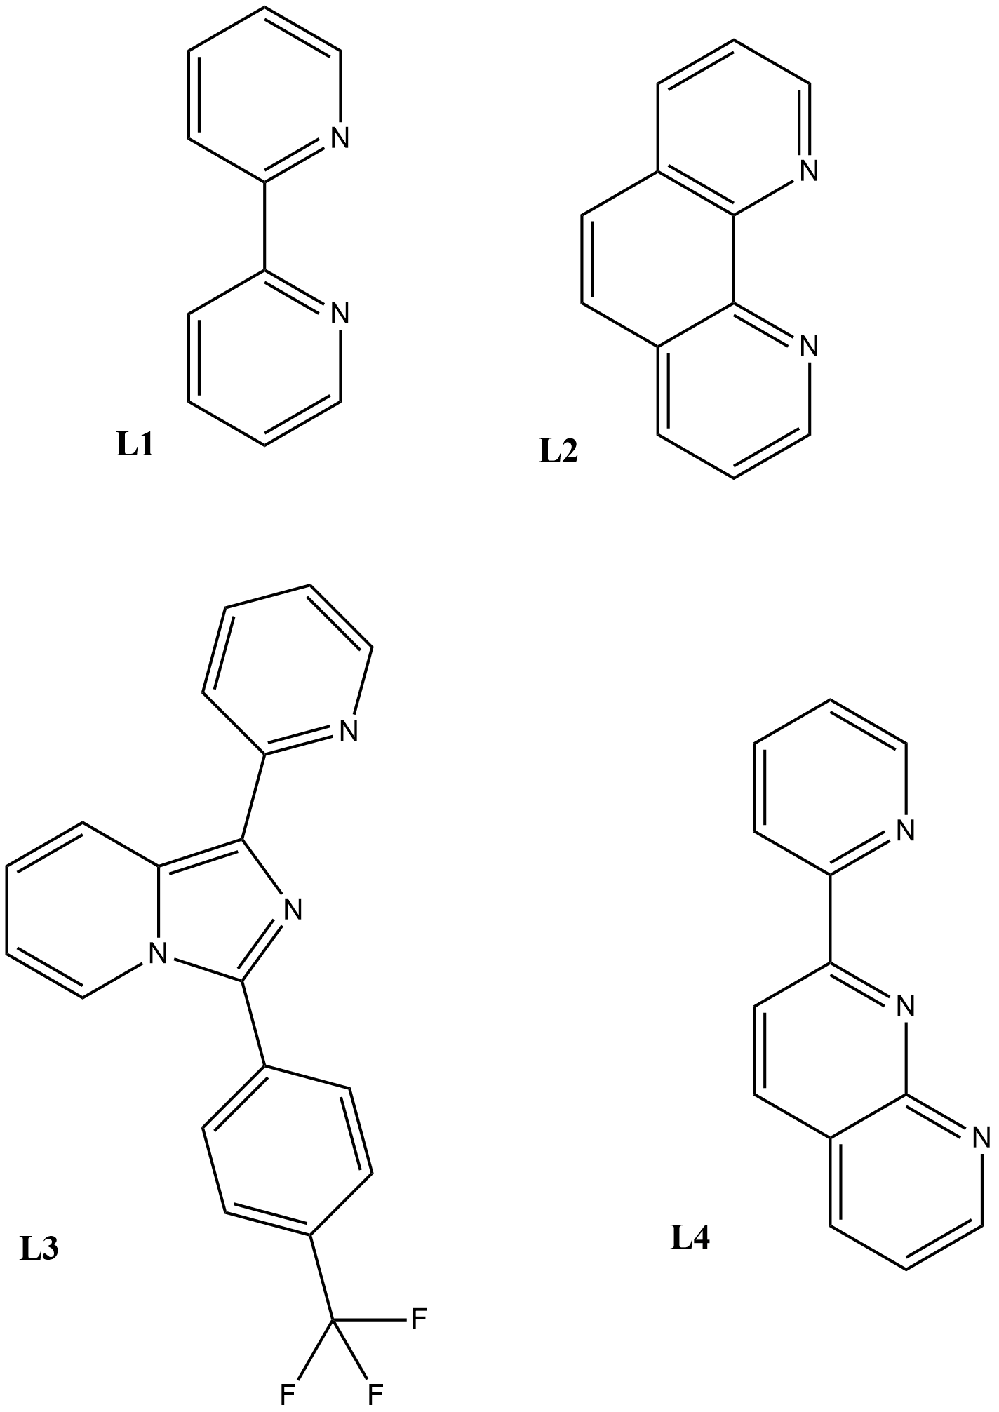b)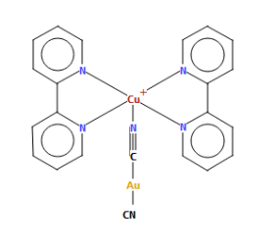
Figure 2: (a) Scheme of employed organic ligands and (b) example of structural formula of 1-6 complexes.
Experimental
Materials and general methods
All reagents have been obtained from Sigma-Aldrich, except for ligands L3 and L4 which were synthesised according to literature procedures.⁴⁵⁻⁴⁷ No further purification was performed on commercial reagents. Regarding the metal source, we report here the copper salt that achieved the best yield and purity of the final compound, but it is worth notice that all reactions can be carried out with copper oxo salts or copper chloride, similarly to that observed in the preparation of the Zn(II)-dicyanoaurate compounds.²⁹ Correspondence between the bulk and SC-XRD structures, as well as sample purity, were verified for compounds 1–6 through the elemental analysis (C, H, N and S), carried out using a Thermo Flash EA 1112 CHNS-O analyser. When a mixture of more than one compound has been obtained, elemental analysis was not possible, but Raman and IR spectroscopic characterization has been performed. For all the synthesised compounds 1-6 the entire IR and Raman spectra can be found in ESI.
Synthesis
(1) {Cu(L1)₂[(μ-CN)Au(CN)]}[Au(CN)₂]: 43.3 mg of Cu(SO₄).5H₂O, 54.0 mg of L1 were dissolved in 10 ml of a 50:50 EtOH/H₂O and a separate solution in the same solvent mixture was prepared using 100 mg of K[Au(CN)₂] (molar ratio 1:2:2). Solutions were brought to boil with energic stirring and mixed. At the establishment of equilibrium (5 minutes) a green precipitate immediately appeared, which was redissolved after 30 minutes of stirring, forming a transparent light blue solution. After slow cooling to room temperature, the compound began to crystallize into dark navy-blue prisms. The crystals were separated by filtration, washed with cold water and dried. They are stable to air and humidity. (Yield: 96.8 %, Elemental analysis (%): Calcd for C24H16Au2N8Cu: C, 32.35%; H, 2.51%; N, 12.83%; Found: C, 32.65%; H, 2.41%; N, 12.86%. IR(ATR) cm⁻¹: 3394(s), 3208(s), 2926(s), 2856(s), 2145(s), 1605(s), 1572(m), 1467(m), 1429(m), 1301(m), 1243(m), 1019(m), 766(m), 733(m), 647(w).)
(2) {Cu(L1)₂[(μ-CN)Au(CN)](H₂O)}[Au(CN)₂]: 21.6 mg of Cu(SO₄).5H₂O and 27.0 mg of L1 were dissolved in 3 ml of deuterated water, and a second solution in the same solvent was prepared with 50.0 mg of K[Au(CN)₂] (overall molar ratio 1:2:2) at the boiling point with vigorous stirring. Solutions were brought to boil with energic stirring and slowly mixed. At theestablishment of equilibrium (5 min.) a transparent pale green solution was finally obtained. After slow cooling and complete evaporation, transparent pale blue platelets were obtained, and crystals of compound 1 were found as impurity. Pure samples of 2 were obtained by dissolving 1 in aqueous ammonia. The crystals of 2 are stable to air and humidity. The suitable crystal of 2 for the SCXRD measurement was selected from the crystal mixture by colour observation under the microscope. (Yield: 97.5 %, Elemental analysis (%): Calcd for C24H18Au2N8OCu: C, 32.31%; H, 2.03%; N, 12.56%; Found: C, 32.55%; H, 2.10%; N, 12.72%. IR(ATR) cm⁻¹: 3389(s), 2171(m), 2148(s), 1607(m), 1569(w), 1476(m), 1446(s), 1156(m), 1102(w), 766(s), 731(m).)

Table 1: Au-Cu bimetallic new products reported in this paper. For the structural formula of complexes 1-6 see Scheme 1 in ESI.
Compound | Aurophilic interactions | Dimensionality | Coordination polyhedron of Cu sites
(1) {Cu(L1)₂[(μ-CN)Au(CN)]}[Au(CN)₂] | Yes | 1D Supramolecular Chain | Trigonal bipyramid
(2) {Cu(L1)₂[(μ−CN)Au(CN)](H₂O)}[Au(CN)₂] | Yes | 1D Supramolecular Chain. | Distorted octahedron
(3) K{[Cu(L2)₂]₂[(μ-CN)₂Au]}[Au(CN)₂]₂Cl₂ | Yes | 1D Supramolecular Chain. | Trigonal bipyramid
(4) {Cu(L3)₂[(μ-CN)AuCN]₂}‧DMSO | No | Molecular entity | Distorted octahedron
(5) {Cu(L4)[(μ-CN)Au(CN)]}_{ꝏ}‧CH₃CN | Yes | Coordination Polymer | Tetrahedron

(3) K{[Cu(L2)₂]₂[(μ-CN)₂Au]}[Au(CN)₂]₂Cl₂: 29.6 mg of CuCl₂‧2H₂O and 62.6 mg of L3 were dissolved in 10 ml of a 50:50 EtOH/H₂O and a different solution was prepared by dissolving 100 mg of K[Au(CN)₂] (overall molar ratio 1:2:2) in 10 ml of a 50:50 EtOH/H₂O. Solutions were brought to boil with energic stirring and then slowly mixed. At the establishment of equilibrium (5 min.) a light green powder precipitated. Big dark green prismatic crystals were obtained by a solution in dimethyl sulfoxide of the previous powder kept at 277 K. Crystals have been separated by filtration, washed with cold water and dried. They are stable to air and humidity. (Yield: 94.5 %, Elemental analysis (%): Calcd for K1.5Cl2.5C54H32Au3N8OCu2: C, 37.21%; H, 1.85%; N, 10.22%; Found: C, 37.33%; H, 1.89%; N, 10.35%. IR(ATR) cm⁻¹: 3567(m), 3486(m), 2198(s), 2140(s), 1522(m), 1434(s), 1148(m), 1109(m), 851(s), 720(s), 619(w)).
(4) {Cu(L3)₂[(μ-CN)AuCN]₂}‧DMSO: 13.0 mg of Cu(NO₃)₂‧2.5H₂O and 35.0 mg of L3 were dissolved in 10 ml of a 50:50 EtOH/H₂O solution and a separate solution in the same solvent mixture was prepared using 100 mg of K[Au(CN)₂] (overall molar ratio 1:2:2). Solutions were brought to boil with energic stirring and slowly mixed. At the establishment of equilibrium (5 min.) a pale olive-green powder precipitated. Red prismatic crystals were obtained by slow evaporation of a DMSO solution of the product. Crystals were separated by filtration, washed with cold water and dried. They are stable to air and humidity. (Yield: 96.5 %, Elemental analysis (%): Calcd for C44H26Au2N10SOCuF3: C, 40.14%; H, 2.14%; N, 10.64%; Found: C, 40.23%; H, 2.11%; N, 10.96%. IR(ATR) cm⁻¹: 3440(m), 3085(w), 2188(m), 2140(s), 1607(m), 1518(m), 1322(s), 1171(m), 1129(s), 1067(s), 851(m), 785(m), 700(w)).
(5) {Cu(L4)[(μ-CN)Au(CN)]}_{ꝏ}‧CH₃CN: 64.7 mg of [Cu(NCCH₃)₄](PF₆), 36.0 mg of L4] (molar ratio 1:1:1) were dissolved 5 ml acetonitrile and a separate solution in the same solvent was prepared using 50.0 mg of K[Au(CN)_{2.} Solutions were brought to boil with energic stirring and slowly mixed. At the establishment of equilibrium (5 min.) a transparent dark red solution was obtained. After slow cooling to room temperature, the compound started to crystallise in transparent red prisms. The crystals were separated by filtration, washed with cold water and dried. They are stable to air and humidity. The employed synthetic procedure is similar to the one used by Leznoff and coworkers^{38,48,49}, and could be used with other ligands. (Yield: 90.5 %, Elemental analysis (%): Calcd for C32H21Au2N11Cu2: C, 35.56%; H, 1.95%; N, 14.25%; Found: C, 35.35%; H, 1.89%; N, 14.33%. IR(ATR) cm⁻¹: 3073(w), 3002(w), 2152(s), 1604(m), 1515(w), 1449(w), 1254 (vs), 1170(s), 1037(s), 785(s), 771(m), 639(s), 519(w)).
(6) {Cu(L1)₂}[Au(CN)₂]₂‧2Hg(CN)₂ Cocrystals of compounds 1 with mercury cyanide were obtained by dissolving a small amount of 1 in dimethylformamide (DMF) with a strong excess of Hg(CN)₂. By slow evaporation, dark green platelets began to grow on the surface of the concomitantly crystallised mercury cyanide colourless prisms. The products are stable to air and humidity. The crystals have been isolated from the mercury cyanide crystals by washing with cold water or by mechanical separation. (IR(ATR) cm⁻¹ for 6: 3384(s), 3197(s), 2922(s), 2856(m), 2139(s), 1606(s), 1568(m), 1475(m), 1431(s), 1320(m), 1148(m), 1011(m), 703(m), 626(m)).

X-ray crystallography
Single-crystal data were collected with a Gemini R Ultra diffractometer with graphite-monochromatized Mo-Kα radiation (λ = 0.71073 Å) for (1)–(6) with the ω-scan method. Data collection, data reduction and multi-scan absorption collection were performed in the CrysAlisPro software [CrysAlis PRO 1.171.38.46 (Rigaku OD, 2015)]. Using the Olex² program, ⁵⁰ all structures were solved with Direct Methods with SHELXS-14 solution program⁵¹ and refined with full-matrix least-squares techniques on F² with SHELXL-14⁵² refinement program. All non-hydrogen atoms were refined anisotropically. Hydrogen atoms positions were calculated and refined riding on the corresponding bonded atoms. The graphics of the crystal structures were generated using Mercury 3.9.⁵³ CCDC codes 2078268 (1), 2078274 (2), 2078273 (3), 2078276 (4), 2078280 (5), 2078267 (6) contain the supplementary crystallographic data for 1 to 6. These data can be obtained free of charge via http://www.ccdc.cam.ac.uk/conts/retrieving.html, or from the Cambridge Crystallographic Data Centre, 12 Union Road, Cambridge CB2 1EZ, UK; fax: (+44) 1223-336-033; or e-mail: deposit@ccdc.cam.ac.uk.
For variable temperature measurements of compounds 1 and 6, the crystals were cooled through a nitrogen flux from the room temperature to 110 K for 1 and 150 K for 6, with steps of 30 K/h. At each step, a complete data collection was performed, keeping the temperature fixed, and the structures were solved and refined with the same programs and methods of environmental temperature measurements. CCDC codes 2078281-2078285 contain the supplementary crystallographic data for 1 and 6 at the measured temperatures.
For X-ray diffraction measurements under high-pressure condition of compound 1, two crystals were selected and loaded in ETH-type diamond anvil cell (DAC).⁵⁴ A foil of T301 steel of 250 µm thickness was used as a gasket to hold the crystals; the gasket was pre-indented to a thickness of approximately 100 µm before drilling a hole by spark-erosion (Ø 250 µm). The cell was loaded with an oil equivalent to that previously used in literature⁵⁵ as a pressure-transmitting medium. The two different crystals were used to accurately centre the main diffraction peaks positions to calculate the unit cell parameters and measure the diffraction intensities to refine the structural details and changes in HP. In the first case, we used the Siemens-Bruker P4 diffractometer (graphite monochromatized Mo-Kα radiation) equipped with a point detector. Along with the crystal (0.07 x 0.06 x 0.05 mm³), a single crystal of quartz was loaded into the DAC, which allows the estimation of the internal pressure (P) on the base of its unit cell volume. ⁵⁶ The uncertainty on P was estimated on the base of the standard deviation of the volume of the quartz unit cell. Data collection to determine the HP structure was performed in the same Gemini R Ultra diffractometer used for the ambient condition measurement; in the DAC were loaded the crystal (0.15 × 0.14 × 0.11 mm³) together with three spherical rubies (Ø 10 µm) and the internal pressure was checked with a LABRAM HRVIS (Horiba–Jobin micro-Raman spectrometer), by measuring the shift of the ruby fluorescence line.⁵⁷ The single crystal X-ray data were collected at each pressure in four ω- and twelve φ-scans, covering the whole accessible reciprocal space (1785 frames, width 0.2°, exposure time = 60 s per frame, detector-sample distance 80 mm). The 171.35.21 version of CrysAlysPro (Rigaku Technologies) software has been used for data collection and reduction. Prior to integration, the diamond reflections were rejected. All high pressurestructures have been refined with the same programs and methods of room temperature measurements. CCDC codes 2078286-2078289 contain the supplementary crystallographic data for 1 at the measured pressures. Details about crystal structures are reported in ESI.

Vibrational spectroscopy
Infrared-attenuated total reflection (IR-ATR) spectra were collected using a Bruker Vertex 70 spectrometer equipped with Harrick MVP2 ATR cell and using KBr optics and a DLaTGS detector. The spectra were acquired at 4 cm⁻¹ resolution over 32 scans. FT-Raman spectra were obtained with a Bruker Vertex 70 spectrometer, equipped with the RAMII accessory, by exciting with a 1064 nm laser and with a resolution of 4 cm⁻¹. Raman spectra of multiphase crystalline samples were obtained with a Horiba Jobin Yvon HR800 instrument equipped with an Olympus BX41 microscope. The samples were excited with a 633 nm laser radiation with a magnification ratio of 50×. The results obtained for 3 in presence of NH₃ will be commented in the experimental results paragraph. In Table S1, the diagnostic ν(CN) stretching frequencies of 1-6 are reported at atmospheric pressure.

Raman spectroscopy at high pressure
Raman spectra were acquired using a T64000 spectrometer from Horiba-Jobin-Yvon with an objective lens from Olympus (20x, focal distance f = 20.5 mm, numerical aperture NA = 0.35) coupled to a liquid nitrogen cooling CCD. To obtain high pressure conditions, a membrane diamond anvil cell was used with stainless steel gaskets with holes of ~ 150 μm as the chamber, indented to 80 μm. The chosen pressure transmitting medium was Nujol oil. In the same chamber, a small ruby chip was loaded to calibrate the pressure through the standard R1/R2 luminescence lines. To excite the sample, an Argon laser emitting at 514.5 nm wavelength was used.

Vapochromism detection
Vapochromism has been detected by employing the apparatus reported in Supplementary Information (Figure S16): test tubes containing crystals of the complexes 1-5 have been sealed in a container under a vapour atmosphere. NH₃, pyridine, water, ethanol, methanol, tetrahydrofuran, dioxane, dichloromethane, chloroform, N,N’-dimethylformamide have been checked. For each complex, changes have been observed within a week by means of UV-Vis and vibrational spectroscopy. The UV-Vis measurements have been performed on the powder sample with a Perkin Elmer Lambda 900 spectrophotometer in reflectance mode.
Results

Solid state characterisation of 1–6 at environmental conditions
The reaction of ligand L1 with Cu- and Au-salts gives rise to two crystalline products: (i) dark navy-blue crystals of {Cu(L1)₂[(μ-CN)Au(CN)]}[Au(CN)₂] (1) were obtained from ethanol, water or DMSO solutions, and (ii) pale blue crystals of {Cu(L1)₂[(μ-CN)Au(CN)](H₂O)}[Au(CN)₂] (2) were obtained from deuterated water or ammonia solutions. Compound 1 is characterised by {Cu(L1)₂[(μ-CN)Au(CN)]}⁺ cationic units involved in aurophilic chains and free dicyanoaurates anionic units (Figure 3.1). These chains run along the a axis and are not homogeneous: strongly bonded trimeric units, formed by two cationic fragments and an anion with a + - + order, are connected by long Au…Au interactions (inner Au(1)…Au(2) distance= 3.293(1) Å
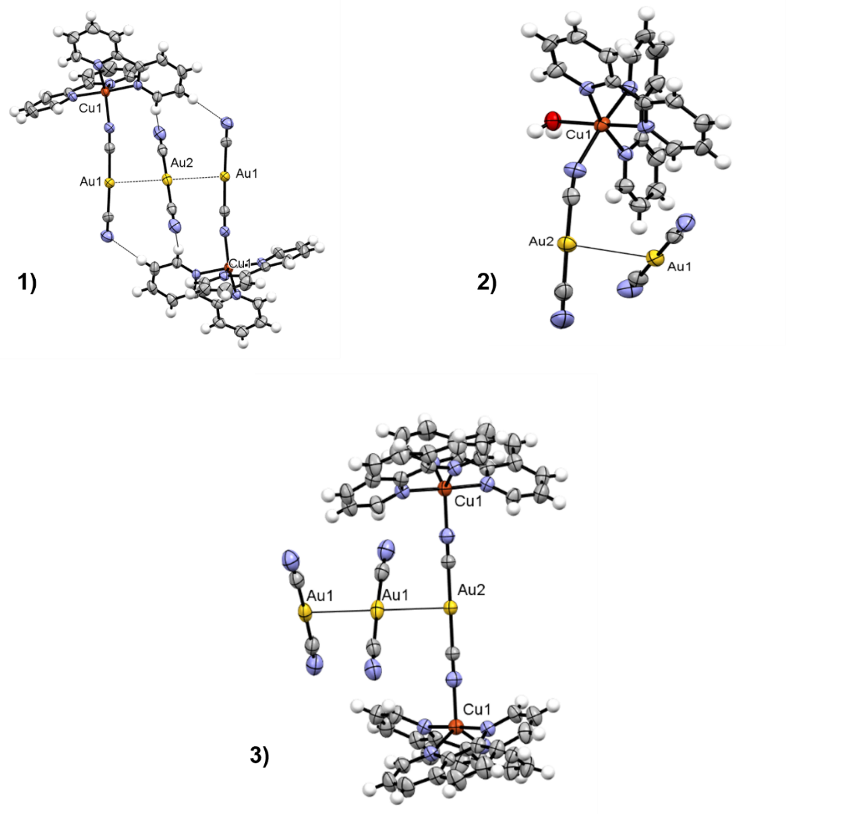
Figure 3: ORTEP plots of the trimeric aurophilic bonded structure of compound 1, of the aurophilic-hydrogen bonded aggregate in compound 2 and of the aurophilic chains of compound 3 (50 % probability) (Color code: white, hydrogen; gray, carbon; blue, nitrogen; yellow, gold; orange, copper; red, oxygen)

Figure 4: ORTEP plots of the molecular structure of compound 4 and of the polymeric structure of compound 5 (50 % probability) (Color code: white, hydrogen; gray, carbon; blue, nitrogen; yellow, gold; orange, copper; red, oxygen; light green, fluorine).

, outer Au(1)…Au(1) distance= 3.653(1) Å, see Figure 3a). This last Au…Au interaction is quite long and can be due to the charge or steric repulsion between the bulkier fragments {Cu(L1)₂[(μ-CN)Au(CN)]}⁺, although the steric repulsion is minimised by the inversion of the copper position in relation to the gold chain. Cu(II) ions are surrounded by two L1 chelating ligands and an N-bonded cyanide, forming a distorted trigonal bipyramid of nitrogen donors. The Cu-dicyanoaurate fragment is quite linear (ang(Au(1)-N1-Cu(1))= 164,02(10)°). A third non-equivalent dicyanoaurate is inserted between the chains in a cradle formed by pyridyl rings (d(Au(3)…Cu(1))= 4.294(4) Å, d(Au(3)…C(15))= 3.318(5) Å and ang(Au(1)-Cu(1)-Au(3))= 148.17(10)°) and is not involved in strong directional interactions.
The crystal structure of 2 is analogous to that of {Zn(L1)₂[(μ-CN)Au(CN)](H₂O)}[Au(CN)₂].²⁹ This phase can be obtained in deuterated water, which stabilises this crystal phase through stronger internal hydrogen bonds due to deuterium substitution.⁵⁸ The same result can be obtained by recrystallisation of 1 from ammonia solutions where a slow loss of the monodentate ligand occurs. It is interesting to consider that the Zn(II)-L1-dicyanoaurate system forms the hydrated complex both in solution and in the solid state (but not in the gas phase); while for Cu(II) the situation is the opposite. In almost all solvents the anhydrous 1 complex is formed, probably for a softer character of the metal centre, while formation of hydrated complex 2 must be promoted with some expedients (stronger hydrogen bond of deuterated water or sacrificing one ammonia ligand).
In the crystal structure of 2, a cationic molecular complex {Cu(L1)₂[(μ-CN)Au(CN)](H₂O)}⁺ and an anionic [Au(CN)₂]⁻complex are present, linked by aurophilic interactions and hydrogen bonds (Figure 3.2). A 2D supramolecular network similar to the network analogous {M(L)₂[(μ-CN)M’(CN)](H₂O)}[M’(CN)₂] (M= Zn, Mn, Ni, Cd, L=1,10-phenantroline, 2,2’-bipiridine, M’= Ag, Au) was observed (see Figure 3b).^{29, 59-62} The general structural characteristics observed for {Zn(L1)₂[(μ-CN)Au(CN)](H₂O)}[Au(CN)₂] are maintained, but the two compounds are not perfectly isomorphic, although they crystallise in the same Space Group type P2₁/c. Moving from the zinc to the copper complex, a and c axes are contracted by 0.107 Å and 0.03 Å respectively, while the b axis expands by 0.101 Å and the β angle increases of 0.9°. These metric differences can probably explain the impossibility of obtaining solid solutions between these compounds. In fact, when compound 2 and the zinc analogue are dissolved in DMF or ethanol, crystals of both the complexes are obtained separately. These characteristics can be explained by the elongated octahedral environment of the Cu(II) ion due to the pseudo Jahn-Teller effect (d(Cu(1)–N(6))= 2.022(5) Å with respect to d(Cu(1)–N(7))= 2.291(4) Å). This distortion is propagated within the structure through the dicyanoaurate fragment that is more parallel to the copper-cyanide axes with respect to the zinc analogue [ang(Cu(1)-N(1)-N(2))= 151.55(8)° and ang(Zn(1)-N(3)-N(4))=155.42(10)°]. This arrangement decreases from 3.2673(6) Å to 3.2360(5) Å the Au(1)…Au(2) distance and from 2.802(5) Å and 2.769(5) Å to 2.760(4) Å and 2.726(4) Å the two hydrogen bonds connecting the water ligand and the terminal cyanides (calculated on the oxygen-nitrogen donor acceptor distance). Thus, the supramolecular network in the Cu complex results more compact than in the Zn derivative.⁶³ Besides, in all octahedral complexes reported in this work, the L ligands are in cis configuration, unlike the case of the ethylenediamine (or similar substituted ligands) derivatives [M(en)₂[M’(CN)₂]₂} (M= Zn, Cu, M’=Ag, Au), which are invariantly in trans configuration.^{64-68,69-71} This difference can be attributed to steric factors.
By employing L2, green crystals of K{[Cu(L2)₂]₂[(μ-CN)₂Au]}[Au(CN)₂]₂Cl₂ (3) were obtained from DMSO solution. In this case, the Cu(II) centre is penta-coordinated with two chelating ligands and a dicyanoaurate, forming a nearly perfect trigonal bipyramid. Two copper centres are bonded to the same dicyanoaurate, forming a positively charged {[Cu(L2)₂]₂[(μ-CN)₂Au]}³⁺ fragment (see Figure 3.3). This fragment interacts with two other dicyanoaurates through short aurophilic interactions [d(Au(1)…Au(2))=3.216(2) Å, d(Au(1)…Au(1))=3.171(2) Å] forming Au chains along the a axis. In these chains there are one positive fragment and two negative fragments, with an anti-coulombic 2+ - - 2+ order. The two free dicyanoaurates are rotated with respect to each other and with respect to the positively charged fragment [torsional angle (N(2)-Au(2)-Au(1)-N(1))=39.93(8)° and torsional angle (N(1)-Au(1)-Au(1)-N(1))=79.95(8)°, see Figure 3.3]. The aromatic rings of L2 bonded to the Cu(II) centres form cradles, which define channels filled with a residual disordered electron density. This electron density was interpreted as disordered potassium and chloride ions.
With strongly substituted L3, we obtained {Cu(L3)₂[(μ-CN)AuCN]₂}‧DMSO (4) (Figure 4.4). Both dicyanoaurate anions are directly coordinated to the copper centre, forming a distorted octahedral environment with the aromatic ligands. The pseudo Jahn-Teller effect is quite strong, shortening the axial distance Cu(1)–N(3) (2.012(5) Å) compared to the equatorial Cu(1)–N(4) and Cu(1)–N(1) (2.238(4) Å and 2.158(5) Å respectively). Also in this case, there is a strong similarity with the zinc complex {Zn(L3)₂[(μ-CN)Au(CN)]₂}‧DMSO²⁹, not considering the inherent distortion. However, with copper it was not possible to obtain the homologous coordination polymer from DMF.²⁹ Imidazo[1,5a]pyridines may form mono- and bis-coordinated complexes with copper,^{45,72-74} but in this case no mono-chelated crystalline product was detected. In CSD database the majority of the complexes present Cu(I) as metal centre (17 of 28 crystal structures reported). Complex 4 has the peculiarity of being one of the stable imidazo[1,5a]pyridine complexes formed by the Cu(II) ion.⁷⁵⁻⁸¹ The stability of Cu(II) may be related to the presence of dicyanoaurate in the first coordination sphere. Compound Cu(L4)[(μ-CN)Au(CN)]}_{ꝏ}‧.CH₃CN 5 has Cu(I) cations with a tetrahedral environment of L4.⁸² It forms a wavy 1D coordination polymer with bridged dicyanoaurate. The ribbons are parallel arranged and interact in couples through strong aurophilic interactions (d(Au(1)…Au(2))=3.134(1) Å, see Figure 4.5). Some other Cu(I)-dicyanoaurate compounds have been reported, but no nitrogen chelating ligand has been used until now.^{38,48,49} In this system binuclear Cu(I) products have been reported using CuCN with the same ligand ^{43,2,8}, but no similar products have been obtained in this case.

Figure 5: (a) Infrared spectra and (b) UV-Vis absorption spectra of (3) (in green), of the product obtained after ammonia exposure (in blue) and after ammonia removal (in pink)
Vapochromism solid state characterisation.
Heterobimetallic coordination polymers based on the dicyanoaurate unit have shown to be remarkable for sensing application. ^{17, 18, 37} The mechanisms have been studied and can be explained either by a selective complexation of the host’s vapour molecules by the metal (for example in Cu[Au(CN)₂]₂)¹⁷ or by some weak interaction that changes the electronic properties of the compound. ⁸³ We verified the response of our compounds to several different volatile molecules and the most interesting behaviour has been found with crystals of 3 in the presence of ammonia vapours. The green crystals change their electronic properties and turn blue, but completely lose their crystalline structure, according to PXRD measurement. This modification is completely reversible, either with exposure to heat (330 K for 15 minutes) or by redissolving and recrystallizing the compound in DMSO or THF. The compound is stable for several cycles, although the mono-crystallinity is lost after the first ammonia passage. The interaction with ammonia was studied with UV-Vis and micro-IR spectroscopies. In the UV-visible spectra of 3 there is a clear shift in the π-π* inter-ligand ultraviolet band of L3 from 351 nm to 299 nm, while the visible region is less indicative because it is too broad (Figure 5b). More detailed information has been obtained from vibrational data. The IR spectrum of the blue product presents new signals related to the presence of ammonia at 3300, 1630, 1275 and 760 cm⁻¹ (Figure 5a). These bands are attributable to the stretching, deformation and rocking modes of NH₃ molecules in copper complexes.^{84, 85} It has been suggested that hydrogen bonding shifts signals at higher frequencies, and the most sensitive shift is generally observed for the rocking mode,⁸⁶ as observed in our product. The presence of hydrogen bond is confirmed by the broadening of stretching modes signals. Some water molecules may also be present and involved in hydrogen bonding, but no sure assignment can be done due to the signals proximity.⁸⁷ In the spectrum of blue products, there are some bands attributable to the free L2 and we observed a different multiplicity of cyanide signals. These features suggest that L2 is partially substituted by ammonia in the first coordination sphere of Cu(II), causing a large modification in the crystal environment.⁸⁸
It can be supposed that the ammonia molecules penetrate the crystal architecture through the disordered channels between the L2 ligands, but further studies should be carried out. Furthermore, the spectrum of the product after heating (pink line in Figure 5a) is analogous to that of 3, suggesting that ammonia absorption is completely reversible.

Environmental condition solid state characterisation of co-crystal with Hg(CN)₂.
Starting from the assumption that the {Cu(L)₂[Au(CN)₂]}⁺ , as we demonstrated earlier,²⁹ is quite stable in solution, we tried to form co-crystals by dissolving the previously described solids with other d¹⁰ metal complexes, such as mercury halides and pseudohalides.
When 1 is dissolved in solution in presence of a strong excess of Hg(CN)₂, dark green crystals of 6 are formed, which show a peculiar architecture. In this compound, the dicyanoaurate is detached from the copper centre, leaving a distorted tetrahedral [Cu(L)₂]²⁺ molecule (ang(N(5)-Cu(1)-N(5))= 104.3(1)° for 6), and forms aurophilic attracted anion pairs with a tilted conformation (d(Au(1)…Au(1))=3.232(3) Å and ang(C(1)-Au(1)…Au(1)-C(1))= 59.90(10)° for 6, see Figure 6.6b). These pairs of dicyanoaurates interact with the mercury(II) cyanide molecules through a long secondary interaction (d(N(1)…Hg(1))=2.860(5) Å for 6). This is not the only case of Hg‧‧‧NC contacts: Hg(CN)₂ and its adducts present similar interactions.⁸⁹⁻⁹¹ In the crystal structure of 6 the disordered mercury cyanide molecules form layers that separate the ordered molecular part of the crystal packing (see Figure 6.6a). The disorder of the mercury cyanides in these layers can be described with a network of randomly parallel and perpendicular molecules of Hg(CN)₂, which can interact with each other with long CN…Hg contacts (around 3 Å, see Figure 6.6c). Any attempt to find an ordered supercell at room temperature failed due to the absence of any weak superlattice diffraction reflections. In the next sections, the attempt to force a low temperature ordering will be commented. The trimetallic architecture observed in 6 is an example in which the cocrystal

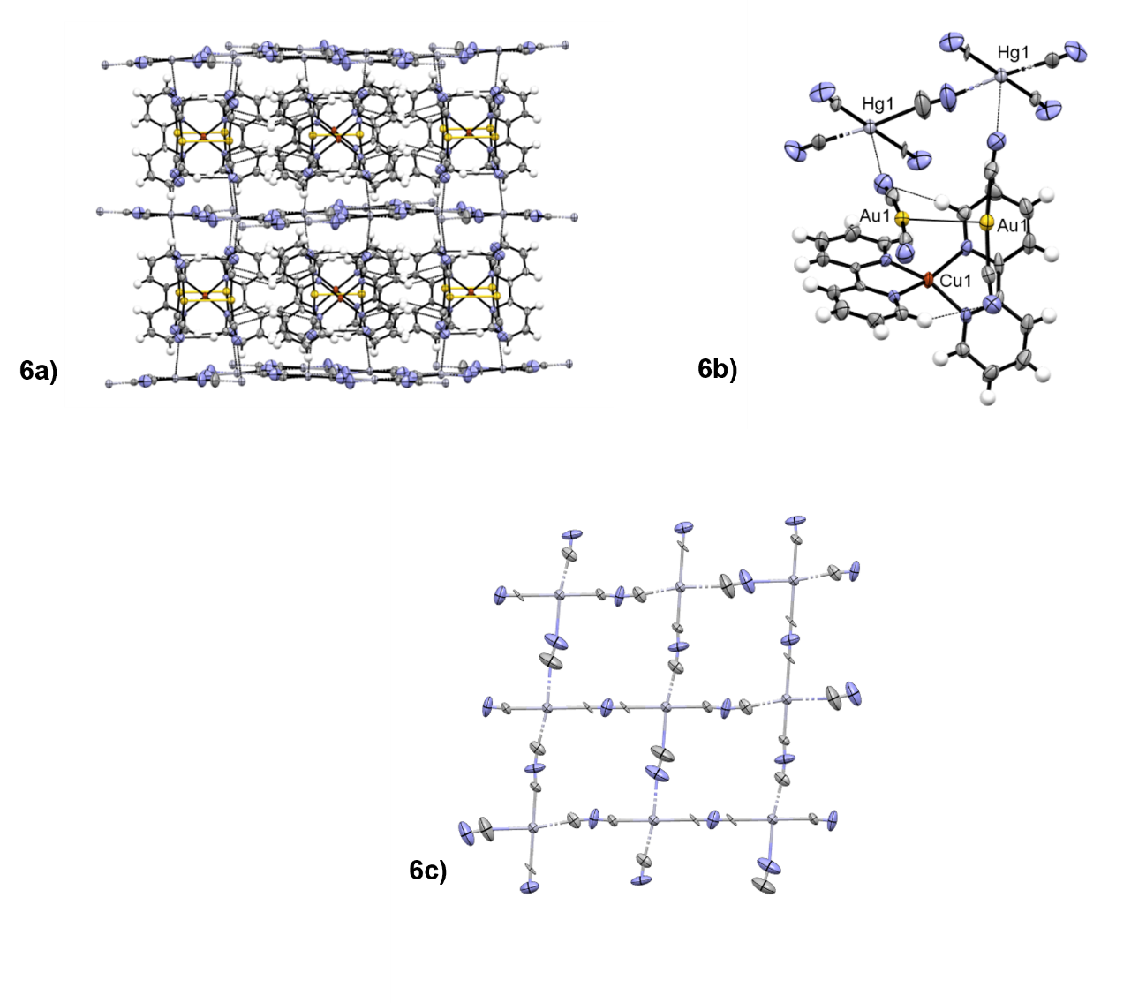
Figure 6: ORTEP plots of the polymeric structure of the supramolecular structure of compound 6 (a), a fragment of the complex architecture (b) and a detail on the HgCN₂ disordered layer (6c) (50 % probability) (Colour code: white, hydrogen; gray, carbon; blue, nitrogen; yellow, gold; orange, copper; red, oxygen; light gray, mercury; light green, fluorine; green, chlorine).

does not maintain the original unit, so the dicyanoaurate anion interact separately from the other d¹⁰ metal centre. The results obtained with 6 open the way for further studies toward other molecular fragments involving metal centres that can interact more strongly with Au(I), obtaining multi-metallic aurophilic supramolecular architectures.

High-pressure solid-state characterization of 1
High pressure measurements on gold complexes showing aurophilic interactions have been performed in the past, especially to modulate the luminescence emission or to study polymorphism.⁹²⁻⁹⁷ Further investigations have been done on inorganic salts like AuX or M[Au(CN)₂]_{n} to study the solid state compressibility of peculiar arrangements of gold atoms. ⁹⁸⁻¹⁰¹ By selecting 1 as a prototype of the supramolecular architectures formed by the dicyanoaurate and metal-gold complexes with a chelating ligand, high pressure and low temperature measurements have been performed. To our knowledge, no HP-VT study has been performed so far on this type of bimetallic supramolecular materials, other than on coordination polymers based on iron-dicyanoargentate or dicyanoaurate for spin transition studies.^{102, 103}
Raman spectra at variable pressure have been recorded in the 50-1300 cm⁻¹ range. The assignment of vibrational modes has been done by comparison with vibrational spectra of 2,2’-bipyridine ¹⁰⁴, L1-Cu(II) complexes ¹⁰⁵ and K[Au(CN)₂]¹⁰⁶ and is reported in Table S21.
In the 1300-600 cm⁻¹ region there are mainly C–C and C–N ring stretchings, along with in-plane C-H and C-C-C bending. The

Figure 7: High pressure Raman spectra in the 200-600 cm⁻¹ (a) and 600-1000 cm⁻¹ (b) spectral range of 1 from 0.6 to 3.6 GPa. (d), (e) and (f) are the evolution of heavy atoms distances within crystal structure of 1 (c) between 0 to 1.5 GPa.

pressure effect on these modes, in the interval explored, is mainly a moderate blue shift. By considering a linear volume reduction as a consequence of the applied pressure, from ambient pressure to 1.59 GPa the cell volume undergoes a 23% contraction, and this probably does not significantly affect the geometry of coordinated L1. A similar behaviour is detected for the ring bending mode at 371 cm⁻¹, which blue shifts to 383 cm⁻¹ at 1.59 GPa. The vibrational stretching involving Cu(II) can be attributed to the 268 cm⁻¹ band (ν_{Cu-N(L1))}, that in addition to a broadening is not significantly affected by the pressure variation. The modes attributable to [Au(CN)₂]⁻ fragment show an interesting behaviour: from ambient pressure to 0.8 GPa they undergo a decrease in intensity and from 1.1 GPa they are no longer detectable from the background (see the rectangle in the spectrum at 0.8 GPa in Figure 7a). We may attribute the bands centred at 248 cm⁻¹ to the Au–CN bending, the strong band at 408 cm⁻¹ to the Cu–N(C) stretching and the weak band at 470 cm⁻¹ to the ν_{Au-C(N)} stretching. Starting from 1.1 GPa, two bands appeared at 401 and 419 cm⁻¹, and this suggests a phase change in the crystal structure, mainly affecting the [Au(CN)₂]⁻ units. Consequently, high pressure Raman measurements show modifications in the 0.8-1.2 GPa range and in the 1.4-1.7 GPa range (see Figure 7a-b), suggesting two main events in a pressure range under 3.6 GPa. In particular, Raman peaks increase their linewidths above 1.4 GPa, suggesting an increase in the disorder or even the onset of amorphization. The presence of a series of modifications at relatively low pressure is typical of soft molecular materials.^{107, 108} Interested by these results, we performed SC-XRD diffraction studies on 1 at high pressure. However, structural studies in single crystals could be possible up to 1.5 GPa for sample amorphization. At the same time, the low symmetry and the complexity of the crystal structure of 1 made not possible to have a good parameter/data ratio. For this reason, in the following discussion only cell parameters and heavy atom (the most important scatterer) will be commented.
When looking at SC-XRD data, the b axis is the most influenced by pressure, decreasing by more than 0.9 Å (Figure S11b), compared to a lengthening of 0.1 Å of the c axis (Figure S11b) and a decrease of 0.3 Å of the a axis (Figure S11b). This suggests greater compressibility in the direction parallel to the dicyanoaurates and greater rigidity due to steric hindrance in the other two perpendicular directions. In the pressure range 0-1.5 GPa, some general variation in the distances between metal atoms can be observed. The geometry of the {Cu(L1)₁[Au(CN)₂]}⁺ fragment, evaluated through the Cu(1)–Au(1) distance, remains unaltered up to 1.3 GPa. After this pressure, we observe a shortening of 0.4 Å of this distance (see Figure 7f), suggesting a strong distortion, probably a closure of the Cu-CN-Au angle. In the same pressure range, the two aurophilic contacts have different behaviours. The shorter Au(1)…Au(2) distance has an intense compression of 0.27 Å (see Figure 7e), while the longer Au(1)…Au(1) distance, after lighter compression before 1.0 GPa, exhibits a decisive lengthening (see Figure 7d). This anomalous behaviour can also be probably attributed to the distortion of the cationic complex and to the shift of the molecular fragments in the direction of maximal compression. It is also interesting to note that the Au(3)…Cu(1) distance, involving the dicyanoaurate unit inserted in the cradle of the pyridine rings, has an intense shortening of 0.3 Å before 1.3 GPa and a lengthening after this pressure (see Figure S19d and Figure 7c). This behaviour may suggest the presence of an attractive force between the pyridyl groups of L1 and the dicyanoaurate complex with a minimum in the energy surface at about 3.95 Å, distance after which the interaction becomes repulsive. The existence of this attraction is also suggested by the high probability that the linear dicyanoaurate show this arrangement in crystals presenting aromatic ligands.¹⁰⁹ All these data, with the analysis of the evolution of the cell parameters (see ESI for details), suggest the presence of a distortive isosymmetric phase transition between 1.3 and 1.5 GPa.

Variable temperature SC-XRD characterization of 1 and 6
Variable temperature studies on 1 and 6 have been performed for three reasons: 1) to study the possibility of a phase transition analogous to that found under high pressure conditions for 1; 2) to study the temperature dependence of weak interaction distances and structural parameters; 3) to search for an ordered supercell for 6. Analogous studies on dicyanoaurate salts, coordination polymers or gold complexes to study the thermal expansion and luminescence have been reported in the literature.^{19, 21, 22, 93, 110-112}
1 and 6 have been studied with SC-XRD from 150 K to 343 K for 1 (200 K to 343 K for 6). No distortive isosymmetric phase transition has been found, but a continuous temperature dependence of the cell parameters. Unlike pressure, temperature has a small effect on the reticular parameters and distances in 1, probably due to the high steric hindrance of the molecular fragments. A specific graph for each main structural and cell parameter can be found in the ESI (Figure S14-S15). A more visible effect can be observed on the motion component of the atoms, especially the oscillation of the C(3)N(3) cyanide of the free dicyanoaurate around the centre of Au(3) (see Figure S16 for the main motion components of N3).
In 6, although no ordered supercell has been found, more pronounced effects on the overall architecture have been observed between 200 K and 343 K. In this range, Au(1)…Au(1) aurophilic interaction has a lengthening of 0.04 Å (see Figure S19a) and the arrangement of the couple of dicyanoaurate has a slightly more tilted conformation (Figure S19c). The molecular fragment [Cu(L1)₂]²⁺ becomes slightly more tetrahedral as the temperature rises (Figure S19b). This is probably due to the increase in the interplanar distance between mercury cyanide layers (from 11.019(7) Å at 200 K to 11.044(8) Å at 343 K) and the lengthening of the CN…Hg(1) distance of 0.04 Å that connects the layers (see Figure S18d).
Conclusions
In this article, we demonstrate the possibility of systematically obtaining a family of supramolecular architectures constructed by aurophilic interactions based on copper-dicyanoaurate molecular fragments in the presence of chelating ligands. These results have been possible due the tendency of Cu(II) to be coordinated by two chelating ligands, leaving one or two free sites to the attachment of dicyanoaurate. The stability of these bis-chelated Cu(II)-Au(I) fragments allows to obtain co-crystals with other d¹⁰ metals, even in absence of aurophilic interactions, opening the way for an aurophilic-based crystal engineering between bimetallic complexes. The new bimetallic materials were investigated for vapochromism, and one of them shows a reversible response to the presence of ammonia, measurable by UV-Vis and IR vibrational spectroscopies. Finally, the first high pressure-variable temperature study on a bimetallic supramolecular aurophilic architecture were performed. A series of isosymmetric distorsive phase transitions due to high pressure has been detected by Raman spectroscopy, but the effect of these two parameters on the crystal structure is, in general, not so strong, probably due to the high steric hindrance. In particular, aurophilic interactions are not necessarily involved in the main movements in the crystal structure, while some distortion around copper centres can be preferred. However, more studies must be done to unravel the possible transformations of these materials with high pressure and variable temperature and, possibly, to systematically obtain abnormal phenomena such as giant negative linear compressibility.
Conflicts of interest
There are no conflicts to declare.
References

1. J. Gil-Rubio and J. Vicente, Chemistry – A European Journal, 2018, 24, 32-46.
2. E. V. Alexandrov, A. V. Virovets, V. A. Blatov and E. V. Peresypkina, Chem. Rev., 2015, 115, 12286-12319.
3. M. J. Katz, K. Sakai and D. B. Leznoff, Chem. Soc. Rev., 2008, 37, 1884-1895.
4. A. Canumalla, C. F. Shaw and F. E. Wagner, Inorganic Chemistry, 1999, 38, 3268-3269.
5. R. D. Hancock, N. P. Finkelstein and A. Evers, Journal of Inorganic and Nuclear Chemistry, 1972, 34, 3747-3751.
6. X.-B. Wang, Y.-L. Wang, J. Yang, X.-P. Xing, J. Li and L.-S. Wang, J. Am. Chem. Soc., 2009, 131, 16368-16370.
7. M. Bardají and A. Laguna, Journal of Chemical Education, 1999, 76, 201.
8. H. Schmidbaur and A. Schier, Chem. Soc. Rev., 2012, 41, 370-412.
9. H. Schmidbaur and A. Schier, Chem. Soc. Rev., 2008, 37, 1931-1951.
10. H. Schmidbaur, Gold Bulletin, 2000, 33, 3-10.
11. J. A. Hill, A. L. Thompson and A. L. Goodwin, J. Am. Chem. Soc., 2016, 138, 5886-5896.
12. J. A. Hill, C. A. Murray, C. C. Tang, P. M. M. Thygesen, A. L. Thompson and A. L. Goodwin, Chemical Communications, 2019, 55, 5439-5442.
13. J. Suárez-Varela, H. Sakiyama, J. Cano and E. Colacio, Dalton Trans., 2007, DOI: 10.1039/B611684A, 249-256.
14. A. B. Cairns, J. Catafesta, C. Levelut, J. Rouquette, A. van der Lee, L. Peters, A. L. Thompson, V. Dmitriev, J. Haines and A. L. Goodwin, Nat. Mater., 2013, 12, 212-216.
15. E. J. Fernandez, A. Laguna and J. M. Lopez-De-Luzuriaga, Dalton Trans., 2007, DOI: 10.1039/b702838p, 1969-1981.
16. G. L. Cui, X. Y. Cao, W. H. Fang, M. Dolg and W. Thiel, Angew. Chem.-Int. Edit., 2013, 52, 10281-10285.
17. J. Lefebvre, R. J. Batchelor and D. B. Leznoff, J. Am. Chem. Soc., 2004, 126, 16117-16125.
18. M. J. Katz, T. Ramnial, H.-Z. Yu and D. B. Leznoff, J. Am. Chem. Soc., 2008, 130, 10662-10673.
19. L. Wang, H. Luo, S. Deng, Y. Sun and C. Wang, Inorganic Chemistry, 2017, 56, 15101-15109.
20. X. Zhang, B. Li, Z.-H. Chen and Z.-N. Chen, Journal of Materials Chemistry, 2012, 22, 11427-11441.
21. A. L. Goodwin, B. J. Kennedy and C. J. Kepert, J. Am. Chem. Soc., 2009, 131, 6334-6335.
22. J. L. Korčok, M. J. Katz and D. B. Leznoff, J. Am. Chem. Soc., 2009, 131, 4866-4871.
23. R. K. Arvapally, P. Sinha, S. R. Hettiarachchi, N. L. Coker, C. E. Bedel, H. H. Patterson, R. C. Elder, A. K. Wilson and M. A. Omary, The Journal of Physical Chemistry C, 2007, 111, 10689-10699.
24. X. He and V. W.-W. Yam, Coord. Chem. Rev., 2011, 255, 2111-2123.
25. J. R. Thompson, M. J. Katz, V. E. Williams and D. B. Leznoff, Inorganic Chemistry, 2015, 54, 6462-6471.
26. M. J. Katz and D. B. Leznoff, J. Am. Chem. Soc., 2009, 131, 18435-18444.
27. A. S. Abouelwafa, C. E. Anson, A. Hauser, H. H. Patterson, F. Baril-Robert, X. Li and A. K. Powell, Inorganic Chemistry, 2012, 51, 1294-1301.
28. T. P. Seifert, V. R. Naina, T. J. Feuerstein, N. D. Knöfel and P. W. Roesky, Nanoscale, 2020, 12, 20065-20088.
29. E. Priola, G. Volpi, R. Rabezzana, E. Borfecchia, C. Garino, P. Benzi, A. Martini, L. Operti and E. Diana, Inorganic Chemistry, 2020, 59, 203-213.
30. W. A. E. McBryde, A critical review of equilibrium data for proton- and metal complexes of 1,10-phenantroline, 2,2'-bipyridyl and related compounds, IUPAC CHEMICAL DATA SERIES, Oxford, 1978.
31. K. Yamasaki and M. Yasuda, J. Am. Chem. Soc., 1956, 78, 1324-1324.
32. M. Yasuda, K. Sone and K. Yamasaki, The Journal of Physical Chemistry, 1956, 60, 1667-1668.
33. B. Murphy, M. Aljabri, A. M. Ahmed, G. Murphy, B. J. Hathaway, M. E. Light, T. Geilbrich and M. B. Hursthouse, Dalton Trans., 2006, DOI: 10.1039/B509070A, 357-367.
34. B. Murphy, B. Hathaway, Coord. Chem. Rev., 2003, 243, 237 - 262.
35. B. J. Hathaway, Coord. Chem. Rev., 1981, 35, 211-252.
36. B. J. Hathaway, Berlin, Heidelberg, 1984.
37. J. Lefebvre, J. L. Korčok, M. J. Katz and D. B. Leznoff, Sensors, 2012, 12.
38. B. R. Varju, J. S. Ovens and D. B. Leznoff, Chemical Communications, 2017, 53, 6500-6503.
39. D. B. Leznoff, B.-Y. Xue, C. L. Stevens, A. Storr, R. C. Thompson and B. O. Patrick, Polyhedron, 2001, 20, 1247-1254.
40. S. Kitagawa, M. Munakata and A. Higashie, Inorg. Chim. Acta, 1984, 84, 79-84.
41. M. M. Turnbull, G. Pon and R. D. Willett, Polyhedron, 1991, 10, 1835-1838.
42. F. Grifasi, E. Priola, M. R. Chierotti, E. Diana, C. Garino and R. Gobetto, European Journal of Inorganic Chemistry, 2016, 2016, 2975-2983.
43. A. Giordana, E. Priola, G. Gariglio, E. Bonometti, L. Operti and E. Diana, Polyhedron, 2021, 198, 115059.
44. G. Volpi, Journal of Chemical Education, 2016, 93, 891-897.
45. G. Volpi, E. Priola, C. Garino, A. Daolio, R. Rabezzana, P. Benzi, A. Giordana, E. Diana and R. Gobetto, Inorg. Chim. Acta, 2020, 509, 119662.
46. G. Volpi, G. Magnano, I. Benesperi, D. Saccone, E. Priola, V. Gianotti, M. Milanesio, E. Conterosito, C. Barolo and G. Viscardi, Dyes Pigment., 2017, 137, 152-164.
47. A. Giordana, E. Priola, E. Bonometti, P. Benzi, L. Operti and E. Diana, Polyhedron, 2017, 138, 239-248.
48. J. S. Ovens, P. R. Christensen and D. B. Leznoff, Chemistry – A European Journal, 2016, 22, 8234-8239.
49. J. S. Ovens and D. B. Leznoff, ChemPlusChem, 2016, 81, 842-849.
50. O. V. Dolomanov, L. J. Bourhis, R. J. Gildea, J. A. K. Howard and H. Puschmann, Journal of Applied Crystallography, 2009, 42, 339-341.
51. G. M. Sheldrick, Acta Crystallogr. Sect. A, 2008, 64, 112-122.
52. G. M. Sheldrick, Acta Crystallogr. Sect. A, 2015, 71, 3-8.
53. C. F. Macrae, P. R. Edgington, P. McCabe, E. Pidcock, G. P. Shields, R. Taylor, M. Towler and J. van De Streek, Journal of Applied Crystallography, 2006, 39, 453-457.
54. D. R. A. a. W. F. K. Miletich, Rev. Mineral Geochem., 2000, 45, 445-519.
55. F. Bertolotti, N. Curetti, P. Benna and G. Gervasio, Journal of Molecular Structure, 2013, 1041, 106-112.
56. D. R. A. R.J. Angel, R. Miletich, L. W. Finger, Journal of Applied Crystallography, 1997, 30, 461--466.
57. H. K. Mao, J. Xu and P. M. Bell, Journal of Geophysical Research: Solid Earth, 1986, 91, 4673-4676.
58. S. Scheiner and M. Čuma, J. Am. Chem. Soc., 1996, 118, 1511-1521.
59. G. F. Xu, Z. Q. Liu, H. B. Zhou, Y. Guo and D. Z. Liao, Aust. J. Chem., 2006, 59, 640-646.
60. M. Monim-ul-Mehboob, M. Ramzan, T. Ruffer, H. Lang, S. Naddem, M. Akhtar and S. Ahmad, Z.Naturforsch.(B), 2013, 68, 161-167.
61. Y. Guo, Y. Ma, N. Zhou, Z. Q. Liu, Q. L. Wang, S. P. Yan and D. Z. Liao, Z. Anorg. Allg. Chem., 2010, 636, 865-871.
62. J. Qu, W. Gu and X. Liu, J. Coord. Chem., 2008, 61, 618-626.
63. E. R. T. Tiekink, Coord. Chem. Rev., 2014, 275, 130-153.
64. P. M. Aguiar, M. J. Katz, D. B. Leznoff and S. Kroeker, Physical Chemistry Chemical Physics, 2009, 11, 6925-6934.
65. F. Baril-Robert, X. B. Li, M. J. Katz, A. R. Geisheimer, D. B. Leznoff and H. Patterson, Inorganic Chemistry, 2011, 50, 231-237.
66. C. Kappenstein, A. Ouali, M. Guerin, J. Cernak and J. Chomic, Inorg. Chim. Acta, 1988, 147, 189-197.
67. L. Triscikova, J. Chomic, K. S. Abboud, J. H. Park, M. W. Meisel and J. Cernak, Inorg. Chim. Acta, 2004, 357, 2763-2768.
68. A. Karadag, A. Aydin, S. Dede, S. Tekin, Y. Yanar, B. H. Cadirci, M. S. Soylu and O. Andac, New Journal of Chemistry, 2015, 39, 8136-8152.
69. J. Piromchom, N. Wannarit, C. Pakawatchai and S. Youngme, Acta Crystallogr. Sect. C-Cryst. Struct. Commun., 2013, 69, 1136-+.
70. T. V. Popova and N. V. Aksenova, Russian Journal of Coordination Chemistry, 2003, 29, 743-765.
71. C. C. L. McCrory, X. Ottenwaelder, T. D. P. Stack and C. E. D. Chidsey, The Journal of Physical Chemistry A, 2007, 111, 12641-12650.
72. G. A. Ardizzoia, S. Brenna, S. Durini and B. Therrien, Polyhedron, 2015, 90, 214-220.
73. G. A. Ardizzoia, G. Colombo, B. Therrien and S. Brenna, European Journal of Inorganic Chemistry, 2019, 2019, 1825-1831.
74. G. A. Ardizzoia, S. Brenna, S. Durini, B. Therrien and M. Veronelli, European Journal of Inorganic Chemistry, 2014, 2014, 4310-4319.
75. M. D. Weber, C. Garino, G. Volpi, E. Casamassa, M. Milanesio, C. Barolo and R. D. Costa, Dalton Trans., 2016, 45, 8984-8993.
76. C. M. Álvarez, L. Álvarez-Miguel, R. García-Rodríguez, J. M. Martín-Álvarez and D. Miguel, European Journal of Inorganic Chemistry, 2015, 2015, 4921-4934.
77. M. E. Bluhm, M. Ciesielski, H. Görls, O. Walter and M. Döring, Inorganic Chemistry, 2003, 42, 8878-8885.
78. Y. Chen, L. Li, Y. Cao, J. Wu, Q. Gao, Y. Li, H. Hu, W. Liu, Y. Liu, Z. Kang and J. Li, Crystengcomm, 2013, 15, 2675-2681.
79. S. Priyanga, T. Khamrang, M. Velusamy, S. Karthi, B. Ashokkumar and R. Mayilmurugan, Dalton Trans., 2019, 48, 1489-1503.
80. N. Kundu, M. Maity, P. B. Chatterjee, S. J. Teat, A. Endo and M. Chaudhury, J. Am. Chem. Soc., 2011, 133, 20104-20107.
81. Y. Chen, L. Li, Z. Chen, Y. Liu, H. Hu, W. Chen, W. Liu, Y. Li, T. Lei, Y. Cao, Z. Kang, M. Lin and W. Li, Inorganic Chemistry, 2012, 51, 9705-9713.
82. A. Giordana, E. Priola, E. Bonometti, P. Benzi, L. Operti and E. Diana, Polyhedron, 2017, 138, 239-248.
83. R. J. Roberts, D. Le and D. B. Leznoff, Chemical Communications, 2015, 51, 14299-14302.
84. K. H. Schmidt and A. Müller, Journal of Molecular Structure, 1974, 22, 343-352.
85. B. N. Cyvin, S. J. Cyvin, K. H. Schmidt, W. Wiegeler, A. Müller and J. Brunvoll, Journal of Molecular Structure, 1976, 30, 315-332.
86. K. Nakamoto, Infrared and Raman Spectra of Inorganic and Coordination Compounds, 2008, 1-273.
87. A. Bromberg, S. Kimel and A. Ron, Chemical Physics Letters, 1977, 46, 262-266.
88. E. Priola, G. Mahmoudi, J. Andreo and A. Frontera, Chemical Communications, 2021, 57, 7268-7271.
89. M. Frey, M. Ledésert Acta Crystallographica Section B, 1971, 27, 2119--2123.
90. P. T. T. Wong, The Journal of Chemical Physics, 1980, 72, 6721-6725.
91. G. Gervasio, M. Marabello, Acta Crystallographica Section C, 2007, 63, m318--m320.
92. A. E. O'Connor, N. Mirzadeh, S. K. Bhargava, T. L. Easun, M. Schröder and A. J. Blake, Chemical Communications, 2016, 52, 6769-6772.93. A. J. Blake, R. Donamaría, V. Lippolis, J. M. López-de-Luzuriaga, M. Monge, M. E. Olmos, A. Seal and J. A. Weinstein, Inorganic Chemistry, 2019, 58, 4954-4961.
94. R. J. Roberts, N. Bélanger-Desmarais, C. Reber and D. B. Leznoff, Chemical Communications, 2014, 50, 3148-3150.
95. C. H. Woodall, S. Fuertes, C. M. Beavers, L. E. Hatcher, A. Parlett, H. J. Shepherd, J. Christensen, S. J. Teat, M. Intissar, A. Rodrigue-Witchel, Y. Suffren, C. Reber, C. H. Hendon, D. Tiana, A. Walsh and P. R. Raithby, Chemistry – A European Journal, 2014, 20, 16933-16942.
96. D. Paliwoda, P. Wawrzyniak and A. Katrusiak, The Journal of Physical Chemistry Letters, 2014, 5, 2182-2188.
97. C.H. Woodall, J. Christensen, J.M. Skelton, L.E. Hatcher, A. Parlett, P.R. Raithby, A. Walsh, S.C. Parker, C.M. Beavers, S.J. Teat, M. Intissar, C. Reber, D.R. Allan, IUCrJ, 2016, 3, 367--376.
98. V. Monteseguro, D. Errandonea, S. N. Achary, J. A. Sans, F. J. Manjón, S. Gallego-Parra and C. Popescu, Inorganic Chemistry, 2019, 58, 10665-10670.
99. J. Strasser, H. Yersin and H. H. Patterson, Chemical Physics Letters, 1998, 295, 95-98.
100. P. Fischer, J. Mesot, B. Lucas, A. Ludi, H. Patterson and A. Hewat, Inorganic Chemistry, 1997, 36, 2791-2794.
101. D. M. Adams and P. A. Fletcher, Spectrochimica Acta Part A: Molecular Spectroscopy, 1988, 44, 437-443.
102. J.A. Rodríguez-Velamazán, L. Canadillas-Delgado, M. Castro, G. J. McIntyre, J. A. Real, Acta Crystallographica Section B, 2014, 70, 436--443.
103. G. Agustí, A. B. Gaspar, M. C. Muñoz and J. A. Real, Inorganic Chemistry, 2007, 46, 9646-9654.
104. L. Ould-Moussa, M. Castellà-Ventura, E. Kassab, O. Poizat, D. P. Strommen and J. R. Kincaid, Journal of Raman Spectroscopy, 2000, 31, 377-390.
105. R. E. Wilde and T. K. K. Srinivasan, Journal of Inorganic and Nuclear Chemistry, 1974, 36, 323-328.
106. B. M. Chadwick and S. G. Frankiss, Journal of Molecular Structure, 1976, 31, 1-9.
107. E. V. Boldyreva, Acta Crystallographica Section A, 2008, 64, 218--231.
108. E. V. Boldyreva, Crystal Engineering, 2003, 6, 235-254.
109. E. Priola, A. Giordana, P. P. Mazzeo, G. Mahmoudi, R. M. Gomila, F. I. Zubkov, K. M. Pokazeev, k. S. Valchuk, A. Bacchi, E. Zangrando and A. Frontera, Dalton Trans., 2021, DOI: 10.1039/D1DT02632A.
110. M. A. Omary and H. H. Patterson, Inorganic Chemistry, 1998, 37, 1060-1066.
111. P. Fischer, B. Lucas, M. A. Omary, C. L. Larochelle and H. H. Patterson, Journal of Solid State Chemistry, 2002, 168, 267-274.
112. P. Fischer, B. Lucas, H. H. Patterson and C. L. Larochelle, Applied Physics A, 2002, 74, s1296-s1298.

