This is the author's final version of the contribution published as:

Chiesa, Luca; Pasquale, Elisa; Panseri, Sara; Cannizzo, Francesca T.; Biolatti, Bartolomeo; Pavlovic, Radmila; Arioli, Francesco
Pseudoendogenous presence of β-boldenone sulphate and glucuronide in untreated young bulls from the food chain
Food Addit Contam Part A Chem Anal Control Expo Risk Assess. 2015;32(6):825-32
doi: 10.1080/19440049.2015.1027965]

The publisher's version is available at:
[http://www.tandfonline.com/doi/full/10.1080/19440049.2015.1027965]

When citing, please refer to the published version.

Link to this full text:
[inserire l'handle completa, preceduta da http://hdl.handle.net/]

This full text was downloaded from iris-Aperto: https://iris.unito.it/

Abstract
- Introduction
- Materials and methods
- Results and discussion
- Conclusions
- Disclosure statement
The administration of boldenone (bold) to bovines, either for growth promotion or therapeutic purposes, has been banned in the EU since 1981. It is, however, a pseudoendogenous hormone, thus its detection in bovine urine, in the form of α-boldenone conjugates, is considered fully compliant up to 2 ng ml⁻¹. Greater attention has been placed on β-boldenone, the anabolic active epimer, whose conjugated form must be absent in urine. Recently, the identification of a biomarker representing unquestionable evidence of illicit treatment with bold or its precursor androstadienedione has been a major topic in the literature regarding the detection of residues in bovine urine, and β-boldenone sulphate is a candidate molecule. In this study, we used a method previously validated according to the European Commission Decision 2002/657/EC for the determination of sulphate and glucuronide conjugates of β-boldenone. We assessed the occurrence of these molecules in young bull urine, with the aim of understanding whether they could be of endogenous origin, and to check for a possible relationship with particular environmental and stress conditions. Urine samples from 56 young bulls were collected after transport stress, under non-stressful conditions and after transport and slaughter stress. Histopathological investigation of the hormone target organs, i.e. the bulbourethral and prostate glands, was also performed. The results indicate an inverse relationship between the presence and concentration of β-boldenone sulpho- and gluco-conjugates in urine, and stress conditions, expressed by the absence of detection at the slaughterhouse. No significant macroscopic and histologic lesions were detected. Our study indicates that β-boldenone sulphate could be a biomarker of treatment only at the slaughterhouse, while at the farm, in untreated animals (i.e. after a five-month period under the control of Official Veterinarians), sulphate and glucuronide metabolites were found with a frequency of 78% and 46%, respectively, showing the endogenous origin of boldenone.

Keywords
- β-boldenone sulphate; β-boldenone glucuronide,
- young bull urine,
- LC-MS/MS analysis

Introduction

Jump to section
- Introduction
- Materials and methods
- Results and discussion
- Conclusions
- Disclosure statement
The steroid β-boldenone (β-bold), also called 1-dehydrotestosterone or androsta-1,4-diene-17β-ol-3-one, is an anabolic steroid, which differs in structure from testosterone by dehydrogenation at the C1–C2 position of the cycloperhydrophenanthrene ring as indicated in Figure 1, where the conjugated forms of bold are shown. β-Bold exhibits strong anabolic activity and for this reason can be used by athletes in doping preparations (principally as the ester form, i.e. as undecylenate ester) (Piper et al. 2010). In the veterinary field, β-bold, like other anabolic steroids, is among the most important drugs tested for at horse racing and equestrian events (Fidani et al. 2009), and is known to be administered illicitly as a growth promoter to meat-producing cattle (De Brabander et al. 2004; Scarth et al. 2009). Bold belongs to the A group of Council Directive 96/23/EC, which includes substances having anabolic effect and unauthorised substances (European Commission 1996). The presence of β-bold conjugates in veal calf urine is considered proof of illicit treatment, while a threshold of 2 ng ml⁻¹ has been set for α-bold conjugates in the urine of veal calves, under which it could be considered endogenous and not proof of illegal administration. A detection capability (CCβ) of screening methods or a decision limit (CCα) for confirmatory methods for β-bold conjugates of 1 ng ml⁻¹ in urine is required for surveillance purposes (European Commission 2003; De Brabander et al. 2004; Community Reference Laboratories 2007).
Figure 1. Chemical structures of the analytes.

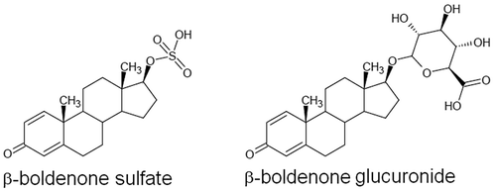

PowerPoint slideOriginal jpg (53.00KB)Display full size
The presence of bold in veal calf urine was first demonstrated by Arts et al. (1996), who detected α-bold in the urine of untreated calves in concentrations ranging from < 0.1 to 2.7 ng ml⁻¹, while β-bold was not observed at levels exceeding 0.1 ng ml⁻¹. These results were confirmed by Sterk et al. (1998) on two bovines of unspecified gender and age.
However, it is necessary to elucidate the mechanisms that lead to the presence of endogenous bold in cattle urine. Faecal contaminations of calf urine could be a source of false positives for free α- and β-bold, due to the transfer of boldenone and/or its precursors from faeces to urine (Sgoifo Rossi et al. 2004; Pompa et al. 2006; Arioli et al. 2008). It has therefore been recommended to pay particular attention to the procedure of bovine urine sampling to prevent faecal contamination in order to avoid boldenone false positives (De Brabander et al. 2004).
The endogenous occurrence of β-bold, α-bold and related substances with hormonal activity in cattle urine and faeces could be linked to the conversion of phytosterols and other steroid precursors in feed (Barthakur et al. 1996; Poelmans et al. 2003; Gallina et al. 2007; Verheyden et al. 2009). In 2004, Nielen et al. stated the importance of investigating the phase II metabolites of bold, asserting that the presence of β-bold conjugates (without specifying the kind of conjugated moiety) in the urine of calves can be considered evidence of illicit treatment. Le Bizec et al. (2006) and Destrez et al. (2009) suggested, in studies carried out on a limited number of Holstein–Friesian calves, that the presence in urine of the sulpho-conjugate fraction could be useful to distinguish between natural situations and the illegal use of β-bold in cattle.
The determination of conjugated forms of anabolic androgen steroids like β-bold is mainly based on the analysis of the free form after a preliminary step of deconjugation, with the use of specific hydrolytic enzymes (glucuronidase and sulphatase) from Escherichia coli or Helix pomatia. After extraction, the analysis of steroids can be performed by gas chromatography–tandem mass spectrometry (GC-MS/MS) or liquid chromatography–tandem mass spectrometry (LC-MS/MS). However, the enzymatic hydrolysis may be incomplete. Moreover, steroid conversion or degradation and artefact formation (Pozo et al. 2008; Gomez et al. 2014) may occur.
As an alternative to the indirect detection (i.e. after enzymatic hydrolysis) of β-bold conjugates, we have developed and validated a method which uses immunoaffinity purification coupled to LC-MS/MS in order to perform direct analysis of the glucuronide and sulphate forms of β-bold (European Commission 2002; Chiesa et al. 2015). In contrast to the present study, in that study the free forms of α- and β-bold, as well as α-bold conjugates and androstadienedione (ADD) were also considered.
In order to verify the possible endogenous origin of β-bold II phase metabolites in young bulls, we carried out a study on urine samples from 56 animals collected at different times at the farm, where the animals were under veterinary control, and at the slaughterhouse. As already shown for the relationship between prednisolone and cortisol (Pompa et al. 2011), we hypothesised that an increase in the release of androstenedione (AED) by the adrenal glands, stimulated by pituitary adrenocorticotropic hormone (ACTH), could lead to the production of bold through the formation of ADD.
Additionally, we performed a histological examination of the accessory sex glands of each animal, a screening test introduced in Italy in 2009 by the Ministry of Health to control the illegal use of sex hormones (Piano Nazionale Residui 2009 – Ministero della Salute). This strategy is based on the biological effects of the different steroid classes in target organs. Morphological alterations to the accessory sex glands of boldenone-treated animals were reported by Groot and Biolatti (2004) and Cannizzo et al. (2007). The official monitoring of residues in cattle throughout the European Union in 2012 found 0.25% non-compliance for the use of illegal growth promoters, including sex steroids, corticosteroids and β-agonists. In particular, in the group of steroids (A3), there were 0.09% non-compliant samples in all animal and product categories. These figures may underestimate the real incidence of steroid abuse in meat cattle breeding.
The conditions that could lead to the detectable presence of β-bold glucuronide and sulphate in the urine were hence considered: uncontrolled, stressed animals upon arrival at the farm, animals in non-stressful conditions after an adequate period of adaptation, and animals stressed by transport and slaughtering operations. In this last case, histological alterations to the bulbourethral and prostate glands were also studied.

Materials and methods

Chemicals and reagents
Methanol (HPLC-MS grade), ethanol (HPLC grade) were purchased from Fluka (Sigma-Aldrich, St. Louis, MO, USA). Formic acid 98–100% was from Riedel-de-Haën (Sigma-Aldrich, St. Louis, MO, USA). Ultrapure water was prepared with a Milli-Q Plus apparatus (Millipore, Molsheim, France).
β-Bold sulphate (triethylamine salt) and β-bold glucuronide were procured from LGC Standards (Teddington, UK). Internal standards were β-bold sulphate-d3 for the sulphate form and epitestosterone (EpiT) glucuronide-d3 for β-bold glucuronide (National Measurement Institute, Pymble, NSW, Australia). Stock solutions of each analyte and of the internal standards were prepared in methanol at a concentration of 1 mg l⁻¹ and stored at −40°C. Working solutions were prepared daily by diluting the stock solutions. Immunoaffinity columns (IAC) were from Randox. Concentrated wash and storage buffers were supplied with the columns and diluted following the manufacturer’s instructions before use (DM 2185, Randox Laboratories, Antrim, UK).

Animal housing and urine collection
The study was performed on 47 Charolaise, 4 Limousine and 5 Charolaise–Limousine cross-breed young bulls, totalling 56 animals. They were reared in France, transported to Italy, housed for 7 months in a farm, and slaughtered in an abattoir, both located in Piedmont. At the beginning of the study, the animals aged 13 months and weighed 300–350 kg. The young bulls were accommodated on a solid concrete floor bedded with straw, in loose conditions (each animal had a pen area allowance of 5.0 m²). All animals were fed a concentrated diet of cattle feed core green line (Astesana Spa, Villafalletto, Cuneo, Italy) (18%), corn silage (36.5%), corn meal (13%), cereal straw (6%) and corn mash (26.5%). Water was supplied ad libitum. Throughout the experimental period, the animals were under the control of Official Veterinarians of the National Health Service, who also collected urine at different times. The first collection was performed upon arrival (T1) at the farm. The second urine collection was performed at the farm after a five-month adaptation period (T2) in order to assess untreated, unstressed animals. The first and the second urine samples at the farm were collected into long-handled sterile container and collection was performed in the morning hours under conditions of natural micturition, as recommended by the Italian National Residues Plan (Ministero Della Salute 2013). The third urine sampling was performed at the slaughterhouse after a period of 7 months (T3) of residence at the farm, when the age of the animals was 20 months and their weight was about 550–600 kg. This last urine sample was collected directly from the urinary bladder immediately after slaughter. A visual inspection was made to check the turbidity or the presence of raw materials. Only clean urine was sampled, frozen and taken to the laboratory for storage at −40°C until extraction and analysis.

Tissue collection
The bulbourethral and prostate glands of each animal were collected after slaughter. Tissue samples were fixed in 10% neutral-buffered formalin overnight at room temperature and paraffin-embedded according to routine histological procedures. Representative sections of each sample were stained with haematoxylin–eosin (HE).

Sample preparation, extraction, LC-MS/MS analysis, validation and analyte quantification
Urine extraction and analysis were performed as previously described by Chiesa et al. (2015). Briefly, a 5 ml centrifuged urine sample spiked with internal standards (2 ng ml⁻¹) and adjusted to pH 8 with 0.1 N NaOH was loaded into a previously washed IAC column (5 ml ethanol:water; 70:30, v/v) and equilibrated (3 × 5 ml wash buffer). The column was then washed (wash buffer, 2 × 5 ml and water, 1 × 5 ml). The elution was performed with 4 ml ethanol:water (70:30, v/v) (all the flow rates were ≤ 3 ml min⁻¹). The eluate was evaporated until dry in a rotary evaporator, reconstituted in 500 µl of methanol:water (50:50; v/v) and transferred to an autosampler vial. A volume of 10 µl was analysed by LC-MS/MS. The LC apparatus and chromatographic conditions were: Surveyor AS autosampler and Surveyor MS quaternary pump (ThermoFisher Scientific, San Jose, CA, USA), Synergi Hydro RP reverse-phase HPLC column 150 × 2.0 mm, i.d. 4 µm, with a C18 4 × 3.0 mm guard column (Phenomenex, Torrance, CA, USA), kept at 30°C. The mobile phase consisted of 0.1% aqueous formic acid (solvent A) and methanol (solvent B) with a flow rate of 200 μl min⁻¹. The gradient programme was: from 0 to 1 min A was kept at 40%, then decreased to 5% in 11 min, and maintained for 1 min, then A was increased again to 40% from 13 to 15 min; the last 7 min were in isocratic elution (A = 40% and B = 60%). The run length was 22 min. The MS/MS apparatus and conditions were: triple quadrupole TSQ Quantum (Thermo Fisher Scientific, San Jose, CA, USA) equipped with an electrospray interface (ESI) set both in positive and negative ionisation mode; capillary voltage 3.5 kV; ion transfer capillary temperature 340°C; nitrogen as the sheath and auxiliary gas at 30 and 10 arbitrary units, respectively; argon as the collision gas at 1.5 mTorr and peak resolution 0.70 Da FWHM; the scan time for each monitored transition was 0.1 s and the scan width was 0.5 amu. The acquisition was performed in multiple reaction monitoring (MRM) after selecting, for each analyte and internal standard, four diagnostic product ions, one of which used for quantification (Table 1). Data were acquired and elaborated by Xcalibur™ software from Thermo. Figure 2 shows the reconstructed chromatograms with the ion spectra of β-bold glucuronide and sulphate in the solvent. The validation protocol, performed according to the European Commission 2002/657/EC, is described by Chiesa et al. (2015). The analytes were quantified through a matrix calibration curve prepared with seven levels and three replications in the range 0.1–5.0 ng ml⁻¹.

Table 1. MS/MS conditions for the MRM acquisitions of analytes and internal standards. Ions for quantification are in bold. CE (eV): collision energy.
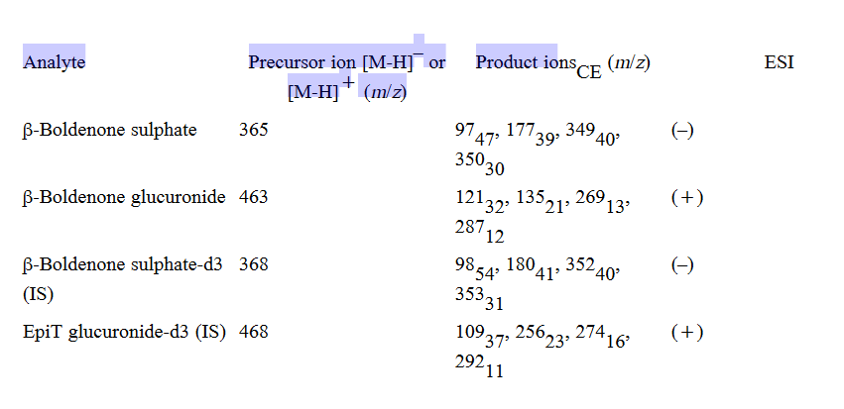

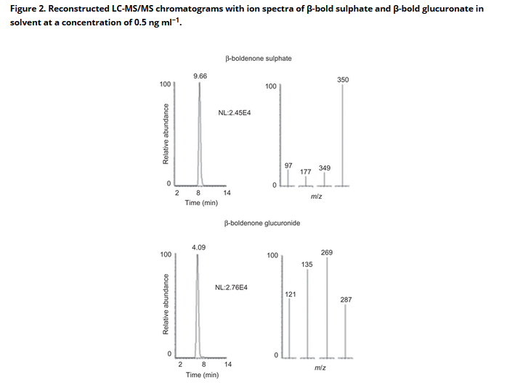

Statistical analysis
All statistical analyses were performed by taking into account only the samples in which β-bold sulphate and glucuronate were found. The Kolmogorov–Smirnov test was performed to check the normality of the positive results from each data set and the non-parametric Spearman correlation test was used to verify the effective pairing of the data sets. The differences in the results obtained from the analysis were checked using the Wilcoxon matched-pairs signed-rank test. The null hypothesis was set at P > 0.05. GraphPad InStat version 3.10 for Windows (GraphPad Software, San Diego, CA, USA) was used to perform these calculations.

Results and discussion

Validation and analyte quantification
The parameters of the validation are reported here in a summarised way: linear matrix validation curves for each analyte were in the range from 0.05 to 0.2 ng ml⁻¹ (r² = 0.99 for both analytes) (6 samples × 3 concentration levels × 3 series = 54 analyses). Intra-day and inter-day repeatability, representing the precision, were calculated by one-way analysis of variance (ANOVA), expressed as CVs, and were below 14.7% and 17.0%, respectively. The mean recoveries ranged between 93% and 109%. The CCα value, calculated as described in the document SANCO/2004/2726 revision 4, was 0.07 ng ml⁻¹ and the CCβ value was 0.09 ng ml⁻¹ for both analytes. The values of the decision limit (CCα) and detection capability (CCβ) were significantly lower than the actual recommended concentration set at 1 ng ml⁻¹ for β-bold (Community Reference Laboratories 2007). Both matrix calibration curves for analytes quantification showed a correlation coefficient higher than 0.99.

Urine analyses
The reconstructed chromatograms with ion spectra of β-bold sulphate and β-bold glucuronate in a urine sample at the three different times of collection are shown in Figure 3. The results of this study are reported in Table 2. The most evident datum is the lack of detection of both β-bold conjugates in urine samples collected at the slaughterhouse. Moreover, the phase II metabolites were found with a lower frequency at collection time T1 than at T2, i.e. 32% and 78% for β-bold sulphate, and 18% and 46% for β-bold glucuronide, respectively. The three collection times were chosen due to their correspondence to different stress conditions: the collection at T1 occurred after transport stress, at T2 there were no stressors, at T3 the animal had transport and slaughter stresses. The cause of stress can be psychological (restraint, handling, unfamiliar smell, breakdown of social groupings, crowding) or physical (hunger, thirst, noise, etc.) (Grandin 1997; Warriss 2010; Adzitey 2011), and animals respond to stressful challenges in their environment through interacting mechanisms that include neuro-hormonal parameters (Fazio & Ferlazzo 2003). It can be supposed that, even if the listed causes of stress are related to both transport and slaughtering, the cattle perceives with greater intensity the stimuli at the slaughterhouse (i.e. the smell of blood). In addition, the young bulls underwent a long period of transport, with grouping in assembly centres and subsequent transfer to the farm where the first urine collection was performed on the day of arrival. An adaptive response to stressors as a function of their duration can be expected (Costa 2009). Due to these considerations, a ranking can be made based on the stress suffered at different sample collection times: T3 (higher stress conditions) > T1 (lower stress conditions) > T2 (presumable absence of stress). If the frequencies in detection of β-bold sulphate and glucuronate are considered, an inverse relationship was found. It is therefore conceivable that the starting hypothesis expressed in the introduction, i.e. a positive correlation between stress and ACTH-induced boldenone release, has to be turned upside down. In the urine collected at T2, when the animals were under control for five months, we found more positive samples, demonstrating the production of endogenous bold and, by the comparison with T1 and T3 samples, a possible inhibitory role of stress on bold production, dependent on individual variability. In fact, all the animals positive to β-bold glucuronide were positive to β-bold sulphate both at T1 (n = 10) and T2 (n = 26); all the animals positive to β-bold glucuronide at T1 (n = 10) were positive at T2; all the animals positive to β-bold sulphate at T1 (n = 18) were positive at T2; the phase II metabolites were never found in 12 young bulls. The detected concentrations of β-bold sulphate were related to the frequencies, i.e. they were statistically higher when the frequencies of detection were higher. A similar observation does not seem feasible for the glucuronide metabolite, as there was no statistical difference. The high standard deviations, however, did not allow for finding a difference between the average values at T2 and T1. The means per se and the maximum values were higher at T2, as for β-bold sulphate. The T2 concentrations of β-bold sulphate were higher than the T1 maximum concentration in 11 of 44 samples, i.e. in about 25% of the samples, while the T2 concentrations of β-bold glucuronide were above the T1 maximum concentration in 9 of 26 samples, i.e. in about 35% of the samples. This higher percentage seems to indicate an actual difference between the concentrations of β-bold glucuronide at the first two time points. Also for the concentrations, a negative correlation between stress and β-bold endogenous production was suggested; this hypothesis is strengthened by the consideration that the animals at T1 had just been put under veterinary control for bold treatment, thus we cannot exclude a lower frequency of detection and concentration of β-bold conjugates of endogenous origin at the first sampling.
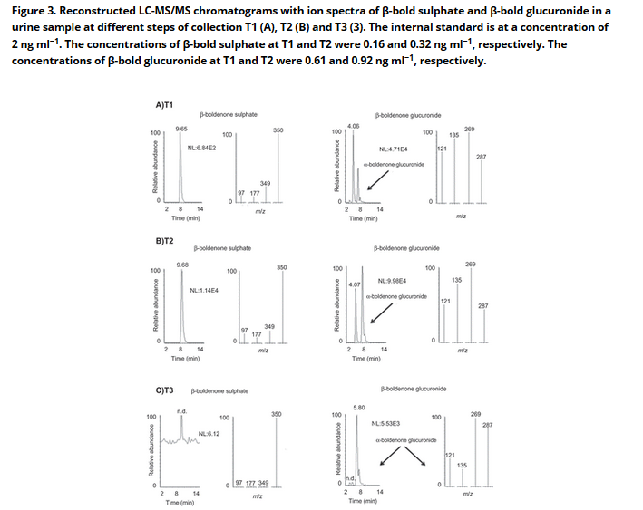

Table 2. Number of young bull urine samples analysed and found positive for β-boldenone sulphate and glucuronide at different times on the farm (T1 = arrival; T2 = after five months) and after slaughtering (T3 = 7 months); mean, minimum and maximum concentrations of the two conjugated forms.

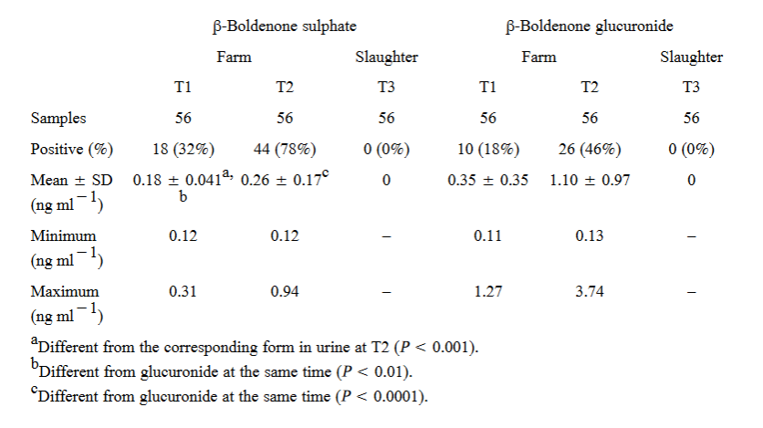

The concentration of the sulphate form found in our study was higher than has been described in the literature. In a study in 2004, performed using GC-MS, Sterk et al. stated that almost all boldenone excreted in urine is present as the glucuronic acid conjugate. In 2009, Destrez et al. proposed β-bold sulphate as a candidate marker of treatment. Both studies were performed on treated (bold or ADD) bovines. Particularly the second study, performed using LC-MS/MS, showed a CCα value of 0.2 ng ml⁻¹ and a CCβ of 0.4 ng ml⁻¹. These higher analytical limits could have caused misleading conclusions, considering that we found β-bold sulphate in 37 urine samples at a concentration lower than the CCα indicated in the previous study, and 21 of these 37 samples were collected in the absence of stress.
Finally, even if determining the endogenous presence of α-bold sulphate and glucuronate was not the aim of the study, because of their nature as conjugates of the epimer of β-bold, the LC-MS/MS method detected their eventual presence. α-Bold sulphate was found just once at T2; α-bold glucuronate was found at the three collection time points, generally together with β-bold glucuronate.

Gross pathology and histopathology
No macroscopic alterations were detected in the genital tracts and accessory sex glands of the examined subjects. In 18.1% (n = 10) of cases, slight prostate ectasia was detected, but sometimes these lesions were associated with other changes, such as slight hypersecretion, which was observed in 5.5% (n = 3) of the examined animals.
Slight hypersecretion of the bulbourethral glands was observed in 16.4% (n = 9) of cases, and slight ectasia was detected in 3.6% of the examined glands.

Conclusions

Jump to section
- Introduction
- Materials and methods
- Results and discussion
- Conclusions
- Disclosure statement
The analyses performed on urine samples from 56 young bulls at three collection times showed that β-boldenone conjugates, both the sulphate and glucuronide forms, can be naturally present with variable concentrations in urine collected at the farm.
The finding that β-boldenone conjugates were not found at the slaughterhouse is of note. A negative influence of stress on bold endogenous production is conceivable. The results obtained from urine collected at the farm confirm this hypothesis. This study indicates that β-bold sulphate presence is not a biomarker of treatment per se when urine sample collection is performed at the farm; it still needs to be ascertained if a cut-off level can be set for both β-bold conjugates. The presence of β-bold sulphate and glucuronide in urine at the slaughterhouse could contrariwise represent a useful parameter for the control of illicit treatments. To this aim, a study on urine collected at the slaughterhouse from treated animals should be performed. No relevant morphological alterations to the sexual organs and associated glands were detected in these animals. These results are compatible with the physiological findings typical of untreated animals.

Disclosure statement

Jump to section
- Introduction
- Materials and methods
- Results and discussion
- Conclusions
- Disclosure statement
No potential conflict of interest was reported by the author(s).

Acknowledgements
The authors wish to thank Nicola Brina and Piero Giorgi whose involvement allowed “Coop Italia Società Cooperativa” to fund the study; they also are grateful to the “Bruno Maria Zaini” Reference Centre of Comparative Pathology, School of Veterinary Medicine of the University of Turin, Italy. Elisa Pasquale is the recipient of a Cariplo Ph.D. fellowship in Animal Production in the Laboratory of Inspection of Food of Animal Origin at the University of Milan.

References
- 1. Adzitey F. 2011. Effect of pre-slaughter animal handling on carcass and meat quality. Int Food Res J. 18:484–490.
- 2. Arioli F, Gavinelli MP, Fracchiolla ML, Casati A, Fidani M, Ferrer E, Pompa G. 2008. Evaluation of boldenone formation and related steroids transformations in veal faeces by liquid chromatography/tandem mass spectrometry. Rapid Commun Mass Sp. 22:217–223. [CrossRef], [PubMed], [Web of Science ®]
- 3. Arts C, Schilt R, Schreurs M, Van Ginkel L 1996. Boldenone is a naturally occurring (anabolic) steroid in cattle. Proceedings EuroResidue III, Veldhoven, the Netherlands. pp. 212–217.
- 4. Barthakur S, Roy MK, Bera SK, Ghosh AC. 1996. Steroid transformation by mutants of Mycobacterium sp. with altered response to antibiotics. J Basic Microb. 36:383–387. [CrossRef], [PubMed], [Web of Science ®]
- 5. Cannizzo FT, Zancanaro G, Spada F, Mulasso C, Biolatti B. 2007. Pathology of the testicle and sex accessory glands following the administration of boldenone and boldione as growth promoters in veal calves. J Vet Med Sci. 69:1109–1116. [CrossRef], [PubMed], [Web of Science ®]
- 6. Chiesa LM, Pavlovic R, Dusi G, Pasquale E, Casati A, Panseri S, Arioli F. 2015. Determination of α- and β-boldenone sulfate, glucuronide and free forms, and androstadienedione in bovine urine using immunoaffinity columns clean-up and liquid chromatography tandem mass spectrometry analysis. Talanta. 131:163–169. [CrossRef], [PubMed], [Web of Science ®]
- 7. Community Reference Laboratories. 2007. Guidance CRL. Paper of 7th December 2007. CRLs view on state of the art analytical methods for national residue control plans.Available from: http://www.bvl.bund.de/EN/09_Laboratories/01_Tasks/02_reference_laboratories/01_reference_laboratories_EURL/reference_laboratories_EU_node.html
- 8. Costa LN. 2009. Short-term stress: the case of transport and slaughter. Ital J Anim Sci. 8:241–252. [Taylor & Francis Online], [Web of Science ®]
- 9. De Brabander HF, Poelmans S, Schilt R, Stephany RW, Le Bizec B, Draisci R, Sterk S, Van Ginkel L, Courtheyn D, Van Hoof N, Macrì A, De Wasch K. 2004. Presence and metabolism of the anabolic steroid boldenone in various animal species: a review. Food Addit Contam. 21:515–525. [Taylor & Francis Online], [PubMed], [Web of Science ®]
- 10. Destrez B, Bichon E, Rambaud L, Courant F, Monteau F, Pinel G, Antignac JP, Le Bizec B. 2009. Criteria to distinguish between natural situations and illegal use of boldenone, boldenone esters and boldione in cattle: 2. Direct measurement of 17β-boldenone sulpho-conjugate in calf urine by liquid chromatography–high resolution and tandem mass spectrometry. Steroids. 74:803–808. [CrossRef], [PubMed], [Web of Science ®]
- 11. European Commission. 1996. EEC Council Directive N° 23/ 1996 on measures to monitor certain substances and residues thereof in live animals and animal products and repealing Directives 85/358/EEC and 86/469/EEC and decision 89/187/EEC and 91/664/EEC. Off J Eur Commun L. 125:10–32.
- 12. European Commission. 2002. Commission Decision of 12 August 2002 implementing Council Directive 96/23/EC concerning the performance of analytical methods and the interpretation of results. Off J Eur Commun L. 221:8–36.
- 13. European Union, European Commission, Health & Consumer Protection, Directorate General, Directorate D, Food Safety: production and distribution chain D3, chemical and physical risks; surveillance, Boldenone Control In Veal Calves–Draft Proposal, 30 Sep; Brussels.
- 14. European Union, European Commission, Health & Consumer Protection, Directorate General Directorate E, Safety of the Food Chain, Document SANCO/2004/2726‐revision 4, December 2008, Guidelines for the Implementation of Decision 2002/657/EC.
- 15. Fazio E, Ferlazzo A. 2003. Evaluation of stress during transport. Vet Res Commun. 27:519–524. [CrossRef], [PubMed], [Web of Science ®]
- 16. Fidani M, Gamberini MC, Pasello E, Palazzoli F, De Iuliis P, Montana M, Arioli F. 2009. Evaluation of equine urine reactivity towards phase II metabolites of 17‐hydroxy steroids by liquid chromatography/tandem mass spectrometry. Rapid Commun Mass Sp. 23:65–76. [CrossRef], [PubMed], [Web of Science ®]
- 17. Gallina G, Ferretti G, Merlanti R, Civitareale C, Capolongo F, Draisci R, Montesissa C. 2007. Boldenone, boldione, and milk replacers in the diet of veal calves: the effects of phytosterol content on the urinary excretion of boldenone metabolites. J Agric Food Chem. 55:8275–8283. [CrossRef], [PubMed], [Web of Science ®]
- 18. Gomez C, Fabregat A, Pozo ÓJ, Marcos J, Segura J, Ventura R. 2014. Analytical strategies based on mass spectrometric techniques for the study of steroid metabolism. Trends Anal Chem. 53:106–116. [CrossRef], [Web of Science ®]
- 19. Grandin T. 1997. Assessment of stress during handling and transport. J Anim Sci. 75:249–257. [PubMed], [Web of Science ®], [CSA]
- 20. Groot MJ, Biolatti B. 2004. Histopathological effects of boldenone in cattle. J Vet Med A Physiol Pathol Clin Med. 51:58–63. [CrossRef], [PubMed]
- 21. Le Bizec B, Courant F, Gaudin I, Bichon E, Destrez B, Schilt R, Draisci R, Monteau F, André F. 2006. Criteria to distinguish between natural situations and illegal use of boldenone, boldenone esters and boldione in cattle: 1. Metabolite profiles of boldenone, boldenone esters and boldione in cattle urine. Steroids. 71:1078–1087. [CrossRef], [PubMed], [Web of Science ®]
- 22. Ministero Della Salute; Dipartimento Della Sanità Pubblica Veterinaria, Della Sicurezza Alimentare E Degli Organi Collegiali Per La Tutela Della Salute; Direzione Generale Per L’igiene E La Sicurezza Degli Alimenti E La Nutrizione; Piano Nazionale Per La Ricerca Di Residui, Relazione Finale Anno 2009.
- 23. Ministero Della Salute; Dipartimento Della Sanità Pubblica Veterinaria, Della Sicurezza Alimentare E Degli Organi Collegiali Per La Tutela Della Salute; Direzione Generale Per L’igiene E La Sicurezza Degli Alimenti E La Nutrizione; Piano Nazionale Per La Ricerca Di Residui, Relazione Finale Anno 2013.
- 24. Nielen MWF, Rutgers P, Bennekom EOV, Lasaroms JJP, Van Rhijn JA. 2004. Confirmatory analysis of 17β-boldenone, 17α-boldenone and androsta-1, 4-diene-3, 17-dione in bovine urine, faeces, feed and skin swab samples by liquid chromatography–electrospray ionisation tandem mass spectrometry. J Chromatogr B. 801:273–283. [CrossRef], [PubMed], [Web of Science ®]
- 25. Ój P, Van Eenoo P, Van Thuyne W, Deventer K, Delbeke FT. 2008. Direct quantification of steroid glucuronides in human urine by liquid chromatography–electrospray tandem mass spectrometry. J Chromatogr A. 1183:108–118. [CrossRef], [PubMed], [Web of Science ®]
- 26. Piper T, Geyer H, Gougoulidis V, Flenker U, Schänzer W. 2010. Determination of 13C/12C ratios of urinary excreted boldenone and its main metabolite 5β‐androst‐1‐en‐17β‐ol‐3‐one. Drug Test Anal. 2:217–224. [CrossRef], [PubMed], [Web of Science ®]
- 27. Poelmans S, De Wash K, Martelé Y, Schilt R, Van Hoof N, Noppe H, Verslycke T, Janssen C, Courtheyn D, De Brabander H 2003. The possible transformation of phytosterols to boldenone. Strategies for safe food. Analytical, industrial and legal aspects: challenges in organization and communication. Proc. Euro Food Chem XII, Bruges, Belgium. 74–77.
- 28. Pompa G, Arioli F, Casati A, Fidani M, Bertocchi L, Dusi G. 2011. Investigation of the origin of prednisolone in cow urine. Steroids. 76:104–110. [CrossRef], [PubMed], [Web of Science ®]
- 29. Pompa G, Arioli F, Fracchiolla ML, Rossi CAS, Bassini AL, Stella S, Biondi P. 2006. Neoformation of boldenone and related steroids in faeces of veal calves. Food Addit Contam. 23:126–132. [Taylor & Francis Online], [PubMed], [Web of Science ®]
- 30. Scarth J, Akre C, Van Ginkel L, Le Bizec B, De Brabander HF, Korth W, Points J, Teale P, Kay J. 2009. Presence and metabolism of endogenous androgenic–anabolic steroid hormones in meat-producing animals: a review. Food Addit Contam. 26:640–671. [Taylor & Francis Online], [Web of Science ®]
- 31. Sgoifo Rossi CA, Arioli F, Bassini A, Chiesa LM, Dell’Orto V, Montana M, Pompa G. 2004. Evidence for false-positive results for boldenone testing of veal urine due to faecal cross-contamination during sampling. Food Addit Contam. 21:756–762. [Taylor & Francis Online], [PubMed]
- 32. Sterk S, Van Tricht F, Van Soeren-Kieft A, Herbold H, Stephany R, Van Ginkel L. 1998. Bank of reference samples of blank urine from livestock. Fresen J Anal Chem. 360:454–455. [CrossRef]
- 33. Verheyden K, Noppe H, Vanhaecke L, Wille K, Bussche JV, Bekaert K, Thas O, Janssen CR, De Brabander HF. 2009. Excretion of endogenous boldione in human urine: influence of phytosterol consumption. J Steroid Biochem Mol Biol. 117:8–14. [CrossRef], [PubMed], [Web of Science ®]
- 34. Warriss PD. 2010. Meat science (Second Edition): an introductory text. Oxfordshire: CAB International.

