Fuel desulfurization/denitrification via adsorption or extraction: a complementary approach to oxidative treatments

Emanuela Calcio Gaudino¹, Diego Carnaroglio¹, Stefano Mantegna¹, Silvia Tabasso², Elizabeth M. Moreira³, Giancarlo Cravotto¹*

¹Dipartimento di Scienza e Tecnologia del Farmaco, and NIS - Centre for Nanostructured Interfaces and Surfaces, University of Turin, via P. Giuria 9, 10125 Torino, Italy.
²Dipartimento di Chimica, University of Turin, via P. Giuria 7, 10125 Torino, Italy.
³Centro de Pesquisas e Desenvolvimento Leopoldo Américo Miguez de Mello, Cenpes/Petrobras, 21941-915 Rio de Janeiro, RJ, Brazil.
* Fax: +39.011.6707687; e.mail: giancarlo.cravotto@unito.it

Abstract
Strict rules and environmental concerns make the production of clean fuels that display very low sulfur content mandatory for the petroleum refining industry. In parallel, nitrogenated compounds present in feedstock are deleterious for the various processes in a refinery. Herein, diesel oil desulfurization and denitrification via adsorption or extraction have been investigated as sequential and complementary treatments to oxidative protocols. Diesel fuel (S = 231 ppm and N = 115 ppm) has been treated with a number of adsorbents (including commercial silica gel and Fuller’s Earth powder) at room temperature in fixed bed cartridges. Comparisons with typical extraction procedures showed that processes with suitable adsorption agents were more efficient in terms of both residual S/N content and fuel mass balance. These simple adsorption methods can be applied to any refining processes as pre- or post-treatment. The application of these methods in oxidative desulfurization/denitrification has been found to be particularly beneficial.
1. Introduction
The presence of high levels of sulfur (S) and nitrogen (N) compounds in diesel fuels is still a major source of SOx, sulfate particulate matter (SPM) and NOx emissions which all contribute to air pollution (Wagner et al., 2010). In recent years, many countries have introduced more stringent regulations in order to reduce S levels in fuel oil to ultra-low levels (S<10-15 ppm) (www.epa.gov/otaq/diesel.htm; Velu et al., 2003; Stanislaus et al., 2010). Current hydrodesulfurization (HDS) processes, used by oil refineries, require CoMo/Al₂O₃ or NiMo/Al₂O₃ catalysts and severe operating conditions and thus entail large amounts of expensive hydrogen gas and energy (300-400°C, 4-5 MPa) (Tawara et al., 2001; Song et al., 2003; Mochida et al., 1996). Although the traditional HDS process is highly efficient in removing thiols, sulfides and disulfides, this approach is relatively ineffective in removing more refractory S-compounds, which include benzothiophene (BT), dibenzothiophene (DBT), and their alkyl derivatives, 4-methyldibenzothiophene (4-MDBT) and 4,6-dimethyldibenzothiophene (4,6-DMDBT). Similarly N-compounds, such as quinoline and carbazole, are quite refractory to this treatment (Yang et al., 2003). This limitation, largely attributed to the steric hindrance of these compounds, has prompted the development of new liquid fuel desulfurization and denitrification methods. Ideally, a process that avoids the use of hydrogen and yet provides cleaner and cheaper diesel is needed to produce ultra-low sulfur/nitrogen diesel (ULSND) (Srivastava, 2012; Stanislaus et al., 2010). Several trends toward minimizing S content in fuels are currently coming to the fore, these include: oxidative desulfurization and denitrification (ODS/ODN) (Collins et al., 1997; Martin et al., 2004; Duarte et al., 2011; Calcio Gaudino, et al., 2014; Carnaroglio et al., 2014), bio-desulfurization (BDS) (Davoodi-Dehaghani et al., 2010; Boltes et al., 2013), adsorptive desulfurization (ADS) (Wang et al., 2011; Sarda et al., 2012; Zhang et al., 2012; Shahadat Hussain and Tatarchuk, 2013), and extractive desulfurization (EDS) (Kulkarni and Alfonso, 2010), which can even make use of task specific ionic-liquids (Huang et al., 2004; Wilfred et al. 2012). All of these processes seem promising with regards to energy consumption when compared to HDS, because of their mild operating conditions (atmospheric pressure, <100°C), and can all be carried out without hydrogen consumption (Muzic et al., 2010). However, the challenge of developing an easily remunerable adsorbent with a high adsorption capacity and high selectivity for refractory aromatic S/N-compounds still remains.
Several solid polar adsorbents have been used in this role, including zeolite (Zhang et al., 2008; King and Li, 2006; Shan et al. 2008; Hernandez-Maldonado and Yang, 2004), alumina (Hernandez-Maldonado et al., 2005; Yang et al., 2006), charcoal (Kumar and Srivastava, 2012) and silica (Nanoti et al., 2009), which are, in some cases, used in combination with transition metals which are able to form π-complexes between organosulfur compounds and the adsorbents (Shi et al., 2011). Molecular orbital calculations have demonstrated that Cu⁺ forms stronger π-complexation bonding with thiophenic compounds than other transition metals (Yang, 2003; Chen et al., 2009).
This last decade has also seen an ever increasing trend of investigations into the possibility of replacing existing desulfurization processes with extraction techniques. Liquid-liquid (l/l) extraction is an alternative method that can be used for the desulfurization and denitrification of diesel fuels. However, liquid-liquid extraction generates organic waste which requires disposal. In order to minimize costs, solvents should be recyclable, reusable and capable of being regenerated. Recent approaches employ various ionic liquids as selective solvents, due to their general immiscibility with gasoline and diesel, negligible vapour pressure and high selectivity for S- and N-containing compounds (Gabric et al., 2013).
In this work, adsorption and extraction protocols have been optimized and compared. Various commercially available adsorbents and common solvents have been used for liquid/solid (l/s) and l/l treatment. Numerous ADS/N and EDS/N experiments have been carried out in order to identify which system gave the better results, with the final aim of combining the best technique with the ODS and ODN processes.

2. Material and Methods
Most adsorbents and solvents were purchased from Sigma Aldrich - Italy, Silica gel 60 (0.063-0.200 mm) for column chromatography (70-230 mesh ASTM, Specific Surface Area (according to BET): 480-540 m²/g; Pore Volume (N₂-isotherm):0.74-0.84 mL/g; pH value (10% suspension): 6.5-7.5) from MERCK - Germany and Fuller's earth (Pure-Flo Natural B80/M85-20; Particle Size: 77% through 325 mesh < 45 μm; pH value: 7.2 for a suspension 5%) were used. A hydrotreated diesel feedstock (S = 231 ± 3.63 ppm, and N = 115.50 ± 1.25 ppm) was provided by Petrobras (Brazil).
2.1. Analysis
Fuel sample sulfur and nitrogen elemental analyses were performed on a Multi EA® 5000 Analytik Jena - Germany, in accordance with national and international standards (ASTM D 5453 and D 4629). Fuel sample viscosity and density were measured on a viscometer Stabinger SVM 3000 (Anton Paar GmbH, Graz, Austria), according to ASTM D 7042-04.
Diesel oil acidity was determined using the Titrando 836 titration system (Metrohm, Herisau, Switzerland) which was equipped with a magnetic stirrer (module 803 Ti Stand), 20 mL burette (Dosino 800) and pH electrode (LL Electrode plus, model 6.0262.100).
2.2. General procedures
Liquid/Liquid extraction: hydrotreated diesel (10 mL) was shaken for 1 min with either a mixture of MeOH, acetic acid and oxalic acid (aq. solution) or a mixture of MeOH and oxalic acid (aq. solution) (v/v ratio from 1:0.2 to 1:1) in a separatory funnel. After 5 min at 25°C the treated diesel was recovered and analyzed on the EA 5000 without further purification.
Liquid/Solid adsorption: adsorption experiments were carried out at 25°C using 5 g adsorption cartridges (1 cm Ø × 10 cm length). Hydrotreated diesel (10 mL) was eluted through a fixed bed of various solid adsorbents (v/w ratio from 1:0.05 to 1:0.2) using a practical multi-sample vacuum device (water pump at about 19-20 kPa). The sulfur and nitrogen content of the effluent was then analysed on the EA 5000 without further purification.
Liquid/Solid repetitive filtration on the same cartridge: a cartridge filled with the same solid adsorbent (v/w ratio from 1:0.05 to 1:0.2) was employed to filter five portions of fresh hydrotreated diesel over five cycles at 25°C (10 mL for each sample) using a practical multi-sample vacuum device (water pump at about 19-20 kPa). The sulfur and nitrogen content of the effluent was then analysed on the EA 5000 without further purification.
Diesel Oxidation procedure: diesel was oxidized with Oxone or H₂O₂ using a cup-horn like cavitating tube (Danacamerini-Italy) working at 19.9 kHz following a previously reported procedure (Calcio Gaudino, et al., 2014; Carnaroglio et al., 2014). Ultrasound power, reaction time and temperature were defined as follows: 80 W, 90 min and 80°C.

3. Results and discussion
l/l Extraction or l/s adsorption can be used to reduce S and N content in fuels. (please check meaning) The use of commercially available solvents or materials in this process is an essential parameter in developing a complementary and cheaper process to oxidative treatment. Many alternatives, where liquids and solids were used alone or in mixtures, have been evaluated and summarized in this work (table 1).
Table 1
Liquids and solids tested in l/l extraction and l/s adsorption
l/l extraction | l/s adsorption
 | Solid powder | Powder mixture
MeOH  Oxalic acid ª  MeOH+Oxalic acid ª  Acetic acid | Oxalic acid  SiO₂  Activated charcoal  Al₂O₃ ac.  Celite  TsOH ^{b}  Fuller’s earth | A = (Oxalic acid : Fuller’s earth)^{c}  B = (Al₂O₃ ac. : Fuller’s earth)^{c}  C = (Oxalic ac. : Fuller’s earth)^{d}  D = (SiO₂ : Fuller’s earth)^{c}  E = (TsOH : Fuller’s earth)^{c}
ª aqueous solution; ^{b} TsOH (p-toluenesulfonic acid); ^{c} Ratio=1:3 (w/w); d Ratio=1:1 (w/w)

All the liquid and solid agents used are commonly available both at the laboratory and industrial scale and are ready-to-use without pre-treatment. MeOH was chosen as the common polar solvent used in this process but other polar-acidic systems were tested. Polar solid surfaces were used for the adsorption and mixture of materials with Fuller’s earth (Mixture A – E). Hydrotreated diesel, with a total content of N = 115.50 ± 1.25 ppm and S = 231.00 ± 3.63 ppm was used in all experiments. Total content underwent elemental analysis in accordance with national and international standards (ASTM D 5453 and D 4629). The percentage of diesel recovery was evaluated in order to quantify mass loss after the process, in all experiments.
In l/l extraction (table 2), modest results were achieved with MeOH (<25% of N reduction and <15% of S reduction). Best results were obtained using acetic acid (1:1 v/v) which reduced S residual content in diesel to lower than 60% and N content to 30%, while giving nearly quantitative diesel recovery (99%).
Table 2
N and S amount (ppm) after diesel l/l extraction with different extracting systems (initial content in diesel was S = 231 ± 3.63 ppm, and N = 115.50 ± 1.25 ppm)
Entry | Solvent | v/v ratioª | Residual (ppm)  N S
1 | MeOH | 1:1 | 85.79 ± 2.58 | 196.35 ± 6.07
2 | Oxalic acid (aq. solution)^{b} | 1:1 | 90.37 ± 1.23 | 231.00 ± 2.41
 |  | 1:0.5 | 92.12 ± 0.85 | 231.00 ± 1.86
3 | MeOH+  Oxalic acid (aq. solution)^{b,c} | 1:1 | 79.08 ± 3.73 | 231.00 ± 1.70
4 | CH₃COOH | 1:0.2 | 103.69 ± 1.22 | 231.00 ± 2.23
 |  | 1:0.4 | 71.25 ± 0.63 | 207.00 ± 1.58
 |  | 1:0.6 | 54.70 ± 0.45 | 196.00 ± 0.98
 |  | 1:1 | 43.91 ± 0.73 | 161.70 ± 1.19
5 | TsOH (aq. solution) | 1:1 | 51.69 ± 1.21 | 298.00 ± 3.23
ª Diesel : extractant; ^{b} Oxalic acid (5.1 g) dissolved in H₂O (50 mL) (1.1 M, pH = 1);^{c} MeOH (50%) + Oxalic acid (aq. solution) (50%).

This is not only due to the acidic pH (<1) of this extracting agent (the same pH was measured in the aqueous solution of oxalic acid) but probably to the greater repartition of acetic acid in diesel (because of its aliphatic moiety) compared to the oxalic acid aqueous solution. This probably allows for greater protonation in the N aromatic compounds present in diesel, thus enabling their simple extraction in the acidic aqueous phase. While using an aqueous solution of a strong organic acid, such as p-toluenesulfonic acid (pH~1), we encountered the drawback of an increase in S content up to 298 ppm due to a partial distribution of the sulfonic acid itself in the diesel phase.

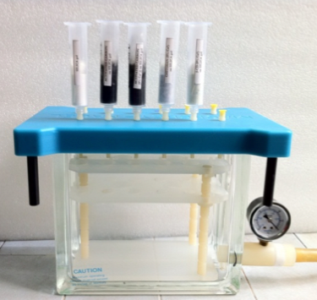 | 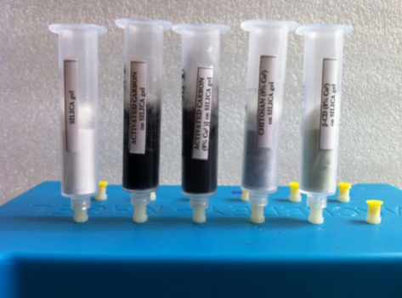
Figure 1. Vacuum device (working at 19-20 kPa) for our fast laboratory filtration processes

A useful vacuum device was used to perform l/s filtration with different cartridges loaded with the solid adsorbents (Figure 1).

Table 3
N and S amount (ppm) after diesel l/s filtration on the different adsorption systems with a ratio (v/w) of 1:0.2 (initial content in diesel was S = 231 ± 3.63 ppm, and N = 115.50 ± 1.25 ppm)
Entry | Adsorbent | Residual (ppm) |  | Diesel recovery  (%)
 |  | N | S
1 | Oxalic ac. | 103.17 ± 0.92 | 231.00 ± 2.04 | 98
2 | SiO₂ | 9.03 ± 0.45 | 150.15 ± 0.90 | 76
3 | Al₂O₃ ac. | 50.85 ± 1.59 | 173.25 ± 1.96 | 94
4 | Celite | 115.50 ± 1.22 | 231.00 ± 5.23 | 90
5 | TsOH | 90.16 ± 0.67 | 334.95 ± 8.33 | 100
6 | Fuller’s earth | 52.95 ± 3.29 | 184.80 ± 4.31 | 100
7 | SiO₂/charcoal | 2.45 ± 0.30 | 100.05 ± 0.72 | 52
8 | Mixture A | 63.81 ± 0.45 | 196.35 ± 2.27 | 96
9 | Mixture B | 43.62 ± 0.30 | 173.25 ± 4.79 | 92
10 | Mixture C | 83.82 ± 4.34 | 219.45 ± 9.23 | 96
11 | Mixture D | 58.74 ± 0.85 | 173.25 ± 1.38 | 86
12 | Mixture E | 67.85 ± 1.48 | 207.38 ± 3.82 | 96

As far as adsorption protocols are concerned, Table 3 compares the different adsorption efficiencies of the various adsorbents used for S and N removal. This depends on adsorbent properties and the nature of the S and N compounds to be removed. In these l/s adsorptions, excellent results were obtained with solid media such as SiO₂ (entry 2, Table 3), acidic Al₂O₃ (entry 3, Table 3) and its mixture with Fuller's earth (Mixture B and D). N and S content reduction of up to 93% and 35%, respectively, was obtained. Another important parameter is final diesel recovery that was unsatisfactory with SiO₂.
Unexpected results were obtained from Fuller’s earth (entry 6, Table 3), which is generally used as an inert solid to increase surface contact area, but in this case proved itself to be an efficient and cheaper diesel desulfurization and denitrification system. Fuller’s earth chiefly consists of hydrated aluminium silicates that contain metal ions such as magnesium (Hydrous Magnesium Silicate), sodium and calcium within their structure. Montmorillonite is the main clay mineral in Fuller’s earth, but other minerals such as kaolinite, attapulgite and palygorskite also occur and account for its variable chemical composition. Although it is similar in appearance to clay, Fuller’s earth differs as it is more finely-grained and has little natural plasticity. The substance is found in a wide range of natural colours, from brown or green to yellow and white. Fuller’s earth is used to refine and decolourize petroleum products, cottonseed and soy oils, tallow and other fats and oils.
Comparing the results obtained with Fuller’s earth (entry 6, Table 3) with the data from the combination of Fuller’s earth and other adsorbents (entry 8-12, Table 3), it becomes clear that the principle role in S and N adsorption was being played by Fuller’s earth.
Considering the good performance of SiO₂ and Fuller’s earth, a fine screening was extended to those solid adsorbents.
Table 4
N and S amount (ppm) after diesel l/s filtration at various SiO₂ and Fuller’s earth ratios (v/w) (initial content in diesel was S = 231 ± 3.63 ppm, and N = 115.50 ± 1.25 ppm)
Entry | Adsorbent | l/s ratioª | Residual (ppm) |  | Diesel recovery (%)
 |  |  | N | S
1 | SiO₂ | 1:0.05 | 100.03 ± 0.49 | 207.90 ± 6.85 | 96
2 |  | 1:0.1 | 84.38 ± 1.40 | 184.80 ± 3.45 | 90
3 |  | 1:0.2 | 78.93 ± 4.98 | 183.20 ± 6.10 | 84
4 |  | 1:0.3 | 52.45 ± 2.34 | 163.18 ± 2.87 | 79
5 |  | 1:0.4 | 35.21 ± 1.98 | 161.68 ± 2.13 | 69
6 |  | 1:0.5 | 15.98 ± 0.77 | 120.32 ± 5.41 | 60
7 |  | 1:0.6 | 9.28 ± 1.57 | 115.50 ± 8.38 | 58
8 | Fuller’s earth | 1:0.05 | 95.26 ± 5.40 | 207.90 ± 10.23 | 99
9 |  | 1:0.1 | 71.82 ± 0.63 | 196.35 ± 6.50 | 99
10 |  | 1:0.2 | 58.98 ± 0.71 | 184.80 ± 5.60 | 98
11 |  | 1:0.3 | 39.00 ± 0.72 | 184.80 ± 5.97 | 85
12 |  | 1:0.4 | 36.90 ± 0.38 | 184.80 ± 9.45 | 72
13 |  | 1:0.5 | 23.77 ± 0.58 | 173.25 ± 4.17 | 60
14 |  | 1:0.6 | 6.20 ± 0.54 | 150.15 ± 4.83 | 50
ª v/w (adsorbent:diesel)

Two parameters must be considered when selecting the best l/s ratio (v/w): N and S residual content and diesel recovery. Table 4 shows a study of the effect of SiO₂:Fuller’s earth ratio on results; good results in terms of N and S residual content were achieved using a l/s ratio of 1:0.6, however, that ratio gave a diesel mass loss of about 50%. This loss is far too high for industrial applications and a compromise is required. An l/s ratio of 1:0.2 allows interesting N and S residual content values (entries 3,10; Table 4). Fuller's earth affinity to N and S compounds was as good as silica’s, but its diesel recovery was higher: Table 4 diesel recovery was 98% as seen under entry 10. A 2% diesel loss is still too high for an industrial plant, however the scaling-up process will clearly reduce this gap.
Five consecutive filtrations on SiO₂ and Fuller’s earth cartridges (l/s ratio = 1:0.2 v/w) were then performed to evaluate the N and S adsorption limit on those materials (Figure 2).
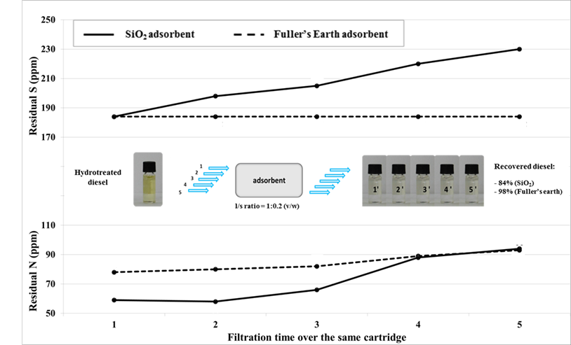
Figure 2. SiO₂ and Fuller’s earth S/N adsorption efficiency after diesel l/s repetitive filtration on the same cartridge (initial content in diesel was S = 231 ± 3.63 ppm, and N = 115.50 ± 1.25 ppm)

Fuller’s earth gave better retention than SiO₂ and allows higher diesel recovery to be achieved even after five filtrations (Figure 2).
Full cartridge regeneration was obtained via MeOH elution (3x5 mL) and material drying at 60°C (1 h). The results obtained after diesel filtration on regenerated cartridges (entries 1 and 2, Table 5) were comparable with the data obtained on the fresh ones (Figure 2). In this way, the same cartridge can be used for many cycles. The process does not generate large amounts of adsorbent waste, concentrating S and N compounds in MeOH.
Table 5
N and S amount (ppm) after diesel l/s filtration on MeOH regenerated SiO₂ and Fuller’s earth cartridges
Entry | Adsorbentª | Residual (ppm) |  | Diesel recovery  (%)
 |  | N | S
1 | SiO₂ | 77.82 ± 2.89 | 183.22 ± 3.21 | 83
2 | Fuller’s earth | 54.17 ± 0.76 | 185.44 ± 2.32 | 98
ª l/s ratio = 1:0.2 (v/w)
The main diesel quality parameters (density, viscosity and acidity) are not affected by SiO₂ and Fuller’s earth treatment (Table 6).
Table 6
Physical parameters of diesel samples before and after adsorption treatment
Treatment | Density  (g cm⁻³, 20°C) | Viscosity  (mm² s⁻¹, 40°C) | Acidity  (mg KOH g⁻¹)
Untreated | 0.8683 ± 0.0003 | 4.3165 ± 0.0054 | < 0.02
SiO₂ | 0.8670 ± 0.0008 | 4.3177 ± 0.0049 | < 0.02
Fuller’s earth | 0.8639 ± 0.0011 | 4.3167 ± 0.0114 | < 0.02

The methods described above were combined with ODS and ODN processes in an attempt to further improve S and N removal from diesel. In order to evaluate the efficacy of the tested procedures, hydrogen peroxide and Oxone were used as oxidizing agents (Calcio Gaudino, et al., 2014; Carnaroglio et al., 2014), while Fuller’s earth and MeOH were chosen as the best pre- and post- treatment agents, used to remove native or oxidized compounds.
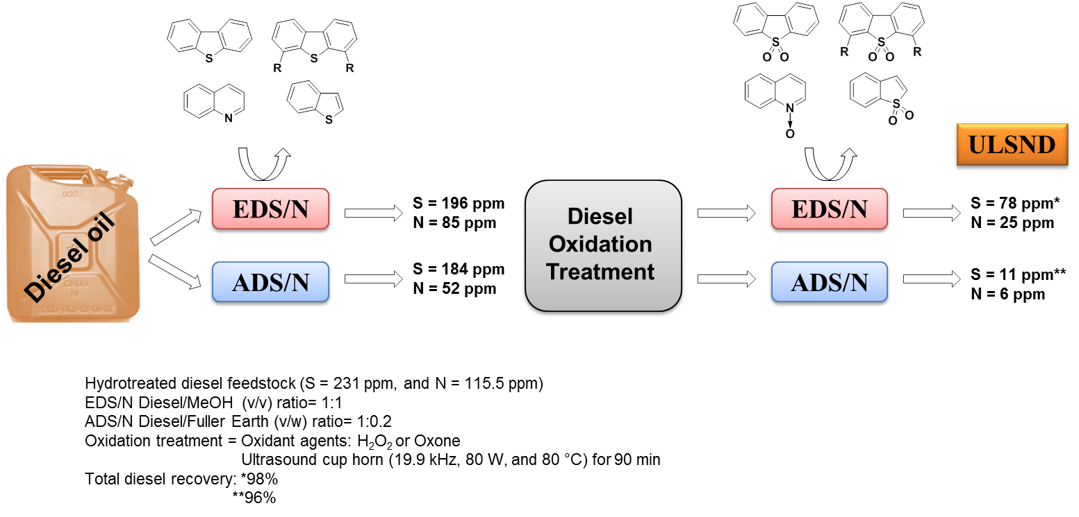
Figure 3. From hydrotreated diesel to ULSND by combining EDS/N or ADS/N pre- and post-treatments with an oxidative process
As shown in Figure 3, there are no significant differences between l/s or l/l pre- treatment in native diesel S removal, as both give a 15-20% S reduction. However, l/s extraction has been proven to be much more selective for N compounds, allowing 55% removal, rather than the 25% obtained with l/l treatment. However, after the oxidation step, post-diesel treatment using the Fuller’s earth adsorbent shows higher affinity for S oxidized compounds giving up to 95% S removal instead of the 60% for the post l/l extraction with MeOH. No differences were observed in selectivity towards the oxidized N compounds in the ADN and EDN processes. Combining these l/s pre- and post- treatments, as a complementary approach to ODS/N, ULSND was obtained with 95% S and N removal. Moreover, these simple diesel l/s or l/l pre- treatments, lead to a great reduction (up to 20%) in the consumption of the expensive oxidizing agents that are used to obtain ULSND at the same N and S residual content levels (Calcio Gaudino, et al., 2014; Carnaroglio et al., 2014).

4. Conclusions
In the search for complementary methods for fuel desulfurization and denitrification, we found that suitable adsorption agents, such as inexpensive, commercial Fuller's earth, provide a good solution. In particular, this simple approach has been successfully applied to oxidative protocols as both pre- and post-treatment methods and has efficiently removed both native and oxidized S-/N-compounds in diesel. These two simple steps may dramatically reduce the amount of reagent required for oxidation. Although ADS and EDS cannot substitute HDS, they can both be complementary to any type of refinery processes.

Acknowledgment
The authors acknowledge CENPES/PETROBRAS S.A. (Brazil) for hydrotreated diesel samples and financial support.

References
Boltes, K., Alonso del Aguila, R., and Garcìa-Calvo, E. 2013. Effect of mass transfer on biodesulfurization kinetics of alkylated forms of dibenzothiophene by Pseudomonas putida CECT5279. J. Chem. Technol. Biotechnol. 88:422–431.
Calcio Gaudino, E., Carnaroglio, D., Boffa, L., Cravotto, G., Moreira, E. M., Nunes, M. A. G., Dressler, V. L., Flores, E. M. M. 2014. Efficient H₂O₂/CH₃COOH oxidative desulfurization/denitrification of liquid fuels in sonochemical flow-reactors. Ultrason. Sonochem. 21(1):283–288.
Carnaroglio, D., Calcio Gaudino, E., Mantegna, S., Moreira, E. M., Vicente de Castro, A., Flores E. M. M., and Cravotto, G. 2014. Ultrasound-assisted oxidative desulfurization/denitrification of liquid fuels with solid oxidants. Energ. Fuel 28 (3):1854–1859.
Chen, H., Wang, Y., Yang, F. H., and Yang, R. T. 2009. Desulfurization of high-sulfur jet fuel by mesoporous π-complexation adsorbents. Chem. Eng. Sci. 64(24):5240–5246.
Collins, F. M., Lucy, A. R., and Sharp, C. 1997. Oxidative desulphurisation of oils via hydrogen peroxide and heteropolyanion catalysis. J. Mol. Catal. A: Chem. 117:397–403.
Davoodi-Dehaghani, F., Vosoughi, M., and Ziaee, A. A. 2010. Biodesulfurization of dibenzothiophene by a newly isolated Rhodococcus erythropolis strain. Bioresource Technol. 101:1102–1105.
Duarte, F. A., De Mello, P. A., Bizzi, C. A., Nunes, M. A. G., Moreira, E. M., Alencar, M. S., Motta, N. H., Dressler, V. L., and Flores, E. M. M. 2011. Sulfur removal from hydrotreated petroleum fractions using ultrasound-assisted oxidative desulfurization process. Fuel 90:2158–2164.
Gabric, B., Sander, A., Cvjetko Bubalo, M., and Macut, D. 2013. Extraction of S- and N-compounds from the mixture of hydrocarbons by ionic liquids as selective solvents. The Scientific World Journal 1:1-11.
Hernandez-Maldonado, A. J., Qi, G., and Yang, R. T. 2005. Desulfurization of commercial fuels by π-complexation: monolayer CuCl/γ-Al₂O₃. Appl. Catal. B: Environ. 61:212–218.
Hernandez-Maldonado, A. J., and Yang, R.T. 2004. Desulfurization of diesel fuels by adsorption via π-complexation with vapor-phase exchanged Cu(I)−Y zeolites. J. Am. Chem. Soc. 126:992–993.
Huang, C., Chen, B., Zhang, J., Liu, Z., and Li, Y. 2004. Desulfurization of gasoline by extraction with new ionic liquids. Energ. Fuels 18:1862–1864.
King, D. L., and Li, L. 2006. Removal of sulfur components from low sulfur gasoline using copper exchanged zeolite Y at ambient temperature. Catal. Today 116 (4):526–529.
Kulkarni, P. S., and Afonso, C. A. M. 2010. Deep desulfurization of diesel fuel using ionic liquids: current status and future challenges, Green Chem. 12:1139–1149.
Kumar, D. R., and Srivastava, V. C. 2012. Studies on adsorptive desulfurization by activated carbon. Clean – Soil, Air, Water 40(5):545–550.
Martin, J. M. C., Sanchez, M. C. C., and Fierro, J. L. G. 2004. Highly efficient deep desulfurization of fuels by chemical oxidation. Green Chem. 6:557–562.
Mochida, I., Sakanishi, K., Ma, X., Nagao, S., and Isoda, T. 1996. Deep hydrodesulfurization of diesel fuel: Design of reaction process and catalysts. Catal. Today 29:185–189.
Muzic, M., Sertic-Bionda, K., Gomzi, Z., Podolski, S., and Telen, S. 2010. Study of diesel fuel desulfurization by adsorption. Chem. Eng. Res. Des. 88:487–495.
Nanoti, A., Dasgupta, S., Goswami, A. N., Nautiyal, B. R., Rao, T. V., Sain, B., Sharma, Y. K., Nanoti, S. M., Garg, M. O., and Gupta, P. 2009. Mesoporous silica as selective sorbents for removal of sulfones from oxidized diesel fuel. Micropor. Mesopor. Mat. 124:94–99.
Sarda, K. K., Bhandari, A., Pant, K. K., and Jain, S. 2012. Deep desulfurization of diesel fuel by selective adsorption over Ni/Al2O3 and Ni/ZSM-5 extrudates. Fuel 93:86–91.
Shahadat Hussain, A. H. M., and Tatarchuk, B. J. 2013. Adsorptive desulfurization of jet and diesel fuels using Ag/TiOx–Al2O3 and Ag/TiOx–SiO2 adsorbents. Fuel 107:465–473.
Shan, J. H., Liu, X. Q., Sun, L. B., and Cui, R. 2008. Cu−Ce Bimetal ion-exchanged Y zeolites for selective adsorption of thiophenic sulfur. Energ. Fuel 22(6):3955–3959.
Shi, F., Hammoud, M., and Thompson, L.T. 2011. Selective adsorption of dibenzothiophene by functionalized metal organic framework sorbents. Appl. Catal. B: Environ. 103:261–265.
Song, C. 2003. An overview of new approaches to deep desulfurization for ultra-clean gasoline, diesel fuel and jet fuel. Catal. Today 86:211–263.
Srivastava, V. C. 2012. An evaluation of desulfurization technologies for sulfur removal from liquid fuels. RSC Adv. 2:759–783.
Stanislaus, A., Marafi, A., and Ran, M. 2010. Recent advances in the science and technology of ultra low sulfur diesel (ULSD) production. Catal. Today 153:1–68.
Stanislaus, A., Marafi, A., and Rana, M. S. 2010. Recent advances in the science and technology of ultra low sulfur diesel (ULSD) production. Catal. Today 153:1–68.
Tawara, K., Nishimura, T., Iwanami, H., Nishimoto, T., and Hasuike, T. 2001. New hydrodesulfurization catalyst for petroleum-fed fuel cell vehicles and cogenerations. Ind. Eng. Chem. Res. 40:2367–2370.
Velu, S., Ma, X., and Song, C. 2003. Selective adsorption for removing sulfur from jet fuel over zeolite-based adsorbents. Ind. Eng. Chem. Res. 42:5293–5304.
Wagner, F. T., Lakshmanan, B., and Mathias, M. F. 2010. Electrochemistry and the future of the automobile. J. Phys. Chem. Lett. 1:2204–2219.
Wang, L. T., Sun, Z. L., Dong, Y., Chen, Y. C., Li, Q., Xu, M., Li, H. L., and Song, L. J. 2011. A theoretical study of thiophenic compounds adsorption on cation-exchanged Y zeolites, Appl. Surf. Sci. 257:7539–7544.
Wilfred, C. D., Kiat, C. F., Man, Z., Bustam, M. A., Mutalib, M. I. M., and Phak, C. Z. 2012, Extraction of dibenzothiophene from dodecane using ionic liquids. Fuel Process. Technol. 93:85–89.
www.epa.gov/otaq/diesel.htm; United States Environmental Protection Agency. Part II 40 CFR Parts 80, 85, and 86. Final Rule. Fed. Regist. 65 (2000) 6697; United States Environmental Protection Agency. Part V 40 CFR Parts 69, 80, and 86. Final Rule. Fed. Regist. 66 (2001) 5001.
Yang, R.T. 2003. Adsorbents: Fundamentals and Applications. John Wiley and Sons: New York.
Yang, X., Erickson, L. E., Hohn, K. L., Jeevanandam, P., and Klabunde, K. K. 2006. Sol−Gel Cu−Al₂O₃ adsorbents for selective adsorption of thiophene out of hydrocarbon. Ind. Eng. Chem. Res. 45: 6169–6174.
Yang, R. T., Hernández-Maldonado, A. J., and Yang, F. H., 2003. Desulfurization of transportation fuels with zeolites under ambient conditions. Science 301:79–81.
Zhang, S., Zhang, Y., Huang, S., Wang, P., and Tian, H. 2012. Mechanistic investigations on the adsorption of thiophene over Zn₃NiO₄ bimetallic oxide cluster. Appl. Surf. Sci. 258:10148–10153.
Zhang, Z. Y., Shi, T. B., Jia, C. Z., Ji, W. J., Chen, Y., and He, M. Y. 2008. Adsorptive removal of aromatic organosulfur compounds over the modified Na-Y zeolites. Appl. Catal. B: Environ. 82(12):1–10.

