Received 00th January 20xx,
- Dipartimento di Chimica, University of Turin, Via P. Giuria 7, 10125 Turin (Italy).
- Dipartimento di Scienza e Tecnologia del Farmaco and NIS - Centre for Nanostructured Interfaces and Surfaces, University of Turin, Via P. Giuria 9, 10125 Turin (Italy).
*E-mail: giancarlo.cravotto@unito.it
- Université Claude Bernard Lyon 1, CNRS-UMR 5246, Institut de Chimie et Biochimie Moléculaires et Supramoléculaires, CPE - Lyon 43 Boulevard du 11 Novembre 1918, Lyon (France).
*Email concerning computational studies: paolo.larini@univ-lyon1.fr
† Electronic Supplementary Information (ESI) available: Characterization data and copies of 1H and 13C NMR spectra, computational details. See DOI: 10.1039/x0xx00000x
Accepted 00th January 20xx
DOI: 10.1039/x0xx00000x
www.rsc.org/
Microwave-assisted, ligand-free, direct C-H arylation of thiophenes in biomass-derived γ-valerolactone
S. Tabasso,ª E. Calcio Gaudino^{b} L. Rinaldi^{b}, A. Ledoux^{c}, P. Larini*^{c} and G. Cravotto*^{b}
The Pd-catalyzed, C-H arylation of heterocycles with aryl halides is a straightforward and more environmentally-friendly route to the synthesis of well-defined, pi-conjugated polymers for challenging applications in electronic devices. Although this type of transformation is more atom efficient than cross-couplings, it still poses environmental issues in the form reaction media and the use of phosphine ligands. A procedure for the C-H arylation of thiophenes, with substantially improved environmental impact, and a promising application of this protocol to the synthesis of regioregular polythiophenes are reported in this work. γ-Valerolactone (GVL), a non-toxic biomass-derived solvent, has been used in this phosphine-free microwave-assisted process and replaces commonly used dipolar aprotic media. Activated aryl bromides gave arylthiophenes in good yields, while iodides were used and pivalic acid added when electron-withdrawing groups were present. The reaction has been also extended to C-H (hetero)arylation polycondensation and a high molecular weight poly(3-hexyl)thiophene was obtained, using low Pd loading, in high yields and good regioregularity in short reaction times. Computational studies have shed light on GVL’s role as a ligand in the catalytic system.
Introduction
The replacement of conventional methods with microwave (MW) irradiation-based environmentally friendly procedures has gained increasing interest in recent decades. This interest is certainly well-deserved as the use of MWs in synthetic organic chemistry offers many advantages which are in line with green chemistry recommendations; it promotes rate acceleration, enhanced yields and selectivity,¹ leading to potentially lower energy and metal consumption, while also avoiding undesirable reactions and by-products. Moreover, the particular properties of MW irradiation mean that polar non-toxic solvents, such as water and alcohols, can be coupled with reduced catalyst amounts. MW irradiation is therefore a suitable tool with which to overcome the limitations encountered in challenging organic reactions, such as direct C-H arylation.²
Direct C-H arylation holds significant synthetic potential for the synthesis of various biologically active compounds,³ and organic functional materials,⁴ that bear biaryl and heteroaryl skeletons. A great deal of attention has been devoted, in particular, to the synthesis of arylthiophenes because of their biological and physical properties.⁵
Thiophenes have been used to build materials for organic electronics and considerable effort has recently been dedicated to the synthesis of conjugated polymers via C-H activation-based, direct (hetero)arylation polymerization (DHAP).^{6,7} Direct C-H (hetero)arylation is more environmentally-friendly than traditional cross-coupling reactions, as it does not lead to the formation of metallic salts as by-products. Furthermore, no additional synthetic steps are required to produce the organometallic intermediates. Despite these advantages, this reaction still suffers from a number of drawbacks, which include the frequent need for high catalyst loadings (1-10 mol%),⁸ and monophosphine or diphosphine ligands.⁹ Wu et al. have recently developed a phosphine free, direct C−H arylation of thiophenes at low catalyst amounts,¹⁰ which, however, required prolonged reaction times (24 h) in order to achieve reasonable yields. Other ligandless protocols with low catalyst loadings have been developed by Doucet and co-workers, but the reaction still took 20 h to complete.^{11,12} Additional impetus for change can be found in the fact that C-H arylations usually occur in dipolar, aprotic solvents, which, despite being very useful in promoting such reactions, are to be banned in the near future because of their toxicity and environmental impact.¹³ For example, DMA is the most widespread solvent used in C-H sp2 arylation of heterocycles, being classified as toxic to reproduction by the ECHA¹⁴ (European Chemical Agency). This has obviously led to effort being shifted to the search for a green substitute for this solvent class. A significant amount of recent interest has focused on the use of γ-valerolactone (GVL), in particular, as a bio-based, dipolar, aprotic solvent.¹⁵
GVL is commonly synthesized from the hydrogenation of biomass-derived levulinic acid.¹⁶ The MW-assisted, cascade production of GVL directly from lignocellulosic biomass has recently been reported,¹⁷ and is worth interest as GVL is both the process solvent and product. Despite GVL’s noteworthy chemical and physical properties, which make it a valuable, green alternative to polar aprotic solvents,¹⁸ only a few papers have so far dealt with its application to organic synthesis.¹⁹ While a number of works on its use as a green solvent in cross-coupling reactions do already exist,²⁰⁻²³ only one report has been, to the best of our knowledge, made in the C-H activation of heteroarenes (1,2,3 triazoles) by Vaccaro and Ackermann.²⁴ This work describes a ligand-free, MW-assisted coupling of aryl halides with thiophenes using low catalyst loadings and GVL as the solvent. The synthesis of a polythiophene has been carried out under optimized conditions and MW irradiation, via direct, (hetero)arylation polymerization (DHAP). Moreover, computational methods have granted useful insights into the mechanism of this phosphine-free reaction.
Experimental
Materials and instruments
All starting organic reagents and solvents were purchased from Aldrich and used without further purification. NMR spectra were recorded on a Bruker Avance 300 (300 MHz and 75 MHz for ¹H and ¹³C, respectively) at 25°C in CDCl₃. Chemical shifts were calibrated to the residual solvent proton and carbon resonances. GC-MS analyses were performed on a GC Agilent 6890 (Agilent Technologies - USA), fitted with a Agilent Network 5973 mass detector, using a HP-5 column (30 m long capillary column, i.d of 0.25 mm and film thickness 0.25 μm). MW-assisted reactions were carried out in a SynthWAVE (MLS GmbH, Milestone Srl) reactor which houses a closed MW-cavity. SEC THF polymer analyses were performed on a Viskotek GPCmax VE 2001.

General procedure for MW-assisted coupling of thiophenes and electron-deficient aryl halides
The aryl bromide (0.5 mmol), thiophene derivative (1 mmol) and KOAc (1 mmol) were placed into a quartz vial equipped with a magnetic stirrer and suspended in GVL (3 mL). The vial was purged with N₂ and Pd(OAc)₂ (0.2 mol%) was added. The mixture was heated to the required temperature under MW irradiation for 2 hours (average power 960 W) in a N₂ (1 MPa) atmosphere and under magnetic stirring (450 rpm). The reactor was cooled after 2 hours and solid products were recovered via precipitation after the addition of water (4 mL), filtered off and washed with 1 mL of cold water. The solid was then dried under vacuum and purified by flash column chromatography (hexane). Alternatively, liquid products were filtered on a silica pad, washed with 3 mL EtOAc and purified by flash column chromatography (hexane) after solvent evaporation.

General procedure for MW-assisted coupling of thiophenes and non-activated aryl halides
The aryl iodide (0.5 mmol), thiophene derivative (1 mmol), K₂CO₃ (1.5 mmol) and PivOH (0.5 mmol) were placed into a quartz vial equipped with a magnetic stirrer and suspended in GVL (3 mL). The vial was purged with N₂ and Pd(OAc)₂ (0.2 mol%) was added. The mixture was heated to the required temperature under MW irradiation for 2 hours (average power 960 W) in a N₂ (1 MPa) atmosphere and under magnetic stirring (450 rpm), the product was then precipitated after the addition of water, filtered off and purified by column chromatography (hexane) after solvent evaporation. Alternatively, crude reactions were filtered on a silica pad, washed with 3 mL of EtOAc and, after solvent evaporation, purified by flash column chromatography (hexane).

Procedure for MW-assisted coupling polymerization of 2-bromo-3-hexylthiophene
2-bromo-3-hexylthiophene (2 mmol, 490 mg), K₂CO₃ (6 mmol, 800 mg), and PivOH (2 mmol, 204 mg) were placed into a quartz vial equipped with a magnetic stirrer and suspended in GVL (2 mL). The vial was purged with N₂, and Pd(OAc)₂ (1 mg, 0.004 mmol, 0.2 mol%) was added.
The mixture was heated to 100 °C for 3 hours under MW irradiation (average power 960 W) and magnetic stirring (450 rpm) in a N₂ (1 MPa) atmosphere. After cooling to room temperature, the crude reaction was poured into vigorously stirred MeOH (10 mL). Centrifugation of the resulting mixture at 4000 rpm for 15 minutes led to the precipitation of the polymer. The supernatant was removed by decantation, 10 mL of distilled water were added and the mixture was centrifuged under the same conditions to remove the water soluble salts. The deep purple residue obtained after the decantation of water was then dried under vacuum to give a solid of poly(3-hexyl)thiophene.

Results and discussion
The reaction between 2-methylthiophene and 4-bromonitrobenzene was studied, using a variety of bases that are commonly used for C-H activation under conventional conditions (Table 1), in order to set up the protocol for C-H activation in GVL.
Table 1. Screening of bases for arylation between 4-bromonitrobenzene and 2-methylthiophene.
Entry | Base (eq.) | Conversion (%) | Yield (%)
1 | KOAc (0.25) | 100 | 99
2 | TEA (2) | - | -
3 | Cs₂CO₃ (2) | 4 | 2ª
4 | K₂CO₃ (0.25) | 75 | 61^{b}
5 | DBU (2) | 40 | 11
ªBiphenyl was also obtained. ^{b}5,5′-dimethyl-2,2′-bithiophene was also obtained.

The organic bases, triethylamine and DBU, proved to be unsatisfactory (Table 1, entries 2 and 5), whereas inorganic bases gave good results. Organic bases probably did not give good results due to their lack in establishing the CMD (Concerted Metalation Deprotonation) process (see the mechanistic part below). Both carbonate bases (Table 1, entries 3 and 4), gave evidence of the cation effect. However, caesium furnished very low conversion (Table 1, entry 3), probably due to the low solubility of this base in the reaction media, while potassium provided improved conversion, but, unfortunately, also a bis-thiophene by-product (Table 1, entry 4). Finally, the best results were obtained using potassium acetate as the base (Table1, entry 1), although an excess of methylthiophene (2 eq.) was necessary to avoid the formation of the homo-coupling product.

Substrate scope
These preliminary reactions occurred in very promising reaction times, which were far lower than those previously reported under conventional heating using DMAc as the solvent and the same catalyst amounts.²⁵ It was therefore decided to assess the scope and limitations of this reaction by studying the coupling of electron-deficient aryl halides with thiophenes under the optimized conditions (Table 2).
Target compounds were obtained in good yields when the various thiophenes were reacted with 4-bromonitrobenzene (Table 2, entries 1-3). Quite surprisingly, 2-acetylthiophene was less reactive in these conditions, as 51% of the starting material was recovered unreacted (Table 2, entry 4). As expected, the meta-substituted bromonitrobenzene showed almost the same reactivity as its para-substituted analogue (Table 2, entry 3), but this behaviour was not reflected by bromoacetophenone. Indeed, while 4-bromoacetophenone gave the desired product in good yields (Table 2, entry 5), 3-bromoacetophenone was less reactive and the ortho-isomer did not react at all (Table 2, entries 6 and 7). An increase in temperature did not afford the desired products either. This is probably a result of coordination between the acetyl function and palladium. 2-n-butylthiophene reacted with 4-bromoacetophenone more slowly than in the same reaction with 2-methylthiophene and the yield was 40 % after 2 hours. However, it was nevertheless faster than under conventional heating (Table 2, entries 8 and 9). Disappointing results were also obtained with 4-iodoacetophenone, as the major product was biphenyl (Table 2, entry 10). The presence of an additional halide makes the aryl bromide unreactive (Table 2, entry 11), even at higher temperatures.
Attempts to couple unsubstituted aryl bromides with thiophenes led to the reaction not proceeding (harsher conditions gave biphenyl as the only product), while only 12% product was formed using aryl iodide (yield as determined by GC). This result was dramatically different to when the same reaction was performed using DMAc as the solvent (78% yield from bromobenzene). Additionally, the reaction between deactivated 4-bromoanisole and methylthiophene, under MW irradiation in DMAc, afforded the product in a 38% yield, whereas the reaction did not proceed in GVL. Wu et al. have reported on the addition of pivalic acid (PivOH) to the coupling of 4-bromoanisole with methylthiophene in DMAc, using K₂CO₃ as the base.¹⁰ In fact, enhanced product yields have herein been achieved under these conditions in DMAc (64%), while MW irradiation led to shorter reaction times than in the previous work (2h instead of 24h). This result caused us to change the reaction conditions in order to test the coupling of electron-rich substrates with thiophenes in GVL (Table 3).
While, for electron-deficient substrates, aryl bromides were more promising than other aryl halides, only aryl iodides led to the desired products in the presence of the methoxy group (Table 3, entries 4 and 5). Not even acetyl thiophene reacted with 3-bromoanisole, probably because of coordination between the acetyl function and palladium (Table 3, entry 3).

Table 2. Palladium-catalysed coupling of heteroaromatics and electron-deficient aryl halides.ª
Entry | Heteroaryl | Aryl  halide | T  (°C) | Product | Yield^{b} (%)
1 | 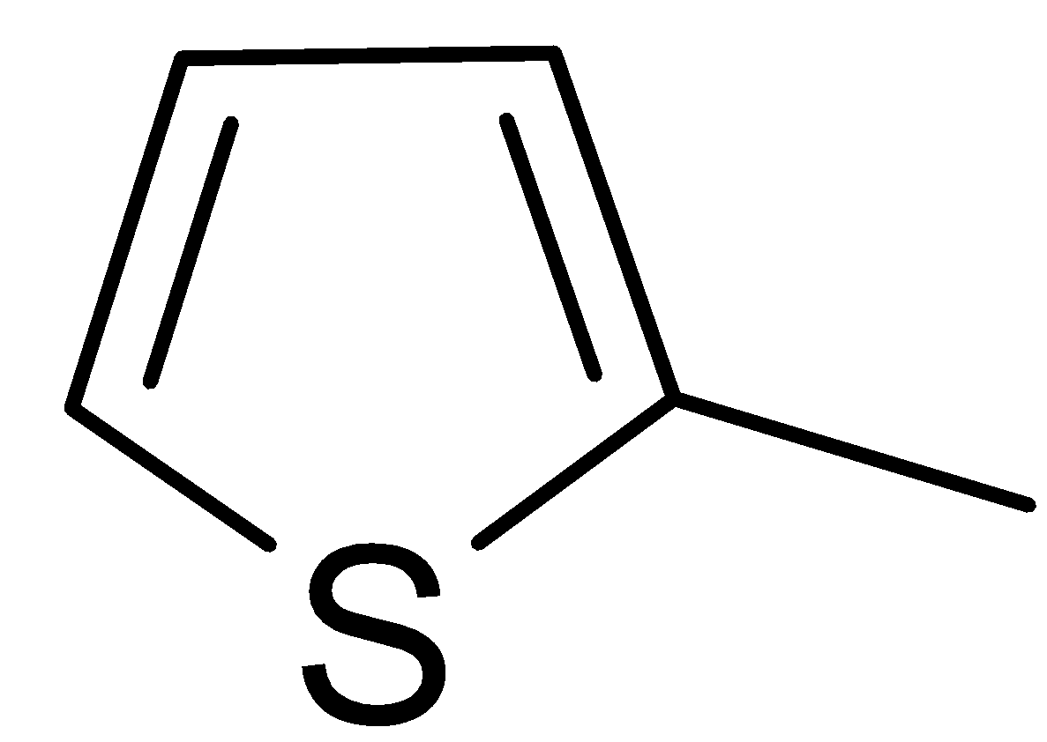 | 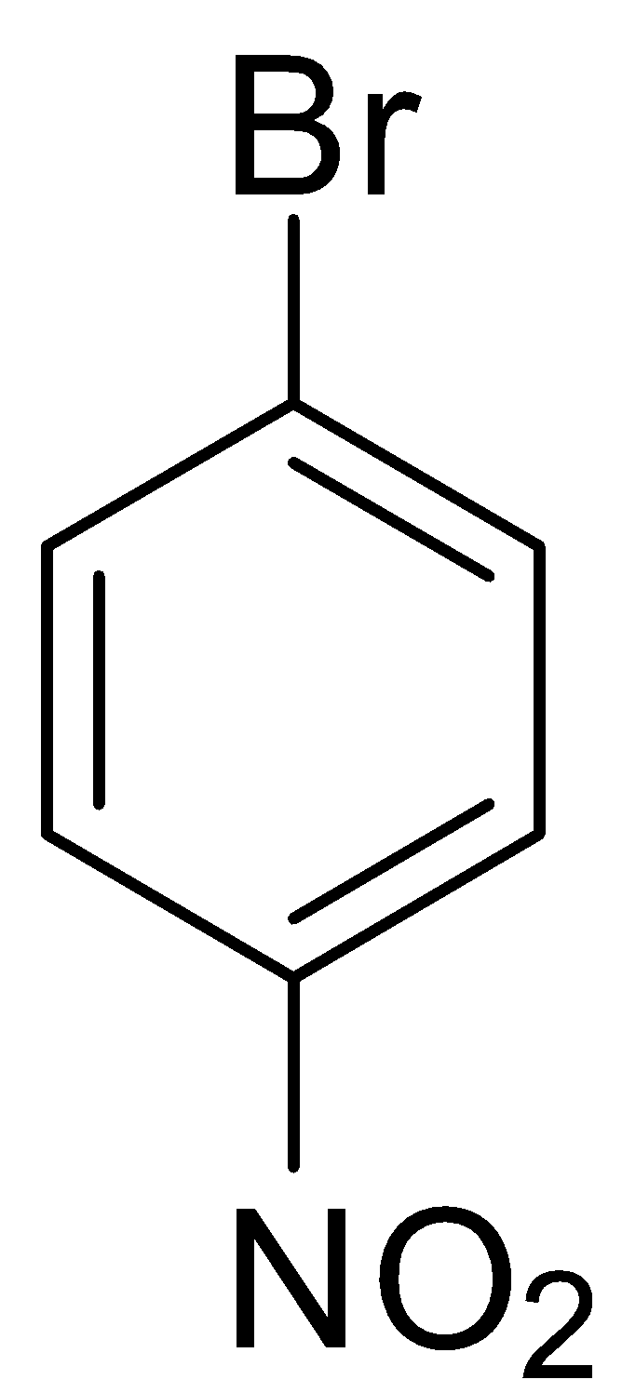 | 140 | 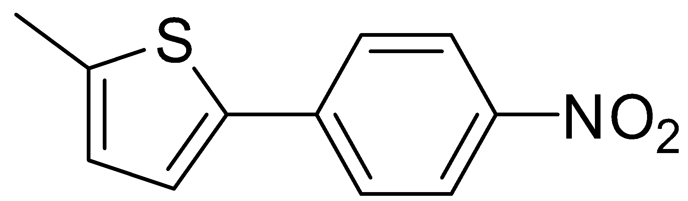  1 | 99 (82)
2 | 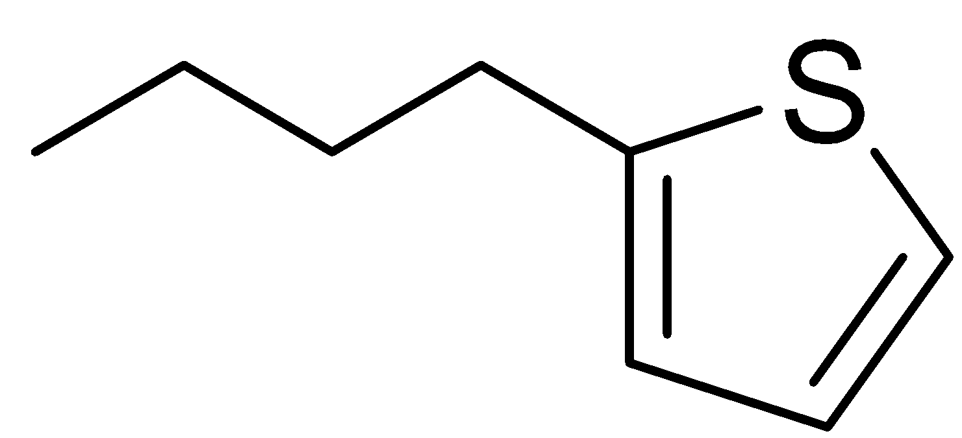 |  | 140 | 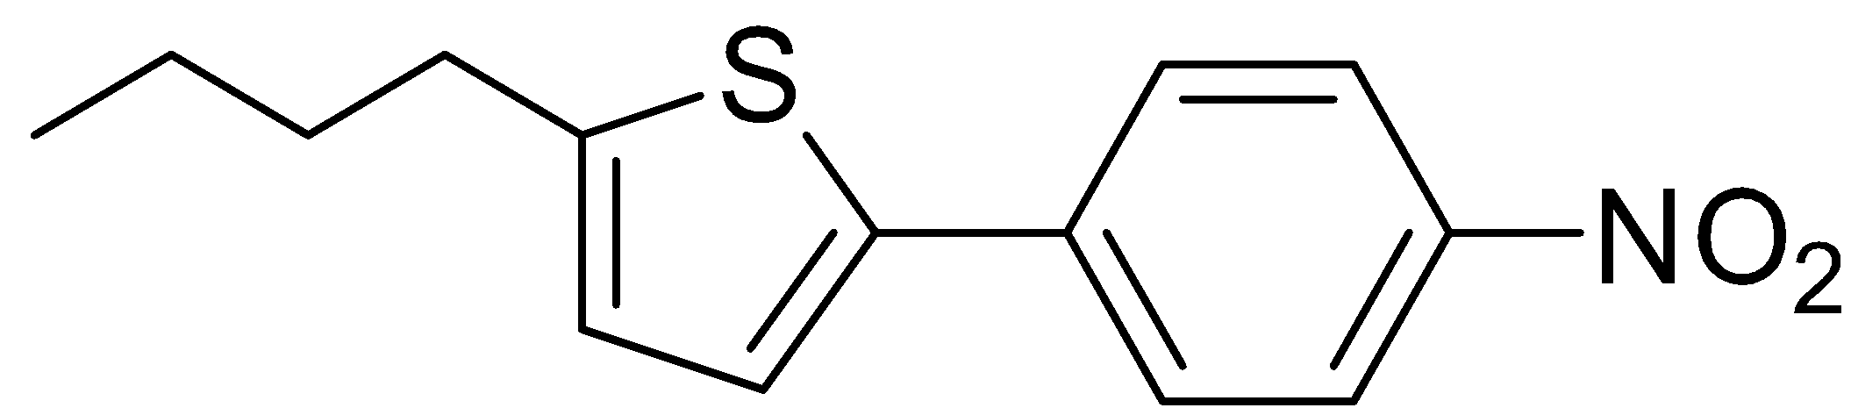  2 | 94 (76)
3 |  | 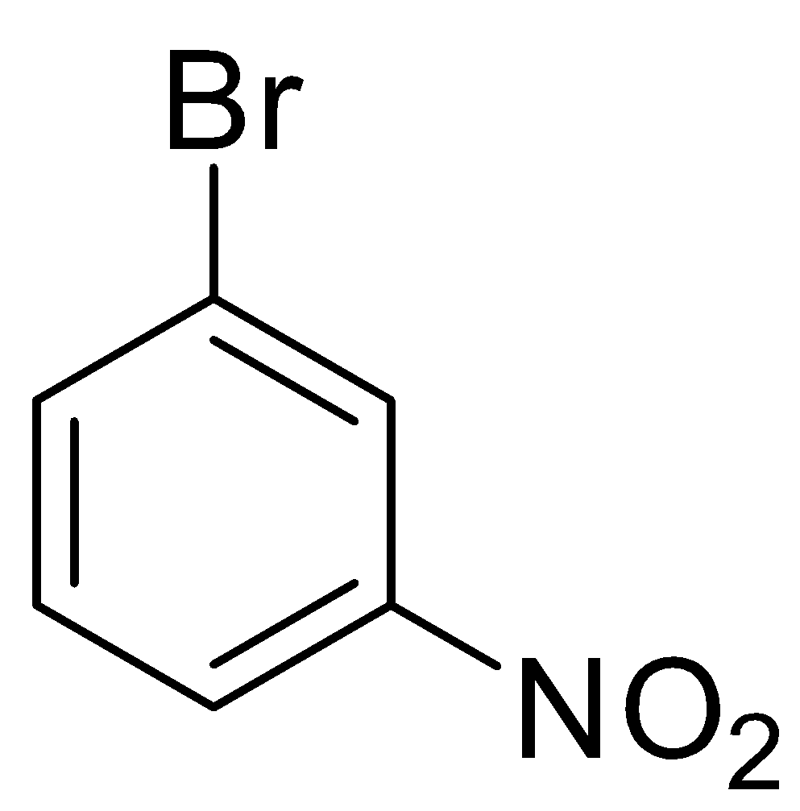 | 140 | 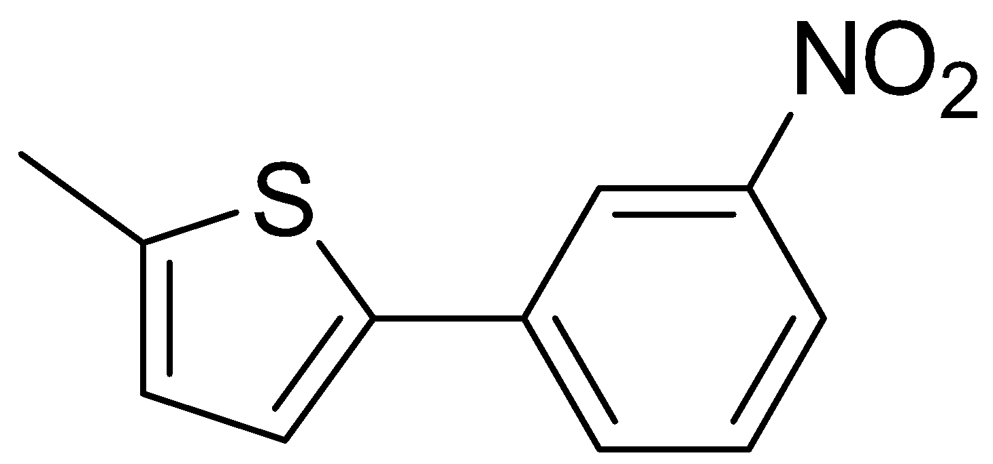  3 | 99 (80)
4 | 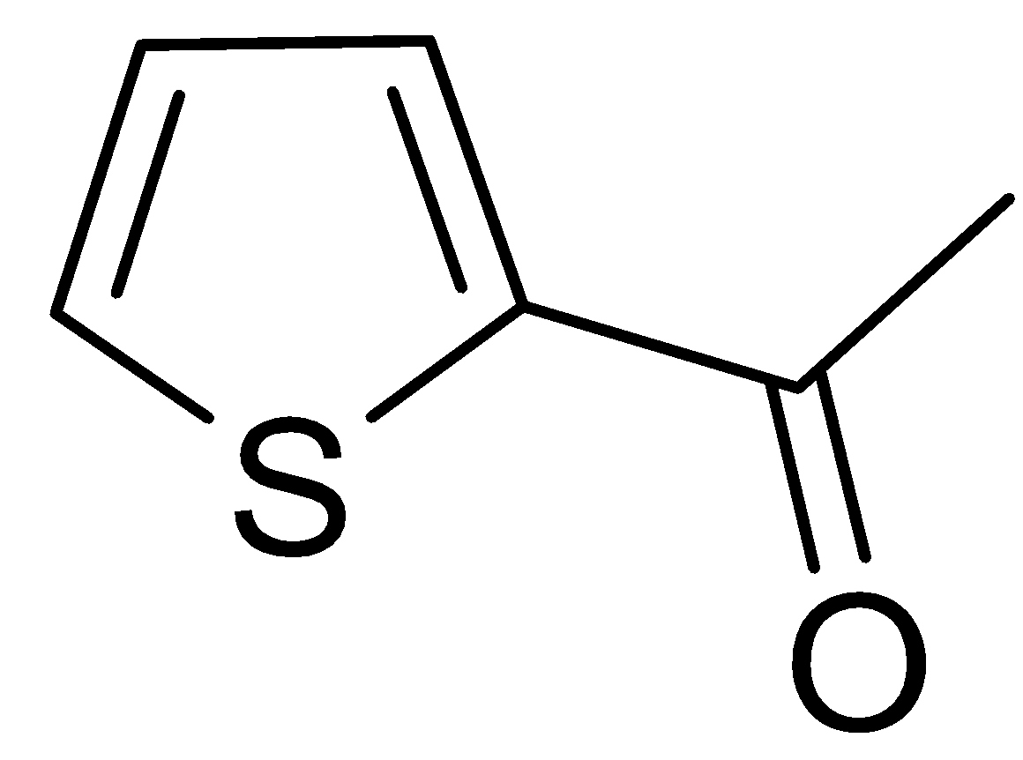 |  | 140 | 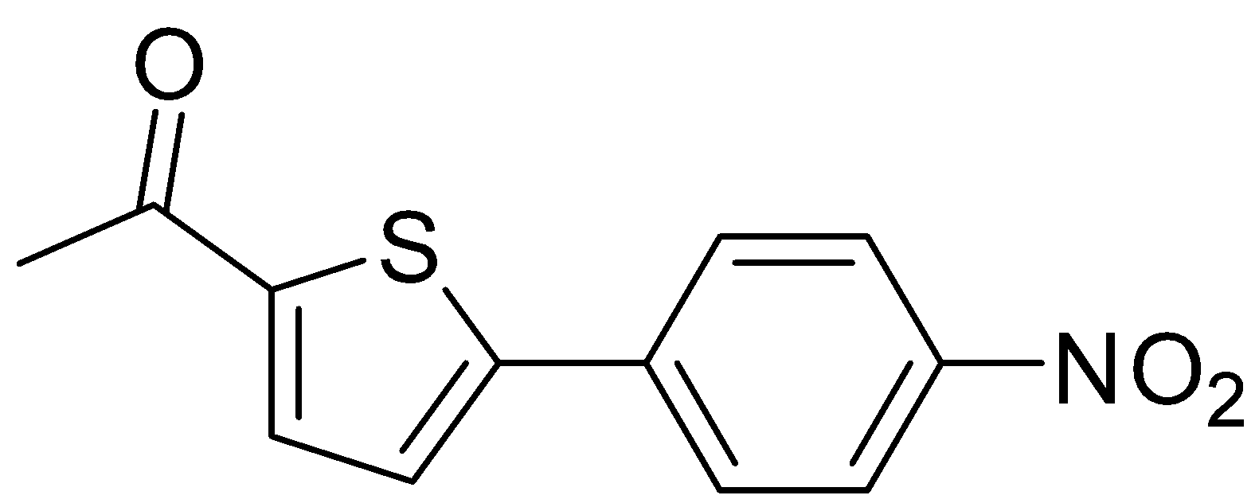  4 | 36 (28)
5 |  | 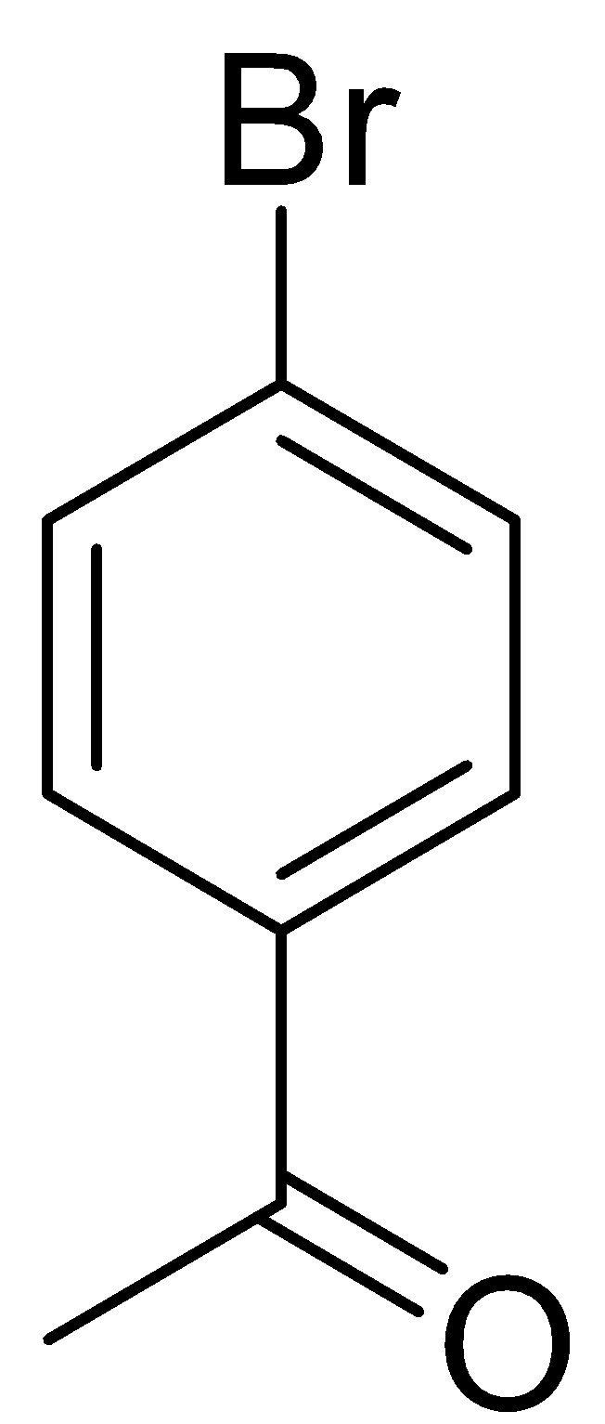 | 140 | 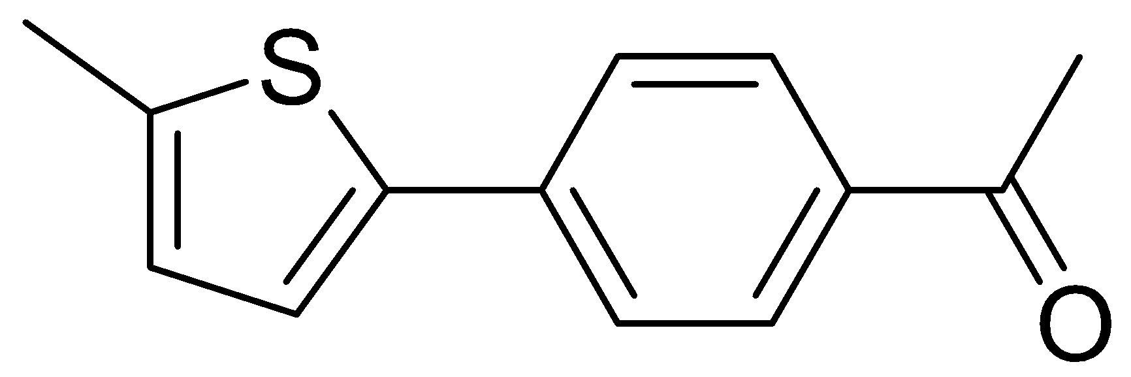  5 | 74 (66)
6 |  | 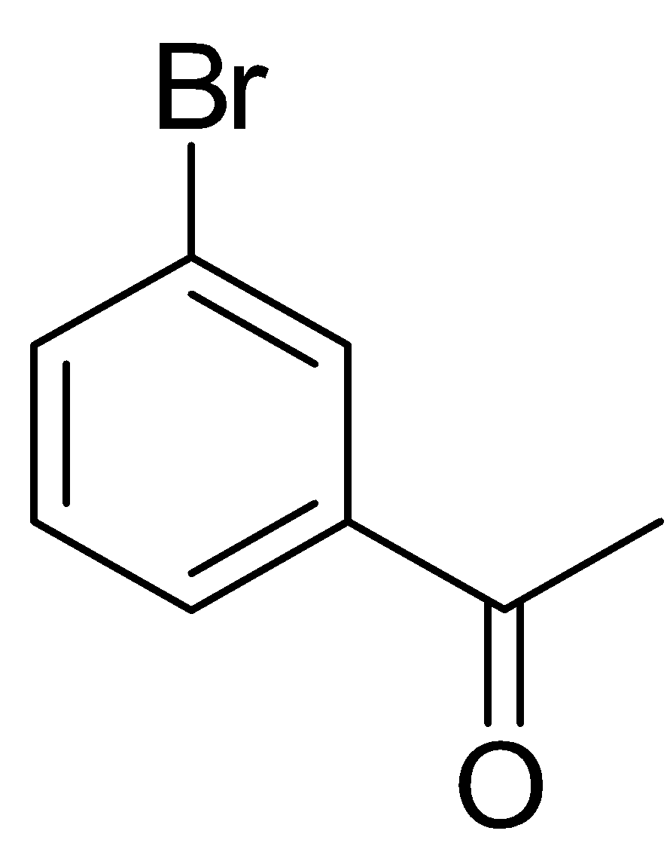 | 200 | 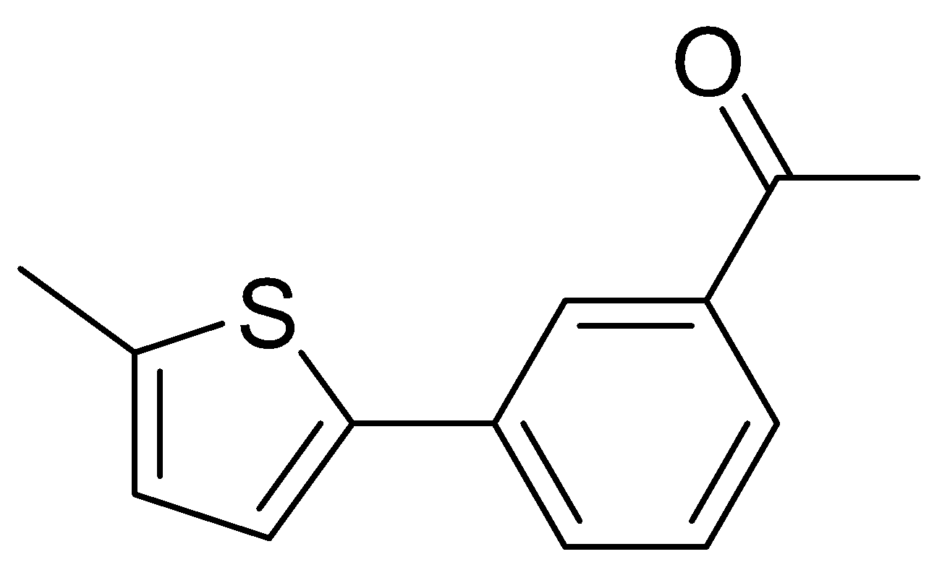  6 | 26 (13)
7 |  | 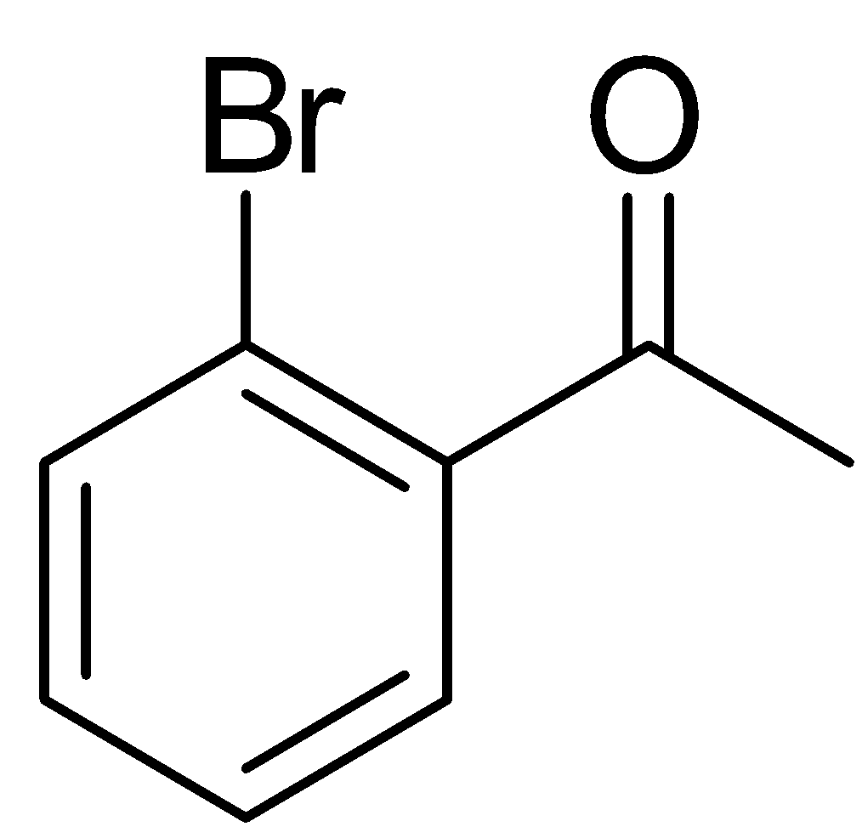 | 200 | 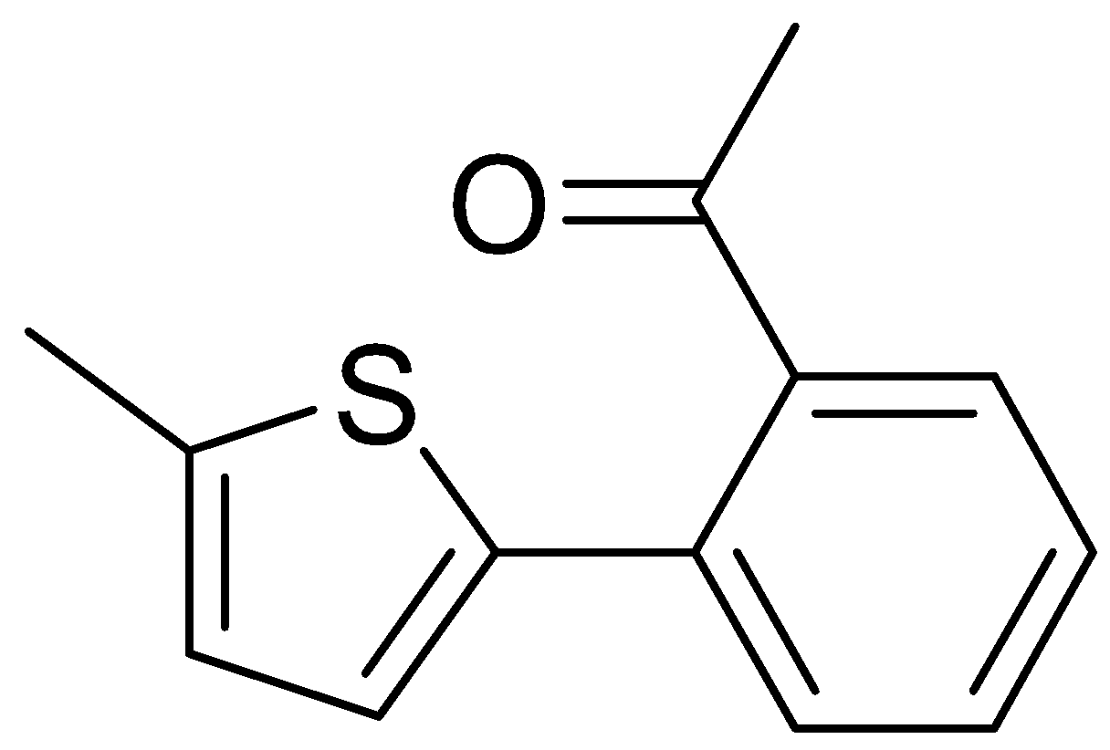  7 | 0
8 |  |  | 140 | 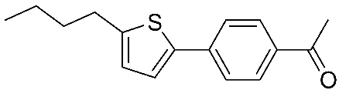  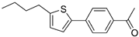  8 | 40 (28)
9^{c} |  |  | 140 | 8 | 20 (14)
10 |  | 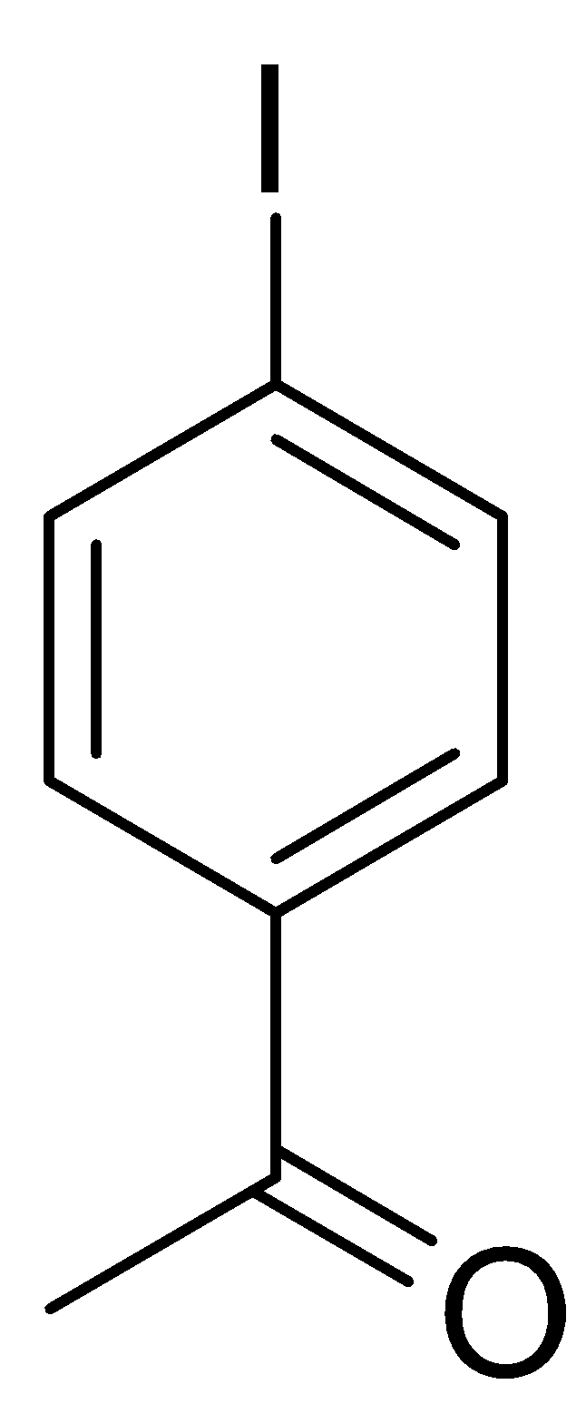 | 140 | 5 | 14% (8)  (86)^{d}
11 |  | 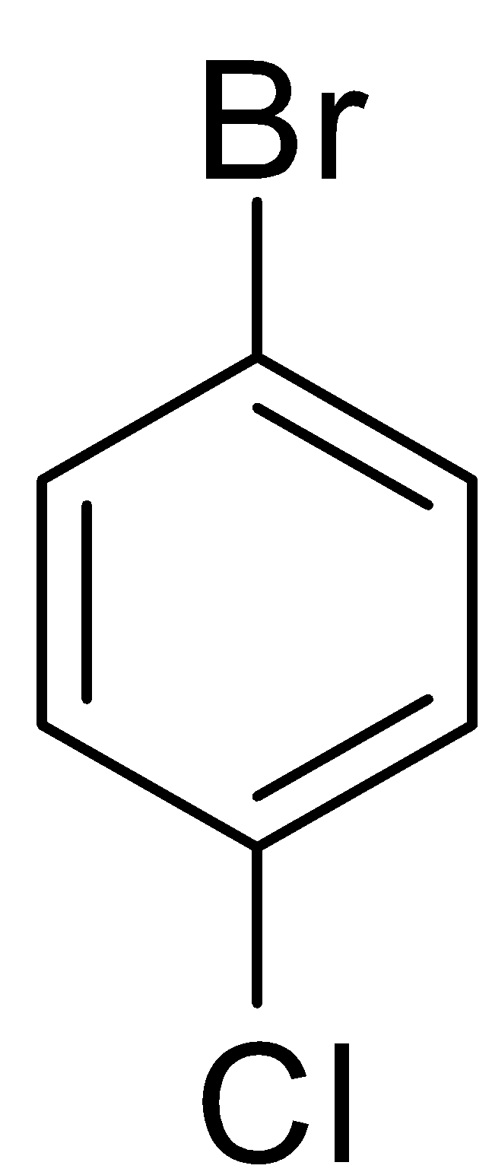 | 200 | 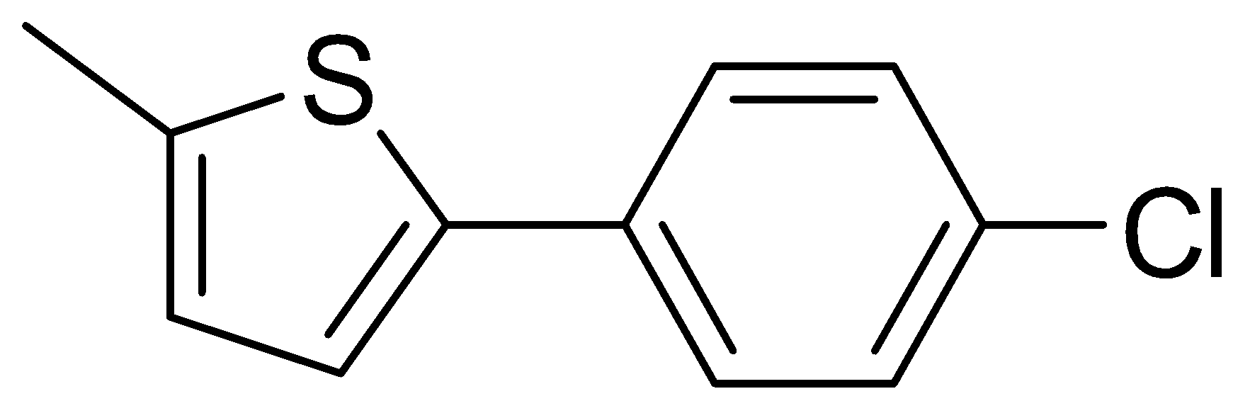  9 | 0
ªConditions: Pd(OAc)₂ (0.2 mol %), heteroaryl (2 equiv), aryl halide (1 equiv), KOAc (2 equiv), GVL, 140°C, 2 h. ^{b}Yields as determined by GC, yields in parentheses are isolated. ^{c} Conventional heating. ^{d}(biphenyl).
On the other hand, good yields were quite surprisingly achieved even with a non-activated congested substrate, 2-iodotoluene (Table 3, entry 6).

Table 3. Palladium-catalysed coupling of heteroaromatics and non-activated aryl halidesª
Entry | Heteroaryl | Aryl halide | Product | Yield^{b}  (%)
1 |  | 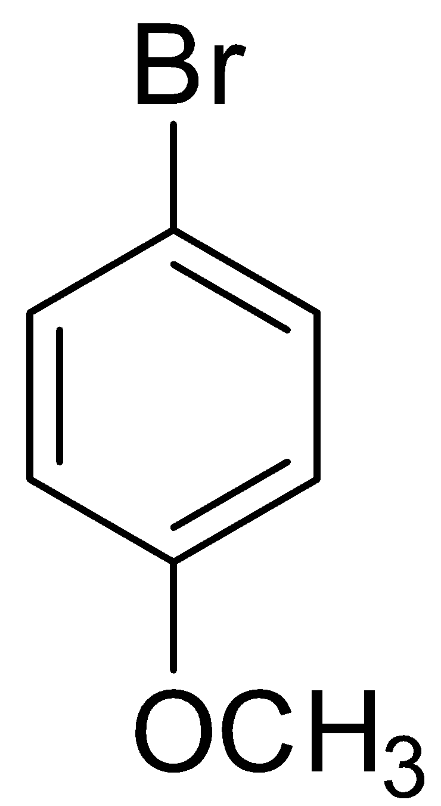 | 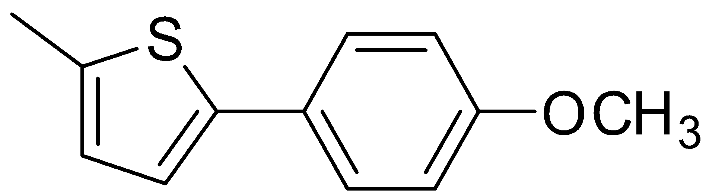  10 | 0
2 |  | 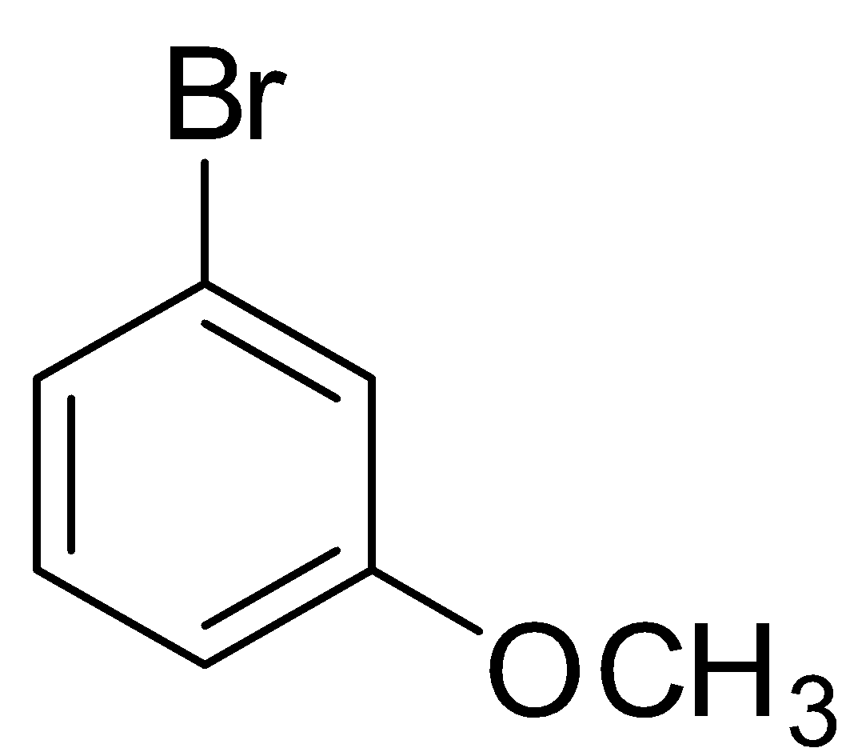 | 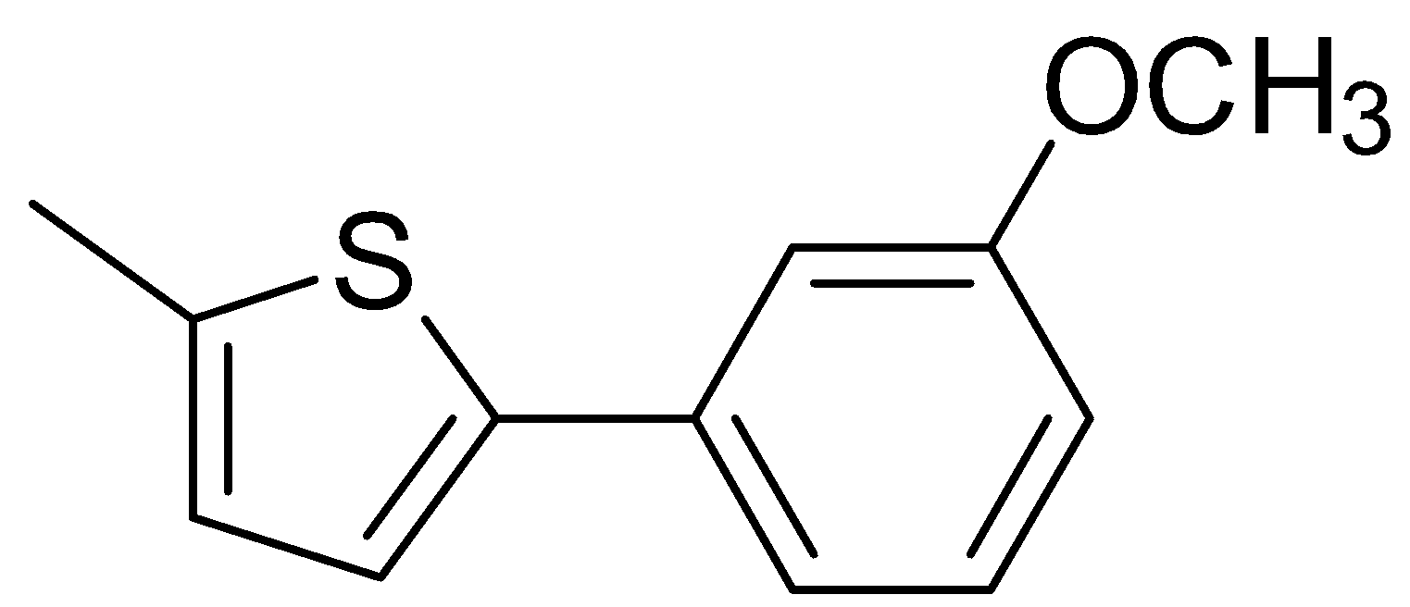  11 | 0
3^{c} |  |  | 11 | 0
4^{d} |  | 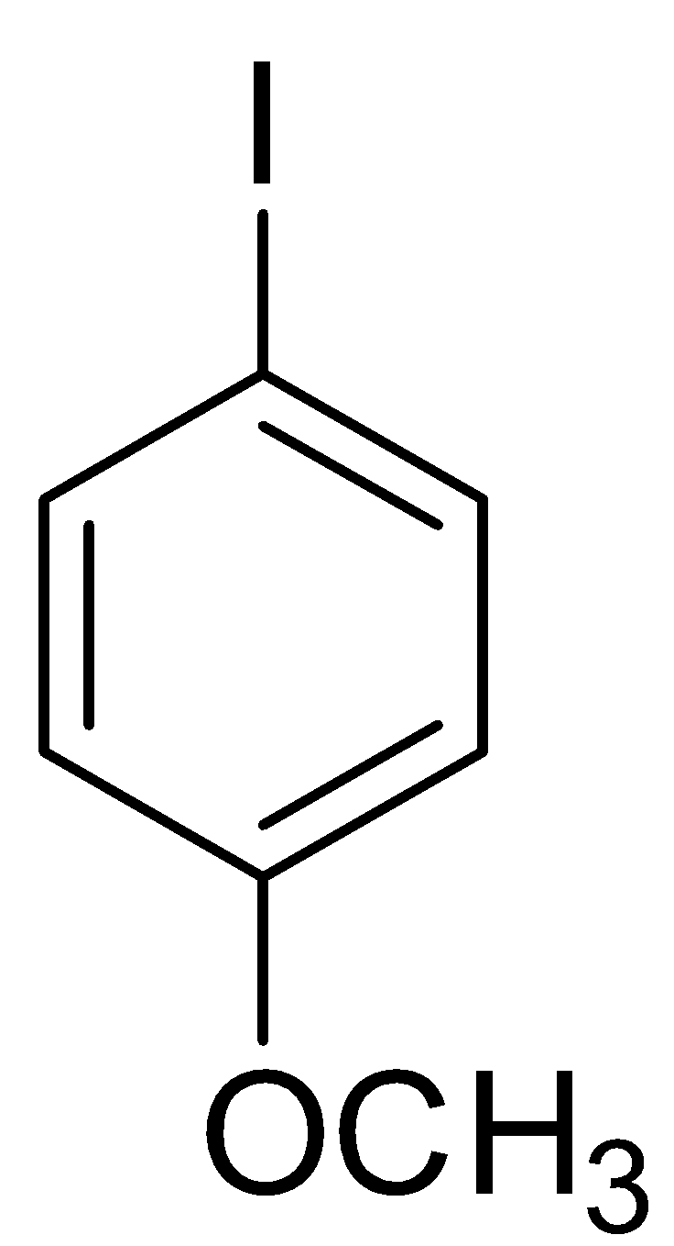 | 10 | 48% (42)
5 |  |  | 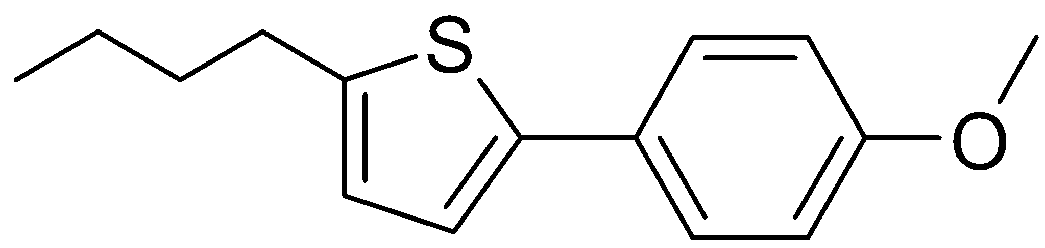  12 | 59% (50)
6 |  | 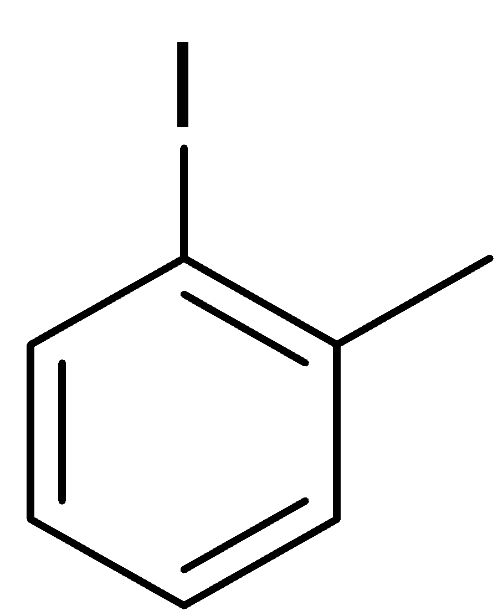 | 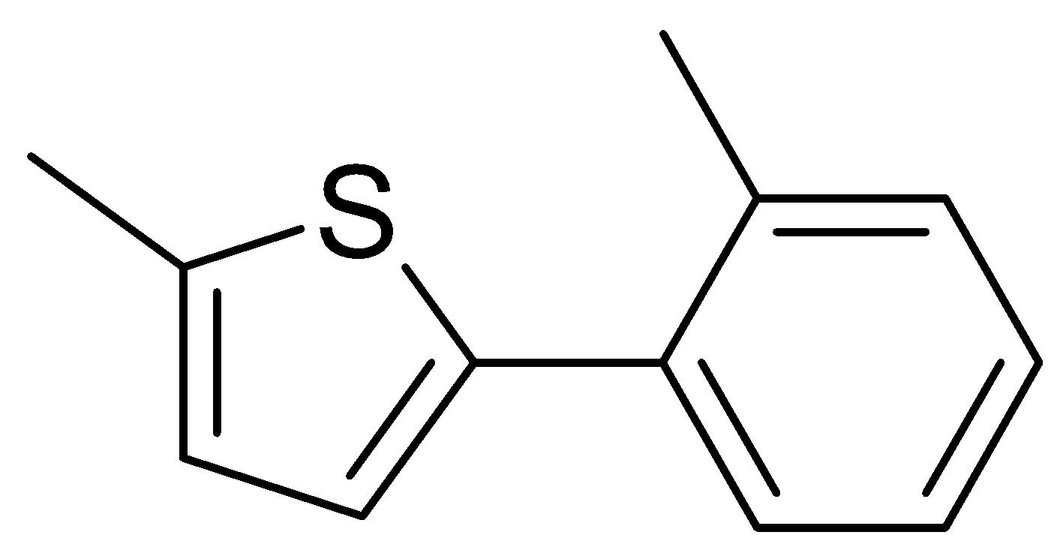  13 | 60% (52)
ªConditions: Pd(OAc)₂ (0.2 mol %), heteroaryl (2 equiv), aryl halide (1 equiv), K₂CO₃ (1.5 equiv), PivOH (1 equiv), GVL, 140 °C, 2 h. ^{b}Yields as determined by GC, yields in parentheses are isolated. ^{c}The reaction was performed at 180 °C. ^{d}3 equiv. of methylthiophene were necessary to avoid the formation of biphenyl.
Direct (hetero)arylation polymerization: synthesis of poly(3-hexyl)thiophene (P3HT).
It was decided to assess the versatility of this environmentally-improved methodology in the synthesis of poly(3-hexyl)thiophene (P3HT);²⁶ a reference polymer used in the development of electronic devices, such as flexible solar cells.²⁷ The properties of this polymer depend on its regioregularity, which is the ratio of repeating head-to-tail units. Thompson and co-workers obtained P3HT (Mn = 14.3 kDa), using Pd(OAc)₂/PivOH and K₂CO₃ in DMAc.²⁸ The amount of Pd(OAc)₂ was relatively high (2.0 mol%) and the reaction lasted for 48h, affording the polymer in modest yields (44 %), relatively high molecular-weight (Mn = 14.3 kDa) and a good degree of regioregularity (RR = 88%). This work sees direct, MW-assisted C-H (hetero)arylation polymerization performed on 2-bromo-3-hexylthiophene (1M concentration), using low catalyst loading (Pd(OAc)_{2,} 0.2 mol %), PivOH and K₂CO₃ as the base (3 equiv.) in GVL (100°C, 3h) (Figure 1).
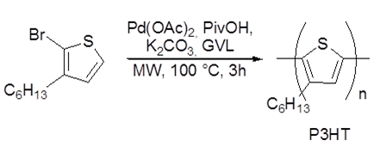
Figure 1. Synthesis of poly(3-hexyl)thiophene (P3HT)
These conditions afforded P3HT with improved molecular weight (Mn = 25 kDa) and yield (75%). P3HT, synthesized in these conditions, shows a molecular weight which is comparable to Thompson’s, while being in stark contrast with the P3HT reported by Koizumi and Hayashi,²⁹ which had low Mn (5.5 kDa) due to the use of Pd/C as a heterogeneous catalyst. These results show that GVL allows an active, catalytic species homogeneous phase to form, which occurred thanks to the coordination of GVL with Pd. To further understand the role that GVL plays in the internal coordination sphere of the metal center, it was decided to investigate the reaction mechanism using computational studies.

Reaction mechanism
Pd(OAc)₂ gives rise to insoluble (Pd black) and soluble nanoparticles at temperatures above 120 °C in the absence of ancillary ligands.³⁰ Experimental results,²⁷ led the authors to believe that the catalytically active species was to be found in the homogeneous phase, meaning that Pd is probably solubilized in the reaction medium. The homogeneous palladium could be either in the form of monomeric and/or soluble nanoparticles (PdNP). This hypothesis is corroborated by the complete selectivity towards the C2 (C2:C3>99:1) position observed in the benzothiophene reaction, as is in accordance with Glorius and co-workers.³¹ These authors reported the selective C3 C-H arylation of benzo[b]thiophenes with aryl chloride (C3:C2>99:1), using a ligand-free dual heterogeneous catalytic system (Figure 2). Furthermore, they demonstrate that site-selectivity was reversed when homogeneous Pd(0) was used, leading to a C2 arylated product.

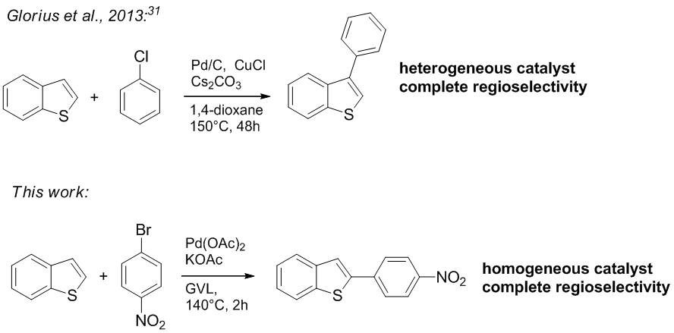Figure 2. Selectivity in the arylation of benzo[b]thiophenes.
Thus, it was decided to investigate the effects of GVL on the present reaction, with the hypothesis of having a monometallic homogeneous palladium, as the catalytically active species. Computational investigations, at the DFT level (Density Functional Theory), were pursued in order to support our hypotheses of GVL’s impact and further our interest in the mechanistic studies of palladium catalysed, C-H activation reactions.³² Since the starting, catalytically active palladium species possesses an oxidation number of 0, the coordination strength of GVL was compared with that of DMAc.³³ The maximum number of GVL molecules that can coordinate a Pd(0) atom was found to be two. Pd(0)GVL₂ was found to be more stable than Pd(0)GVL by ∆G = 9.8 kcal mol⁻¹. The same result was obtained when DMAc was considered (∆G = 10.2 kcal mol⁻¹ in favor of Pd(0)DMAc₂). An isodesmic reaction between Pd(0)GVL₂ and Pd(0)DMAc₂ showed that the equilibrium is indeed in favor of the latter by ∆G = 1.1 kcal mol⁻¹ (Figure 3). To summarize, DMAc was found to be more efficient than GVL in coordinating Pd atoms and could thus favor the presence of a higher amount of homogeneous Pd. However, the low ∆ value indicates that DMAc and GVL have coordination strengths to Pd (0) that are very similar.

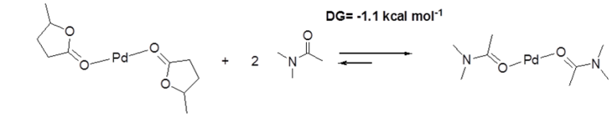
Figure 3. Isodesmic reaction between Pd(0)GVL₂ and Pd(0)DMAc₂.
In order to further understand the impact that GVL has on the reaction of non-activated aryl halides, our attention was shifted to the pathways involved in the catalytic cycle (Figure 4). DFT computational studies of the mechanism behind the C(sp2)-H activation of thiophenes have previously been reported by Gorelsky,³⁴ and Ozawa.³⁵ However, to the best of our knowledge, a reaction pathway involving a ligand-free C(sp2)-H arylation of thiophene had not yet been computed. We herein present the most likely reaction pathway, according to DFT computational studies.
After oxidative addition, complex I³⁶ associates with methyl thiophene giving rise to a more reactive intermediate II (∆G = 2.3 kcal mol⁻¹). The pivalate ligand changes its coordination from 𝜅2 to 𝜅1 while methyl thiophene establishes a 𝜅2 coordination with Pd(II) II. TS-III (∆G = 15.8 kcal mol⁻¹) consequently corresponds to the C-H activation step that takes place via a CMD (Concerted Metalation Deprotonation), leading to product III (∆G = 4.3 kcal mol⁻¹). From here, TS-IV (∆G = 21 kcal mol⁻¹) is the reductive elimination step yielding a C-C bond between the p-OMe phenyl moieties and the thiophene, which irreversibly leads to final product IV (∆G = -8.2 kcal mol⁻¹). Since the energy difference between TS-III and TS-IV is ∆∆s = 5.2 kcal mol⁻¹, reductive elimination and not C-H activation can be considered the rate limiting step, in accordance with work by Ozawa and co-workers.²⁶

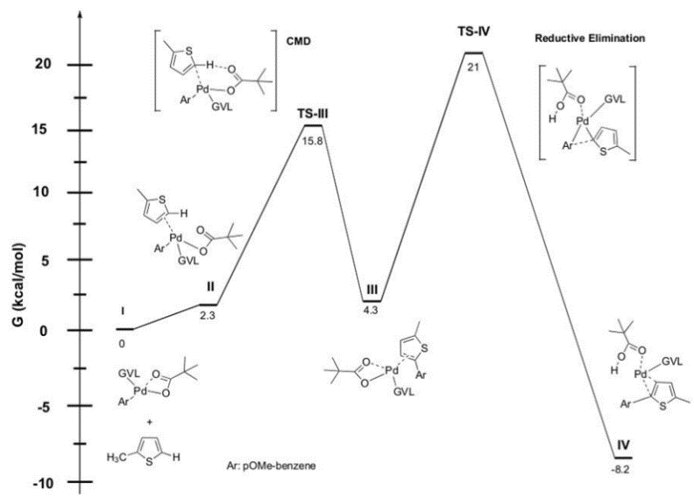

Figure 4. Gibbs free energy change along the reaction pathway of the direct arylation of 2-methylthiophene and oxidative addition complex I

The difference between our computational system and Ozawa’s lies in the presence of GVL as the ligand, in place of PH₃. This leads to a slightly larger energy gap between TS-III and TS-IV (∆∆G = 5.2 kcal mol⁻¹) in our case than in computations with PH₃ as the ligand (∆∆G = 3 kcal mol⁻¹). This is due to the lowering of the activation barrier for TS-III (CMD step) when GVL is the ligand. The rate limiting step of the compute pathway, being TS-IV (∆G = 21 kcal mol⁻¹), means that either we have a very small amount of monometallic homogeneous species in solution that catalyze the reaction or that the process takes place on soluble palladium nanoparticles (PdNP), probably resulting in higher reaction barriers.
Conclusions
In this work, we have successfully developed more environmentally-friendly conditions for the direct C-H arylation of thiophenes. This has been accomplished via a series of enhancements: the use of toxic ligands, such as phosphines, has been avoided; the amount of palladium has been lowered to 0.2 mol %; a green bio-sourced solvent (GVL) has been used and, finally, microwave heating has furnished reduced reaction times. The ligand-free procedure was then successfully applied to the synthesis of poly(3-hexyl)thiophene (P3HT), although it is limited to relatively reactive substrates.¹¹
Computational investigations have quantified the coordinating ability of GVL towards the Pd atom as being slightly weaker than DMAc’s. This most likely has an effect on the heterogeneous: homogeneous Pd equilibrium, which is thought to be the rate limiting step of the entire process.³⁰ Furthermore, the activation barriers for this C-H arylation are similar to those computed when PH₃ is the ligand,²⁶ suggesting that the role of the ancillary ligand is not key to the above mentioned reaction steps, although it is more likely to be in the stability of the active homogeneous palladium species.
Experimental and theoretical investigations into the impact of green solvents and additives on the Pd black:Pd nanoparticle: homogeneous Pd equilibrium will be the focus of our future studies, the goal of which will be enhancing ligandless C-H arylations in environmentally-benign conditions
Acknowledgements
The authors thank the University of Turin (ricerca locale 2015), CNRS, CPE Lyon, UCBL and INSA for funding. CCIR-ICBMS (UCBL) is gratefully acknowledged for the allocation of their computational resources.
Notes and references

- C. O. Kappe, Angew. Chem., 2004, 116, 6408.
- A. Sharma, D. Vacchani, E. Van der Eycken, Chem. Eur. J., 2013, 19, 1158.
- Bioactive Heterocyclic Compound Classes: Pharmaceuticals and Agrochemicals, ed. C. Lamberth and J. Dinges, Wiley-VCH, New York, 2012.
- C. Wang, H. Dong, W. Hu, Y. Liu, D. Zhu, Chem. Rev., 2012, 112, 2208.
- Y. J. Cheng, S.H. Yang, C.S. Hsu, Chem. Rev., 2009, 109, 5868.
- L.G. Mercier, M. Leclerc, Accounts Chem. Res., 2013, 46, 597.
- A. Facchetti, L. Vaccaro, A. Marrocchi, Angew. Chem. Int. Ed., 2012, 51, 3520.
- G. L. Turner, J. A. Morris, M. F. Greaney, Angew. Chem. Int. Ed., 2007, 46, 7996.
- K. Masui, A. Mori, K. Okano, K. Takamura, M. Kinoshita, T. Ikeda, Org. Lett., 2004, 6, 2011.
- Y. Li, Jingran W., Mengmeng H., Z. Wang, Y. Wu, J. Org. Chem. 2014, 79, 2890.
- J. Roger, F. Pozganb, H. Doucet, Green Chem., 2009, 11, 425.
- F. Pozganb, J. Roger, H. Doucet, ChemSusChem, 2008, 1, 404.
- F. P. Byrne, S. Jin, G. Paggiola, T. H. M. Petchey, J. H. Clark, T.J. Farmer, A. J. Hunt, C. R. McElroy, J. Sherwood, Sust. Chem. Process, 2016, 4, 7.
- https://echa.europa.eu/substance-information/-/substanceinfo/100.004.389
- Y. Gu, F. Jerome, Chem. Soc. Rev., 2013, 42, 9550.
- A.O. Ali, A. Heyden, J.Q. Bond, ACS Catal., 2014, 4, 1171.
- S. Tabasso, G. Grillo, D. Carnaroglio, E. Calcio Gaudino, G. Cravotto, Molecules, 2016, 21, 413.
- S. Aparicio, R. Alcalde, Phys. Chem. Chem. Phys., 2009, 11, 6455.
- Z.Q. Duan, F. Hu, Green Chem., 2012, 14, 1581.
- E. Ismalaj, G. Strappaveccia, E. Ballerini, F. Elisei, O. Piermatti, D. Gelman, L. Vaccaro, ACS Sustainable Chem. Eng., 2014, 2, 2461.
- G. Strappaveccia, L. Luciani, E. Bartolini, A. Marrocchi, F. Pizzo, L. Vaccaro, Green Chem., 2015, 17, 1071.
- G. Strappaveccia, E. Ismalaj, C. Petrucci, D. Lanari, A. Marrocchi, M. Drees, A. Facchetti, L. Vaccaro, Green Chem., 2015, 17, 365.
- S. Santoro, F. Ferlin, L. Luciani, L. Ackermann, L. Vaccaro, Green Chem., 2017, DOI: 10.1039/c7gc00067g.
- X. Tian, F. Yang, D. Rasina, M. Bauer, S. Warratz, F. Ferlin, L. Vaccaro, L. Ackermann, Chem. Commun., 2016, 52, 9777.
- S. Bensaid, J. Roger, K. Beydoun, D. Roy, H. Doucet, Synthetic Communications, 2011, 41, 3524.
- Q.Wang, R. Takita, Y. Kikuzaki, F. Ozawa, J. Am. Chem. Soc., 2010, 132, 11420; Q. Wang, M. Wakioka, F. Ozawa, Macromol. Rapid Commun., 2012, 33, 1203.
- Y. J. Cheng, S. H. Yang, C.S. Hsu, Chemical Reviews, 2009, 109, 5869.
- A. E. Rudenko, C.A. Wiley, S. M. Stone, J. F. Tannaci, B. C. Thompson, J. Polym. Sci., Part A: Polym. Chem., 2012, 50, 3691.
- S. Hayashi, Y. Kojima, T. Koizumi, Polym. Chem., 2015, 6, 881.
- M. T. Reetz, J. G. de Vries, Chem. Commun., 2004, 1559; J. G. de Vries, Dalton Trans., 2006, 421; A. J. Reay, I. J. S. Fairlamb, Chem. Commun., 2015, 51, 16289; A. H. M. de Vries, J. M. C. A. Mulders, J. H. M. Mommers, H. J. W. Henderickx, J. G. de Vries, Org. Lett., 2003, 5, 3285.
- D-T. D. Tang, K. D. Collins, F. Glorius, J. Am. Chem. Soc., 2013, 135, 7450.
- P. Larini, C.E. Kefalidis, R. Jazzar, A. Renaudat, E. Clot, O. Baudoin, O., Chemistry, 2012, 18, 1932; A. Goutierre, H.V. Trinh, P. Larini, R. Jazzar, O. Baudoin, Organometallics, 2016, 535, DOI: 10.1021/acs.organomet.6b00535; A. Millet, P. Larini, E. Clot, O. Baudoin, Chem. Sci., 2013, 4, 2241; P. M. Holstein, M. Vogler, P. Larini, G. Pilet, E. Clot, O. Baudoin, ACS Catal. 2015, 5, 4300; A. Millet, D. Dailler, P. Larini, O. Baudoin, Angew. Chem. Int. Ed. 2014, 53, 2678.
- The dielectric constants of the two solvents are quite similar (36.47 for GVL and 37.8 for DMAc at 25°C).
- S. I. Gorelsky, D. Lapointe, K. Fagnou, J. Org. Chem., 2012, 77, 658.
- M. Wakioka, Y. Nakamura, Y. Hihara, F. Ozawa, S. Sakaki, Organometallics, 2013, 32, 4423; M. Wakioka, Y. Nakamura, Q. Wang, F. Ozawa, Organometallics, 2012, 31, 4810.
- Palladium bromide oxidative addition specie was not considered, since the pivalate is a stronger ligand, being thus capable of replacing the former in solution: a) M. Ahlquist, P. Fristrup, D. Tanner, P.-O. Norrby, Organometallics 2006, 25, 2066; b) Nella, N., Parker, E., Hitce, J., Larini, P., Jazzar, R., Baudoin, O. Chem. Eur. J. 2014, 20, 13272.

